
Kerberos C64/C128 MIDI Flash Interface
Quick Start Guide

- Turn off your C64 or C128
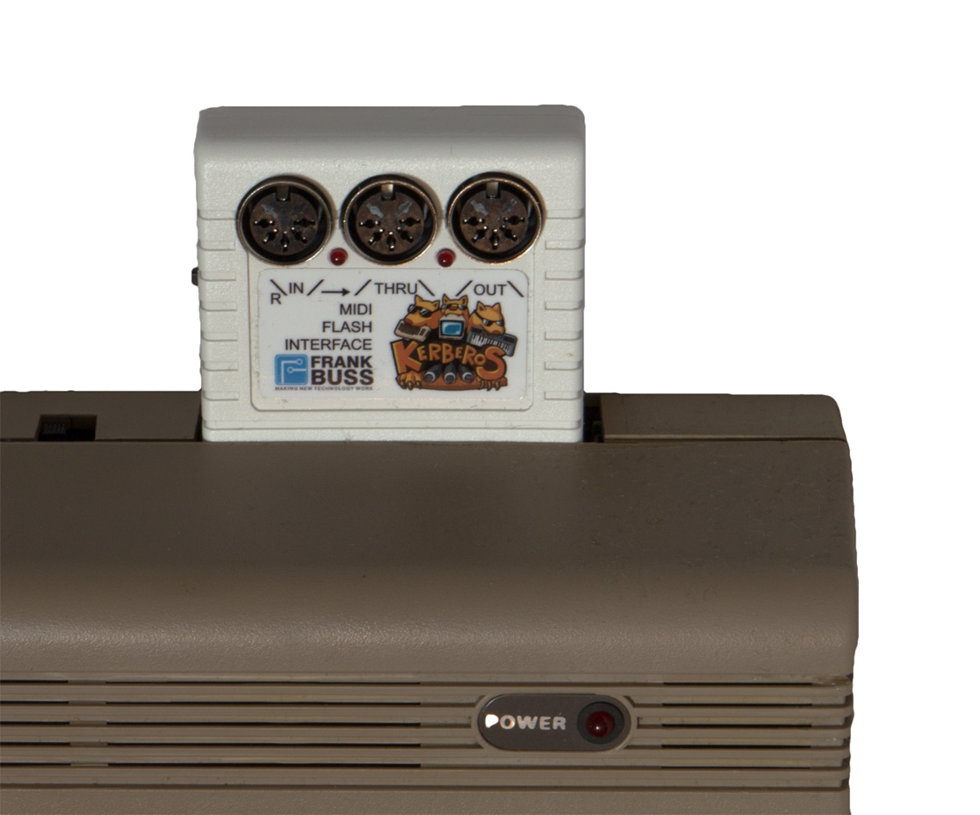
- Insert the cartridge into the cartridge port at the back of your C64/C128, on the right side:

- Turn on your C64/C128. You should see the start menu:
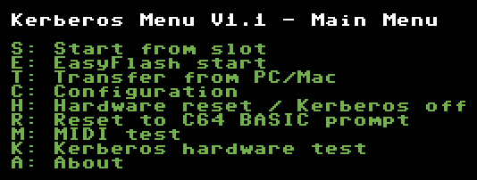
- Press the „S“ key to list all pre-installed programs, and then a number key to start a program, or press E to start the pre-installed EasyFlash program
- Press the reset button at the left side of the cartridge to go back to the menu
- For connecting a MIDI keyboard to use with Cynthcart or other MIDI programs, connect it with a MIDI cable to the MIDI-in connector at the left side. For uploading programs from a PC or Mac to the flash memory of the cartridge, connect MIDI-out of an USB MIDI adapter to MIDI-in of the cartridge.

For the PC/Mac program to transfer your own programs or games and to update the menu program, and for the detailed user's and developer's guide, visit
http://www.frank-buss.de/kerberos


