**CS 410000 Computer Architecture**

**Homework 1**

**(Due: 2019-09-29 23:59)**

[106033233] [周聖諺]

Please evaluate your computer performance by executing the following benchmarks, and fill the blanks of table. In addition, basic hardware information of your computer has to be reported too. You can download the benchmark source code from iLms, and re-compile them for your Linux system.

|  |
| --- |
| **Compile Instructions**  1) Change directories to “src” of benchmarks. (eq. SPEC2000_SS/CINT2000/164.gzip/src)  2) Make sure your gcc location in *Makefile.defaults* (eq. cc=gcc), and type "make",  3) Execute the “./run” script, and report your program elapsed time. |

|  |  |
| --- | --- |
| Reference machine information | |
| Processor model | Intel(R) Core(TM) i5-4440 CPU @ 3.10GHz |
| Memory size | 3809176 kB |
| Operating system (OS) | Ubuntu precise (12.04.5 LTS) |

|  |  |  |  |
| --- | --- | --- | --- |
| Benchmark | Execution time of your machine (second) | Execution time of reference machine (second) | Speedup of your machine w.r.t. reference machine |
| 175.vpr | 0m0.764s | 0.557 | 71.90%(Slower) |
| 256.bzip2 | 0m4.558s | 2.911 | 63.87%(Slower) |
| 181.mcf | 0m0.131s | 0.081 | 61.83%(Slower) |
| Arithmetic mean |  |  | 65.87% |

|  |  |
| --- | --- |
| Your machine information | |
| Processor number | 16 CPU Intel(R) Xeon(R) CPU X5570 @ 2.93GHz |
| Memory | 49431916 kB |
| Operating system (OS) | CentOS release 5.11 (Final) |

Snapshots of compilation results (including 175.vpr, 256.bzip2, and 181.mcf). 3*5%

E.g.

175.vpr compile:

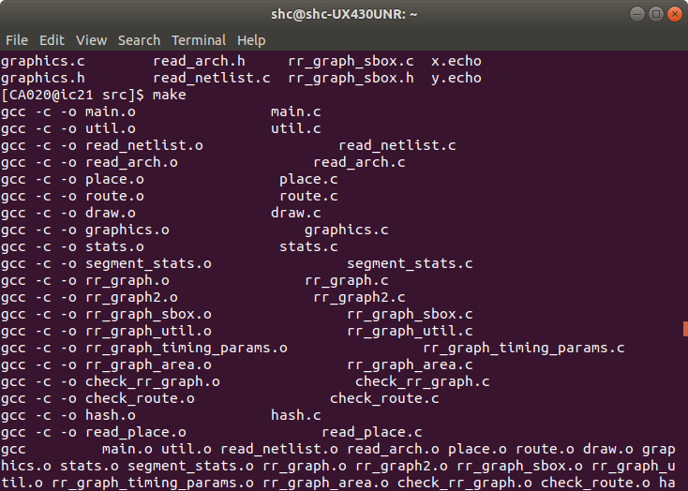

256.bzip2 compile:

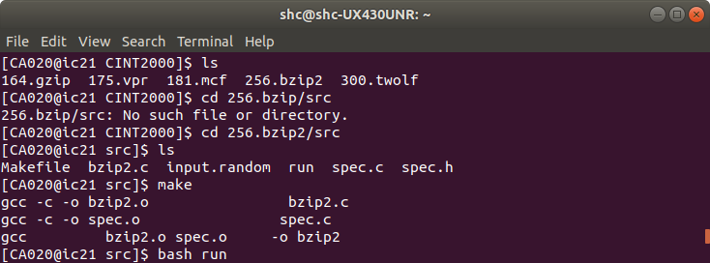

181.mcf compile:

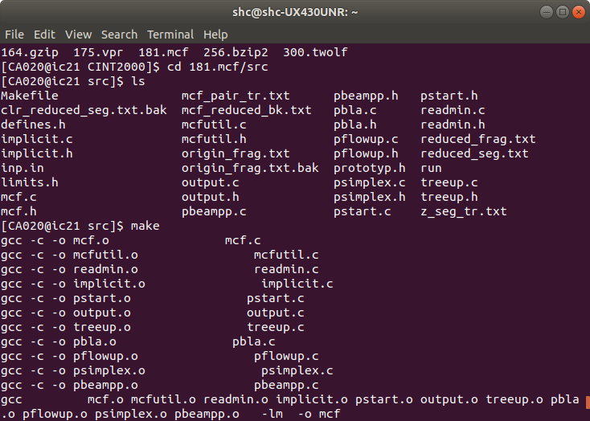

Snapshots of execution results (including 175.vpr, 256.bzip2, and 181.mcf). 3*5%

E.g.

175.vpr run:

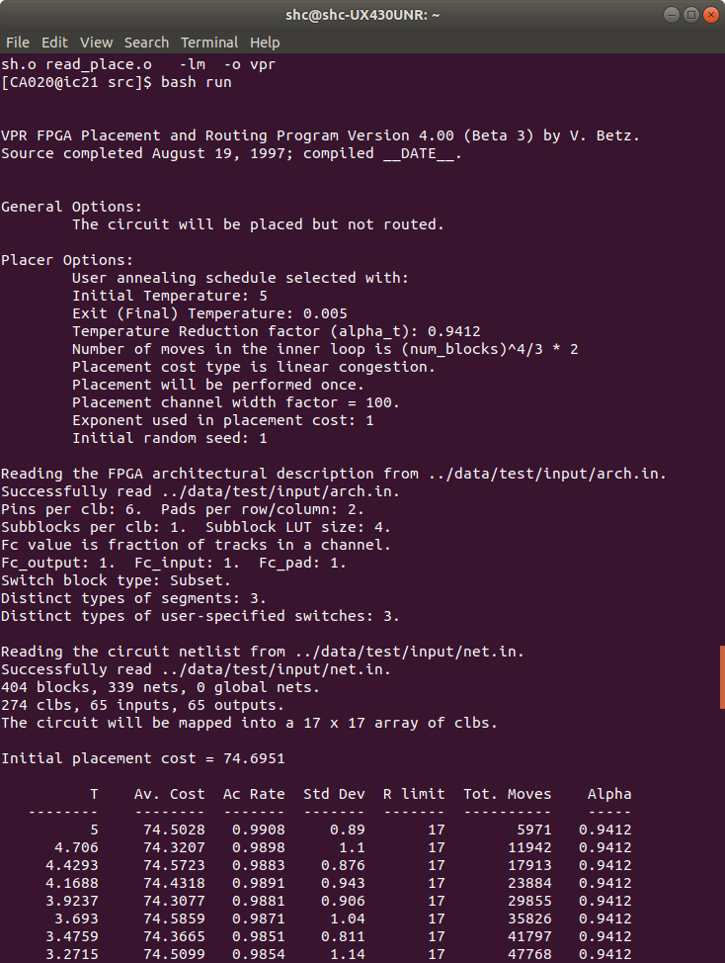

256.bzip2 run:

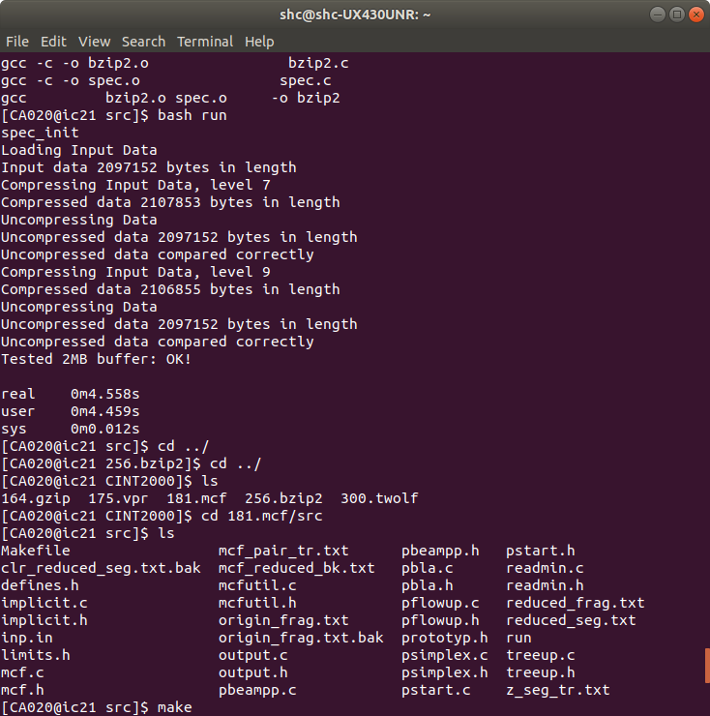

181.mcf run:

