電路與電子學一Circuits and Electronics (I) CS210000

Exam 1 Date:106/03/06

\*請務必寫出計算過程，否則不予計分。

1. (10%) Compute the power for each element shown in below. For each element, state whether energy is being absorbed by the element or supplied by it.

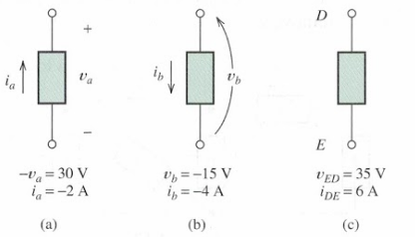

1. (10%) Solve for the node voltage Vx shown in below.

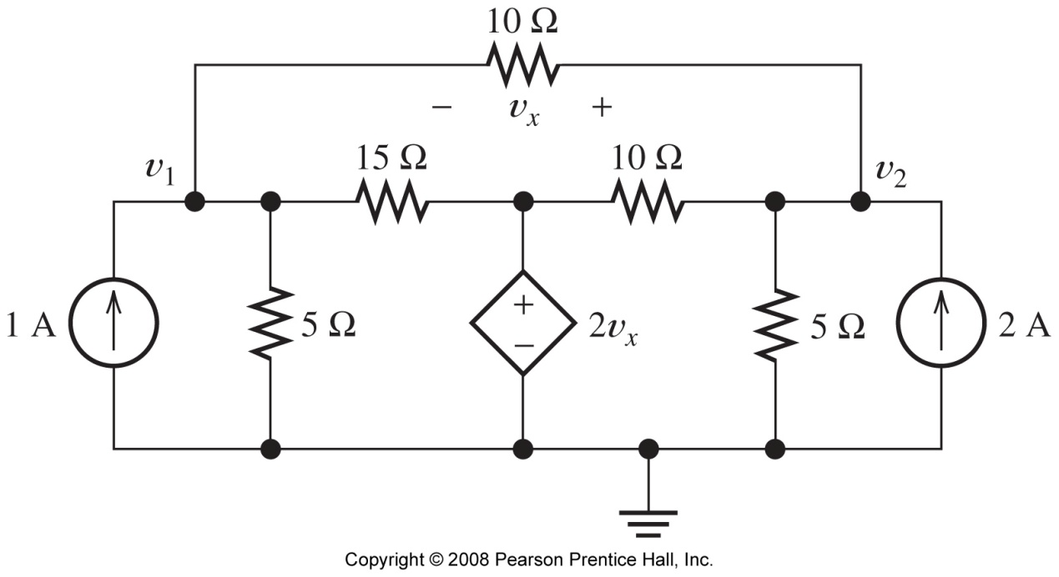

1. (10%)
2. Which elements are in series and which are in parallel shown in below?
3. What is the relationship between ia and ie?
4. Given that ib=8A, and ic=–2A, determine the values of ia and id.

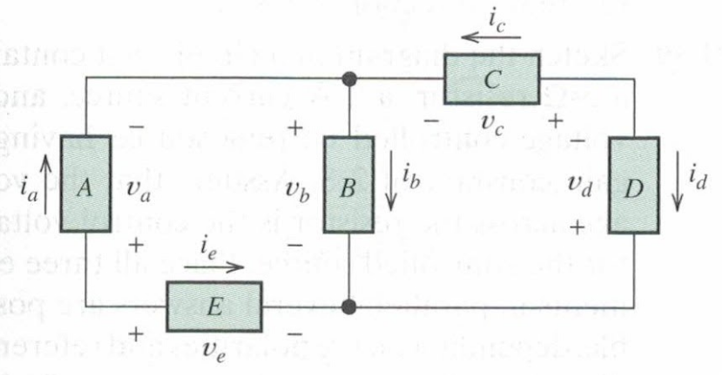

1. (10%) We know that va=12V, vb=–3V, vf=12V, and vh=5V, solve for the other voltages shown in below.

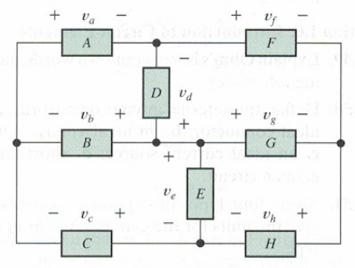

1. (10%) Use repeated applications of Ohm’s law, KVL, and KCL to eventually find the value of Ix in the circuit shown in below.

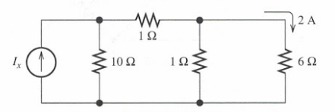

1. (10%) Reduce each of the networks shown in below to a single equivalent resistance by combining resistances in series and parallel.

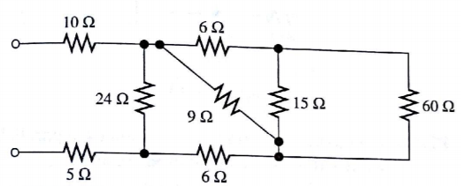

1. (10%) Find the values of i1 and i2 shown in below. Find the power for each element in the circuit, and state whether each is absorbing or delivering energy. Verify that the total power absorbed equals the total power delivered.

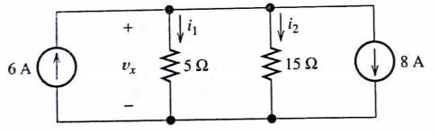

1. (10%) Determine the values of i1 and i2 shown in below.

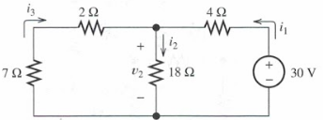

1. (10%) Consider the circuit shown below. Find the values of v1, v2, vab, vbc, and vca.

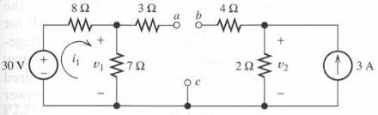

1. (10%) Use superposition to find the current i shown in below.

First, zero the current source and find the value caused by the voltage source alone. Then, zero the voltage source and find the value caused by the current source alone. Finally, add the results algebraically.



