CS 2102-01 Logic Design Fall 2010 Final exam
2011/01/11 10:10a.m. ~ 12 noon
Student ID: ________ Name:________

1. In each sub-problem, explain the difference between the terms briefly and clearly. (6 pts. each)
(a) Sequential circuit and combinational circuit,
(b) Moore machine and Mealy machine.

2. The circuit below implements a commonly used building block in logic design. It has inputs S1, S0, I3, I2, I1, I0 and an output Y. What is the name of building block the given circuit implements? (6 pts.)
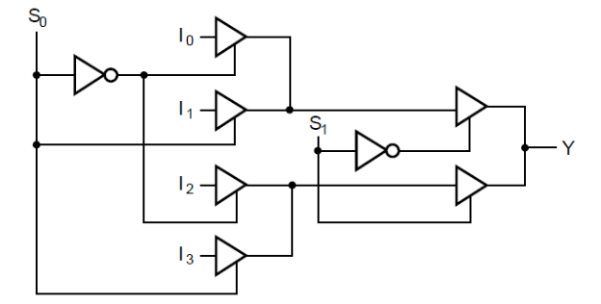
- Find the simplest SOP form Boolean expression for each function below. (6 pts. each)
(a)
(b)

4. According to the circuit, fill in the following timing diagram. (10 pts.)
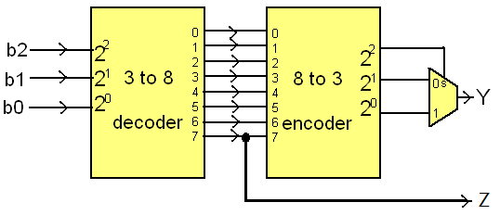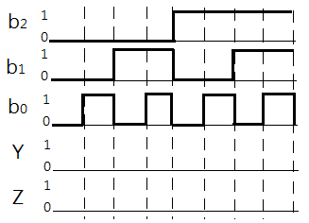

5. Design a combinational circuit that computes 2x + 1 for a 4-bit binary number x. (10 pts.)

6. Below is a state table for a design. Reduce the number of states to the minimum possible and tabulate the reduced state table: (10 pts.)
Present State | Next State |  | Output
Present State | Y=0 | Y=1 | Y=0 | Y=1
A | G | B | 0 | 1
B | A | B | 0 | 1
C | G | B | 0 | 1
D | C | B | 0 | 1
E | G | D | 0 | 0
F | E | D | 0 | 0
G | G | F | 0 | 0

7. A sequential circuit with one D flip-flop A, two inputs X, Y, and one output Z is specified by the following equations: A(t+1)=XY+AX, Z=A+A’Y. Draw the logic diagram for the circuit. (10 pts.)

9. Draw a Mealy state diagram for a circuit that detects if two successive inputs of signal X are the same. If X has the same value at two successive positive clock edges, the output Y is equal to 1 immediately. Otherwise, output Y is 0. Explain the meaning of each state briefly. (When the first bit of input is received, there is no previous value and the “otherwise” category applies.) (10 pts.)

8. The following state diagram describes the behavior of a sequence recognizer. It takes one bit at a time at input X and generates an output Y = 1 when and only when a particular sequence is detected. The initial state is 00.
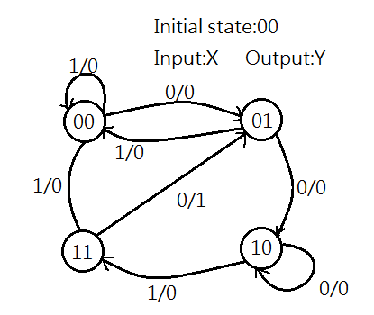
- What sequence does this recognizer detect? (5 pts.)
- Complete the state stable below for the recognizer and fill in the flip-flop inputs columns assuming JK flip-flops are used as the state flip-flops. (6 pts.)
Present state |  | Input | Next state |  | Output | Flip-flop inputs
A | B | X | A | B | Y | J_{A} | K_{A} | J_{B} | K_{B}
0 | 0 | 0
0 | 0 | 1
0 | 1 | 0
0 | 1 | 1
1 | 0 | 0
1 | 0 | 1
1 | 1 | 0
1 | 1 | 1

- Derive the logic equations for output Y and the flip-flop inputs if JK flip-flops are used as the state flip-flops. (5 pts.)
- Convert the given state diagram into an ASM chart. (4 pts.)

Answer the following question for extra credit.
10. Consider the circuit below. The operands are stored in registers A and B initially. It has inputs ‘shift control’, ‘CLK’, and ‘serial input’. What function does the circuit perform? Explain how it works clearly. (10 pts.)
