- (10%) Explain the following terms:
  - Yield
  - Stored Program Concept
  - Harvard Architecture
  - Memory Alignment

Ans:
(a) Yield：
The percentage of good dies from the total number of dies on the wafer.
整塊wafer上好的die所佔的比率。

(b) Stored Program Concept：
Instruction and data of many types can be stored in the memory as numbers, leading to the stored program computer
將程式和程式運算所需的資料一起按照同樣的方式儲存在電腦內部的儲存器內，利用PC來指定位址並存取指令。
http://big5.pconline.com.cn/b5/www.pconline.com.cn/pcjob/pxdt/0611/914264.html

(c)Harvard Architecture：
Harvard architecture is a computer architecture with physically separate storage and signal pathways for instructions and data
是一種將程式和資料分開儲存在不同的記憶體內的結構。
http://en.wikipedia.org/wiki/Harvard_architecture

(d) Memory Alignment：
A requirement that data be aligned in memory on natural boundaries.
當資料在儲存時，必須存在特定的位置，才不會去超過邊界的限制，以word儲存為例，必須儲存在address為4的倍數的地方。

- (10%) Please give the three types of instruction format in MIPS. Explain each field briefly.

Ans:
OP
OP
OP
$rs
$rt
$rd
sa
funct
$rs
$rt
immediate
jump target

第一行是R-type
第二行是I-type
第三行是J-type

Op : opcode，用來表示是哪一種operation和哪一種format。
Rs：The first register source operand
Rt：The second register source operand
Rd：The register destination operand. It gets the results of the operation.
Sa：shift amount,用來表示執行shift operation時所要shift的位移量。
Funct：配合opcode用來明確指出這個instruction是執行哪一種operation。
Imm：在做I-type指令時，用來表示常數或是address。
Jump：代表執行jump operation時，所要jump的destination的memory address。
因為想要提供更大範圍的跳躍，所以真正會跳到的memory address是 4 *
(jump target)

- (10%) The following figure shows an implementation of ALU. Please give the function specifications of the following operations.
Operations 4 bits (Anegat, Binvert, Operation[1:0])
(a + b)
(a – b)
(a nor b)
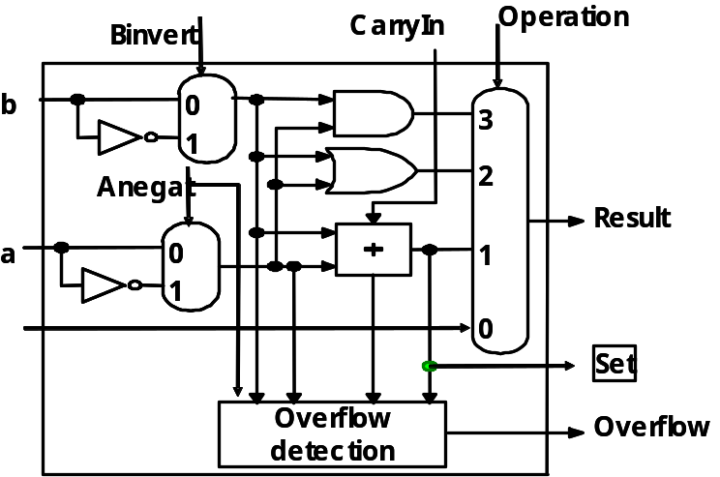
(a or b)

Ans:

(a+b) : (0, 0, 01)
(a-b) : (0, 1, 01)
(a nor b) : (1, 1, 11)
(a or b) : (0, 0, 10)

- (20%) Adder design.
  - (8%) Design a carry look-ahead adder. Please give the logic equation of pi (propagate term) and gi (generate term). Given c0, p1, g1, p2, g2, p3, g3. Give the equation to produce c3.
  - (4%) Propagation delay of carry look-ahead adder. Given a 64-bit adder and each carry look-ahead unit for 4 bits. What is the delay of this 64-bit adder.
  - (8%) Design a 4n-bit carry select adder. Let the adder be partitioned into four n-bit adders. (a) Give the block diagram of the design (b) What is the propagation delay of the adder in terms of n-bit adder and mux delay?
Ans:
(a)
(the index is for 1 to i)
gi = ai ● bi
pi = ai + bi
c3 = g3 + (p3 ● g2) + (p3 ● p2 ● g1) + (p2 ● p2 ● p1 ● c0)
(b)
1+ 2 + 2 + 2 + 2 + 2 + 1 = 12
ai, bi
4-bit
4-bit
4-bit
4-bit
PPi, GGi
4-bit
4-bit
4-bit
4-bit
ai, bi
4-bit
4-bit
4-bit
4-bit
2
2
2
2
2
result
result
ai, bi
result
1
1
C
C
C
s
Pi, Gi
pi, gi

(c)
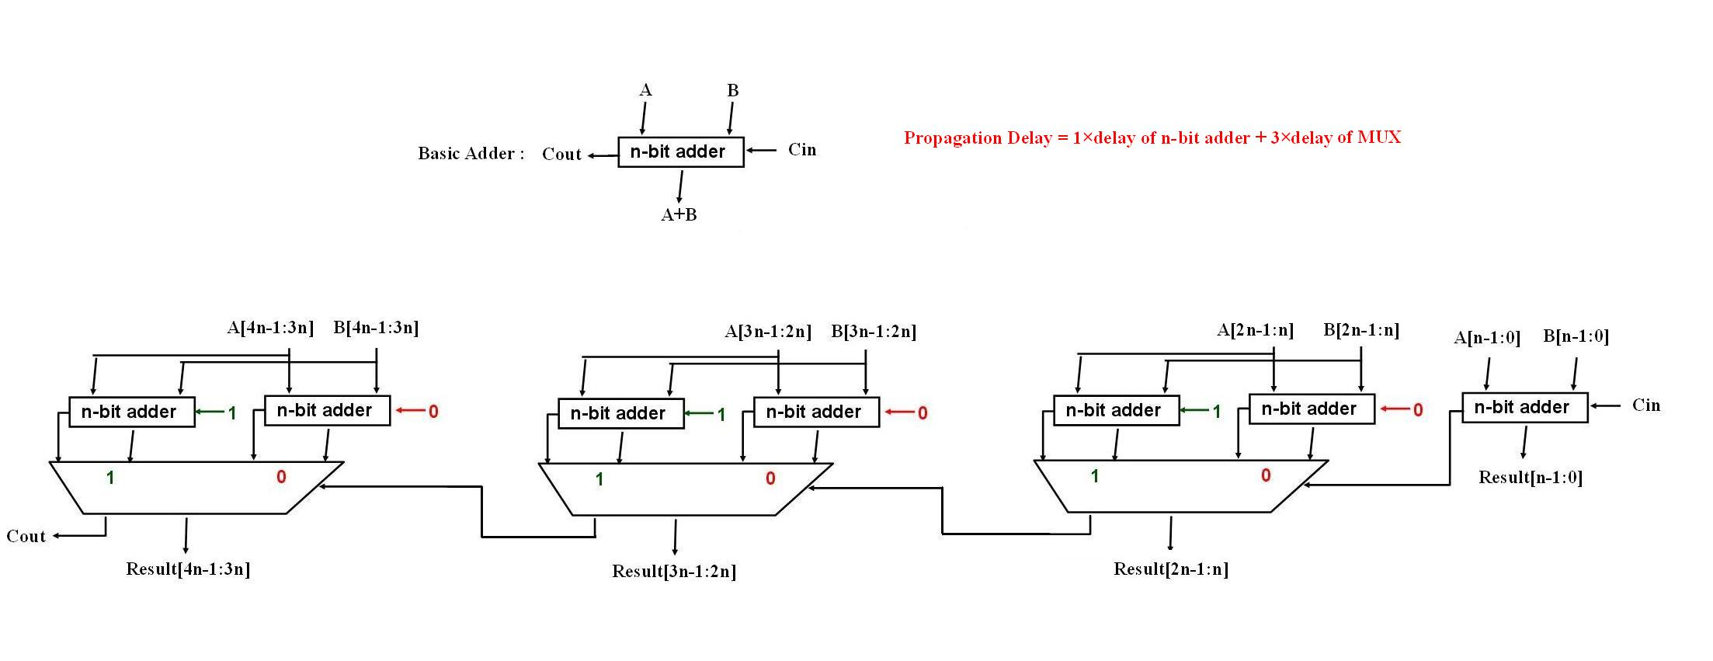
Delay = 1 n-bit adder + 3 MUX

- (a) (5%) In class we have described a 32-bit ALU which supports set on less than
(slt) using just the sign bit of the adder. Please use a 4-bit version of the ALU
shown in question (3) and give an example to show that the result of slt could
be wrong.
(b) (5%) What changes should be made for the ALU to handle slt correctly?
Ans:
(a) This problem is from B.24, Appendix B (page B.14)
Want to see if x is less than y.
Any values of x and y causing x-y to be an overflow can serve as an example.
For example, if x=-7 and y=6, we have 1001 – 0110 = 1001 + 1010 = 0011
This result would suggest that -7 > 6, which is clearly wrong.
(b) The sign bit can be XORed with the overflow bit to get the correct result.

- (a) (4%) In MIPS, there are instruction like lb, lbu, and sb, but there is no sbu
(store byte unsigned). Why not?
(b) (4%) A MIPS branch instruction performs a modification of PC+4 if the condition is true. The maximum range of the jump is (PC+4)-A to (PC+4)+B, where both A and B are positive numbers. What are A and B?
(c) (6%) You wish to call a subroutine named FOO. This subroutine will use register $t1. Write a MIPS code segment to perform the following operations: Before calling FOO, save $t1 on the stack, then call FOO, then once FOO returns, copy the value from $t1 to $t2, and restore the value from the stack back to $t1. Note that this is an example of caller-saved subroutine.
(d) (6%) Write a MIPS code segment to determine if bit k of register $s1 is 1,
where the value of k is contained in $s3. If so, set $s2 to 1, otherwise, set it
to 0.

Ans:
(a) Because an unsigned variant is only needed when writing a value to a location that’s larger than the value. For lb, an 8-bit value is written to a 32-bit register, and so the instruction must specify what to do with the other 24 bits (sign extended for lb, and set to 0 for lbu). For sb, an 8-bit value is written to an 8-but memory location and so there are no extra bits to set.
(b) A= ( 2¹⁵ x 4), B=(2¹⁵-1) x 4
(c) The following one is a possible solution.
addi $sp, $sp, -4
sw $t1, 0($sp)
jal FOO
addi $t2 $t1, 0
lw $t1, 0($sp)
addi $sp, $sp, 4

Note: subi is not a MIPS instruction; use addi with negative immediate values.

(d) The following one is a possible solution.
addi $t0, $zero, 1 # $t0=1
add, $t1, $s3, $zero # $t1=i
loop: beq $t1, $zero, check # left shift $t0 by I bits
sll $t0, $t0, 1
sub $t1, $t1, 1
j loop
check: and $t0, $t0, $s1 # check to see if bit i is 1
beq $t0, $zero, else
addi $s2, $zero, 1 # $s2=1
j end # jump over else
else: addi, $s2, $zero, 0 # $s2=0
end

- The function bzero(void *b, size_t len) writes 0 to the string b by the amount of len bytes. If len is 0, bzero() does nothing. The following MIPS assembly code implements bzero() that clears bytes one by one:

bzero: beq $a1, $zero, end
loop: sb $zero, 0($a0)
add $a0, $a0, 1
sub $a1, $a1, 1
bne $a1, $zero, loop
end: jr $ra

Suppose you want to run bzero() to clear a string of 20 bytes on a 4 GHz processor with the following CPI table.

Instruction type | CPI
Arithmetic (add, sub) | 3
Data transfer (load, store) | 5
Control (branch, jump) | 4

- (5%) How much CPU time does it take?
- (5%) What is the average CPI?
- (5%) If you could reduce the CPI of one instruction type (arithmetic, memory, or control) by a single cycle, which instruction type would be the best choice and why?

Ans:
(a) First, assign CPI values to each instruction:
bzero: beq $a1, $zero, end (4)
loop: sb $zero, 0($a0) (5)
add $a0, $a0, 1 (3)
sub $a1, $a1, 1 (3)
bne $a1, $zero, loop (4)
end: jr $ra (4)
Next, calculate number of cycles. Since loop is executed 20 times, the total number of cycles is: 4 + 20 * (5 + 3 + 3 + 4) + 4 = 8 + 20 * 15 = 308 cycles
Given 0.25 ns per cycle (4 GHz), the total CPU time is: 308 * 0.25 ns =77 ns.

(b) Average CPI = number of cycles needed / number of instructions executed
Number of cycles, calculated above is 308.
Number of instructions is 2 + 20 * 4 = 82.
Average CPI = 308/82.

(c) Regardless of the instruction type we select, the savings is one cycle per instruction, so we need to select the instruction type that is most often used in the function (more precisely, in the loop). The loop consists of two arithmetic instructions, one memory instruction and one control instruction. To best improve this code, we should reduce arithmetic instruction type by one cycle.

8 (5%) What is the single precision floating-point representation (IEEE 754) for the decimal number -17.5?
Ans:
17.5 is 10001.1 in binary, which is equal to 1.00011 x 2⁴.
So the exponent is 127 + 4 = 131 = 10000011 in binary.
Therefore, the sign bit is 1, the exponent is 10000011, and the fraction is 000110….0.

