九十二學年第二學期PHYS1143普通物理B 第一次段考試題(共兩頁)
[Benson Ch. 22 – 28] 2004/03/23, 8:30AM – 10:00AM

0.【5分】依下面說明在答案卷上作答者，可得5分
(i) 所有演算過程及答案寫在答案卷上。
(ii) 答案卷由六張紙裝訂成冊，第一張為封面。記得寫上學號，班別及姓名等。第一張正反兩面不要作答。
(iii) 由第二張紙開始作答，每張紙有正反兩頁。依題號順序每頁答一題。即第二張的正反兩頁分別答第1題及第2題，第三張答第3題及第4題，…，最後一頁(封底)不要作答。

- Some useful integrals

- (5%,5%) A cube of side L has one corner at the origin and its sides lie along the + x, + y and + z axes, respectively. There is a field given by E = a + bx² i. (a) What is the net flux through the cube? (b) What is the net charge enclosed by the cube?

Fig. 1

- (5%, 5%, 5%) The field strength E is at distance y along the perpendicular bisector of a uniformly charged rod of length L with linear charge density  C/m, as in Fig. 1. (a) Find E. (b) Find E when y << L. (c) Find E when y >> L.
L

- (3%, 3%, 3%, 3%, 3%) A nonconducting uniformly charged sphere of radius R has total charge Q uniformly distributed throughout its volume. (a) Find the electric field inside, (b) electric field outside, (c) potential outside, (d) potential inside, the sphere. (e) What is the potential energy of the sphere?
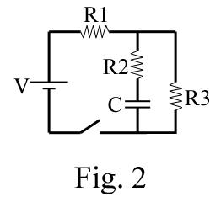

- (3%, 3%, 3%, 6%) For the circuit in Fig. 2 find (a) the initial current through each resistor when the switch is closed; (b) the final steady-state current through each resistor; (c) the final energy stored in the capacitor; (d) the time constant when the switch is opened.

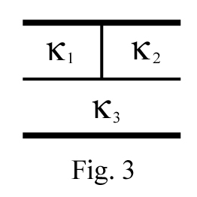
- (10 %) A parallel-plate capacitor is filled with three different dielectrics (₁, ₂, ₃), as in Fig.3. (The upper and lower half have the same height. And, the left and right part of the upper half have the same width.) What is the resulting capacitance? Express your answer in terms of ₁, ₂, ₃, and C₀, the capacitance with no dielectric.

Fig. 4
- (3%, 3%, 6%, 3%) A cylindrical capacitor consists of a central conductor of radius a surrounded by a cylindrical shell of radius b, as shown in Fig. 4. The central conductor has a linear charge density  C/ m, and the length of this capacitor is L. Assuming the L >> b, the end effect is negligible. (a) Find the electric field in the region a < r < b; (b) What is the energy density u_{E} in this region; (c) what is the capacitance? (d) Find the total energy stored in this capacitor.
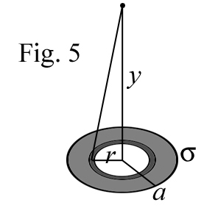
- (5%, 5%) A nonconducting disk of radius a has a surface charge density  as a function of r,  =  / r, where  is a constant, as shown in Fig.5. (a) What is the potential at a point on the axis of the disk at a distance y from its center? (b)What is the electric field at this point?

- (3%, 7%) A half spherical metal rod is planted into ground, as shown in Fig. 6. The ground can be considered as a half spherical shell with an inner radius a and an outer radius infinite . The resistivity of the earth (the ground) is . Current I flows radially from the inner rod surface (contacting surface) to the outer surface (infinitely far). (a) Find the current density J at a distance r from the center of rod. (b) Find the total resistance of the ground (from a to ).
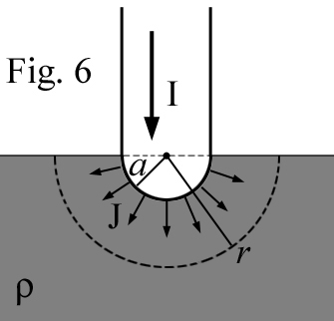

- (a)

……….Ans
(b) ……Ans
- (a) , and
……Ans
(b) y>>L ……Ans
(c) y<<L ……Ans
- (a) , ()……Ans
(b) , ()……Ans
(c) ……Ans
(d)
……Ans
(e),

- (a) V_{C1}=0, therefore the total current

(b) steady state I_{R2}=0 V_{R2}=0 V_{C1}=V_{R3}

(c) ……Ans
(d) ……Ans

……Ans
- (a), or ……Ans
(b) or …..Ans
(c)
or ……Ans
(d) or ……Ans

- (a) …Ans
(b) ,

- (a) ……Ans
(b)
,
……Ans

