九十二學年第二學期PHYS1143普通物理B 第二次段考試題
[Benson Ch. 29 – Ch. 32] 2004/05/04, 8:30AM – 10:00AM

0.【5分】依下面說明在答案卷上作答者，可得5分
(i) 所有演算過程及答案寫在答案卷上。
(ii) 答案卷由六張紙裝訂成冊，第一張為封面。記得寫上學號，班別及姓名等。第一張正反兩面不要作答。
(iii) 由第二張紙開始作答，每張紙有正反兩頁。依題號順序每頁答一題。即第二張的正反兩頁分別答第1題及第2題，第三張答第3題及第4題，…，最後一頁(封底)不要作答。
Some useful integrals: ,

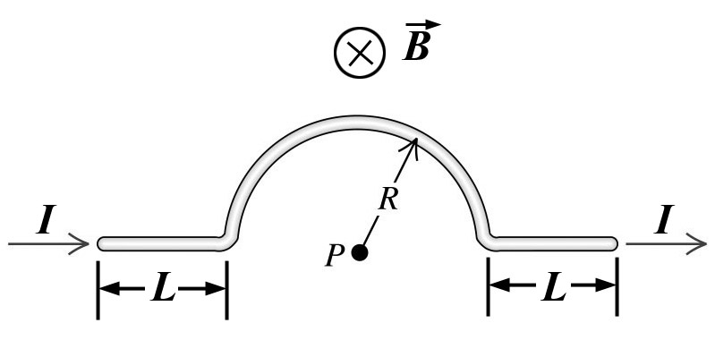

1. (5%, 5%) (a) Calculate the magnitude and direction of the magnetic field at point P due to the segment (線段) of the wire bent as shown in right figure. (b) If a uniform magnetic field B is directed into the plane of the wire, find the force on the wire.

2. (3%, 3%, 2%, 6%) A nonconducting disk of radius R has a surface charge density σ C/m² and rotates about its central axis at ω rad/s. (a) What is the current dI in an elemental ring (with radius r) of width dr? (b) What is the magnetic field at the center of such a ring? (c) Find the magnetic moment of the disk. (d) If a uniform magnetic field B is applied normal to the rotating axis of the disk, find the torque on the disk (Expressed in terms of σ, ω, B and R).
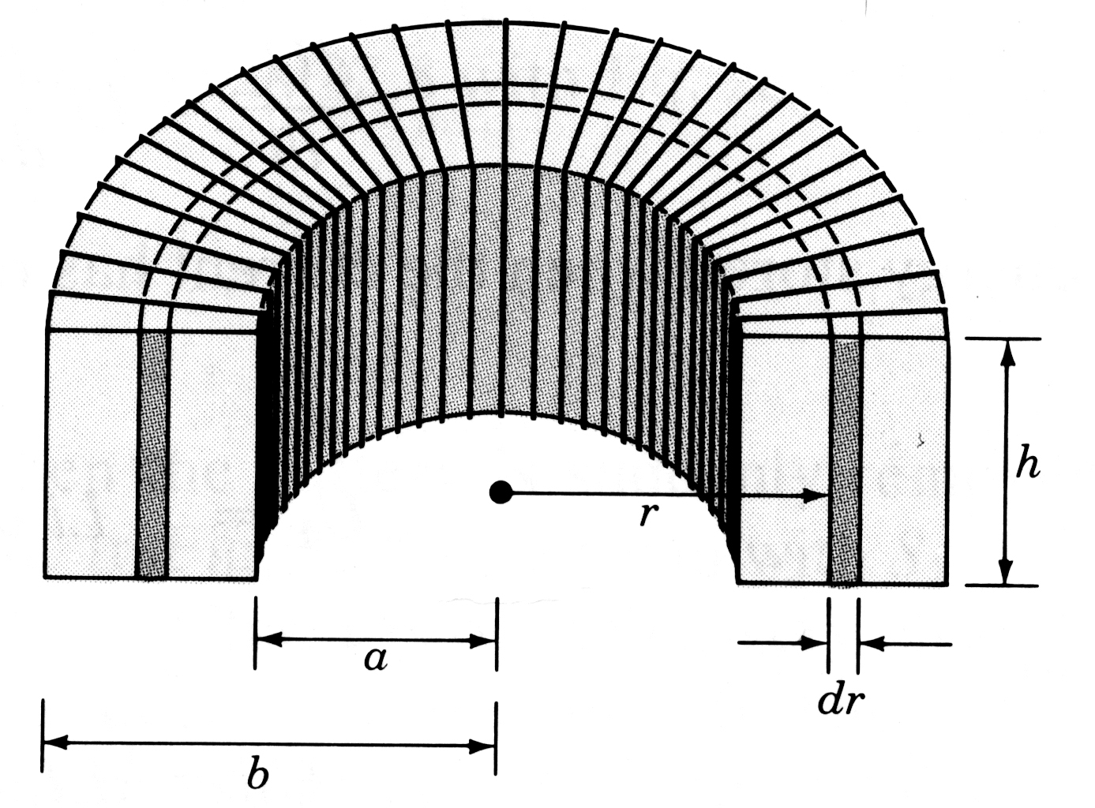
3. (5%, 5%) A toroidal coil (shaped like a doughnut) is tightly wound with N turns and carries a current I. We assume that it has a rectangular cross section, as shown in right figure. (a) Find the field strength within the toroid. (b) Calculate its self-inductance.

4. (6%, 4%) An infinitely long thin metal plate of width w carries a current I, as shown in right figure. (a) By dividing the plate into infinitesimal strips and using the result for the field due to an infinite wire, calculate the magnetic field, (expressed in terms of I, w and D), at point P. (b) If the width of the plate is extended to infinite, what will be the magnetic field, expressed in terms of current density J and plate thickness t, at point P. Do not forget to indicate their directions.
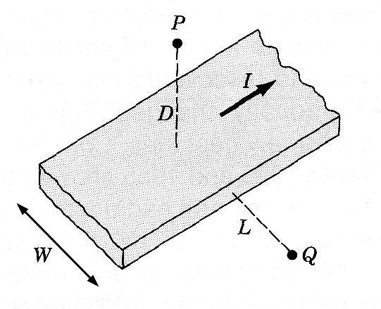

5. (4%, 4%, 3%, 3%) The wire wound on a solenoid, with n turns per unit length, carries a current varied sinusoidally with time, i = i₀ sin(t), (a) What is the magnetic field inside the solenoid? Right figure shows a square loop of side L perpendicular (垂直於) to the magnetic field of the solenoid. (b) At point on the corner of the loop, find the component of the induced electric field along the side. (c) Evaluate the induced emf that arises from the closed line integral of the induced electric field around the loop. (d) Indicate their directions for the first quarter period.
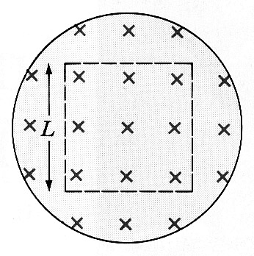

6. (4%, 4%, 4%, 4%) A bar of length L is free to slide without friction on horizontal rails, as shown in lower figure. There is a uniform magnetic field B directed into the plane of the figure. At one end of the rails there is a battery ξ and a switch. The bar has mass m and resistance R, and all other resistance in the circuit can be ignored. The switch is closed at time t = 0. (a) Just after the switch is closed, what is the acceleration of the bar? (b) What is the acceleration of the bar when its speed is v? (c) Sketch the speed of the bar as a function of time. (d) What is the terminal speed of the bar?
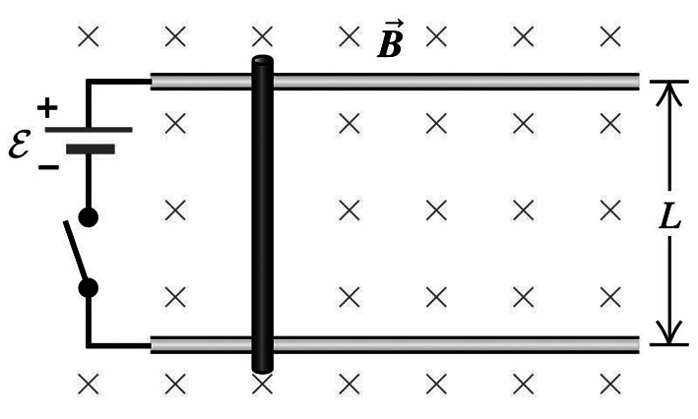

7. (4%, 4%, 4%, 4%) Consider the circuit shown in lower figure. Find the three currents I₁, I₂ and I₃: (a) when the switch is first closed; (b) after the currents have reached steady values; (c) when the switch is first opened (after being closed for a long time). (d) What is the potential difference across R₂ for case (c).
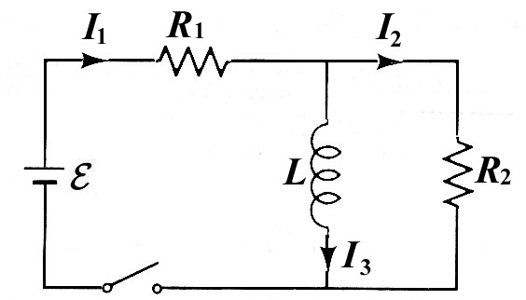

8. (3%, 4%, 3%) In the Bohr model of the hydrogen atom, an electron with charge e travels in a circular orbit about a stationary proton. The radius of the orbit is r and the speed of the electron is v. (a) What is the magnetic moment L associated with the orbital motion? (Express L in terms of e, v, and r) (b) Relate the magnetic moment µ to the orbital angular momentum L of the electron. (Express µ in terms of L, e and m). (c) What is the origin of the diamagnetic effect of matter when external magnetic field is applied on it? (State the law).

