**PreLab3_1**

**Design Specification**

* For a counter:

Input: clk, rst_n

Output: q[3:0]

* Draw the block diagram of the design.

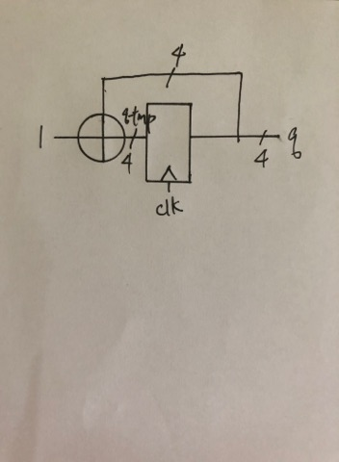

**Design Implementation**

* Truth table

|  |  |  |  |  |  |  |  |  |  |
| --- | --- | --- | --- | --- | --- | --- | --- | --- | --- |
| input | | q | | | | output(q_next) | | | |
| rst | clk | q0 | q1 | q2 | q3 | q'0 | q'1 | q'2 | q'3 |
| 0 | X | X | X | X | X | 0 | 0 | 0 | 0 |
| 1 | 1 | 0 | 0 | 0 | 0 | 0 | 0 | 0 | 1 |
| 1 | 1 | 0 | 0 | 0 | 1 | 0 | 0 | 1 | 0 |
| 1 | 1 | 0 | 0 | 1 | 0 | 0 | 0 | 1 | 1 |
| 1 | 1 | 0 | 0 | 1 | 1 | 0 | 1 | 0 | 0 |
| 1 | 1 | 0 | 1 | 0 | 0 | 0 | 1 | 0 | 1 |
| 1 | 1 | 0 | 1 | 0 | 1 | 0 | 1 | 1 | 0 |
| 1 | 1 | 0 | 1 | 1 | 0 | 0 | 1 | 1 | 1 |
| 1 | 1 | 0 | 1 | 1 | 1 | 1 | 0 | 0 | 0 |
| 1 | 1 | 1 | 0 | 0 | 0 | 1 | 0 | 0 | 1 |
| 1 | 1 | 1 | 0 | 0 | 1 | 1 | 0 | 1 | 0 |
| 1 | 1 | 1 | 0 | 1 | 0 | 1 | 0 | 1 | 1 |
| 1 | 1 | 1 | 0 | 1 | 1 | 1 | 1 | 0 | 0 |
| 1 | 1 | 1 | 1 | 0 | 0 | 1 | 1 | 0 | 1 |
| 1 | 1 | 1 | 1 | 0 | 1 | 1 | 1 | 1 | 0 |
| 1 | 1 | 1 | 1 | 1 | 0 | 1 | 1 | 1 | 1 |
| 1 | 1 | 1 | 1 | 1 | 1 | 0 | 0 | 0 | 0 |
| 1 | 0 | 0 | 0 | 0 | 0 | 0 | 0 | 0 | 0 |
| 1 | 0 | 0 | 0 | 0 | 1 | 0 | 0 | 0 | 1 |
| 1 | 0 | 0 | 0 | 1 | 0 | 0 | 0 | 1 | 0 |
| 1 | 0 | 0 | 0 | 1 | 1 | 0 | 0 | 1 | 1 |
| 1 | 0 | 0 | 1 | 0 | 0 | 0 | 1 | 0 | 0 |
| 1 | 0 | 0 | 1 | 0 | 1 | 0 | 1 | 0 | 1 |
| 1 | 0 | 0 | 1 | 1 | 0 | 0 | 1 | 1 | 0 |
| 1 | 0 | 0 | 1 | 1 | 1 | 0 | 1 | 1 | 1 |
| 1 | 0 | 1 | 0 | 0 | 0 | 1 | 0 | 0 | 0 |
| 1 | 0 | 1 | 0 | 0 | 1 | 1 | 0 | 0 | 1 |
| 1 | 0 | 1 | 0 | 1 | 0 | 1 | 0 | 1 | 0 |
| 1 | 0 | 1 | 0 | 1 | 1 | 1 | 0 | 1 | 1 |
| 1 | 0 | 1 | 1 | 0 | 0 | 1 | 1 | 0 | 0 |
| 1 | 0 | 1 | 1 | 0 | 1 | 1 | 1 | 0 | 1 |
| 1 | 0 | 1 | 1 | 1 | 0 | 1 | 1 | 1 | 0 |
| 1 | 0 | 1 | 1 | 1 | 1 | 1 | 1 | 1 | 1 |

* Logic

Set q_tmp = q + 1

If rst_n = 1, clk = 0, q_next <= q

Else if rst_n = 1, clk = 1, q <= q_tmp

Else if rst_n = 0, q = 0

* Simulation

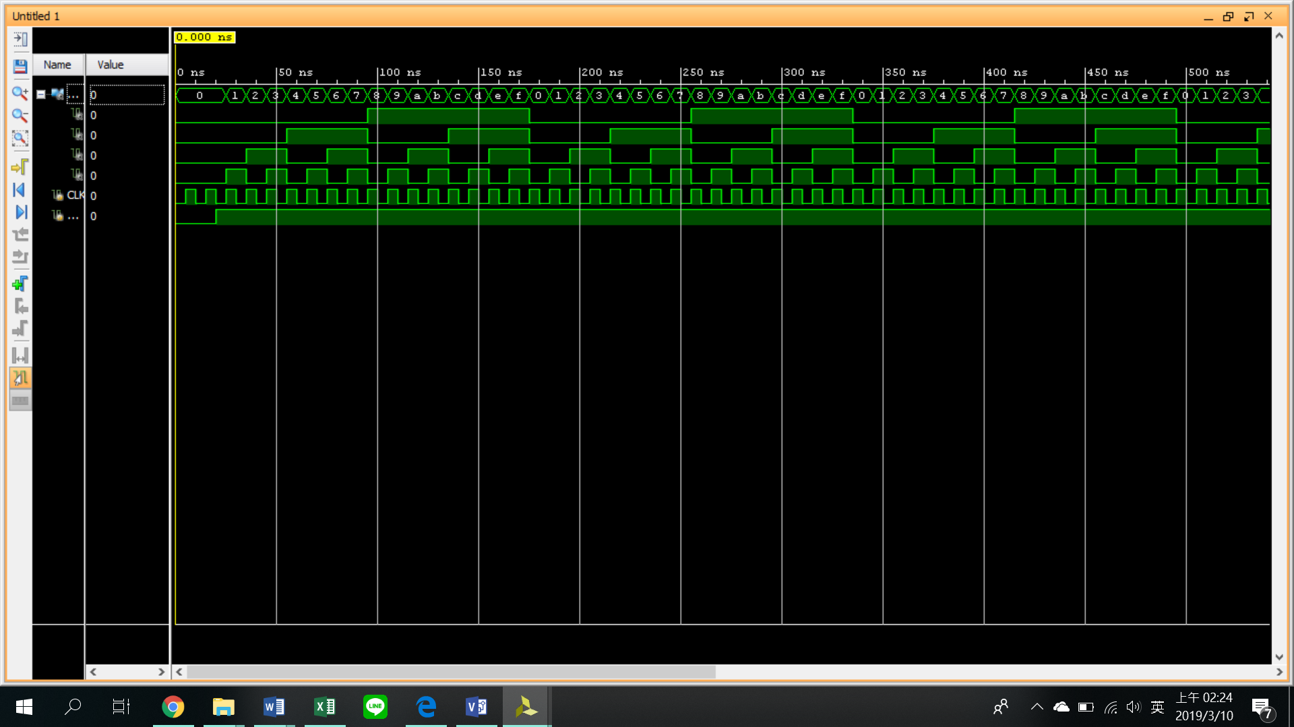

**PreLab3_2**

**Design Specification**

* For a 8-bit ring counter:

Input: clk, rst_n.

Output: t[3:0].

* Draw the block diagram of the design.

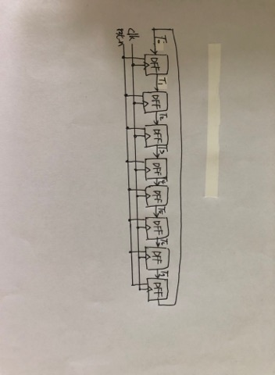

**Design Implementation**

* Truth table

|  |  |  |  |  |  |  |  |  |  |  |  |  |  |  |  |  |  |
| --- | --- | --- | --- | --- | --- | --- | --- | --- | --- | --- | --- | --- | --- | --- | --- | --- | --- |
| clk | rst | t0 | t1 | t2 | t3 | t4 | t5 | t6 | t7 | t'0 | t'1 | t'2 | t'3 | t'4 | t'5 | t'6 | t'7 |
| X | 0 | X | X | X | X | X | X | X | X | 0 | 1 | 0 | 1 | 0 | 1 | 0 | 1 |
| 1 | 1 | 0 | 1 | 0 | 1 | 0 | 1 | 0 | 1 | 1 | 0 | 1 | 0 | 1 | 0 | 1 | 0 |
| 1 | 1 | 1 | 0 | 1 | 0 | 1 | 0 | 1 | 0 | 0 | 1 | 0 | 1 | 0 | 1 | 0 | 1 |
| 0 | 1 | 0 | 1 | 0 | 1 | 0 | 1 | 0 | 1 | 0 | 1 | 0 | 1 | 0 | 1 | 0 | 1 |
| 0 | 1 | 1 | 0 | 1 | 0 | 1 | 0 | 1 | 0 | 1 | 0 | 1 | 0 | 1 | 0 | 1 | 0 |

* Logic function

If rst_n = 1, t[0] <= t[1];

t[1] <= t[2];

t[2] <= t[3];

t[3] <= t[4];

t[4] <= t[5];

t[5] <= t[6];

t[6] <= t[7];

t[7] <= t[0];

If rst_n = 0, t = 01010101

* Simulation

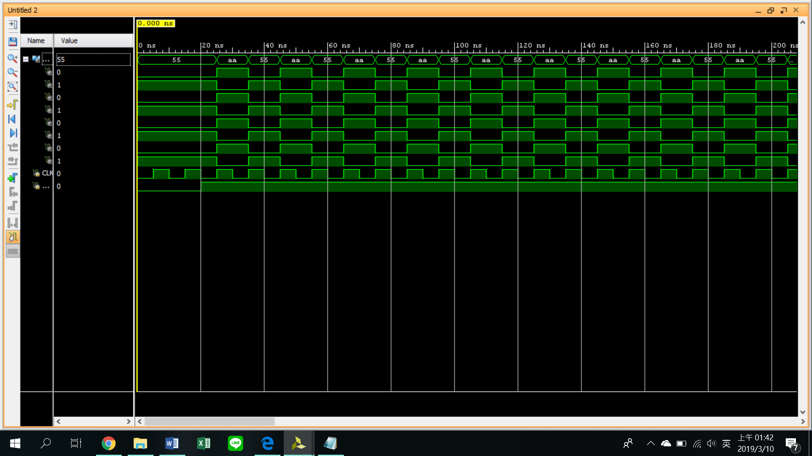

**Discussion**

須注意q跟q_next的關聯，以及其切換條件，如clk和rst_n的設定會影響是否trigger。另須注意其為posedger或nenedger。

**Conclusion**

這次的prelab內容多為上學期課程，主要的問題是對於verilog語法不夠熟悉，上課也只有帶過一點點，大多都須看講義才知道要怎麼打code。