**PreLab5**

**Design Specification**

* For a 30 second stopwatch:

Input: rst_n, clk, in

Output: ten[3:0], digit[3:0], led[14:0], state_led

* FSM function table

|  |  |  |  |  |  |
| --- | --- | --- | --- | --- | --- |
| current state | | input | next state | | output |
| S1 | S0 | in | S1 | S0 | count_en |
| 0 | 1 | 0 | 0 | 1 | 0 |
| 0 | 1 | 1 | 1 | 0 | 1 |
| 1 | 0 | 0 | 1 | 0 | 1 |
| 1 | 0 | 1 | 0 | 1 | 0 |

* Draw the block diagram of the design.

stopwatch

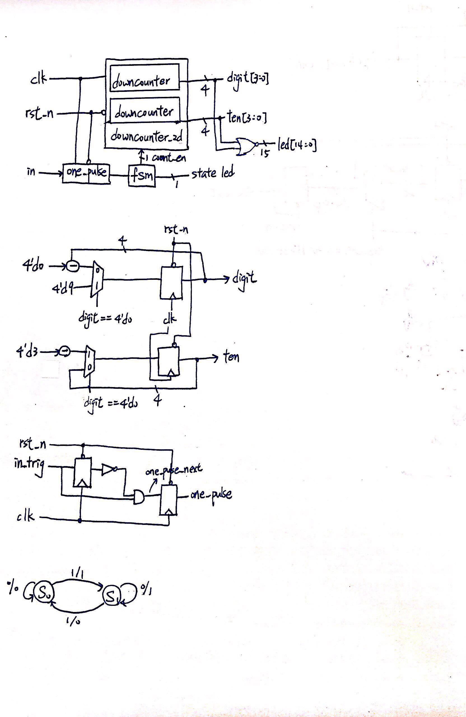

Downcounter_2d



One_pulse



FSM



**Design Implementation**

* FSM function table

|  |  |  |  |  |  |  |
| --- | --- | --- | --- | --- | --- | --- |
| current state | | input | next state | | output | |
| S1 | S0 | in | S1 | S0 | count_en | state_led |
| 0 | 1 | 0 | 0 | 1 | 0 | 0 |
| 0 | 1 | 1 | 1 | 0 | 1 | 0 |
| 1 | 0 | 0 | 1 | 0 | 1 | 1 |
| 1 | 0 | 1 | 0 | 1 | 0 | 1 |

**Stimulation**

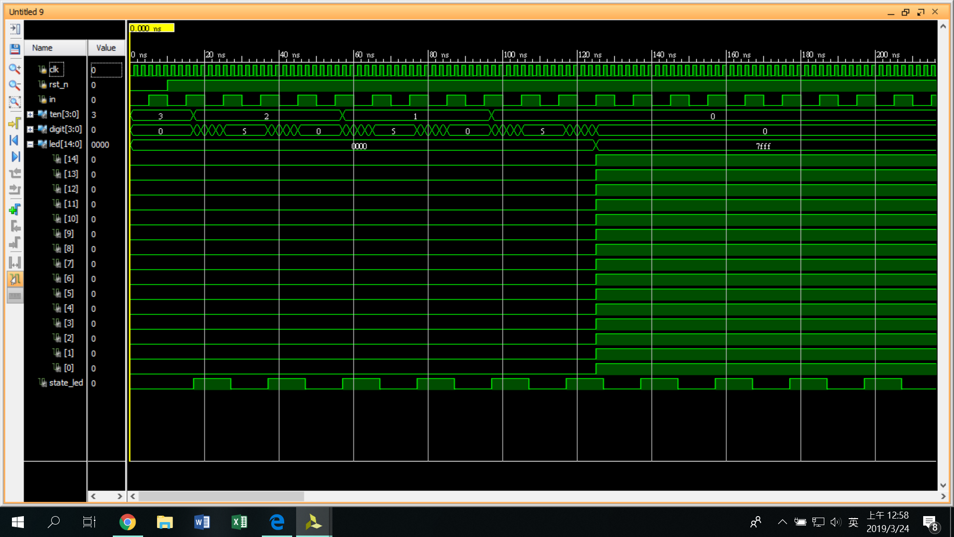

**Discussion**

Stopwatch的主要組成為30 second downcounter、one_pulse、FSM，其中30 second downcounter在Lab4就做過了，可以直接修改細節。而one_pulse是為了讓之後lab5-1按鈕可以按一下即維持next state，因此in_trig須超過clk頻率的時間。透過(in_trig)&(~in_trig)形成one_pulse。FSM則是用來控制是否暫停倒數，因此設定1與0代表倒數或停止倒數的條件，其中設定decrease控制30 second downcounter中的flip flop是否前往next state或停留在current state。

**Conclusion**

由於這次是由多個module組成，因此用top module去寫會比較清楚。因此要注意不同module跟top module間如何接線。