title: “Statistical Computing HW1” author: “106033233 資工21 周聖諺” date: “3/21/2021” output: pdf_document: latex_engine: xelatex html_document: df_print: paged

## Problem 1:

### (a) Generate standard normal distribution by using Box-Muller approach with 10000 samples. Display the result by the histogram and the boxplot.

**Pseudo Code:**

Step 1. Generate $U_{1}$, $U_{2}$ from uniform $U(0,1)$ independently

Step 2. Let variable

$$X=\sqrt{−2ln U_{1}}\text{cos}(2πU_{2})$$

$$Y=\sqrt{−2ln U_{1}}\text{sin}(2πU_{2})$$

Step 3. Return $X$ or $Y$, since $X,Y\overset{i.i.d}{∼}N(0,1)$

## Welcome to compositions, a package for compositional data analysis.  
## Find an intro with "? compositions"

##   
## Attaching package: 'compositions'

## The following objects are masked from 'package:stats':  
##   
## cor, cov, dist, var

## The following objects are masked from 'package:base':  
##   
## %*%, norm, scale, scale.default

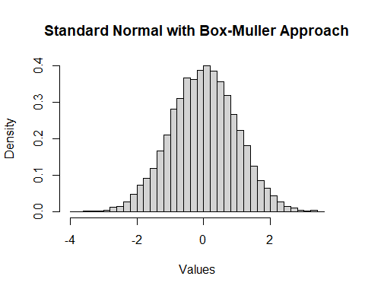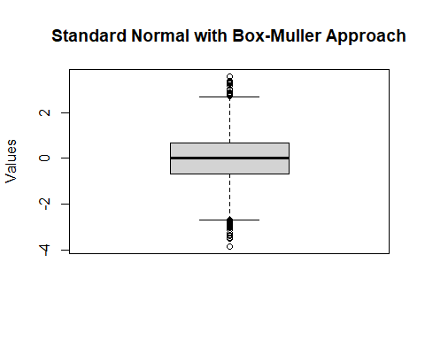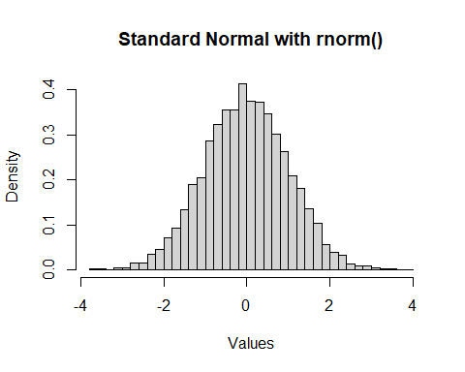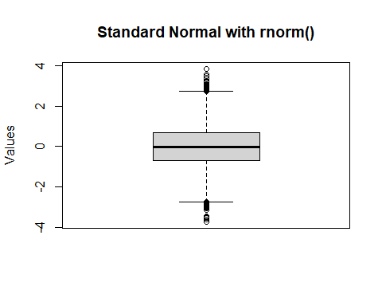

### (b) Generate standard normal distribution by using Acceptance and Rejection approach with 10000 samples. Display the result by the histogram and the boxplot.

**Pseudo Code:**

Step 1. Generate $Y∼Exp(1)$, $U_{1}∼U(0,1)$

Step 2. If $U_{1}≤\frac{f_{|X|}(Y)}{cg(X)}=e^{−(Y−1)^{2}}$, set $X=Y$. Otherwise, go back to Step 1.

Step 3. Generate $U_{2}∼U(0,1)$. If $U_{2}≤0.5$, set $X=|X|$. Otherwise, $X=−|X|$.

Step 4. Return X

## [1] "Acceptance Rate(%)"  
## [1] 76.08613

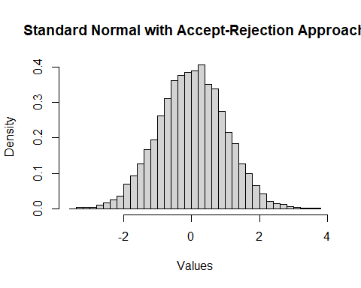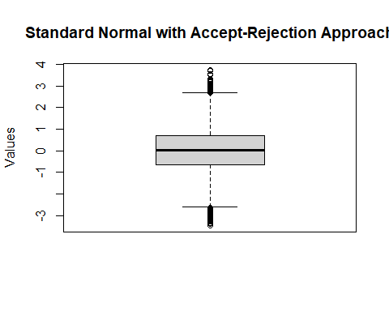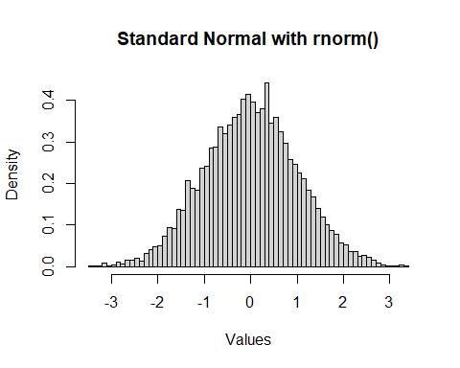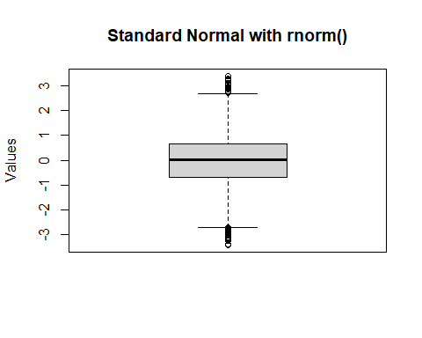

## Problem 2:

### (a) Generate Poisson distribution with 10000 samples. Display the result by the histogram and the boxplot.

$$X∼Poisson(μ=10)$$

where $λ$ the happening rate of the event during $T$ time and the $μ$ means the average occurrence of the event during $T$ time.

$$λ⋅T=μ$$

**Pseudo Code**

For $Poisson(μ)$

Step 1. Let $t=0,X=0$

Step 2. If $t≤μ$, generate $U∼U(0,1)$. Otherwise, go to Step 5.

Step 3. $t=t−log(U)$

Step 4. if $t≤μ$, $X=X+1$. Otherwise, go back to Step 2.

Step 5. Return $X$

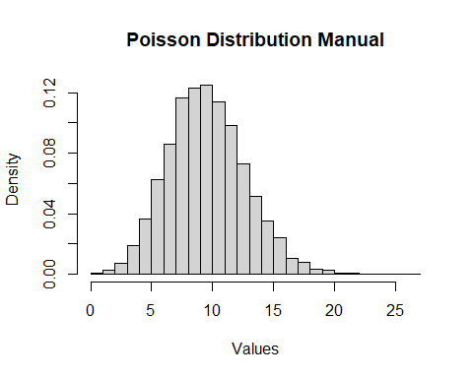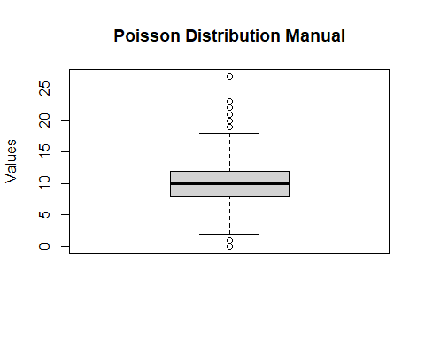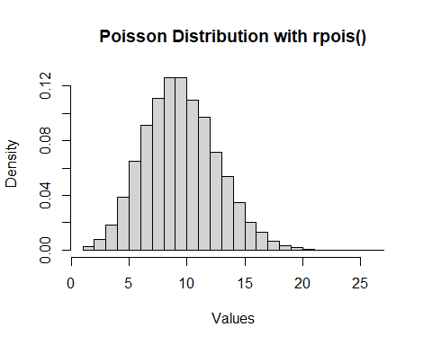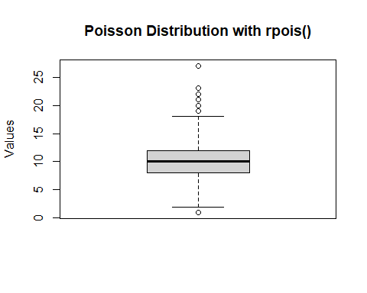

### (b) Generate Gamma distribution with 10000 samples. Display the result by the histogram and the boxplot.

$X∼Gamma(α=5,β=3)$

**Pseudo Code**

For $Gamma(α,β)$

Step 1. Generate $X_{1},X_{2},...,X_{α}\overset{i.i.d}{∼}Exp(β)$

Step 2. Return $\sum_{i=1}^{α}{X_{i}}$

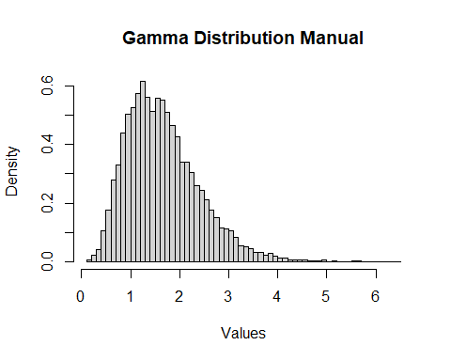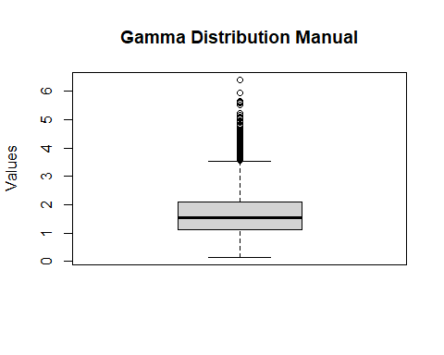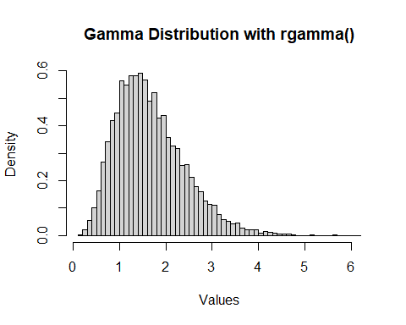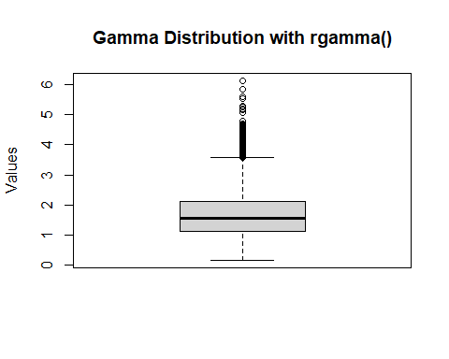

## Problem 3

### (a)

Suppose

$$X|μ∼Poisson(μ)=\frac{μ^{x}e^{−μ}}{x!}$$

$$μ∼Gamma(α,β)=\frac{μ^{α−1}e^{−\frac{μ}{β}}}{β^{α}Γ(α)}$$

The marginal distribution $f_{X}(x)$ of $X$ is





$$=\frac{1}{x!Γ(α)β^{α}}\int_{0}^{∞}{μ^{x}}e^{−μ}μ^{α−1}e^{−\frac{μ}{β}} dμ$$

$$=\frac{1}{x!Γ(α)β^{α}}\int_{0}^{∞}{μ^{α+x−1}}e^{−μ(1+\frac{1}{β})} dμ$$

$$=\frac{1}{Γ(x+1)Γ(α)β^{α}}Γ(α+x)\frac{β}{1+β}$$

$$=\left(\begin{matrix}α−1+x \\ x\end{matrix}\right)(\frac{1}{1+β})^{α} (1−\frac{1}{1+β})^{x}$$

Let $n=α,p=\frac{1}{1+β}$

$$=\left(\begin{matrix}n−1+x \\ x\end{matrix}\right)p^{n}(1−p)^{x}$$

It is a Negative Binomial distribution $NB(n,p)$

**Pseudo Code Of Geometric**

For $Geo(p)$

Step 1. Generate $U∼U(0,1)$

Step Return $⌊\frac{log U}{log (1−p)}⌋$

**Pseudo Code Of Negative Binomial**

For $NB(n,p)$

Step 1. Generate $X_{1},X_{2},...,X_{n}\overset{i.i.d}{∼}Geo(p)$

Step 2. Return $\sum_{i=1}^{n}{X_{i}}$

### (b)

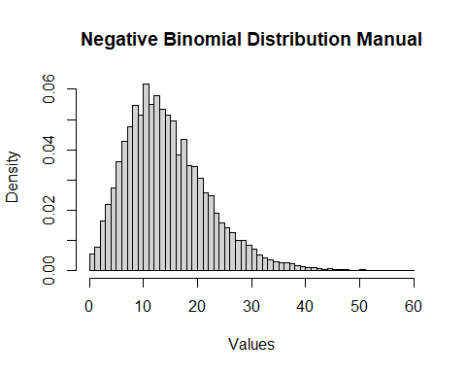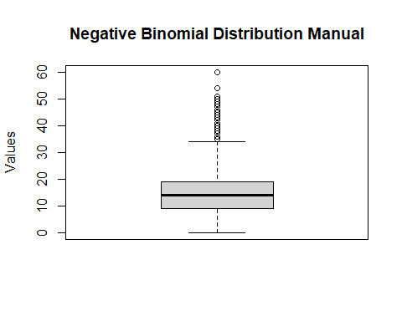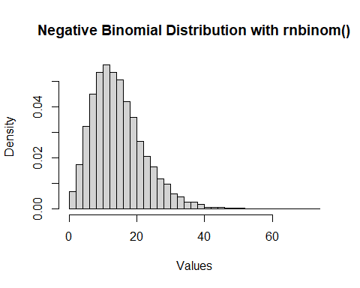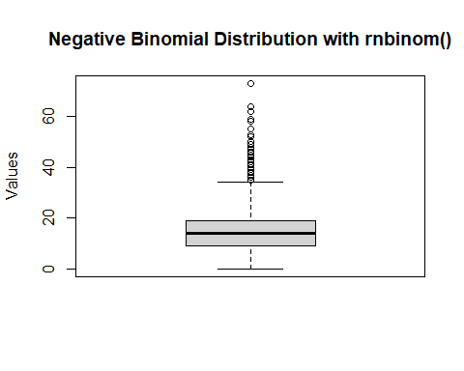

### (c) What are the mean and variance of $X$?

Mean

$$\frac{pr}{1−p}=\frac{\frac{1}{1+β}α}{1−\frac{1}{1+β}}=\frac{α}{β}=\frac{5}{3}$$

Variance

$$\frac{pr}{(1−p)^{2}}=\frac{\frac{1}{1+β}α}{(1−\frac{1}{1+β})^{2}}=\frac{α(1+β)}{β^{2}}=\frac{20}{9}$$

# Problem 4

### (a)

$$X_{1}∼N(μ_{1},σ_{1}^{2}), X_{2}∼N(μ_{2},σ_{2}^{2})$$

A mixture model of $X_{1},X_{2}$

$$f_{X_{1},X_{2}}(x)=p_{1}⋅p_{X_{1}}(x)+p_{2}⋅p_{X_{2}}(x)$$

$$=p_{1}⋅\frac{1}{σ_{1}\sqrt{2π}}e^{−\frac{1}{2}(\frac{x−μ_{1}}{σ_{1}})^{2}}+p_{2}⋅\frac{1}{σ_{2}\sqrt{2π}}e^{−\frac{1}{2}(\frac{x−μ_{2}}{σ_{2}})^{2}}$$

Let $μ_{1}=0,μ_{2}=3$ and $σ_{1}^{2}=σ_{2}^{2}=1$

$$=p_{1}⋅\frac{1}{\sqrt{2π}}e^{−\frac{1}{2}x^{2}}+(1−p_{1})⋅\frac{1}{\sqrt{2π}}e^{−\frac{1}{2}(x−3)^{2}}$$

### (b)

Let $p_{1}=0.75$ and generate 10000 samples from the mixture model.

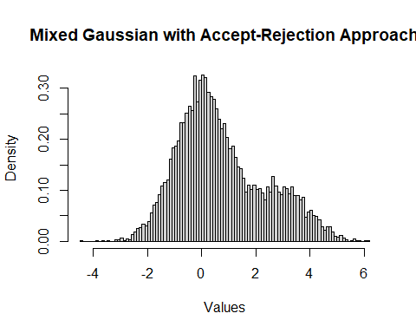

The distribution seems bimodal.