**CS5590 APS - Python Programming**

**LAB1 Report**

**Team members：Zhang Hao**

**Fang Peihao**

**Chen Ziqing**

1. **introduction**

Our lab ID is 3. The lab1 has 6 questions. Zhang Hao is mainly responsible for question 3 and 4, Fang Peihao is mainly responsible for question 5 and 6, and Chen Ziqing is mainly responsible for question 1 and 2.

1. **Objectives**

For the question 1:

we will input transactions with type and the amount – for that it will computer it in an infinite loop while True. A transaction input will be string type- convert/split the values to the list which is delimited by the space. For this, we use string.split() method. Then deposit=+ withdraw=-, use Addition and Subtraction to calculate total amount. After that, ask for the user for the next transaction, if the user’s choice is not "Y" or "y"(like N for no), break the loop and print the total amount.

For the second question: putting the data in a list. And then sorting the data by course name. let course as the key, then append every scores behind the person. And sort it by different values. Then print the result as a dictionary. The sort() method sorts the elements of a given list in a specific order.

The third question is mainly described that if we have a list of students who are attending class "Python" and another list of students who are attending class "Web Application" and we need to find the lists of students who are in both classes and the list of students who are not common in both classes.

The fourth question: We are given a string, and we need to find the longest substring without repeating characters along with the length.

The fifth question: We have a simple airlines ticket booking system based on five classes, and we want to know how to implement and call class or father class with inheritance.

Question 6: We have page and we need to do web scraping to select and extract the data meaningful and useful for us.

1. **Approaches/Methods**

For the third question I just used the operation between two set & and ^. It is easy to implement this by using it.

For the fourth question：Firstly, I used for loop to the string, and then I used the len（）function to compare the length of string and the maxstring（temporary）, then we return the maxstring. Finally I output the string and the length.

Question 5:

Initialize a father-class(person), then we initialize a son-class employee and passenger to inherit father-class.

● Initialize another father-class(flight), then a son-class passenger can inherit it. Currently, the class passenger has two fathers. One is (multiple inheritance)

● Create a son-class named Mileage member inherits passenger.

Question 6: 

Obtain entire content from the specific web

● Get familiar with HTML label, class, tag

● Use F12 to check the source code on this page by HTML

● Use beautiful soup to select and extract data

● Put the results set into a local file

Datasets (if applicable)

For the question 2:

[( ‘John’, (‘Physics’, 80)) , (‘ Daniel’, (‘Science’, 90)), (‘John’, (‘Science’, 95)), (‘Mark’,(‘Maths’, 100)), (‘Daniel’, (’History’, 75)), (‘Mark’, (‘Social’, 95))]

For the question 6:

https://en.wikipedia.org/wiki/List_of_states_and_territories_of_the_United_States

1. **Workflow**

Question 1:

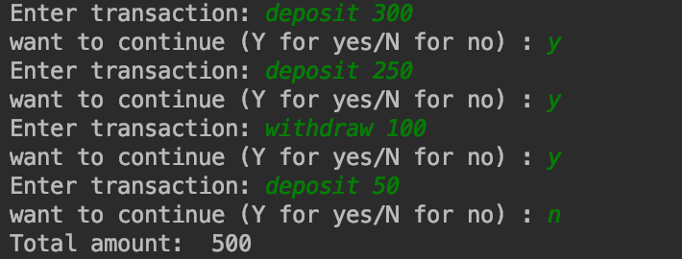

Question 2:

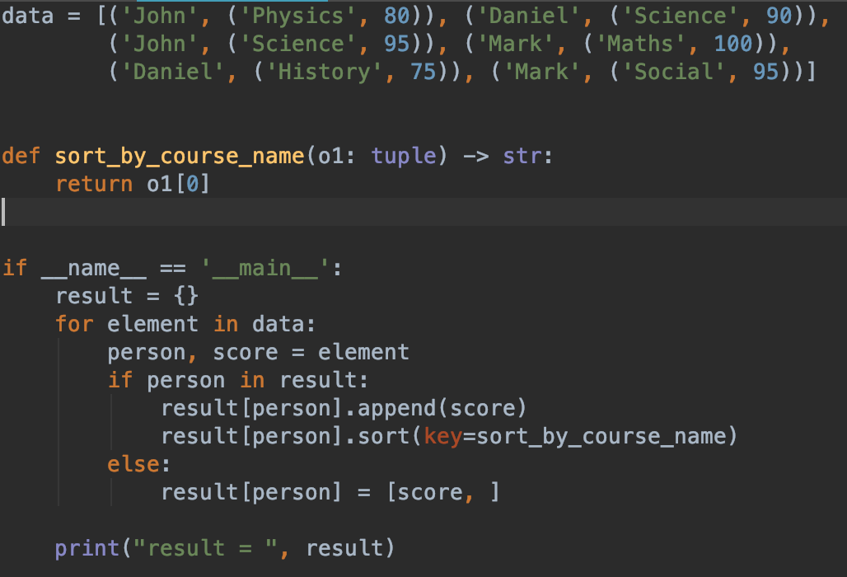



The third question:

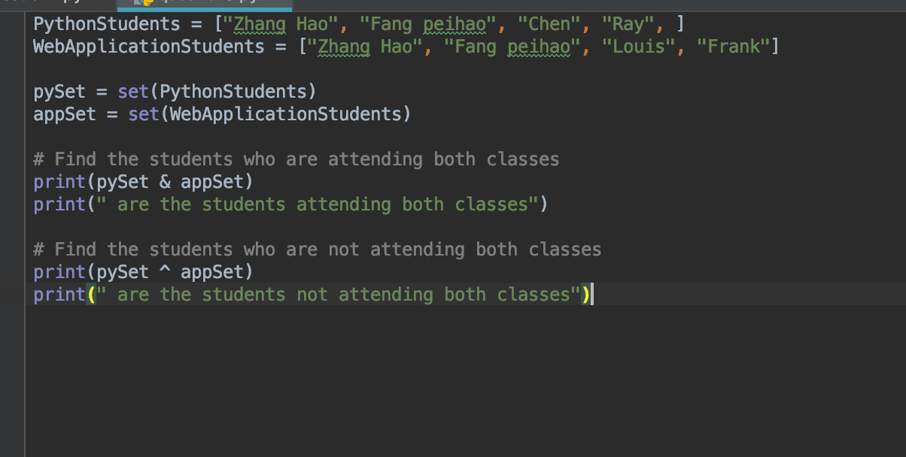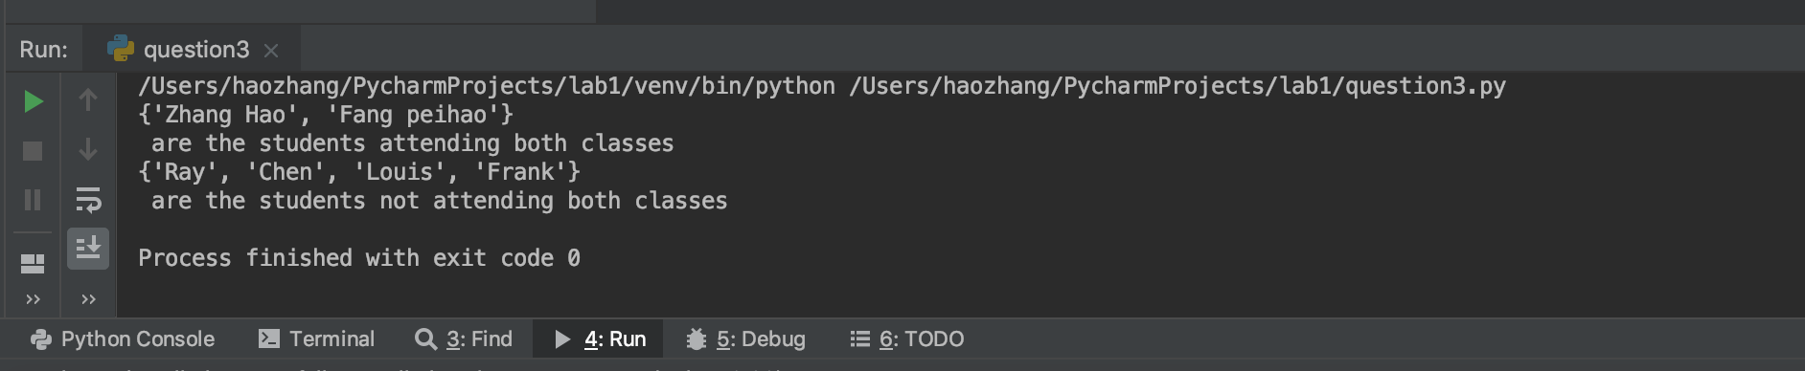

The fourth question:

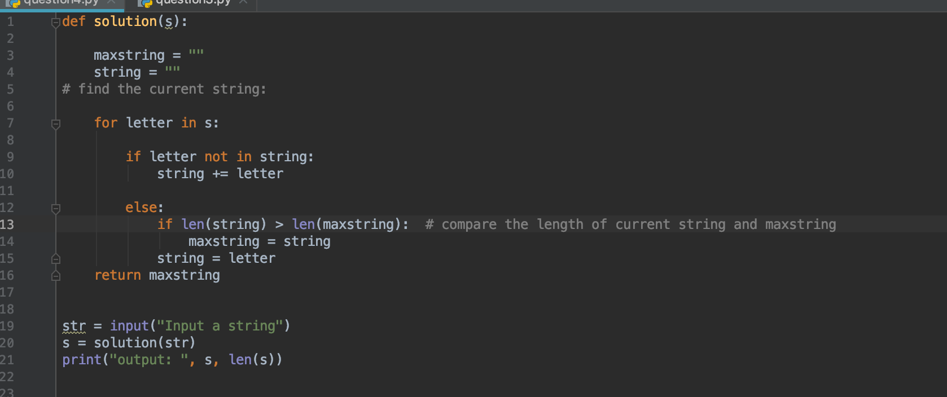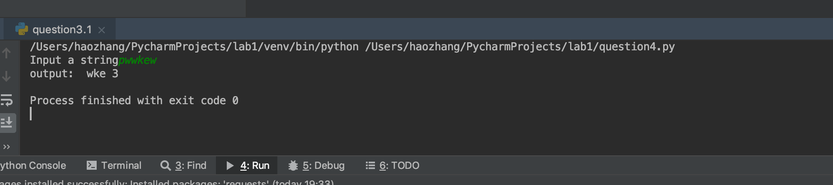

For the fifth question:

● Initialize a father-class(person), then we initialize a son-class employee and passenger to inherit father-class.

● Initialize another father-class(flight), then a son-class passenger can inherit it. Currently, the class passenger has two fathers. One is (multiple inheritance)

● Create a son-class named Mileage member inherits passenger.

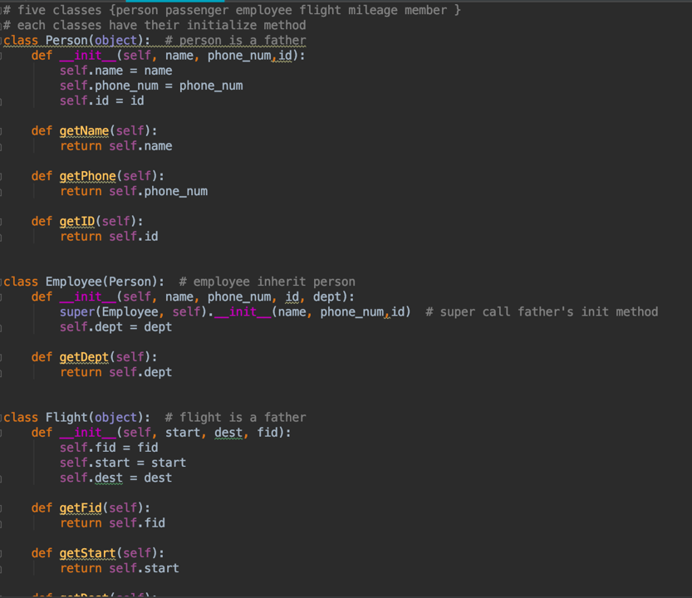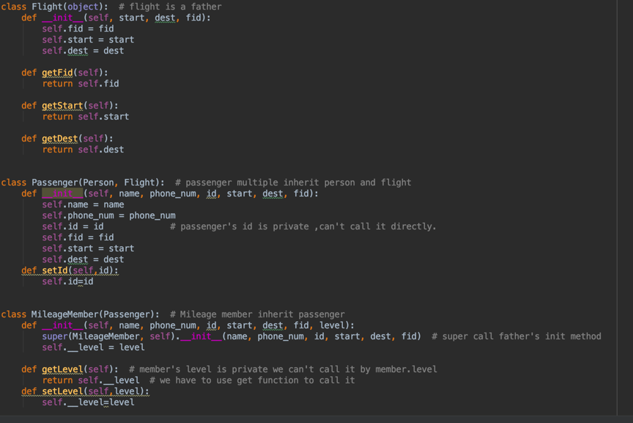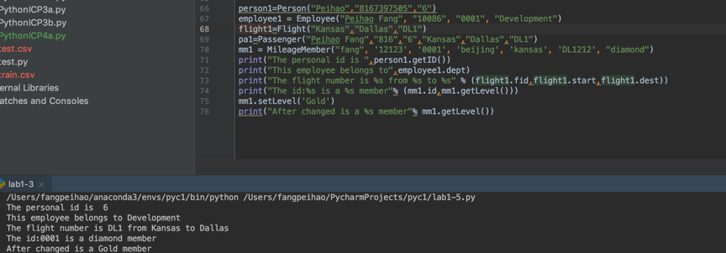

Question 6:

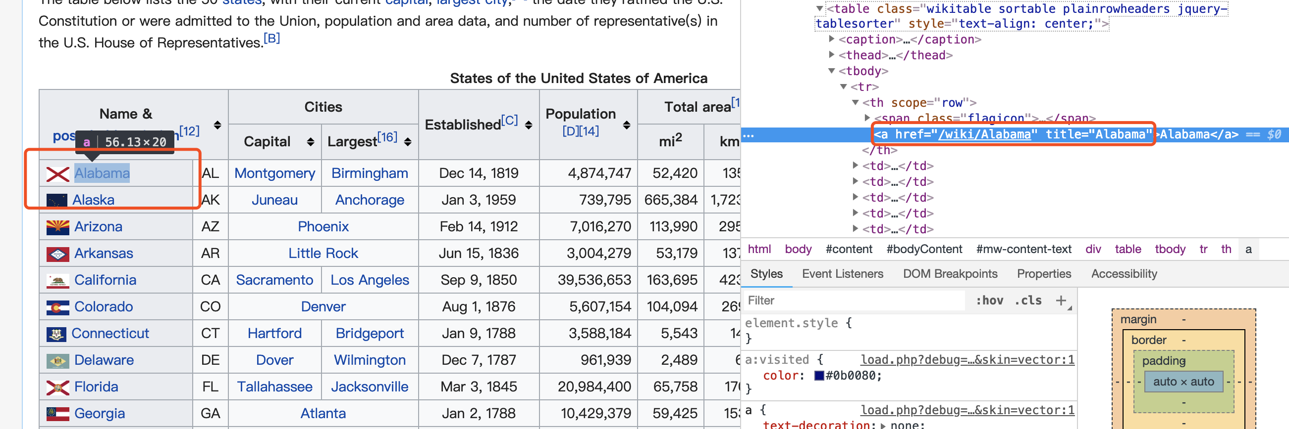

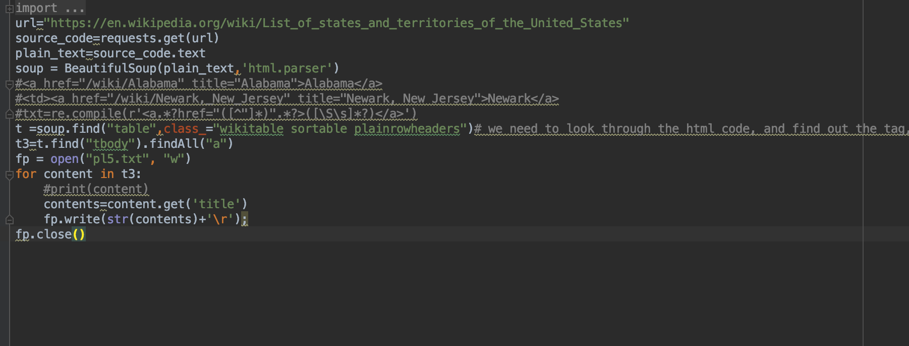

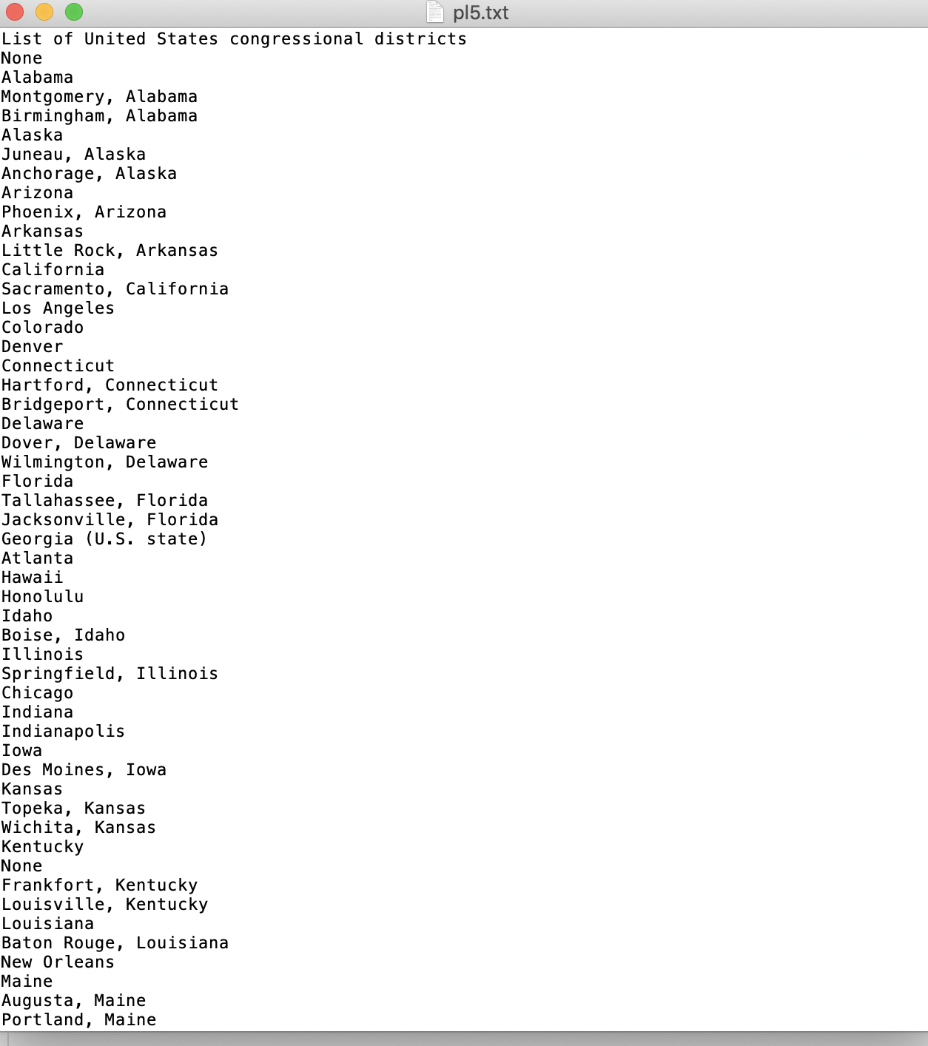

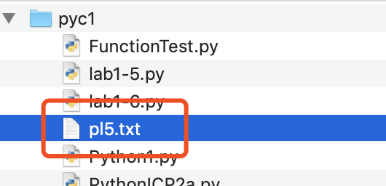

1. **Parameters**

Question 1:

Type=deposit,withdraw

Question 2:

Person= John Daniel Mark

Course=Physics Science Maths History Social

For the third question：

pySet: the set of PythonStudents

appSet: the set of WebApplicationStudents

Input：

PythonStudents = ["Zhang Hao", "Fang peihao", "Chen", "Ray", ]

WebApplicationStudents = ["Zhang Hao", "Fang peihao", "Louis", "Frank"]

Output：

attending both classes：{'Fang peihao', 'Zhang Hao'}

not attending both classes：{'Frank', 'Louis', 'Ray', 'Chen'}

For the fifth question:

Person: name, phone number, id

Employee: name, phone number, id and department

Flight: Start, destination, flight number

Passenger: name, phone number, id, start, destination, flight number

Mileage Member: name, phone number, id, start, destination, flight number, level

Question 6:

Html-parse:This module defines a class HTMLParser which serves as the basis for parsing text files formatted in HTML (HyperText Mark-up Language) and XHTML.

1. **Evaluation & Discussion**

The question 1 can be improved, and it taught me how to convert the amount in integer format, covert its type like code: amount = int(list[1]). For the question 2: the knowledges of dictionary are very useful. This program is a small piece of dictionary knowledge. We don’t find any problems about question 3 and question 4. It is too simple for a booking system, but the topic of this question is practicing inheritance. So the classes I divide and design are more helpful to fit this problem. I make some simple instances to test and call them following the requirements. For the question 6, the disadvantages for my work is that I don’t separate larges city and capital city completely (only mark the category in the final result). Because the source code for these two categories on HTML are same. Both like  .So in future, we can optimize it by a more clear distinguishing.

And for find html faster, we can use regular expression. (I try this for a long time ,but something stuck me that I can’t get any data.)

1. **Conclusion**

This lab1 is a little difficult for us. We helped each other and finally we got it.