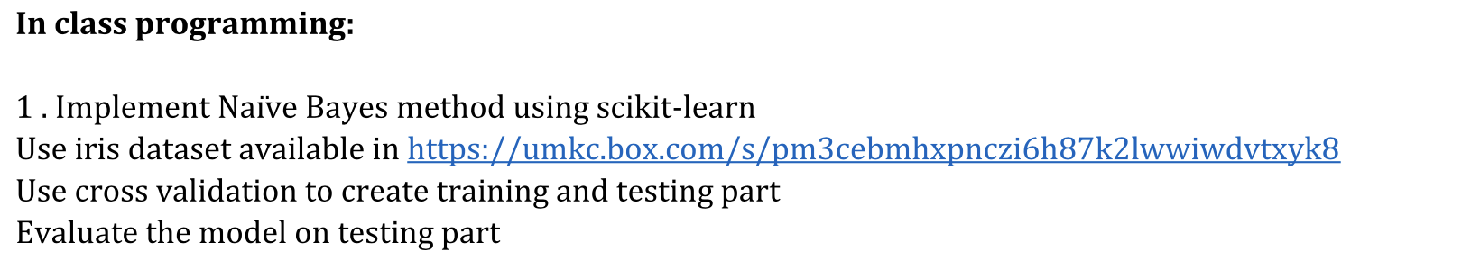

First we use iris dataset from datasets package.

Then we have a brief look about our data such as samples size and relevant labels.

We use cross validation by train_test_split() to divides data into two parts. One is test ,the other is training. The test data occupies 0.4 ,training data occupies 0.6 of entire data.



Finally, we use naïve Bayes to fit model with training data.

The accuracy calculated by score() with test data.

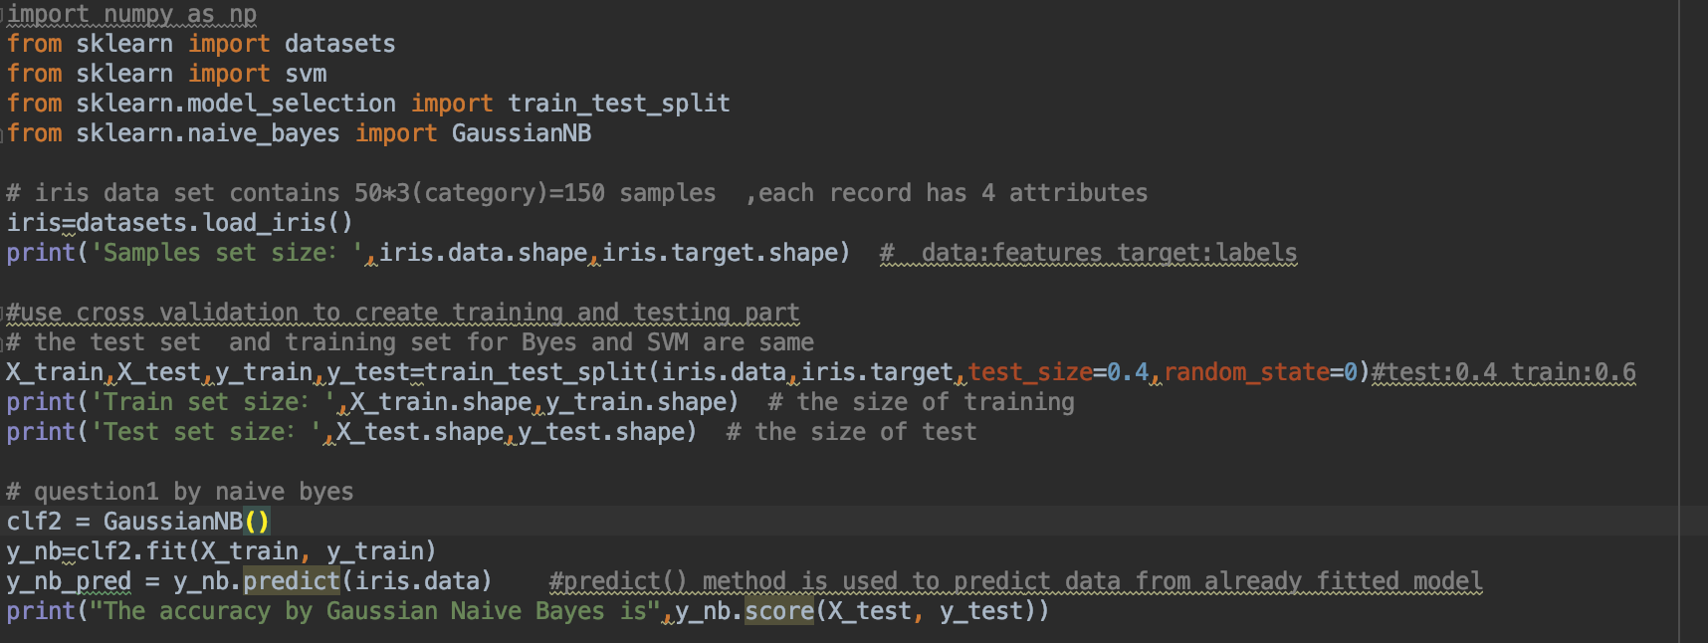



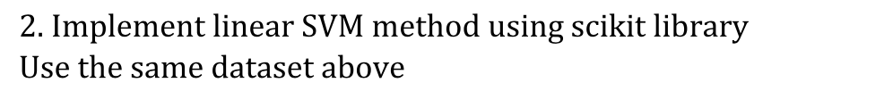

The purpose of entire ICP is emphasizing on the difference between SVM and Naïve Bayes. So we have to use the same dataset to make a comparison.

We just change a method to fit data, we use linear SVM.

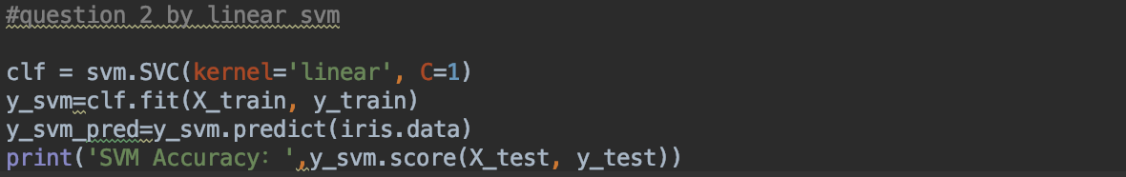





Before we compared , we need to make a prediction by predict() method . We use our new fitted model with original data from Iris to find the label(target).

And compare original label (iris.target) with our new predicted label.

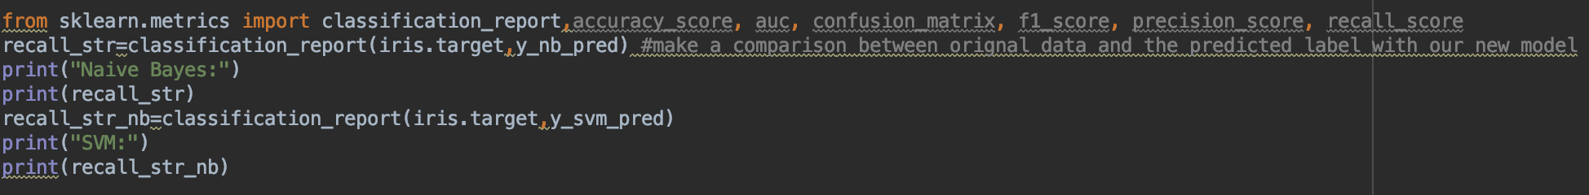

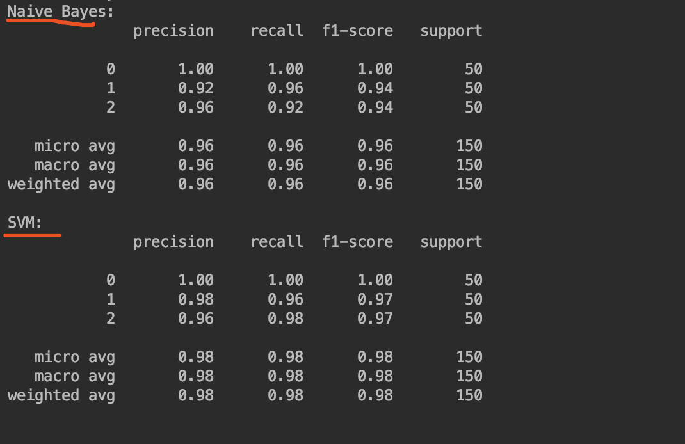

We can know that SVM is more fitter than Naïve Bayes for Iris dataset