Receipt Analysis Report
Report Date: 2026-01-17 17:28:17 UTC

Overview
Total Receipts | 68
Total Amount | $255.54
Average Receipt Amount | $3.76
Date Range | November 2025 - January 2026

Category Distribution
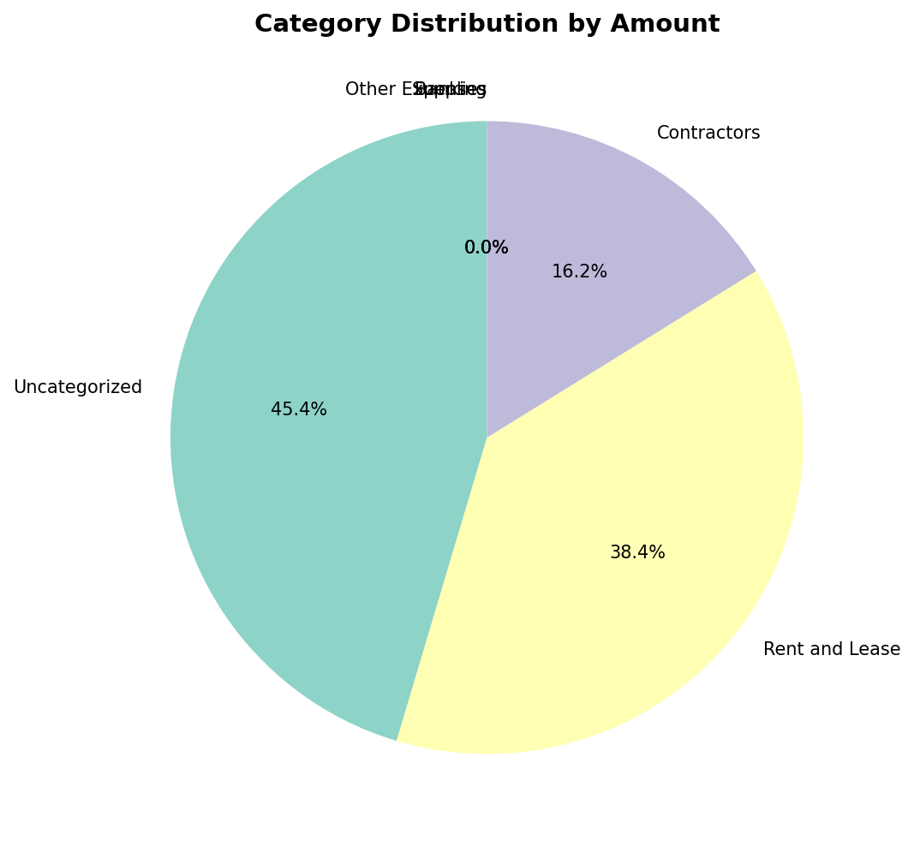

Category Breakdown
Category | Count | Total Amount | Percentage
Uncategorized | 50 | $115.99 | 45.4%
Rent and Lease | 7 | $98.21 | 38.4%
Contractors | 1 | $41.34 | 16.2%
Supplies | 4 | $0.00 | 0.0%
Banking | 5 | $0.00 | 0.0%
Other Expenses | 1 | $0.00 | 0.0%

Monthly Spending Trends
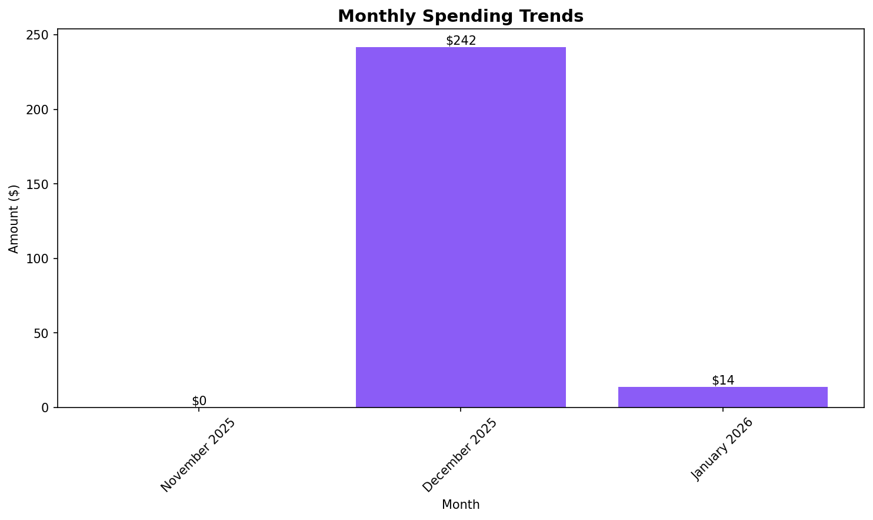

Top Businesses by Spending
Business Name | Count | Total Amount | Average Amount
Walmart | 2 | $196.44 | $98.22
All African Food Stores | 1 | $41.34 | $41.34
Costco Wholesale | 1 | $6.99 | $6.99
TRADER JOE'S | 1 | $5.99 | $5.99
TechWave Solutions | 1 | $4.00 | $4.00
UNITED STATES POSTAL SERVICE | 1 | $0.78 | $0.78
Unknown Business | 60 | $0.00 | $0.00
Unknown Store | 1 | $0.00 | $0.00

All Receipts
Business | Category | Payment Method | Amount | Date | Source
UNITED STATES POSTAL SERVICE | Uncategorized | MasterCard | $0.78 | 2026-01-16 | uploaded
Costco Wholesale | Uncategorized | EFT/Debit | $6.99 | 2026-01-15 | uploaded
TRADER JOE'S | Uncategorized | MasterCard | $5.99 | 2026-01-09 | uploaded
Unknown Business | Uncategorized | Unknown | $0.00 | 2026-01-05 | uploaded
Unknown Business | Rent and Lease | Unknown | $0.00 | 2026-01-05 | uploaded
TechWave Solutions | Uncategorized | Unknown | $4.00 | 2025-12-16 | uploaded
Unknown Business | Supplies | Unknown | $0.00 | 2025-12-16 | uploaded
Unknown Business | Rent and Lease | Unknown | $0.00 | 2025-12-16 | uploaded
Unknown Business | Banking | Unknown | $0.00 | 2025-12-16 | uploaded
Unknown Business | Rent and Lease | Unknown | $0.00 | 2025-12-16 | uploaded
Unknown Business | Banking | Unknown | $0.00 | 2025-12-16 | uploaded
Unknown Business | Uncategorized | Unknown | $0.00 | 2025-12-16 | uploaded
Unknown Business | Uncategorized | Unknown | $0.00 | 2025-12-16 | uploaded
Unknown Business | Uncategorized | Unknown | $0.00 | 2025-12-16 | uploaded
Unknown Business | Uncategorized | Unknown | $0.00 | 2025-12-16 | uploaded
Unknown Business | Uncategorized | Unknown | $0.00 | 2025-12-16 | uploaded
Unknown Business | Uncategorized | Unknown | $0.00 | 2025-12-16 | uploaded
Unknown Business | Uncategorized | Unknown | $0.00 | 2025-12-16 | uploaded
Unknown Business | Uncategorized | Unknown | $0.00 | 2025-12-16 | uploaded
Unknown Business | Uncategorized | Unknown | $0.00 | 2025-12-16 | uploaded
Unknown Business | Uncategorized | Unknown | $0.00 | 2025-12-16 | uploaded
Unknown Business | Uncategorized | Unknown | $0.00 | 2025-12-16 | uploaded
Unknown Business | Uncategorized | Unknown | $0.00 | 2025-12-16 | uploaded
Unknown Business | Uncategorized | Unknown | $0.00 | 2025-12-16 | uploaded
Unknown Business | Uncategorized | Unknown | $0.00 | 2025-12-16 | uploaded
Unknown Business | Supplies | Unknown | $0.00 | 2025-12-16 | uploaded
Unknown Business | Rent and Lease | Unknown | $0.00 | 2025-12-16 | uploaded
Unknown Business | Banking | Unknown | $0.00 | 2025-12-16 | uploaded
Unknown Business | Uncategorized | Unknown | $0.00 | 2025-12-16 | uploaded
Unknown Business | Uncategorized | Unknown | $0.00 | 2025-12-16 | uploaded
Unknown Business | Uncategorized | Unknown | $0.00 | 2025-12-16 | uploaded
Unknown Business | Uncategorized | Unknown | $0.00 | 2025-12-16 | uploaded
Unknown Business | Uncategorized | Unknown | $0.00 | 2025-12-16 | uploaded
Walmart | Uncategorized | VISA | $98.23 | 2025-12-15 | uploaded
Unknown Business | Supplies | Unknown | $0.00 | 2025-12-15 | uploaded
Unknown Store | Rent and Lease | Unknown | $0.00 | 2025-12-15 | uploaded
Unknown Business | Banking | Unknown | $0.00 | 2025-12-15 | uploaded
Unknown Business | Supplies | Unknown | $0.00 | 2025-12-15 | uploaded
Unknown Business | Rent and Lease | Unknown | $0.00 | 2025-12-15 | uploaded
Unknown Business | Banking | Unknown | $0.00 | 2025-12-15 | uploaded
Unknown Business | Uncategorized | Unknown | $0.00 | 2025-12-15 | uploaded
Unknown Business | Uncategorized | Unknown | $0.00 | 2025-12-15 | uploaded
Unknown Business | Uncategorized | Unknown | $0.00 | 2025-12-15 | uploaded
Unknown Business | Uncategorized | Unknown | $0.00 | 2025-12-15 | uploaded
Unknown Business | Uncategorized | Unknown | $0.00 | 2025-12-15 | uploaded
Unknown Business | Uncategorized | Unknown | $0.00 | 2025-12-15 | uploaded
Unknown Business | Uncategorized | Unknown | $0.00 | 2025-12-15 | uploaded
Unknown Business | Uncategorized | Unknown | $0.00 | 2025-12-15 | uploaded
Unknown Business | Uncategorized | Unknown | $0.00 | 2025-12-15 | uploaded
Unknown Business | Uncategorized | Unknown | $0.00 | 2025-12-15 | uploaded
Unknown Business | Uncategorized | Unknown | $0.00 | 2025-12-15 | uploaded
Unknown Business | Uncategorized | Unknown | $0.00 | 2025-12-15 | uploaded
Unknown Business | Uncategorized | Unknown | $0.00 | 2025-12-15 | uploaded
Unknown Business | Uncategorized | Unknown | $0.00 | 2025-12-15 | uploaded
Unknown Business | Other Expenses | Unknown | $0.00 | 2025-12-15 | uploaded
Unknown Business | Uncategorized | Unknown | $0.00 | 2025-12-15 | uploaded
Unknown Business | Uncategorized | Unknown | $0.00 | 2025-12-15 | uploaded
Unknown Business | Uncategorized | Unknown | $0.00 | 2025-12-15 | uploaded
Unknown Business | Uncategorized | Unknown | $0.00 | 2025-12-15 | uploaded
Unknown Business | Uncategorized | Unknown | $0.00 | 2025-12-15 | uploaded
Unknown Business | Uncategorized | Unknown | $0.00 | 2025-12-15 | uploaded
Walmart | Rent and Lease | VISA | $98.21 | 2025-12-09 | uploaded
All African Food Stores | Contractors | Mastercard (Contactless) | $41.34 | 2025-12-09 | uploaded
Unknown Business | Uncategorized | Unknown | $0.00 | 2025-11-20 | uploaded
Unknown Business | Uncategorized | Unknown | $0.00 | 2025-11-20 | uploaded
Unknown Business | Uncategorized | Unknown | $0.00 | 2025-11-17 | uploaded
Unknown Business | Uncategorized | Unknown | $0.00 | 2025-11-16 | uploaded
Unknown Business | Uncategorized | Unknown | $0.00 | 2025-11-16 | uploaded

