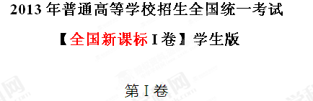

注意事项：

1. 答第Ⅰ卷前，考生务必将自己的姓名、考生号填写在答题卡上。
2. 选出每小题答案后，用铅笔把答题卡上对应题目的答案标号涂黑。如需改动，用橡皮擦干净后，再选涂其他答案标号。不能答在本试卷上，否则无效。

第一部分 听力（共两节，满分30分）

做题时，先将答案标在试卷上。录音内容结束后，你将有两分钟的时间将在试卷上的答案转涂到答题卡上。

**第一节（共5小题；每小题1. 5分，满分7. 5分）**

听下面5段对话。每段对话后有一个小题，从题中所给的A、B、C三个选项中选出最佳选项，并标在试卷的相应位置。听完每段对话后，你都有10称钟的时间来回答有关小题如阅读下一小题。每段对话仅读一遍。

例：How much is the shirt?

A. ￡19. 15. B. ￡9.18. C. ￡9.15.

答案是C。

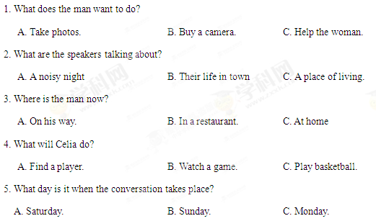

**第二节（共15小题：每小题1. 5分，满分22. 5分）**

听下面5段对话或独白。每段对话或独白后有几个小题，从题中所给的A、B、C三个选项中选出最佳选项，并标在试卷的相应位置。听每段对话或独白前，你将有时间阅读各个小题，每小题5秒钟；听完后，每个小题将给出5秒钟的作答时间。每段对话或独白读两遍。

听第6段材料，回答6、7题。

6. What is Sara going to do?

A. Buy John a gift. B. Give John a surprise C. Invite John to France.

7. What does the man think of Sara’s plan?

A. Funny. B. Exciting. C. Strange.

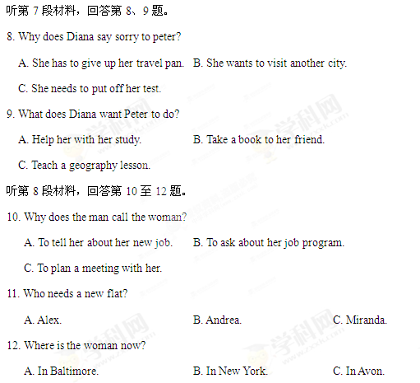

听第9段材料，回答第13至16题。

13. What does Jan consider most important when he judges a restaurant?

A. Where the restaurant is. B. Whether the prices are low.

C. How well the food is prepared.

14. When did Jan begin to write for a magazine?

A. After he came back to Sweden. B. Before he went to the United States.

C. As soon as he got his first job in 1982.

15. What may Jan do to find a good restaurant?

A. Talk to people in the street. B. Speak to taxi drivers. C. Ask hotel clerks.

16. What do we know about Jan?

A. He cooks for a restaurant. B. He travels a lot of his work.

C. He prefers American food.

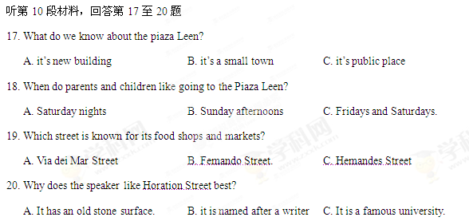

**第二部分 英语知识运用（共两节，满分45分）**

**第一节 单项填空（共15小题；每小题1分，满分15分）**

从A、B、C、D四个选项中，选出可以填入空白处的最佳选项，并在答题卡上将该项涂黑。

例：We ________ last night, but we went to the concert instead.

A. must have studied B. might study

C. should have studied D. would study

答案是C。

21.—Why, this is nothing but common vegetable soup!

—_________ , madam. It's our soup of the day!

A. Let me see B. So it is C. Don't mention it D. Neither do I

22. They might just have a place ________ on the writing course— why don’t you give it a try?

A. leave B. left C. leaving D. to leave

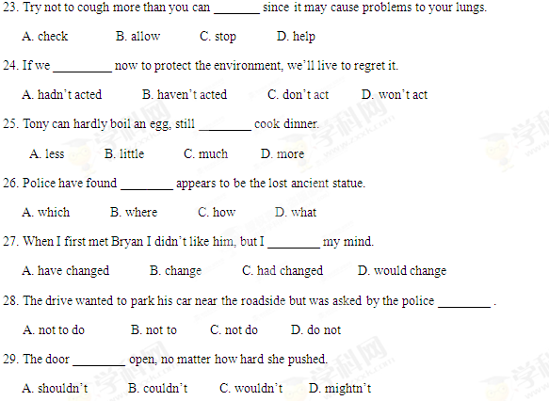

30. At the last moment, Tom decided to ________ a new character to make the story seem more likely.

A. put up B. put in C. put on D. put off

31. India attained ________ independence in 1947, after _______ long struggle.

A. 不填; a B. the; a C. an; 不填 D. an; the

32. There’s no way of knowing why one man makes an important discovery ________ another man, also intelligent, fails.

A. since B. if C. as D. while

33. “You can’t judge a book by its cover,” ________ .

A. as the saying goes old B. goes as the old saying

C. as the old saying goes D. goes as old the saying

34. It was a real race _______ time to get the project done. Luckily, we made it.

A. over B. by C. for D. against

35. The sunlight is white and blinding, _______ hard-edged shadows on the ground.

A. throwing B. being thrown C. to throw D. to be thrown

第二节 完形填空（共20小题；每小题1.5分，满分30分）

阅读下面短文，从短文后各题所给的四个选项A、B、C和D中，选出可以填入空白处的最佳选项，并在答题卡上将该项涂黑。

I went to a group activity, “Sensitivity Sunday” which was to make us more 36 the problem faced by disabled people. We were asked to “ 37 a disability” for several hours one Sunday. Some member 38 chose the wheel chair. Other wore sound-blocking earplugs (耳塞) or blindfolds (眼罩).

Just sitting in the wheelchair was a 39 experience, I had never considered before how 40 it would be to use one. As soon as I sat down my 41 made the chair begin to roll. Its wheel were not 42 . Then I wondered where to put my 43 , It took me quite a while to get the metal footrest into 44 , I took my first uneasy look at what was to be my only means of 45 for several hours. For disabled people, “adopting a wheelchair” is not a temporary(临时的) 46 .

I tried to find a 47 position and thought it might be restful, 48 kind of nice to be 49 around for a while. Looking around, I 50 would have to handle the thing myself! My hands started to ache as I 51 the heavy wheels, I came to know that controlling the 52 of the wheelchair as not going to be 53 task,

My wheelchair experiment was soon 54 . It made a deep impression on me. A few hours of “disability” gave me only a taste of the 55 , both physical and mental, that disabled people must overcome.

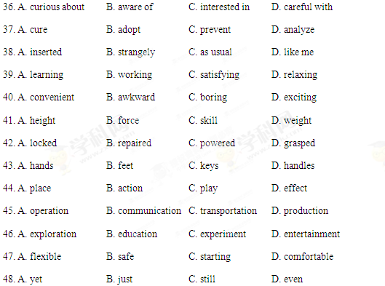

49. A. shown B. pushed C. driven D. guided

50. A. realized B. suggested C. agreed D. admitted

51. A. lifted B. turned C. pressed D. seized

52. A. path B. position C. direction D. way

53. A. easy B. heavy C. major D. extra

54. A. forgotten B. repeated C. conducted D. finished

55. A. weaknesses B. anxieties C. challenges D. illnesses

**第三部分 阅读理解（共两节，满分40分）**

**第一节（共15小题；每小题2分，满分30分）**

阅读下列短文，从每题所给的四个选项（A、B、C和D）中，选出最佳选项，并在答题卡上将该项涂黑。

**A**

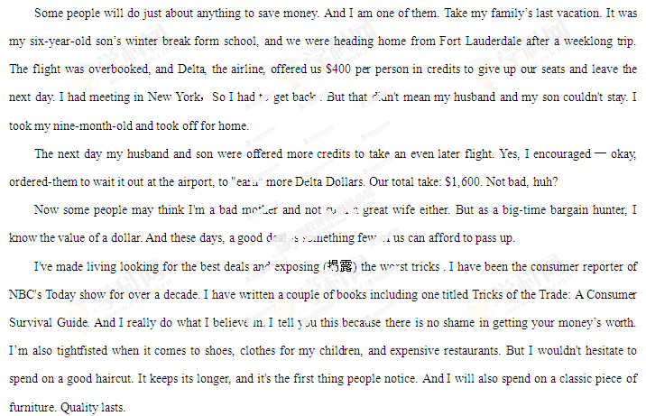

56. Why did Delta give the author's family credits?

A. They took a later flight.

B. They had early bookings.

C. Their flight had been delayed.

D. Their flight had been cancelled.

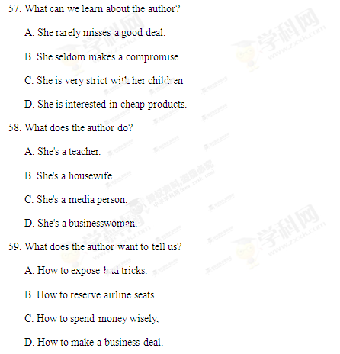

B

The baby is just one day old and has not yet left hospital. She is quiet but alert (警觉). Twenty centimeters from her face researchers have placed a white card with two black spots on it. She stares at it carefully. A researcher removes the card and replaces it by another, this time with the spots differently spaced. As the cards change from one to the other, her gaze(凝视) starts to lose its focus - until a third, with three black spots, is presented. Her gaze returns; she looks at it for twice as long as she did at the previous card. Can she tell that the number two is different from three, just 24 hours after coming into the world?

Or do newborns simply prefer more to fewer? The same experiment, but with three spots shown before two, shows the same return of interest when the number of spots changes. Perhaps it is just the newness? When slightly older babies were shown cards with pictures of objects(a comb, a key, an orange and so on), changing the number of objects had an effect separate from changing the objects themselves. Could it be the pattern that two things make, as opposed to three? No again. Babies paid more attention to squares moving randomly on a screen when their number changed from two to three, or three to two. The effect even crosses between senses. Babies who were repeatedly shown two spots became more excited when they then heard three drumbeats than when they heard just two; likewise(同样地) when the researchers started with drumbeats and moved to spots.

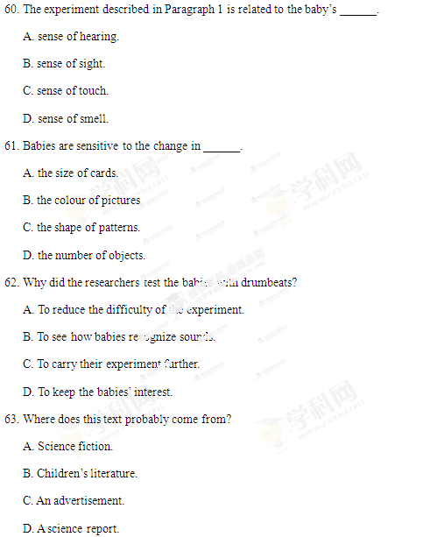

C

It happened to me recently. I was telling someone how much I had enjoyed reading Barack Obama’s *Dreams From My 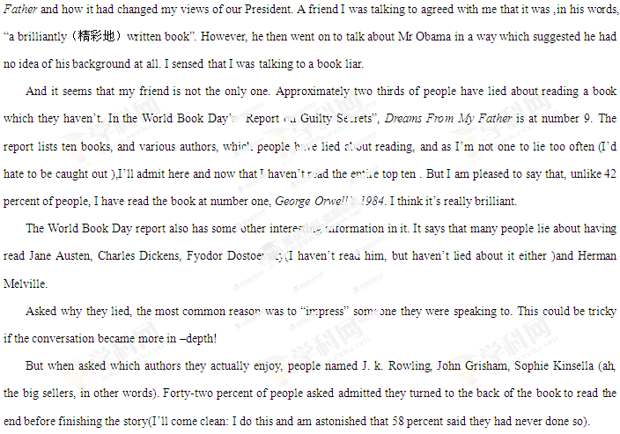*64. How did the author find his friend a book liar?

A. By judging his manner of speaking.

B. By looking into his background.

C. By mentioning a famous name.

D. By discussing the book itself.

65. Which of the following is a “guilty secret” according to the World Book Day report?

A. Charles Dickens is very low on the top-ten list.

B. 42% of people pretended to have read 1984.

C. The author admitted having read 9 books.

D. *Dreams From My Father* is hardly read.

66. By lying about reading, a person hopes to .

A. control the conversation

B. appear knowledgeable

C. learn about the book

D. make more friends

67. What is the author’s attitude to 58%of readers?

A. Favorable.

B. Uncaring

C. Doubtful

D. Friendly

D

**The National Gallery**

**Description:**

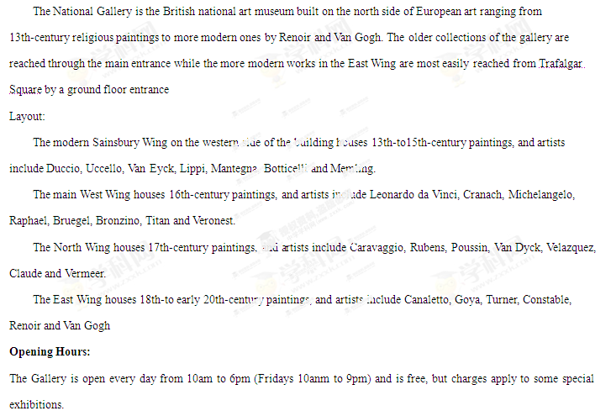**Getting There:**

Nearest underground stations: Charing Cross (2-minute walk). Leicester Square (3-minute walk), Embankment (7-minute walk), and Piccadilly Circus(8-minute walk).

68. In which century’s collection can you see religious paintings?

A. The 13th

B. The 17th

C. The 18th

D. The 20th

69. Where are Leonardo da Vinci’s works shown?

A. In the East Wing.

B. In the main West Wing.

C. In the Sainsbury Wing.

D. In the North Wing.

70. Which underground station is closest to the National Gallery?

A. Piccadilly Circus.

B. Leicester Square.

C. Embankment.

D. Charing Cross.

**第二节(共5小题:每小题2分，满分10分)**

根据短文内容，从短文后的选项中选出能填入空白处的最佳选项。

选项中有两项为多余选项。

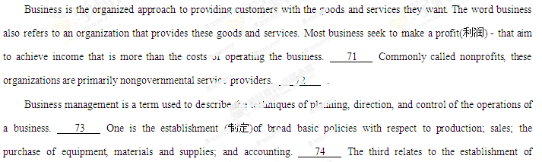standards of word in all departments. Direction is concerned primarily with supervision(监管)and guidance by the management in authority. 75

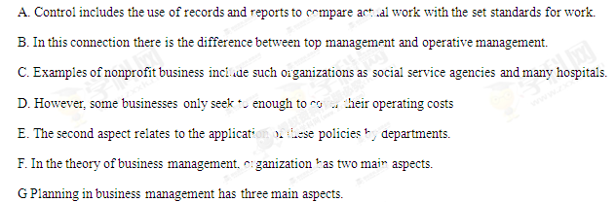

**第四部分 写作（共两页，满分35分）**

第一节[2013·新课标I] 短文改错（共10小题；每小题1分，满分10分）

假定英语课上老师要求同桌中间交换修改作文，请你修改你同桌写的以下作文。文中共有10处语言错误，每句中最多有两处，每处错误仅涉及一个单词的增加、删除或修改。

增加：把缺词处叫个娄子符号（∧），并在其下面写出该加的词。

删除： 把多余的词用斜线（\）划掉。

修改：在错的词下划一横线，并在该词下面写出修改后的词。

注意：1. 每处错误及其修改均仅限一词；

2. 只允许修改10处，多者（从第11处起）不计分。

I hardly remember my grandmother. She used to holding me on her knees and sing

old songs. I was only four when she passes away. She is just a distant memory for me

now.

I remember my grandfather very much. He was tall, with broad shoulder and a beard

that turned from black toward gray over the years. He had a deep voice, which set himself

apart from others in our small town, he was strong and powerful. In a fact, he even

scared my classmates away during they came over to play or do homework with me.

However, he was the gentlest man I have never known.

**第二节 书面表达(满分25分)**

