GSI'15
GEOMETRIC SCIENCE OF INFORMATION
28th-30th October 2015, Ecole Polytechnique, Paris-Saclay Campus
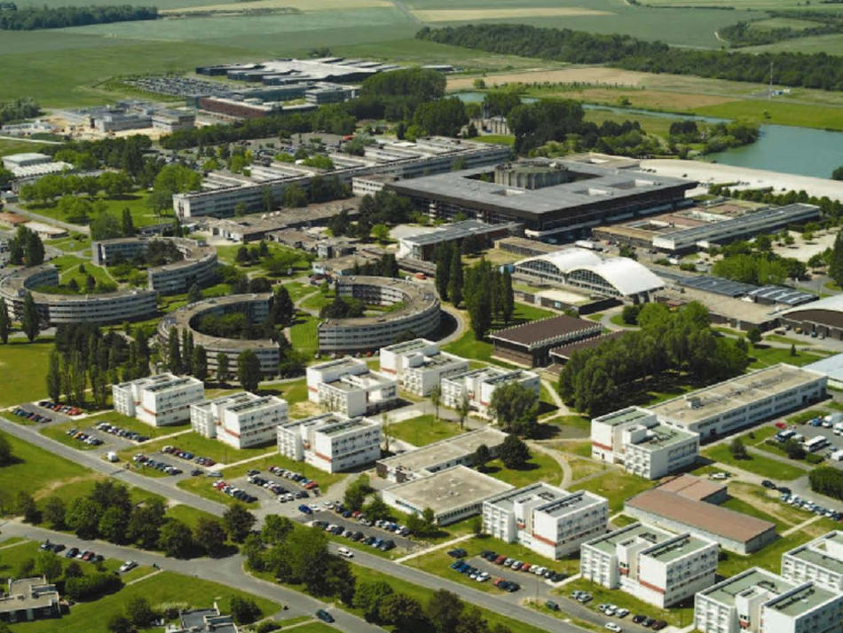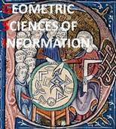

Conference chairs:  Frank Nielsen  LIX - Laboratoire d’Informatique de l’Ecole Polytechnique  UMR 7161, Campus Paris-Saclay  Palaiseau, France  Frédéric Barbaresco  President of SEE Club ISIC Ingénierie des Systèmes d’Information et de Communications  Thales Air Systems  Limours, France  Local organizing committee:  To be defined |  | First announcement and call for papers  As for GSI’13 (https://www.see.asso.fr/gsi2013), the objective of this SEE Conference GSI’15, hosted by Ecole , is to bring together pure/applied mathematicians and engineers, with common interest for Geometric tools and their applications for Information analysis.  It emphasizes an active participation of young researchers for deliberating emerging areas of collaborative research on “Information Geometry Manifolds and Their Advanced Applications”.  Current and ongoing uses of Information Geometry Manifolds in applied mathematics are the following: Advanced Signal/Image/Video Processing, Complex Data Modeling and Analysis, Information Ranking and Retrieval, Coding, Cognitive Systems, Optimal Control, Statistics on Manifolds, Machine Learning, Speech/sound recognition, natural language treatment, etc., which are also substantially relevant for the industry.  The Conference will be therefore being held in areas of priority/focused themes and topics of mutual interest with a mandate to:  - Provide an overview on the most recent state-of-the-art  - Exchange of mathematical information/knowledge/expertise in the area  - Identification of research areas/applications for future collaboration  - Identification of academic & industry labs expertise for further collaboration  This conference will be an interdisciplinary event and will federate skills from Geometry, Probability and Information. The conference proceedings are published in Springer's Lecture Notes in Computer Science (LNCS) series.
Secretariat:    SEE MaxEnt 2014  Mrs. Valérie ALIDOR  SEE, France  Tel.: + 33 (0) 1 56 90 37 02  Fax: + 33 (0) 1 56 90 37 19  Internet web page:  http://www.gsi15.org/  Scientific committee:  Jesus Angulo - Mines-Paristech  Marc Arnaudon - Université de Poitiers  Michael Aupetit - CEA LIST  Frédéric Barbaresco – Thales Air Systems  Silvere Bonnabel - Mines-Paristech  Michel Boyom - Université de Montpellier  Michel Broniatowski - UPMC  Frédéric Chazal - INRIA  Arshia Cont - IRCAM  Michel Deza - Ecole Normale Supérieure Paris  Stanley Durrleman - INRIA  Nicolas Le Bihan - Université de Grenoble  Jean-François Marcotorchino – Thales Com  Bertrand Maury - Université Paris Sud  Ali Mohammad-Djafari - Supelec  Frank Nielsen - Ecole Polytechnique  Richard Nock - Université des Antilles  Xavier Pennec - INRIA  Michel Petitjean - Université Paris Diderot  Gabriel Peyre - Université Paris Dauphine  Olivier Schwander - Ecole Polytechnique  Hichem Snoussi - UTT Troyes  Alain Trouvé - ENS Cachan  Roger Balian – CEA  Daniel Bennequin – Paris-Diderot University  Laurent Decreusefond – Telecom ParisTech  Jérémie J. Jakubowicz – Telecom SudParis  Yann Ollivier – Paris-Sud University |  | Authors will be solicited to submit a paper in a special Issue “Geometric Science of Information” in Entropy Journal, an international and interdisciplinary open access journal of entropy and information studies published monthly online by MDPI.  http://www.mdpi.com/journal/entropy  Important Dates:  Main deadlines are the following:  - Deadline for 8 pages LNCS format: 1st of March 2015  - Notification of acceptance: 30th of April 2015  - Final paper submission: 30th of May 2015  Provisional topics of Special Sessions and Keynote Speakers:  Provisional Topics of Special Sessions:  - Shape spaces (geometric statistics on manifolds and Lie groups, deformations in shape space,…)  - Probability/optimization & algorithms on manifolds (structured matrix manifold, structured data/Information, …)  - Relational and discrete metric spaces (graph metrics, distance geometry, relational analysis,…)  - Computational and hessian information geometry,  - Algebraic/infinite dimensionnal/Banach information manifolds,  - Divergence geometry,  - Tensor-valued morphology,  - Optimal transport theory,  - Manifold & topology learning  Provisional program of Keynote Speakers:  Stochastic Flow on Compact and Non-Compact Manifolds, Marc Arnaudon  To be completed
