Jean-Louis Koszul and the elementary structures of Information Geometry
Frédéric Barbaresco
Thales Land & Air Systems, Voie Pierre-Gilles de Gennes, F91470 Limours, France
frederic.barbaresco@thalesgroup.com
Abstract. This paper is an admiration exercise of Jean-Louis Koszul works on homogeneous bounded domains that have appeared over time as elementary structures of Information Geometry. Koszul has introduced fundamental tools to characterize the geometry of these sharp convex cones, as Koszul-Vinberg characteristic Function, Koszul Forms, and affine representation of Lie Algebra and Lie Group. The 2nd Koszul form is an extension of classical Fisher metric. Koszul theory of hessian structures could be considered as main foundation of Information Geometry.
Keywords: Koszul-Vinberg Characteristic Function, Koszul Forms, Affine representation of Lie Algebra and Lie Group, Homogeneous Bounded Domains
- Preamble
In this article, we go tribute to a part of Professor Jean-Louis Koszul work and basic contributions of this great algebraist and geometer in the field of Information Geometry, which have many applications in the field of applied mathematics, and in the emerging field of Artificial Intelligence where the most powerful algorithms are based on the natural gradient of the information geometry deduced from the Fisher matrix, as Yann Ollivier recently showed [112-113].

Strong of the French mathematical tradition, and the teachings of his master Elie Cartan, Jean-Louis Koszul was a real avant-garde, if we take the definition given by Clausewitz «An avant-garde is a group of units intended to move in front of the army to: explore the terrain to avoid surprises, quickly occupy the strong positions of the battlefield (high points), screen and contain the enemy the time the army can deploy". Indeed, Jean-Louis Koszul was a pioneer and cleared many areas of mathematics, described in the book “Selected papers of JL Koszul” [3]. What we will expose here is therefore only one part of his work which concerns the study of homogeneous bounded domains, on the basis of Elie Cartan's earlier work on symmetric bounded domains. In a letter from André Weil to Henri Cartan, linked in the proceedings of the conference "Elie Cartan and today's mathematics” in 1984, it says "As to the symmetrical spaces, and more particularly to the symmetric bounded domains at the birth of which you contributed, I have kept alive the memory of the satisfaction I felt in finding some incarnations in Siegel from his first works on quadratic forms. and later to convince Siegel of the value of your father's ideas on the subject". At this 1984 conference, two disciples of Elie Cartan gave a conference, Jean-Louis Koszul [5] and Jean-Marie Souriau.

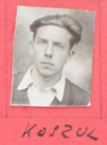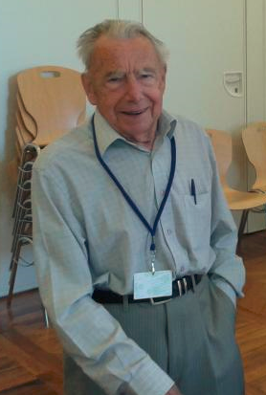
Fig. 1. (on the left) Jean-Louis Koszul student at ULM ENS in 1940, (on the right) Jean-Louis Koszul at GSI’13 conference at the École des Mines of Paris August 2013
In the book "Selected papers of JL Koszul" [3], Koszul summarizes the work we are going to detail in the following : "It is with the problem of the determination of the homogeneous bounded domains posed by E. Cartan around 1935 that are related [my papers]. The idea of ​​approaching the question through invariant Hermitian forms already appears explicitly in Cartan. This leads to an algebraic approach which constitutes the essence of Cartan's work and which, with the Lie J-algebras, was pushed much further by the Russian School [19-32]. It is the work of Piatetski Shapiro on the Siegel domains, then those of E.B. Vinberg on the homogeneous cones that led me to the study of the affine transformation groups of the locally flat manifolds and in particular to the convexity criteria related to invariant forms.". In particular, J.L. Koszul found one of the sources of his inspiration in this last sentence of Elie Cartan 's 1935 article [2]:
"It is clear that if one could demonstrate that all homogeneous domains whose form 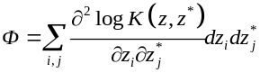is positive definite are symmetric, the whole theory of homogeneous bounded domains would be elucidated. This is a problem of Hermitian geometry certainly very interesting". It was not until 1953 that the classification of non-Riemannian symmetric spaces has been achieved by Marcel Berger [61]. The work of Koszul has also been extended and deepened by one of his student Jacques Vey in [16] and [17]. Jacques Vey has transposed the notion of hyperbolicity, developed by W. Kaup for Riemann surfaces, into the category of differentiable manifolds with flat linear connection (locally flat manifolds), which makes it possible to completely characterize the locally flat manifolds admitting as universal covering a convex open sharp cone of R^{n} , which had been studied by Koszul in [11]. The links between Koszul's work and those of Ernest B. Vinberg [19-26] were recently developed at the conference "Transformation groups 2017" in Moscow dedicated to the 80th anniversary of Professor EB Vinberg, in the Dmitri Alekseevsky talk on “Vinberg's theory of homogeneous convex cones: developments and applications" [18]. Koszul and Vinberg are actually associated with the concept of Koszul-Vinberg's characteristic function on convex cones, which we will develop later in the paper. In the framework of this study, Koszul introduced the so-called “Koszul forms” and a canonical metric given by the Hessian of the opposite of the logarithm of this Koszul-Vinberg characteristic function, from which we will see the links with Fisher's metric in Information Geometry, the scope of which it generalizes.

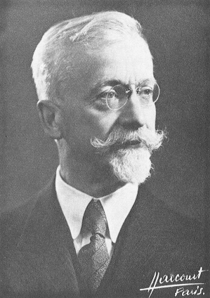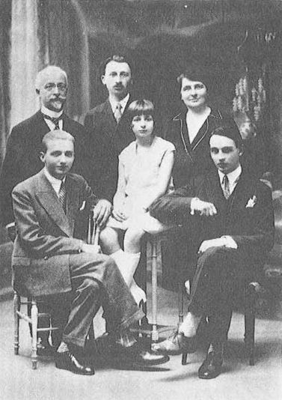
Fig. 2. (on the left) Professor Elie Cartan, (to the right) the Cartan family

Professor Koszul's main papers, which form the elementary structures of information geometry, are as follows:
- « Sur la forme hermitienne canonique des espaces homogènes complexes » [7] of 1955 : Koszul considers the Hermitian structure of a homogeneous G/B manifold (G related Lie group and B a closed subgroup of G, associated , up to a constant factor, to the single invariant G , and to the invariant complex structure by the operations of G) . Koszul says "The interest of this form for the determination of homogeneous bounded domains has been emphasized by E. Cartan: a necessary condition for G/B to be a bounded domain is indeed that this form is positive definite". Koszul calculates this canonical form from infinitesimal data Lie algebra of G, the sub-algebra corresponding to B and an endomorphism algebra defining the invariant complex structure of G/B. The results obtained by Koszul proved that the homogeneous bounded domains whose group of automorphisms is semi-simple are bounded symmetric domains in the sense of Elie Cartan. Koszul also refers to André Lichnerowicz's work on Kählerian homogeneous spaces [37]. Koszul introduces a left invariant form of degree 1 on G: 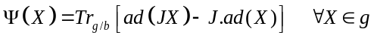 with J an endomorphism of the Lie algebra space and the trace 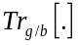 corresponding to that of the endomorphism g/b. The Kähler form of the canonical Hermitian form is given by the differential of 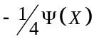 of this form of degree 1.
- « Exposés sur les espaces homogènes symétriques » [8] of 1959 is a Lecture written as part of a seminar held in September and October 1958 at the University of Sao Paulo, which details the determination of homogeneous bounded domains. He returns to [7] and shows that any symmetric bounded domain is a direct product of irreducible symmetric bounded domains, determined by Elie Cartan (4 classes corresponding to classical groups and 2 exceptional domains). For the study of irreducible symmetric bounded domains, Koszul refers to Elie Cartan, Carl-Ludwig Siegel and Loo-Keng Hua. Koszul illustrates the subject with two particular cases, the half-plane of Poincaré and the half-space of Siegel, and shows that with its trace formula of endomorphism g/b, he finds that the canonical Kähler hermitian form and the associated metrics are the same as those introduced by Henri Poincaré and Carl-Ludwig Siegel [35] (who introduced them as invariant metric under action of the automorphisms of these spaces).
- « Domaines bornées homogènes et orbites de groupes de transformations affines » [9] of 1961 is written by Koszul at the Institute for Advanced Study at Princeton during a stay funded by the National Science Foundation. On a complex homogeneous space, an invariant volume defines with the complex structure the canonical invariant Hermitian form introduced in [7]. If the homogeneous space is holomorphically isomorphic to a bounded domain of a space C^{n}, this Hermitian form is positive definite because it coincides with the Bergmann metric of the domain. Koszul demonstrates in this article the reciprocal of this proposition for a class of complex homogeneous spaces. This class consists of some open orbits of complex affine transformation groups and contains all homogeneous bounded domains. Koszul addresses again the problem of knowing if a complex homogeneous space, whose canonical Hermitian form is positive definite is isomorphic to a bounded domain, but via the study of the invariant bilinear form defined on a real homogeneous space by an invariant volume and an invariant flat connection. Koszul demonstrates that if this bilinear form is positive definite then the homogeneous space with its flat connection is isomorphic to a convex open domain containing no straight line in a real vector space and extends it to the initial problem for the complex homogeneous spaces obtained in defining a complex structure in the variety of vectors of a real homogeneous space provided with an invariant flat connection. It is in this article that Koszul uses the affine representation of Lie groups and algebras. By studying the open orbits of the affine representations, he introduced an affine representation of , written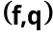, and the following equation setting the linear representation of the Lie algebra of , defined by and the restriction to and the differential of ( and are differential respectively of and ):
- « Ouverts convexes homogènes des espaces affines » [10] of 1962. Koszul is interested in this paper by the structure of the convex open non-degenerate Ω (with no straight line) and homogeneous (the group of affine transformations of E leaving stable Ω operates transitively in Ω) in a real affine space of finite dimension. Koszul demonstrates that they are all deduced from non-degenerate and homogeneous convex open cones built in [9]. He uses for this the properties of the group of affine transformations leaving stable a non-degenerate convex open domain and an homogeneous domain.
- « Variétés localement plates et convexité » [11] of 1965. Koszul established the following theorem: let M be a locally related differentiable manifold. If the universal covering of M is isomorphic as a flat manifold with a convex open domain containing no straight line in a real affine space, then there exists on M a closed differential form α such that Dα (D linear covariant derivative of zero torsion) is defined positive in all respects and which is invariant under every automorphism of M. If G is a group of automorphisms of M such that G\M is quasi-compact and if there exists on M a closed 1-differential form α invariant by G and such that Dα is definite positive at any point, then the universal covering of M is isomorphic as a flat manifold with a convex open domain that does not contain a straight line in a real affine space.
- « Lectures on Groups of Transformations » [12] of 1965. This is lecture notes given by Koszul at Bombay "Tata Institute of Fundamental Research " on transformation groups. In particular in Chapter 6, Koszul studies discrete linear groups acting on convex open cones in vector spaces based on the work of C.L. Siegel (work on quadratic forms [34]). Koszul uses what we will call in the following Koszul-Vinberg characteristic function on convex sharp cone.
- « Déformations des variétés localement plates » [13] of 1968. Koszul provides other proofs of theorems introduced in [11]. Koszul considers related differentiable manifolds of dimension n and TM the fibered space of M vectors. The linear connections on M constitute a subspace of the space of the differentiable applications of the TMxTM fiber product in the space T(TM) of the TM vectors. Any locally flat connection D (the curvature and the torsion are zero) defines a locally flat connection on the covering of M, and is hyperbolic when universal covering of M, with this connection, is isomorphic to a sharp convex open domain (without straight lines) in R^{n}. Koszul shows that, if M is a compact manifold, for a locally flat connection on M to be hyperbolic, it is necessary and sufficient that there exists a closed differential form of degree 1 on M whose covariant differential is positive definite.
- « Trajectoires Convexes de Groupes Affines Unimodulaires » [14] in 1970 . Koszul demonstrates that a convex sharp open domain in R^{n} that admits a unimodular transitive group of affine automorphisms is an auto-dual cone. This is a more geometric demonstration of the results shown by Ernest Vinberg [25] on the automorphisms of convex cones.

The elementary geometric structures discovered by Jean-Louis Koszul are the foundations of Information Geometry. These links were first established by Professor Hirohiko Shima [42-47]. These links were particularly crystallized in Shima book 2007 “The Geometry of Hessian Structures" [48], which is dedicated to Professor Koszul. The origin of this work followed the visit of Koszul in Japan in 1964, on a mission for the French government. Koszul taught lectures on the theory of flat manifolds at Osaka University. Hirohiko Shima was then a student and attended these lectures with the teachers Matsushima and Murakami. This lecture was at the origin of the notion of Hessian structures and the beginning of the works of Hirohiko Shima. Henri Cartan noted concerning Koszul's ties with Japan, "Koszul has attracted eminent mathematicians from abroad to Strasbourg, in Grenoble. I would like to mention in particular the links he has established with representatives of the Japanese School of Differential Geometry". Shima’s book [48] is a systematic introduction to the theory of Hessian structures (provided by a pair of a flat connection D and an Hessian metric g). Koszul studied flat manifolds with a closed 1-form α , such that Dα be positive definite, where Dα is a hessian metric . However, not all Hessian metrics are globally of the form g =Dα . Shima introduces the notion of Codazzi structure for a pair (D,g), with D a torsion-free connection, checking the equations of Codazzi . A Hessian structure is a Codazzi structure for which connection D is flat. This is an extension of Riemannian geometry. It is then possible to define a connection D' and a structure of dual Codazzi (D',g) with with the connection of Levi-Civita. For a hessian structure with 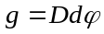, the dual Codazzi structure 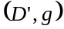 is also a Hessian structure and 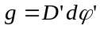, where is the Legendre transform of : 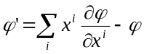. Shima observed that Information Geometry framework could be introduced by dual connections, and linked with Fréchet, Rao and Chentsov works [58]. A hessian structure (D, g) is of Koszul type, if there is a closed 1-form as 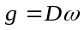. Using D and the volume element of g, Koszul introduced a 2nd form, which plays a similar role to the Ricci tensor for a Kählerian metric. Let be the volume element of , we define a closed 1-form such that 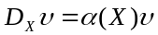 and a symmetric bilinear form 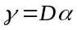. and forms are called 1st and 2nd form of Koszul for Hessian structure 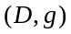. We can consider the forms associated with the Hessian dual structure 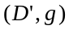 by 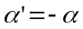 and 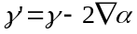. In the case of a homogeneous regular convex cone , the Koszul forms and for the canonical Hessian structure 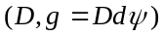 are given by 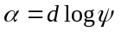 and . The volume element determined by is invariant under the action of the group of automorphisms of .
Jean-Louis Koszul attended the 1 ^{st} GSI "Geometric Science of Information” in August 2013 at the Ecole des Mines in Paris, where he followed Hirohiko Shima talk, given for his honor on the topic "Geometry of Hessian Structures " [49]. In the photo below, we can see from left to right, Jean-Louis Koszul, Hirohiko Shima and Michel Nguiffo Boyom. Professor Michel Boyom has extensively studied and developed, at the University of Montpellier, Koszul models [93-100] in relation to symplectic flat affine manifolds and to the cohomology of Koszul-Vinberg algebras (KV Cohomology) and with his PhD student Byande [91-92] links with Information Geometry. See also André Lichnerowicz’s work on the topic of homogeneous Kähler manifolds [111].

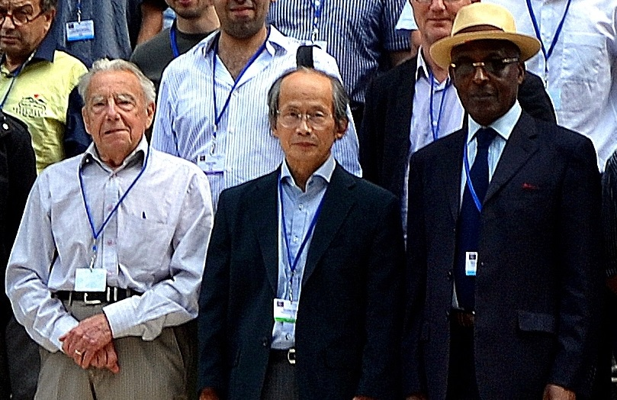
Fig. 3. From left to right, Jean-Louis Koszul, Hirohiko Shima and Michel Nguiffo Boyom at GSI’13 conference at the École des Mines of Paris in August 2013

- Biographical reminder of Jean-Louis Koszul scientific life
Jean Louis André Stanislas Koszul born in Strasbourg in 1921, is the son a family of four (with three older sisters, Marie Andrée, Antoinette and Jeanne). He is the son of André Koszul (born in Roubaix on November 19th 1878, professor in Strasbourg university), and Marie Fontaine (born in Lyon on June 19th 1887), who was a friend of Henri Cartan’s mother. Henri Cartan writes on this subject “My mother in her youth, had been a close friend of the one who was to become the mother of Jean-Louis Koszul"[4]. His paternal parents were Julien Stanislas Koszul and Hélène Ludivine Rosalie Marie Salomé. He attended high school in Fustel-de-Coulanges in Strasbourg and the Faculty of Science in Strasbourg and in Paris. He entered ENS Ulm in the class of 1940 and defended his thesis with Henri Cartan. Henri Cartan notes "This promotion included other mathematicians like Belgodère or Godement, and also physicists and some chemists, like Marc Julia and Raimond Castaing"[4]. Jean-Louis Koszul married on July 17th 1948 with Denise Reyss-Brion, student of ENS Sèvres, entered in 1941. They have three children Michel (married to Christine Duchemin), Anne (wife of Stanislas Crouzier) and Bertrand. He then taught in Strasbourg and was appointed Associate Professor at the University of Strasbourg in 1949. He was promoted to professor in 1956. He became a member of Bourbaki with 2nd generation, Dixmier, R. Godement, S. Eilenberg, P. Samuel, J. P. Serre and L. Schwartz. Henri Cartan remark in [4] "In the vehement discussions within Bourbaki, Koszul was not one of those who spoke loudly; but we learned to listen to him because we knew that if he opened his mouth he had something to say". He was promoted to Senior Lecturer at the University of Grenoble in 1963. He became an honorary professor at the Joseph Fourier University [6]. In Grenoble, he practiced mountaineering and was a member of the French Alpine Club. Koszul was elected correspondent at the Academy of Sciences on January 28th 1980. The following year, he was elected to the Academy of São Paulo. Jean-Louis Koszul was the cousin of the composer Henri Dutilleux, whose common grandfather was Julien Koszul (1844-1927), pupil of Camille Saint-Saëns, friend of Gabriel Fauré, and professor of Albert Roussel. The most famous works of his grandfather Julien Koszul were replayed recently at IHES by Bertrand Maury, following a presentation that developed the elements described in this paper by the author. The most remarkable works of Julien Koszul, the grandfather of Jean-Louis Koszul are: Quo Vadis for chorus of men with 5 voices, Pié Jesus in si m, Pieces for piano with two hands and 1 piece for piano with 4 Hands and Melodies of 1872 and 1879. Jean-Louis Koszul died on January 12th 2018, at the age of 97.

As early as 1947, Jean-Louis Koszul published three articles in CRAS of the Academy of Sciences, on the Betti number of a simple compact Lie group , on cohomology rings , generalizing ideas of Jean-Leray, and finally on the homology of homogeneous spaces. In 1987, an International Symposium on Geometry was held in Grenoble in honor of Jean-Louis Koszul, whose proceedings are published in the Annales of the Fourier Institute, Volume 37, No. 4. This conference began with a presentation by Henri Cartan , who noted in his article in honor of Koszul the mention he made when passing the aggregation of Koszul [4]: "Distinguished Spirit; he is successful in his problems. Should beware, orally, of overly systematic trends. a little less subtle complications, baroque ideas, a little more common sense and balance would be desirable". Commenting on the fact that Koszul is addressing him for his thesis, Henri Cartan writes "Why did he turn to guide him (so-called) ? Is it because he found inspiration in Elie Cartan's work on the topology of Lie groups ? Perhaps he was surprised to note that mathematical knowledge is not necessarily transmitted by descent. In any case it was he who made me better know what my father had brought to the theory" [4]. On the work of Koszul algebrisation, Henri Cartan notes "it was Koszul who was the first to give a precise algebraic formalization of the situation studied by Leray in his 1946 publication, which became the theory of the spectral sequence. It took a good deal of insight to unravel what lay behind Leray's study. In this respect, Koszul's Note in the July 1947 CRAS is of historical significance."[4]. From June 26th to July 2nd 1947, CNRS, received an International conference in Paris, on "Algebraic Topology". This was Leray's first postwar international diffusion of ideas. Koszul writes about this lecture "I can still see Leray putting his chalk at the end of his talk by saying (modestly?) that he definitely did not understand anything about Algebraic Topology". In writing his lectures at the Collège de France, Leray adopted the algebraic presentation of the spectral suite elaborated by Koszul. As early as 1950, J.P. Serre used the term "Leray-Koszul". Speaking of Leray, Koszul wrote "around 1955 I remember asking him what had put him on the path of what he called the ring of homology of a representation in his Notes to the CRAS of 1946. His answer was Künneth's theorem ; I could not find out more.". The sheaf theory, introduced by Jean-Leray, followed in 1947, at the same time as the spectral sequences.

In 1950, Koszul published an important 62-pages book entitled Homology and Cohomology of Lie Algebras in which he studied the links between homology and cohomology (with real coefficients) of a compact connected Lie group and purely algebraic problems of Lie algebra. Koszul then gave a lecture in São Paulo on the topic " sheaves and cohomology". The superb lecture notes were published in 1957 and dealt with the cohomology of Čech with coefficients in a sheaf. In the autumn of 1958, he again organized a series of seminars in São Paulo, this time on symmetric spaces [8]. R. Bott commented on these seminars "very pleasant. The pace is fast, and the considerable material is covered elegantly. In addition to the more or less standard theorems on symmetric spaces, the author discusses the geometry of geodesics, Bergmann's metrics, and finally studies the bounded domains with many details.". In the mid-1960s, Koszul taught at the Tata Institute in Bombay on transformation groups [12] and on fiber bundles and differential geometry. The second lecture dealt with the theory of connections and the lecture notes were published in 1965. In 1986 he published "Introduction to symplectic geometry"[15] following a Chinese course in China (with the agreement of Jean-Louis Koszul given in 2017, this lecture given at the University of Nanjing will be translated into English by Springer and will be published in 2018). This book takes up and develops works of Jean-Marie Souriau [107-108] on homogeneous symplectic manifolds and the affine representation of algebras and Lie groups in geometric mechanics (another fundamental source of structures of Information Geometry extended on homogeneous varieties [101-105] ). Chuan Yu Ma writes in a review, on this latest book in Chinese, that "This work coincided with developments in the field of analytical mechanics. Many new ideas have also been derived using a wide variety of notions of modern algebra, differential geometry, Lie groups, functional analysis, differentiable manifolds, and representation theory. [Koszul's book] emphasizes the differential-geometric and topological properties of symplectic manifolds. It gives a modern treatment of the subject that is useful for beginners as well as for experts".

In 1994, in [3], a comment by Koszul explains the problems he was preoccupied with when he invented what is now called the "Koszul complex". This was introduced to define a theory of cohomology for Lie algebras and proved to be a general structure useful in homological algebra.
- Koszul-Vinberg Characteristic Function, Koszul forms and Maximum Entropy Density
Through the study of the geometry of bounded homogeneous domains initiated by Elie Cartan [1-2], Jean-Louis Koszul discovered that the elementary structures are associated with Hessian manifolds and sharp convex cones [7-14]. In 1935, Elie Cartan proved in [2] that the symmetric homogeneous irreducible bounded domains could be reduced to 6 classes, 4 canonical models and 2 exceptional cases. Ilya Piatetski-Shapiro [27-31], after Luogeng Hua [36], extended Siegel's description [34-35] to other symmetric spaces, and showed by a counterexample that Elie Cartan's conjecture, that all transitive domains are symmetrical, was false. At the same time, Ernest B. Vinberg [19-26] worked on the theory of homogeneous convex cones and the construction of Siegel domains [34-35]. More recently, the classical complex symmetric spaces were studied by F. Berezin [38 ][77] in the context of quantification . In parallel, O.S. Rothaus [33] and Piatetski-Shapiro [27-31] with Karpelevitch, explored the underlying geometry of these complexes homogeneous fields, and more particularly the fibration areas on the components of the border. In Italy, we note the work of E. Vessentini [39] and U. Sampieri [40-41]. The Siegel domains, which fit into these classes of structures, nowadays play an important role in the processing of radar spatio-temporal signals and, more broadly, in learning from structured covariance matrices.
Jean-Louis Koszul and Ernest B. Vinberg have introduced an affinely invariant hessian metric on a sharp convex cone through a function, called characteristic function . In the following is a sharp convex cone in a vector space of finite size on (a convex cone is sharp is there is no straight lines). In dual space of , is the set of linear strictly positive forms on . , dual cone of , is also a sharp convex cone. If , then intersection is bounded. is the group of linear transformation from that preserves (group of automorphisms). acts on such that, then . Koszul introduce an integral, of Laplace kind, on sharp dual convex cone, as :
Koszul-Vinberg Characteristic definition:
Let Lebesque measure on , following integral:
(1)
with the dual cone, is analytical function on , with , called Koszul-Vinberg characteristic function of cone .

Nota: the logarithm of the characteristic function is called « barrier function » for convex optimization algorithms. Yurii Nesterov and Arkadii Nemirovskii [114] have proved in modern theory of « interior point », using function , that all convex cones in R^{n} have a self-dual barrier, linked with Koszul characteristic function.

Koszul-Vinberg Characteristic function has the following properties:
- Bergman kernel of 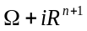 is written 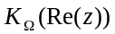 up to a constant. 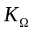 is defined by integral:
(2)
- is an analytical function defined in the interior of and 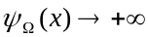 when . If then and as for all , we have:
(3)
- 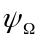 is strictly log convex, such that 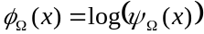 is strictly convex.

From this characteristic function, Koszul introduced 2 formes:
1st Koszul form α : Differential 1-form
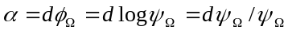 (4)
is invariant with respect to all automorphisms 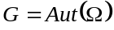 of . If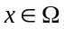 and 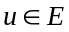 then
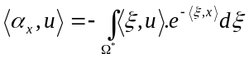 and (5)
and
2nd Koszul form γ : Differential symmetric 2-form
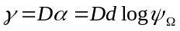 (6)
Is a bilinear symmetric positive definite form invariant with respect to the action of and 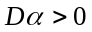
Positivity is given by Schwarz inequality and :
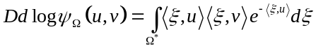 (7)
Koszul has proved that from this 2nd form, we can introduce an invariant Riemannian metric with respect to the action of cone automorphisms:
Koszul Metric: 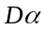 defines a Riemannian invariant structure by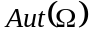, and the Riemannian metric is given by :
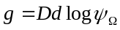 (8)
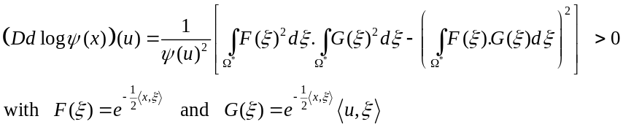 (9)

We can prove the positivity with Schwarz inequality, 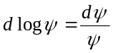 and where and .
Koszul uses this diffeomorphism to define dual coordinates :
(10)
with . When the cone is symmetric, the map 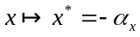 is a bijection and an isometry with only one fixed point (the manifold is a symmetric Riemannian space given by its isometry):
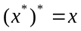 , 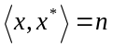 et 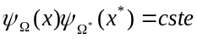 (11)
is characterized by 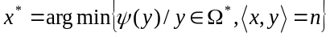 and is the gravity center of the transverse cut 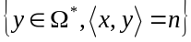 of 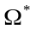:
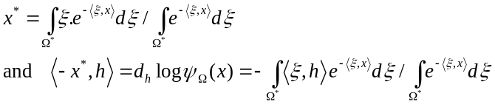 (12)
In [78-81], Misha Gromov was interested by these structures. If we set 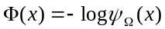, Gromov has observed that 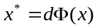 is an injection where the image closure is equal to the convex envelop of the support and the volume of this envelop is the n-dimensionnel volume defined by the integral of hessian determinant of this function, 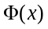, where the map 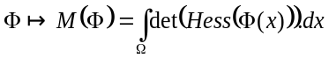 obeys a non-trivial inequality given by Brunn-Minkowsky :
(13)
These relations appear also in statistical physics. As the physicist Jean-Marie Souriau [101-107] did, it is indeed possible to define the concept of Shannon's Entropy via the Lengendre transform associated with the opposite of the logarithm of this characteristic function of Koszul-Vinberg. Taking up the seminal ideas of François Massieu [63-66] in Thermodynamics (classmate of the Corps des Mines, it is François Massieu who influenced Henri Poincaré [62] who introduced the characteristic function in Probability, with a Laplace transform, and not a Fourier transform as did then Paul Levy), which were recently developed by Roger Balian in Quantum Physics [67-76], replacing Shannon Entropy Entropy by von Neumann one. We will also note the work of Jean-Leray on the extensions of the Laplace transform in [50]. Starting from the characteristic function of Koszul-Vinberg, it is thus possible to introduce an entropy of Koszul defined as the Legendre transform of this function, which is the opposite of the logarithm of the characteristic function of Koszul-Vinberg (a logarithm lies the characteristic function of Massieu and the characteristic function of Koszul or Poincaré). Starting from the Koszul function, its Legendre transform gives a dual potential function in the dual coordinate system.:
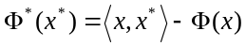with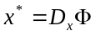and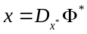 where (14)

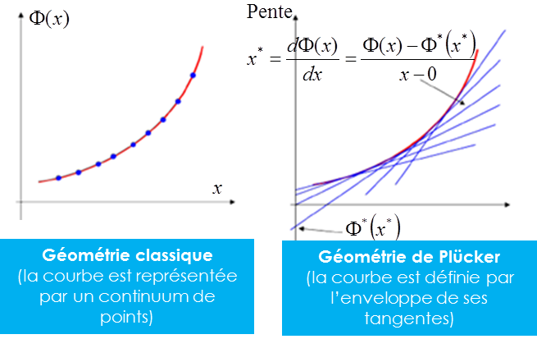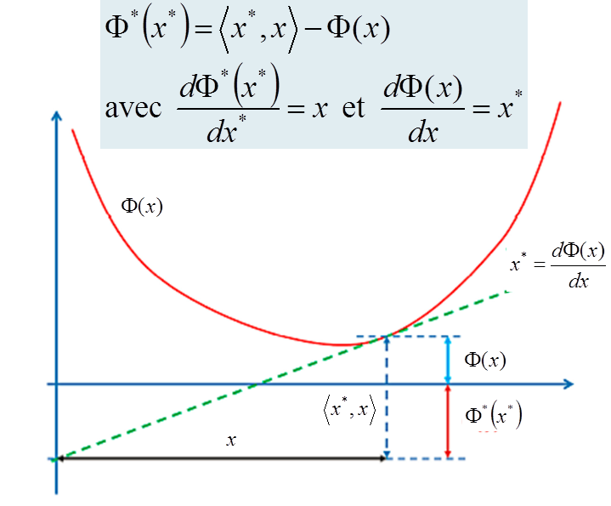
Fig. 4. Legendre Transform and Plücker Geometry

Concerning the Legendre transform [51], Darboux gives in his book an interpretation of Chasles: "What comes back according to a remark of M. Chasles, to replace the surface with its polar reciprocal with respect to a paraboloid". We have the same reference to polar reciprocal in "Lessons on the calculus of variations" by Jacques Hadamard, taken by M.E. Vessiot, which uses the "figuratrice", as polar reciprocal of the "figurative".

It is possible to express this Legendre transform only from the dual coordinate system , using that . We then obtain the Clairaut equation:
(15)
This equation was discovered by Maurice Fréchet in his 1943 paper [55], in which he introduced for the first time the bound on the variance of any statistical estimator via the Fisher matrix, wrongly attributed merely Cramer and Rao [56]. Fréchet was looking for "distinguished densities" [106], densities whose covariance matrix of the estimator of these parameters reaches this bound. Fréchet there showed that these densities were expressed while using this characteristic function , and that these densities belong to the exponential densities family.

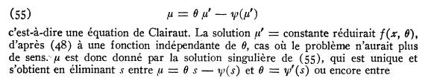
Fig. 5. Legendre-Clairait equation in 1943 Fréchet paper

Apparently, this discovery by Fréchet dates from winter 39, because Fréchet writes at the bottom of the page [55] "The content of this dissertation formed part of our mathematical statistics Lecture at the Institut Henri Poincaré during the winter of 1939 -1940. It is one of the chapters of the second edition (in preparation) of our ' Lessons in Mathematical Statistics', the first of which is 'Introduction: Preliminary Lecture on the Probability Calculation' (119 pages in quarto, typed in ) has just been published at the University Documentation Center , Tournaments and Constans. Paris'.". More recently Muriel Casalis [87-88], the PhD student of Gérard Letac [86], was interested in the exponential families and their invariance with respect to the affine group.

To make the link between the characteristic function of Koszul-Vinberg and Entropy of Shannon, we will detail the formulas of Koszul in the following developments. Using the fact that 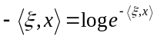, we can write:
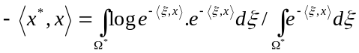 (16) and then developing the Legendre transform to make appear the density of maximum entropy in 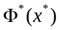, and also the Shannon entropy :
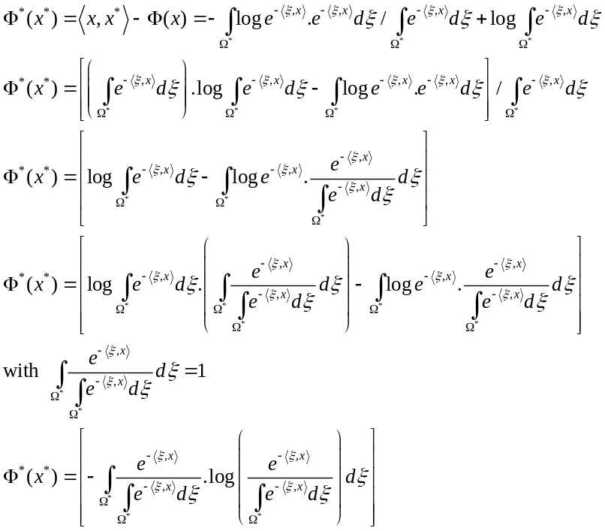 (17)
In this last equation, 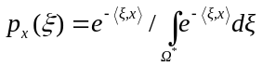 plays the role of maximum entropy density as introduced by Jaynes [52-54] (also called, Gibbs density in Thermodynamics). We call the associated entropy, Koszul Entropy:
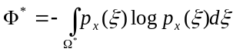 (18)
with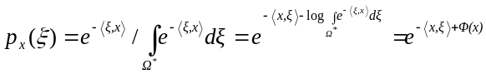and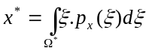 (19)
This Koszul density 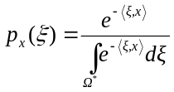 help us to develop the log likelihood :
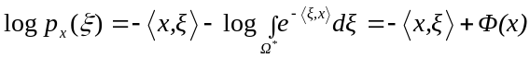 (20)
and deduce from the expectation:
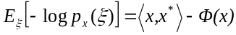 (21)
We also obtain the equation about normalization:
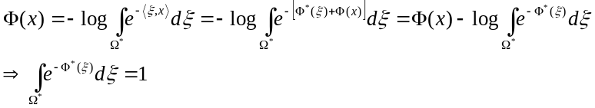 (22)
But we have to make appear the variable in 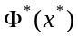. We have then to write:
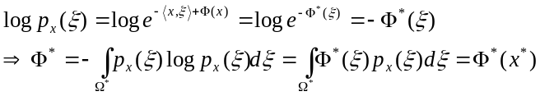 (23)
Last equality is true, if we have:
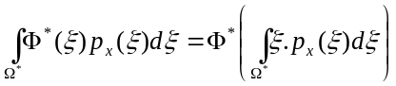 with 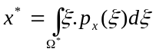 (24) This last relation is associated to classical Jensen inequality. Equality is obtained for Maximum Entropy density for 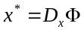 [60]:
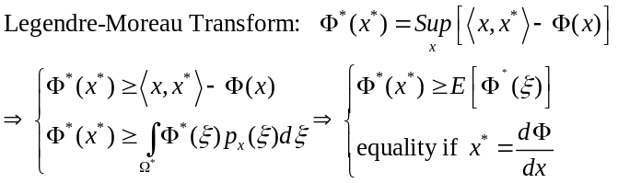 (25)
We obtain for the maximum entropy density, the equality:
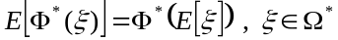 (26)
To make the link between this Koszul model and maximum entropy density [82-84] introduced by Jaynes [52-54], we use previous notation and we look for the density 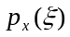 that is the solution to this maximum entropy variational problem. Find the density that maximizes the Shannon entropy with constraint on normalization and the knowledge of first moments:
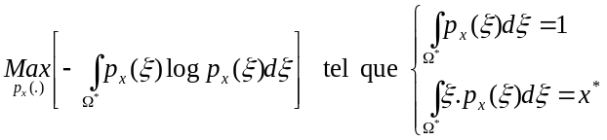 (27) If we consider the density 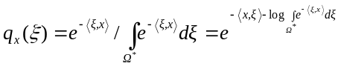 such that:
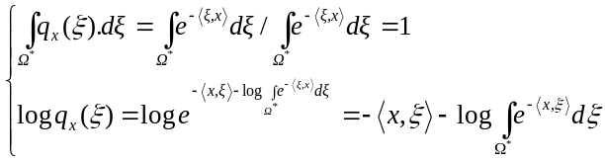 (28)
By using the inequality 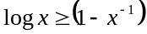 with equality if 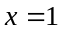, we can then write that:
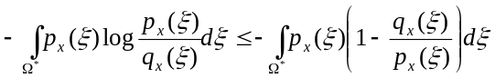 (29)
We develop the right term of the equation:
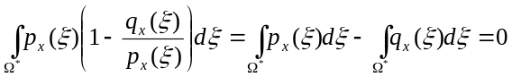 (30) knowing that 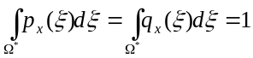, we can deduce that:
(31)
We have then to develop the right term by using previous expression of 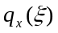:
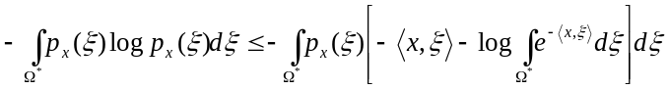 (32)
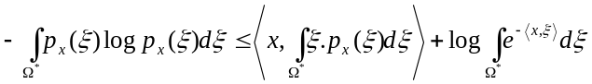 (33)
If we use that 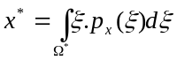 et 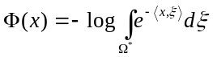, then we obtain that the density is the maximum entropy density constrained by 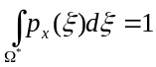 et 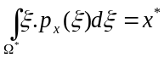 :
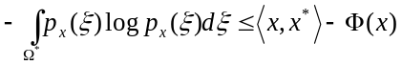 (34)
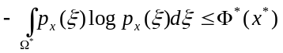 (35)
In the following, we will write 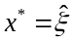, to give to this variable his link with momentum . To express the density with respect to 1st moment as variable, we have to inverse 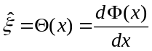, by writting 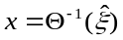 the inverse function (given by Legendre transform):
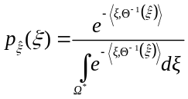 with 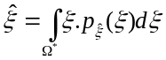 and (36)
We find finally the Maximum entropy density parametrized by 1st moment .
- Links between Koszul-Vinberg Characteristic Function, Koszul forms and Information Geometry
Koszul Hessian Geometry Structures is the key tool to define elementary structures of Information Geometry, that appear as one particular case of more general framework studied by Koszul. In the Koszul-Vinberg Characteristic function 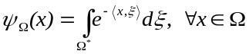 where Ω is a sharp convex cone and Ω∗ its dual cone, the duality bracket <.,.> has to be defined. We will introduce it by using Cartan-Killing form 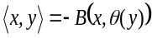 with 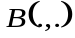 killing form and 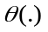 Cartan involution. The inner product is then invariant with respect to automorphims of cone Ω. Koszul-Vinberg characteristic function could be developed as [57]:
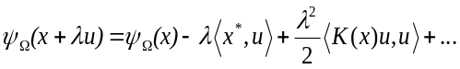 (37)
with 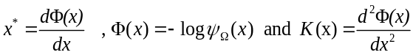
In the following developments, we will write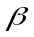, previous variable written , because in thermodynamics, this variable corresponds to the Planck temperature, classically 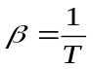. The variable will be the dual variable of .

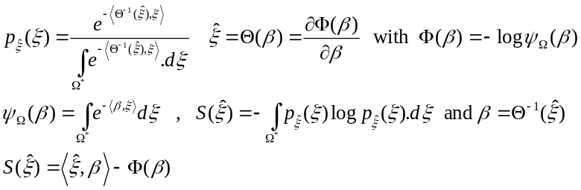 (38)
Inversion of the function 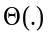 is given by 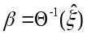 is achieved by Legendre transform using relation between Entropy 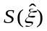 and the function 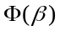 (opposite of the logarithm of the Koszul-Vinberg characteristic function):
(39)
We will prove that the 2nd Koszul form 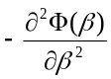 is linked with Fisher Metric of Information Geometry :
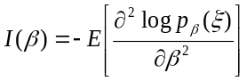 (40)
To compute the Fisher metric 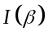, we use the following relations between variable
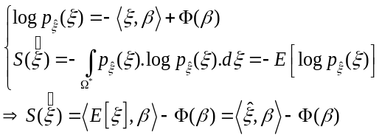 (41)
We can observe that the logarithm of the density is affine with respect to the variable , and that the Fisher matrix is given by the hessian. We can then deduce that the Fisher Metric is given by the hessian.
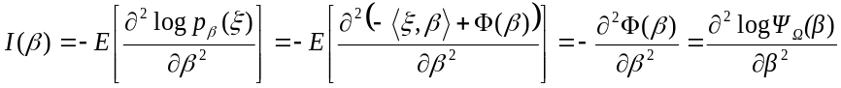 (42)
We can also identify the Fisher metric as a variance:
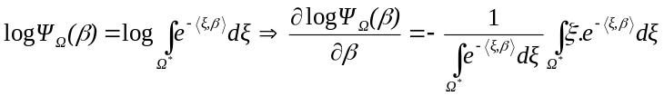 (43)
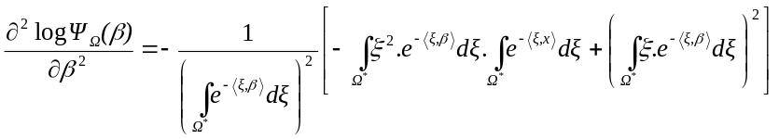 (44)
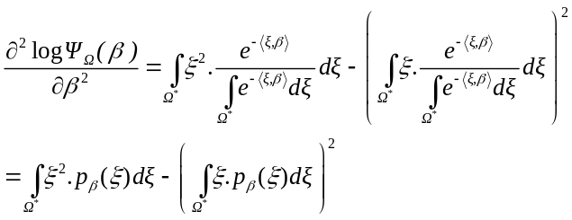 (45)
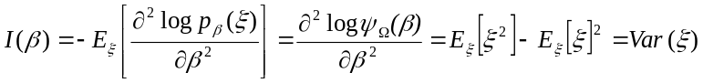 (46)
In 1977, Crouzeix [59][85] has identified the following relation between both hessian of entropy and characteristic function 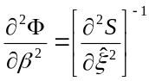giving a relation between the dual metrics in their dual coordinate systems. The metric could be given by Fisher metric or given by the hessian of Entropy S :
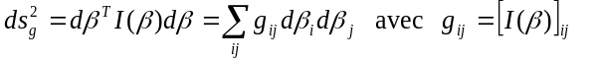 (47)
Thanks to Crouzeix relation [59][85], we observe that 2 geodesic distances given by hessian of dual potential functions in dual coordinates systems that are equal:
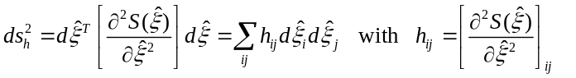 (48)
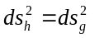 (49)
One can ask oneself the question of what is the most natural product of duality. This question has been treated by Elie Cartan in his thesis in 1894, by introducing a form called Cartan-Killing form, a symmetric bilinear form naturally associated with any Lie algebra. This form of Cartan-Killing is defined via the endomorphism 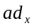 of Lie algebra via the Lie bracket :
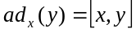 (50)
The trace of the composition of these 2 endomorphisms defines this bilinear form by:
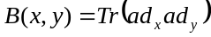 (51)
The Cartan-Killing form is symmetric:
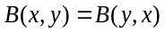 (52)
and verify associativity property:
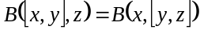 (53)
given by:
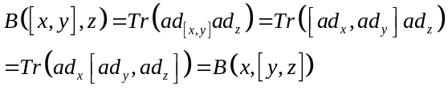 (54)
Elie Cartan proved that if is a simple Lie algebra (the form of Killing is non-degenerate) then any symmetric bilinear form is a scalar multiple of the form Cartan-Killing. The Cartan-Killing form is invariant under the action of automorphisms 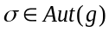 of the algebra :
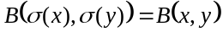 (55)
This invariance is deduced from:
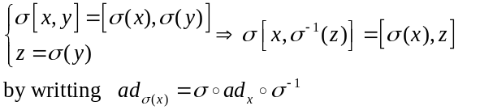 (56)
Then, we can write:
(57)
Cartan has introduced this natural inner product that is invariant by the automorphisms of the Lie algebra , from this Cartan-Killing form:
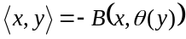 (58)
with 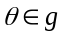 the Cartan involution (an involution on the Lie algebra is an automorphism such that the square is equal to identity).
We summarize all these relations of information geometry from the characteristic function of Koszul-Vinberg, and the duality given via the Cartan-Killing form, as described in the figure below:
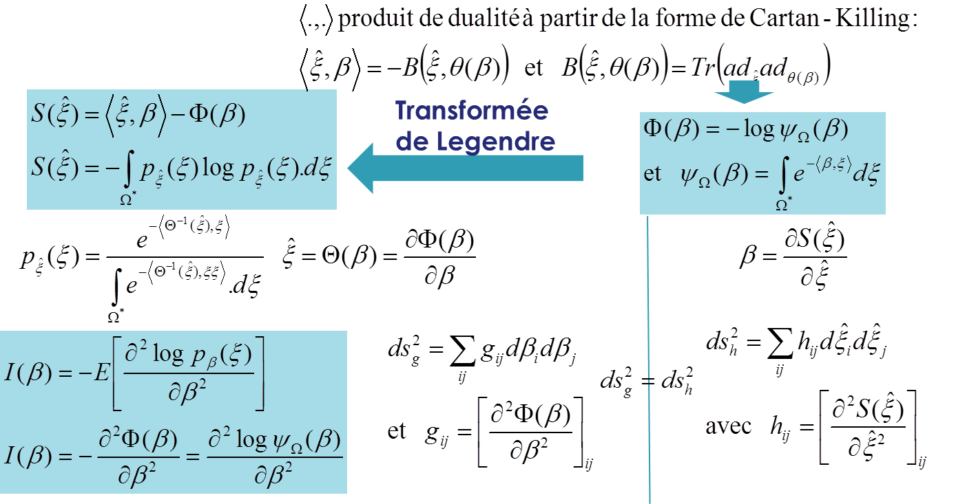
Fig. 6. Relations between Cartan-Killing Form, Koszul-Vinberg Characteristic Function, Potentials and Dual Coordinates, and Metrics of Information Geometry

Thanks to the expression of the characteristic function of Koszul-Vinberg and the Cartan-Killing form, one can express the maximum Entropy density in very general way. For example, by applying these formulas to the cone  (self-dual : 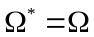) symmetric positive definite matrices 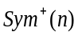, Cartan-Killing form gives us the duality of product :
(59)
The maximum entropy density is given by:
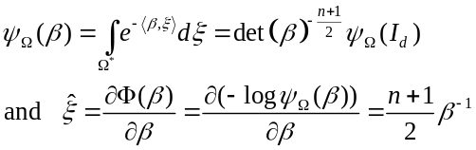 (60)
From which, we can deduce the final expression:
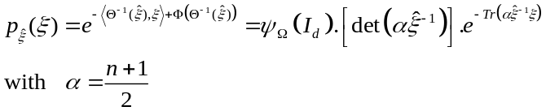 (61)
In the case of multivariate Gaussian densities, as noted by Souriau [107-108], the classical Gibbs expression can be rewritten by modifying the coordinate system and defining a new duality product [101-106]. The multivariate Gaussian density is classically written with the following coordinate system 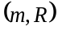, with the mean vector, and the covariance matrix of the vector :
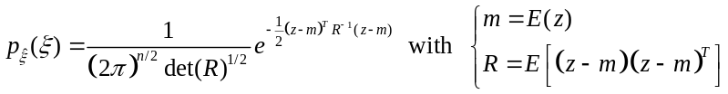 (62)
By developing the term in the exponential:
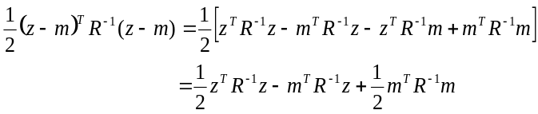 (63)
We can writte this density as a Gibbs density by introducing a new duality braket between 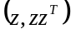 and 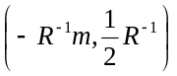:
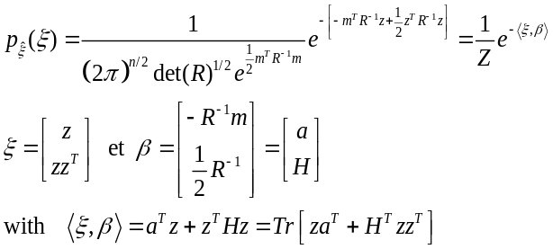 (64)
We can then writte the density in Koszul form:
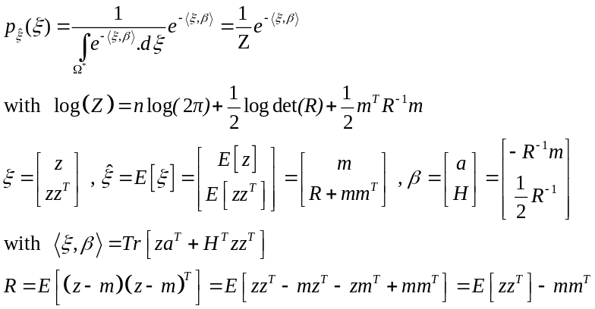 (65)
We can then compute the Koszul-Vinberg characteristic function whose opposite of the logarithm provides the potential function:
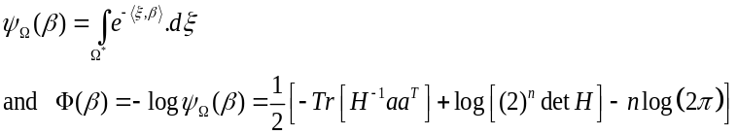 (66)
That verify the following relation given by Koszul and linked with 1st Koszul form:
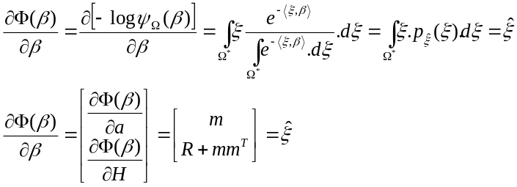 (67)
The 2nd dual potential is given by the Legendre transform of 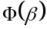:
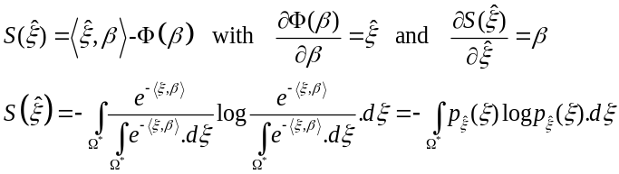 (68)
that is the Shannon Entropy:
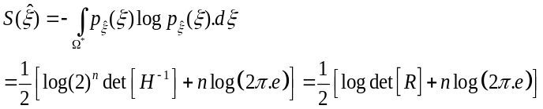 (69)
The Fisher metric of Information Geometry is given by the hessian of the opposite of the logarithm of the Koszul-Vinberg characteristic function:
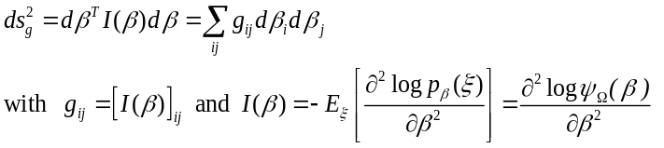 (70)
Then, for the multivariate gaussian density, we have the following Fisher metric :
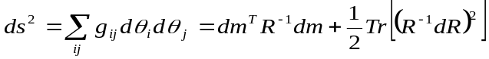 (71)
Geodesic equations are given by Euler-Lagrange equations:
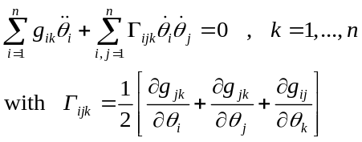 (72)
that can be reduced to the equations:
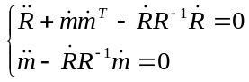 (73)
We can use a result of Souriau [107] that the component of « moment map » are constants (geometrization of Emmy Noether theorem), to identify the following constants [104]:
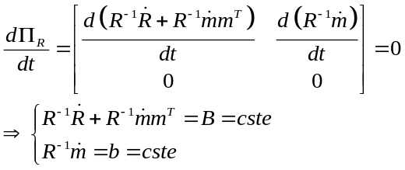 (74)
with 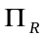 the moment map introduced by Souriau [107]. This moment map could be computed if we consider the following Lie group acting in case of gaussian densities:
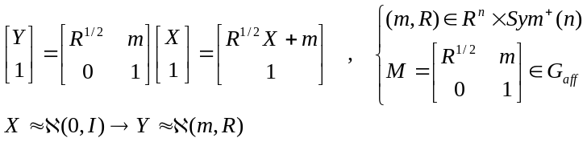 (75)
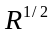 is given by Cholesky decomposition of . is the group of triangular matrix with positive elements on the diagonal. Euler-Poincaré equations, reduced equations from Euler-Lagrange equations:
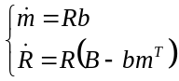 (76)
Geodesic distance between multivariate gaussian density is then obtained by “geodesic shooting” method that will provide iteratively the final solution from the tangent vector at the first point:
(77)
and then deduce the distance :
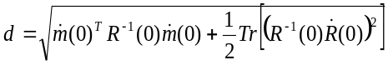 (78)
Geodesic shooting is obtained by using equations established by Eriksen [89-90] for “exponential map” using the following change of variables:
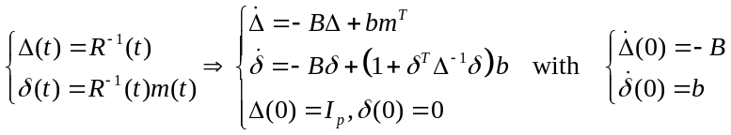 (79)
The method based on geodesic shooting consists in iteratively approaching the solution by geodesic shooting in direction 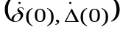, using the following exponential map :
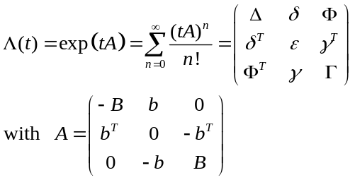 (80)

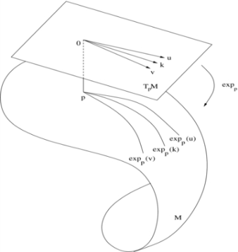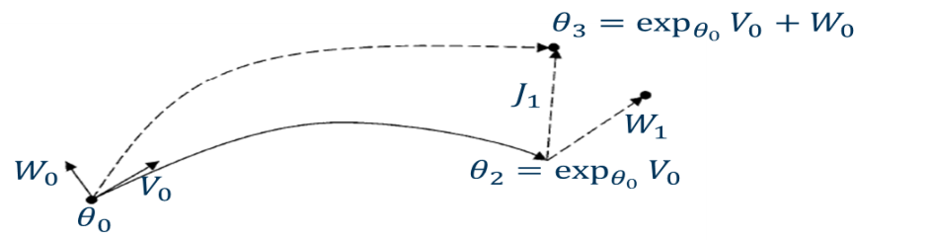
Fig. 7. Principle of Geodesic Shooting in the direction of the initial vector V0 at the origin and correction by W0

The principle of geodesic shooting is the following. We consider one geodesic between 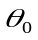 and 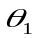 with an initial tangent vector 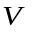from origin, and assume that is modified by 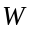, with respect to 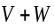. Variation of final point could be obtained by Jacobi vector field 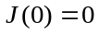 and 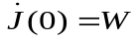 :
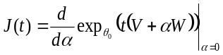 (81)
- Koszul's study of homogeneous bounded domains and affine representations of Lie groups and algebras
Jean-Louis Koszul [7-14] and his student Jacques Vey [16-17] introduced new theorems with more general extension than previous results:

Koszul theorem [14] : Let Ω be a sharp convex open in an affine space of E of finite dimension on R. If a unimodular Lie group of affine transformations operates transitively on Ω, Ω is a cone.

Koszul-Vey Theorem [17]: Let a hessian connected manifold associated with the hessian metric . Assume that M has a closed 1-form such that 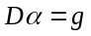 and that there is a group of affine automorphisms of preserving , then :
- If 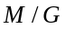 is almost compact, then the manifold, universal covering of , is affinely isomorphic to a convex domain of an affine space containing no straight line.
- If is compact, then is a sharp convex cone.

Jean-Louis Koszul developed his theory, studying the homogeneous domains, in particular the homogeneous symmetric bounded domains of Siegel, which we note DS [34-35]. He has proved that there is a subgroup G in the group of complex affine automorphisms of these domains (Iwasawa subgroup), so that G acts on DS in a merely transitive way. The Lie algebra of G has a structure which is an algebraic translation of the Kähler structure DS.
Koszul considered on G/B an invariant complex structure tensor I. All the invariant volumes on G/B, equal up to a constant factor, define with the complex structure the same invariant Hermitian form on G/B, called Hermitian canonical form, denoted h. Let E be a differentiable fiber space of base M and let p be the projection of E on M, such that 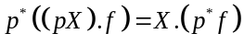. The projection 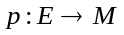 defines an injective homomorphism 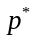 of the space of differential forms of M in the space of the differential forms of E such that for any form of degree n on M and any sequence of n projectable vectors fields, we have . Let I be the tensor of an almost complex structure on the basis M, there exists on E a tensor J of type (1,1) and only one which possesses the following properties 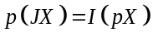 and 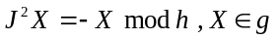 for any vector field X on E. Let G be a connected Lie group and B a closed subgroup of G, we note g the Lie algebra left invariant vector fields on G and b sub-algebra of g corresponding to B. The canonical mapping of G on G/B is denoted p (defining E as before). We assume that there exists on G/B an invariant volume by G, which consist in assuming that, for all , the automorphism of g defines by passing to the quotient an automorsphism of determinant 1 in g/b . Let r be the dimension of G/B and 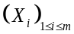 a base of g such that 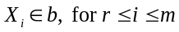. Let 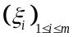 the base of the space of differential forms of degree 1 left invariant on G such that 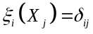. If is an invariant volume on G/B, then 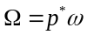 is equal, up to a constant factor, to 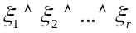. We will assume the base 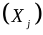 chosen so that this factor is equal to 1, let 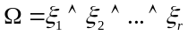. For any vector field that can be projected X on G, we have:
(82)
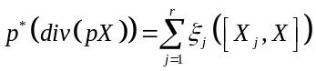 (83)
These elements being defined, Koszul calculates the Hermitian canonical form of G/B, denoted h, more particularly 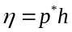 on G. Let X and Y both right invariant vector fields on G. They are projectable and the fields 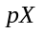 and 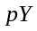 are conformal vector fields on G/B such that 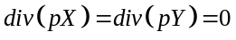, because the volume and the complex structure of G/B are invariant under G. As a result, if is the Kähler form of h and if 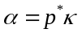, then:
(84)
and as 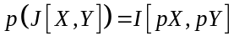, we obtain :
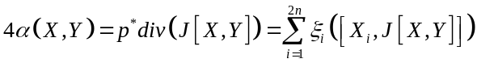 (85)
X and Y are two left invariant vectors fields on G. X ' and Y' right invariant vectors fields coinciding with X and Y at the point e, neutral element of G. If 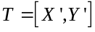 is tight invariant vectors fields which coincide with 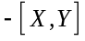on e, then:
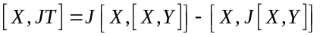 at point e (86)
At point e, we have the equality:
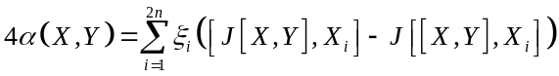 (87)
As the form is invariant on the left by G, this equality is verified for all points. For any endomorphism of the space g such that , we denote by 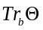 the trace of the restriction of to b and by the trace of the endomorphism of g/b deduced from by passage to the quotient, with . We have :
(88)
Whatever and , we have . If 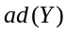 is the endomorphism of g defined by 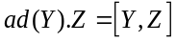, we have 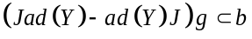 for all . We can deduce, for all , the endomorphism leaves steady the subspace b. Koszul defines a linear form on the space g by defining:
(89)
Koszul has finally obtained the following fundamental theorem :
Theorem of Koszul [7]:
The Kähler form of the Hermitian canonical form has for image by the differential of the form 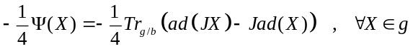
Koszul note that the form is independent of the choice of the tensor J. It is determined by the invariant complex structure of G/B. The form is right invariant by B . For all , note the endomorphism 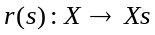 of g . Since 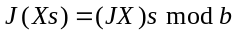 and that 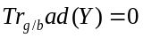, we have:
(90)
(91)
(92)
As 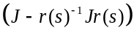 maps g in b, we get 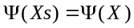. The form is not zero on b. This is not the image by of a differential form of G/B. However, the right invariance of on B is translated, infinitesimally by the relation:
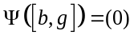 (93)
Koszul proved that the canonical hermitian form h of a homogeneous Kähler manifold G/B has the following expression:
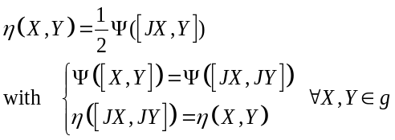 (94)
To do, the link with the first chapters, we can summarize the main result of Koszul that there is an integrable structure almost complex on , and for 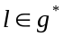defined by a positive J -invariant inner product on :
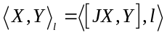 (95)
Koszul has proposed as admissible form, , the form :
(96)
Koszul proved that 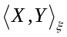 coincides, up to a positive multiplicative constant, with the real part of the Hermitian inner product obtained by the Bergman metric of symmetric homogeneous bounded domains DS by identifying with the tangent space of DS . The 1st Koszul form is then given by:
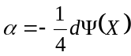 (97)
We can illustrate this structure for the simplest example of DS, the Poincaré upper half-plane 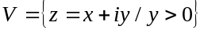 which is isomorphic to the open 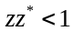, which is a bounded domain. The group G of transformations with a and b real values with is simply transitive in V. We identify G and V by the application passing from an element to the image 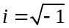 by .
Let's define vector fields 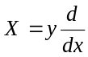 and 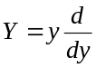 which generate the vector space of left invariant vectors fields on G, and J an almost complex structure on V defined by 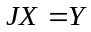. As 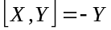 and 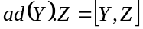 then:
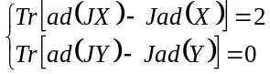 (98)
The Koszul forms and the Koszul metric are respectively given by :
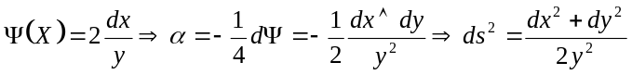 (99)
We note that is indeed the Kähler form of Poincaré's metric, which is invariant by the automorphisms of the upper half-plane.
The following example concerns the upper half-space of Siegel (which is the most natural extension of the Poincaré half-plane) with:
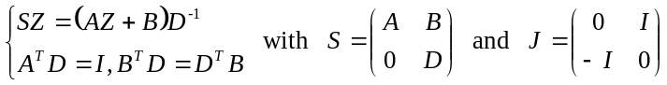 (100)
We can then compute Koszul forms and the metric:
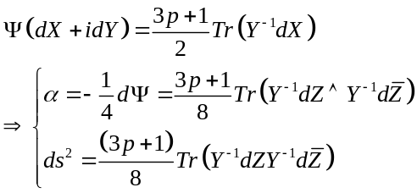 (101)
We recover Carl-Ludwig Siegel metric for the upper half space.
More recent development on Kähler manifolds are described in [109] et [110].
Koszul studied symmetric homogeneous spaces and defines the relation between invariant flat affine connections and the affine representations of Lie algebras and invariant Hessian metrics characterized by affine representations of Lie algebras. Koszul provides a correspondence between symmetric homogeneous spaces with invariant Hessian structures using affine representations of Lie algebras, and proves that a symmetric homogeneous space simply connected with an invariant Hessian structure is a direct product of a Euclidean space and of a homogeneous dual-cone. Let G be a connected Lie group and G/K a homogeneous space over which G acts effectively. Koszul gives a bijective correspondence between all planar G -invariantes connections on G/K and all of a certain class of affine representations of the Lie algebra of G. The main theorem of Koszul is:
Koszul's theorem: Let G/K be a homogeneous space of a connected Lie group G and be and the Lie algebras of G and K, assuming that G/K has G-invariant connection, then admits an affine representation (f, q) on the vector space E. Conversely, assume that G is simply connected and has an affine representation, then G/K admits a flat G-invariant connection.
In the foregoing, the basic tool studied by Koszul is the affine representation of Lie algebra and Lie group. To study these structures, Koszul introduced the following developments.
Let a convex domain on 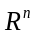 without any straight lines, and an associated convex cone , then there exist an affine embedding:
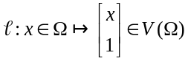 (102)
If we consider the group of homomorphism of 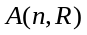 in 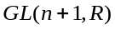 given by:
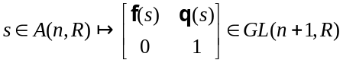 (103)
and the affine representation of Lie algebra:
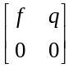 (104)
with the group of all affine representations of . We have 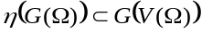 and the pair 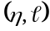 of homomorphism and the application 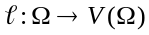 is equivariant.
If we observe Koszul affine representations of Lie algebra and Lie group, we have to consider a convex Lie group and a real or complex vector space of finite size, Koszul has introduced an affine representation of in such that:
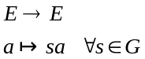 (105)
is an affine representation. We set 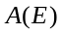 the set of all affine transformation of a real vector space , a Lie group called affine representation group of. The set 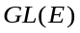 of all regular linear represnetation of , a sub-group of .
We define a linear representation of in :
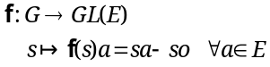 (106)
and a map from to :
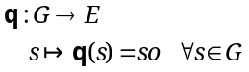 (107)
then, we have 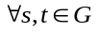:
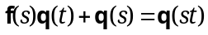 (108)
deduced from .
Inversely, if a map from to and a linear representation from to verifying previous equation, then we can define an affine representation from in , written by :
(109)
The condition 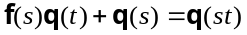 is equal to the request that the following mapping is an homomorphism:
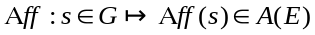 (110)
We write the affine representation of Lie algebra of , defined by and the restriction to to the differential of ( and differential of and respectivelly), Koszul proved the following equation:
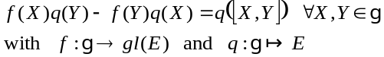 (111)
where 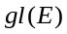 the set of all linear endomorphisms of , Lie algebra of .
We use the assumption that:
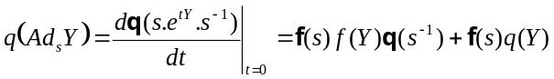 (112)
We then obtain:
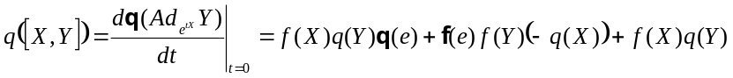 (113)
where is neutral element of . Since 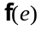 is identity map and 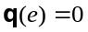, we have the equality:
(114)
A pair 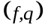of linear representation of of a Lie algebra on and a linear map from in is an affine representation of in , if it satisfy:
(115)
Inversely, if we assume that has an affine representation on , by using the coordinate systems 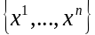 on , we can express the affine map 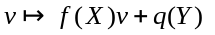by a matrix representation of size 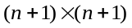:
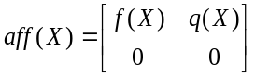 (116)
where 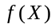 is a matrix of size and 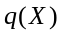 a vector of size .
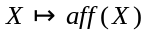 is an injective homomorphism of Lie algebra in Lie algebra of matrices , :
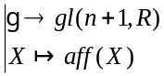 (117)
If we note 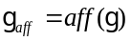, we write 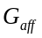 linear Lie sub-group of generated by 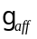. One element of 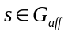 could be expressed by:
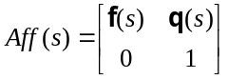 (118)
Let 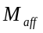 the orbit of from the origin , then 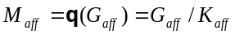 where 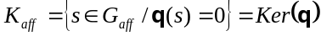.
We can give as example the following case. Let a convex domain in without any straight line, we define the cone 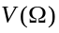 in 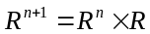 by . Then, there is an affine embedding:
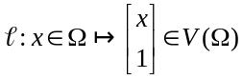 (119)
If we consider the group of homomorphisms of in given by:
(120)
with the group of all affine transformations in . We have and the pair of homomorphism 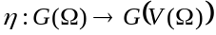 and the map are equivariant:
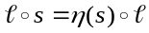 and 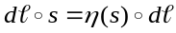 (121)
- Conclusion
The community of “Geometric Science of Information” (GSI) has lost a mathematician of great value, which informed his views by the depth of his knowledge of the elementary structures of hessian geometry and bounded homogeneous domains. His modesty was inversely proportional to his talent. Professor Koszul built in over 60 years of mathematical career, in the silence of his passions, an immense work, which makes him one of the great mathematicians of the XXth century, whose importance will only affirm with the time. In this troubled time and rapid transformation of society and science, the example of Professor Koszul must be regarded as a model for future generations, to avoid them the trap of fleeting glories and recognitions too fast acquired. The work of Professor Koszul is also a proof of fidelity to his masters and in the first place to Prof. Elie Cartan, who inspired him throughout his life. Henri Cartan writes on this subject "I do not forget the homage he paid to Elie Cartan's work in Differential Geometry during the celebration, in Bucharest, in 1969, of the centenary of his birth. It is not a coincidence that this centenary was also celebrated in Grenoble the same year. As always, Koszul spoke with the discretion and tact that we know him, and that we love so much at home". I will conclude by quoting Jorge Luis Borges "Forgetfulness and memory are also inventive" (Brodie's report). Our generation and previous one have forgotten or misunderstood the depth of the work of Jean-Louis Koszul and Elie Cartan on the study of bounded homogeneous domains. It is our responsibility to correct this omission, and to make it the new inspiration for the Geometric Science of Information. I will conclude by asking you to listen to the last interview of Jean-Louis Koszul for 50th birthday of Joseph Fourier Institute [6], especially when Koszul is interested by "conifers and cedars trees planted by Claude Chabauty”, or by the "pretty catalpa tree" which was at the Fourier Institute and destroyed by wind, "the tree with parentheses" he says, to which he seemed to be sentimentally attached. He also regrets that the Institute did not use the 1% artistic fund for the art mosaic project in the library. In this Koszul family of mathematicians, musicians, and Scientifics, there was a constant recollection of "beauty" and "truth". Our society no longer cares about timeless "beauty". We have then to extase ourself with Jean-Louis Koszul by observing beautiful “Catalpa tree” with “Parenthese Mushroom”, before there is no longer people to contemplate them.

"I am studying! I am only the subject of the verb study. To think I do not dare. Before thinking, we must study "- Gaston Bachelard, the flame of a candle

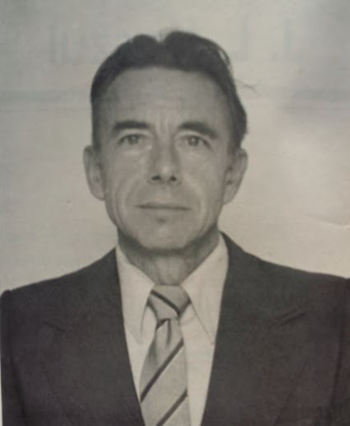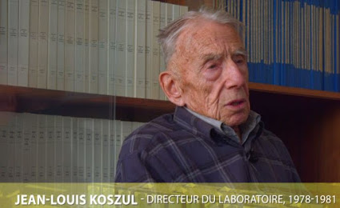
Fig. 8. (on the left) Jean-Louis Koszul at Grenoble in December 1993, (on the right) last interview of Jean-Louis Koszul in 2016 for 50th birthday of Institut Joseph Fourier in Grenoble

- References
- Cartan E., Sur les invariants intégraux de certains espaces homogènes clos et les propriétés topologiques de ces espaces, Ann. Soc. Pol. De Math., n°8, pp.181-225, 1929
- Cartan E., Sur les domaines bornés de l’espace de n variables complexes, Abh. Math. Seminar Hamburg, vol. 1, p.116-162, 1935
- Selected Papers of J L Koszul, Series in Pure Mathematics, Volume 17, World Scientific Publishing, 1994
- Cartan H., Allocution de Monsieur Henri Cartan, colloques Jean-Louis Koszul, Annales de l’Institut Fourier, tome 37, n°4, pp.1-4, 1987
- Koszul J.L., L'œuvre d'Élie Cartan en géométrie différentielle, in Élie Cartan, 1869-1951. Hommage de l'Académie de la République Socialiste de Roumanie à l'occasion du centenaire de sa naissance. Comprenant les communications faites aux séances du 4e Congrès du Groupement des Mathématiciens d'Expression Latine, tenu à Bucarest en 1969 (Editura Academiei Republicii Socialiste Romania, Bucharest, 1975), pp. 39-45.
- dernière interview de J.L. Koszul pour le laboratoire mathématique de l’Institut Fourier en 2016 : vidéo : https://www.youtube.com/watch?v=AzK5K7Q05sw
- Koszul J.L. , Sur la forme hermitienne canonique des espaces homogènes complexes. Can. J. Math., n°7, 562–576, 1955
- Koszul J.L. , Exposés sur les Espaces Homogènes Symétriques; Publicação da Sociedade de Matematica de São Paulo: São Paulo, Brazil, 1959
- Koszul J.L., Domaines bornées homogènes et orbites de groupes de transformations affines, Bull. Soc. Math. France 89, pp. 515-533., 1961
- Koszul J.L. , Ouverts convexes homogènes des espaces affines. Math. Z., n°79, 254–259, 1962
- Koszul J.L. , Variétés localement plates et convexité. Osaka. J. Math., n°2, 285–290, 1965
- Koszul J.L, Lectures on Groups of Transformations, Tata Institute of Fundamental Research, Bombay, 1965
- Koszul J.L., Déformations des variétés localement plates, .Ann Inst Fourier, n°18 , 103-114., 1968
- Koszul J.L. , Trajectoires Convexes de Groupes Affines Unimodulaires. In Essays on Topology and Related Topics; Springer: Berlin, Germany, pp. 105–110, 1970
- Koszul J.L., Introduction to Symplectic Geometry, Science Press, Beijing, 1986 (en chinois); traduction en anglais prevue par SPRINGER en 2018
- Vey J., Sur une notion d’hyperbolicité des variétés localement plates, Thèse de troisième cycle de mathématiques pures, Faculté des sciences de l’université de Grenoble, 1969
- Vey J., Sur les automorphismes affines des ouverts convexes saillants, Annali della Scuola Normale Superiore di Pisa, Classe di Science, 3e série, tome 24,n°4, p.641-665, 1970
- Alekseevsky D., Vinberg's theory of homogeneous convex cones: developments and applications, Transformation groups 2017. Conference dedicated to Prof. Ernest B. Vinberg on the occasion of his 80th birthday, Moscou, December 2017; https://www.mccme.ru/tg2017/slides/alexeevsky.pdf; vidéo: http://www.mathnet.ru/present19121
- Vinberg E.B., Homogeneous cones, Dokl. Akad. Nauk SSSR., n° 133, pp. 9–12, 1960; Soviet Math. Dokl., n°1, pp. 787–790, 1961
- Vinberg E.B., The Morozov-Borel theorem for real Lie groups, Dokl. Akad. Nauk SSSR., n°141, pp. 270–273, 1961; Soviet Math. Dokl., n°2, pp.1416–1419, 1962
- Vinberg E.B., Convex homogeneous domains, Dokl. Akad. Nauk SSSR., 141 1961, 521–524; Soviet Math. Dokl., n°2, pp. 1470–1473, 1962
- Vinberg E.B., Automorphisms of homogeneous convex cones, Dokl. Akad. Nauk SSSR., n°143 pp. 265–268, 1962; Soviet Math. Dokl., n°3, pp. 371–374, 1963
- Vinberg E. B., The Theory of Homogeneous Convex Cones, Trudy Moskovskogo Matematicheskogo Obshchestva, Vol.12, pp. 303-358, 1963; Trans. Moscow Math. Soc., n°12, pp. 340–403, 1963
- Vinberg E.B., Gindikin S.G., Pyatetskii-Shapiro I.I., On the classification and canonical realization of bounded homogeneous domains, Trudy Moskov. Mat. Obshch., n°12, pp.359–388, 1963 ; Trans. Moscow Math. Soc., n°12, pp.404–437, 1963
- Vinberg E.B., The structure of the group of automorphisms of a convex cone, Trudy Moscov. Mat. Obshch., n°13, pp.56–83, 1964; Trans. Moscow Math. Soc., n°13, 1964
- Vinberg E. B., Structure of the Group of Automorphisms of a Homogeneous Convex Cone, Trudy Moskovskogo Matematicheskogo Obshchestva, n°13, pp. 56-83, 1965
- Pyatetskii-Shapiro I.I., Certain problems of harmonic analysis in homogeneous cones, Dokl. Akad. Nauk SSSR., pp. 181–184, 1957
- Pyatetskii-Shapiro I.I., On a problem of E. Cartan, Dokl. Akad. Nauk SSSR., n°124, pp.272–273, 1959
- Pyatetskii-Shapiro I.I., The geometry of homogeneous domains and the theory of automorphic functions, The solution of a problem of E. Cartan, Uspekhi Mat. Nauk., vol. 14 n°3, pp.190–192, 1959
- Pyatetskii-Shapiro I.I., On the classification of bounded homogeneous domains in n-dimensional complex space, Dokl. Akad. Nauk SSSR., n°141, pp. 316–319, 1961; Soviet Math. Dokl., n°, pp. 1460–1463, 1962
- Pyatetskii-Shapiro I.I., On bounded homogeneous domains in n-dimensional complex space, Izv. Akad. Nauk SSSR. Ser. Mat., n°26, pp.107–124, 1962
- Gindikin S.G., Analysis in homogeneous domains", Uspekhi Mat. Nauk., vol.19, n°4, pp.3–92, 1964; Russian Math. Surveys, vol.19, n°4, pp.1–89, 1964
- Rothaus O. S., The Construction of Homogeneous Convex Cones, Annals of Mathematics, Ser.2, Vol.83, pp.358-376, 1966
- Siegel C.L. , Über der analytische Theorie der quadratischen Formen, Ann. Math. 36, p. 527-606, 1935
- Siegel C.L., Symplectic geometry ,Amer. J. Math., n° 65, pp.1-86, 1943
- Hua L.K., Harmonic Analysis of Functions of Several Complex Variables in the Classical Domains; American Mathematical Society: Providence, RI, USA, 1963
- Lichnerowicz A., Espaces homogènes Kähleriens. In Colloque de Géométrie Différentielle; Publication du CNRSP: Paris, France, pp. 171–184, 1953
- Berezin F., Quantization in complex symmetric spaces. Izv. Akad. Nauk SSSR Ser. Math. , n°9, 363–402., 1975
- Vesentini E., Geometry of Homogeneous Bounded Domains, Springer-Verlag 2011, reprint of the 1rst Ed. C.IM.E., Ed. Cremonese, Roma 1968
- Sampieri U., A generalized exponential map for an affinely homogeneous cone, Atti della Accademia Nazionale dei Lincei. Classe di Scienze Fisiche, Matematiche e Naturali. Rendiconti Lincei. Matematica e Applicazioni, Serie 8, Vol. 75, n.6, p. 320–330, 1983
- Sampieri U., Lie group structures and reproducing kernels on homogeneous siegel domains, Annali di Matematica Pura ed Applicata, Volume 152, Issue 1, pp 1–19, December 1988
- Shima H., Symmetric spaces with invariant locally Hessian structures. J. Math.Soc. Japan, pp. 581–589, 1977
- Shima H., Homogeneous Hessian manifolds. Ann. Inst. Fourier, pp. 91–128, 1980
- Shima H., Vanishing theorems for compact Hessian manifolds. Ann. Inst. Fourier, pp. 183–205, 1986
- Shima H., Harmonicity of gradient mappings of level surfaces in a real affine space. Geometriae Dedicata, pp. 177–184, 1995
- Shima H., Hessian manifolds of constant Hessian sectional curvature. J. Math. Soc. Japan, pp. 735–753, 1995
- Shima H., Homogeneous spaces with invariant projectively flat affine connections. Trans. Amer. Math. Soc., pp. 4713–4726, 1999
- Shima H., The Geometry of Hessian Structures, World Scientific, 2007
- Shima H., Geometry of Hessian Structures, Springer Lecture Notes in Computer Science, Vol. 8085, F. Nielsen, & Barbaresco, Frederic (Eds.), pp.37-55, 2013 (planches: https://www.see.asso.fr/file/5104/download/25050); (vidéos GSI’13: https://www.youtube.com/watch?time_continue=139&v=6pyXxdIzDNQ ; https://www.youtube.com/watch?time_continue=182&v=jG2tUjniOUs ; https://www.youtube.com/watch?time_continue=6&v=I5kdMJvuNHA )
- Leray J., Un prolongement de la transformation de Laplace qui transforme la solution unitaire d'un opérateur hyperbolique en sa solution élémentaire. (Problème de Cauchy. IV.). Bulletin de la Société Mathématique de France, n°90, p. 39-156, 1962
- Legendre, A.M. Mémoire Sur L’intégration de Quelques Equations aux Différences Partielles; Mémoires de l’Académie des Sciences: Paris, France, pp. 309–351, 1787
- Jaynes E.T., Information Theory and Statistical Mechanics, Phys. Rev. Ser. II , n°106, pp. 620–630, 1957
- Jaynes E.T., Information Theory and Statistical Mechanics II, Phys. Rev. Ser. , n°108, pp. 171–190, 1957
- Jaynes E.T., Prior Probabilities, IEEE Trans. Syst. Sci. Cybern., n°4, pp. 227–241, 1968
- Fréchet M., Sur l’extension de certaines évaluations statistiques au cas de petits échantillons, Revue de l’Institut International de Statistique, vol. 11, n° 3/4, pp. 182–205, 1943
- Rao C.R., Information and the accuracy attainable in the estimation of statistical parameters, Bull. Calcutta Math. Soc., n°37, pp. 81–89, 1945
- Burbea J., Rao C.R., Entropy differential metric, distance and divergence measures in probability spaces: A unified approach, J. Multivar. Anal., n°12, pp. 575–596, 1982
- Chentsov N.N., Statistical Decision Rules and Optimal Inferences, Transactions of Mathematics Monograph, American Mathematical Society: Providence, RI, USA, Volume 53, 1982
- Crouzeix J.P., A relationship between the second derivatives of a convex function and of its conjugate, Math. Progr., n°3, pp. 364–365 , 1977
- Moreau J.J., Fonctions convexes duales et points proximaux dans un espace hilbertien, C. R. Acad. Sci., n°255, pp. 2897–2899, 1962
- Berger M., Les espaces symétriques noncompacts, Annales scientifiques de l'École Normale Supérieure, Série 3 : Tome 74, n°2 , pp. 85-177, 1957
- Poincaré H., Calcul des Probabilités; Gauthier-Villars: Paris, France, 1896
- Massieu F., Sur les Fonctions caractéristiques des divers fluides. C. R. Acad. Sci. , n°69, pp. 858–862, 1869
- Massieu F., Addition au précédent Mémoire sur les Fonctions caractéristiques. C. R. Acad. Sci. , n° 69, pp. 1057–1061, 1869
- Massieu F., Exposé des Principes Fondamentaux de la Théorie Mécanique de la Chaleur (note Destinée à Servir D'introduction au Mémoire de L'auteur sur les Fonctions Caractéristiques des Divers Fluides et la Théorie des Vapeurs); Académie des Sciences, Paris, 31p., 1873
- Massieu F., Thermodynamique: Mémoire sur les Fonctions Caractéristiques des Divers Fluides et sur la Théorie des Vapeurs; Académie des Sciences: Paris, France, 1876; p. 92. , 1876
- Balian R., Alhassid Y.; Reinhardt H., Dissipation in many-body systems: A geometric approach based on information theory. Phys. Rep., n°131, pp.1-146, 1986
- Balian R., Balazs N., Equiprobability, inference and entropy in quantum theory. Ann. Phys. , n°179, pp. 97–144, 1987
- Balian R., On the principles of quantum mechanics, Am. J. Phys. , n°57, pp. 1019–1027, 1989
- Balian R., From Microphysics to Macrophysics: Methods and Applications of Statistical Physics; Springer: Heidelberg, Germany, Volumes I and II, 1991 & 1992
- Balian R., Incomplete descriptions and relevant entropies, Am. J. Phys. , n°67, pp. 1078–1090, 1999
- Balian R., Valentin P., Hamiltonian structure of thermodynamics with gauge. Eur. Phys. J. B, n°21, pp. 269–282, 2001
- Balian R., Entropy, a protean concept. In Poincaré Seminar 2003; Dalibard, J., Duplantier, B., Rivasseau, V., Eds.; Birkhauser: Basel, Switzerland, pp. 119–144, 2004
- Balian R., Information in statistical physics, In Studies in History and Philosophy of Modern Physics, Part B; Elsevier, Amsterdam, February 2005.
- Balian R., The entropy-based quantum metric. Entropy, n°16, pp. 3878–3888, 2014
- Balian R., François Massieu et les Potentiels Thermodynamiques, Évolution des Disciplines et Histoire des Découvertes; Académie des Sciences: Avril, France, 2015
- Maliavin P., Invariant or quasi-invariant probability measures for infinite dimensional groups, Part II: Unitarizing measures or Berezinian measures. Jpn. J. Math., n°3, pp. 19–47, 2008
- Gromov M., Convex Sets and Kähler Manifolds, In Advances in Differential Geometry and Topology; Tricerri, F., Ed.; World Scientific: Singapore, Singapore; pp. 1–38, 1990
- Gromov M., In a Search for a Structure, Part 1: On Entropy, 23 June 2012 . Available online: http://www.ihes.fr/~gromov/PDF/structre-serch-entropy-july5-2012.pdf
- Gromov M., Gromov Six Lectures on Probability, Symmetry, Linearity. October 2014, Jussieu, November 6th , 2014; Lecture Slides & video of Gromov lectures on youtube: http://www.ihes.fr/~gromov/PDF/probability-huge-Lecture-Nov-2014.pdf; https://www.youtube.com/watch?v=hb4D8yMdov4
- Gromov M., Gromov Four Lectures on Mathematical Structures arising from Genetics and Molecular Biology, IHES, October 2013; video of Lectures on youtube: https://www.youtube.com/watch?v=v7QuYuoyLQc&t=5935s
- Dacunha-Castelle D., Gamboa F., Maximum d’entropie et problèmes des moments. Ann. Inst. H. Poincaré Prob. Stat., n°26, pp. 567–596, 1990
- Gamboa F., Gassiat E., Maximum d’entropie et problème des moments: Cas multidimensionnel. Probab. Math. Stat., n°12, pp. 67–83, 1991
- Dacunha-Castelle D., Gamboa F., Maximum de l’entropie sous contraintes non linéaires. Ann. Inst H. Poincaré Prob. Stat., n°4, pp. 567–596, 1990
- Hiriart-Urruty J.B., A new set-valued second-order derivative for convex functions, In Mathematics for Optimization; Mathematical Studies Series 129; Elsevier: Amsterdam, The Netherlands, 1986
- Letac G., Lectures on Natural Exponential Families and Their Variance Functions, Volume 50 of Monografias de Matematica (Mathematical Monographs); Instituto de Matematica Pura e Aplicada (IMPA): Rio de Janeiro, Brazil, 1992.
- Casalis M., Familles exponentielles naturelles invariantes par un groupe de translations. C. R. Acad. Sci. Ser. I Math., n°307, pp. 621–623, 1988
- Casalis M., Familles Exponentielles Naturelles Invariantes par un Groupe. Ph.D. Thesis, Thèse de l'Université Paul Sabatier, Toulouse, France, 1990
- Eriksen P., Geodesics Connected with the Fisher Metric on the Multivariate Normal Manifold; Technical Report, 86-13; Institute of Electronic Systems, Aalborg University: Aalborg, Denmark, 1986.
- Eriksen P.S., Geodesics connected with the Fisher metric on the multivariate normal manifold, In Proceedings of the GST Workshop, Lancaster, UK, 28–31 October 1987
- Byande P.M.; Ngakeu F., Boyom M.N., Wolak R., KV-cohomology and differential geometry of affinely flat manifolds. Information geometry. Afr. Diaspora J. Math., n°14, pp. 197–226, 2012
- Byande P.M., Des Structures Affines à la Géométrie de L’information; European University Editions, 2012
- Nguiffo Boyom M., Sur les structures affines homotopes à zéro des groupes de Lie. J. Differ. Geom., n°31, pp. 859–911, 1990
- Nguiffo Boyom M., Structures localement plates dans certaines variétés symplectiques. Math. Scand., n°76, pp. 61–84, 1995
- Nguiffo Boyom M., Métriques kählériennes affinement plates de certaines variétés symplectiques. I., Proc. London Math. Soc. (3), n°66, n°2, pp.358-380, 1993
- Nguiffo Boyom M., The cohomology of Koszul-Vinberg algebras. Pacific J. Math. 225, pp. 119-153, 2006
- Nguiffo Boyom M., Some Lagrangian Invariants of Symplectic Manifolds, Geometry and Topology of Manifolds; Banach Center Institute of Mathematics, Polish Academy of Sciences, Warsaw, Volume 76, pp. 515–525, 2007
- Nguiffo Boyom M., Byande P.M. , KV Cohomology in Information Geometry Matrix Information Geometry; Springer: Heidelberg, Germany, pp. 69–92, 2013
- Nguiffo Boyom M., Transversally Hessian foliations and information geometry I. Am. Inst. Phys. Proc. , n°1641, pp. 82–89, 2014
- Nguiffo Boyom M, Wolak, R., Transverse Hessian metrics information geometry MaxEnt 2014. AIP. Conf. Proc. Am. Inst. Phys. 2015
- Barbaresco F., Koszul information geometry and Souriau Lie group thermodynamics, AIP Conf. Proc. n°1641, n° 74, 2015, Proceedings of MaxEnt’14 conference, Amboise, Septembre 2014
- Barbaresco F., Koszul Information Geometry and Souriau Geometric Temperature/Capacity of Lie Group Thermodynamics, Entropy, vol. 16, 2014, pp. 4521-4565. Published in the book Information, Entropy and Their Geometric Structures, MDPI Publisher, September 2015
- Barbaresco F., Symplectic Structure of Information Geometry: Fisher Metric and Euler-Poincaré Equation of Souriau Lie Group Thermodynamics. In Geometric Science of Information, Second International Conference GSI 2015 Proceedings, Lecture Notes in Computer Science vol. 9389, Springer, pp. 529–540, 2015
- Barbaresco F., Geometric Theory of Heat from Souriau Lie Groups Thermodynamics and Koszul Hessian Geometry: Applications in Information Geometry for Exponential Families. Entropy, n°18, pp. 386, 2016
- Barbaresco F., Poly-symplectic Model of Higher Order Souriau Lie Groups Thermodynamics for Small Data Analytics, GSI 2017, SPRINGER LNCS 10589, pp. 432–441, 2017
- Barbaresco F., Les densités de probabilité « distinguées » et l’équation d’Alexis Clairaut: regards croisés de Maurice Fréchet et de Jean-Louis Koszul, GRETSI’17, Juan-Les-Pins, Sept. 2017
- Souriau J.-M, Structures des systèmes dynamiques, Dunod, Paris, 1970
- Souriau, J.-M., Mécanique statistique, groupes de Lie et cosmologie, Colloques int. du CNRS numéro 237, Géométrie symplectique et physique mathématique, 1974, pp. 59–113.
- Bourguignon J.P., La géométrie kählérienne, domaines de la géométrie différentielle, séminaire Histoires de géométries, FMSH, 2005, vidéo : https://youtu.be/SDmMo4a1vbk
- Gauduchon P., Calabi's extremal Kähler metrics: An elementary introduction; preprint : germanio.math.unifi.it/wp-content/uploads/2015/03/dercalabi.pdf
- Lichnerowicz A., Groupes de Lie à structures symplectiques ou Kähleriennes invariantes. Albert C. (eds) Géométrie Symplectique et Mécanique. Lecture Notes in Mathematics, vol 1416. Springer, 1990
- Ollivier Y., Marceau-Caron G., Natural Langevin dynamics for neural networks, Proc. of the conference on Geometric Science of Information (GSI 2017), F. Nielsen and F. Barbaresco (eds), Lecture Notes in Computer Science 10589, Springer (2017), 451–459. (Best paper award.)
- Ollivier Y., True Asymptotic Natural Gradient Optimization, manuscript disponible sur arxiv http://arxiv.org/abs/1712.08449
- Nesterov Y and Nemirovskii A., Interior-Point Polynomial Algorithms in Convex Programming, SIAM Series: Studies in Applied and Numerical Mathematics, Pages: ix + 396, 1994

