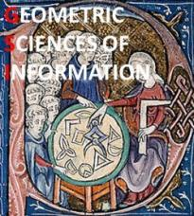

GSI’13
Geometric Science of
Information
Ecole des Mines ParisTech
28th – 30th August 2013
http://www.gsi2013.org

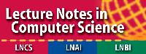
WELCOME TO GSI’13 CONFERENCE
On behalf of both organizing and scientific committees, it is a great pleasure to welcome all delegates, representatives and participants from around the world to the first International SEE conference on “Geometric Science of Information”, GSI’13, hosted by Ecole des Mines de Paris, from 28th to 30th of August 2013.
GSI’13 benefits from scientific sponsor of SMF (Société Mathématique de France: http://smf.emath.fr/), and financial sponsor by THALES (www.thalesgroup.com), INRIA (http://www.inria.fr/en/), GDR CNRS MIA (https://fadili.users.greyc.fr/mia/) and GDR CNRS Maths & Entreprises (http://www.maths-entreprises.fr/). The conference is also organized in the frame of the relations set up between SEE (http://www.see.asso.fr/) and scientific institutions or academic labs: Ecole des Mines de Paris, Supelec, Université Paris-Sud, Institut Mathématique de Bordeaux, SONY Research.
Let me express all my thanks to the Mathematical Department of Ecole des Mines de Paris for hosting this first scientific event at the interface between Geometry, Probability and Information Geometry.
GSI’13 event has been motivated in the continuity of first initiatives launched by Leon Brillouin seminar (http://repmus.ircam.fr/brillouin/home) since 2009 on “Geometric Sciences of Information” by THALES, IRCAM and Ecole Polytechnique: among others, the French-Indian Workshop organized at Ecole Polytechnique and Thales Research & Technology in 2011 on “Matrix Information Geometry” with proceedings published by SPRINGER (http://www.springer.com/engineering/signals/book/978-3-642-30231-2) and GDR CNRS MIA Symposium at Institut Henri Poincaré on “Optimal Transport and Information Geometry” (https://www.ceremade.dauphine.fr/~peyre/mspc/mspc-thales-12).
The technical program covers all the main topics and highlights in the domain of “Geometric Science of Information” including Information Geometry Manifolds of structured data/information and their advanced applications. GSI’13 addresses inter-relations between different mathematical domains like shape spaces (geometric statistics on manifolds and Lie groups, deformations in shape space,…), probability/optimization & algorithms on manifolds (structured matrix manifold, structured data/Information, …), relational and discrete metric spaces (graph metrics, distance geometry, relational analysis,…), computational and hessian information geometry, algebraic/infinite dimensionnal/Banach information manifolds, divergence geometry, tensor-valued morphology, optimal transport theory, manifold & topology learning, … and applications like geometries of audio-processing, inverse problems and signal processing.
Papers are presented in keynote and plenary oral sessions in the morning, parallel oral sessions in the afternoon, with one poster session the first day. 100 publications will be presented and testify the world wide interest for topics covered by GSI’13. Three international experts have been scheduled with a keynote presentation each day: Yann Ollivier on “Information-geometric optimization” (Université Paris-Sud, France), Hirohiko Shima on “Geometry of Hessian Structures” (Yamaguchi University, Japan) and Giovanni Pistone on “Nonparametric Information Geometry” (Collegio Carlo Alberto, Italy). Talk of Professor Shima will be dedicated to Professor Jean-Louis Koszul work on flat manifold and at the origin of the notion of Hessian structures. As guest speaker, we have the great honor to welcome Professor Shun-ichi Amari (RIKEN Brain Science Institute, Japan) for a tutorial on “Information Geometry and Its Applications: Survey”.
I would like to acknowledge all the Organizing and Scientific Committee members for their hard work, in evaluating submissions. I also give my thanks to authors and co-authors, for their tremendous effort and scientific contribution.

Frédéric BARBARESCO
SEE/SMF GSI’13 General Chair
President of SEE SI²D Club (Signal, Image, Information & Decision)
Senior Scientist & Advanced Studied Manager, Thales Land & Air Systems
frederic.barbaresco@thalesgroup.com
+33 (0)630071419
GSI’13 CONFERENCE
The objective of this SEE international Conference hosted by MINES ParisTech, is to bring together pure/applied mathematicians and engineers, with common interest for Geometric tools and their applications for Information analysis, with active participation of young researchers for deliberating emerging areas of collaborative research on “Information Geometry Manifolds and Their Advanced Applications”.
Current and ongoing uses of Information Geometry Manifolds in applied mathematics are the following: Advanced Signal/Image/Video Processing, Complex Data Modeling and Analysis, Information Ranking and Retrieval, Coding, Cognitive Systems, Optimal Control, Statistics on Manifolds, Machine Learning, Speech/sound recognition, natural language treatment, etc., which are also substantially relevant for the industry.
This international conference will be an interdisciplinary event and will federate skills from Geometry, Probability and Information Theory to address the following topics among others:
- Geometric Statistics on manifolds and Lie groups
- Deformations in Shape Spaces
- Relational Metric and Discrete Metric Spaces
- Computational/Hessian Information Geometry
- Optimization on Matrix Manifolds
- Optimal Transport Theory
- Probability on Manifolds
- Divergence Geometry & Ancillarity
- Tensor-Valued Mathematical Morphology
- Machine/Manifold/Topology Learning
- Algebraic/Infinite dimensionnal/Banach Information Manifolds
- …
Invited talks are scheduled with 3 Keynote and 1 Guest speakers in plenary sessions:
- Yann OLLIVIER (Paris-Sud Univ.):
  - “Information-geometric optimization: The interest of information theory for discrete and continuous optimization”
- Hirohiko SHIMA (Yamaguchi Univ.):
  - “Geometry of Hessian Structures” dedicated to Prof. J.L. KOSZUL
- Giovanni PISTONE (Collegio Carlo Alberto):
  - “Nonparametric Information Geometry”
- Shun-ichi AMARI (Riken):
  - “Information Geometry and Its Applications: Survey”
GSI’13 ORGANIZATION
Program Chairs
Jésus Angulo Mines-Paristech, France
Frédéric Barbaresco THALES AIR SYSTEMS, France
Silvère Bonnabel Mines-Paristech, France
Arshia Cont IRCAM, France
Frank Nielsen Ecole Polytechnique, France
Scientific Committee
Jésus Angulo Mines-Paristech, France
Marc Arnaudon Universit´e de Poitiers, France
Michael Aupetit CEA LIST, France
Frédéric Barbaresco THALES AIR SYSTEMS, France
Michèle Basseville IRISA, France
Silvère Bonnabel Mines-Paristech, France
Michel Boyom Université de Montpellier, France
Michel Broniatowski UPMC, France
Paul Byande Université de Montpellier, France
Frédéric Chazal INRIA, France
Arshia Cont IRCAM, France
Arnaud Dessein University of York, France
Michel Deza Ecole Normale Supérieure Paris, France
Stanley Durrleman INRIA, France
Edwin Hancock University of York, UK
Nicolas Le Bihan Université de Grenoble, France
Jonathan Manton The University of Melbourne, Australia
Jean-François Marcotorchino THALES COMMUNICATIONS, France
Bertrand Maury Université Paris Sud, France
Ali Mohammad-Djafari Supelec, France
Frank Nielsen Ecole Polytechnique, France
Richard Nock Université des Antilles et de la Guyane, France
Xavier Pennec INRIA, France
Michel Petitjean Université Paris Diderot, France
Gabriel Peyré Université Paris Dauphine, France
Olivier Schwander Ecole Polytechnique, France
Rodolphe Sepulchre Université de Liège, Belgium
Hichem Snoussi Université de Technologie de Troyes, France
Alain Trouvé ENS Cachan, France

GSI’13 PROGRAM & AGENDA
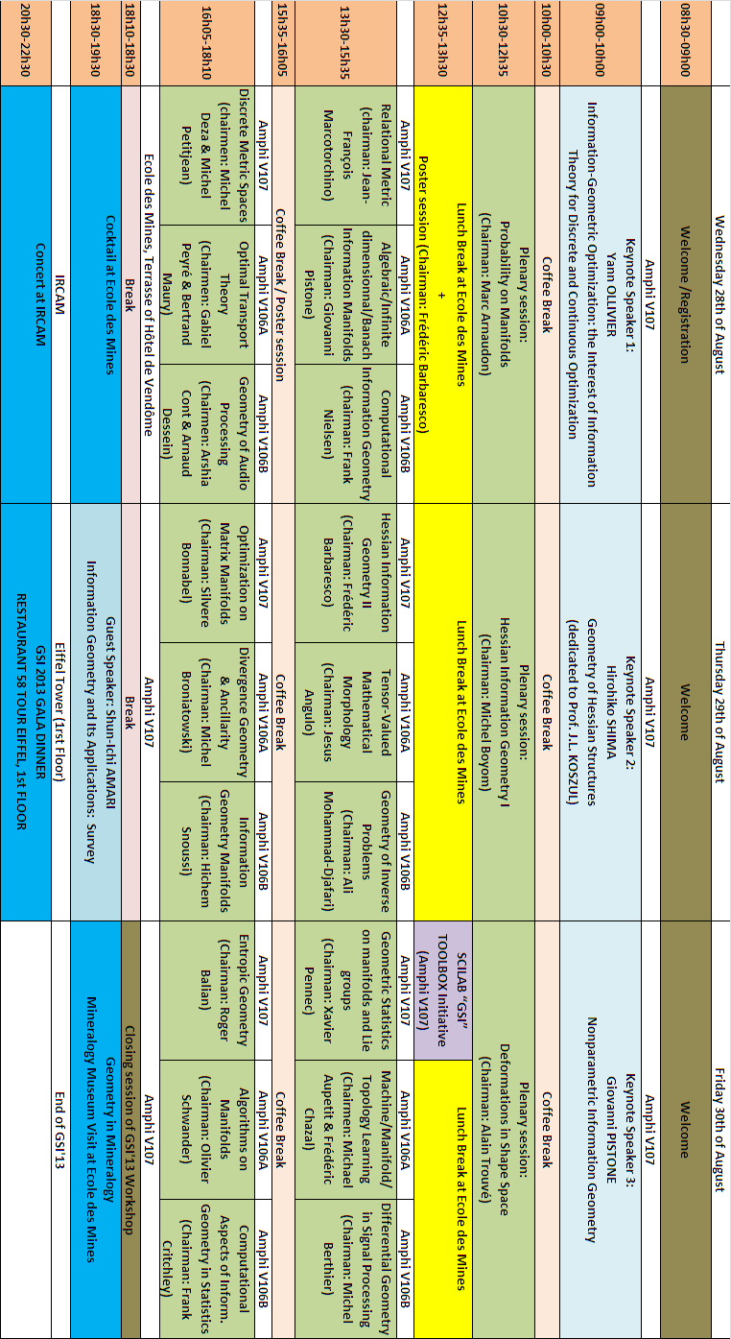
GSI’13 KEYNOTE & GUEST SPEAKERS
Invited talks are scheduled with 3 Keynote speakers and 1 Guest Speaker for plenary sessions:
KEYNOTE SPEAKERS
- Yann OLLIVIER (Paris-Sud Univ.): “Information-geometric optimization: The interest of information theory for discrete and continuous optimization”
- Hirohiko SHIMA (Yamaguchi Univ.): “Geometry of Hessian Structures” dedicated to Prof. J.L. KOSZUL
- Giovanni PISTONE (Collegio Carlo Alberto): “Nonparametric Information Geometry”
GUEST SPEAKER
- Shun-ichi Amari (RIKEN Brain Science Institute): « Information Geometry and Its Applications: Survey”

Yann Ollivier, Paris-Sud University, France
Information-geometric optimization: The interest of information theory for discrete and continuous optimization
Abstract |  | Black box optimization is the problem of searching for the minimum of a function on a given space (discrete or continuous), without any prior knowledge about the function. Information geometry provides a systematic method, IGO (information-geometric optimization) to easily build optimization algorithms having nice properties; in particular it minimizes the influence of arbitrary choices such as how the space of solutions is represented. In some situations IGO recovers known and widely used algorithms, thus providing theoretical justification for them.  Specific properties of information geometry and the Kullback-Leibler divergence guarantee, at each step, minimal diversity loss in the exploration of possible solutions; this suggests IGO algorithms automatically tune the simultaneous exploration of different regions.
References |  | - L. Arnold, A. Auger, N. Hansen, Y. Ollivier, Information-geometric optimization: A unifying picture via invariance principles, preprint, arXiv:1106.3708 Y. Ollivier, Ricci curvature of Markov chains on metric spaces, J. Funct. Anal. 256 (2009), no. 3, 810-864.  - A. Joulin, Y. Ollivier, Curvature, concentration, and error estimates for Markov chain Monte Carlo, Ann. Probab. 38 (2010), no. 6, 2418-2442.  - Y. Ollivier, A January 2005 Invitation to Random Groups, Ensaios Matemáticos 10, Sociedade Brasileira de Matemática, Rio de Janeiro (2005).  - Y. Ollivier, Sharp phase transition theorems for hyperbolicity of random groups, GAFA, Geom. Funct. Anal. 14 (2004), no. 3, 595-679.  - C. Chevalier, F. Debbasch, Y. Ollivier, Multiscale cosmological dynamics, Physica A 388 (2009), 5029-5035.  - Y. Ollivier, P. Senellart, Finding related pages using Green measures: An illustration with Wikipedia, Proc. of the Twenty-Second Conference on Artificial Intelligence (AAAI 2007), 1427-1433.
Biography |  | Yann's research generally focuses on the introduction of probabilistic models on structured objects, and more particularly addresses the interplay between probability and differential geometry.  He is currently Research scientist at the CNRS, currently in the Computer Science department at Paris-Sud Orsay University, previously in the Mathematics department at the École Normale Supérieure in Lyon (2004–2010).  He graduated to his PhD in Mathematics, under the supervision of M. Gromov and P. Pansu in 2003 and is accredited to supervise research since 2009  http://www.yann-ollivier.org/rech/index
 |  | Hirohiko Shima, Yamaguchi University, Japan  Geometry of Hessian Structures
Abstract |  | A Riemannian metric g on a flat manifold M with flat connection D is called a Hessian metric if it is locally expressed by the Hessian of local functions φ with respect to the aﬃne coordinate systems, that is, g = Ddφ. Such pair (D, g), g, and M are called a Hessian structure, a Hessian metric, and a Hessian manifold, respectively [S7]. Typical examples of these manifolds include homogeneous regular convex cones [V] (e.g. the space of all positive definite real symmetric matrices). J.L. Koszul studied a flat manifold endowed with a closed 1-form α such that Dα is positive definite [K1][K2]. Then g = Dα is exactly a Hessian metric. Hence this is the ultimate origin of the notion of Hessian structures. On the other hand, a Riemannian metric on a complex manifold is said to be a Kählerian metric if it is locally expressed by the complex Hessian of functions with respect to holomorphic coordinate systems. For this reason S.Y. Cheng and S.T. Yau called Hessian metrics aﬃne Kähler metrics [CY]. These two types of metrics are not only formally similar, but also intimately related. In fact, the tangent bundle of a Hessian manifold is a Kählerian manifold. Hessian geometry (the geometry of Hessian structures) is thus a very close relative of Kählerian geometry, and may be placed among, and finds connection with important pure mathematical fields such as aﬃne diﬀerential geometry, homogeneous spaces, cohomology, non-associative algebras (e.g. left symmetric algebras, Jordan algebras) and others. Moreover, Hessian geometry, as well as being connected with these pure mathematical areas, also, perhaps surprisingly, finds deep connections with information geometry. The notion of flat dual connections, which plays an important role in information geometry, appears in precisely the same way for our Hessian structures [A][AN]. Thus Hessian geometry oﬀers both an interesting and fruitful area of research.  A Hessian structure is characterized by the Codazzi equation; (D_{X} g)(Y, Z) = (D_{Y} g)(X, Z). Using this equation the notion of Hessian structure is easily generalized as follows. A pair (D, g) of a torsion free connection D and a Riemannian metric g on M is called a Codazzi structure if it satisfies the Codazzi equation;(D_{X} g)(Y, Z) = (D_{Y} g)(X, Z) [Del]. For a Codazzi structure (D, g) we can define a new torsion-free connection D' by Xg(Y, Z) = g(D_{X}Y, Z) + g(Y, D'_{X}Z). Then we have D' = 2∇ - D where ∇ is the Levi-Civita connection of g. The pair (D', g) is also a Codazzi structure. The connection D' and the pair (D', g) are called the dual connection of D and the dual Codazzi structure of (D, g), respectively.  Historically, the notion of dual connections was obtained by quite distinct approaches. In aﬃne diﬀerential geometry the notion of dual connections was naturally obtained by considering a pair of a non-degenerate aﬃne hypersurface immersion and its conormal immersion [NS]. In contrast, S. Amari and H. Nagaoka found that smooth families of probability distributions admit dual connections as their natural geometric structures. Information geometry aims to study information theory from the viewpoint of the dual connections [A][AN].
References |  | - [A] Amari, S. (1985). Diﬀerential-geometrical methods in statistics, Springer Lecture Notes in Statistics.  - [AN] Amari, S. and Nagaoka, H (2000). Methods of information geometry, Translation of Mathematical Mono-graphs, AMS, Oxford, Univ. Press.  - [CY] Cheng, S. Y and Yau, S. T. (1982). The real Monge-Ampère equation and aﬃne ﬂat structures, Proc. the 1980 Beijing symposium of diﬀerential geometry and diﬀerential equations, Science Press, Beijing, hina, Gordon and Breach, Science Publishers, Inc., New York, pp. 339-370.  - [Del] Delanoë, P. (1989). Remarques sur les variétés localement hessiennes, Osaka J. Math., pp. 65-69.  - [K1] Koszul, J. L. (1961). Domaines bornés homogènes et orbites de groupes de transformations aﬃnes, Bull. Soc. Math. France 89, pp. 515-533.  - [K2] Koszul, J. L. (1965). Variétés localement plates et convexité, Osaka J. Maht. 2, pp. 285-290.  - [NS] Nomizu, K. and Sasaki, T. (1994). Aﬃne Diﬀerential Geometry, Cambridge Univ. Press.  - [S1] Shima, H. (1977). Symmetric spaces with invariant locally Hessian structures, J. Math. Soc. Japan,, pp. 581-589.  - [S2] Shima, H. (1980). Homogeneous Hessian manifolds, Ann. Inst. Fourier, Grenoble, pp. 91-128.  - [S3] Shima, H. (1986). Vanishing theorems for compact Hessian manifolds, Ann. Inst. Fourier, Grenoble, pp.183-205.  - [S4] Shima, H. (1995). Harmonicity of gradient mappings of level surfaces in a real aﬃne space, Geometriae Dedicata, pp. 177-184.  - [S5] Shima, H. (1995). Hessian manifolds of constant Hessian sectional curvature, J. Math. Soc. Japan, pp. 735-753.  - [S6] Shima, H. (1999). Homogeneous spaces with invariant projectively ﬂat aﬃne connections, Trans. Amer. Math. Soc., pp. 4713-4726.  - [S7] Shima, H. (2007). The Geometry of Hessian Structures, World Scientiﬁc.  - [V] Vinberg, E. B. (1963). The Theory of convex homogeneous cones, Trans. Moscow Math. Soc., pp. 340-403.
Biography |  | Emeritus Professor of Yamaguchi University Degree of PhD (Osaka University 1970)  Osaka University (1966-1970) Yamaguchi University (from 1970 to the present)  http://www.worldscientific.com/worldscibooks/10.1142/6241
 |  | Giovanni Pistone, Collegio Carlo Alberto, Italy  Nonparametric Information Geometry
Abstract |  | The differential-geometric structure of the set of positive densities on a given measure space has raised the interest of many mathematicians after the discovery by CR Rao of the geometric meaning of the Fisher information. Most of the research is focused on parametric statistical models. In series of papers [1-5] a particular version of the nonparametric case has been discussed. This minimalistic structure is modeled according the theory of exponential families: given a reference density other densities are represented by the centered log likelihood which is an element of an Orlicz space. This mappings give a system of charts of a Banach manifold. It has been observed that, while the construction is natural, the practical applicability is limited by the technical difficulty to deal with such a class of Banach spaces. It has been suggested recently [7-8] to replace the exponential function with other functions with similar behavior but polynomial growth at infinity in order to obtain more tractable Banach spaces, e.g. Hilbert spaces. The aim of the talk is to present a state of the art of this issue and to discuss its connection with other approaches [9-10].
References |  | - [1] G.Pistone and C. Sempi, An infinite-dimensional geometric structure on the space of all the probability measures equivalent to a given one, The Annals of Statistics (1995) 1543-1561.  - [2] P. Gibilisco, G. Pistone, Connections on non-parametric statistical manifolds by Orlicz space geometry, Infinite Dimensional Analysis, Quantum Probability and Related Topics (1998) 325-345.  - [3] G. Pistone and M.-P. Rogantin, The exponential statistical manifold: mean parameters, orthogonality and space transformations, Bernoulli (1999) 721-760.  - [4] A. Cena and G. Pistone, Exponential statistical manifold, Annals of the Institute of Statistical Mathematics (2007) 27-57.  - [5] M. R. Grasselli, Dual connections in nonparametric classical information geometry, Ann Inst Stat Math (2010) 873-896.  - [6] G. Pistone, K-exponential models from the geometrical viewpoint, Eur. Phys. J. B (2009) 29-37.  - [7] R.F. Vigelis and C.C. Cavalcante, On Phi-Families of Probability Distributions, Journal of Theoretical Probability (2011) in press.  - [8] N.N. Newton, An infinite-dimensional statistical manifold modelled on Hilbert space, Journal of Functional Analysis (2012) in press.  - [9] P. Gibilisco, E. Riccomagno, M.-P. Rogantin, H. Wynn, Algebraic and Geometric Methods in Statistics (2010) Cambridge University Press.  - [10] N. Ay, J. Jost, Hông Vân Lê, and L. Schwachhöfer, Information geometry and sufficient statistics, arXiv:1207.6736.
Biography |  | Giovanni Pistone has been professor of Probability of the Politecnico di Torino to the year 2009 when he retired. Previously he was professor at the Università di Genova, where he served as Head of the Department of Mathematics. He obtained his Master degree from the Università di Torino in 1969, and the degree "docteur de 3me cycle" from the Universitè de Rennes (France) in 1975. Contributions to Probability and Mathematical Statistics cover various topics, e.g. Stochastic Partial Differential Equations, Industrial Statistics, Information Geometry, Algebraic Statistics. Currently he is affiliate of the de Castro Statistics Initiative of the Collegio Carlo Alberto, Moncalieri, Italy.  http://www.giannidiorestino.it
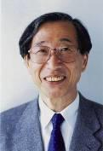 | Shun-ichi Amari, RIKEN Brain Science Institute, Japan  Information Geometry and Its Applications: Survey
Abstract | Information geometry emerged from the study of the geometrical structure of a manifold of probability distributions under the criterion of invariance. It defines a Riemannian metric uniquely, which is the Fisher information metric. Moreover, a family of dually coupled affine connections are introduced. Mathematically, this is a study of a triple {M, g, T}, where M is a manifold, g is a Riemannian metric, and T is a third-order symmetric tensor. Information geometry has been applied not only to statistical inferences but also to various fields of information sciences where probability plays an important role.  Many important families of probability distributions are dually flat Riemannian manifolds. A dually flat manifold possesses a beautiful structure: It has two mutually coupled flat affine connections and two convex functions connected by the Legendre transformation. It has a canonical divergence, from which all the geometrical structure is derived. The KL-divergence in probability distributions is automatically derived from the invariant flat nature. Moreover, the generalized Pythagorean and geodesic projection theorems hold.  Conversely, we can define a dually flat Riemannian structure from a convex function. This is derived through the Legendre transformation and Bregman divergence connected with a convex function. Therefore, information geometry is applicable to convex analysis, even when it is not connected with probability distributions. This widens the applicability of information geometry to convex analysis, machine learning, computer vision, Tsallis entropy, economics, and game theory.  The present talk summarizes theoretical constituents of information geometry and surveys a wide range of its applications.
References | - S. Amari and H. Nagaoka, Methods of Information Geometry, American Mathematical Society and Oxford University Press, 2000  - S. Amari, Information geometry and its applications: Convex function and dually flat manifold. Emerging Trends in Visual Computing, edited by F. Nielsen, Springer Lecture Notes in Computer Science, vol. 5416, pp 75-102, 2009
Biography | Shun-ichi Amari received Dr. Eng. degree from the University of Tokyo in 1963. He had worked as a professor at the University of Tokyo and is now Professor-Emeritus. He served as Director of RIKEN Brain Science Institute for five years, and is now its senior advisor. He is a foreign member of the Polish Academy of Science. He has been engaged in research in wide areas of mathematical engineering, in particular, mathematical foundations of neural networks, including statistical neurodynamics, dynamical theory of neural fields, associative memory, self-organization, and general learning theory. Another main subject of his research is information geometry initiated, which provides a new powerful method to information sciences. Dr. Amari served as President of International Neural Networks Society and President of Institute of Electronics, Information and Communication Engineers, Japan. He received Emanuel A. Piore Award and Neural Networks Pioneer Award from IEEE, the Japan Academy Award, Order of Cultural Merit of Japan, Gabor Award, Caianiello Award, Bosom Friend Award from Chinese Neural Networks Council, and C&C award, among many others.  http://www.brain.riken.jp/labs/mns/amari/home-E.html
GSI’13 SPECIAL SESSIONS & POSTERS
Wednesday 28th of August

08h30-09h00 | Welcome /Registration
 | Amphi V107
09h00-10h00 | Keynote Speaker 1:  Yann OLLIVIER  Information-Geometric Optimization: the Interest of Information Theory for Discrete and Continuous Optimization
10h00-10h30 | Coffee Break

 | Amphi V107
10h30-12h35 | Plenary session:  Probability on Manifolds  (Chairman: Marc Arnaudon)

Group Action Induced Distances on Spaces of High-Dimensional Linear Stochastic Processes
Bijan Afsari and René Vidal
Extrinsic vs Intrinsic Means on the Circle
Thomas Hotz
Nonlinear Modeling and Processing Using Empirical Intrinsic Geometry with Application to Biomedical Imaging
Ronen Talmon, Yoel Shkolnisky, and Ronald R. Coifman
Integral Geometry of Linearly Combined Gaussian and Student-t, and Skew Student’s t Random Fields
Yann Gavet, Ola Suleiman Ahmad, and Jean-Charles Pinoli

12h35-13h30 | Lunch Break at Ecole des Mines  +  Poster session (Chairman: Frédéric Barbaresco)

 | Couloir
12h35-18h05 | Poster Session (Chairman : Frédéric Barbaresco)

Fast Polynomial Spline Approximation for Large Scattered Data Sets via L1 Minimization
Laurent Gajny, Eric Nyiri, and Olivier Gibaru
Target Detection of Non-stationary Radar Signal and Riemannian Geometry
Haiyan Fan, Yongmei Jiang, and Gangyao Kuang
High-Dimensional Range Profile Geometrical Visualization and Performance Estimation of Radar Target Classification via a Gaussian Mixture Model
Thomas Boulay, Ali Mohammad-Djafari, Nicolas Gac, and Julien Lagoutte
Visual Point Set Processing with Lattice Structures: Application to Parsimonious Representations of Digital Histopathology Images
Nicolas Loménie
Activity Video Analysis via Operator-Based Local Embedding
Xiao Bian and Hamid Krim
Multivariate Texture Discrimination Based on Geodesics to Class Centroids on a Generalized Gaussian Manifold
A. Shabbir, G. Verdoolaege, and G. Van Oost
Robust Estimation of Natural Gradient in Optimization by Regularized Linear Regression
Luigi Malago and Matteo Matteucci
To the Homogeneous Symplectic Manifold toward the Geometry of Information
F. Mouna, T.B. Bouetou, and M.B. Nguiffo

 | Amphi V107
13h30-15h35 | Relational Metric  (chairman: Jean-François Marcotorchino)

Optimal Transport and Minimal Trade Problem, Impacts on Relational Metrics and Applications to Large Graphs and Networks Modularity
F. Marcotorchino and P. Conde Céspedes
Comparing Different Modularization Criteria Using Relational
P. Conde Céspedes and J.F. Marcotorchino
A General Framework for Comparing Heterogeneous Binary Relations
Julien Ah-Pine
On Prime-Valent Symmetric Bicirculants and Cayley Snarks
Ademir Hujdurovic, Klavdija Kutnar, and Dragan Marusi
 | Amphi V106A
13h30-15h35 | Algebraic/Infinite dimensionnal/Banach Information Manifolds  (Chairman: Giovanni Pistone)

Asymptotically Efficient Estimators for Algebraic Statistical Manifolds
Kei Kobayashi and Henry P. Wynn
Infinite-Dimensional Manifolds of Finite-Entropy Probability Measures
Nigel J. Newton
Invariant geometric structures on statistical models
Hông Vân Lê
The Δ2-Condition and ϕ-Families of Probability Distributions
Rui F. Vigelis and Charles C. Cavalcante
A Riemannian Geometry in the q-Exponential Banach Manifold Induced by q-Divergences
G. Loaiza and H.R. Quiceno

 | Amphi V106B
13h30-15h35 | Computational Information Geometry  (chairman: Frank Nielsen)

Hypothesis Testing, Information Divergence and Computational Geometry
Frank Nielsen
A New Implementation of k-MLE for Mixture Modeling of Wishart Distributions
Christophe Saint-Jean and Frank Nielsen
Variational Problem in Euclidean Space with Density
Lakehal Belarbi and Mohamed Belkhelfa
The Exponential Family in Abstract Information Theory
Jan Naudts and Ben Anthonis
15h35-16h05 | Coffee Break / Poster session

 | Amphi V107
16h05-18h10 | Discrete Metric Spaces  (chairmen: Michel Deza & Michel Petitjean)

Discrete Metric Spaces Studying New Classes of Graph Metrics
Pavel Chebotarev
Tessellabilities, Reversibilities, and Decomposabilities of Polytopes (A Survey)
Jin Akiyama, Ikuro Sato, and Hyunwoo Seong
Counting the Number of Solutions of ^{K}DMDGP Instances
Carlile Larvor, Leo Liberti, Jorge Alencar, and Germano Abud
On the Identification of Discretization Orders for Distance Geometry with Intervals
Antonio Mucherino

 | Amphi V106A
16h05-18h10 | Optimal Transport Theory  (Chairmen: Gabiel Peyré & Bertrand Maury)

A Comparison of Two Dual Methods for Discrete Optimal Transport
Quentin Mérigot
The Tangent Earth Mover’s Distance
Ofir Pele and Ben Taskar
A Geometric Study of Wasserstein Spaces: An Addendum on the Boundary
Jérôme Bertrand and Benoît R. Kloeckner
A Primal-Dual Approach for a Total Variation Wasserstein Flow
Martin Benning, Luca Calatroni, Bertram Düring, and Carola-Bibiane Schönlieb

 | Amphi V106B
16h05-18h10 | Geometry of Audio Processing  (Chairmen: Arshia Cont & Arnaud Dessein)

Online Change Detection in Exponential Families with Unknown Parameters
Arnaud Dessein and Arshia Cont
Differential Geometry Applied to Acoustics: Non Linear Propagation in Reissner Beams
Joel Bensoam
Predictive Information in Gaussian Processes with Application to Music Analysis
Samer Abdallah and Mark Plumbley
Characterizing Time Series Variability and Predictability from Information Geometry Dynamics
Shlomo Dubnov

 | Ecole des Mines, Terrasse of Hôtel de Vendôme
18h10-18h30 |  | Break
18h30-19h30 | Cocktail at Ecole des Mines
 | IRCAM
20h30-22h30 | Concert at IRCAM

Thursday 29th of August

08h30-09h00 | Welcome
 | Amphi V107
09h00-10h00 | Keynote Speaker 2:  Hirohiko SHIMA  Geometry of Hessian Structures  (dedicated to Prof. J.L. KOSZUL)
10h00-10h30 | Coffee Break

 | Amphi V107
10h30-12h35 | Plenary session:  Hessian Information Geometry I  (Chairman: Michel Boyom)

Hessian Structures on Deformed Exponential Families
Hiroshi Matsuzoe and Masayuki Henmi
Foliations on Affinely Flat Manifolds: Information Geometry
Michel Nguiffo Boyom and Robert Wolak
Hypersurfaces with Isometric Reeb Flow in Hermitian Symmetric Spaces of Rank
Young Jin Suh
Complexification of information geometry in view of quantum estimation theory
Hiroshi Nagaoka
Fisher information geometry of the barycenter of probability measures
Mitsuhiro Itoh

12h35-13h30 | Lunch Break at Ecole des Mines

 | Amphi V107
13h30-15h35 | Hessian Information Geometry II  (Chairman: Frédéric Barbaresco)

Geometry on Positive Definite Matrices Induced from V-Potential Function
Atsumi Ohara and Shinto Eguchi
Information/Contact Geometries and Koszul Entropy
Frédéric Barbaresco
Symplectic and Kähler Structures on Statistical Manifolds Induced from Divergence Functions
Jun Zhang and Fubo Li
Geometric Quantization of Complex Monge-Ampère Operator for Certain Diffusion Flows
Julien Keller

 | Amphi V106A
13h30-15h35 | Tensor-Valued Mathematical Morphology  (Chairman: Jesus Angulo)

Frames for Tensor Field Morphology
Jasper J. van de Gronde and Jos B.T.M. Roerdink
Complete Lattice Structure of Poincaré Upper-Half Plane and Mathematical Morphology for Hyperbolic-Valued Images
Jesus Angulo and Santiago Velasco-Forero
Supervised Morphology for Structure Tensor-Valued Images Based on Symmetric Divergence Kernels
Santiago Velasco-Forero and Jes´us Angulo
Using the Bhattacharyya Mean for the Filtering and Clustering of Positive-Definite Matrices
Malek Charfi, Zeineb Chebbi, Maher Moakher, and Baba C. Vemuri

 | Amphi V106B
13h30-15h35 | Geometry of Inverse Problems  (Chairman: Ali Mohammad-Djafari)

Variational Bayesian Approximation for Linear Inverse Problems with a Hierarchical Prior Models
Ali Mohammad-Djafari
Learning General Gaussian Kernel Hyperparameters for SVR
F. Abdallah, Hichem Snoussi, H. Laanaya, and R. Lengellé
Stochastic Filtering by Projection: The Example of the Quadratic Sensor
John Armstrong and Damiano Brigo
A Probabilistic Solution to the AX=XB Problem: Sensor Calibration without Correspondence
M. Kendal Ackerman and Gregory S. Chirikjian
Random Clouds on Matrix Lie Groups
Simone Fiori
15h35-16h05 | Coffee Break

 | Amphi V107
16h05-18h10 | Optimization on Matrix Manifolds  (Chairman: Silvere Bonnabel)
Interpolation and Regression of Rotation Matrices
Nicolas Boumal
A Geometric Framework for Non-Unitary Joint Diagonalization of Complex Symmetric Matrices
Martin Kleinsteuber and Hao Shen
An Extrinsic Look at the Riemannian Hessian
P.-A. Absil, Robert Mahony, and Jochen Trumpf
Law of Cosines and Shannon-Pythagorean Theorem for Quantum Information
Roman V. Belavkin
A Note on the Intrinsic Cramer-Rao Bound
Axel Barrau and Silvère Bonnabel
 | Amphi V106A
16h05-18h10 | Divergence Geometry & Ancillarity  (Chairman: Michel Broniatowski)

Estimation and Tests Under L-Moment Condition Models
Alexis Decurninge
Weighted Sampling, Maximum Likelihood and Minimum Divergence Estimators
Michel Broniatowski
Some Decision Procedures Based on Scaled Bregman Distance Surfaces
Anna-Lena Kißlinger and Wolfgang Stummer
Generalized minimizers of convex integral functionals, Bregman distance, Pythagorean identities
Drantisek Matus
Some Results on a χ-divergence, an Extended Fisher Information and Generalized Cramer-Rao Inequalities
Jean-François Bercher
 | Amphi V106B
16h05-18h10 | Information Geometry Manifolds  (Chairman: Hichem Snoussi)

Harmonic Maps Relative to α-Connections on Hessian Domains
Keiko Uohashi
A Kernel View on Manifold Sub-sampling Based on Karcher Variance Optimization
Nicolas Courty and Thomas Burger
Maximal Information Divergence from Statistical Models Defined by Neural Networks
Guido Montufar, Johannes Rauh, and Nihat Ay
Neighborhood Random Classification
Djamel A. Zighed, Diala Ezzeddine, and Fabien Rico

 | Amphi V107
18h10-18h30 |  | Break
18h30-19h30 | Guest Speaker: Shun-Ichi AMARI  Information Geometry and Its Applications: Survey
 | Eiffel Tower (1rst Floor)
20h30-22h30 | GSI 2013 GALA DINNER  RESTAURANT 58 TOUR EIFFEL, 1st FLOOR

Friday 30th of August

08h30-09h00 | Welcome
 | Amphi V107
09h00-10h00 | Keynote Speaker 3:  Giovanni PISTONE  Nonparametric Information Geometry
10h00-10h30 | Coffee Break

 | Amphi V107
10h30-12h35 | Plenary session:  Deformations in Shape Space  (Chairman: Alain Trouvé)

Geodesic Image Regression with a Sparse Parameterization of Diffeomorphisms
James Fishbaugh, Marcel Prastawa, Guido Gerig, and Stanley Durrleman
Template Estimation for Large Database: A Diffeomorphic Iterative Centroid Method Using Currents
Claire Cury, Joan A. Glaunès, and Olivier Colliot
On the Geometry and the Deformation of Shapes Represented by Piecewise Continuous Bézier Curves with Application to Shape Optimization
Olivier Ruatta
Random Spatial Structure of Geometric Deformations and Bayesian Nonparametrics
Christof Seiler, Xavier Pennec, and Susan Holmes
 | Amphi V107
12h35-12h55 | SCILAB “GSI” TOOLBOX Initiative

Contributing to “Geometric Science of Information” development, project of SCILAB “GSI” TOOLBOX is initiated, inviting contributors to write external modules that extend Scilab capabilities in specific fields of GSI (Information Geometry, Geometry of Structured Matrices, Statistics/optimization on Manifolds, …). These modules provide new features and documentation to Scilab users. A new website called "ATOMS Portal" has been released that host all external modules developed by external developers. These modules can be made available to Scilab users directly from Scilab console via a new feature named ATOMS (AuTomatic mOdules Management for Scilab), if the module author wishes it.
http://wiki.scilab.org/ATOMS
In parallel, external modules sources can now be managed through the new Scilab Forge.
http://forge.scilab.org/index.php/projects/
12h35-13h30 | Lunch Break at Ecole des Mines

 | Amphi V107
13h30-15h35 | Geometric Statistics on manifolds and Lie groups  (Chairman: Xavier Pennec)

Bi-invariant Means on Lie Groups with Cartan-Schouten Connections
Xavier Pennec
Parallel Transport with Pole Ladder: Application to Deformations of Time Series of Images
Marco Lorenzi and Xavier Pennec
Horizontal Dimensionality Reduction and Iterated Frame Bundle Development
Stefan Sommer
A Subspace Learning of Dynamics on a Shape Manifold: A Generative Modeling Approach
Sheng Yi and Hamid Krim
 | Amphi V106A
13h30-15h35 | Machine/Manifold/Topology Learning  (Chairmen: Michael Aupetit & Frédéric Chazal)

Deconvolution for the Wasserstein Metric and Geometric Inference
Claire Caillerie, Frédéric Chazal, Jérôme Dedecker, and Bertrand Michel
On Directional-Search Procedures for Orbifolds: Connections with the Manifold Framework
Fabian Lim
Adaptation of Multiscale Function Extension to Inexact Matching: Application to the Mapping of Individuals to a Learnt Manifold
Nicolas Duchateau, Mathieu De Craene, Marta Sitges, and Vicent Caselles
Interleaved Filtrations: Theory and Applications in Point Cloud Data Analysis
Frédéric Chazal and Steve Y. Oudot

 | Amphi V106B
13h30-15h35 | Differential Geometry in Signal Processing  (Chairman: Michel Berthier)

A Riemannian Fourier Transform via Spin Representations
T. Batard and M. Berthier
K-Centroids-Based Supervised Classification of Texture Images Using the SIRV Modeling
Aurélien Schutz, Lionel Bombrun, and Yannick Berthoumieu
Bayesian Atlas Estimation from High Angular Resolution Diffusion Imaging (HARDI)
Jia Du, Alvina Goh, and Anqi Qiu
Dimensionality Reduction for Classification of Stochastic Fibre Radiographs
C.T.J. Dodson and W.W. Sampson
15h35-16h05 | Coffee Break / Poster session

 | Amphi V107
16h05-18h10 | Entropic Geometry  (Chairman: Roger Balian)

The Stochastic Flow Theorem for an Operator of Order Four
Rémi Léandre
Geometry and Shannon Capacity
Philippe Jacquet
A Metric for Quantum States Issued from von Neumann’s Entropy
Roger Balian
Continuity of f-projections on Discrete Spaces
Christoph Gietl and Fabian P. Reffel

 | Amphi V106A
16h05-18h10 | Algorithms on Manifolds  (Chairman: Olivier Schwander)

Information Geometry and Interior-Point Algorithms
Satoshi Kakihara, Atsumi Ohara, and Takashi Tsuchiya
Geometric Mean Algorithms Based on Harmonic and Arithmetic Iterations
Ben Jeuris and Raf Vandebril
Multiscale Covariance Fields, Local Scales, and Shape Transforms
Diego H. Diaz Martinez, Facundo Memoli, and Washington Mio
Deterministic Walks and Quasi-Subgradient Methods for the Karcher Mean on NPC Spaces
Miklos Palfia

 | Amphi V106B
16h05-18h10 | Computational Aspects of Inform. Geometry in Statistics  (Chairman: Frank Critchley)

Computational information geometry in statistics: foundations
Karim Anaya-Izquierdo, Frank Critchley, Paul Marriott, and Paul Vos
Computational information geometry in statistics: mixture modeling
Karim Anaya-Izquierdo, Frank Critchley, Paul Marriott, and Paul Vos
A General Metric for Riemannian Manifold Hamiltonian Monte Carlo
Michael Betancourt
Visualizing projective shape space
John T. Kent

 | Amphi V107
18h10-18h30 | Closing session of GSI'13 Workshop
18h30-19h30 | Geometry in Minearology  Minearology Museum Visit at Ecole des Mines
 | End of GSI'13
GSI’13 SOCIAL EVENTS
Wednesday 28th of August

COCKTAIL AT ECOLE DES MINES, TERRASSE OF HÔTEL DE VENDÔME
Address: Ecole des Mines ParisTech, 60 Boulevard Saint-Michel, 75006 Paris
RER/Metro: RER B Luxembourg
http://www.mines-paristech.eu/
18h30 – 19h30
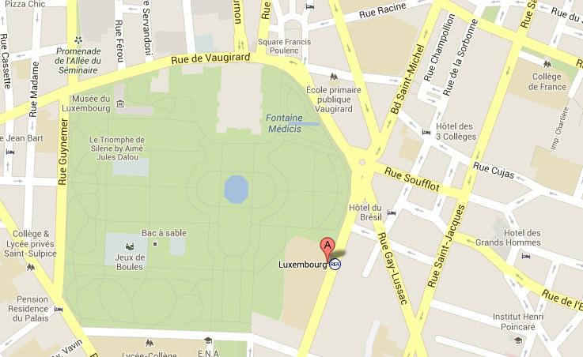
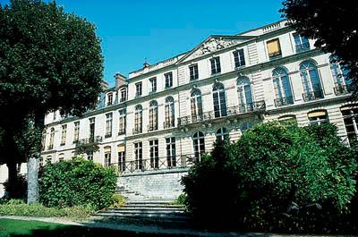
CONCERT AT IRCAM (organized by Arshia Cont)
Address: 1 Place Igor-Stravinsky, 75004 Paris
RER/Metro: RER B Châtelet-Les-Halles
http://www.ircam.fr/?&L=1
20h30 – 22h30
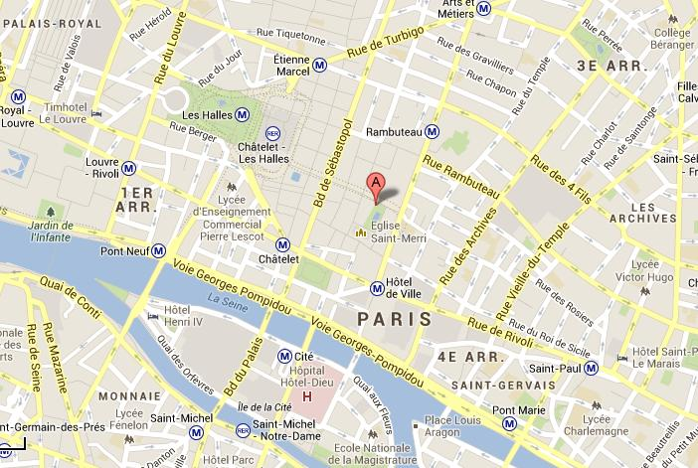
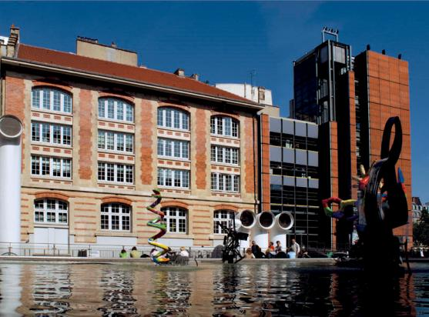
Thursday 29th of August

GSI 2013 GALA DINNER: RESTAURANT 58 TOUR EIFFEL, 1st FLOOR
Address: Eiffel Tower, Champ de Mars, 5 Avenue Anatole France, 75007 Paris (1rst Floor)
RER/Metro: RER C, Champs-de-Mars - Tour Eiffel
http://www.restaurants-toureiffel.com/UK/EIFFEL-TOWER-RESTAURANTS/58-TOUR-EIFFEL/Lunch-Dinner-in-paris-eiffel-tower.html
20h30 – 22h30
The most fashionable Brasserie in Paris. Dine in the heart of Parisian nightlife... When the sun goes down, 58 Tour Eiffel takes on a new dimension. Soft lights and minimalist furniture so as not to upstage the beauty of the City of Lights. Ultra-modern interior design by Patrick Jouin and menu featuring chic classical cuisine.
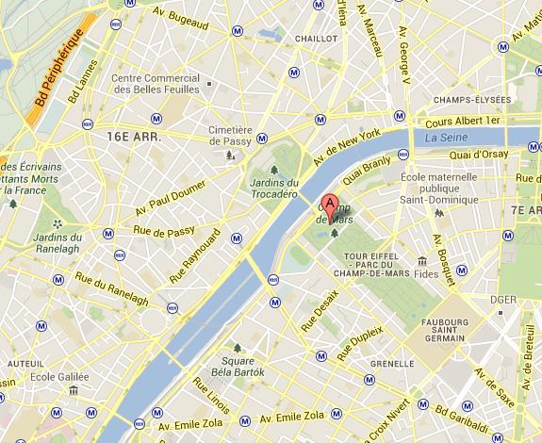
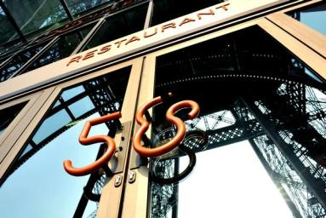
Friday 0th of August

GEOMETRY IN MINERALOGY – THE MUSEUM
Address: Ecole des Mines ParisTech, 60 Boulevard Saint-Michel, 75006 Paris
RER/Metro: RER B Luxembourg
http://www.mines-paristech.eu/About-us/Heritage/The-Museum/
18h30 – 19h30
Geometry in Mineralogy - The Museum
The Mineralogy Museum has been located in the former Hôtel de Vendôme since 1815 and is open to the public.
All students have access to it and can make use of the geological information for free. It constitutes a unique tool not only for students but for all geological service specialists, miners and prospectors.
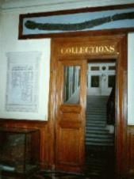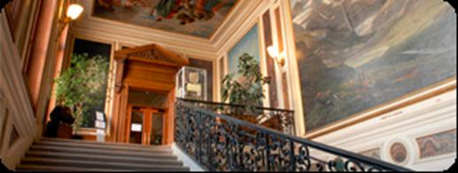
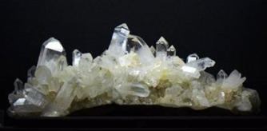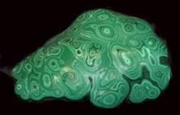
It ranks as the top collection in the world and serves as a constant reference for systematic mineralogy. Its specific activities are centred on its collections and stands as a milestone in mineralogical history.
The Mineralogy Museum hosts exhibitions on the premises of the Hôtel de Vendôme, as well as at provincial and foreign locations (eg. Athens, Alexandria and Casablanca, etc.).
It also welcomes school parties, amateurs and foreign museum curators and organizes meetings and workshops on themes chosen at the request of associations such as Les Amis du Louvre or the Association for the Advancement of Science, etc.
GSI’13 SPONSORS
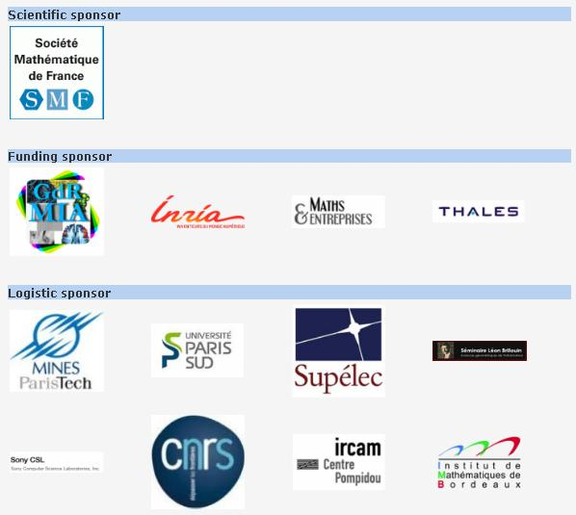
GSI’13 PROCEEDINGS
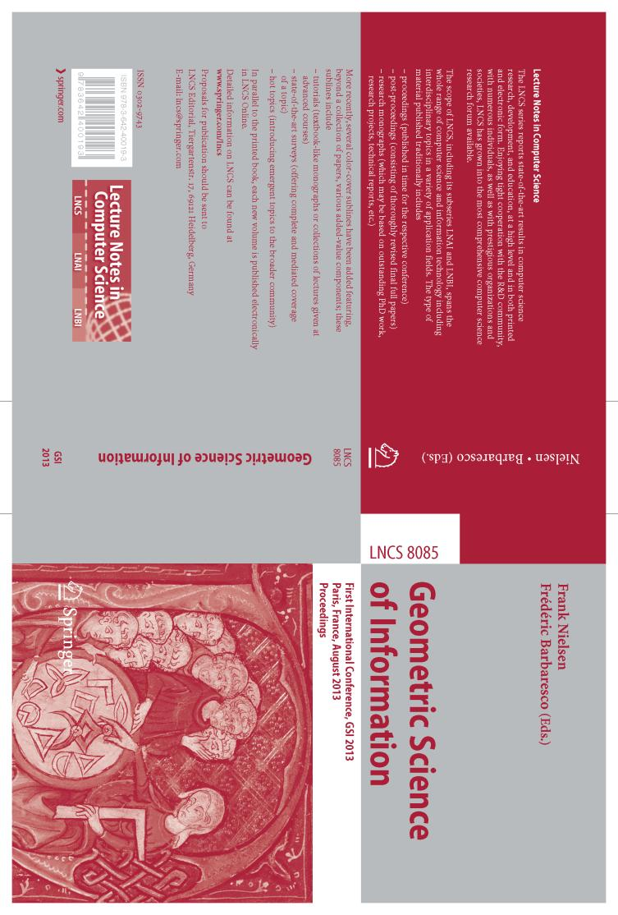

ECOLE DES MINES DE PARIS SINCE 1816
