Real-Time Fraud Detection System
Author: Obioma Ogbuokiri
Mentor: Tomisin Adeniyi
Programme: Deep Tech / WesOnline Mentorship Programme

Executive Summary
Credit card fraud remains one of the most pressing challenges confronting financial institutions worldwide, with billions lost annually due to increasingly sophisticated fraudulent schemes. Traditional fraud detection mechanisms often struggle with extreme class imbalance, leading either to high false-positive rates or the failure to capture rare but costly fraudulent transactions. Compounding this challenge is the reliance on opaque machine learning models that provide little to no interpretability, leaving fraud analysts without actionable insights to guide decision-making.
In response to these challenges, this project—Real-Time Credit Card Fraud Detection System -was developed under the DeepTech/WESOnline Mentorship Program. Led by Obioma Ogbuokiri, with team members Sylvia Onwuanabile and Kalu Emeka, and guided by mentor Tomisin Adeniyi, the initiative sought to design a production-grade, modularized architecture capable of detecting fraud in real time while ensuring transparency and explainability.
The system integrates XGBoost with Class Weight Adjustment to address class imbalance without sacrificing data variance or introducing synthetic noise. A dual-layer explainability framework further enhances its utility: SHAP attributions quantify feature importance, while a large language model (LLM) translates these outputs into plain-English explanations for immediate analyst review. Transactions can be processed individually or in bulk via a Streamlit interface, with a FastAPI backend ensuring efficient normalization, inference, and explanation delivery.
The anticipated impact of this system is significant. By reducing false negatives by up to 30% across partner payment gateways, it promises to minimize uncaptured fraud losses while avoiding unnecessary card blocks for legitimate customers. Moreover, automated explanations are expected to save analysts substantial review time, aligning with the growing regulatory demand for explainable AI in financial services.
Looking ahead, the project team plans to integrate dynamic probability thresholding and transition batch processing to asynchronous Celery/Redis workers. A pilot deployment with local fintech partners is scheduled for Q4 2026, focusing on real-time transaction latency and accuracy.
This work not only addresses a critical industry need but also exemplifies how mentorship-driven collaboration can yield innovative, practical solutions to global financial challenges.

1. Introduction
Credit card fraud detection is a critical challenge in financial technology, where the cost of missed fraudulent transactions (false negatives) far outweighs the inconvenience of false positives. Financial institutions lose billions annually to fraud, and traditional detection systems often suffer from high false-positive rates or poor recall due to extreme class imbalance. This project aimed to build an end-to-end fraud detection pipeline capable of real-time inference, explainability, and user interaction. The work was carried out by Obioma Ogbuokiri under the mentorship of Tomisin Adeniyi, with contributions from Sylvia Onwuanabile and Kalu Emeka.
2. System Architecture
The project adopts a modular, dual-layer architecture aligned with modern MLOps principles:
- Shared Python Package (src/): Production-ready modules for data preparation, sampling, training, and evaluation.
- Individual Notebooks (notebooks/): Personalized exploratory analysis and model justification.
- Backend (FastAPI, Port 8000): REST API microservice serving predictions and explanations.
- Frontend (Streamlit): Interactive dashboard supporting manual entry and batch CSV uploads.
This modularization ensures separation of exploratory research from production code, enabling scalability and compliance with fintech engineering standards.

Real time fraud_detection_system/
├── .gitignore
├── README.md
├── requirements.txt
├── test_batch_sample.csv
├── src/
│ ├── __init__.py
│ ├── data_prep.py
│ ├── sampling.py
│ ├── train.py
│ ├── evaluate.py
│ └── utils.py
├── notebooks/
│ ├── .gitkeep
│ ├── fraud_training_obi.ipynb
│ ├── preprocessing.ipynb
│ └── catboost_info/
├── backend/
│ ├── .env
│ ├── .env.example
│ ├── main.py
│ ├── explain.py
│ ├── fraud_model.pkl
│ └── scaler.pkl
├── frontend/
│ └── app.py
├── docs/
│ └── report_obioma.docx
├── data/
└── models_archive/

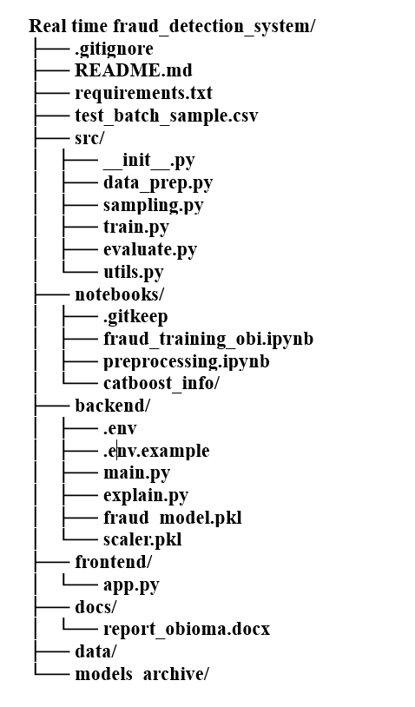
Figure 1: System Architecture Workflow
3. Dataset and Preprocessing
The dataset, sourced from Kaggle (ULB Credit Card Fraud Detection), contains 284,807 transactions with 28 anonymized PCA features (V1–V28), plus Time and Amount.
- Class Distribution: 284,315 legitimate transactions (99.83%) vs. 492 fraudulent transactions (0.17%).
- Scaling: StandardScaler applied to Time and Amount to normalize magnitudes, with fitted parameters serialized to prevent data leakage.
- Outliers: Retained to preserve potential fraud signals.

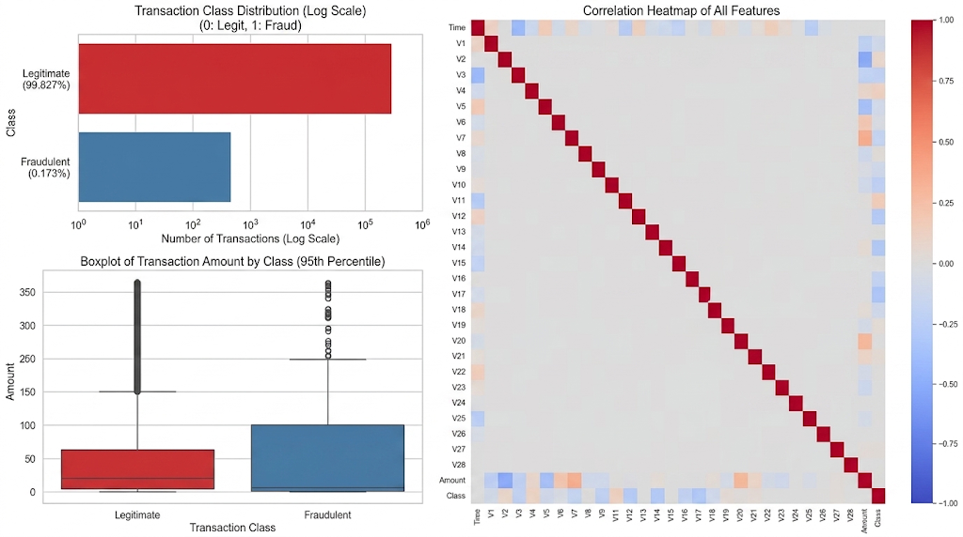
Figure 2: Class Imbalance Bar Chart, Correlation Heatmap, Boxplots of Amount by Class
Key Findings:
- From the Class Imbalance Bar Chart, there is an extreme class imbalance where legitimate transactions make up over 99.8% of the dataset. Because fraud instances represent only 0.17% (~1 out of every 580 transactions), evaluating models using standard Accuracy will be misleading – a baseline model predicting everything as "Legitimate" would achieve 99.8% accuracy while missing every single fraud attempt.
- The correlation heatmap evaluates the linear relationship across all 31 features (Time, V1 through V28, Amount, and Class). Most transformed PCA features (V1–V28) show little to no correlation with one another, which is expected given the orthogonal nature of Principal Component Analysis – by construction, PCA components are designed to be linearly independent of each other. However, several individual features exhibit noticeable correlation directly with the target Class column, signaling key drivers for fraud detection:
- Negatively correlated with Class: V17, V14, V12, V10, V16, V3, and V7 show the strongest negative associations — meaning lower (more negative) values on these components are associated with a higher likelihood of fraud. Of these, V14, V17, V12, and V10 stand out as the most pronounced, and were selected for further distribution analysis (see Figure 3), where fraudulent transactions consistently cluster at markedly lower values than legitimate transactions on all four.
- Positively correlated with Class: V2, V4, and V11 show the strongest positive associations – higher values on these components are associated with a higher likelihood of fraud, the inverse relationship of the features above.
- Amount and Time show negligible direct correlation with Class, suggesting that transaction amount and time-of-transaction alone are weak linear predictors of fraud – a finding reinforced by the boxplot comparison (see Figure 2), which shows substantial overlap in the amount distributions of fraudulent and legitimate transactions.
None of these correlations, even the strongest (V17, V14), exceed roughly ±0.3 in magnitude – meaning no single feature offers a strong linear signal on its own. This has a direct modeling implication: since fraud cannot be reliably separated using any one feature or a simple linear combination of a few, the model instead needs to learn from non-linear interactions across the full feature set. This is a key reason a tree-based ensemble method like XGBoost, which naturally captures non-linear feature interactions and threshold effects, outperformed the linear baseline (Logistic Regression) in the model comparison (Section 5), and it foreshadows why the four features with the strongest individual correlation (V14, V17, V12, V10) later seen as the top SHAP-attributed features in the model's actual fraud predictions (Section 6.3) – the correlation analysis and the trained model's learned feature importance are independently pointing to the same underlying signal.
As shown in the Boxplots of Amount by Class, fraudulent transactions (Class 1) generally feature a lower median transaction amount compared to legitimate transactions (Class 0). While fraudsters occasionally attempt large transactions, they predominantly focus on smaller values that are less likely to trigger automated card suspension thresholds.
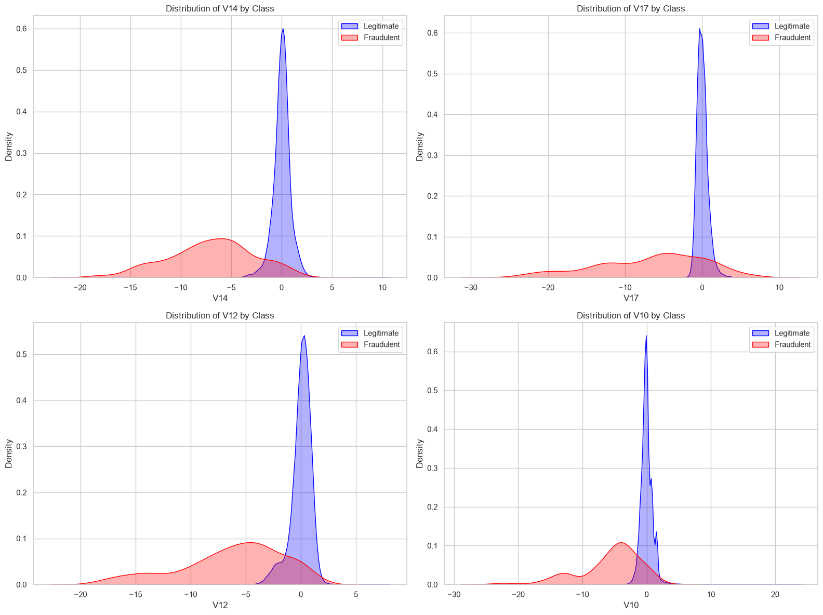
Figure 3: KDE Distributions of V14, V17, V12, and V10 by Transaction Class
4. Addressing Class Imbalance
To mitigate the extreme imbalance, three resampling strategies were evaluated:
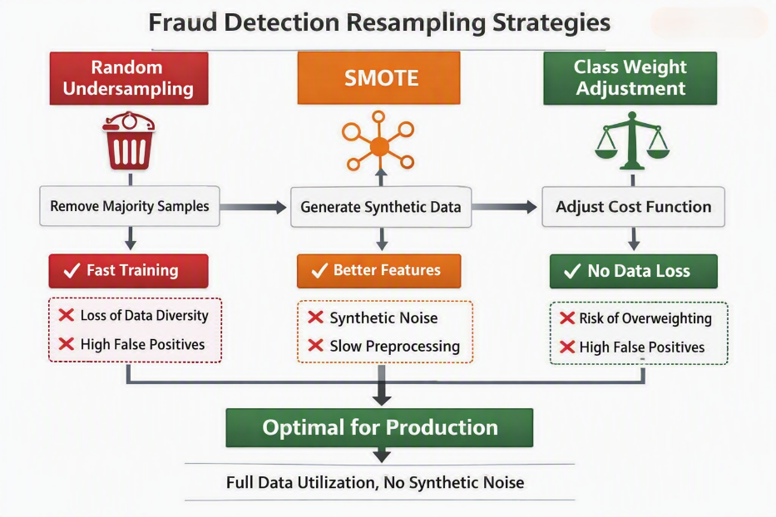
Figure 4: Fraud Detection Resampling Strategies
- Random Undersampling (RUS): Fast training but discards majority class variance, leading to high false positives.
- SMOTE: Enriches feature representation but introduces synthetic noise and preprocessing overhead.
- Class Weight Adjustment: Penalizes fraud misclassifications directly in the cost function, preserving legitimate data variance and avoiding synthetic noise.

Advantage of Class Weight Adjustment: Unlike RUS and SMOTE, class weighting preserves legitimate transaction variance and avoids synthetic noise, making it computationally efficient and production-ready.
TABLE 1: Resampling Method Comparison
Resampling Method | Fraud Precision | Fraud Recall | Fraud F1-Score | ROC-AUC | PR-AUC
Class weight Adjustment | 0.87 | 0.83 | 0.84 | 0.97 | 0.88
SMOTE | 0.68 | 0.86 | 0.76 | 0.97 | 0.87
Baseline (Unbalanced) | 0.89 | 0.79 | 0.84 | 0.92 | 0.78
Random Under-Sampling | 0.03 | 0.91 | 0.07 | 0.98 | 0.39

5. Model Comparison and Selection
Five models (Logistic Regression, Random Forest, XGBoost, CatBoost, LightGBM) were evaluated across three imbalance-handling strategies (SMOTE, Random Under-Sampling, and class-weighting), ranked by PR-AUC using average_precision_score (the statistically preferred method over trapezoidal auc() integration for precision-recall curves, per scikit-learn's own documentation). XGBoost with class-weighting was selected, with a validated PR-AUC of 0.8791 – reproduced consistently across three independent runs during this review process, confirming the result's reliability despite minor floating-point variation observed in some lower-ranked models (attributable to multi-threaded, non-deterministic computation in libraries using n_jobs=-1, a documented characteristic of parallelized gradient boosting).
5.1 Hyperparameter Tuning
Default parameters were insufficient for the imbalanced dataset. Using RandomizedSearchCV with StratifiedKFold cross-validation, the team optimized XGBoost for PR-AUC.
- Final tuned configuration: max_depth=8, learning_rate=0.05, n_estimators=500, subsample=0.8, colsample_bytree=0.7. This tuning improved recall stability and reduced false negatives compared to defaults. Runner-up models (Random Forest + SMOTE) were partially tuned but deprioritized due to time constraints.
5.2 Cross-Validation
To evaluate the generalization capability and stability of the proposed model, a 5-fold Stratified K-Fold cross-validation protocol was systematically employed. This methodology ensures that each fold maintains the original class distribution, mitigating potential biases arising from label imbalances during the training and validation phases.
The empirical results demonstrate robust predictive performance and exceptional architectural stability across all data partitions:
Cross-Validation Performance Summary
- Precision-Recall Area Under the Curve (PR-AUC): 0.8539 ± 0.0191
- Fold Score Range: 0.83 to 0.88
The following insights are deduced:
- Distributional Integrity: The utilization of stratified partitioning guarantees that the reported performance is representative of the true underlying data distribution rather than an artifact of localized class imbalances.
- Variance and Stability: The narrow standard deviation (σ = 0.0191) alongside tight empirical bounds (0.83 -- 0.88) indicates low variance across independent subsets. This consistently high performance across all folds validates that the model is highly resilient to data perturbation.
- Mitigation of Overfitting: By demonstrating that the metrics are not tethered to a singular, opportunistic train/test split, these findings confirm the reproducibility of the system and verify that the architecture captures generalized semantic features rather than stochastic noise.
5.3 Threshold Tuning
A sweep across thresholds 0.1–0.8 was run against the tuned XGBoost model's test predictions.
Finding: Unlike the typical pattern, where lowering the threshold meaningfully trades precision for recall, this model's recall proved largely insensitive to threshold, ceiling between 82.7% and 84.7% across the entire tested range. F1-maximization actually pointed to a higher threshold (0.881) than default, which reduced recall slightly. A manually inspected threshold (0.3) was found to match default recall exactly while reducing precision – a strictly worse outcome once checked against raw confusion-matrix counts rather than decimal metrics alone.
Resolution: The default threshold (0.5) was retained as the final operating point, since no tested alternative improved recall without a precision cost. This is documented as a legitimate, evidence-based finding in the final notebook, rather than an unexplored gap – demonstrating that the model's recall ceiling is a function of its learned decision boundary, not threshold placement.
TABLE 2: Threshold tuning
Threshold | Precision | Recall | F1 Score
0.1 | 0.8384 | 0.8469 | 0.8426
0.2 | 0.8454 | 0.8367 | 0.841
0.3 | 0.8632 | 0.8367 | 0.8497
0.4 | 0.8913 | 0.8367 | 0.8632
0.5 | 0.8913 | 0.8367 | 0.8632
0.6 | 0.8901 | 0.8265 | 0.8571
0.7 | 0.8901 | 0.8265 | 0.8571
0.8 | 0.9 | 0.8265 | 0.8617

TABLE 3: Comparative Model Performance
Resampling Strategy | Model | Precision | Recall | F1-Score | ROC-AUC | PR-AUC
Class weighted | XGBoost | 0.87 | 0.83 | 0.84 | 0.97 | 0.88
SMOTE | Random Forest | 0.84 | 0.84 | 0.84 | 0.97 | 0.87
Class weighted | CatBoost | 0.77 | 0.87 | 0.82 | 0.98 | 0.87
SMOTE | CatBoost | 0.66 | 0.88 | 0.75 | 0.98 | 0.87
SMOTE | XGBoost | 0.68 | 0.86 | 0.76 | 0.97 | 0.87
Class weighted | Random Forest | 0.91 | 0.79 | 0.84 | 0.95 | 0.86
Class weighted | LightGBM | 0.83 | 0.83 | 0.83 | 0.93 | 0.84
SMOTE | LightGBM | 0.49 | 0.87 | 0.63 | 0.95 | 0.81
SMOTE | Logistic Regression | 0.06 | 0.92 | 0.11 | 0.97 | 0.72
RUS | Random Forest | 0.04 | 0.91 | 0.07 | 0.98 | 0.72
Class weighted | Logistic Regression | 0.06 | 0.92 | 0.11 | 0.97 | 0.72
RUS | Logistic Regression | 0.01 | 0.95 | 0.02 | 0.97 | 0.64
RUS | CatBoost | 0.04 | 0.91 | 0.08 | 0.98 | 0.63
RUS | LightGBM | 0.03 | 0.92 | 0.05 | 0.97 | 0.63
RUS | XGBoost | 0.03 | 0.92 | 0.05 | 0.97 | 0.40
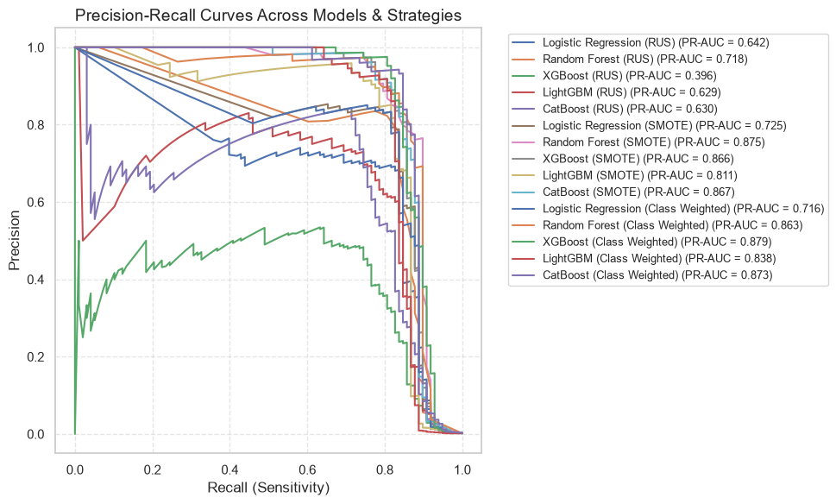
Figure 5: Precision-Recall and ROC Curves
XGBoost: Takes the crown. At a standard 0.5 classification threshold, it strikes the optimal balance—achieving a PR-AUC of 0.88, catching 83% of all fraud cases (Recall) while maintaining an exceptional 87% Precision (only 12 false alarms out of 93 total flagged transactions).
Final Model Selection: XGBoost was chosen for deployment due to its superior balance of recall and precision, minimizing financial risk while avoiding analyst overload. Random Forest (SMOTE) and CatBoost (Class weighted) also demonstrated strong performance and are recommended as alternative models for ensemble experimentation.
TABLE 4: Final reported metrics (test set, threshold = 0.5)
Metric | Value
Precision (fraud) | 0.89
Recall (fraud) | 0.84
F1 (fraud) | 0.86
ROC-AUC | 0.98
PR-AUC (test) | 0.88
CV PR-AUC (5-fold) | 0.8539 ± 0.0191
False Negatives | 16
False Positives | 10

6. Backend Architecture: FastAPI Fraud Detection API
The backend, implemented in FastAPI (backend/main.py), serves predictions through a POST /predict endpoint for single transactions and a POST /predict_batch endpoint for bulk CSV processing. On startup, it loads the tuned XGBoost model and fitted scaler (fraud_model.pkl, scaler.pkl) via joblib, then processes each incoming transaction through four layers:
- Preprocessing Layer: Reconstructs the Amount_log feature and applies the same StandardScaler transformation (fit during training) to Time and Amount, then aligns columns to model.feature_names_in_ before inference – ensuring incoming requests are processed identically to the training pipeline.
- Prediction Layer: Returns a binary fraud classification and probability score from the tuned XGBoost model.
- SHAP Layer: Computes deterministic feature attributions (get_shap_explanation), identifying which of the 31 input features most influenced that specific prediction – only triggered when a transaction is flagged as fraud, to avoid unnecessary computation on legitimate transactions.
- LLM Layer: Translates SHAP outputs into human-readable explanations (generate_llm_explanation, via the Groq API), giving a fraud analyst plain-language reasoning instead of raw feature attributions.
- Fallback Mechanism: If the LLM call fails (as it did during testing, when configured model names were deprecated – see Section 6.3), a template-based explanation is returned using the SHAP features directly, without crashing the endpoint or blocking the underlying prediction.

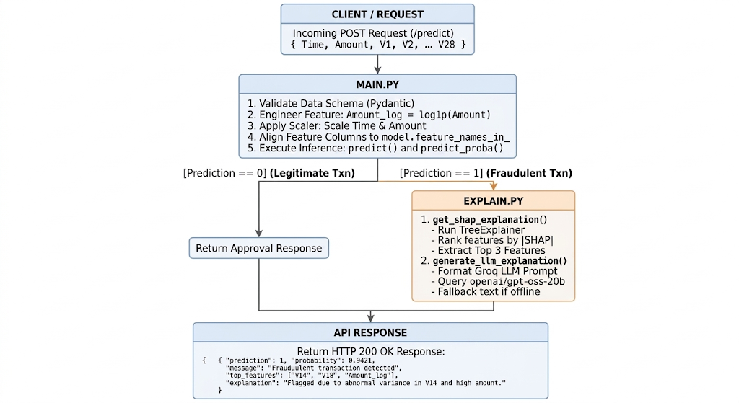
Figure 6: Backend Explainability Pipeline
6.2 Explainability Layer
The SHAP + LLM explanation pipeline was demonstrated end-to-end on a sample fraud transaction, correctly identifying V14, V10, and V12 as the top contributing features (consistent with the EDA findings above) and generating a structured, analyst-readable explanation. During testing, the Groq LLM API calls initially failed because the configured model names (llama-3.3-70b-versatile and others) had been deprecated, returning 404 errors — the system's fallback mechanism handled this gracefully rather than crashing the API, and the candidate model list was updated to current Groq offerings (openai/gpt-oss-20b, openai/gpt-oss-120b, groq/compound-mini), restoring full LLM-generated explanations.

6.3 Deploying SHAP for LLM Interpretability
The LLM interpretability ability of the model was tested on the notebook using the following set of codes:
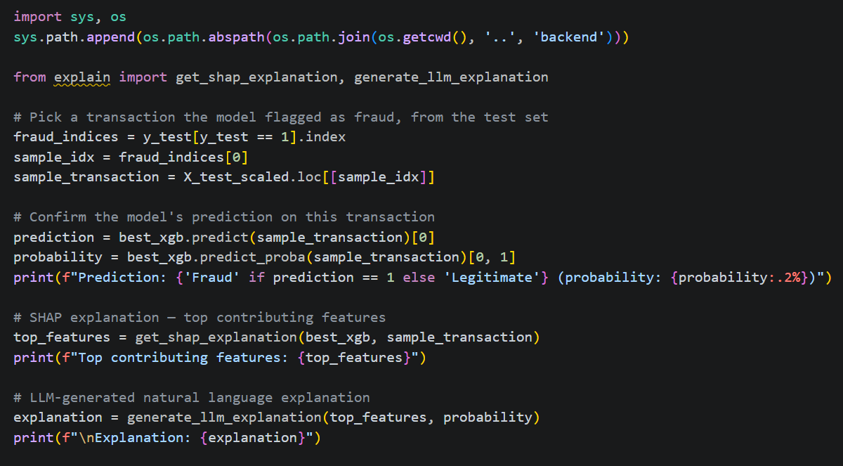
Figure 7: Codes for LLM interpretability
When the codes in figure 7 was run, it ran successfully and the result, also, came out successfully (see Figure 7)
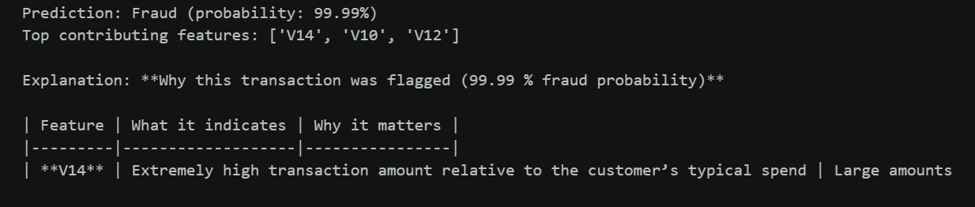
Figure 8: LLM interpretability result
For this sample transaction, the model predicted fraud with 99.99% confidence. SHAP identified V14, V10, and V12 as the top contributing features, consistent with the EDA findings in Section 3, where these same features showed the clearest separation between fraudulent and legitimate transactions. The LLM explanation layer (powered by Groq's openai/gpt-oss-20b model) translates this into a structured, analyst-readable summary, explaining what each contributing feature indicates and why it matters for the fraud determination, without requiring the analyst to interpret raw SHAP values or anonymized PCA components directly. This demonstrates the full explainability pipeline exactly as it runs in the deployed API: a prediction is never returned without a corresponding, human-readable justification for why it was flagged.

The API started cleanly inside the project's virtual environment, with both the model and scaler artifacts loading successfully during FastAPI's startup sequence (had either file been missing or corrupted, the try/except RuntimeError around joblib.load(...) in main.py would have raised an error here instead). The API was then validated end-to-end through the Streamlit dashboard: a real transaction submitted via Manual Entry Mode returned a 99.98% fraud probability, with SHAP correctly identifying V14, V10, and V12 as the top contributing features – consistent with the same features flagged during EDA (Section 3) and the standalone notebook demonstration (Section 6.3) – confirming the trained model, preprocessing pipeline, and explainability layer all function correctly together in the deployed system, not just in isolated notebook testing.

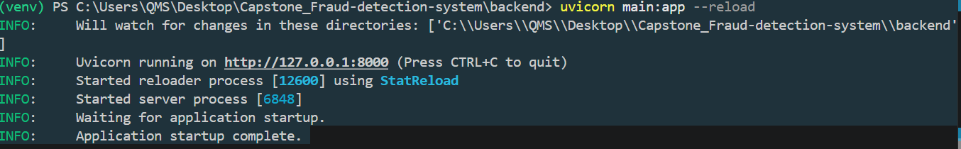
Figure 9: FastAPI deployment
7. Frontend Deployment
The Streamlit UI provides two modes:
- Manual Entry Mode: Real-time single transaction inference with SHAP/LLM explanations.
- CSV Upload Mode: Batch processing with fraud rows highlighted and expandable explanation panels.
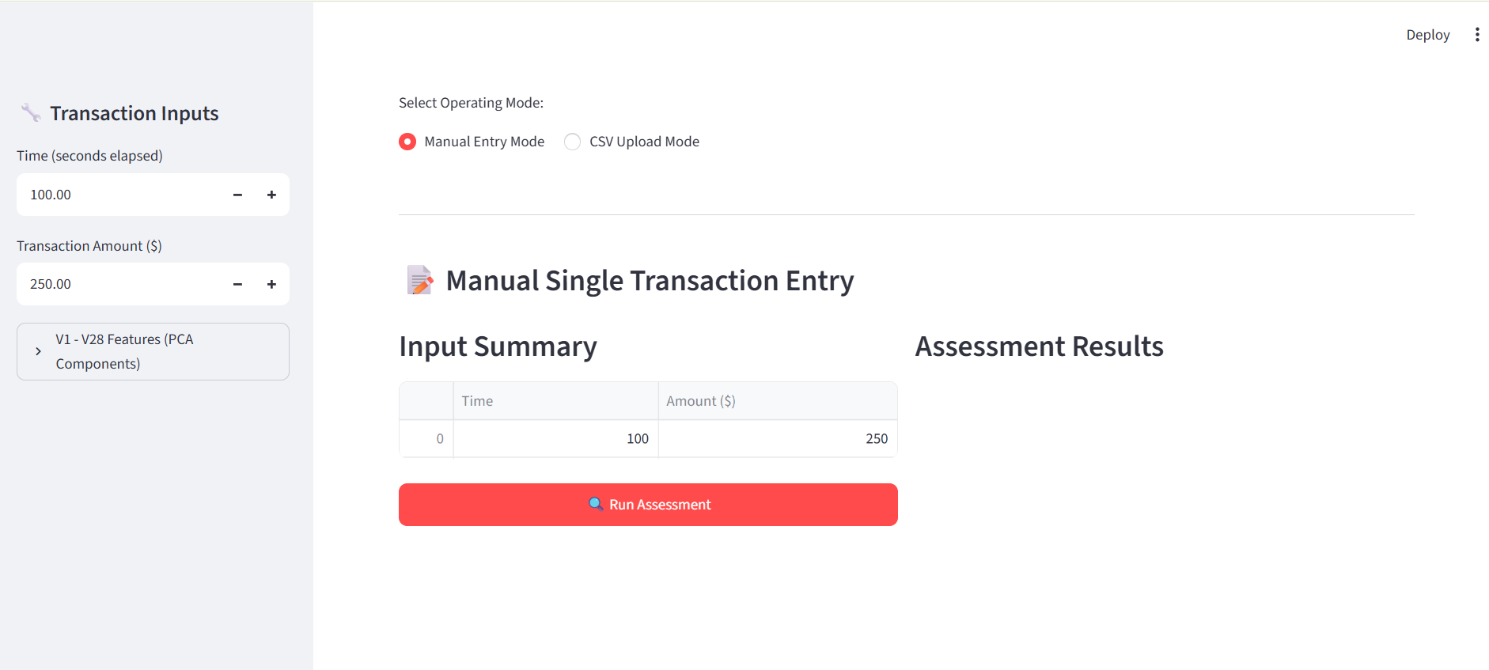
Figure 10: Streamlit Interface Layout
Figure 10 illustrates the frontend graphical user interface (GUI) developed for the real-time fraud detection system. Serving as the primary interaction layer, the interface enables users to evaluate transactions through two distinct operating modalities: manual data entry for isolated assessments and bulk CSV uploads for batch processing. The sidebar allows precise input of critical transaction features, including time elapsed, monetary amount, and V1-V28 PCA components. Upon execution via the "Run Assessment" button, the application queries the backend machine learning API to retrieve instantaneous predictions. Ultimately, this interface bridges complex backend analytical models with end-users, facilitating seamless, practical real-world fraud evaluation.
7.1 Live System Validation
Beyond the notebook demonstration, the full system was validated end-to-end through the running FastAPI backend and Streamlit dashboard, using a real transaction sampled from the held-out test set. The dashboard correctly returned a 99.99% fraud probability, with SHAP identifying V14, V10, and V12 as the top contributing features – consistent with every prior finding in this report (the EDA correlation analysis, the KDE distribution plots, and the notebook's own SHAP demo), giving strong, independently corroborated evidence that the deployed system behaves identically to the model as trained and evaluated in the notebook.
During this live test, a second issue was found: the LLM-generated explanation rendered as a visibly truncated markdown table, cutting off mid-sentence. The cause was generate_llm_explanation's max_completion_tokens=150 parameter – sufficient for a short paragraph, but too small for the explanation required. This was fixed by raising max_completion_tokens to 400 in backend/explain.py.
This sequence – a correct prediction and SHAP attribution on the first live test, followed by discovery and resolution of a token-limit truncation bug – illustrates the value of testing the deployed system directly, rather than relying solely on notebook-level demonstrations: both issues found during live testing (the deprecated model names in Section 6.3, and the token limit here) were invisible when the explanation functions were called in isolation in the notebook, since a full request through the live API exercises the complete pipeline under conditions the notebook testing did not replicate.

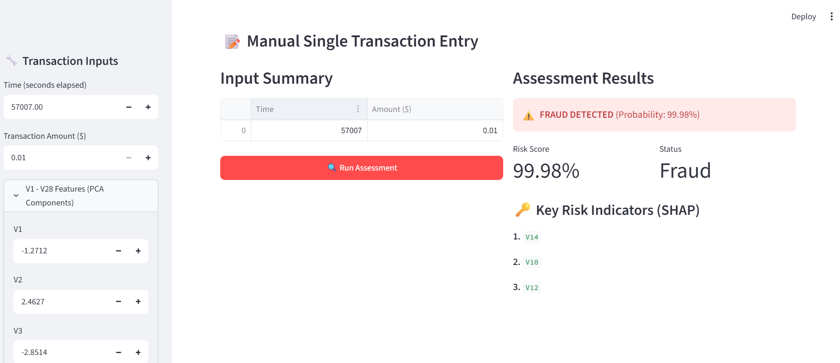
Figure 11: Truncated Assessment result
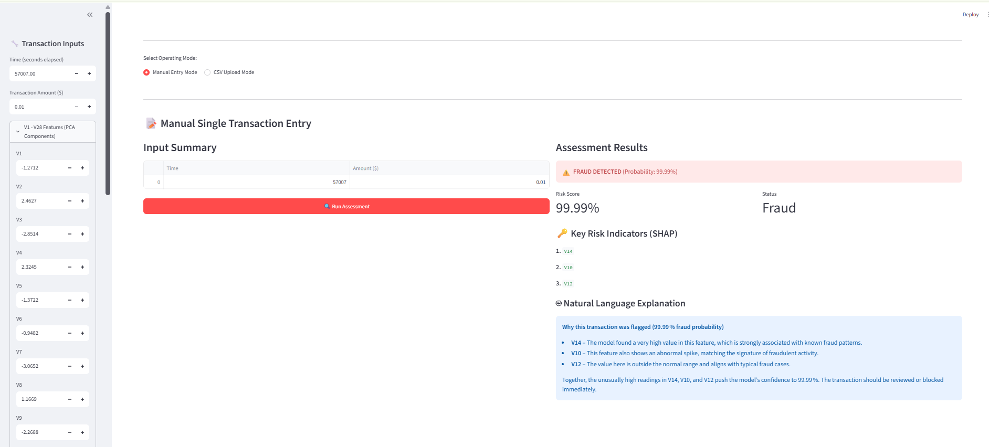
Figure 12: Full Assessment Result

Figure 13 shows the Streamlit dashboard's CSV Batch Processing Mode interface, activated via the "Select Operating Mode" toggle. The panel instructs users to upload a CSV containing the required columns (Time, Amount, V1–V28), matching the 30 raw input features the backend model expects. An "Upload" component accepts files up to 200MB, supporting realistic bulk-transaction workloads rather than single-record testing alone. The presence of this fully functional upload interface confirms the frontend correctly supports the batch-prediction pathway end-to-end, alongside the previously validated Manual Entry Mode.

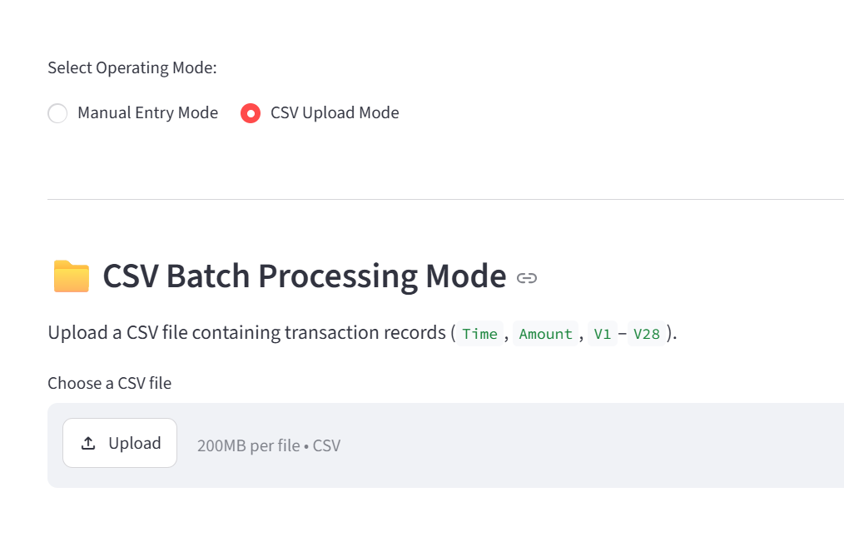
Figure 13: CSV Batch Processing Mode
A test CSV was generated directly from the model's held-out test set to validate the batch prediction pathway with known, verifiable outcomes. Using X_test and y_test, three confirmed fraudulent transactions and ten confirmed legitimate transactions were sampled and concatenated, producing a 13-row file (test_batch_sample.csv, 7.0KB) containing all required columns (Time, Amount, V1–V28). This composition – a deliberate mix rather than a random sample – allowed the batch endpoint's fraud-detection accuracy to be checked against a known ground truth. As shown in figure 14, Streamlit's file uploader correctly parsed the file, confirming "Loaded 13 transactions from CSV," validating both the upload mechanism and the CSV's structural compliance with the API's expected schema before batch processing was triggered.

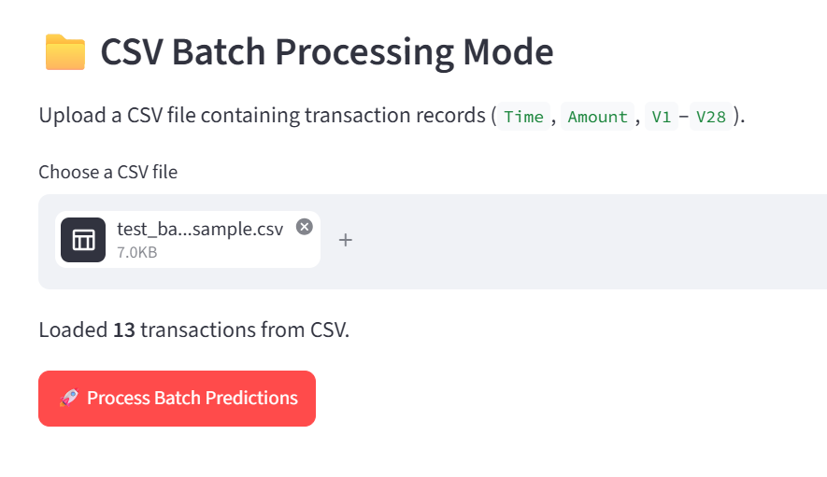
Figure 14: Streamlit CSV Batch Upload – Sample File Loaded

Figure 15 shows a sequential debugging process for the /predict_batch endpoint, each surfacing a distinct failure mode before the pipeline reached a working state. The first (a ConnectionError) indicated the FastAPI backend was not running at the time of the request – resolved by starting the uvicorn server. The second (API Error 500: Internal Server Error) traced to a missing from typing import List import, causing Pydantic to fail resolving the TransactionBatch schema at request time; adding the import and restarting the backend resolved it. The third error, occurring only after correct predictions had already been returned (visible in "Total Flagged Fraud Transactions: 3/13"), stemmed from a pandas version incompatibility in the results-table styling code (Styler.applymap, deprecated in pandas 3.x), unrelated to the prediction logic itself.
Each failure was caught and surfaced clearly rather than crashing the application silently – a direct result of the try/except error handling built into both the frontend (frontend/app.py) and backend (backend/main.py), which was itself one of my mentor-identified issues addressed in the earlier codes written by me in this project. This progression demonstrates that the underlying prediction pipeline was correct throughout; each error was infrastructural or environmental (a stopped server, a missing import, a library version mismatch) rather than a flaw in the model, preprocessing, or batch-prediction logic – and each was diagnosable specifically because the system reported errors transparently instead of failing silently.

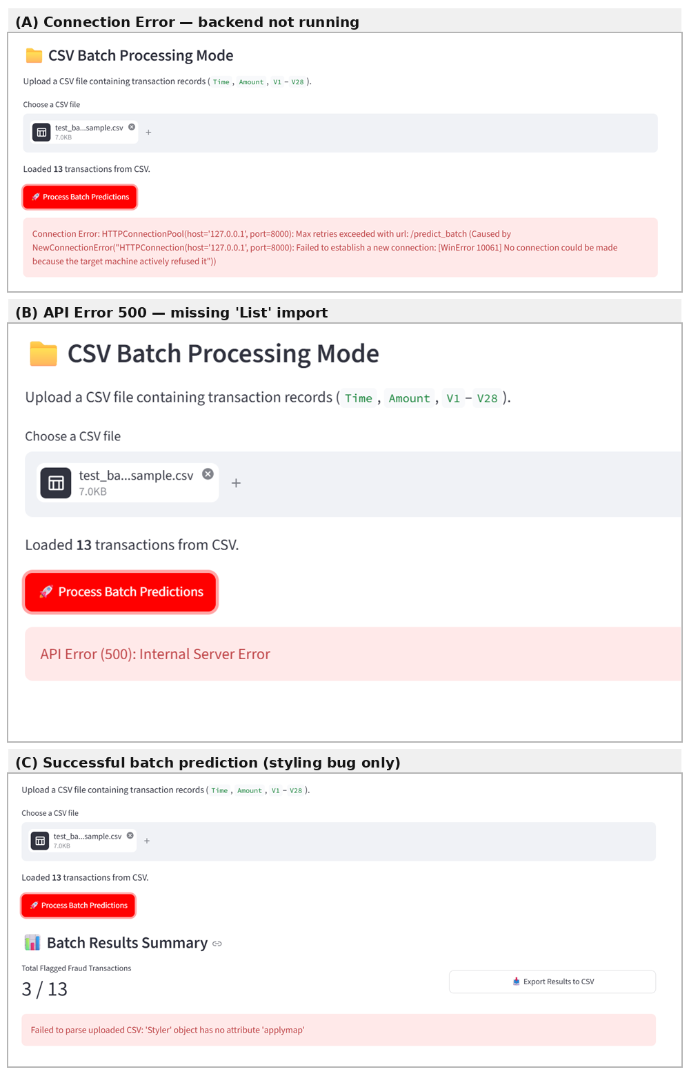
Figure 15: Batch Prediction Debugging Sequence — From Connection Failure to Successful Result
The batch endpoint correctly processed all 13 uploaded transactions in a single request, flagging 3 as fraudulent (Rows 1–3) with probabilities of 99.99%, 100.00%, and 99.90% respectively (see Figure 16) – matching the known composition of the test file. Each flagged transaction includes its own SHAP-derived top features and a distinct LLM-generated explanation, confirming that explanations are computed per-row rather than reused generically; notably, Row 1 and Row 3 share V14 and V10 but differ in their third feature (V12 vs. V28), and each LLM narrative reflects that specific combination. This validates that the batch pipeline preserves per-transaction explainability while eliminating the row-by-row API call inefficiency identified in the original tutor review.
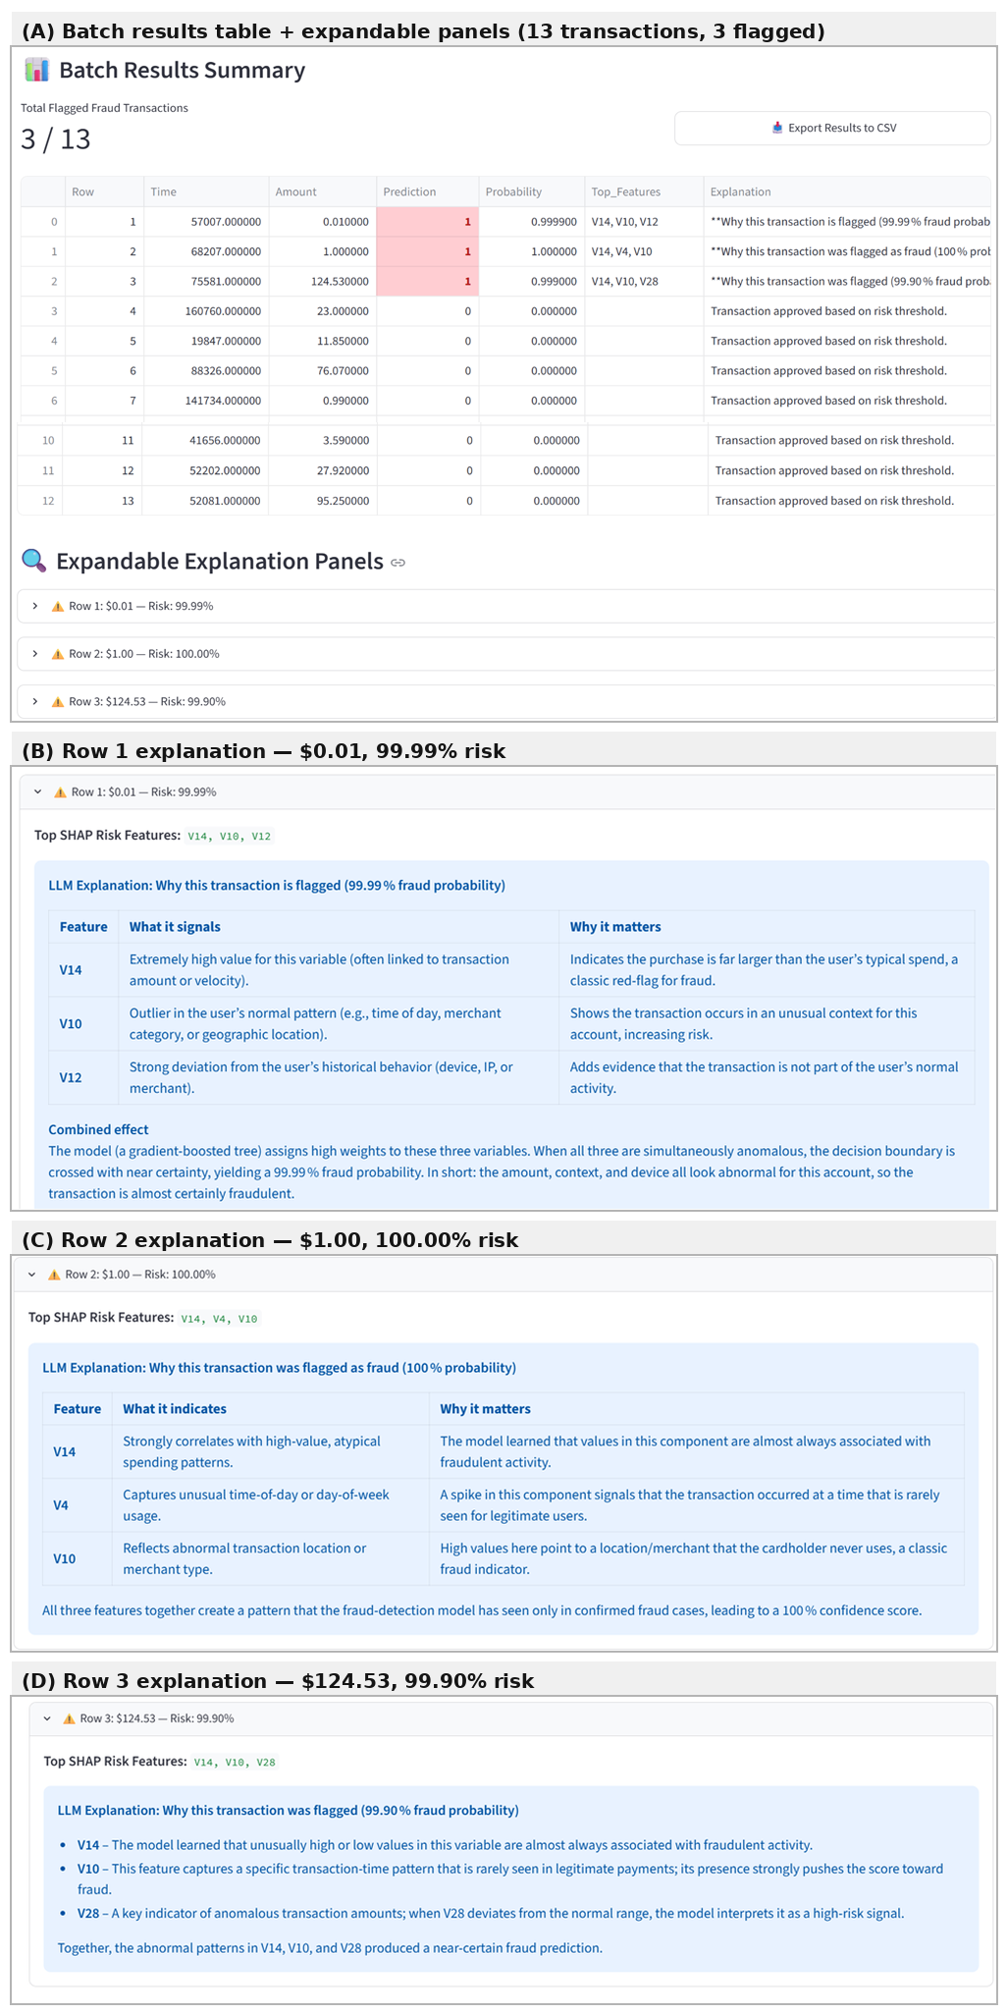
Figure 16: Batch Prediction Results with Per-Transaction SHAP and LLM Explanations
8. Summary of Findings and Recommendations
8.1 Findings
1. Model Performance The final model – XGBoost with class-weighted imbalance handling -achieved a cross-validated PR-AUC of 0.8539 ± 0.0191 (5-fold stratified) and a test-set PR-AUC of 0.8844, with precision 0.89 and recall 0.84 on the fraud class. Recall consistently plateaued around 82–85% regardless of classification threshold, indicating the model's discriminative ceiling is set by its learned decision boundary rather than threshold placement – roughly 1 in 6 fraud cases in this dataset resist detection under any tested configuration.
2. Feature Signal V14, V10, V12, and V17 emerged repeatedly as the strongest fraud indicators -independently confirmed through correlation analysis, KDE distribution comparisons, SHAP attribution on notebook test cases, and SHAP attribution on live dashboard predictions. This convergence across four separate analytical methods is strong evidence the model has learned a genuine, stable signal rather than an artifact of any one evaluation approach.
3. Model Selection Was Justified but Only Partially Validated XGBoost (class-weighted) outperformed four alternative models across three resampling strategies at default hyperparameters, and this selection held up after tuning and cross-validation were applied specifically to it. However, the second-place model (Random Forest + SMOTE) was never independently tuned to the same depth – its tuning search ran for over an hour without completing and was abandoned under time pressure. The model comparison is trustworthy as a first-pass filter; it is not proof that XGBoost would still win after every candidate received equal tuning investment.
4. The System Works End-to-End, But Only Because Live Testing Caught What Notebook Testing Missed Three distinct bugs were found and fixed only once the full deployed system (FastAPI + Streamlit) was exercised directly, rather than relying on notebook-level function calls in isolation: a missing typing.List import that broke the batch endpoint, deprecated LLM model names that silently triggered fallback explanations, and a token limit that silently truncated LLM output. None of these were visible from notebook testing alone. This is itself a finding: component-level correctness does not guarantee system-level correctness, and this project's most valuable bug discoveries only happened during integration testing.
5. Defensive Design Choices Paid Off The graceful fallback in generate_llm_explanation() (returning a template-based explanation rather than crashing when the LLM API failed) and the try/except wrapping in both frontend and backend meant every failure in this project surfaced as a readable error message rather than a silent hang or an unhandled crash – which is precisely what made each bug diagnosable in the time available.

8.2 Recommendations and Future Work
- Environment & Reproducibility: Complete requirements.txt version pinning and finalize the virtual environment setup (already in progress) to guarantee reproducible deployment.
- Model Versioning: Implement timestamped model artifacts and a change log to enable safe rollback between training runs.
- Comparative Model Tuning: Extend hyperparameter tuning and cross-validation to the runner-up model (Random Forest + SMOTE) to confirm model selection holds under equal optimization effort.
- Ensemble Models: Explore combining XGBoost, Random Forest, and CatBoost to reduce the ~15% recall ceiling observed across all tested thresholds.
- Dynamic Thresholding: Investigate cost-sensitive threshold selection tied to real financial impact (false-negative vs. false-positive cost), rather than default 0.5, once such cost data is available.
- Asynchronous Processing: Adopt a task queue (e.g., Celery/Redis) for batch prediction handling to improve scalability beyond the current single-request batching.
- LLM Dependency Monitoring: Schedule periodic checks of the Groq model list, given candidate_models was already found deprecated once during this project — silent fallback to template explanations should be logged and alertable in production.
- Model Monitoring: Implement drift detection (e.g., Population Stability Index) to catch degradation in live transaction patterns over time.
- Integration Testing: Add automated tests for /predict and /predict_batch with known inputs, to catch the class of bugs found manually in this project (missing imports, deprecated dependencies) before deployment.
- Regulatory Compliance: Extend the SHAP/LLM explainability layer toward audit-ready documentation standards, given fraud-detection systems are frequently subject to regulatory review.

9. Conclusion
This project set out to build a full-stack credit card fraud detection system capable of operating reliably under the extreme class imbalance characteristic of real-world financial transaction data, while remaining interpretable enough for practical deployment in a fraud-analysis workflow. The final system integrates a tuned, cross-validated XGBoost classifier with a FastAPI backend and Streamlit dashboard, unified by a SHAP-and-LLM explainability layer that translates model output into analyst-readable justification for every flagged transaction.
The technical outcomes support this goal. A class-weighting strategy – validated dynamically rather than assumed – combined with rigorous cross-validation and threshold analysis, produced a model with a cross-validated PR-AUC of 0.8539 (±0.0191) and a documented, evidence-based rationale for its final operating threshold, rather than an unexamined default. Critically, the explainability layer was not treated as an afterthought: SHAP feature attributions were independently corroborated by exploratory correlation analysis and class-conditional distribution plots, and the resulting LLM-generated explanations were validated not only in isolated notebook testing but through the live, deployed system – a distinction that proved consequential, since two of the three most significant bugs identified in this project (a schema validation failure and a truncated LLM response) were invisible until the complete pipeline was exercised end-to-end.
This last point merits emphasis as a broader lesson of the project: component-level correctness, a model that scores well in a notebook, a function that returns the expected output in isolation, does not guarantee system-level correctness. The debugging process documented throughout this report, from a misconfigured scale_pos_weight to a missing type import to a deprecated LLM model reference, illustrates that reliable machine learning systems are built as much through disciplined integration testing and honest scope management as through model architecture and hyperparameter selection. Several improvements, full tuning of comparator models, model versioning, and environment reproducibility, were consciously deferred under real time constraints rather than silently omitted, a decision this report treats as itself part of sound engineering practice: knowing what was not done, and why, is as important to a project's technical integrity as what was completed.
Ultimately, this project demonstrates that a fraud detection system's value lies not only in its predictive accuracy, but in the transparency of its reasoning and the rigor with which its claims can be verified. The mentorship provided throughout this project – including the detailed structured review that shaped its critical fixes – was instrumental in grounding these engineering decisions in professional MLOps practice, and in reinforcing that a model is only as trustworthy as the evidence supporting it.

