Project 6

Yingjie Qiu  
yqiu322@gatech.edu

# INDICATORS

The first part of this report investigated 5 common technical indicators and described the method we used for calculations. The stock prices were predicted based on historical data through these technical indicators with symbol JPM. The 5 indicators are Simple Moving Average (SMA), Bollinger Bands, Exponential Moving Average (EMA), Momentum, and Moving Average Convergence Divergence (MACD). We set the window size (lookback) to be 14 days, start data is 01/01/2008, and end date is 12/31/2009.

## Simple Moving Averages (SMA)

SMA is a technical indicator based on rolling mean of stock prices over a time rolling window. Simple moving averages take the average of a price range and divide it by the number of periods within that range. A simple moving average is a technical indicator that can help predict whether an asset price will continue or reverse a bull or bear trend.

To quantify SMA, the current price and SMA are used to calculate the ratio between Price and SMA; if stock price goes up and crosses SMA, the stock may show an uptrend (BUY signal); if the stock price goes up and far below SMA, the stock may be heading to SMA (BUY signal); if the stock price goes down and above SMA, the stock may be descending toward the SMA, indicating a SELL or SHORT signal; if stock price falls and crosses SMA , the stock may be in a downtrend, and it could be a SELL or SHORT signal.

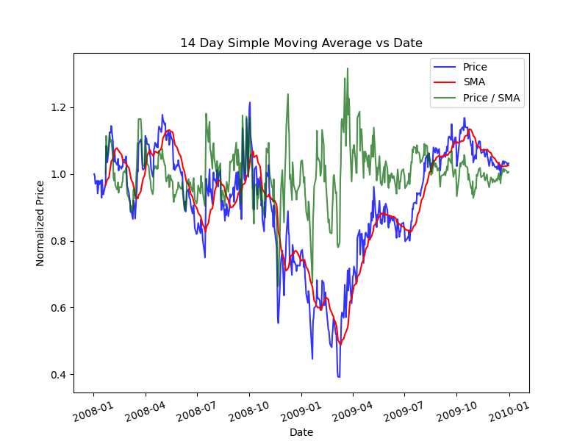

***Figure 1***

## Bollinger Bands

Bollinger Bands are developed by John Bollinger as a technical analysis tool for generating oversold or overbought signals. Bollinger Bands are made up of three lines: a simple moving average (middle band), an upper and lower band, and a trend line. The upper and lower bands are typically 2 standard deviations +/- from the center line. When the price repeatedly touches the upper Bollinger Band, it may indicate an overbought signal, whereas repeatedly touching the lower Bollinger Band may indicate an oversold signal.

***Figure 2***

## Exponential Moving Averages (EMA)

Exponential Moving Average (EMA) and Simple Moving Average (SMA) both measure trend direction over time. However, whereas SMA simply computes an average of price data, EMA gives more weight to more recent data. Because of its unique calculation, the EMA will track prices more closely than a SMA. When interpreting EMA, apply the same rules that apply to SMA. However, EMA is more sensitive to price movement in general. By using this benefit, it can help us identify trends faster than a SMA. But the EMA is likely to experience more short-term changes than a corresponding SMA.

## 

***Figure 3***

## Momentum

Momentum depicts the rate of change in price movement over time to assist investors in determining the strength of a trend. Investors use momentum to trade stocks in an uptrend by going long (buying shares) and short (selling shares) in a downtrend. If momentum exceeds a predetermined threshold, it indicates that the stock is rapidly accelerating, and a BUY signal can be issued, or a SELL signal if the situation is reversed.

***Figure 4***

## Moving Average Convergence Divergence (MACD)

Moving average convergence divergence (MACD) is a trend-following momentum indicator that depicts the relationship between two exponential moving averages (EMAs) of a security's price. The MACD line is calculated by subtracting the 26-period EMA from the 12-period EMA. MACD generates technical signals when the MACD line crosses above the signal line (buy) or below it (sell).

***Figure 5***

# Theoretically Optimal Strategy (TOS)

The return on a stock over a time period can be maximized only if we know the stock at the end of the time period. In theory, if we know the price movement of a stock tomorrow, we can decide whether to BUY or SELL today. If we believe the stock will rise tomorrow, we will BUY it today and SELL it today if we believe the stock will fall tomorrow; otherwise, we will HOLD it. This strategy ensures that we will profit from the stock price regardless of what happens to it. The benchmark is buying the stock and hold it until a specific time period. I compare TOS and Benchmark strategy through the matrices below. It is clear that TOS overperform Benchmark strategy.

***Table 1***

|  |  |  |
| --- | --- | --- |
|  |  |  |
|  | TOS | Benchmark |
| Cumulative Return | 5.7861 | 0.012999 |
| Standard deviation | 0.004548 | 0.017004 |
| Mean | 0.003817 | 0.000168 |
|  | ***Figure 6*** |  |

