Title: | LIN_Protocol_ver 2.2A  SW Component LIN_Protocol

Maturity: | Draft
Authors: | David Antonio Diaz Ramirez
Authors: | Francisco Javier Quirarte Pelayo
VERSION: | Public
Security Classification: | None

History
Issue status  (Index) | Maturity/Date  (draft/invalid/valid)  (dd-mmm-yyyy) | Author  Department | Check/Release  Department | Description
1.0 | Draft  26-nov-15 | Francisco Quirarte | Francisco Quirarte y David Díaz | Creation of the document.
History
Issue status  (Index) | Maturity/Date  (draft/invalid/valid)  (dd-mmm-yyyy) | Author  Department | Check/Release  Department | Description
2.0 | Draft  27-nov-15 | David Díaz | Francisco Quirarte | Added: Purpose, Definitions and abbreviations.
History
Issue status  (Index) | Maturity/Date  (draft/invalid/valid)  (dd-mmm-yyyy) | Author  Department | Check/Release  Department | Description
3.0 | Draft  28-Nov-15 | Francisco Quirarte y  David Díaz | Francisco Quirarte | Added: Realization constraints and targets.
History
Issue status  (Index) | Maturity/Date  (draft/invalid/valid)  (dd-mmm-yyyy) | Author  Department | Check/Release  Department | Description
4.0 | Draft  29- Nov -15 | Francisco Quirarte y  David Díaz | Oswaldo Garcia | Added: SW Conceptual design.

History
Issue status  (Index) | Maturity/Date  (draft/invalid/valid)  (dd-mmm-yyyy) | Author  Department | Check/Release  Department | Description
6.0 | Draft  30-nov-15 | Francisco Quirarte y  David Díaz | Luis Alvarez | Review of SW Component internal breakdown and added general corrections.  General corrections at traceability matrix

History
Issue status  (Index) | Maturity/Date  (draft/invalid/valid)  (dd-mmm-yyyy) | Author  Department | Check/Release  Department | Description
7.0 | Release  30-Nov-15 | Francisco Quirarte y  David Díaz | Oswaldo Garcia e  Isamar Gálvez | Review of SW Conceptual design and added general corrections.  Review of the test plan.

Table of Contents
1 Introduction 5
2 Purpose 6
3 Comparison chart protocols 7
4 LIN Protocol Concepts 8
5 LIN PROTOCOL CONCEPTS 9
6 Definitions and abbreviations 12
7 LIN Software Driver Services 14
8 The ISO/OSI reference model and LIN 15
8.1 Figure 10: reference model ISO/OSI LIN 15
9 APPLICATION LAYER SLAVE 16
9.1 Figure 1: Layers 16
9.2 Layer descriptions 17
9.3 Functional Blocks Descriptions 17
10 Requeriments 19
11 Realization constraints and targets 21
12 Network Graphical Description Diagrams 23
12.1 Figure 4: Deployment Diagram (A) 23
12.2 FIGURE 5: Use Case Diagram 24
12.3 FIGURE 6: Component diagram request & response (A/D) 25
12.3.1 Components Descriptions 25
12.4 FIGURE 7: CLASES DIAGRAM 27
12.5 FIGURE 8: COMPONENT DIAGRAM SW 28
12.6 FIGURE 9: SEQUENCE DIAGRAM 29
12.7 FIGURE 10: STATE MACHINE TRANSMISSION SLAVE2 30
12.8 FIGURE 11: LIN STATE MACHINE SLAVE2 31
12.9 FIGURE 12: LIN PROTOCOL STATE MACHINE 32
12.10 FIGURE 13: STATE MACHINE OF MASTER NODE TRANSMISSION HANDLER ……………………………………………………………………………………………………...33
12.11 FIGURE 14: LED HANDLER 35
13 Application Program Interface Specification ver. 2.2a 36
13.1 CORE API 36

Introduction

This application note shows how to implement a LIN (Local Interconnect Network) slave task in a 32-bit RISC microcontroller without the need for any external components. The LIN protocol is a serial communications protocol which efficiently supports control of mechatronic nodes in a distributed network. This makes the protocol ideal for use in automotive applications. A LIN network consist of a single Master and a set of Slave nodes. This application note show how to implement the protocol for the physical layer and the data link layer according to the two lowest levels of the ISO/OSI reference model. This provides the foundation for message transmissions between nodes in the network. The physical layer of the ISO/OSI model only provides a raw bit-stream between two nodes in the network. The data link layer makes the physical layer reliable by adding error detection and control. It also adds the means to activate, maintain, and deactivate the link. The higher levels of the ISO/OSI reference model is beyond the scope of the LIN protocol and thus not explained here. For now, this is up to the user to specify and implement. The LIN protocol differs from the CAN protocol in the sense that it is below the performance and scope of the CAN. Its strongpoint is that it is provides a simple, low-cost solution for applications not requiring the power of the CAN protocol.

Purpose

Bus Local Interconnect Network, LIN usually abbreviated Bus is a system used in current data transmission networks Automotive System. SPECIFICATION meets the LIN consortium, in its first version 1.1, released in 1999. The specification has been developed from then to version 2.0 para solve the current needs of a red. The LIN bus is a little slow system that USING As a cheap bus para- red sub ​​UN can integrate smart devices or actuators in today's cars.

Is a concept for low cost automotive networks, which complements the existing portfolio of automotive multiplex networks. LIN will be the enabling factor for the implementation of a hierarchical vehicle network in order to again further quality enhancement and cost reduction of vehicles. The standardization will reduce the manifold of existing low-end multiplex solutions and will cut the cost of development, production, service and logistics in vehicle electronics.

Comparison chart protocols
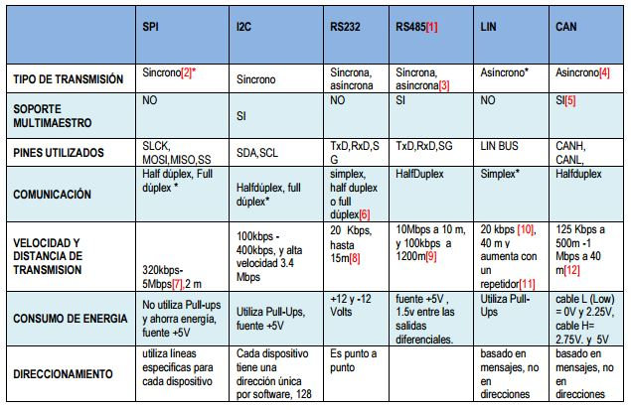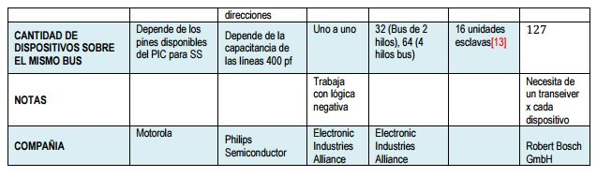

LIN Protocol Concepts
Single Master Multiple Slaves
The LIN protocol does not use bus arbitration. A single Master is responsible for initializing all message transfers. All slaves can respond to the Master or any other node in the network but only after being addressed and given permission by the Master.

Variable Length of Data Frames
Included in the identifier field are two bits indicating the length of the message field (see Table 1). This adds flexibility and reduces overhead bytes when only a limited amount of data is required.

Multi-cast Reception
When a message frame is transmitted from the Master or a Slave task, all connected nodes in the network can read the message. Depending on the identifier byte, the receiving nodes decides if any action is to be initiated or not. For example, a single “CLOSE ALL” command from the Master could be accepted from all nodes and could in the case of a car security system close all windows and doors.
Time Synchronization without Need for Quartz or Ceramic Resonators in the Slave Nodes
After the Synch Break, a Synch Field is transmitted from the Master, this field makes it possible for all the Slaves to synchronize to the master clock. Such synch fields are placed at the beginning of every message frame. The accuracy of the receiving Slaves need only be good enough to keep synchronization through the entire message frame. This feature allows the slave to run on an internal RC Oscillator thus reducing the overall system cost.

Data Checksum Security and Error Detection
The data in the message frame uses an inverted modulo256-checksum with the carry of the MSB added to the LSB for error detection. In addition, the identifier byte uses a XOR algorithm for error detection.

Detection of Defect Nodes in the Network
The Master task is responsible for initiating the transmission of message frames and thus has the responsibility of requesting information and checking that all nodes are alive and working correctly.

Minimum Cost Solution
Due to the simplicity of the protocol, a slave task complying to the LIN standard can be built using a minimum of external components and does not put heavy constraints on the accuracy of the Oscillator in the Slave nodes.

LIN PROTOCOL CONCEPTS
In the following chart will describe the concepts LIN protocol:

Signal Transmission | The LIN bus consists of a single channel that carries both data and synchronization information. The physical medium is a single wire connected to VCC via a pull-up resistor (see Figure 1). The idle state on the bus is high or “recessive” and the active state is low or “dominant”. In automotive applications VCC will typically be the positive battery node. The LIN protocol does not define an acknowledgment procedure for the Slave tasks. The Master task uses its own slave task to verify that the sent message frame is identical with the one received by this slave task. If any discrepancy is detected the message frame can be retransmitted. The data rate for transmitted data is limited to 20 Kbits/s due to EMI (Electro Magnetic Interference) requirements for a single wire transmission medium.
Message Frames  LIN Message Frame  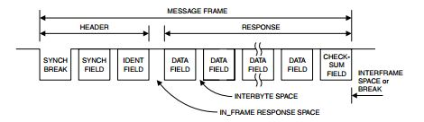 | All information transmitted on the LIN bus is formatted as Message Frames. As shown in Figure 2, a Message Frame consists of the following fields:  • Synch Break  • Synch Field  • Identifier Field  • Data Field  • Checksum Field
Byte Fields  LIN Byte Field  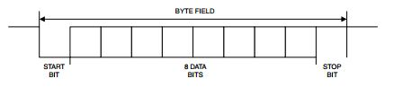 | The Byte Field format, shown in Figure 3, is identical to the commonly used UART serial data format with 8N1 coding. This means that each Byte Field contains eight data bits, no parity bits, and one stop-bit. Every Byte Field has the length of 10 bit-times (Tbit). As shown in the figure, the start bit marks the beginning of the Byte Field and is “dominant” while the stop-bit is “recessive”. The eight data bits can be either “dominant” or “recessive”.

Synch Break  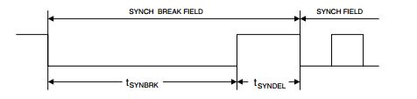 | The Synchronization Break marks the beginning of a Message Frame. This field is always sent by the Master task, and provide a means for the Slave task to prepare for the synchronization field. The Synch Break consists of two different parts: a dominant (low) level that should be minimum 13 bit-times (Tbit) which is followed by a recessive (high) period that should be in the range one to four Tbit. The second field is necessary to detect the dominant (low) level of the start bit of the following Synch Field.
Synch Field  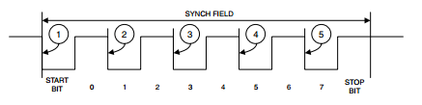 | The Synch Field contains the signaling required for the slave to synchronize with the master clock. The Synch Field is a Byte Field containing the data “0x55” giving the waveform shown in Figure 4.
Identifier Field  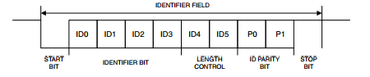 | The Identifier Field contains information about contents and length of a message. As shown in Figure 6, this field is divided into three sections: identifier bits (four bits), length control bits (two bits) and parity bits (two bits). This divides the set of 64 identifiers into four subsets of 16 identifiers each.
Data Field  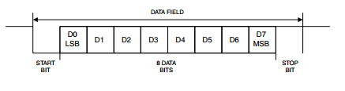 | The data frame contains from two to eight Data Fields containing eight bits of data each. Transmission is done with LSB first. The data fields are written by the responding Slave task. Since there is no bus arbitration, only one slave task should be allowed to respond to each identifier. All other Slave tasks are limited to reading the response and act accordingly.

Checksum Field  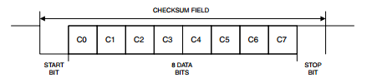 | The last field in the Message Frame is the Checksum Field. This byte contains the inverted modulo-256 sum of all data bytes (data frame not including the identifier). This sum is calculated by doing an “ADD with carry” on all data bytes and then inverting the answer. The properties of the inverted modulo-256 sum are such that if this number is added to the sum of all data bytes the result will be “0xFF”.
Sleep Mode Frame  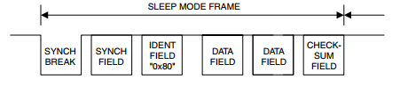 | The frame structure for the Sleep Mode Frame is identical to an ordinary Message Frame and is distinguished by the identifier byte “0x80”. The contents of the data fields are not specified and could be used to distribute system parameters for the sleep mode.
Wake-up Signal  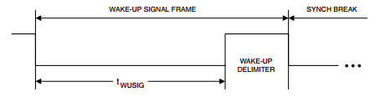 | The sleep mode can be terminated by any connected slave task by sending a wake-up signal. The wake-up signal is only allowed when the bus is in sleep mode and a node internal request for wake-up is pending. The wake-up signal is the character “0x80”.

Definitions and abbreviations
Definitions

LIN 2.2A | Serial network protocol used for communication between components in vehicles
Master (node) | Node chosen to control all communications. Bus arbiter.
Slave (node) | Node that responds to the master in three possible ways: Receive data, transmit data or ignore data.

Abbreviations

LIN | Local Interconnect Network
RX | Reception
TX | Transmission
MSTR | Master
SLV | Slave
MSG | Message
HAL | Hardware Abstraction Layer
LIN | Local Interconnect Network
CAN | Controller Area Network
ECU | Electronic Control Unit
API | Application User Interface
IDE | Integrated Development Enviroment
UART | Universal Asynchronous Receiver Transmitter
ASC | Async/Synchronous Serial Interface
ID | Identifier
EMI | Electro Magnetic Isolation
t_slv_stat | Signal to display slave node status.
t_cmdType | Signal to control LED states and slave node state.
t_LEDstat | Signal to display LED status.
t_boolean | Signal response that indicates slave node status.
array | Signal that contains the team member’s initials for the Msg ID.
scalar | Signal that contains the team assigned number for the Msg ID

References

N° | Document name
1 | Traceability Matrix Template.xls
2 | MPC5604B/C Microcontroller Reference Manual.pdf
3 | Test_template.xls
4 | http://www.freescale.com/products/power-architecture-processors/mpc5xxx-5xxx-32-bit-mcus/mpc56xx-mcus/mpc5606b-startertrak-development-kit:TRK-MPC5606B
5 | http://www.freescale.com/products/power-architecture-processors/mpc5xxx-5xxx-32-bit-mcus/mpc56xx-mcus/ultra-reliable-mpc56xb-mcu-for-automotive-industrial-general-purpose:MPC560xB#pspFeatures
6 | SW_C_Code_Review_Template.docx
7 | Window-lifter-requirements.docx
8 | LIN Protocol_Conti.ppt
9 | LIN_Network_Database
10 | LIN-Spec_2-2A.doc
11 | LIN-Spec_2-2A.pdf
12 | http://www.atmel.com/images/doc1637.pdf

LIN Software Driver Services
The LIN driver provides several API-functions for LIN bus handling. The main services of the LIN software driver are:
• Message transmission
• Message reception
• Message filtering
• Connect/disconnect the LIN node to the LIN bus
• Sending "go to sleep mode" command
• Sending "wake up" command
• Bus timeout detection
• Frame monitoring
• ID field calculation
• Data length extraction
• Checksum calculation
• LIN message scheduler.

LIN Software Driver Requirements
The LIN software driver requires CPU processing time as well as hardware resources like peripherals, code/data memory, and interrupts nodes. The exact requirements are listed next.

Hardware Requirements
LIN utilizes the serial interface for message frame generation and additionally occupies one timer channel for LIN bus timing monitoring e.g. for detection of not responding slaves or no bus activity. Both peripherals require an interrupt handler, with main processes of the LIN software driver being executed from the interrupt handler of the serial communication channel peripheral.

Memory Requirements
The software driver occupies less than 3 kBytes of code memory and less than 100 bytes of data memory. These numbers include all the basic LIN software driver functions. Application specific user LIN message buffers require additional memory space.

Slave task:
1. Receive-ID-Field (message filtering), copy data to LIN transfer buffer and send first databyte
2. Receive first databyte and send second data byte
3. Receive second databyte and send third data byte
4. Receive third databyte and send fourth data byte
5. Receive fourth databyte and calculate / send checksum-field
6. Receive-Checksum
This bus configuration is running at a baudrate of 19.2 kBaud. The length of one message frame is about 4.5 ms. the required CPU time for a LIN frame generation depends strongly on the number of declared ID’s. Within the example network, 16 identifiers are defined. During the states 1 to 9, the CPU of the master LIN node is busy processing LIN driver operations. The overall processing time for the LIN software driver is 110 µs (fCPU = 20 MHz). While sending and receiving a LIN message frame the total CPU load of the LIN master node is below 3%.

The ISO/OSI reference model and LIN

Figure 10: reference model ISO/OSI LIN

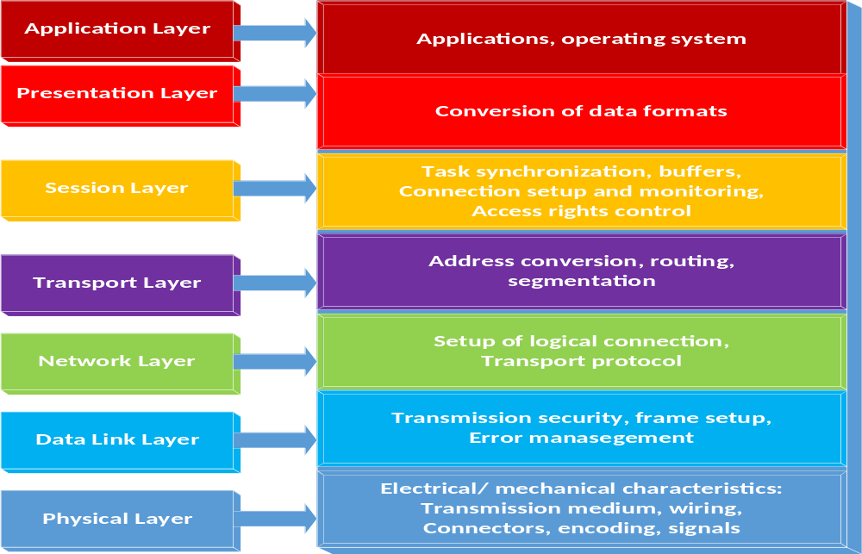

APPLICATION LAYER SLAVE

Figure 1: Layers

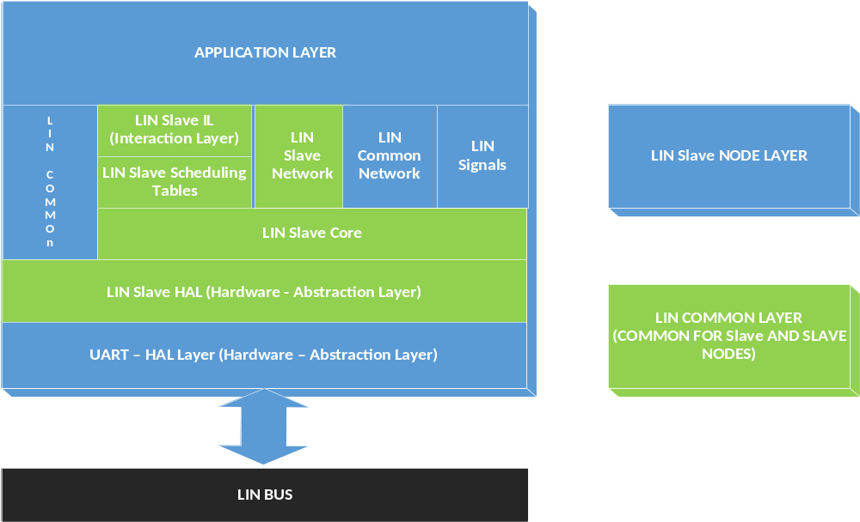

Layer descriptions
Layer | Description
Application Layer | This layer correspond to the application functionally which uses the LIN data being received by LIN and writes the data being transmitted by LIN.
LIN SLAVE Node Layer | This layer implements the functionally of the LIN Master node
LIN common layer | This layer provides implementation of functionally that is common either for a LIN master node or a LIN slave node.
UART Layer | This layer implements all UART related interfaces to be used by the LIN functionally

Functional Blocks Descriptions

Functional Block Name | Description
LIN SLAVE IL | Provides the “skeleton” of the callbacks being called by the Lin master node. Some of those callbacks are associated to messages defined in the LIN network so this file changes defined in the LIN network
LIN SLAVE Network | Defines and implements all functionality related to the LIN messages of the network where the master node is connected. This file changes each time any of the the LIN messages changes in the LIN network definition.
LIN SLAVE Scheduling Tables | Defines and implements all functionality related to the LIN master scheduling tables. This file changes each time a scheduling table or messafe changes in the LIN network
LIN SLAVE Core | Implements the core functionality of the LIN master node, i.e., the functionality for sending and receiving LIN frames. This functionality does not depend on the LIN network definition so it does not change upon changes of it
LIN SLAVE HAL | Implements the interfaces of the LIN master core functionality with the UART hardware.
LIN Common | Provides functionality that is common among any node of the LIN network, i.e., either the master node or any slave node. For example, the checksum calculation is implemented in this functional block.
LIN Common Network | Provides definitions of the LIN network which is common to all LIN nodes (master and slaves). For example, the ID and data length of the messages, etc.
LIN Signals | Provides data structures to ease the access of the individual signals of the LIN frames.
UART HAL | Implements the API’s for sending and receiving bytes with the UART hardware.

Requeriments
Messages defined for this network.

Msg ID | Msg Name | Msg Data Length (byte) | Msg Publisher | Msg Subscribers | Msg Callback
CF | MASTER_CMD_ALL | 1 | MASTER | SLAVE1, SLAVE2, SLAVE3, SLAVE4 | Auto
50 | MASTER_CMD_SLV1 | 1 | MASTER | SLAVE1 | Auto
11 | MASTER_CMD_SLV2 | 1 | MASTER | SLAVE2 | Auto
92 | MASTER_CMD_SLV3 | 1 | MASTER | SLAVE3 | Auto
D3 | MASTER_CMD_SLV4 | 1 | MASTER | SLAVE4 | Auto
20 | SLAVE1_RSP | 2 | SLAVE1 | MASTER | Auto
61 | SLAVE2_RSP | 2 | SLAVE2 | MASTER | Auto
E2 | SLAVE3_RSP | 2 | SLAVE3 | MASTER | Auto
A3 | SLAVE4_RSP | 2 | SLAVE4 | MASTER | Auto
F0 | SLAVE1_ID | 7 | SLAVE1 | MASTER | Auto
B1 | SLAVE2_ID | 7 | SLAVE2 | MASTER | Auto
32 | SLAVE3_ID | 7 | SLAVE3 | MASTER | Auto
73 | SLAVE4_ID | 7 | SLAVE4 | MASTER | Auto

Messages used for and by slave 2

Signal Types defined for this network.

Type Name | Elements…
 | 0 | 1 | 2 | 3 | 4 | 5
t_slv_stat | Disabled | ENABLED
t_cmdType | cmd_NONE | cmd_LED_on | cmd_LED_off | cmd_LED_  toggling | cmd_disable  _slv | cmd_enable_slv
t_LEDstat | OFF | ON | TOGGLING
t_target_active | INACTIVE | ACTIVE
t_boolean | FALSE | TRUE

Signals defined for this network.

Signal Name | Signal Msg | Signal Start Byte | Signal Start Bit | Signal Len (bits) | Signal Type | Signal Endianess
master_cmdForAll | MASTER_CMD_ALL | 0 | 0 | 4 | t_cmdType | LE
master_cmdForSlave1 | MASTER_CMD_SLV1 | 0 | 0 | 4 | t_cmdType | LE
master_cmdForSlave2 | MASTER_CMD_SLV2 | 0 | 0 | 4 | t_cmdType | LE
master_cmdForSlave3 | MASTER_CMD_SLV3 | 0 | 0 | 4 | t_cmdType | LE
master_cmdForSlave4 | MASTER_CMD_SLV4 | 0 | 0 | 4 | t_cmdType | LE
slave1_LEDstat | SLAVE1_RSP | 0 | 0 | 2 | t_LEDstat | LE
slave1_enabled | SLAVE1_RSP | 1 | 0 | 1 | t_boolean | LE
slave1_supplier | SLAVE1_ID | 0 | 0 | 8 | scalar | LE
slave1_serial | SLAVE1_ID | 1 | 0 | 48 | array | LE
slave2_LEDstat | SLAVE2_RSP | 0 | 0 | 2 | t_LEDstat | LE
slave2_enabled | SLAVE2_RSP | 1 | 0 | 1 | t_boolean | LE
slave2_supplier | SLAVE2_ID | 0 | 0 | 8 | scalar | LE
slave2_serial | SLAVE2_ID | 1 | 0 | 48 | array | LE
slave3_LEDstat | SLAVE3_RSP | 0 | 0 | 2 | t_LEDstat | LE
slave3_enabled | SLAVE3_RSP | 1 | 0 | 1 | t_boolean | LE
slave3_supplier | SLAVE3_ID | 0 | 0 | 8 | scalar | LE
slave3_serial | SLAVE3_ID | 1 | 0 | 48 | array | LE
slave4_LEDstat | SLAVE4_RSP | 0 | 0 | 2 | t_LEDstat | LE
slave4_enabled | SLAVE4_RSP | 1 | 0 | 1 | t_boolean | LE
slave4_supplier | SLAVE4_ID | 0 | 0 | 8 | scalar | LE
slave4_serial | SLAVE4_ID | 1 | 0 | 48 | array | LE

Realization constraints and targets

System must ensure reliability on window behavior and security with the anti-pinch function, push buttons functions shall be much delimited in any unusual situation from ambiguous scenarios.
The constrains to accomplish this targets are the use of microcontroller freescale TRK-MPC5606B, emulation just for 10 led bar and anti-pinch function managed only by push button with scheduler control.

The system will be running in the MPC 5606B. With the following specifications:

- MPC5606B MCU in a 144LQFP package.
- On-board JTAG connection via open source OSBDM circuit using the MPC9S08JM MCU
- MCZ3390S5EK system basis chip with advanced power management and integrated CAN transceiver.
- CAN and LIN interface.
- Analog interface with potentiometer.
- High-efficiency LEDs.
- SCI serial communication interface.

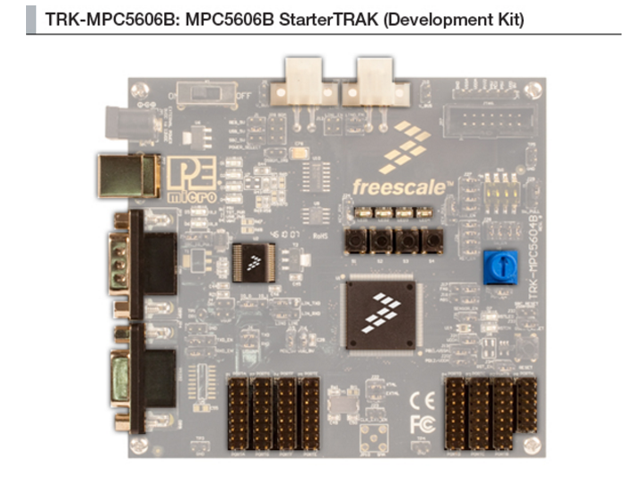

Figure 2: MPC5606B board.

Operating Frequency (Max): 64 MHz.
- Total DMA Channels 16.
- Internal Flash (KB): 512
- GPIOs: 149.
- EEPROM: 64 KB DataFlash®
- RAM: Up to 96 KB
- Timer: 16 bits up to 64 channels
- ADC:
- 10 bits up to 36 channels
- 12 bits up to 16 channels
- Up to six CAN
- Up to six SPI
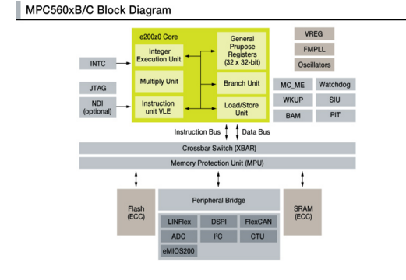
- Up to 10 LINFlex
Figure 3: MPC56X B/C Boolero Arquitecture Family

Network Graphical Description Diagrams

12.1 Figure 4: Deployment Diagram (A)

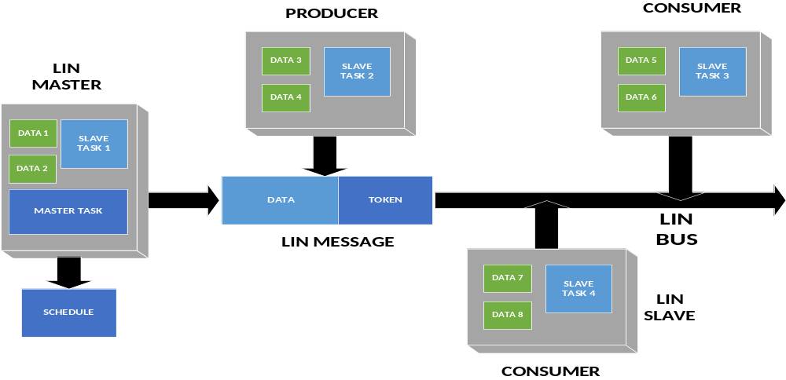
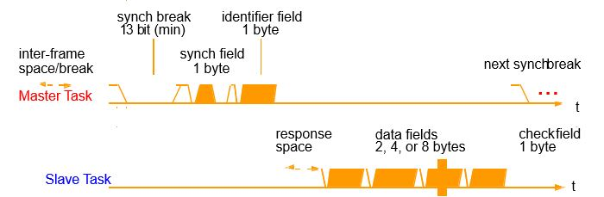

Deployment Diagram. Represents the physical configurations of software and hardware items.
The network showed in the figure above represents the full integrated system, which consists of the master node and the four slaves shown.

Our assignment is to develop the slave node labeled as Slave3, with all its internal components and the required actions to perform.

FIGURE 5: Use Case Diagram
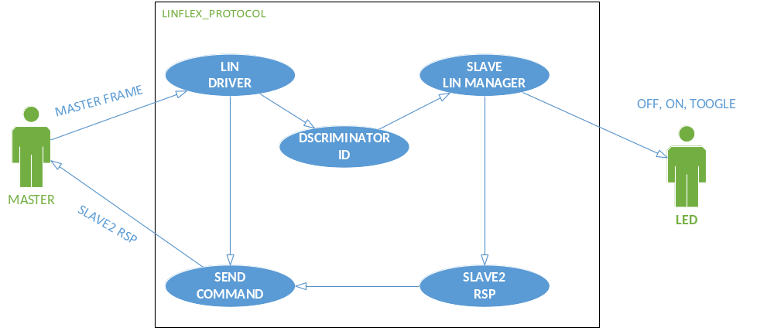

- Master: Node that controls the network.
- This node can send up to of 13 pre-defined messages, but in this diagram only the messages
- relevant to Slave3 node are shown.

- LED: Physical On-board LEDs which will respond to the commands given by the system.

- MASTER_CMD_ALL: Message sent to every slave node to execute a command.

- MASTER_CMD_SLV2: Message sent specifically to slave node 3 to execute a command.

- SLAVE2_RSP: Message sent from Slave3 to the master node with a specific response.

- SLAVE2_ID: Message sent from Slave2 node to the master with the corresponding ID.

FIGURE 6: Component diagram request & response (A/D)

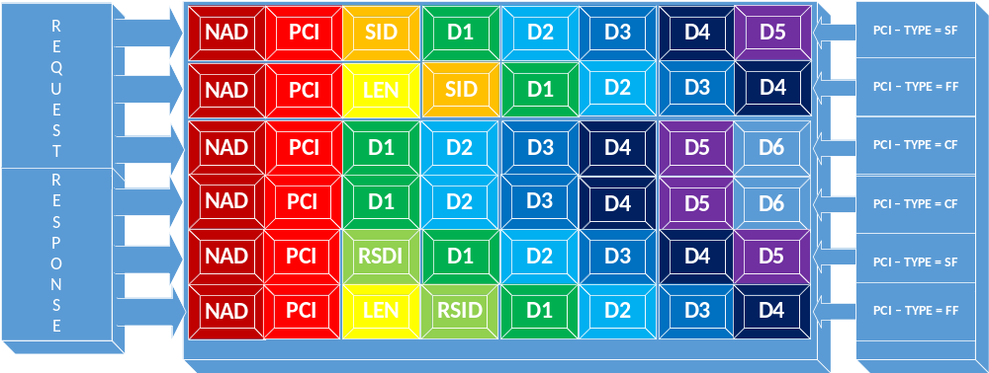

Components Descriptions
NAD | Is the address of the slave node being addressed in a request, only slave nodes have an addressed NAD is also used to indicate the source of a response. NAD values are in the range 1 to 127 (ox7F) while 0 and 128 (0x80) to 255 (oxFF) are reserved for other purpose
PCI  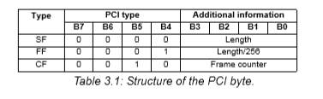 | The PCI (Protocol Control Information) contains the transport layer flow control information. Three interpretations of the PCI byte exist,

LEN | A LEN byte is only used in FF; it contains the eight least significant bits of the message length. Thus, the maximum length of a message is 4095 (0xFFF) bytes.
SID | The service identifier (SID) specifies the request that shall be performed by the slave node addressed. 0 to 0xAF
RSID | The response service identifier (RSID) specifies the contents of the respons. The RSID for a positive response is always SID + 0x40.  If the service is supported in the slave node the response is mandatory (seven if the request is broadcast). The support of a specific service will be listed in the NCF.
D1 TO D5 | The interpretation of the data bytes (up to five in a node configuration PDU) depends on the SID or RSID.  If a PDU is not completely filled the unused bytes shall be recessive, their value shall be 255 this is necessary since a diagnostic frame is always eight bytes long.

FIGURE 7: CLASES DIAGRAM
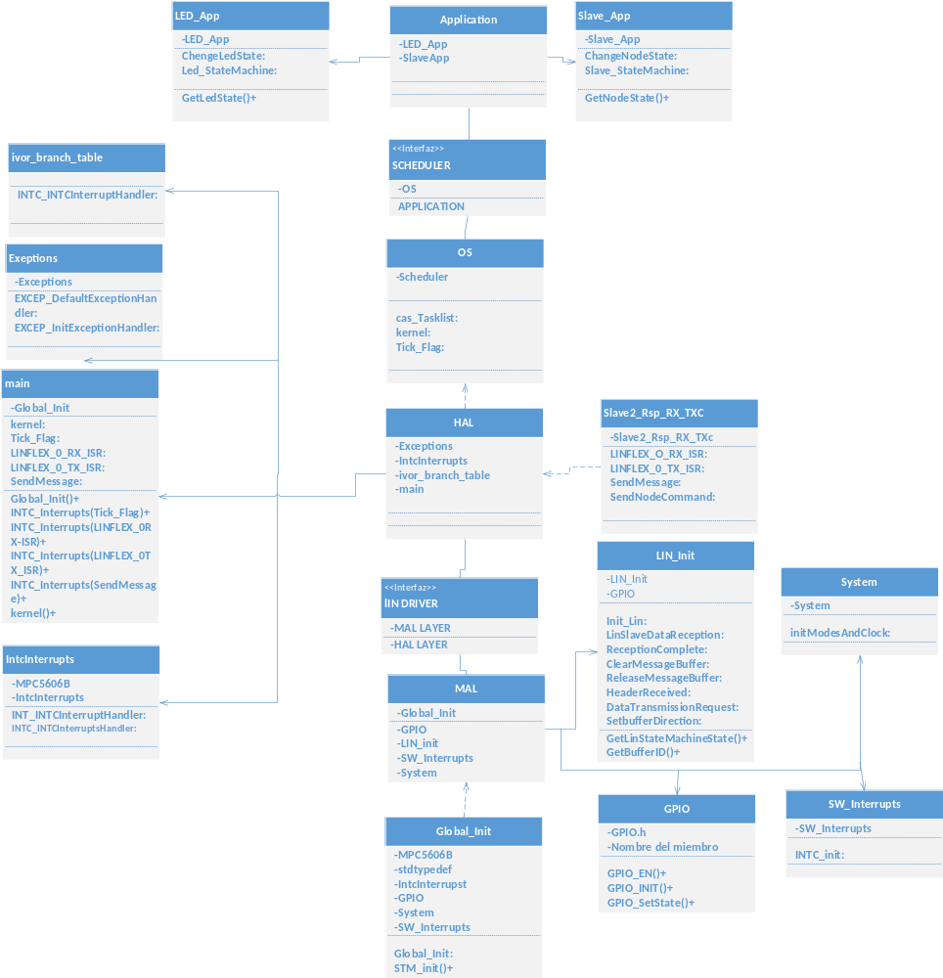

FIGURE 8: COMPONENT DIAGRAM SW

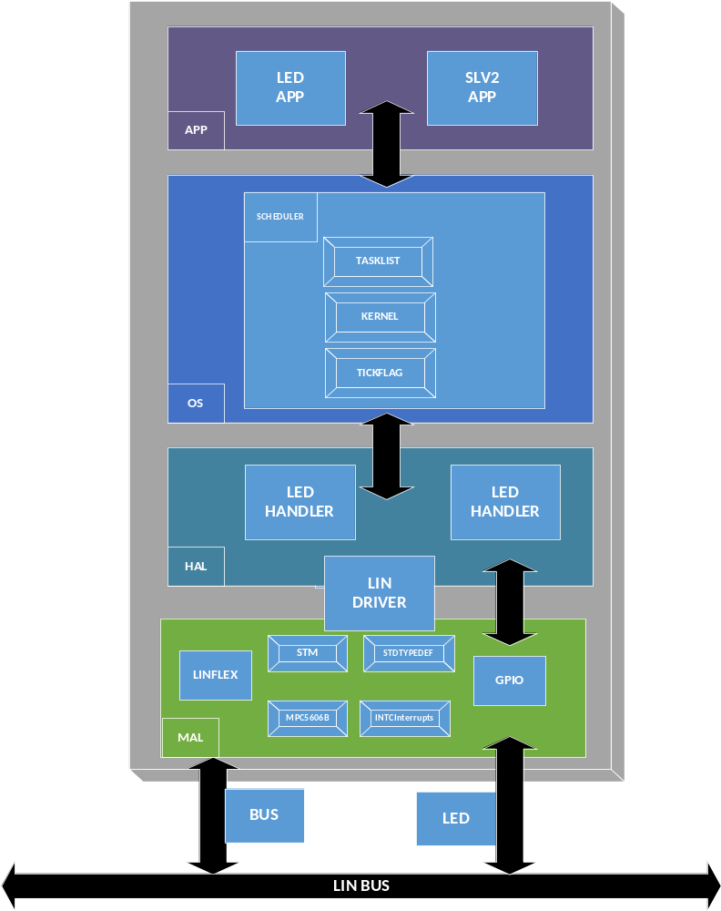

FIGURE 9: SEQUENCE DIAGRAM

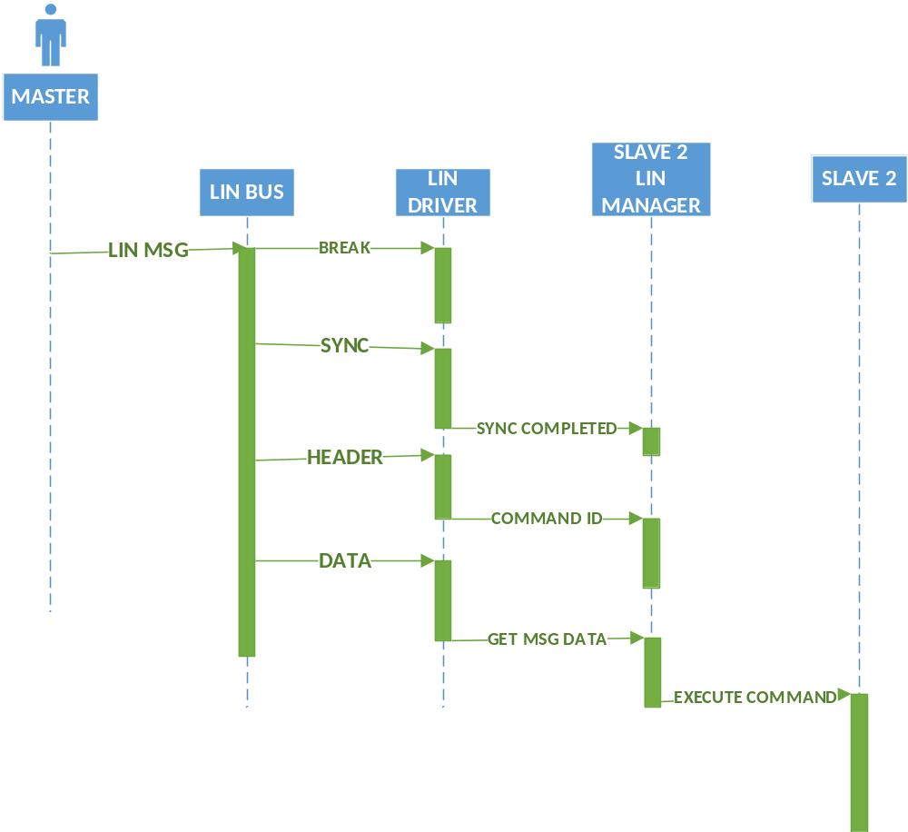

FIGURE 10: STATE MACHINE TRANSMISSION SLAVE2

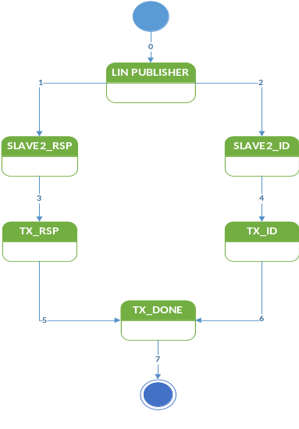

TRANSITION | CONDITION | ACTION
0 | (Signal Msg == SLAVE2_RSP)II(Signal Msg==SLAVE2_ID) | Initialize LIN Publisher.
1 | If Signal Msg == SLAVE2_RSP | Initialize SLAVE2_RSP.
2 | If Signal Msg == SLAVE2_ID | Initialize SLAVE2_ID.
3 | (ID field==valid)&&(Header==sent) | Initialize TX_RSP.
4 | (ID field==valid)&&(Header==sent) | Initialize TX_ID.
5 | Data TX_RSP==transmitted | Go to TX_Done.
6 | Data Tx_ID==transmitted | Go to TX_Done.
7 | Transmission completed. | Exit state machine.

FIGURE 11: LIN STATE MACHINE SLAVE2

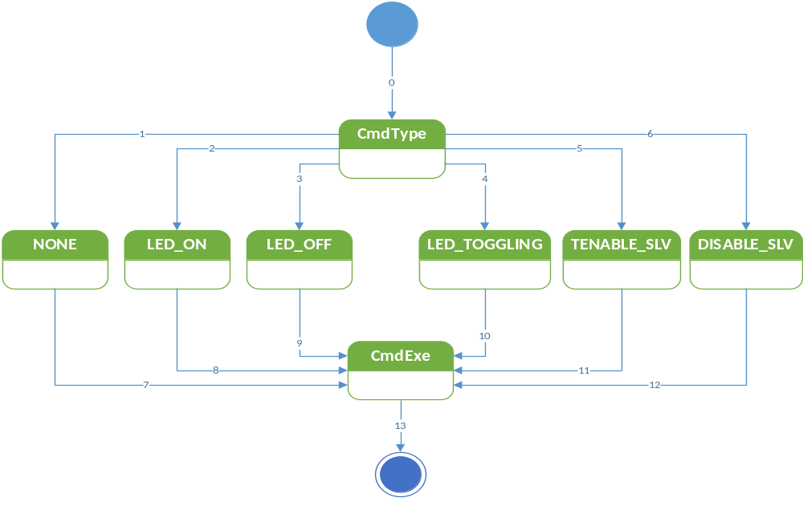

TRANSITION | CONDITION | ACTION
0 | Signal Msg == MASTER_CMD | Initialize CmdType
1 | t_cmdType==cmd_NONE | Initialize none.
2 | t_cmdType==cmd_LED_on | Initialize LED_ON
3 | t_cmdType==cmd_LED_off | Initialize LED_OFF
4 | t_cmdType==cmd_LED_toggling | Initialize LED_TOGGLING
5 | t_cmdType==cmd_enable_slv | Initialize ENABLE_SLV
6 | t_cmdType==cmd_disable_slv | Initialize DISABLE_SLV
7 | Command variable updated to None. | Go to CmdExe
8 | Command variable updated to LED on. | Go to CmdExe
9 | Command variable updated to LED off. | Go to CmdExe
10 | Command variable updated to LED toggling. | Go to CmdExe
11 | Command variable updated to Enable. | Go to CmdExe
12 | Command variable updated to Disable. | Go to CmdExe
13 | Cmd==executed. | Exit state machine.

FIGURE 12: LIN PROTOCOL STATE MACHINE

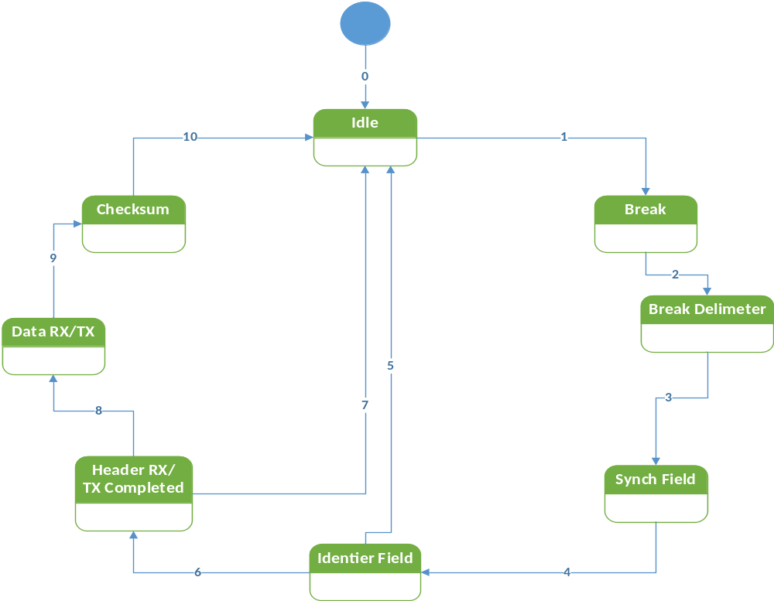

TRANSITION | ACTION
0 | Initialize Idle
1 | Go to break.
2 | Enter Break Delimiter.
3 | Enter Synch Field.
4 | Initialize Identifier Field.
5 | Return to Idle.
6 | Enter Header Rx/ Tx compl.
7 | Return to Idle.
8 | Go to Data Rx/Tx.
9 | Enter Checksum.
10 | Return to Idle.

FIGURE 13: STATE MACHINE OF MASTER NODE TRANSMISSION HANDLER

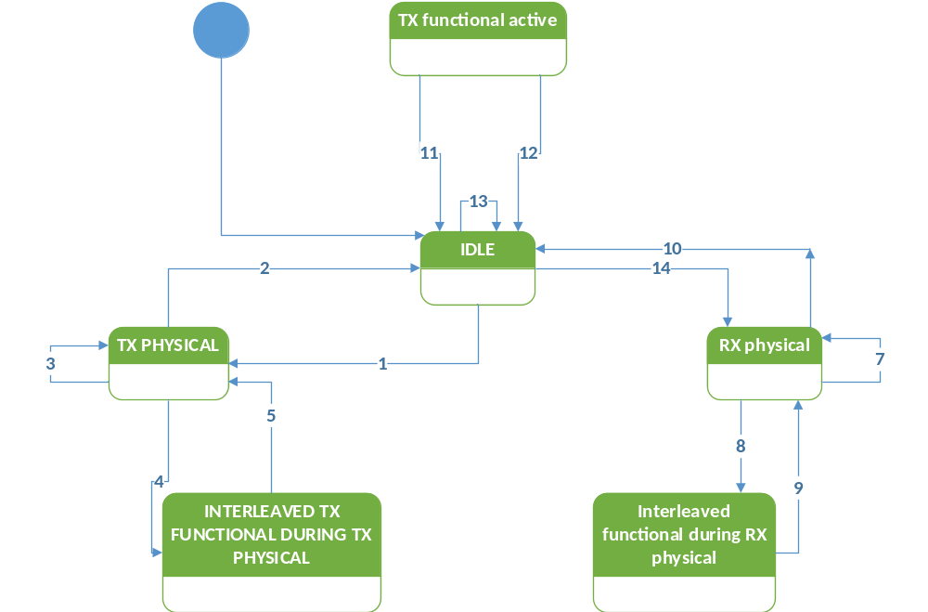

1.- IDLE STATE | Tx physical active state  Trigger:  Start of a physical transmission from the back-bone bus to a slave node.  Effect:  Start executing diagnostic master request frame schedule tables and handle the transport protocol.
2.- Tx physical active state | Idle state  Condition: routing of the physical transmission from the back-bone bus to the cluster has finshed or a transport protocol transmission error  Action: stop executing master request frame schedule tables.
3.- Tx physical active state | Tx physical active state  Condition: routing of the physical transmission from the back-bone bus to the slave node has not finished  Action: continue executing master request schedule table and handle transport protocol on LIN
4.- Tx physical active state | Interleaved functional during Tx physical state  Condition: functional addressed request from the back-bonebus has been received.  Action: interrupt the physical transmission to the slave node and execute a single master request frame schedule to transmit the functional addred request onto the cluster.
5.- interleaved functional during Tx physical state | Tx physical active state  Condition: functional addressed request has been routed onto the cluster.  Action: continue the interrupted physical transmission to the slave node.
6.- Tx physical active state | Rx physical active state  Condition: functional transmission to the slave node has been successfully completed (according to the transport layer specification).  Action: stop executing master request frame schedule tables, start executing slave response frame schedule tables and handle the incoming response from the previously addressed slave node.
7.- interleaved functional during Rx physical state | Rx physical active state  Condition: functional addressed request has been routed onto the cluster.  Action: restart executing slave response frame schedules and continue the interrupted reception from the slave node.

FIGURE 14: LED HANDLER

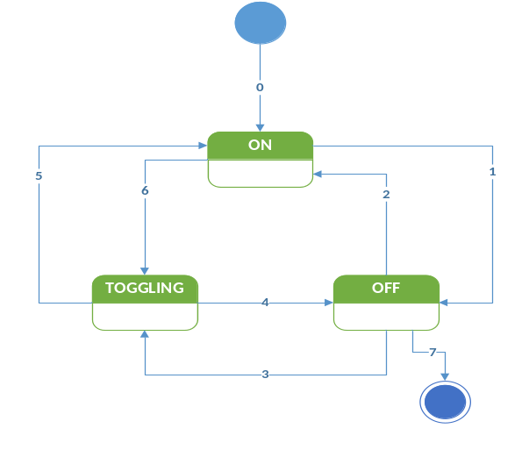

TRANSITION | ACTION
0 | Default state is ON
1 | Go to OFF
2 | Return to ON.
3 | Set to TOGGLING
4 | Go to OFF.
5 | Go to ON.
6 | Go to TOGGLING.
7 | Exit the state machine.

FUNCTIONS MAL LAYER

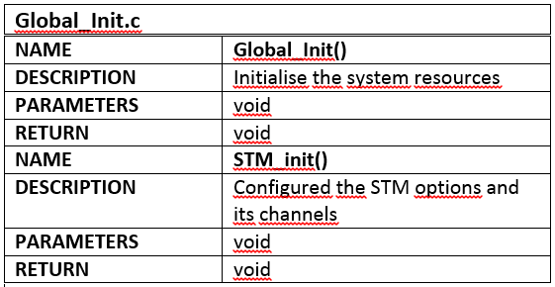

GPIO.C
NAME | GPIO_EN
DESCRIPTION | Program the drive enable pin
PARAMETERS | T_SWORD ch, T_ULONG state
RETURN | void
NAME | GPIO_INIT()
DESCRIPTION | Call GPIO_EN for the ports that will be used
PARAMETERS | void
RETURN | void
NAME | GPIO_SetState()
DESCRIPTION | Set the value received to the pin specified in ch
PARAMETERS | T_UWORD, T_UBYTE
RETURN | void

LIN_Init.c
NAME | Init_Lin()
DESCRIPTION | -Send Init mode request  -INIT_MODE /*SLEEP=0, INIT=1*/  -Enable LIN transmission cannel 0  -Config Baud rate  -Enter normal mode with filters  -Master CMD for all filters  -Master CMD slv2 filter  -Slv2 automatic resynch enable
PARAMETERS | Void
RETURN | Void
NAME | LinSlaveDataReception()
DESCRIPTION | Receive the Buffer data register least significant field (BDRL) Data 0 to data 7
PARAMETERS | Unsigner char
RETURN | Void
NAME | GetLINStateMachineState()
DESCRIPTION | LINSR Lin Status Register  Describe LINFLEX LIN STATUS
PARAMETERS | Unsigned char
RETURN | void
NAME | ReceptionComplete()
DESCRIPTION | Program the drive enable pin
PARAMETERS | Void
RETURN | void
NAME | HeaderReceived()
DESCRIPTION | This bit is set by hardware and indicates a valid header reception is completed. This bit must be cleared by software.
PARAMETERS | Void
RETURN | Void

NAME | INTC_init()
DESCRIPTION | Activates the use of interrupts
PARAMETERS | Void
RETURN | void

System.c
NAME | InitModesAndClock()
DESCRIPTION | Initialise the modes and clock of the MPC5606B
PARAMETERS | Void
RETURN | void

FUNCTIONS OS LAYER

NAME | Kernel()
DESCRIPTION | This function starts by doing an indexing of the task, assigning the offset. This process occurs only once in each execution of the code.  Then an infinite loop starts, the tick of the scheduler is defined by a flag called ub_TickFlag, which was configured to raise every millisecond. Once it was acquired it is restarted to zero. Now, inside the if there is a for cycle which who through all the task accessing to their offset with and if, whenever the offset is over zero it will decrease, for every task. When one of the offset, of whichever task, reach zero, the else of the if will be active and will stablish the period of the task and will call it using the pointer previously defined.
PAAMETERS | void
RETURN | void

NAME | Tick_Flag()
DESCRIPTION | Check if the cannel 0 of the STM as reached 1ms and raise a flag when reached
PARAMETES | Void
RETURN | void

FUNCTIONS HAL LAYER

NAME | LINFLEX_0_RX_ISR()
DESCRIPTION | Modified rx_data – receive data  Switch select both  -master cmd all  -master cmd slv2 id
PARAMETERS | None
RETURN | none
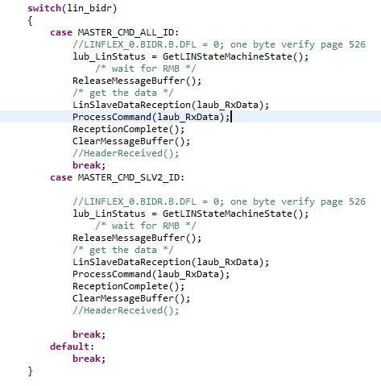

NAME | LINFLEX_0_TX_ISR()
DESCRIPTION | Modified tx_data – transmit data  Switch select both  -master cmd slave2 rsp id  -master cmd slave id id “F,J,Q,D,A,D”
PARAMETERS | None
RETURN | none
CODE
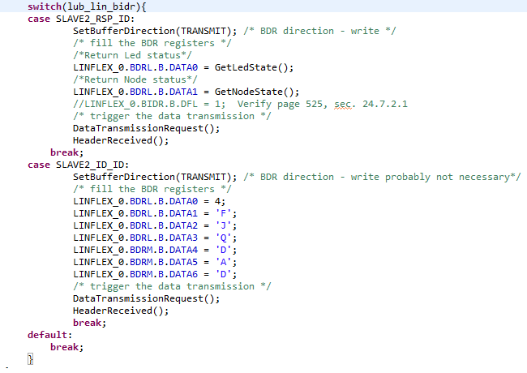

NAME | SendMessage()
DESCRIPTION | Emulates the master commands of function ProcessComman by using the third switch of the board. When switch is pressed and interrupt take place. Each command correspond to a value of counter variable. This function was created for testing purposes to verify the correct functionality of the state machines.
PARAMETERS | Void
RETURN | Void
CODE
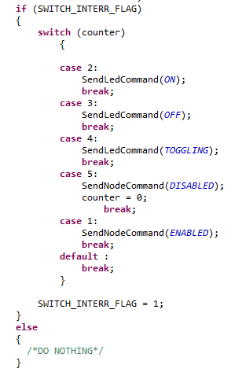

NAME | ProcessCommand()
DESCRIPTION | Reads the response of the master and determines which command the slave will execute: whether to do nothing, request the Led_StateMachine to turn on/off or toggle, or request the Node_StateMachine to disable or enable the node.
PARAMETERS | Void
RETURN | Void
CODE
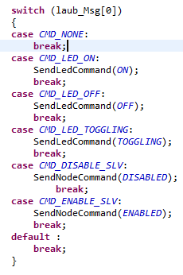

FUNCTIONS APPLICATION LAYER

NAME | ChangeLedState()
DESCRIPTION | Change the state variable depending on the command.
PARAMETERS | T_UBYTE  POSIBLE STATES: OFF, ON, TOOGLE
RETURN | VOID

NAME | LED_STATEMACHINE()
DESCRIPTION | This state machine will be called every 1ms. Initial state is OFF. Led variable state could have three states: OFF, ON, and TOGGLING. If the node is enabled then the master command is listened. When the command is received the rub_LedFlag is changed depending on the command. The state variable will be changed in the subsequent tick. If the node is disable, the current state is kept, until a different command, when node is enabled, is listened.
PARAMETERS | VOID
RETURN | VOID

NAME | SLAVE_STATEMACHINE()
DESCRIPTION | This state machine will be called every 500ms. Initial state is DISABLE. Node variable state could have two states: DISABLED and ENABLED. When master commands, the state variable is changed by using rub_NodeFlag variable that is the command.
PARAMETERS | VOID
RETURN | VOID

