Title: | LIN_Protocol_ver 2.2A  SW Component LIN_Protocol

Maturity: | Draft
Authors: | David Antonio Diaz Ramirez
Authors: | Francisco Javier Quirarte Pelayo
VERSION: | Public
Security Classification: | None

History
Issue status  (Index) | Maturity/Date  (draft/invalid/valid)  (dd-mmm-yyyy) | Author  Department | Check/Release  Department | Description
1.0 | Draft  26-nov-15 | Francisco Quirarte | Francisco Quirarte y David Díaz | Creation of the document.
History
Issue status  (Index) | Maturity/Date  (draft/invalid/valid)  (dd-mmm-yyyy) | Author  Department | Check/Release  Department | Description
2.0 | Draft  27-nov-15 | David Díaz | Francisco Quirarte | Added: Purpose, Definitions and abbreviations.
History
Issue status  (Index) | Maturity/Date  (draft/invalid/valid)  (dd-mmm-yyyy) | Author  Department | Check/Release  Department | Description
3.0 | Draft  28-Nov-15 | Francisco Quirarte y  David Díaz | Francisco Quirarte | Added: Realization constraints and targets.
History
Issue status  (Index) | Maturity/Date  (draft/invalid/valid)  (dd-mmm-yyyy) | Author  Department | Check/Release  Department | Description
4.0 | Draft  29- Nov -15 | Francisco Quirarte y  David Díaz | Oswaldo Garcia | Added: SW Conceptual design.

History
Issue status  (Index) | Maturity/Date  (draft/invalid/valid)  (dd-mmm-yyyy) | Author  Department | Check/Release  Department | Description
6.0 | Draft  30-nov-15 | Francisco Quirarte y  David Díaz | Luis Alvarez | Review of SW Component internal breakdown and added general corrections.  General corrections at traceability matrix

History
Issue status  (Index) | Maturity/Date  (draft/invalid/valid)  (dd-mmm-yyyy) | Author  Department | Check/Release  Department | Description
7.0 | Release  30-Nov-15 | Francisco Quirarte y  David Díaz | Oswaldo Garcia e  Isamar Gálvez | Review of SW Conceptual design and added general corrections.

Table of Contents
1 Introduction 13
2 Purpose 14
3 Comparison chart protocols 15
4 LIN Protocol Concepts 15
4.1 Single Master Multiple Slaves 15
4.2 Variable Length of Data Frames 16
4.3 Multi-cast Reception 16
4.4 Time Synchronization without Need for Quartz or Ceramic Resonators in the Slave Nodes 16
4.5 Data Checksum Security and Error Detection 16
4.6 Detection of Defect Nodes in the Network 16
4.7 Minimum Cost Solution 16
5 Chart Concepts 17
5.1 Figure 1. LIN Message Frame 17
5.2 Figure 2. LIN Byte Field 17
5.3 Figure 3. Synch Break Field 18
5.4 Figure 4. Synch Field 18
5.5 Figure 5. Identifier Field 18
5.6 Figure 6. Data Field 18
5.7 Figure 7. Checksum Field 18
5.8 Figure 8. Sleep Mode Frame 19
5.9 Figure 9. Wake-up Signal Frame 19
6 Definitions and abbreviations 19
6.1 Definitions 19
6.2 Abbreviations 20
6.3 References 21
7 LIN Software Driver Services 22
The LIN driver provides several API-functions for LIN bus handling. The main services of the LIN software driver are: 22
• Message transmission 22
• Message reception 22
• Message filtering 22
• Connect/disconnect the LIN node to the LIN bus 22
• Sending "go to sleep mode" command 22
• Sending "wake up" command 22
• Bus timeout detection 22
• Frame monitoring 22
• ID field calculation 22
• Data length extraction 22
• Checksum calculation 22
• LIN message scheduler. 22
7.1 LIN Software Driver Requirements 22
The LIN software driver requires CPU processing time as well as hardware resources like peripherals, code/data memory, and interrupts nodes. The exact requirements are listed next. 22
7.2 Hardware Requirements 22
LIN utilizes the serial interface for message frame generation and additionally occupies one timer channel for LIN bus timing monitoring e.g. for detection of not responding slaves or no bus activity. Both peripherals require an interrupt handler, with main processes of the LIN software driver being executed from the interrupt handler of the serial communication channel peripheral. 22
7.3 Memory Requirements 22
The software driver occupies less than 3 kBytes of code memory and less than 100 bytes of data memory. These numbers include all the basic LIN software driver functions. Application specific user LIN message buffers require additional memory space. 22
7.4 Slave task: 23
1. Receive-ID-Field (message filtering), copy data to LIN transfer buffer and send first databyte 23
2. Receive first databyte and send second data byte 23
3. Receive second databyte and send third data byte 23
4. Receive third databyte and send fourth data byte 23
5. Receive fourth databyte and calculate / send checksum-field 23
6. Receive-Checksum 23
This bus configuration is running at a baudrate of 19.2 kBaud. The length of one message frame is about 4.5 ms. the required CPU time for a LIN frame generation depends strongly on the number of declared ID’s. Within the example network, 16 identifiers are defined. During the states 1 to 9, the CPU of the master LIN node is busy processing LIN driver operations. The overall processing time for the LIN software driver is 110 µs (fCPU = 20 MHz). While sending and receiving a LIN message frame the total CPU load of the LIN master node is below 3%. 23
8 The ISO/OSI reference model and LIN 23
8.1 Figure 10: reference model ISO/OSI LIN 23
9 Software Layers 24
9.1 Figure 11: Layers 24
9.2 Layer descriptions 25
Layer 25
Description 25
Application Layer 25
This layer correspond to the application functionally which uses the LIN data being received by LIN and writes the data being transmitted by LIN. 25
LIN Master Node Layer 25
This layer implements the functionally of the LIN Master node 25
LIN common layer 25
This layer provides implementation of functionally that is common either for a LIN master node or a LIN slave node. 25
UART Layer 25
This layer implements all UART related interfaces to be used by the LIN functionally 25
9.3 Functional Blocks Descriptions 25
10 LIN NETWORK 27
11 Realization constraints and targets 29
11.1 Network Graphical Description 31
11.1.1 Figure 11: Deployment Diagram (A) 31
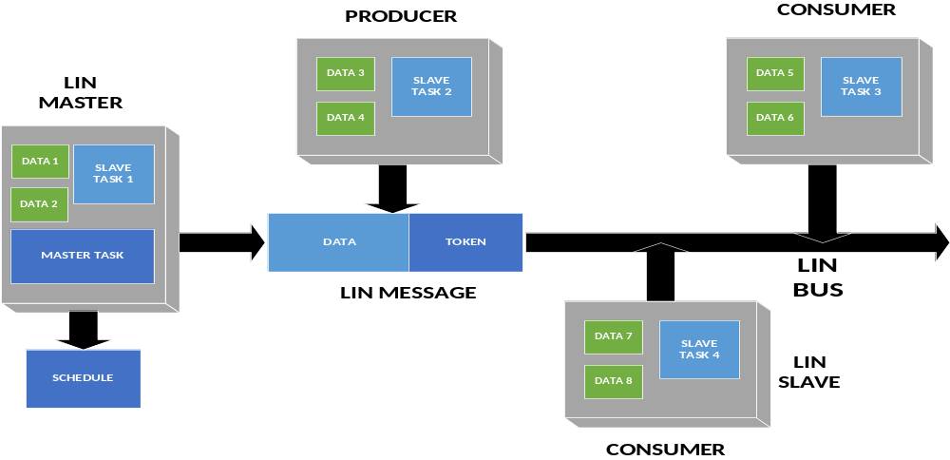 31
Deployment Diagram. Represents the physical configurations of software and hardware items. 31
11.2 Use Case Diagram 32
11.2.1 Figure 12: Use Case Diagram 32
11.3 Component diagram request & response (A/D) 33
11.3.1 Figure 3: Component diagram (A/D). 33
11.3.2 Figure: Components Descriptions 33
11.3.3 Component diagram SW 35
11.4 Activity Diagram (R) 36
11.5 SEQUENCE 39
11.6 Response Sequence Diagram 40
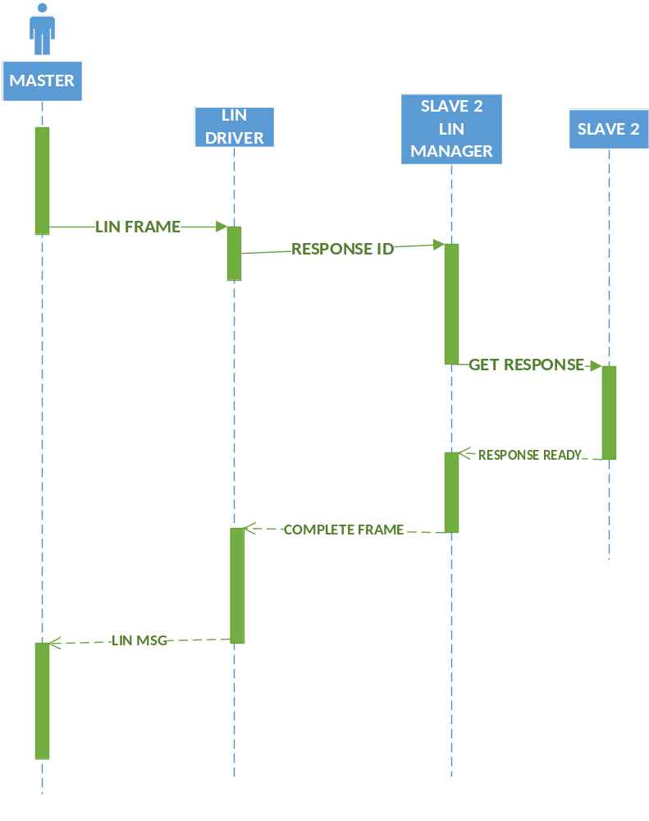 40
11.7 State machine diagram 41
11.7.1 Slave 2 41
11.7.2 Lin manager 42
11.7.3 LIN Handler 44
11.7.4 Master node transmission handler 45
11.7.5 LED Handler 47
12 Application Program Interface Specification ver. 2.2a 48
12.1 CORE API 48
Name 48
Prototype 48
Description 48
L_sys_init 48
L_bool l_sys_init (void); 48
Performs the initialization of the LIN core. The scope of the initialization is the physical node. 48
Static Prototype 48
Dynamic Prototype 48
None 48
None 48
Name 49
Prototype 49
Description 49
Scalar signal read 49
Reads and returns the current value of the signal 49
Static Prototype 49
Dynamic Prototype 49
L_bool l_bool_rd_read (void); 49
L_bool l_bool_rd (l_signal_handle read); 49
L_u16 l_u16_rd (l_signal_handle read); 49
Name 49
Prototype 49
Description 49
Scalar signal write 49
Sets the current value of the signal to v. 49
Static Prototype 49
Dynamic Prototype 49
Void l_bool_wr (l_signal_handle write, l_bool v); 49
Name 50
Prototype 50
Description 50
Byte array read 50
Reads and returns the current values of the selected bytes in the signal. 50
Static Prototype 50
Dynamic Prototype 50
Void l_bytes_rd (l_signal_handle data_read, 50
Name 50
Prototype 50
Description 50
Byte array write 50
Sets the current value of the selected bytes in the signal specified by the name write data to the value specified. 50
Static Prototype 50
Dynamic Prototype 50
Name 51
Prototype 51
Description 51
L_flg_tst 51
Static Prototype 51
Dynamic Prototype 51
Name 51
Prototype 51
Description 51
L_flg_clr 51
Sets the current value of the flag specified by the name clear_flag to zero 51
Static Prototype 51
Dynamic Prototype 51
Name 52
Prototype 52
Description 52
L_flg_tick 52
Static Prototype 52
Dynamic Prototype 52
Name 52
Prototype 52
Description 52
L_sch_set 52
Sets up the next schedule to be followed by the l_sch_tick function for a certain interface tickflg. The new schedule will be activated as soon as the current schedule reaches its next schedule entry point. 52
Static Prototype 52
Dynamic Prototype 52
Name 53
Prototype 53
Description 53
L_ifc_goto_sleep 53
Static Prototype 53
Dynamic Prototype 53
Name 53
Prototype 53
Description 53
L_ifc_wake_up 53
The function will transmit one wake up signal. The wake up signal will be transmitted directly when this function is called. It is the responsibility of the application to retransmit the wake up signal according to the wake up sequence defined 53
Static Prototype 53
Dynamic Prototype 53

Introduction

This application note shows how to implement a LIN (Local Interconnect Network) slave task in a 32-bit RISC microcontroller without the need for any external components. The LIN protocol is a serial communications protocol which efficiently supports control of mechatronic nodes in a distributed network. This makes the protocol ideal for use in automotive applications. A LIN network consist of a single Master and a set of Slave nodes. This application note show how to implement the protocol for the physical layer and the data link layer according to the two lowest levels of the ISO/OSI reference model. This provides the foundation for message transmissions between nodes in the network. The physical layer of the ISO/OSI model only provides a raw bit-stream between two nodes in the network. The data link layer makes the physical layer reliable by adding error detection and control. It also adds the means to activate, maintain, and deactivate the link. The higher levels of the ISO/OSI reference model is beyond the scope of the LIN protocol and thus not explained here. For now, this is up to the user to specify and implement. The LIN protocol differs from the CAN protocol in the sense that it is below the performance and scope of the CAN. Its strongpoint is that it is provides a simple, low-cost solution for applications not requiring the power of the CAN protocol.

Purpose

Bus Local Interconnect Network, LIN usually abbreviated Bus is a system used in current data transmission networks Automotive System. SPECIFICATION meets the LIN consortium, in its first version 1.1, released in 1999. The specification has been developed from then to version 2.0 para solve the current needs of a red. The LIN bus is a little slow system that USING As a cheap bus para- red sub ​​UN can integrate smart devices or actuators in today's cars.

Is a concept for low cost automotive networks, which complements the existing portfolio of automotive multiplex networks. LIN will be the enabling factor for the implementation of a hierarchical vehicle network in order to again further quality enhancement and cost reduction of vehicles. The standardization will reduce the manifold of existing low-end multiplex solutions and will cut the cost of development, production, service and logistics in vehicle electronics.

Comparison chart protocols
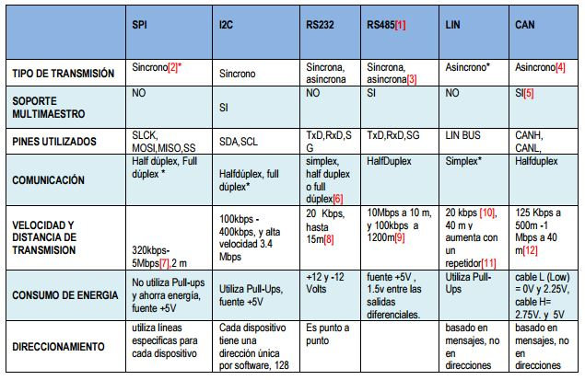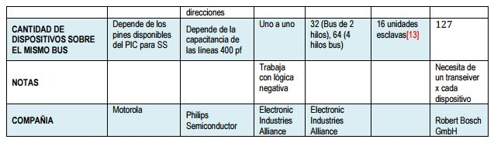

LIN Protocol Concepts

Single Master Multiple Slaves
The LIN protocol does not use bus arbitration. A single Master is responsible for initializing all message transfers. All slaves can respond to the Master or any other node in the network but only after being addressed and given permission by the Master.

Variable Length of Data Frames
Included in the identifier field are two bits indicating the length of the message field (see Table 1). This adds flexibility and reduces overhead bytes when only a limited amount of data is required.

Multi-cast Reception
When a message frame is transmitted from the Master or a Slave task, all connected nodes in the network can read the message. Depending on the identifier byte, the receiving nodes decides if any action is to be initiated or not. For example, a single “CLOSE ALL” command from the Master could be accepted from all nodes and could in the case of a car security system close all windows and doors.

Time Synchronization without Need for Quartz or Ceramic Resonators in the Slave Nodes
After the Synch Break, a Synch Field is transmitted from the Master, this field makes it possible for all the Slaves to synchronize to the master clock. Such synch fields are placed at the beginning of every message frame. The accuracy of the receiving Slaves need only be good enough to keep synchronization through the entire message frame. This feature allows the slave to run on an internal RC Oscillator thus reducing the overall system cost.

Data Checksum Security and Error Detection
The data in the message frame uses an inverted modulo256-checksum with the carry of the MSB added to the LSB for error detection. In addition, the identifier byte uses a XOR algorithm for error detection.

Detection of Defect Nodes in the Network
The Master task is responsible for initiating the transmission of message frames and thus has the responsibility of requesting information and checking that all nodes are alive and working correctly.

Minimum Cost Solution
Due to the simplicity of the protocol, a slave task complying to the LIN standard can be built using a minimum of external components and does not put heavy constraints on the accuracy of the Oscillator in the Slave nodes.

Chart Concepts
In the following chart will describe the concepts LIN protocol:

Signal Transmission | The LIN bus consists of a single channel that carries both data and synchronization information. The physical medium is a single wire connected to VCC via a pull-up resistor (see Figure 1). The idle state on the bus is high or “recessive” and the active state is low or “dominant”. In automotive applications VCC will typically be the positive battery node. The LIN protocol does not define an acknowledgment procedure for the Slave tasks. The Master task uses its own slave task to verify that the sent message frame is identical with the one received by this slave task. If any discrepancy is detected the message frame can be retransmitted. The data rate for transmitted data is limited to 20 Kbits/s due to EMI (Electro Magnetic Interference) requirements for a single wire transmission medium.
Message Frames  Figure 1. LIN Message Frame  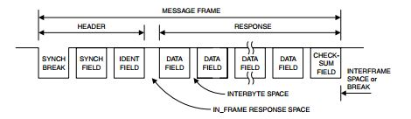 | All information transmitted on the LIN bus is formatted as Message Frames. As shown in Figure 2, a Message Frame consists of the following fields:  • Synch Break  • Synch Field  • Identifier Field  • Data Field  • Checksum Field
Byte Fields  Figure 2. LIN Byte Field  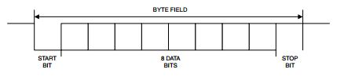 | The Byte Field format, shown in Figure 3, is identical to the commonly used UART serial data format with 8N1 coding. This means that each Byte Field contains eight data bits, no parity bits, and one stop-bit. Every Byte Field has the length of 10 bit-times (Tbit). As shown in the figure, the start bit marks the beginning of the Byte Field and is “dominant” while the stop-bit is “recessive”. The eight data bits can be either “dominant” or “recessive”.

Synch Break  Figure 3. Synch Break Field  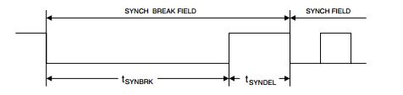 | The Synchronization Break marks the beginning of a Message Frame. This field is always sent by the Master task, and provide a means for the Slave task to prepare for the synchronization field. The Synch Break consists of two different parts: a dominant (low) level that should be minimum 13 bit-times (Tbit) which is followed by a recessive (high) period that should be in the range one to four Tbit. The second field is necessary to detect the dominant (low) level of the start bit of the following Synch Field.
Synch Field  Figure 4. Synch Field  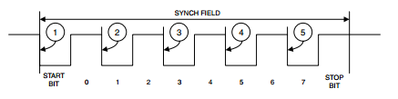 | The Synch Field contains the signaling required for the slave to synchronize with the master clock. The Synch Field is a Byte Field containing the data “0x55” giving the waveform shown in Figure 4.
Identifier Field  Figure 5. Identifier Field  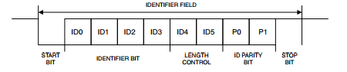 | The Identifier Field contains information about contents and length of a message. As shown in Figure 6, this field is divided into three sections: identifier bits (four bits), length control bits (two bits) and parity bits (two bits). This divides the set of 64 identifiers into four subsets of 16 identifiers each.
Data Field  Figure 6. Data Field  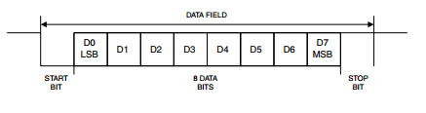 | The data frame contains from two to eight Data Fields containing eight bits of data each. Transmission is done with LSB first. The data fields are written by the responding Slave task. Since there is no bus arbitration, only one slave task should be allowed to respond to each identifier. All other Slave tasks are limited to reading the response and act accordingly.

Checksum Field  Figure 7. Checksum Field  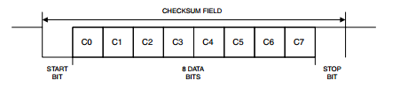 | The last field in the Message Frame is the Checksum Field. This byte contains the inverted modulo-256 sum of all data bytes (data frame not including the identifier). This sum is calculated by doing an “ADD with carry” on all data bytes and then inverting the answer. The properties of the inverted modulo-256 sum are such that if this number is added to the sum of all data bytes the result will be “0xFF”.
Sleep Mode Frame  Figure 8. Sleep Mode Frame  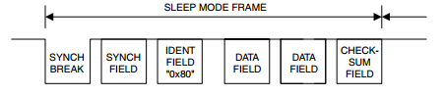 | The frame structure for the Sleep Mode Frame is identical to an ordinary Message Frame and is distinguished by the identifier byte “0x80”. The contents of the data fields are not specified and could be used to distribute system parameters for the sleep mode.
Wake-up Signal  Figure 9. Wake-up Signal Frame  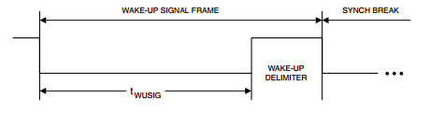 | The sleep mode can be terminated by any connected slave task by sending a wake-up signal. The wake-up signal is only allowed when the bus is in sleep mode and a node internal request for wake-up is pending. The wake-up signal is the character “0x80”.

Definitions and abbreviations

Definitions

LIN 2.2A | Serial network protocol used for communication between components in vehicles
Master (node) | Node chosen to control all communications. Bus arbiter.
Slave (node) | Node that responds to the master in three possible ways: Receive data, transmit data or ignore data.

Abbreviations

LIN | Local Interconnect Network
RX | Reception
TX | Transmission
MSTR | Master
SLV | Slave
MSG | Message
HAL | Hardware Abstraction Layer
LIN | Local Interconnect Network
CAN | Controller Area Network
ECU | Electronic Control Unit
API | Application User Interface
IDE | Integrated Development Enviroment
UART | Universal Asynchronous Receiver Transmitter
ASC | Async/Synchronous Serial Interface
ID | Identifier
EMI | Electro Magnetic Isolation
t_slv_stat | Signal to display slave node status.
t_cmdType | Signal to control LED states and slave node state.
t_LEDstat | Signal to display LED status.
t_boolean | Signal response that indicates slave node status.
array | Signal that contains the team member’s initials for the Msg ID.
scalar | Signal that contains the team assigned number for the Msg ID

References

N° | Document name
1 | Traceability Matrix Template.xls
2 | MPC5604B/C Microcontroller Reference Manual.pdf
3 | Test_template.xls
4 | http://www.freescale.com/products/power-architecture-processors/mpc5xxx-5xxx-32-bit-mcus/mpc56xx-mcus/mpc5606b-startertrak-development-kit:TRK-MPC5606B
5 | http://www.freescale.com/products/power-architecture-processors/mpc5xxx-5xxx-32-bit-mcus/mpc56xx-mcus/ultra-reliable-mpc56xb-mcu-for-automotive-industrial-general-purpose:MPC560xB#pspFeatures
6 | SW_C_Code_Review_Template.docx
7 | Window-lifter-requirements.docx
8 | LIN Protocol_Conti.ppt
9 | LIN_Network_Database
10 | LIN-Spec_2-2A.doc
11 | LIN-Spec_2-2A.pdf
12 | http://www.atmel.com/images/doc1637.pdf

LIN Software Driver Services

The LIN driver provides several API-functions for LIN bus handling. The main services of the LIN software driver are:

• Message transmission

• Message reception

• Message filtering

• Connect/disconnect the LIN node to the LIN bus

• Sending "go to sleep mode" command

• Sending "wake up" command

• Bus timeout detection

• Frame monitoring

• ID field calculation

• Data length extraction

• Checksum calculation

• LIN message scheduler.

LIN Software Driver Requirements

The LIN software driver requires CPU processing time as well as hardware resources like peripherals, code/data memory, and interrupts nodes. The exact requirements are listed next.

Hardware Requirements

LIN utilizes the serial interface for message frame generation and additionally occupies one timer channel for LIN bus timing monitoring e.g. for detection of not responding slaves or no bus activity. Both peripherals require an interrupt handler, with main processes of the LIN software driver being executed from the interrupt handler of the serial communication channel peripheral.

Memory Requirements

The software driver occupies less than 3 kBytes of code memory and less than 100 bytes of data memory. These numbers include all the basic LIN software driver functions. Application specific user LIN message buffers require additional memory space.

Slave task:

1. Receive-ID-Field (message filtering), copy data to LIN transfer buffer and send first databyte

2. Receive first databyte and send second data byte

3. Receive second databyte and send third data byte

4. Receive third databyte and send fourth data byte

5. Receive fourth databyte and calculate / send checksum-field

6. Receive-Checksum

This bus configuration is running at a baudrate of 19.2 kBaud. The length of one message frame is about 4.5 ms. the required CPU time for a LIN frame generation depends strongly on the number of declared ID’s. Within the example network, 16 identifiers are defined. During the states 1 to 9, the CPU of the master LIN node is busy processing LIN driver operations. The overall processing time for the LIN software driver is 110 µs (fCPU = 20 MHz). While sending and receiving a LIN message frame the total CPU load of the LIN master node is below 3%.

The ISO/OSI reference model and LIN

Figure 10: reference model ISO/OSI LIN

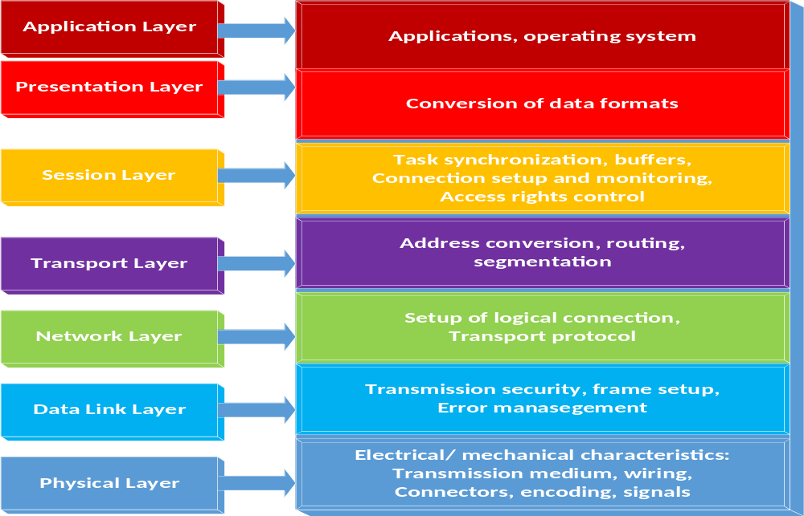

Software Layers

Figure 11: Layers

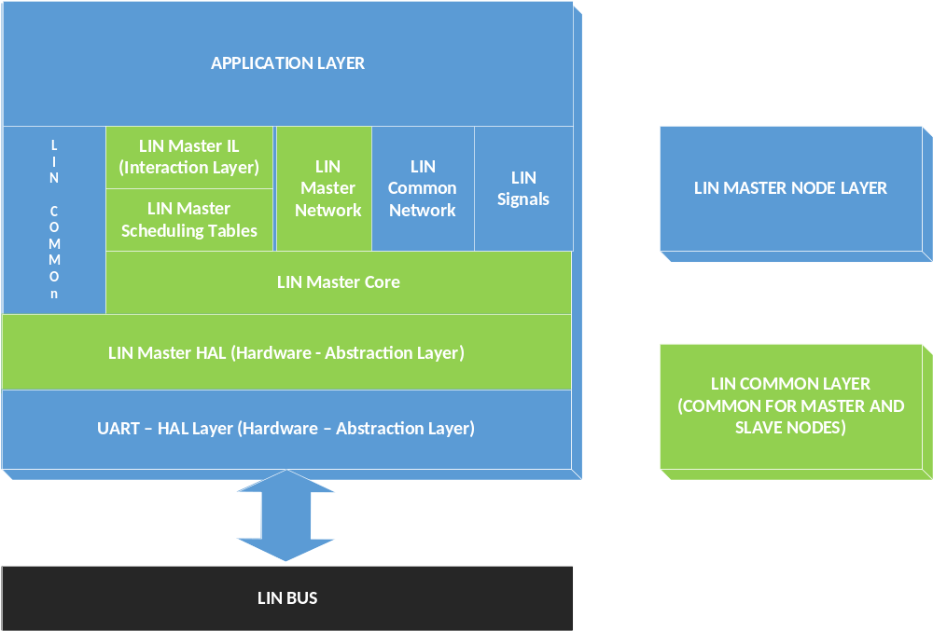

Layer descriptions
Layer | Description
Application Layer | This layer correspond to the application functionally which uses the LIN data being received by LIN and writes the data being transmitted by LIN.
LIN Master Node Layer | This layer implements the functionally of the LIN Master node
LIN common layer | This layer provides implementation of functionally that is common either for a LIN master node or a LIN slave node.
UART Layer | This layer implements all UART related interfaces to be used by the LIN functionally

Functional Blocks Descriptions

Functional Block Name | Description | Related source code files
LIN Master IL | Provides the “skeleton” of the callbacks being called by the Lin master node. Some of those callbacks are associated to messages defined in the LIN network so this file changes defined in the LIN network | LIN_mstr_hal.c  LIN_mstr_hal.h
LIN Master Network | Defines and implements all functionality related to the LIN messages of the network where the master node is connected. This file changes each time any of the the LIN messages changes in the LIN network definition. | LIN_mstr_network.c LIN_mstr_network.h
LIN Master Scheduling Tables | Defines and implements all functionality related to the LIN master scheduling tables. This file changes each time a scheduling table or messafe changes in the LIN network | LIN_mstr_sched.c  LIN_mstr_sched.h
LIN Master Core | Implements the core functionality of the LIN master node, i.e., the functionality for sending and receiving LIN frames. This functionality does not depend on the LIN network definition so it does not change upon changes of it | LIN_mstr_core.c LIN_mstr_core.h
LIN Master HAL | Implements the interfaces of the LIN master core functionality with the UART hardware. | LIN_mstr_hal.c  LIN_mstr_hal.h
LIN Common | Provides functionality that is common among any node of the LIN network, i.e., either the master node or any slave node. For example, the checksum calculation is implemented in this functional block. | LIN_common.c  LIN_common.h
LIN Common Network | Provides definitions of the LIN network which is common to all LIN nodes (master and slaves). For example, the ID and data length of the messages, etc. | LIN_common_network.h
LIN Signals | Provides data structures to ease the access of the individual signals of the LIN frames. | LIN_signals.h
UART HAL | Implements the API’s for sending and receiving bytes with the UART hardware. | UART_hal.c  UART_hal.h

LIN NETWORK
Messages defined for this network.

Msg ID | Msg Name | Msg Data Length (byte) | Msg Publisher | Msg Subscribers | Msg Callback
CF | MASTER_CMD_ALL | 1 | MASTER | SLAVE1, SLAVE2, SLAVE3, SLAVE4 | Auto
50 | MASTER_CMD_SLV1 | 1 | MASTER | SLAVE1 | Auto
11 | MASTER_CMD_SLV2 | 1 | MASTER | SLAVE2 | Auto
92 | MASTER_CMD_SLV3 | 1 | MASTER | SLAVE3 | Auto
D3 | MASTER_CMD_SLV4 | 1 | MASTER | SLAVE4 | Auto
20 | SLAVE1_RSP | 2 | SLAVE1 | MASTER | Auto
61 | SLAVE2_RSP | 2 | SLAVE2 | MASTER | Auto
E2 | SLAVE3_RSP | 2 | SLAVE3 | MASTER | Auto
A3 | SLAVE4_RSP | 2 | SLAVE4 | MASTER | Auto
F0 | SLAVE1_ID | 7 | SLAVE1 | MASTER | Auto
B1 | SLAVE2_ID | 7 | SLAVE2 | MASTER | Auto
32 | SLAVE3_ID | 7 | SLAVE3 | MASTER | Auto
73 | SLAVE4_ID | 7 | SLAVE4 | MASTER | Auto

Messages used for and by slave 2

Signal Types defined for this network.

Type Name | Elements…
 | 0 | 1 | 2 | 3 | 4 | 5
t_slv_stat | Disabled | ENABLED
t_cmdType | cmd_NONE | cmd_LED_on | cmd_LED_off | cmd_LED_  toggling | cmd_disable  _slv | cmd_enable_slv
t_LEDstat | OFF | ON | TOGGLING
t_target_active | INACTIVE | ACTIVE
t_boolean | FALSE | TRUE

Signals defined for this network.

Signal Name | Signal Msg | Signal Start Byte | Signal Start Bit | Signal Len (bits) | Signal Type | Signal Endianess
master_cmdForAll | MASTER_CMD_ALL | 0 | 0 | 4 | t_cmdType | LE
master_cmdForSlave1 | MASTER_CMD_SLV1 | 0 | 0 | 4 | t_cmdType | LE
master_cmdForSlave2 | MASTER_CMD_SLV2 | 0 | 0 | 4 | t_cmdType | LE
master_cmdForSlave3 | MASTER_CMD_SLV3 | 0 | 0 | 4 | t_cmdType | LE
master_cmdForSlave4 | MASTER_CMD_SLV4 | 0 | 0 | 4 | t_cmdType | LE
slave1_LEDstat | SLAVE1_RSP | 0 | 0 | 2 | t_LEDstat | LE
slave1_enabled | SLAVE1_RSP | 1 | 0 | 1 | t_boolean | LE
slave1_supplier | SLAVE1_ID | 0 | 0 | 8 | scalar | LE
slave1_serial | SLAVE1_ID | 1 | 0 | 48 | array | LE
slave2_LEDstat | SLAVE2_RSP | 0 | 0 | 2 | t_LEDstat | LE
slave2_enabled | SLAVE2_RSP | 1 | 0 | 1 | t_boolean | LE
slave2_supplier | SLAVE2_ID | 0 | 0 | 8 | scalar | LE
slave2_serial | SLAVE2_ID | 1 | 0 | 48 | array | LE
slave3_LEDstat | SLAVE3_RSP | 0 | 0 | 2 | t_LEDstat | LE
slave3_enabled | SLAVE3_RSP | 1 | 0 | 1 | t_boolean | LE
slave3_supplier | SLAVE3_ID | 0 | 0 | 8 | scalar | LE
slave3_serial | SLAVE3_ID | 1 | 0 | 48 | array | LE
slave4_LEDstat | SLAVE4_RSP | 0 | 0 | 2 | t_LEDstat | LE
slave4_enabled | SLAVE4_RSP | 1 | 0 | 1 | t_boolean | LE
slave4_supplier | SLAVE4_ID | 0 | 0 | 8 | scalar | LE
slave4_serial | SLAVE4_ID | 1 | 0 | 48 | array | LE

Realization constraints and targets

System must ensure reliability on window behavior and security with the anti-pinch function, push buttons functions shall be much delimited in any unusual situation from ambiguous scenarios.
The constrains to accomplish this targets are the use of microcontroller freescale TRK-MPC5606B, emulation just for 10 led bar and anti-pinch function managed only by push button with scheduler control.

The system will be running in the MPC 5606B. With the following specifications:

- MPC5606B MCU in a 144LQFP package.
- On-board JTAG connection via open source OSBDM circuit using the MPC9S08JM MCU
- MCZ3390S5EK system basis chip with advanced power management and integrated CAN transceiver.
- CAN and LIN interface.
- Analog interface with potentiometer.
- High-efficiency LEDs.
- SCI serial communication interface.

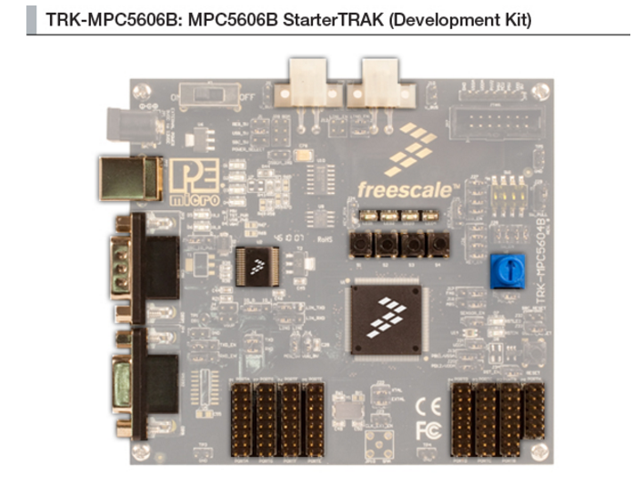

Figure 1: MPC5606B board.

- Operating Frequency (Max): 64 MHz.
- Total DMA Channels 16.
- Internal Flash (KB): 512
- GPIOs: 149.
- EEPROM: 64 KB DataFlash®
- RAM: Up to 96 KB
- Timer: 16 bits up to 64 channels
- ADC:
- 10 bits up to 36 channels
- 12 bits up to 16 channels
- Up to six CAN
- Up to six SPI
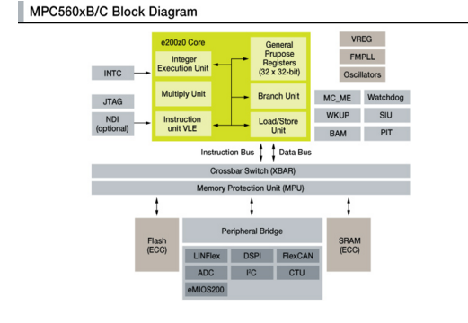
- Up to 10 LINFlex
Figure 2: MPC56X B/C Boolero Arquitecture Family

Network Graphical Description

Figure 11: Deployment Diagram (A)

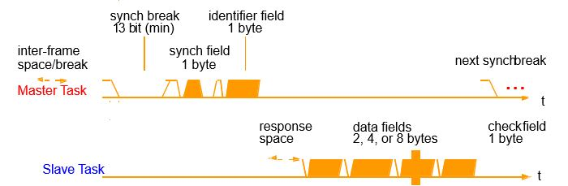

Deployment Diagram. Represents the physical configurations of software and hardware items.
The network showed in the figure above represents the full integrated system, which consists of the master node and the four slaves shown.

Our assignment is to develop the slave node labeled as Slave3, with all its internal components and the required actions to perform.

Use Case Diagram
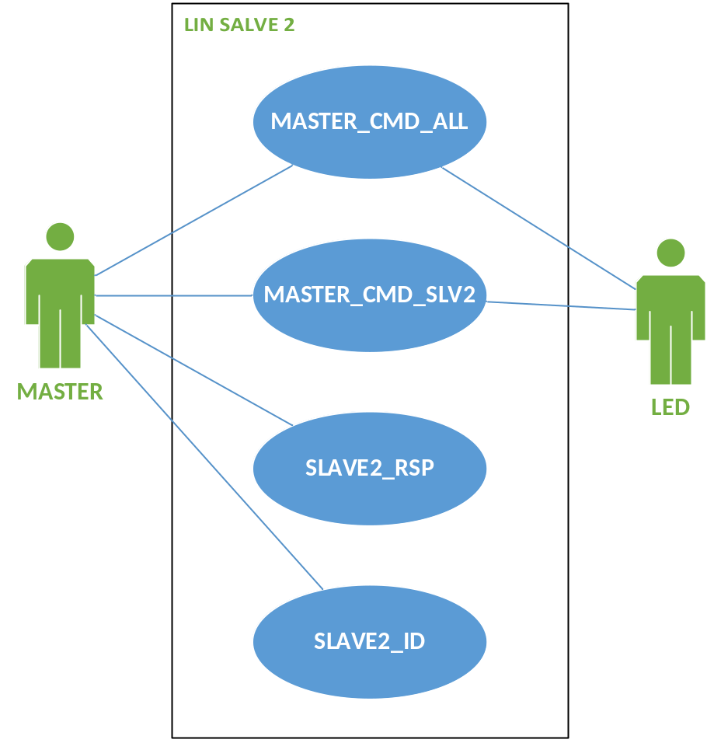

Figure 12: Use Case Diagram
- Master: Node that controls the network. This node can send up to of 13 pre-defined messages, but in this diagram only the messages relevant to Slave3 node are shown.

- LED: Physical On-board LEDs which will respond to the commands given by the system.

- MASTER_CMD_ALL: Message sent to every slave node to execute a command.

- MASTER_CMD_SLV3: Message sent specifically to slave node 3 to execute a command.

- SLAVE3_RSP: Message sent from Slave3 to the master node with a specific response.

- SLAVE2_ID: Message sent from Slave2 node to the master with the corresponding ID.

Component diagram request & response (A/D)
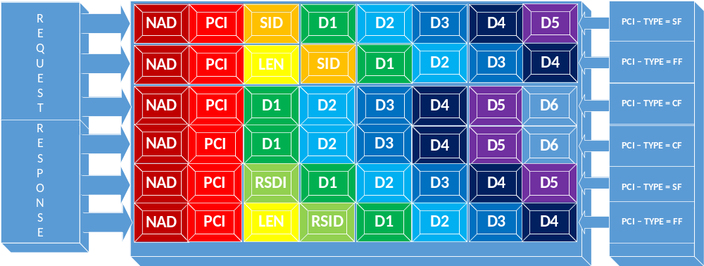

Figure 3: Component diagram (A/D).

Figure: Components Descriptions
NAD | Is the address of the slave node being addressed in a request, only slave nodes have an addressed NAD is also used to indicate the source of a response. NAD values are in the range 1 to 127 (ox7F) while 0 and 128 (0x80) to 255 (oxFF) are reserved for other purpose
PCI  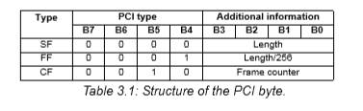 | The PCI (Protocol Control Information) contains the transport layer flow control information. Three interpretations of the PCI byte exist,

LEN | A LEN byte is only used in FF; it contains the eight least significant bits of the message length. Thus, the maximum length of a message is 4095 (0xFFF) bytes.
SID | The service identifier (SID) specifies the request that shall be performed by the slave node addressed. 0 to 0xAF
RSID | The response service identifier (RSID) specifies the contents of the respons. The RSID for a positive response is always SID + 0x40.  If the service is supported in the slave node the response is mandatory (seven if the request is broadcast). The support of a specific service will be listed in the NCF.
D1 TO D5 | The interpretation of the data bytes (up to five in a node configuration PDU) depends on the SID or RSID.  If a PDU is not completely filled the unused bytes shall be recessive, their value shall be 255 this is necessary since a diagnostic frame is always eight bytes long.

Component diagram SW
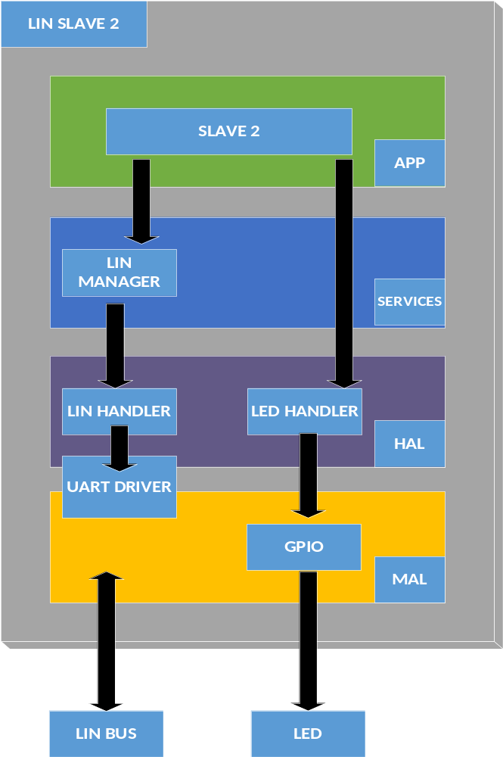

Activity Diagram (R)
Dataflow of ext_int0 Interrupt Handler Routine
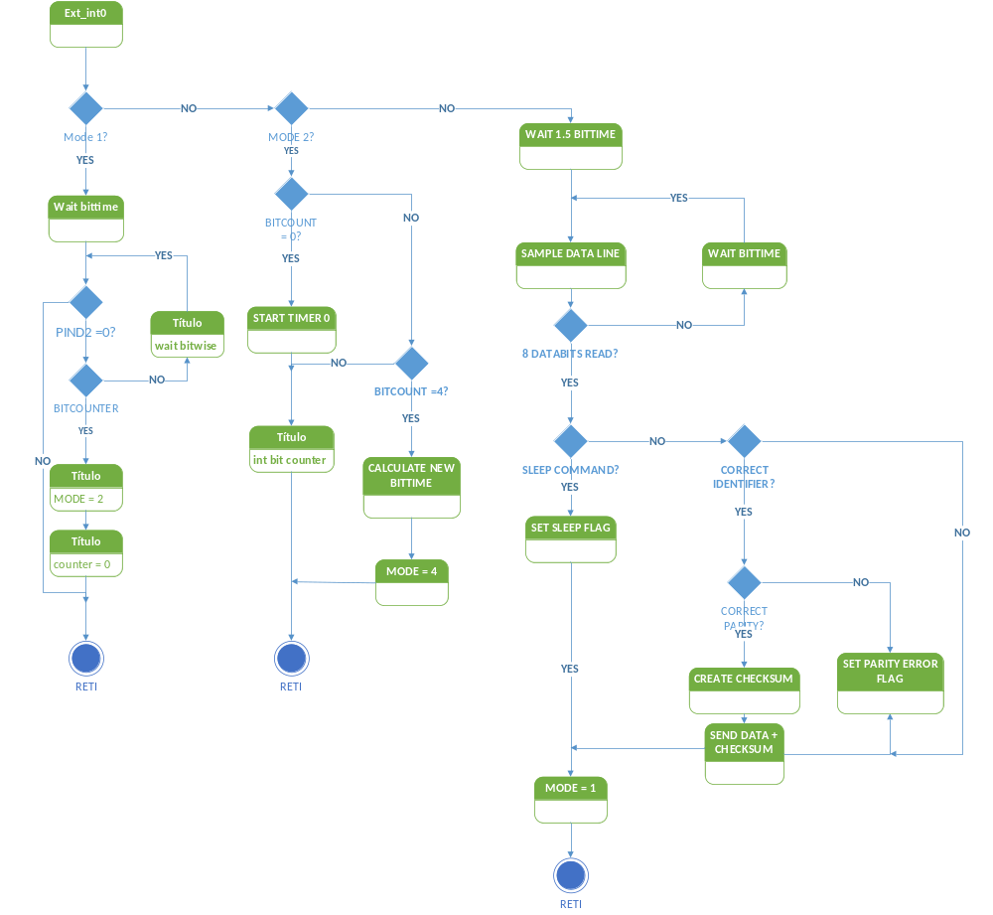

check_parity | This routine counts the number of recessive bits in the counter variable. If the number is even, the LSB of the bitcount variable is 0. If the number is odd, the LSB of the bitcount variable is 1. This is used to check the counter variable for odd or even parity.
Timer0 Overflow: tim0_ovf | Timer/Counter0 used in this application is an 8-bit counter. To be able to count eight bittime, this routine is called when Timer0 overflows, incrementing the “counter” variable. By combining the “counter” value, and the Timer/Counter1 value, the result gives a 16- bit number indicating the time for eight bits. Dividing this by eight gives the bittime. The microcontroller runs on a chosen frequency of 64 MHz and the counter increments every clock cycle. Thus, the bittime is given directly in microseconds.
putchar | The putchar routine is used for sending data via the LIN bus. When sending a “0”, PIND2 is set as output with a “0” in the Port Register. When sending a “1”, PIND2 is set as input and the LIN bus’ pull-up resistor pulls the level to logical “1”. This acts like an open collector output. The data to be sent should be placed in adjacent registers in ascending order (e.g., data1 to datan is placed in register rx to rx+n). The Slave sends either two, four, or eight data bytes decided by bit four and five in the Identifier Field. The constant data_addr in the assembly file holds the register number of the first data to send.
delay | The delay routine gives a delay of [temp2] cycles ± 1 cycle. This routine is used to create the required delay between the sampling of bits.
wake-up | To generate a wake-up call on the bus this routine may be called from the main program. The routine is not used by the ext_int0 routine.
Hardware Considerations | The LIN standard specifies an operating voltage range for the “dominant” voltage between 9V and 18V (40V while not operating). This application is constructed for a LIN voltage of 5V. Since the AVR microcontroller used in this application requires a stable 5V supply, the most cost-effective and easiest solution is to let the LIN bus dominant voltage be 5V. If this is not acceptable there are some hardware solutions to interface the 5V LIN to a 9 - 18V LIN.
Method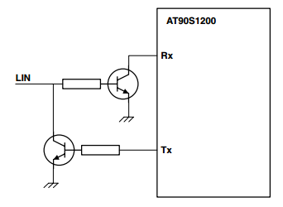 | Using two bipolar transistors (in the same housing) may be a more cost-effective solution (see Figure 14). These transistors are obtainable complete with base resistors and are less expensive than FET transistors.

SEQUENCE

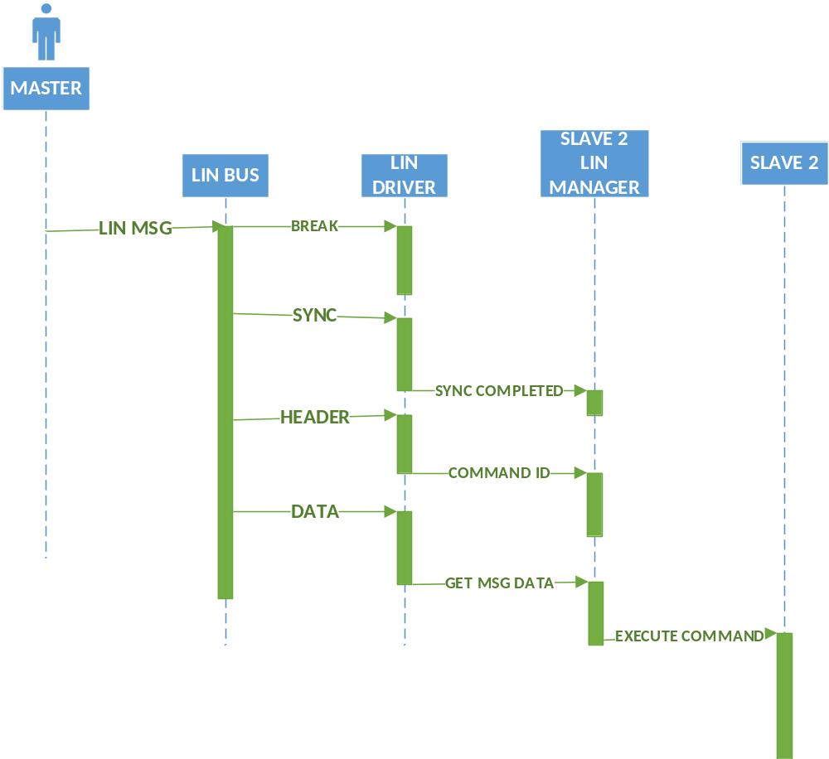

Response Sequence Diagram

State machine diagram

Slave 2

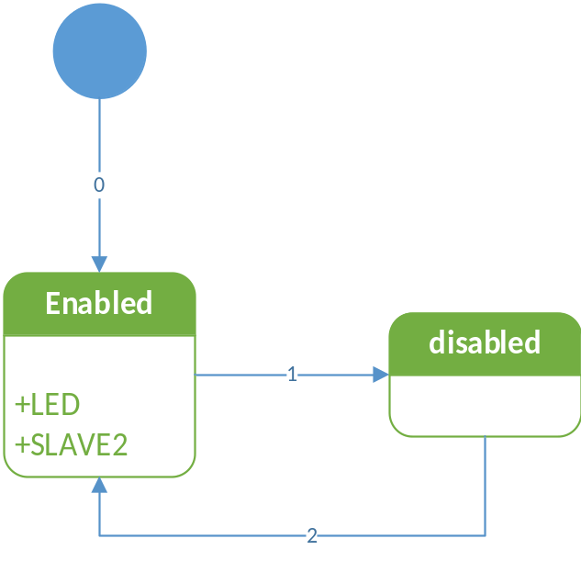

TRANSITION | CONDITION | ACTION
0 | Initialize LIN Slave3 | Initialize node as enabled.
1 | t_cmdType==cmd_disable_slave | Node==Disabled
2 | t_cmdType==cmd_enable_slave | Node==Enabled / Access to either super state.

Lin manager

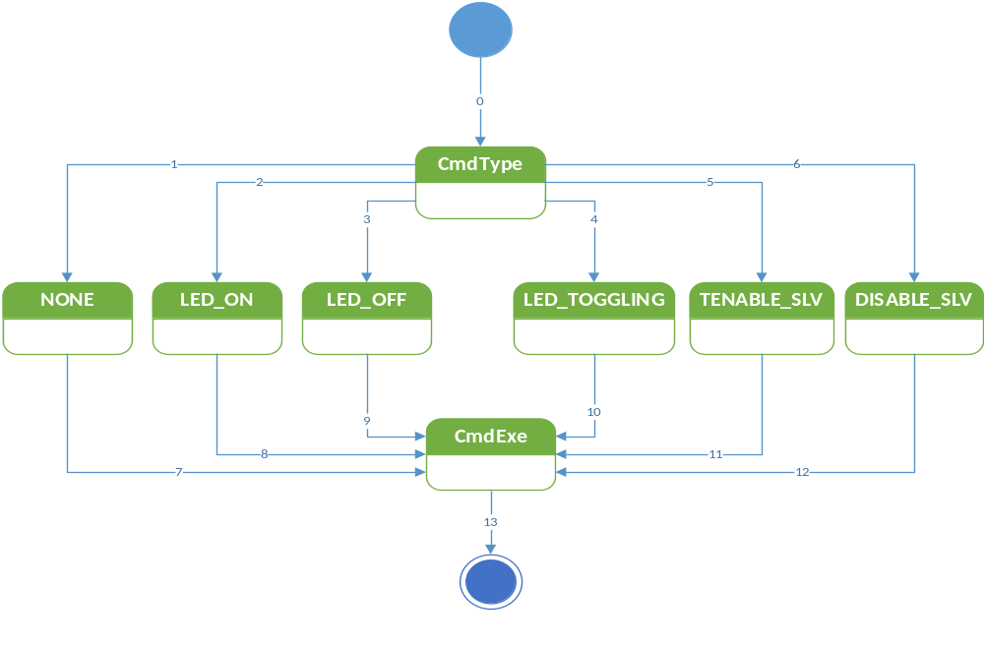

TRANSITION | CONDITION | ACTION
0 | Signal Msg == MASTER_CMD | Initialize CmdType
1 | t_cmdType==cmd_NONE | Initialize none.
2 | t_cmdType==cmd_LED_on | Initialize LED_ON
3 | t_cmdType==cmd_LED_off | Initialize LED_OFF
4 | t_cmdType==cmd_LED_toggling | Initialize LED_TOGGLING
5 | t_cmdType==cmd_enable_slv | Initialize ENABLE_SLV
6 | t_cmdType==cmd_disable_slv | Initialize DISABLE_SLV
7 | Command variable updated to None. | Go to CmdExe
8 | Command variable updated to LED on. | Go to CmdExe
9 | Command variable updated to LED off. | Go to CmdExe
10 | Command variable updated to LED toggling. | Go to CmdExe
11 | Command variable updated to Enable. | Go to CmdExe
12 | Command variable updated to Disable. | Go to CmdExe
13 | Cmd==executed. | Exit state machine.

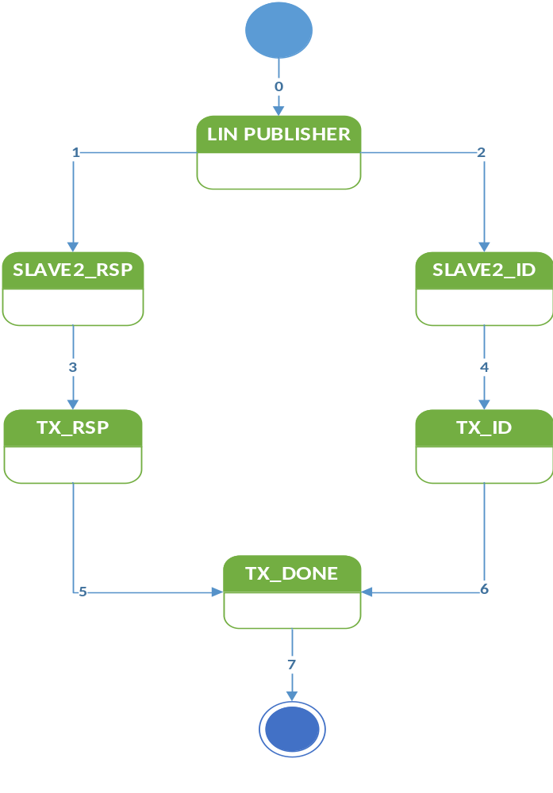

TRANSITION | CONDITION | ACTION
0 | (Signal Msg == SLAVE3_RSP)II(Signal Msg==SLAVE3_ID) | Initialize LIN Publisher.
1 | If Signal Msg == SLAVE3_RSP | Initialize SLAVE3_RSP.
2 | If Signal Msg == SLAVE3_ID | Initialize SLAVE3_ID.
3 | (ID field==valid)&&(Header==sent) | Initialize TX_RSP.
4 | (ID field==valid)&&(Header==sent) | Initialize TX_ID.
5 | Data TX_RSP==transmitted | Go to TX_Done.
6 | Data Tx_ID==transmitted | Go to TX_Done.
7 | Transmission completed. | Exit state machine.

LIN Handler

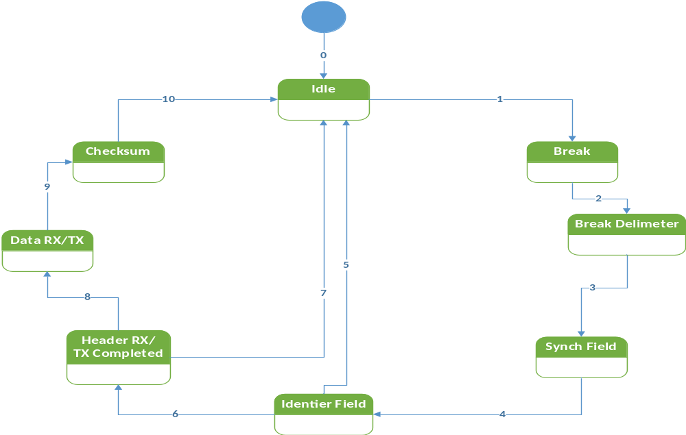

TRANSITION | ACTION
0 | Initialize Idle
1 | Go to break.
2 | Enter Break Delimiter.
3 | Enter Synch Field.
4 | Initialize Identifier Field.
5 | Return to Idle.
6 | Enter Header Rx/ Tx compl.
7 | Return to Idle.
8 | Go to Data Rx/Tx.
9 | Enter Checksum.
10 | Return to Idle.

Master node transmission handler

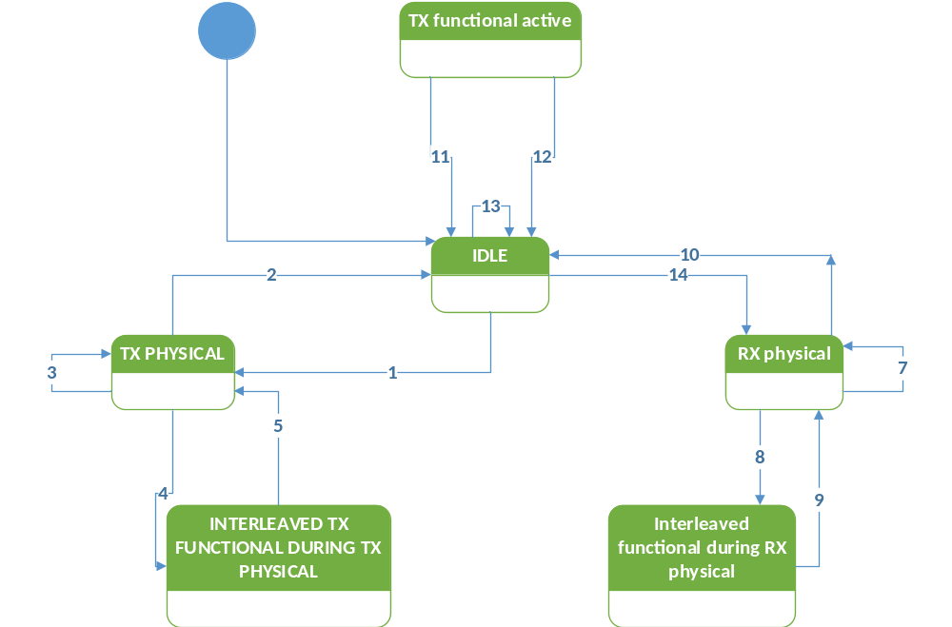

1.- IDLE STATE | Tx physical active state  - Trigger:  Start of a physical transmission from the back-bone bus to a slave node.  - Effect:  Start executing diagnostic master request frame schedule tables and handle the transport protocol.
2.- Tx physical active state | Idle state  - Condition: routing of the physical transmission from the back-bone bus to the cluster has finshed or a transport protocol transmission error  - Action: stop executing master request frame schedule tables.
3.- Tx physical active state | Tx physical active state  - Condition: routing of the physical transmission from the back-bone bus to the slave node has not finished  - Action: continue executing master request schedule table and handle transport protocol on LIN
4.- Tx physical active state | Interleaved functional during Tx physical state  - Condition: functional addressed request from the back-bonebus has been received.  - Action: interrupt the physical transmission to the slave node and execute a single master request frame schedule to transmit the functional addred request onto the cluster.
5.- interleaved functional during Tx physical state | Tx physical active state  - Condition: functional addressed request has been routed onto the cluster.  - Action: continue the interrupted physical transmission to the slave node.
6.- Tx physical active state | Rx physical active state  - Condition: functional transmission to the slave node has been successfully completed (according to the transport layer specification).  - Action: stop executing master request frame schedule tables, start executing slave response frame schedule tables and handle the incoming response from the previously addressed slave node.
7.- interleaved functional during Rx physical state | Rx physical active state  - Condition: functional addressed request has been routed onto the cluster.  - Action: restart executing slave response frame schedules and continue the interrupted reception from the slave node.

LED Handler

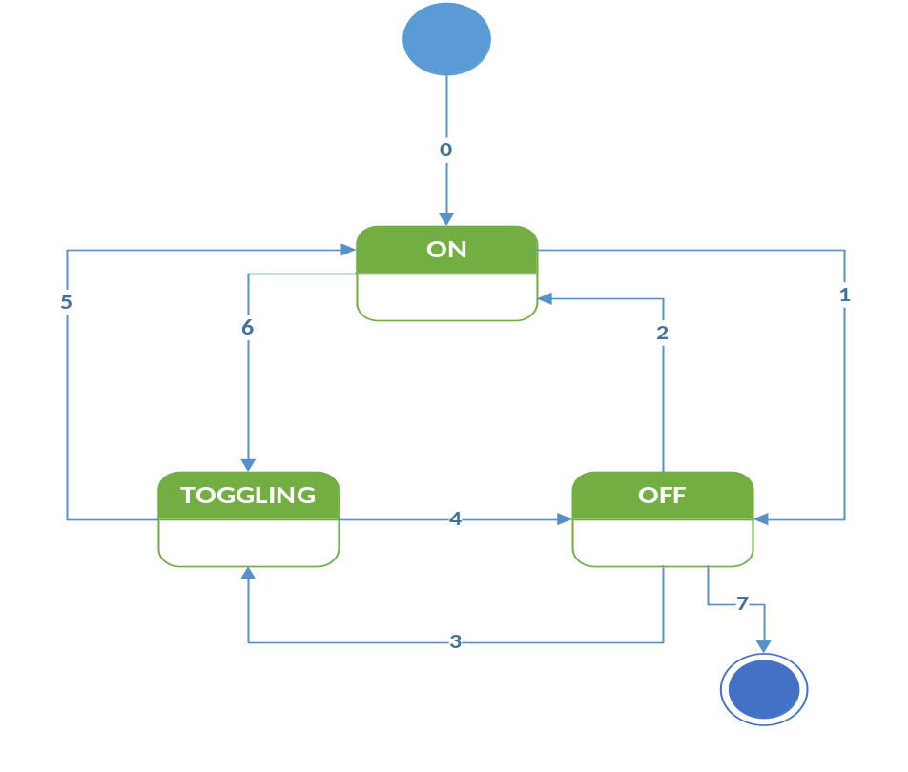

TRANSITION | CONDITION | ACTION
0 | Initialize MCU | Default state is ON
1 |  | Go to OFF
2 |  | Return to ON.
3 |  | Set to TOGGLING
4 |  | Go to OFF.
5 |  | Go to ON.
6 |  | Go to TOGGLING.
7 |  | Exit the state machine.

Application Program Interface Specification ver. 2.2a

CORE API
The LIN core API has a set of functions all based on the idea to give the API a separate name space, in order to minimize the RISK of conflicts with existing software. All functions and types will have the prefix “l_” (lowercase L followed by an undercore).

The LIN core shall define the following types:
- L_bool - 0 is false, and non- zero (>0) is true
- L_ioctl_op - implementation dependent
- L_irqmask - implementation dependent
- L_u8 - unsigned 8 bit integer
- L_u16 - unsigned 16 bit integer

Name | Prototype | Description
L_sys_init | L_bool l_sys_init (void); | Performs the initialization of the LIN core. The scope of the initialization is the physical node.  The call to the l_sys_init is the first call a user must use in the LIN core before using any other API function.  The function returns:  Zero if the initialization succeded  Non-zero if the initialization failed
Static Prototype |  | Dynamic Prototype
None |  | None

Name | Prototype | Description
Scalar signal read | none | Reads and returns the current value of the signal
Static Prototype |  | Dynamic Prototype
L_bool l_bool_rd_read (void);  L_u8 l_u8_rd_read (void);  L_u16 l_u16_rd_read (void); |  | L_bool l_bool_rd (l_signal_handle read);  L_u8 l_u8_rd (l_signal_handle read);  L_u16 l_u16_rd (l_signal_handle read);

Name | Prototype | Description
Scalar signal write | none | Sets the current value of the signal to v.
Static Prototype |  | Dynamic Prototype
Void l_nool_wr_write (l_bool v);  Void l_u8_wr_write (l_u8 v);  Void l_u16_wr_write (l_u16 v); |  | Void l_bool_wr (l_signal_handle write, l_bool v);  Void l_u8_wr (l_signal_handle write, l_u8 v);  Void l]_u16_wr (l_signal_handle write, l_u16 v);

Name | Prototype | Description
Byte array read | none | Reads and returns the current values of the selected bytes in the signal.  The sum of start and count shall never be greater than the length of the byte array.
Static Prototype |  | Dynamic Prototype
Void l_bytes_rd_data_read (l_u8 start,  L_u8 count,  L_u8* const data); |  | Void l_bytes_rd (l_signal_handle data_read,  L_u8 start, /*first byte to read from*/  L_u8 count, /*number of bytes to read*/  L_u16 const data); /*where data will be written*/

Name | Prototype | Description
Byte array write | none | Sets the current value of the selected bytes in the signal specified by the name write data to the value specified.
Static Prototype |  | Dynamic Prototype
Void l_bytes_wr_write_data (l_u8 start,  L_u8 count,  Const l_u8* const data); |  | Void l_bytes_wr (l_signal_handle write_data,  L_u8 start,  L_u8 count,  Const l_u8* const data);

Name | Prototype | Description
L_flg_tst | none | Returns a C boolean indicaing the current state of the flag specifified by the name flag_state, returns zero if the flag is cleared, non-zero otherwise
Static Prototype |  | Dynamic Prototype
L_bool l_flg_tst_flag_state (void); |  | L_bool l_flg_tst (l_flag_handle flag_state);

Name | Prototype | Description
L_flg_clr | none | Sets the current value of the flag specified by the name clear_flag to zero
Static Prototype |  | Dynamic Prototype
Void l_flg_clr_clear_flag (void); |  | Void l_flg_clr (l_flag_handle clear_flag);

Name | Prototype | Description
L_flg_tick | none | The l_sch_tick function follows a schedule. When a frame becomes due, its transmission is initiated. When the end of the current schedule is reached, l_sch_tick starts again at the beginning of the schedule.
Static Prototype |  | Dynamic Prototype
L_u8 l_sch_tick_tickflg |  | L_u8 l_sch_tick (l_ifc_handle tickflg);

Name | Prototype | Description
L_sch_set | none | Sets up the next schedule to be followed by the l_sch_tick function for a certain interface tickflg. The new schedule will be activated as soon as the current schedule reaches its next schedule entry point.
Static Prototype |  | Dynamic Prototype
Void l_sch_set_tickflg (l_schedule_handle schedule, l_u8 entry); |  | Void l_sch_set (l_ifc_handle tickflg,  L_schedule_handle schedule,  L_u8 entry);

Name | Prototype | Description
L_ifc_goto_sleep | none | This call request slave nodes on the cluster connected to the interface to enter bus sleep mode by issuing one go to sleep command,.  The go to sleep command will be scheduled latest when the next schedule entry is due.
Static Prototype |  | Dynamic Prototype
Void l_ifc_goto_sleep (l_ifc_handle gsleep); |  | Void l_ifc_goto_sleep_gsleep (void);

Name | Prototype | Description
L_ifc_wake_up | none | The function will transmit one wake up signal. The wake up signal will be transmitted directly when this function is called. It is the responsibility of the application to retransmit the wake up signal according to the wake up sequence defined
Static Prototype |  | Dynamic Prototype
Void l_ifc_wake_up_wup (void); |  | Void l_ifc_wake_up (l_ifc_handle wup);

