

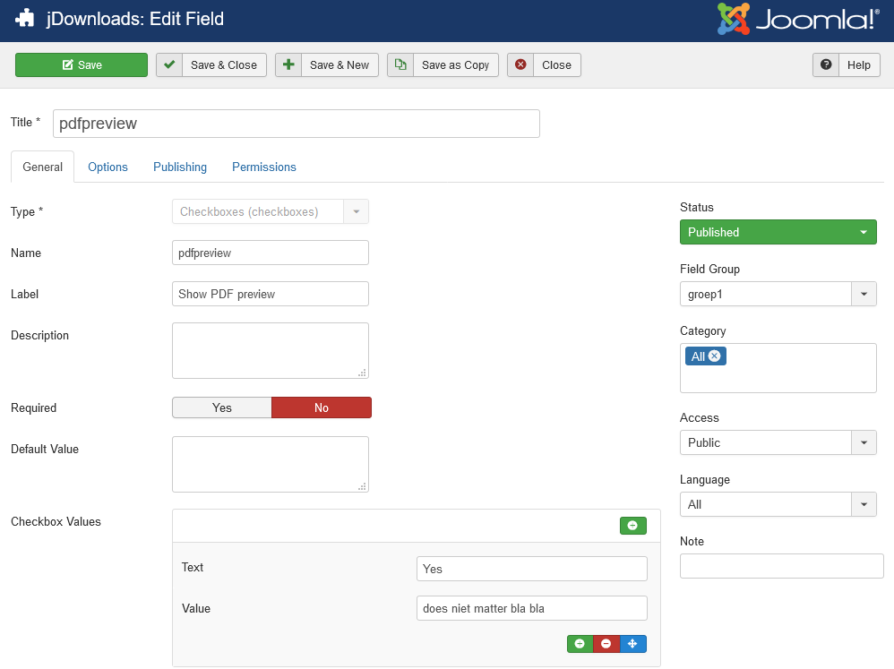

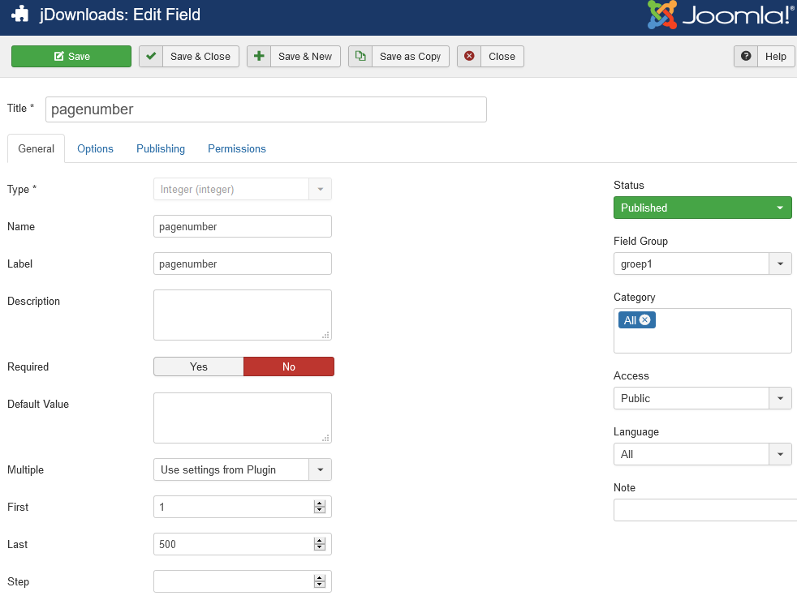

In layout ‘’downloads’ or ‘downloads details’

{pdfviewer jdownloadsid={file_id} page={jdfield 4} showpdfpreview={jdfield 3} }