**Question 2: DNS Lab**

**2-A: What is your default server for nslookup and what is its IP address? To support your answer, also add the screen shot from your computer.**

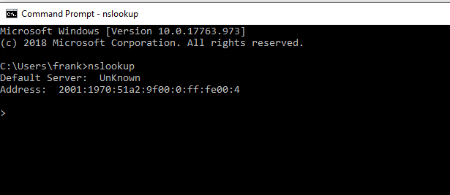

As seen in the above screenshot, the default server for nslookup is: **2001:1970:51a2:9f00:0:ff:fe00:4.** Note: this is the ipv6 ip address

**2-B: Add your answers to lab questions 1-3 in the submission document.**

**2-B-1: Run nslookup to obtain the IP address of a Web server in Asia. What is the ip address of that server?**

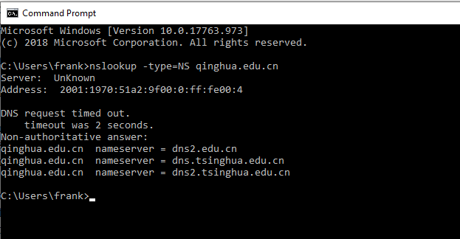

As seen above, the web server I queried was Qinghua university’s server. The ipv6 address is: 2001:1970:51a2:9f00:0:ff:fe00:4

**2-B-2: Run nslookup to determine the authoritative DNS servers for a university in Europe.**

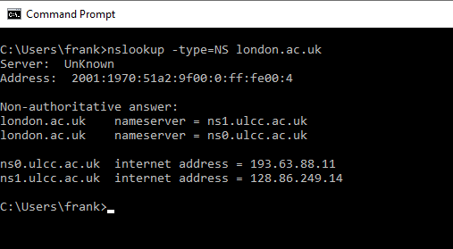

As seen above, the ipv6 address of the authoritative DNS server for the university college of london is: 2001:1970:51a2:9f00:0:ff:fe00:4

**2-B-3: We want to represent the content of a DNS message in the form of a Python Dictionary where keys are the message field names and key-values are the field values. Provide the definition of this dictionary in the submission document.**

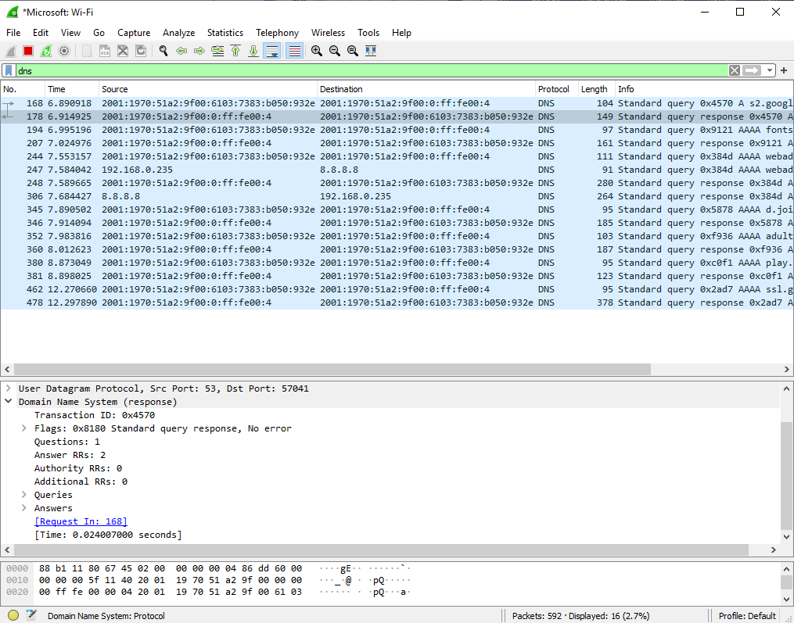

Taking the screenshot of a DNS response message above, we can define a python dictionary to capture this information as such:

DNS = {“Transaction ID:” : 0x72cf, “Flags:” : 0x0100 Standard query, “Questions:” : 1, “Answer RRs:” : 0, “Authority RRs:” : 0, “Additional RRs:” : 0, “Queries” : [Response In: 2565]}