**COMPSCI 4C03 Assignment 4: NAT and ICMP**

**Question 1: Understanding NAT**

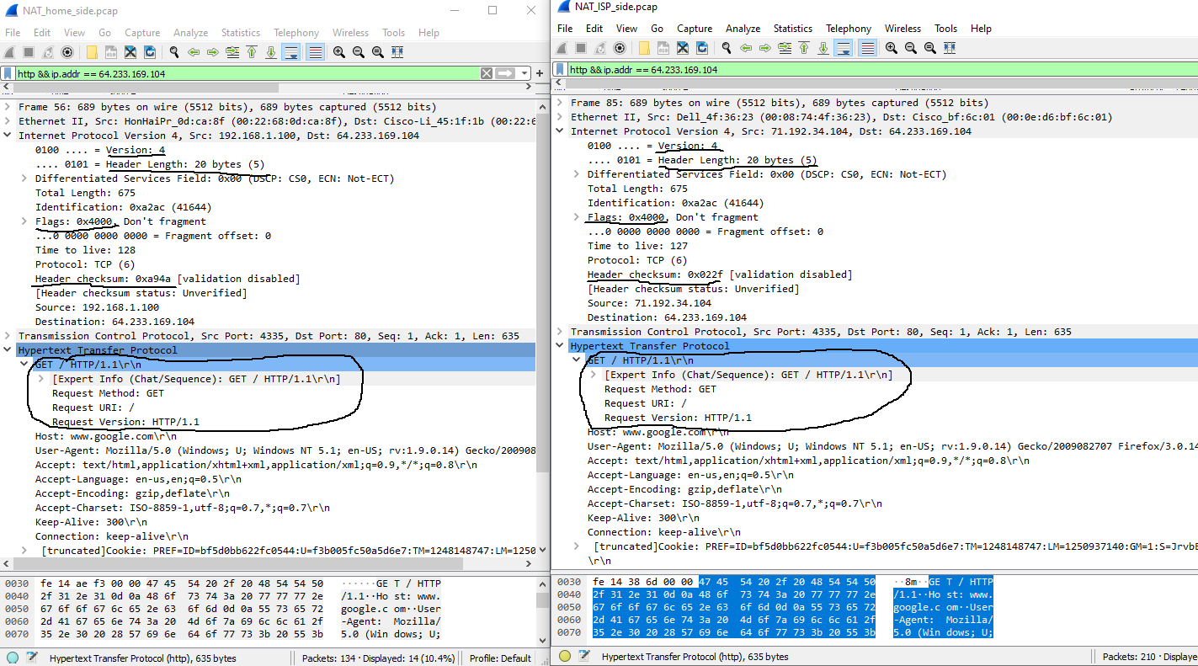**#1-A:**

As shown in the above screenshot, the fields in the HTTP GET message are unchanged. In the IP datagram carrying the HTTP GET, Version (4), Header Length (20 bytes), and Flags (0x4000) are all unchanged. However, the checksum field is changed: NAT_home_side has a checksum of 0x0000a94a, while NAT_ISP_side has a checksum of 0x0000022f. This is because the checksum includes the value of the source ip address, and since this value has changed, the checksum value will also be different.

**#1-B:**

|  |  |
| --- | --- |
| **WAN Side** | **LAN Side** |
| 71.192.34.104, 4335 | 192.168.1.100, 4335 |

**Question 2: Understanding ICMP**

**#2-A:**

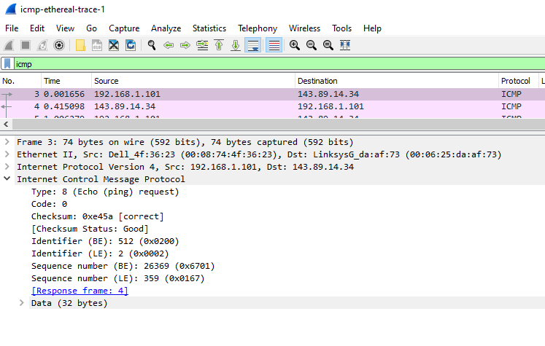As seen in the above screenshot, the ICMP type is 8 and the code number is 0. The other fields that the ICMP packet has are: checksum, identifier, sequence number, and data. The checksum, sequence number and identifier fields all have 2 bytes of data each.

**#2-B: Q8**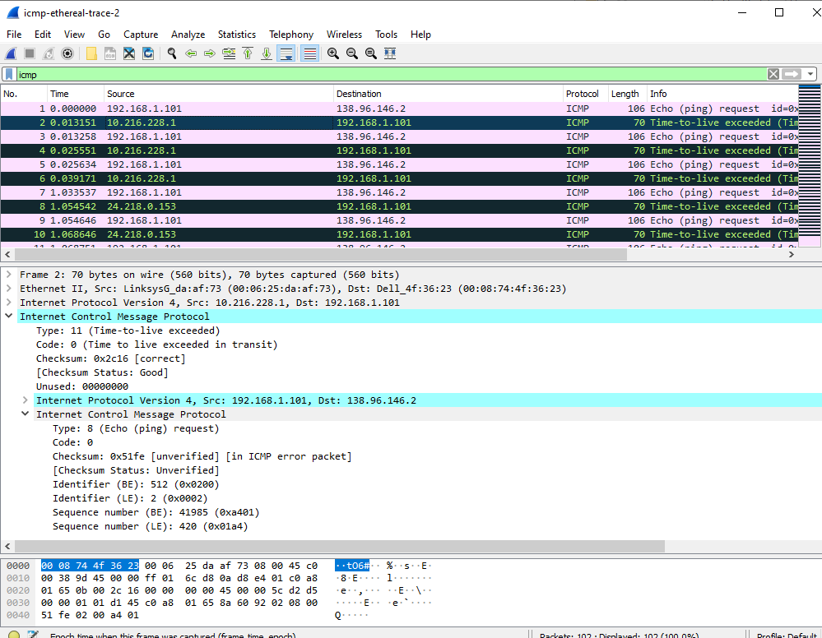

As seen in the above screenshot, the ICMP error packet has both the IP header and the checksum of the ICMP packet that the error is for.

**#2-C:** 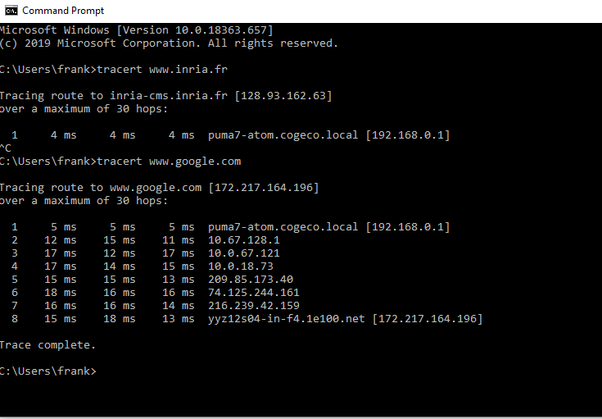

As shown in the screenshot, the tracert experiment to google.com produces results such that there are no significant delays between hops. In the total of 8 hops, all of them are within a couple of ms of each other, which is drastically different from Q10 in the ICMP lab, where there was a delay of over 100 ms.