**COMPSCI 4C03 Assignment 5**

**Question 1: Understanding DHCP**

**#1-A:** First, I will add the screenshots:

**Discover:**

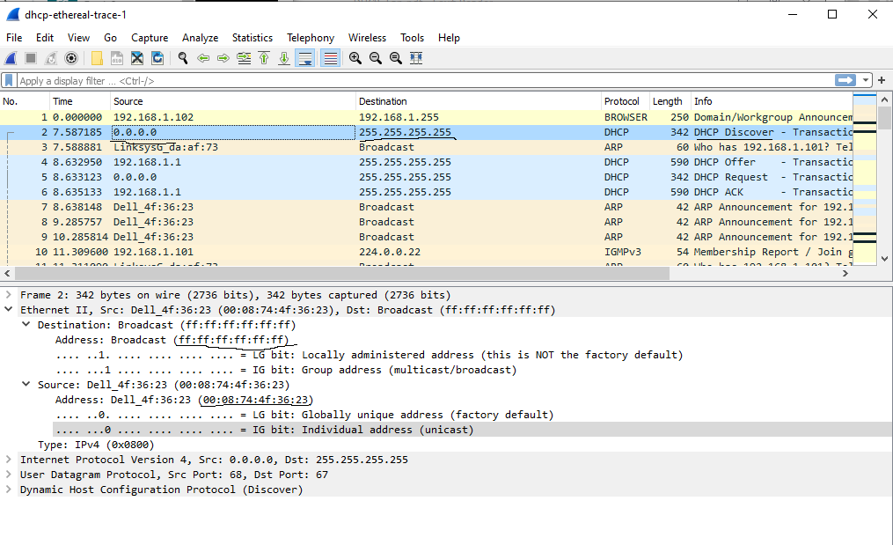

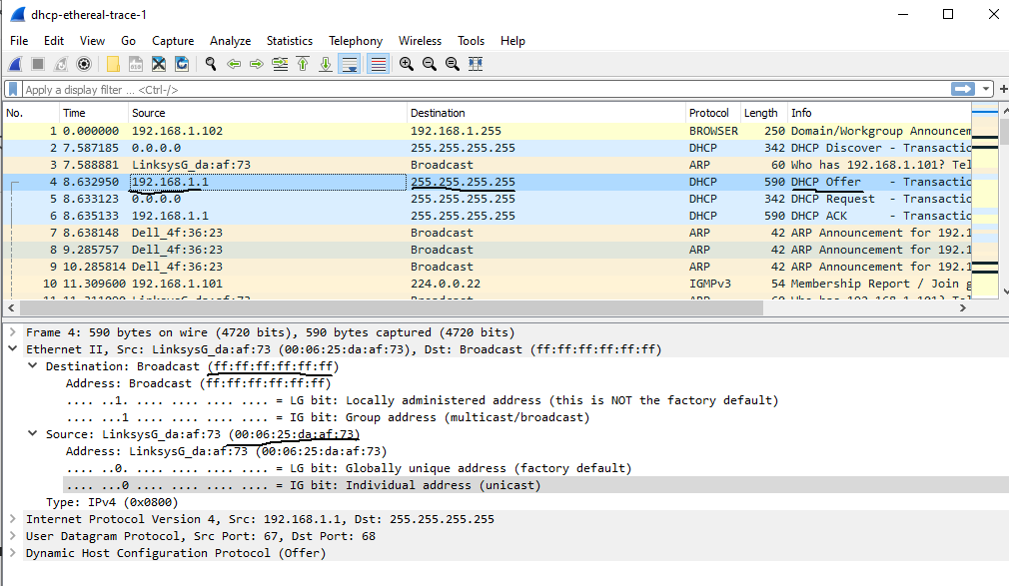**Offer:**

**Request:**

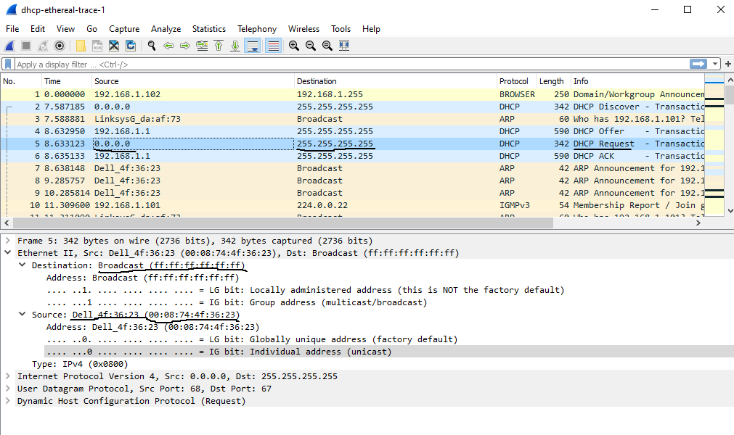

**ACK:**

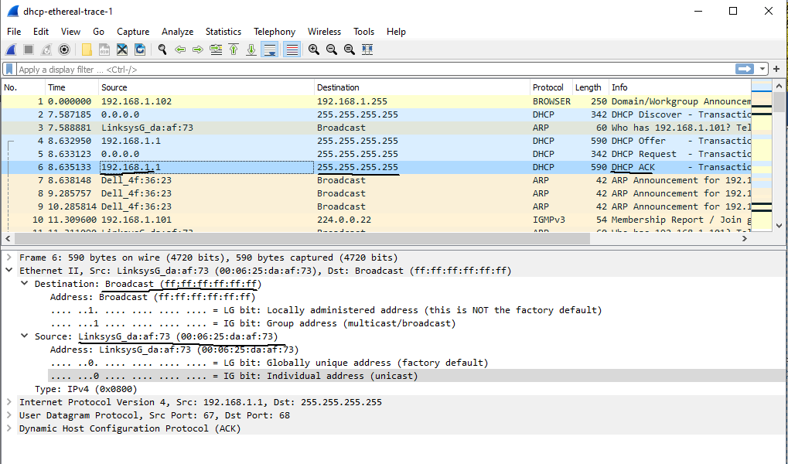

|  |  |  |  |  |
| --- | --- | --- | --- | --- |
| **DHCP Message Type** | **Source IP** | **Source MAC** | **Destination IP** | **Destination MAC** |
| Discover | 0.0.0.0 | 00:08:74:4f:36:23 | 255.255.255.255 | ff:ff:ff:ff:ff:ff |
| Offer | 192.168.1.1 | 00:06:25:da:af:73 | 255.255.255.255 | ff:ff:ff:ff:ff:ff |
| Request | 0.0.0.0 |  | 255.255.255.255 | ff:ff:ff:ff:ff:ff |
| Ack | 192.168.1.1 |  | 255.255.255.255 | ff:ff:ff:ff:ff:ff |

**#1-B:**

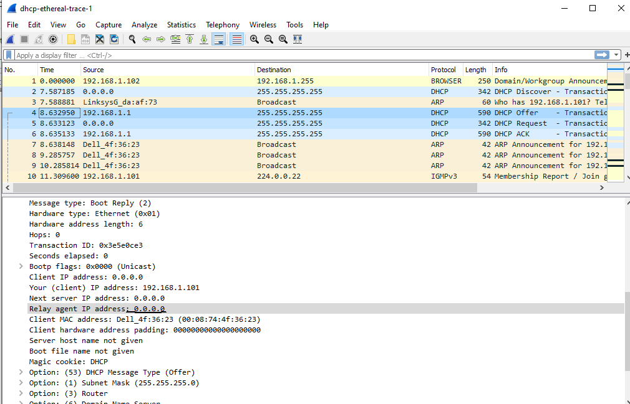

As seen in the screenshot above, the “Relay agent IP adress” is 0.0.0.0. This indicates that there is no DHCP relay used, and thus we can conclude that there was no relay agent used in this experiment.

**#1-C:**

Screenshot off OFFER DHCP packet:

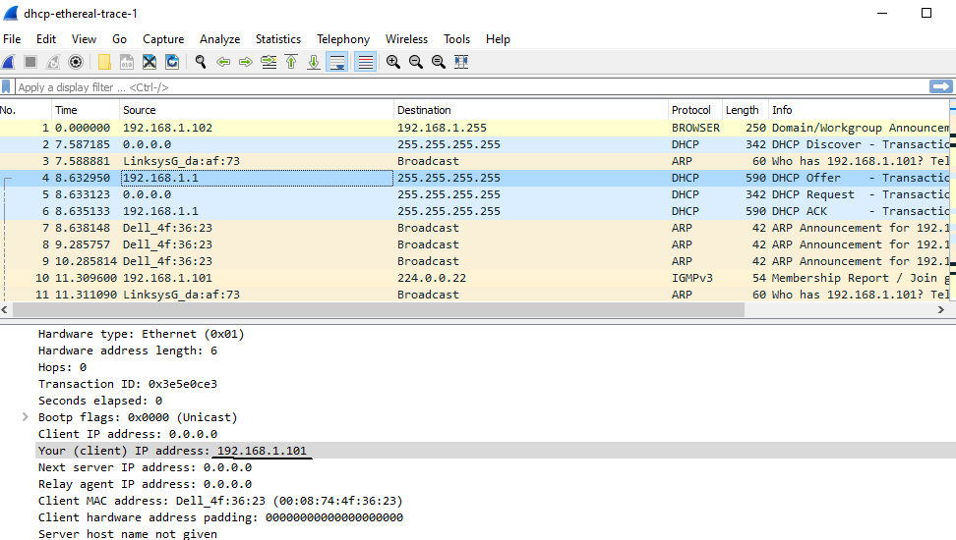

Screenshot of REQUEST DHCP packet:

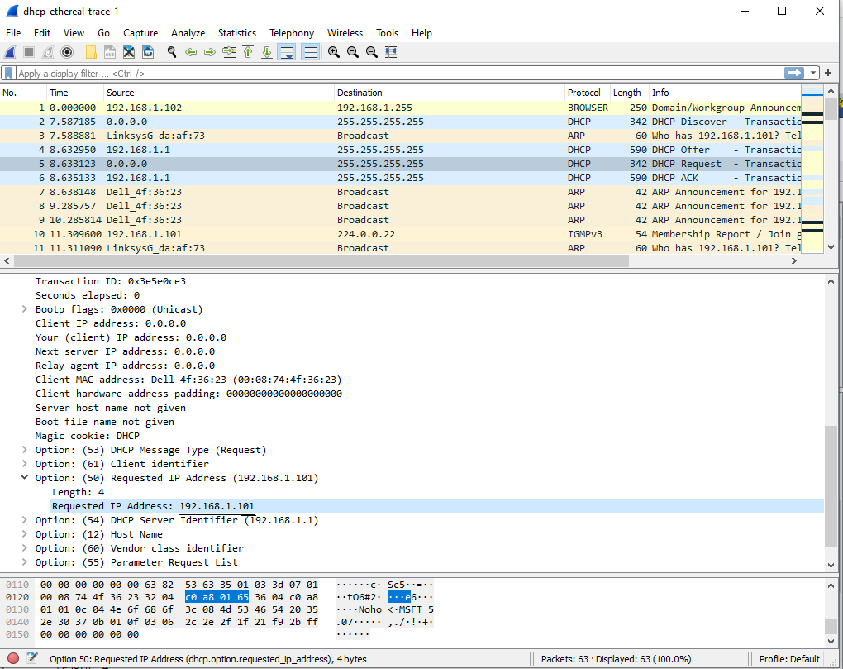

The clients requested address can be found in Option: (50) header field of the Request DHCP packet. This matches the clients IP address in the Offer DHCP packet, and thus, in this experiment the client accepts this IP address.

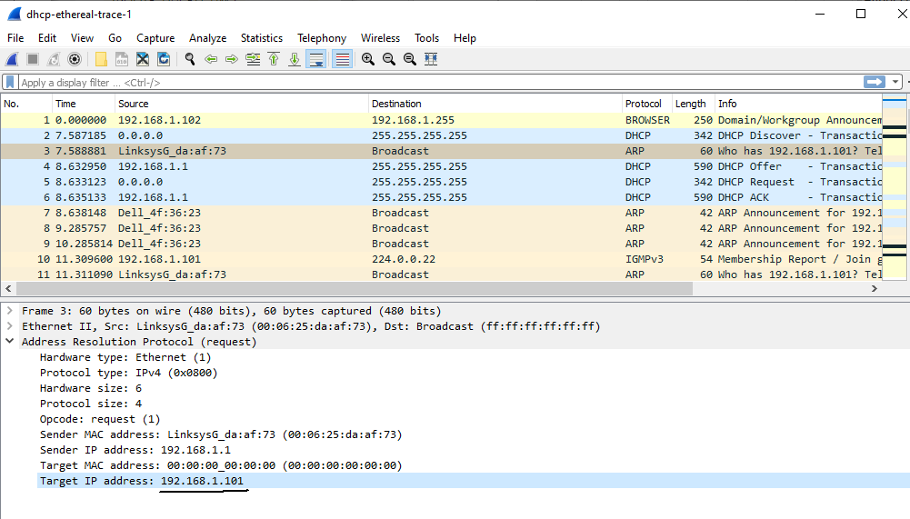**#1-D:**

As seen in the screenshot above of an ARP packet, there are ARP requests made by the DHCP server. Before the DHCP server offers an address to the client, it issues an ARP request for the fofered IP to make sure that it is not occupied by another device in the network.

**Question 2: Routing**

**#2-A:**

For djikstra’s algorithm, we need a dictionary object to represent each link states: cost, router1, and router2, where routers 1 and 2 are the two routers connected by a given link. For example, this dictionary for the link u-v (cost 2) could look like:

Link1 = {‘r1’: ‘u’, ‘r2’: ‘v’, ‘cost’: 2}

**#2-B:**

**See the attached text file for my python implementation**