**Instructions to run stratigraphic modeling code**

This user’s manual elaborates on how to prepare the input files and run the code in order to create a stratigraphy model. The output files are explained at the end.

The Fortran codes provided in the repository use input files to run the model. There are three input data files: Geo_model.inp, GridTopo.csv, and WellLogs.csv. The file Geo_model.inp includes the model parameters. Details of the parameters are in table 1:

|  |  |
| --- | --- |
| **Table 1:** Description parameters in Geo_model.inp file. | |
| Parameter | Description |
| NCELL | Number of cells in the 2D grid |
| NWellLog | Number of well logs |
| MaxLithoBed | Maximum allowed number of lithology beds in a well log |
| dipDirection | Dip direction in degrees |
| dipAngleS | Minimum value of dip slope in vertical direction |
| dipAngleE | Maximum value of dip slope in vertical direction |
| ElevP1 | Elevation above which the dip slope is dipAngleS (ft) |
| ElevP2 | Elevation below which the dip slope is dipAngleE (ft) |
| StartElev | Top elevation of the stratigraphy model (ft) |
| EndElev | Bottom elevation of stratigraphy model (ft) |
| DZ | Resolution of the stratigraphy model in vertical direction (ft) |
| ThickMin | Minimum allowed thickness of facies in stratigraphy model (ft) |
| cutoff | Cutoff value for interpolation method |
| NMinLogs | Minimum number of well logs for interpolation |
| SearchRange | Distance from boundaries of the modeling domain to consider a well log |

The file GridTopo.csv contains the coordinates and elevations of cell centers in 2D grid. The coordinates are in Universal Transverse Mercator (UTM) and elevations are in feet. The first row in the csv file includes header which is skipped in the Fortran code. The total number of rows in GridTopo.csv is NCELL+1. Fig. 1is a sample demonstration of the GridTopo file.

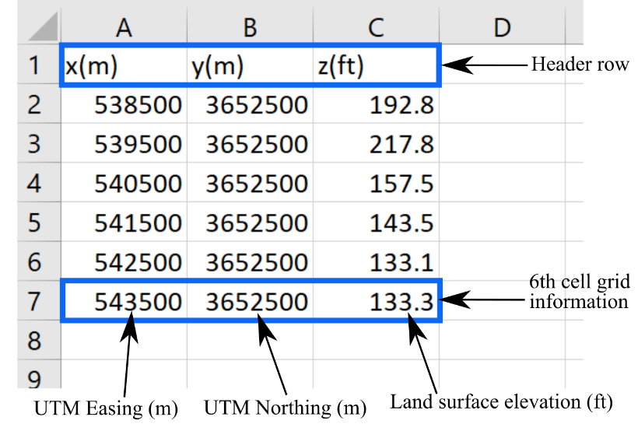

**Fig. 1:** Details of GridTopo.csv file.

The last input file to prepare is WellLogs.csv which includes lithological data of well logs. Fig. 2 displays contents of a WellLogs.csv file. The first row in the file is the header. Each row below the header carries data for a single well log. The data for a single well log are well name, UTM easting of the well log, UTM northing of the well log, elevation of the top of the well in feet, the depth (in feet) at which log starts, and the depths (in feet) of the lithological beds. The lithological bed depths indicate either a sand bed depth or a clay bed depth. Each clay bed is always followed by a sand bed and vice versa. The lithological bed sequence should start at a clay bed. So, if a log includes sand at the top, the depth of the first clay bed is considered to be as same as the depth at which log starts (red box in Fig. 3).

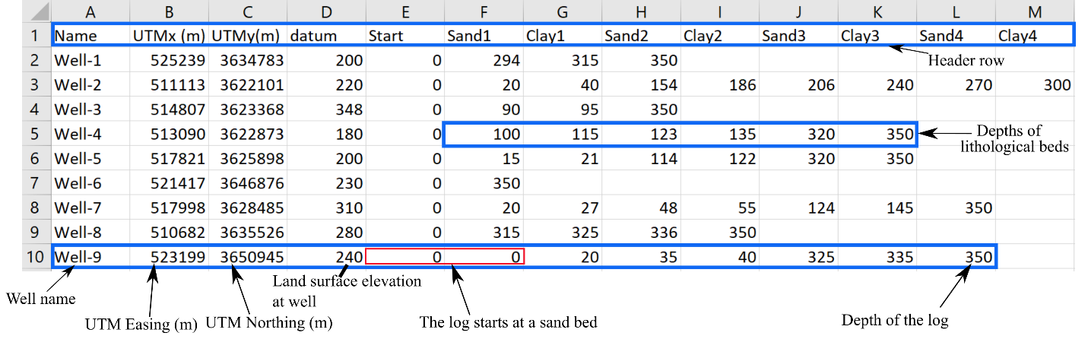

**Fig. 2:** Details of a WellLogs.csv file.

After preparing the input files, all the Fortran codes in repository and input files are copied to the same directory. File Lithology.F90 is the root code which needs to be compiled. The other Fortran codes are called in the Lithology.F90. Running the code, three output files are generated: geomodel.prn, Geo-model.dat, and Geo-model_no_thin.dat. The file geomodel.prn includes some statistics of the modeling process such as the plane numbers, number of logs used for interpolation at each plane, and running time.

The file Geo-model.dat includes the bed elevations of the stratigraphy model. Fig. 3 displays the contents of a Geo-model.dat file. The indicator value is the type of the facies. The value 0 and 1 indicate clay and sand, respectively. For instance, the indicator value of 0 circled in Fig.3 shows that there is a clay facies between elevation -214.8 ft and elevation -219.8 ft. Negative values of indicator (-3,-2, and -1) at the top or bottom of a column show that the stratigraphy information in the model is not available at those parts. The value -999 shows the end of stratigraphy model at a cell. The file Geo-model_no_thin.dat carries the same information as the file Geo-model.dat except for facies thinner than ThickMin.

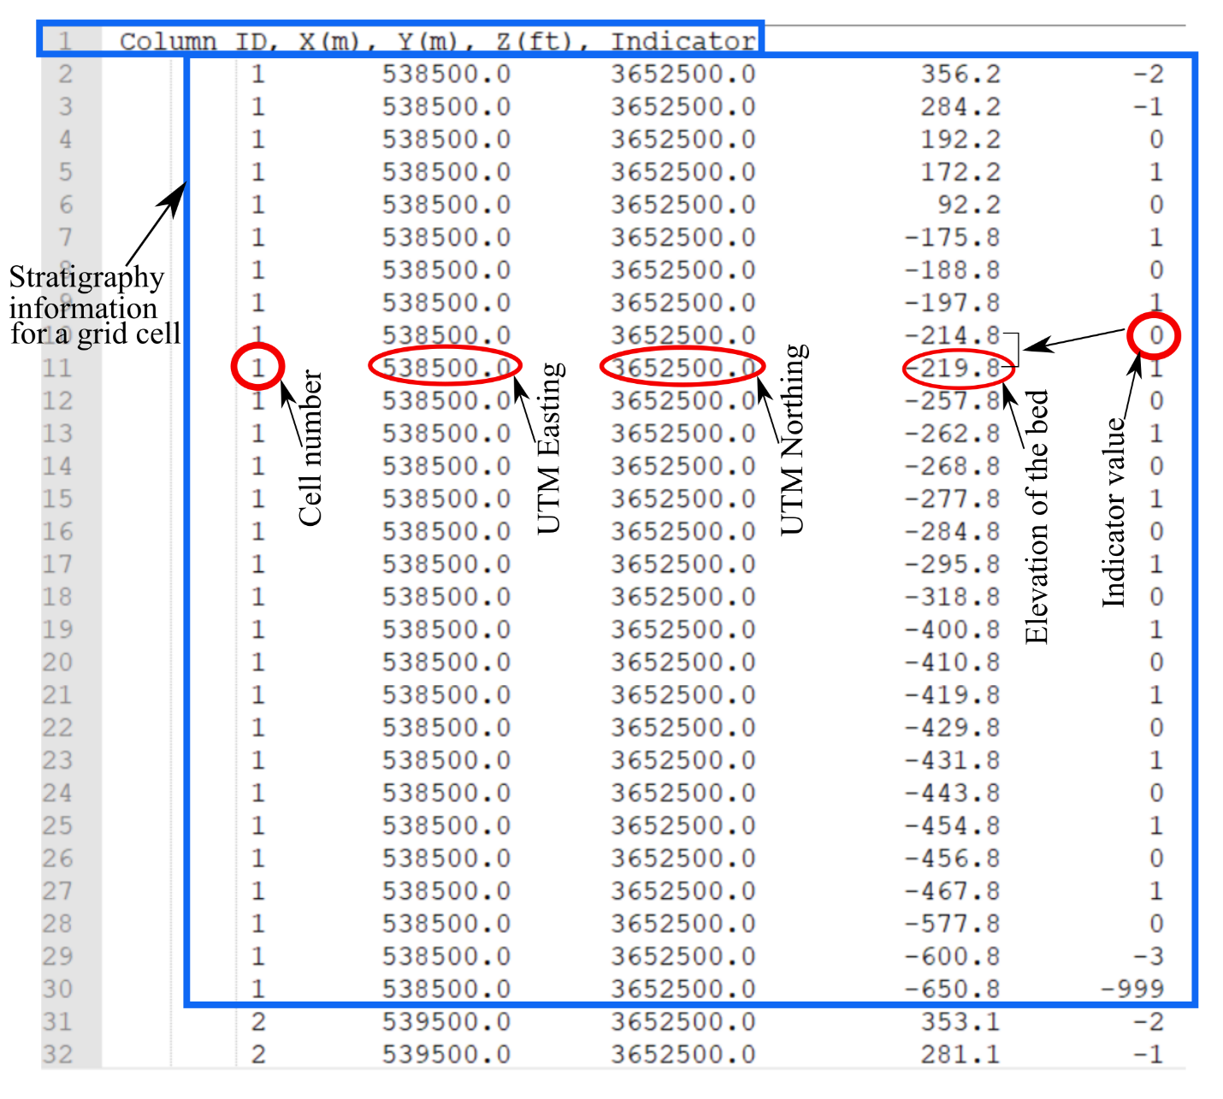

**Fig. 3:** Details of a Geo-model.dat file.