Part B — Off-Market Prediction
  - SSU Data Dash 2026 | Model development and measured results
Histogram gradient boosting achieved 9.08% MdAPE and 11.60% MAPE over 10,069 held-out sales. This is 49.2% lower MdAPE than the rolling community/type baseline (17.89%).

Model and information boundary
Predict log(sold_price), then exponentiate to dollars. Inputs cover size and room counts, property type/style, synthetic location, lot dimensions with missingness indicators, and listing-date calendar features, plus fixed remarks flags for condition, amenities and layout. Area ranges are represented by their midpoint and width. Histogram gradient boosting builds trees sequentially; category encoding and numeric imputation are fitted within each training fold.
No list_price, sold_price, date_sold, days_on_market, external_avm_estimate, external_avm_estimate_date or ml_num enters the learned feature matrix. sold_price is only the target; date_sold only defines training cutoffs and evaluation groups. No external data is used.

Untouched six-month walk-forward backtest
Tune on October–November 2025 only, selecting the lowest pooled MdAPE (MAPE breaks ties). Freeze the model configuration before December 2025–May 2026. For each of those six months, refit on sales strictly before the month's start and predict that month's held-out sales. This follows the official sale-month backtest; it is not a strict per-home listing-time simulation.
Model | MdAPE | MAPE | Homes
Histogram gradient boosting | 9.08% | 11.60% | 10,069
Community/type 12-month median | 17.89% | 22.25% | 10,069
10 nearest earlier sales | 20.84% | 27.43% | 10,069
Global median | 38.46% | 46.68% | 10,069
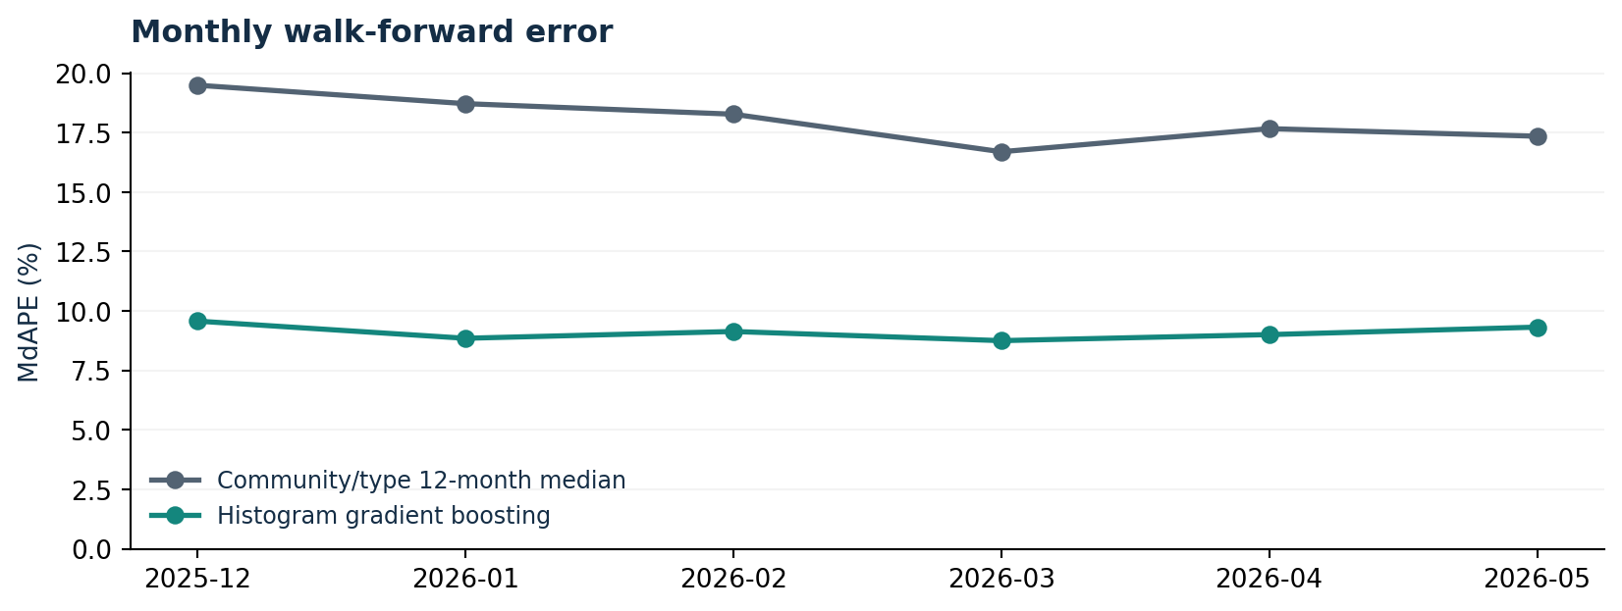
MdAPE = median(100 × |prediction − sale| / sale); MAPE uses the mean. Both are percentages of actual sale price, and lower is better. MdAPE is the competition's primary metric.

Selection, final model and limits

Earlier tuning: October–November 2025
These earlier months select the model; they are separate from the final six-month backtest.
Model | MdAPE | MAPE | Homes
Histogram gradient boosting | 9.31% | 11.71% | 4,117
CatBoost depth 7 / RMSE | 9.54% | 12.07% | 4,117
CatBoost depth 7 / MAE | 9.58% | 12.03% | 4,117
CatBoost depth 6 / RMSE | 9.94% | 12.64% | 4,117
CatBoost depth 6 / no remarks | 10.51% | 13.35% | 4,117
Random forest | 13.28% | 16.99% | 4,117
Community/type 12-month median | 19.02% | 23.58% | 4,117
10 nearest earlier sales | 21.59% | 28.88% | 4,117
Global median | 35.48% | 43.24% | 4,117

Frozen selected configuration
max_iter=350; learning_rate=0.07; max_leaf_nodes=31; l2_regularization=10.0; remarks features=on; log-price target; random seed 42.

Interpretation and deliverable
53.8% of held-out predictions are within 10% of sale price; 83.8% are within 20%. Median signed error: +0.49%. Refit the final selected model on all 150,000 training sales and predict each supplied off-market test ID.
The $2m+ group had 14.68% MdAPE across 719 homes, with -9.57% median signed error. The data is synthetic; results do not establish real-world appraisal accuracy. Six months do not capture every future market regime. Expensive or unusual homes may have larger errors. The June–September 2026 test prices are hidden, so test accuracy is unknown. Do not describe the validation score as a hidden-test score.

Report use and provenance
Use report_section.md as the Part B insert in the team's four-page report. The final team report still needs member names, GitHub and video links; the Part B script targets approximately 75 seconds.
Source: https://github.com/erwinzhang7/SSU-Data-Dash; official commit 6c5831e12f523d617eccd1418d46a5cf2a0bb8b4. No external data used.

