Name & Student ID
Frank Wainwright s20466079

Title
Writing Robot Software Project System Manual

Software Description
The Writing Robot Program initialises communication with the robot by opening the appropriate port and sends instructions to wake up the robot. If this succeeds it asks the user to input a height in mm for their text, then processes text to be written from one file, and the font to use from a second file. This font is then adjusted by the scale the user specified. Following this words are parsed out from the text and GCode is generated for them using the font information. The GCode commands are generated such that they ensure that text does not cross the maximum width and whole words are not broken up. These commands are then sent to the robot. Once all words in the text have been processed a GCode command is sent to send the robot back to the origin and the communication port is closed while the program ends.

Project Files
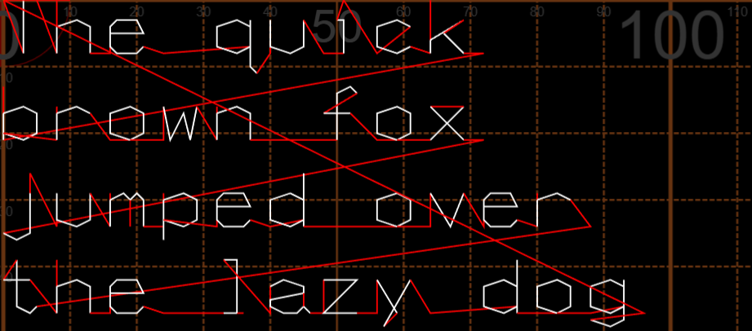

Key Data Items
if (*WordPosition < TextLength && //Skip past special characters after they have been identified earlier
(TextArray[*WordPosition] == 32 ||
TextArray[*WordPosition] == 13 ||
TextArray[*WordPosition] == 10))
{
(*WordPosition)++;
}

Name | Data type | Rationale

Extend table as required

Functions
Only include functions that you have written yourself.
Example (remove before submission)
Short description (one or two lines)
int TemperatureConversion( int InputTemp, float* OutputTemp )
Parameters:
InputTemp – input temperature in degrees C
OutputTemp – pointer to return output temperature in degrees F
Return value – returns 1 if successful, 0 if failed

Testing Information

Function | Test Case | Test Data | Expected Output

Extend table as required. Note that ‘Function’ includes main()

AI Statement

Flowchart(s)
May be included as separate pdf

