static void Main(string[] args)
{
Console.WriteLine("{0}command line arguments were specified:", args.Length);
foreach (string arg in args)
Console.WriteLine(arg);
}
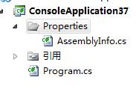
Properties;:产权，特性
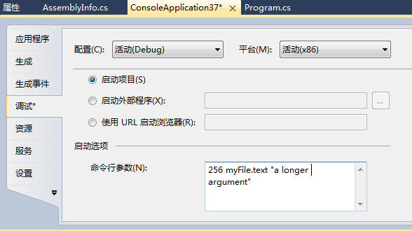
参数用空格分开，不然就用” “分开
这是在调用args函数

