Cloud Computing Lab

Assignment 8

Name: Gargi Mhaskar
Roll No: 33338

Code:
Frontend Main.js

$(function () {
// This is the host for the backend.
// TODO: When running Firenotes locally, set to http://localhost:8081. Before
// deploying the application to a live production environment, change to
// https://backend-dot-<PROJECT_ID>.appspot.com as specified in the
// backend's app.yaml file.
// var backendHostUrl = "http://localhost:8080";
var backendHostUrl = "https://backend-dot-codingatharva.appspot.com";

// [START gae_python_firenotes_config]
// Obtain the following from the "Add Firebase to your web app" dialogue
// Initialize Firebase
var config = {
apiKey: "-YG-XZrjCQ12yxNA1IkU-k",
authDomain: "codingatharva.firebaseapp.com",
databaseURL: "https://codingatharva-default-rtdb.firebaseio.com",
projectId: "codingatharva",
storageBucket: "codingatharva.appspot.com",
messagingSenderId: "1043531589",
};

// [END gae_python_firenotes_config]

// This is passed into the backend to authenticate the user.
var userIdToken = null;

// Firebase log-in
function configureFirebaseLogin() {
firebase.initializeApp(config);

// [START gae_python_state_change]
firebase.auth().onAuthStateChanged(function (user) {
if (user) {
$("#logged-out").hide();
var name = user.displayName;

/* If the provider gives a display name, use the name for the
personal welcome message. Otherwise, use the user's email. */
var welcomeName = name ? name : user.email;

user.getIdToken().then(function (idToken) {
userIdToken = idToken;

/* Now that the user is authenicated, fetch the notes. */
fetchNotes();

$("#user").text(welcomeName);
$("#logged-in").show();
});
} else {
$("#logged-in").hide();
$("#logged-out").show();
}
});
// [END gae_python_state_change]
}

// [START gae_python_firebase_login]
// Firebase log-in widget
function configureFirebaseLoginWidget() {
var uiConfig = {
signInSuccessUrl: "/",
signInOptions: [
// Leave the lines as is for the providers you want to offer your users.
firebase.auth.GoogleAuthProvider.PROVIDER_ID,
firebase.auth.FacebookAuthProvider.PROVIDER_ID,
firebase.auth.TwitterAuthProvider.PROVIDER_ID,
firebase.auth.GithubAuthProvider.PROVIDER_ID,
firebase.auth.EmailAuthProvider.PROVIDER_ID,
],
// Terms of service url
tosUrl: "<your-tos-url>",
};

var ui = new firebaseui.auth.AuthUI(firebase.auth());
ui.start("#firebaseui-auth-container", uiConfig);
}
// [END gae_python_firebase_login]

// [START gae_python_fetch_notes]
// Fetch notes from the backend.
function fetchNotes() {
console.log("Fetching notes");
$.ajax(backendHostUrl + "/notes", {
/* Set header for the XMLHttpRequest to get data from the web server
associated with userIdToken */
headers: {
Authorization: "Bearer " + userIdToken,
},
}).then(function (data) {
console.log("data:", data);

$("#notes-container").empty();
// Iterate over user data to display user's notes from database.
data.forEach(function (note) {
$("#notes-container").append($("<p>").text(note.message));
});
});
}
// [END gae_python_fetch_notes]

// Sign out a user
var signOutBtn = $("#sign-out");
signOutBtn.click(function (event) {
event.preventDefault();

firebase
.auth()
.signOut()
.then(
function () {
console.log("Sign out successful");
},
function (error) {
console.log(error);
}
);
});

// Save a note to the backend
var saveNoteBtn = $("#add-note");
saveNoteBtn.click(function (event) {
event.preventDefault();

var noteField = $("#note-content");
var note = noteField.val();
noteField.val("");
console.log("Posting:", note);
console.log("UserIDToken:", userIdToken);

/* Send note data to backend, storing in database with existing data
associated with userIdToken */
$.ajax(backendHostUrl + "/notes", {
headers: {
Authorization: "Bearer " + userIdToken,
},
method: "POST",
data: JSON.stringify({ message: note }),
contentType: "application/json",
}).then(function () {
// Refresh notebook display.
fetchNotes();
});
});

configureFirebaseLogin();
configureFirebaseLoginWidget();
});

Frontend app.yaml:

runtime: python27
api_version: 1
service: default
threadsafe: true

handlers:

# root
- url: /
static_files: index.html
upload: index.html

- url: /(.+)
static_files: \1
upload: (.+)

Backend Main.py:

# Copyright 2016 Google Inc.
#
# Licensed under the Apache License, Version 2.0 (the "License");
# you may not use this file except in compliance with the License.
# You may obtain a copy of the License at
#
# http://www.apache.org/licenses/LICENSE-2.0
#
# Unless required by applicable law or agreed to in writing, software
# distributed under the License is distributed on an "AS IS" BASIS,
# WITHOUT WARRANTIES OR CONDITIONS OF ANY KIND, either express or implied.
# See the License for the specific language governing permissions and
# limitations under the License.

import logging
import os

from flask import Flask, jsonify, request
import flask_cors
from google.appengine.ext import ndb
import google.auth.transport.requests
import google.oauth2.id_token
import requests_toolbelt.adapters.appengine

# Use the App Engine Requests adapter. This makes sure that Requests uses
# URLFetch.
requests_toolbelt.adapters.appengine.monkeypatch()
HTTP_REQUEST = google.auth.transport.requests.Request()

app = Flask(__name__)
flask_cors.CORS(app)

class Note(ndb.Model):
"""NDB model class for a user's note.

Key is user id from decrypted token.
"""
friendly_id = ndb.StringProperty()
message = ndb.TextProperty()
created = ndb.DateTimeProperty(auto_now_add=True)

# [START gae_python_query_database]
def query_database(user_id):
"""Fetches all notes associated with user_id.

Notes are ordered them by date created, with most recent note added
first.
"""
ancestor_key = ndb.Key(Note, user_id)
query = Note.query(ancestor=ancestor_key).order(-Note.created)
notes = query.fetch()

note_messages = []

for note in notes:
note_messages.append({
'friendly_id': note.friendly_id,
'message': note.message,
'created': note.created
})

return note_messages
# [END gae_python_query_database]

@app.route('/notes', methods=['GET'])
def list_notes():
# print("Notes: " + str(request.headers))
"""Returns a list of notes added by the current Firebase user."""

# Verify Firebase auth.
# [START gae_python_verify_token]
id_token = request.headers['Authorization'].split(' ').pop()
claims = google.oauth2.id_token.verify_firebase_token(
id_token, HTTP_REQUEST, audience='codingatharva')
if not claims:
return 'Unauthorized', 401
# [END gae_python_verify_token]

notes = query_database(claims['sub'])

return jsonify(notes)

@app.route('/notes', methods=['POST', 'PUT'])
def add_note():
"""
Adds a note to the user's notebook. The request should be in this format:

{
"message": "note message."
}
"""

# Verify Firebase auth.
id_token = request.headers['Authorization'].split(' ').pop()
claims = google.oauth2.id_token.verify_firebase_token(
id_token, HTTP_REQUEST, audience='codingatharva')
if not claims:
return 'Unauthorized', 401

# [START gae_python_create_entity]
data = request.get_json()
print("data:", data)
# Populates note properties according to the model,
# with the user ID as the key name.
note = Note(
parent=ndb.Key(Note, claims['sub']),
message=data['message'])
print("claims:", claims)
print("Note:", note)
# Some providers do not provide one of these so either can be used.
note.friendly_id = claims.get('name', claims.get('email', 'Unknown'))
# [END gae_python_create_entity]

# Stores note in database.
note.put()

return 'OK', 200

@app.errorhandler(500)
def server_error(e):
# Log the error and stacktrace.
logging.exception('An error occurred during a request.')
return 'An internal error occurred.', 500

backend app.yaml

runtime: python27
api_version: 1
threadsafe: true
service: backend

handlers:
- url: /.*
script: main.app

env_variables:
GAE_USE_SOCKETS_HTTPLIB: "true"
FIREBASE_PROJECT_ID: "codingatharva"

backend index.yaml

indexes:

- kind: Note
ancestor: yes
properties:
- name: created

- kind: Note
ancestor: yes
properties:
- name: created
direction: desc

Output:
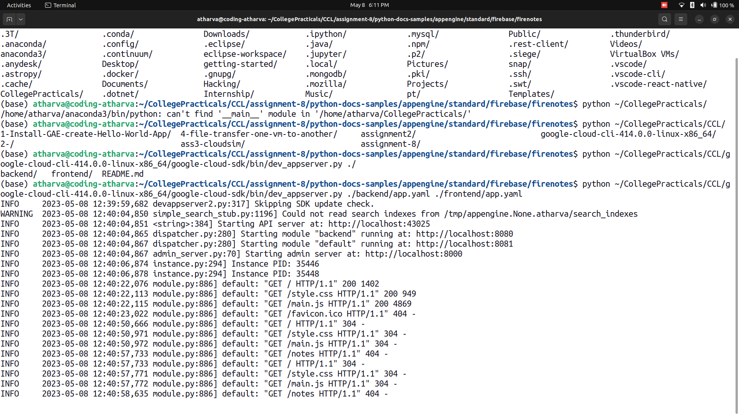

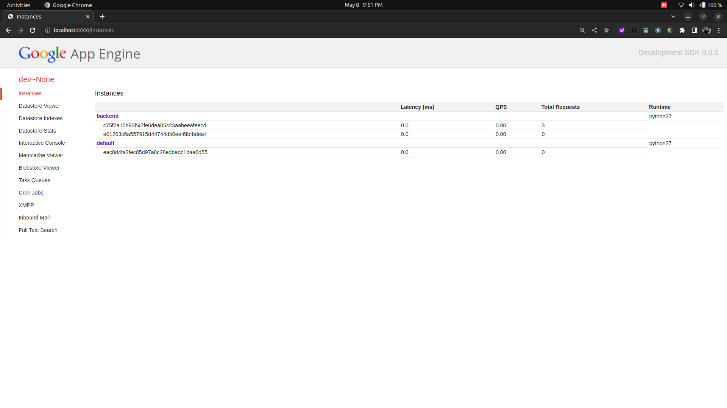

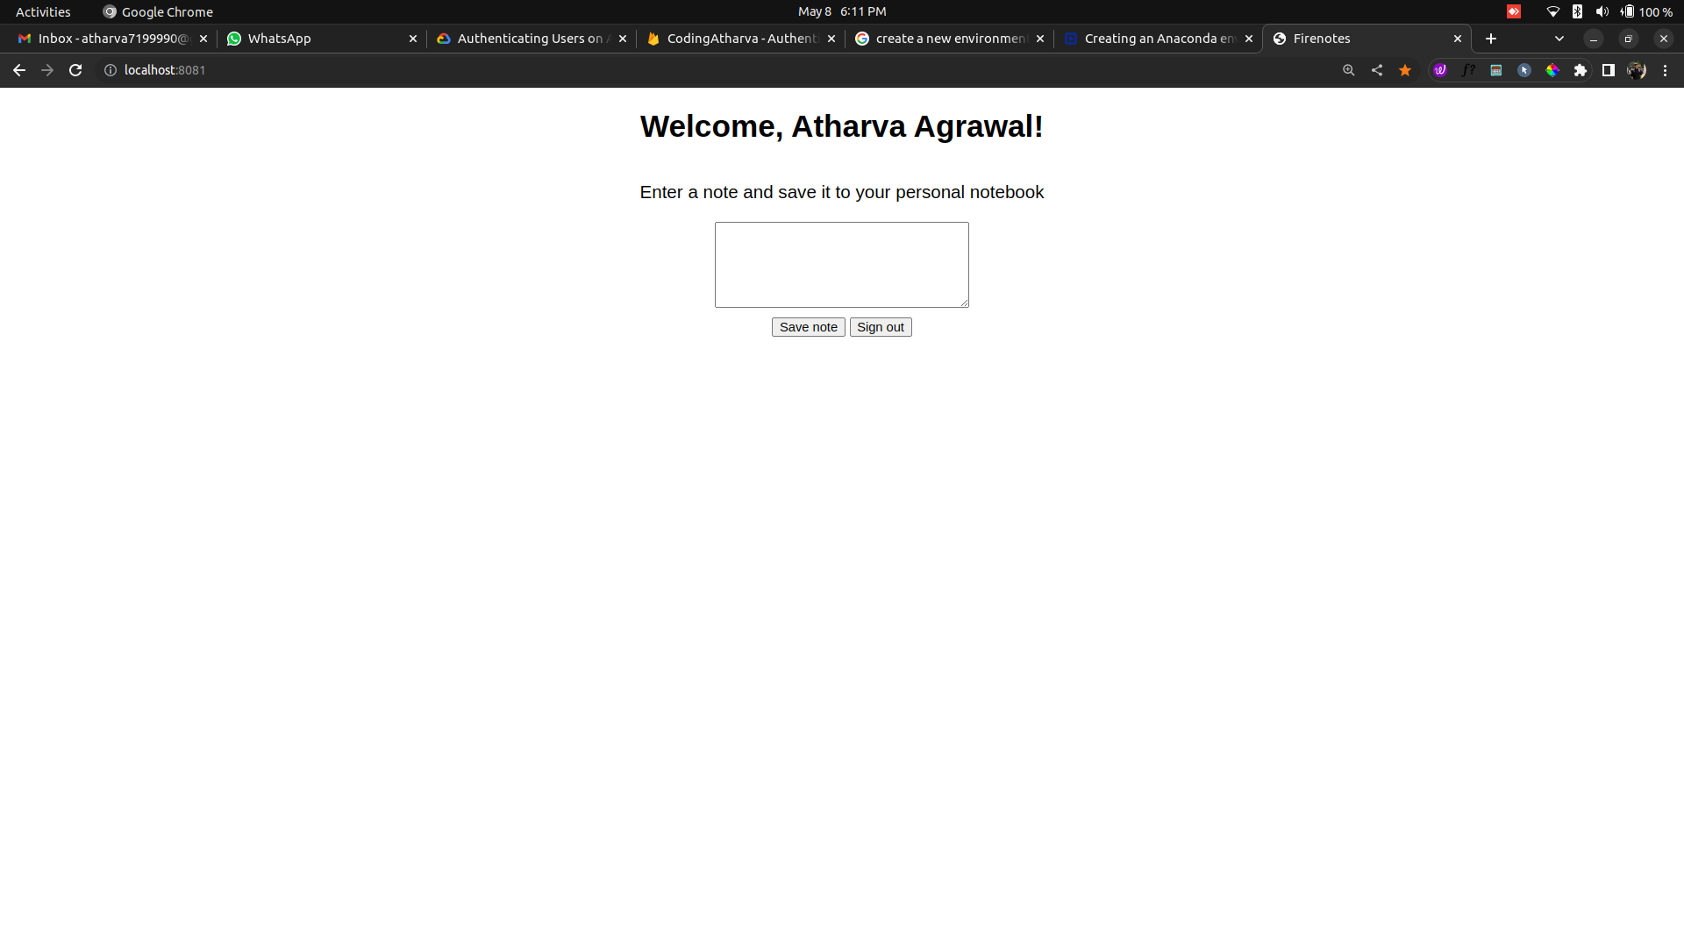

Gargi Mhaskar!

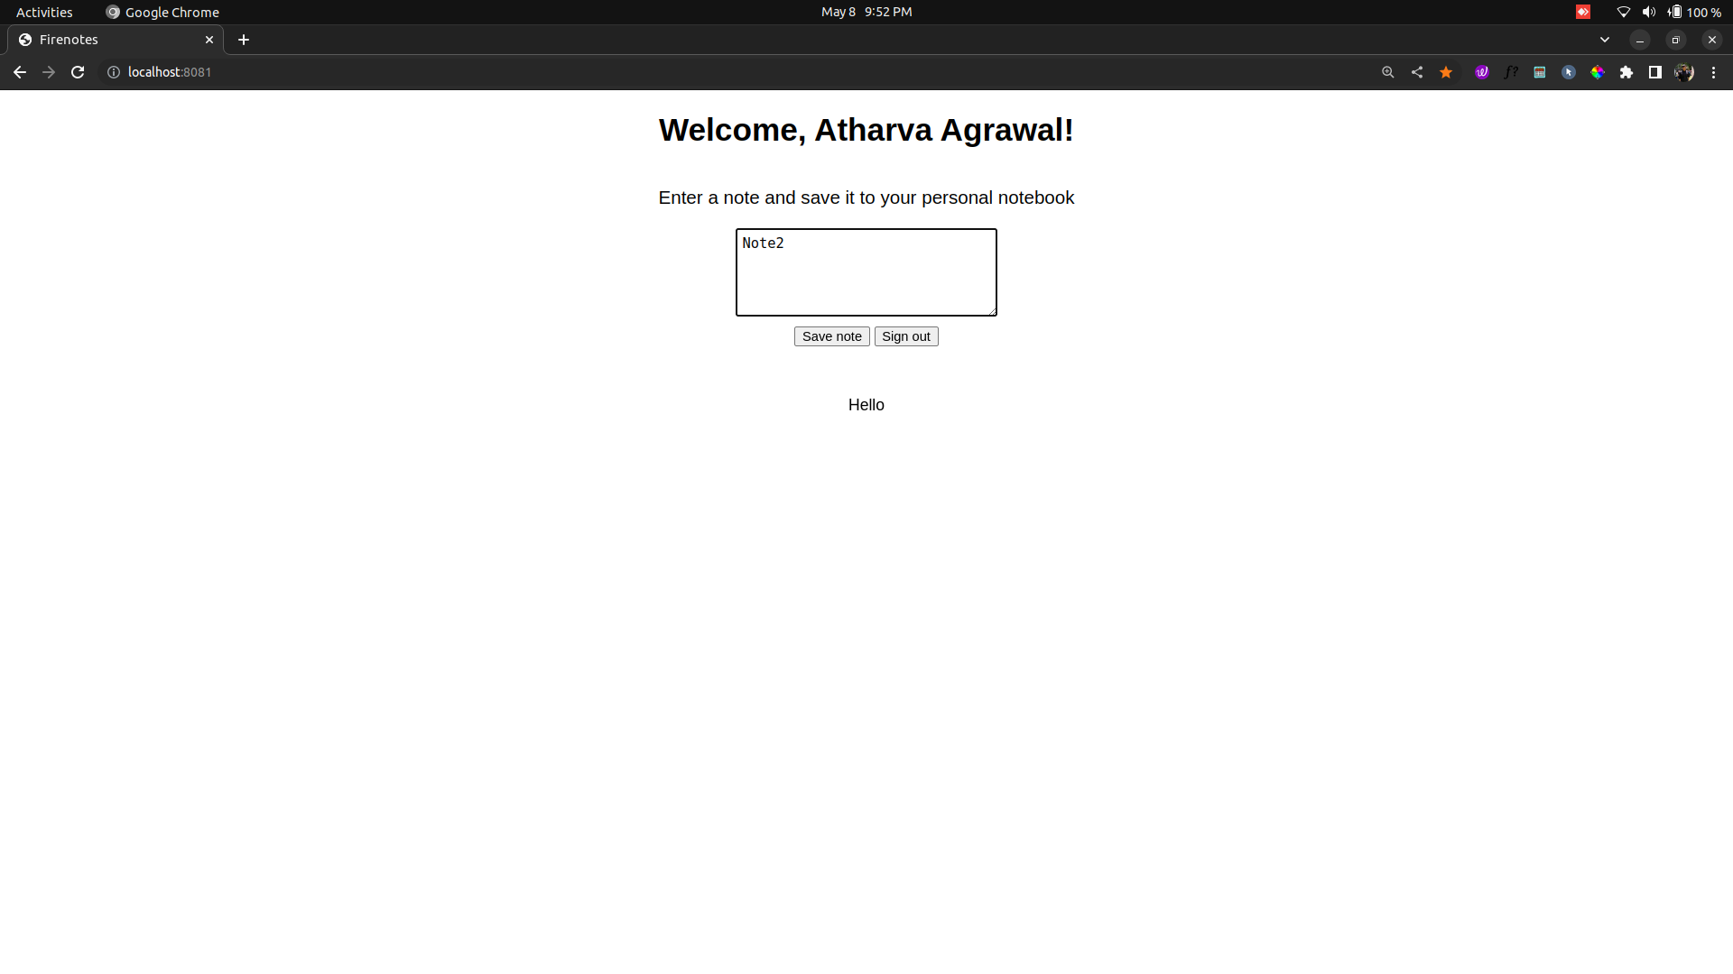

Gargi Mhaskar!

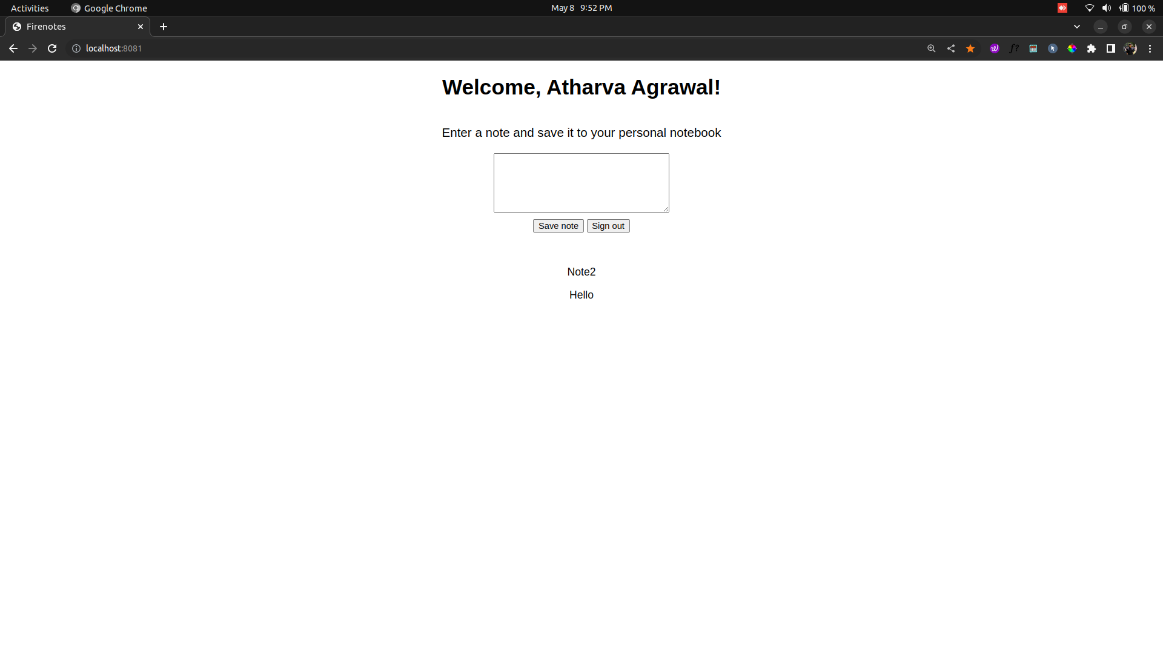
Gargi Mhaskar!

