Environment:

1. Use “pip install” command to install the environment:

pip install scipy

pip install imutils

pip install argparse

pip install time

pip install opencv-python

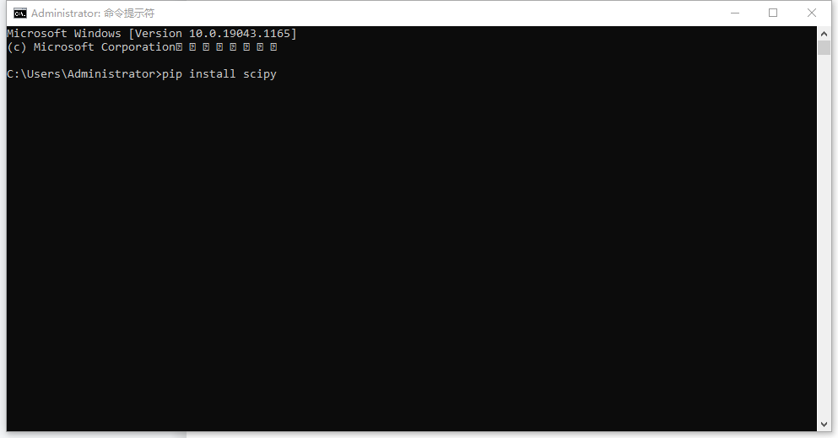

If it doesn’t work, you can open pycharm----file----settings----project Wink.py----python interpretor. Double click any package below, search the package you need and install.

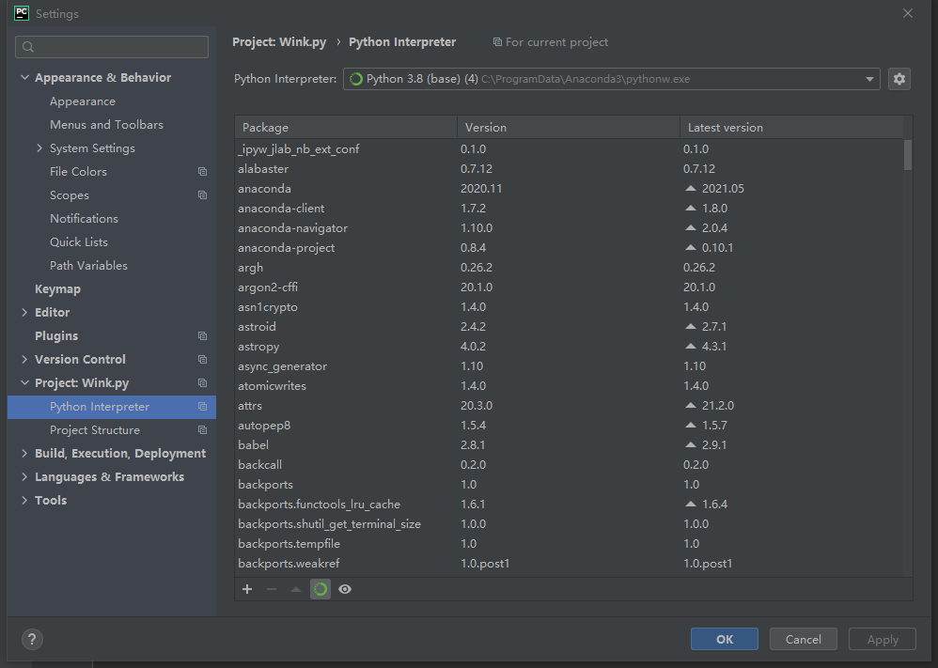

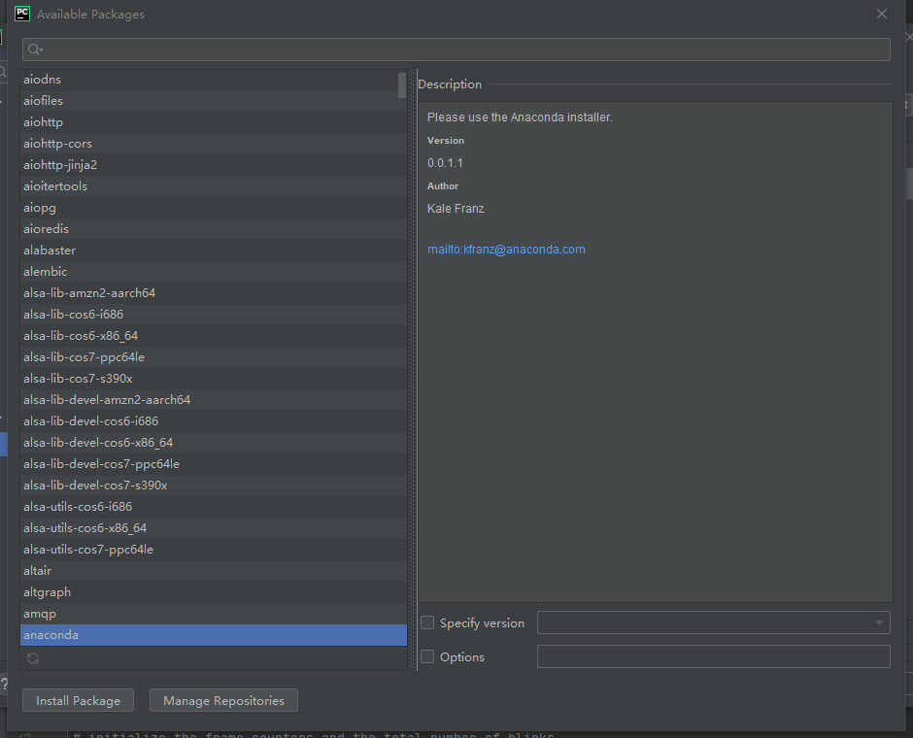

1. For the dlib, open terminal, open dlib-19.22.1 directory. The dlib-19.22.1 is in the project file.

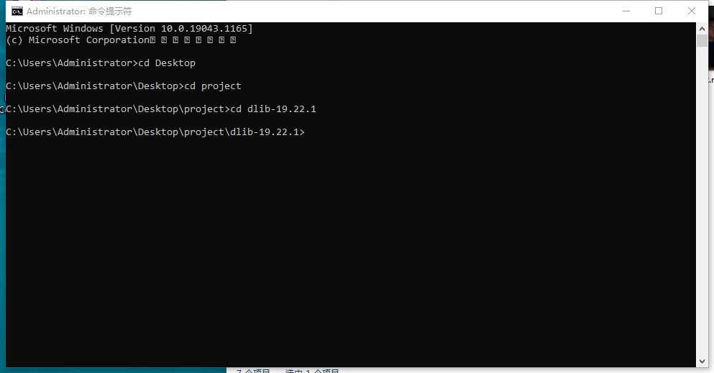

Then, type “python setup.py install”.