**Numerical Analysis – Fall 2022**

Assignment #1

Issued: Sept. 20, 2022 Due: Oct. 10, 2022

Please hand in the C or Matlab or Python or others, graphics, and a brief description of your reasoning as well as comments if any. You should pack all of your files into a .rar or .zip file, titled as “xxxxxxx(your student ID)_Homework_1”, and then submit it by uploading to server before 11:59pm of the due day.

**Problem 1:**

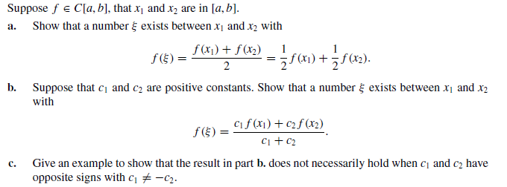

**Problem 2:**

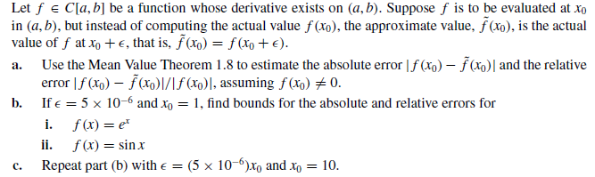

**Problem 3:**

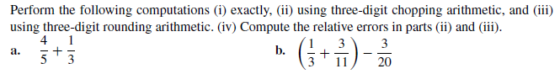

**Problem 4:**

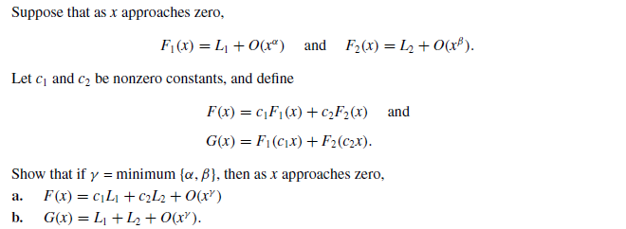

**Problem 5:**

Implement the Bisection method in C or matlab and find solutions accurate to within for the following problems. **(List the midpoints in each iteration as well) . 【请在作业中上交程序代码】**

1.  for 
2.  for  and 

**Problem 6:**

Implement the fixed-point iteration method and find solutions accurate to within  for the following problems. **(List pn in each iteration as well)**. **【请在作业中上交程序代码】**

1.  on [1, 2], use 
2. 

**Problem 7:**

Let and p be in (a, b) with g(p) = p and . Show that there exists a such that if , then . Thus, no matter how close the initial approximation  is to p, the next iterate is father away, so the fixed-point iteration does not converge if .