**Numerical Analysis – Fall 2022**

Assignment #5

Issued: Oct. 25, 2022 Due: Nov. 5, 2021

**Problem 1:**

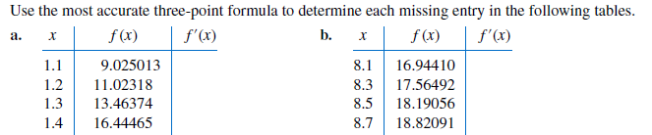

**Problem 2：**

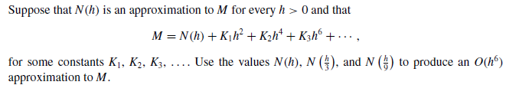

**Problem 3:**

Approximate the following integrals using the Trapezoidal rule and Simpson’s rule, respectively.

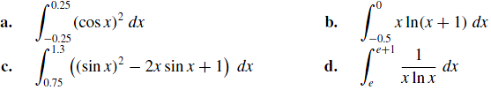

**Problem 4:**

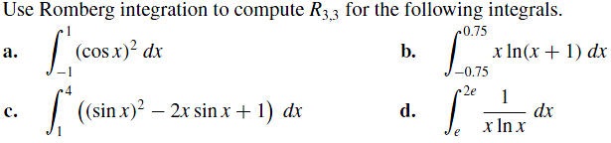

**Problem 5 (After Next Class):**

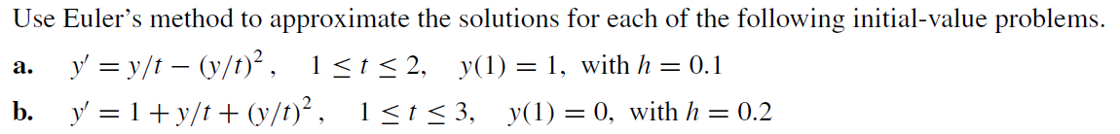

Problem 6

Consider the following data:

|  |  |  |
| --- | --- | --- |
| i | xi | yi |
| 1 | 0 | 6 |
| 2 | 2 | 8 |
| 3 | 4 | 14 |
| 4 | 5 | 20 |

1. Compute the linear least squares polynomial approximation for this data.
2. Compute the error E of the above approximation.