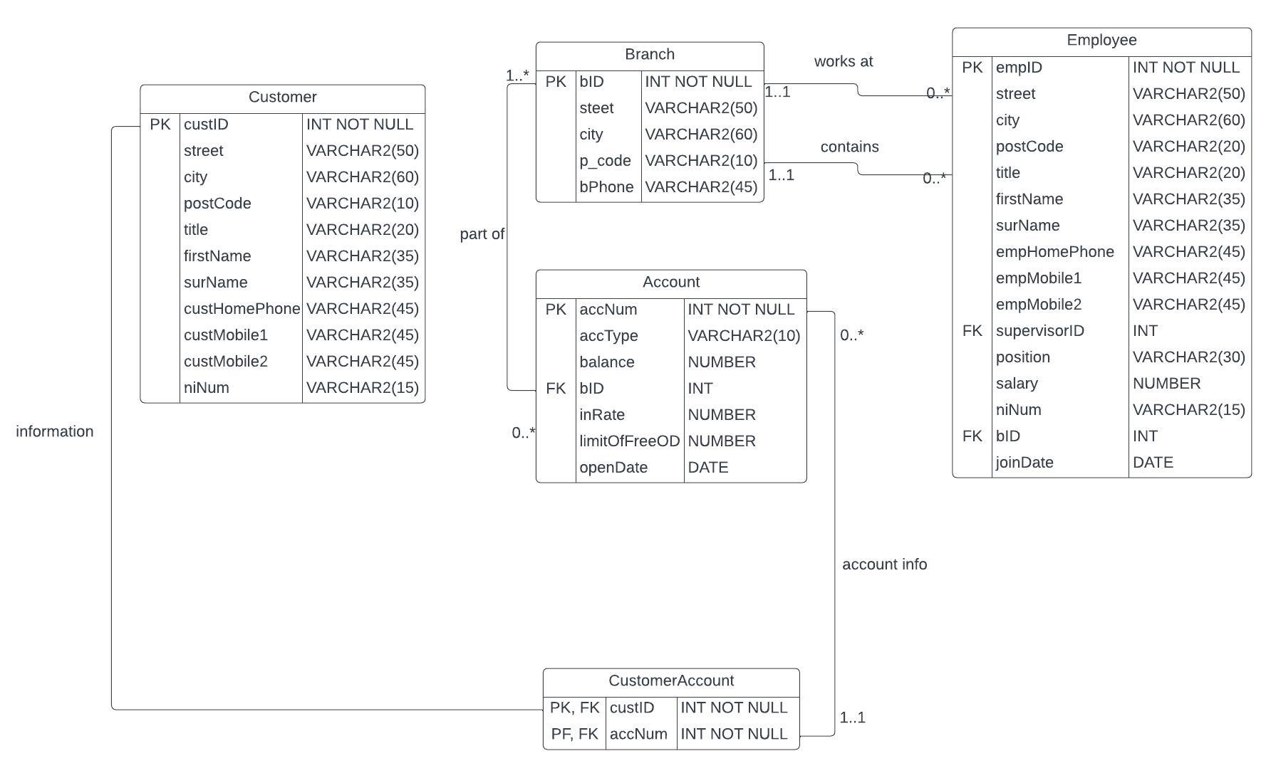

- Database Redesign
  - Structured Types
While redesigning the database in order to capture more of the semantics of the application, I first began at the object-relational features. These include Structured Types, Inheritance, References, Methods, Constraints and lastly Collections. In order to do this, I will also need to keep in mind the queries that will be asked of the database further on in task 4, as such certain additions will be added. I will go into detail for each and talk discuss what was done for each section and applied to the database.
In this section I will go over the structured types. Currently, the database contains 5 types. These include Customer, Branch, Account, Customer Account and Employee. From these I can create user defined Structured Types with it’s respective key data assigned as objects related to the Main Structured Type, then being turned into a sub-table. I will begin with creating user defined types that can create objects that in turn can be used to create new Structured Types or enhance current tables. We will begin at:
- Personal Information Object (obj_pii): This will be made up of two object subtypes; Name & Address which are discussed below.

- Name (obj_name): This would contain the Title, FirstName and SurName attributes with a method to produce a clean full name E.G “FirstName=John SurName = Smith” would be fullName as “John Smith”. It will also contain the niNum.

- Address (obj_address): This would contain the street, city, and postcode attributes with the same method as name to produce a clean Address. This will also be a subtype of Personal Information”, with one last subtype needed to fully form the “Personal Information” supertype.

- Customer Phone Numbers (obj_cPhoneNumbers): This will contain the following: custHomePhone, custMobile1, custMobile2 (any of which can be null) to create a nested table (for easier access in future queries in task 4) that will be inserted into the Customer object type that will be discussed later.

- Employee Phone Numbers (obj_ePhoneNumbers): This will contain the following: empHomePhone, empMobile1, empMobile2. This will also be an object and won’t be nested like Customer Phone Numbers as it’s not needed for a future query.

- Customer (obj_customer): This will be a supertype of Personal Information. It will contain the obj_pii as well as a Customer ID (custID) alongside the table of Customer Phone Numbers (obj_cPhoneNumbers).

- Job (obj_job): This will be an object that contains the job (position) and pay (salary).

- Branch (obj_branch): This will consist of a Branch ID (bID), the address object (obj_bAddress) and lastly a branch phone number (bPhone). In order to ensure that there are no duplicate data entries the bID will be unique and not null.

- Employee (obj_employee): This will be another supertype of Personal Information. It will contain the primary key of Employee (empID) that can’t be empty, the Personal Information object (obj_person), job (obj_job), a reference for the branch ID (bID_ref) and Supervisor ID (supe_ref).

- Account Finances (obj_accFin): This will contain anything related to finances; balance, interest rate (inRate) and overdraft limit (limitOfFreeOD).

- Account (obj_account): This will contain the account finances object (obj_accFin), account number (accNum), account type (accType), date of account opening (openDate) and then a reference to the branch ID (bID_ref)

- Customer Account (obj_cAccount): A simple object that will reference two attributes. Customer ID (cID_ref) and account number (accNum_ref).

  - Inheritance
When it comes to inheritance there is a few instances of it in this database. For example, the Customer and Employee Objects inherit the Personal Information objects attributes, which contain address (street, city, and postcode) and name (title, firstName and Surname).
The employee table also takes in the employee phone numbers attributes and the job attributes from the job object type. Inheriting the objects provides more efficient and sustained hierarchy that doesn’t allow for bloated or repeat data.
  - References
References were used in a few instances. References work in the same way that a foreign key would act. The employee type for acts as a reference. The supe_ref will reference employee ID since the unique identifier for supervisor will be an employee’s ID. The branch ID reference (bID_ref) is also being used for more effective and efficient queries that that are related the branch table.
Another time references are used can be found in the customer account type that will be used in a reference table. This is purely for reference as it contains a customer ID reference (cID_ref) linked to the customer type (custID) and account number reference (accNum_ref) linked to the account type (accNum).
  - Methods
When it comes to using methods in the database, there are two used in order to clean data for proper presentation. This is for the name and address. First name and surname will go through a Member Method and return a full name (firstName = John surname = Smith would become John Smith). The same Member method is applied to the address to create a full clean address from the street and city (5 queens road, Edinburgh).
For task H, I added a member method in order to find how many employees supervisors oversee, their length of service and general employees length of employment in order to award them the appropriate merit.

  - Constraints
Constrains were used in order to make sure that certain conditions were met in the database for data integrity and to minimise bad data entries and prevent errors. An example of this can be simply when setting the datatype for primary key data Branch ID (bID), customer ID (cID) and account number (accNum). None of these values can be duplicates or left empty, so a simple PRIMARY KEY and NOT NULL set of constraints will be placed on these entries.
When the employee job type is being chosen, The job position will be put through a CHECK to make sure that the entry is one of the 5 possible positions that can be entered.

  - Collections
Collections are used in order to contain multiple attributes of data and point it to one attribute. I implemented this into the database by using the type of customer phone numbers and nesting it into the table of customer to contain the home phone number, mobile 1 and mobile 2.

  - Database Rationale and Possible Alternatives
The newly redesigned database adheres more towards an object relational system rather than the original relational database. This is done while continuing to keep the semantics of the application the same and capture more of it.
In order to fully realise this, decisions had to be made about aspects of the system which I will go into detail over here and explain why I went with what I did over the alternative option.
- While creating the Personal Information Object, I had the choices of either combining employee and customer tables and taking their attributes with subtypes to denote them to their position in the bank, customer, or employee. However, I decided to keep personal information about the name, address, and phone number with subtypes for employee and customer to keep their respective key values and unique attributes separate for data integrity. I wanted to keep the personal information type to inheriting the attributes from address and name with the additional type of either customer or employee that can then inherit the personal information object. This would be better functionally and allow for better queries.

- I could have also added a type of Phone Numbers to the personal information object type, however after some contemplation it was better to have one type for employee’s phone numbers and another for customer. This is in the scenario where someone is both an employee and customer for the same bank but want to have different phone numbers as their primary for instance.

- A standalone job object was created for the purpose of keeping data that shouldn’t be changed consistent without interaction when the employee’s job or salary is updated. For example, in task 4H, I need to implement a function where supervisors who oversee a certain number of personnel and have been employed for a certain period of time are awarded something. Now, when an employee’s job and salary are changed or updated, it will not affect the anything keeping the data constant and unchanged as it should be. The only details that would originally be changeable have now been created into its own object.

- SQL STATEMENTS
See DBCreating.sql for the scripts to create types and tables.
See DBPopulating for scripts to populate the tables with test data.

- SQL QUERIES AND ANSWERES
See answersToTask4.sql for the queries found below;
(a)
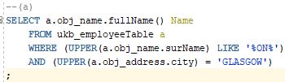
Output:
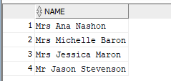

(b)
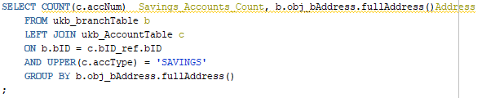
Output:
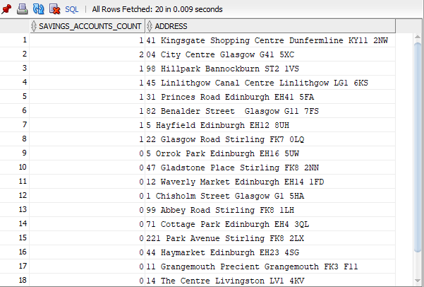

(c)
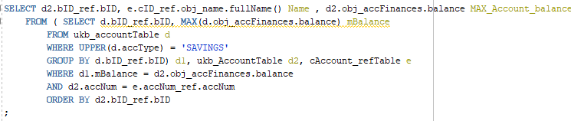Output:
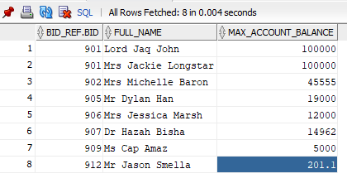

(d)
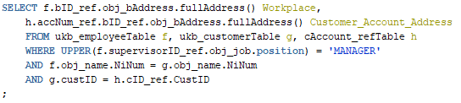
Output:
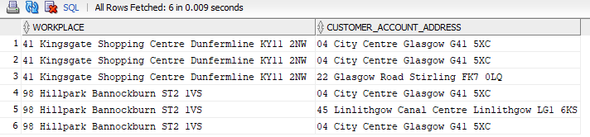

(e)
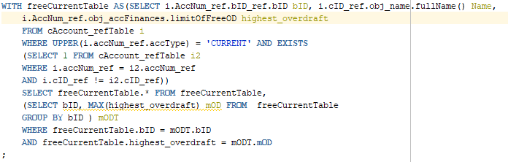Output:
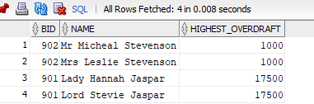

(f)
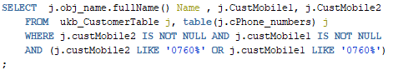
Output:
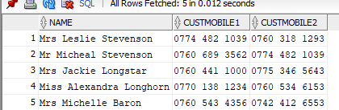
(g)
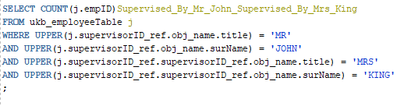

Output:


(h)
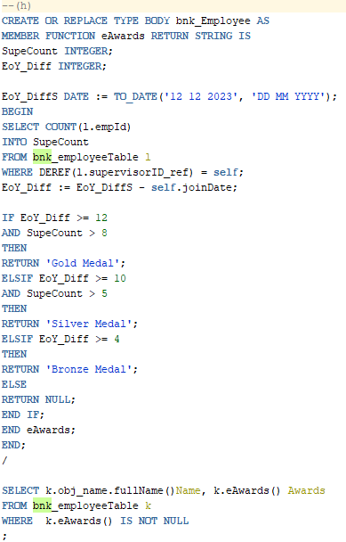
Output
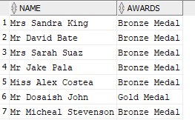

When it comes to the advantages and disadvantages of object-relational model against the relational model, there are some things to consider. With Object-relational models, large datasets can be stored and used very quick and efficiently. In the newly designed bank system, objects are created for people’s basic information, financial information, and other such things. However, with that can come the risk of duplicate entries or data. For example, as employees of the bank can also be customers at another branch, there is the need to have multiple entries of basic information for this person. This is a double-edged sword, as it can be useful if the employee/customer wants to have certain information for business but not for personal account but in the case of an address change or main mobile number changing these types of entries will need to be done cross both tables.
Object-relational systems also add supertypes and subtypes with a level of complexity you would not find a relational model. A big object relational system can get very convoluted as it gets bigger and potentially lose some of that effective flow that is one of the main advantages found in the Object-relational system. The cost of keeping the Object-relational database going can and most likely will get higher as more employees and customers join the bank, and the potential for more customers to be employees needing double management per account. This could be addressed however by making the address point to a single person via NI number regardless of if they are an employee or not.

