

A Comparative Study: The Impact of AI Chatbot

On

Traditional

Customer Service Information Systems in After-Sales Scenario

Course Name：MSc Information System Process
Student Name: Zhiyuan Xu
Student number: 20115990
Supervisor Name: Cian Murphy

Table Of Contents
1 Background of Artificial Intelligence Customer Service 6
1.1 Research Aims 8
1.2 Research questions 9
1.3 Hypotheses 9
1.4 Problem Statement and Motivation 11
1.4.1 Problem Statement 11
1.4.2 Motivation 12
2.Literature Review 13
2.1 Introduction 13
2.2 The evolution of customer service information systems 16
2.3 Current Trends in AI Customer Service 17
2.4 Information System Success Model 18
2.5 The Success of Information System in AI-Enabled Service Contexts 19
2.6 Customer satisfaction indicators and Service performance indicators 22
2.7 The Impact of AI Chatbots with RAG +LLM Technology and with the private company knowledge graph on Human Customer Service 23
2.7.1 Characteristics of Traditional Customer Service 23
2.7.2 Characteristics of Retrieval-Augmented Generation 25
2.7.3 Knowledge Graph (or Structured Knowledge Base) 27
2.7.4 Large Language Models 28
2.7.5 Characteristics of AI customer service 29
2.7.6 Mechanism of Tool Invocation via API 31
2.8 Literature Review Summary 34
2.9 Research Gaps 35
3.Methodology 36
3.1 Methodology Introduction 36
3.2 Research Philosophy and Methodological Approach 37
3.2.1 Philosophy of Research (Post-Positivism) 37
3.2.2 Quantitative research methods (based on recall surveys) 38
3.3 Research Design 39
3.3.1 Overall Research Design 39
3.3.2 Analysis unit and research background 39
3.4 Conceptual Model and Construct Operationalization 39
3.4.1 Conceptual Model 39
3.4.2 Independent Variable 41
3.4.3 Dependent Variables 41
3.4.4 Control Variables 41
3.5 Development of measurement methods and design of questionnaires 42
3.5.1 Scale Development and Response Format 42
3.5.2 Perceived Response Efficiency 43
3.5.3 Perceived Problem-Resolution Accuracy 43
3.5.4 Overall Service Evaluation 44
3.6.5 Questionnaire Structure 44
3.5.6 Manipulation Check 45
3.6 Sampling and Data Collection 45
3.6.1 Target Population 45
3.6.2 Sampling Strategy 45
3.6.3 Sample Size 46
3.6.4 Data Collection Procedure 47
3.6.5 Data Quality Control 47
3.7 Data Analysis Methods 47
3.7.1 Data Preparation 47
3.7.2 Reliability and Validity Assessment 47
3.7.3 Hypothesis Testing Strategy 48
3.8 Mapping with Research Questions and Hypotheses 48
3.9 Ethical Considerations 49
3.10 Chapter Summary 49
3.11 Limitations of the Study and Ethical Considerations 49
4. Data Analysis 50
4.1 Introduction 50
4.2 Data Screening and Sample Profile 50
4.2.1 Data cleaning 50
4.3 Variable Construction and Reliability Testing 52
4.3.1 Variable construction 52
4.3.2 Reliability analysis 53
4.4 Validity Analysis 54
4.4.1 KMO and Bartlett Test 54
4.4.2 Factor Extraction 55
4.4.3 Factor analysis and Its Rotated Component Matrix Interpretation 56
4.5 Independent Samples T-test 59
4.5.1 Purpose of the test 59
4.5.2 Results of Independent Samples T-test 59
4.5.3 Effect size interpretation 60
4.6 Descriptive Statistics 61
4.6.1 Overall Descriptive Statistics 61
4.6.2 Overall Project-level Comparison 64
4.7 Hypothesis Testing 65
4.8 Chapter Summary 66
Appendix: Artificial Intelligence Chatbots ’key Terms’ (Technology Explanation) 68
What are artificial intelligence chatbots? 68
Machine Learning 69
Deep Learning 70
Natural Language Processing 70
Data Analysis Code 71
Reference 72

Categories Of Contents
Table 1 The overview of Literature Review 12
Table 2 The Key Term of Literature Review 13
Table 3 Compare with Three Method 37
Table 4 Hypothesis and Method 47

Table Of Figure
Figure 1 Screenshot of the Taobao homepage. 22
Figure 2 Screenshot of the “Contact Us” page on Taobao’s official website. 23
Figure 3 Retrieval-Augmented Generation Principle 25
Figure 4 The NetEase Qiyu customer service interface without Retrieval-Augmented Generation. 28
Figure 5 Architecture diagram of artificial intelligence customer service and search enhancement. 29
Figure 6 Function calling and MCP protocol based on API for invoking the tool 31
Figure 7 Research AI Customer Service with Retrieve Augmented Generation Information System Modeling 39

1 Background of Artificial Intelligence Customer Service
With the continuous development of artificial intelligence (AI) technology, more business organizations are deploying intelligent information systems based on AI to provide intelligent services to customers. Especially in the field of customer service, tremendous changes have taken place over the past few decades. It has shifted from face-to-face interactions and telephone support to digital channels such as online AI customer service question-and-answer systems. Nowadays, artificial intelligence is significantly transforming customer service. Chatbots have become the main tool for automating tasks and enhancing customer interaction. Due to their efficiency, cost-effectiveness, and ability to imitate human interaction, AI-driven chatbots are rapidly becoming an indispensable part of customer service. Especially in online e-commerce platforms, artificial intelligence customer service systems utilize technologies such as machine learning, deep learning, and natural language processing. These systems employ these technologies to achieve automation in supporting standardized customer inquiries and large-scale daily interactions. This results in artificial intelligence customer service systems, particularly chatbots, having significant advantages in terms of efficiency and cost-effectiveness, and being able to enhance customer engagement and purchase intent by providing human-like interactions (Arora, A., Kapale, R., Sharma, P., Nalavade, M., Saifee, M., & Ukey, M., 2024). Therefore, organizations are increasingly relying on artificial intelligence-based service systems to support operational efficiency and reduce the workload of repetitive service tasks traditionally handled by human agents.
However, although artificial intelligence customer service is efficient and scalable, traditional AI chatbots usually cannot solve complex problems specific to enterprises. On the contrary, traditional customer service systems may maintain an advantage in promoting deep emotional interaction, empathetic communication, and handling the enterprise's own professional and complex issues (Hyungjoon Kim., 2025). This is because previous AI customer service systems, lacking the specific enterprise knowledge set for a particular task, often fail to handle tasks in special circumstances. For instance, in a post-sale environment, when customers deal with complex enterprise issues and inquire about internal policies and strategies that require professional enterprise knowledge and specific internal enterprise information, traditional AI chatbots often cannot predict such knowledge because these tasks are completely different from daily common problems. Therefore, compared with early chatbots without knowledge graphs and retrieval-enhanced production technologies, users trust human services more.
However, this situation has changed. The latest advancements in knowledge graphs based on specific enterprise ontologies, large language models, and retrieval-augmented generation technology have provided a powerful framework for customer service AI. In simple terms, by integrating the knowledge of the ontology into the enterprise's knowledge graph, AI agents can retrieve more accurate data more quickly through retrieval-augmented generation technology. The main process is that the AI chatbot first retrieves relevant organizational knowledge from the enterprise-level structured vector database, then finds the required content in the enterprise knowledge graph relational database, integrates it, and sends it to the large language model, which aims to generate context-aware output based on the specific information of the enterprise. Systems based on retrieval-augmented generation and large language models have stronger dynamic planning thinking capabilities in language generation and stronger static planning retrieval capabilities in information retrieval compared to earlier chatbots. Technically, the development of these retrieval-augmented architectures and large language models indicates that traditional chatbots have the potential for improvement in dynamic thinking speed and static retrieval. With the latest large language models, retrieval-augmented generation technology, and ontology-based enterprise-level knowledge graphs, agents can improve the accuracy and timeliness of responses, especially in service scenarios that enterprises highly value (C. Ren et al, 2021).
Although the adoption of AI chatbots based on RAG and LLM is on the rise, few studies have compared their effectiveness with traditional human-centered systems. Some scholars have emphasized that by creating knowledge graphs through the enterprise's own ontology, AI chatbots using RAG and LLM can enhance operational efficiency, save human resource costs for enterprises, and improve the agents' ability to handle complex tasks (D. Yadav, H. Para, K. Sandhu and P. Selvakumar, 2024). However, critics point out that AI cannot replace humans because AI chatbots have limitations in handling subtle queries, understanding emotional context, and maintaining a human touch, which are characteristics of excellent customer service (Prasad, K. V. S., Xavier, L. A., Jain, S., Subba, R., Mittal, S., & Anute, N., 2024). Therefore, it is necessary to conduct empirical research to evaluate the accuracy, perceived efficiency, and user satisfaction of AI customer service chatbots in complex human-machine interaction scenarios.

1.1 Research Aims
This study aims to evaluate the effectiveness of an AI customer service system based on RAG + LLM in the after-sales service workflow on e-commerce platforms by applying the DeLone and McLean Information System Success Model, to identify the success of this information system, and to use human customer service as a benchmark for comparison. Specifically, it is to address the research question of this paper, that is, to compare the differences between AI customer service based on large language models (LLM) and retrieval augmentation techniques (RAG) and traditional human customer service in the DeLone and McLean Information System Success Model. The focus of this study is to examine whether the AI customer service system based on LLM and RAG can provide higher response efficiency and more accurate problem-solving when dealing with common after-sales issues such as returns, refunds, and complaints, and to summarize these quality improvements as an enhancement in service perceived quality, thereby increasing customer satisfaction.

1.2 Research questions
Research Question One：
RQ1: How does AI customer service based on LLM and RAG compare with traditional manual customer service in terms of perceived response efficiency within the after-sales consultation process of e-commerce platforms?
RQ1 Objective: Compare the response time performance of AI chatbots based on large language models (LLM) and retrieval augmented technology (RAG) with traditional human agent systems in post-sale customer service in human dimension.
Research Question Two：
RQ2: How does AI customer service based on LLM and RAG compare with traditional human customer service in terms of perceived accuracy of problem resolution in after-sales service processes?
RQ2 Objective: Compare the perceived problem resolution accuracy performance of AI chatbots based on large language models (LLM) and retrieval augmented technology (RAG) with traditional human agent systems in post-sale customer service in human dimension.
Research Question Three
RQ3: In the after-sales scenario, how do AI chatbots based on LLM and RAG differ from traditional human agent channels in terms of customer satisfaction and perceived service quality?
RQ3 Objective: Compare the perceived customer satisfaction and service quality of AI chatbots based on large language models (LLM) and retrieval augmented technology (RAG) with traditional human agent systems in post-sale customer service in human dimensions.

1.3 Hypotheses
H1(A): In the context of after-sales service, from the user's perspective, it is believed that the intelligent customer service system will significant statistically positive than human customer service representatives in terms of response efficiency.
H1(B): In the context of after-sales service, from the user's perspective, it is believed that human customer service representatives will significant statistically positive than intelligent customer service in terms of response efficiency.
H1(C): In the context of after-sales service, from the user's perspective, it is believed that human customer service representatives will not significantly statistically compare with intelligent customer service in terms of response efficiency.

H2(A)：In the context of after-sales service, from the user's perspective, it is believed that the intelligent customer service system will be significantly statistically positive than human customer service representatives in terms of accuracy in problem-solving.
H2(B)：In the context of after-sales service, from the user's perspective, it is believed that human customer service representatives will significant statistically positive than intelligent customer service in terms of accuracy in problem-solving.
H2(C)：In the context of after-sales service, from the user's perspective, it is believed that human customer service representatives will not significantly statistically compare with intelligent customer service in terms of accuracy in problem-solving.

H3(A)：In the context of after-sales service, from the user's perspective, it is believed that the intelligent customer service system will be significantly statistically positive than human customer service representatives in terms of Users’ satisfaction with intelligent customer service.
H3(B)：In the context of after-sales service, from the user's perspective, it is believed that human customer service representatives will significant statistically positive than intelligent customer service in terms of Users’ satisfaction with the intelligent customer service.
H3(C)：In the context of after-sales service, from the user's perspective, it is believed that human customer service representatives will not significantly statistically compare with intelligent customer service in terms of Users’ satisfaction with intelligent customer service.

1.4 Problem Statement and Motivation

1.4.1 Problem Statement

1. The impact of task complexity on AI chatbots enhanced by LLM and RAG technologies
This article aims to verify which of the two systems, the one based on large language models (LLM) and retrieval-enhanced generation (RAG) artificial intelligence, and the traditional human customer service system, is more successful. It is well-known that artificial intelligence chatbots are designed to solve problems effectively. Their purpose is to enhance efficiency through automatic responses. However, research has found that the complexity of the specific tasks of enterprises seems to undermine the effectiveness of artificial intelligence customer service.In the early days, the limitations of artificial intelligence chatbots in customer service lay in their inability to perform retrieval-enhanced generation and knowledge graph operations. The problem was that although they were good at handling routine inquiries, they struggled to deal with complex enterprise-specific knowledge issues, which could undermine the overall efficiency of their interaction with customers (Ferraro et al., 2024). It is well-known that in after-sales services, such as refunds, returns, and complaint handling, there are significant interests and high perceived risks, and expectations for timeliness and accuracy are very high. Previous service studies have shown that customers are particularly sensitive to service failures in the post-purchase stage because errors at this stage are more likely to damage trust and satisfaction (Resekiani Mas Bakar, Zhafran Fadhil Damara, & Ahmad Yasser Mansyur., 2020). In this situation, human agents outperformed the early chatbots that lacked retrieval-enhanced generation and enterprise knowledge graphs in complex post-sales scenarios, as they were able to handle subtle emotional nuances and complex problem-solving specific to the enterprise. Due to the inability of early chatbots to generate specific enterprise knowledge answers, these systems although they improved response speed, empirical studies have shown that due to limited context understanding of enterprise-specific situations, the conversation structure becomes rigid and often cannot effectively solve customer problems, resulting in repeated conversations and increased user workload (Iqbal, M., Siregar, M. N. H., & Rismayanti, R. , 2025). Therefore, the early chatbots without enterprise-specific knowledge were less effective than traditional human customer service in handling complex scenarios in the after-sales environment.
However, the latest advancements in large language models (LLMs) and retrieval augmented generation (RAG) aim to overcome these limitations by combining flexible language generation with access to company-specific knowledge bases. Theoretically, systems based on large language models can improve the efficiency of perceptual responses by reducing unnecessary conversations and handling ambiguous or emotional questions. The RAG mechanism can enhance the accuracy of perceptual problem-solving by relying on authoritative and up-to-date information sources (Yıldırım & Samli, 2025). However, when it comes to handling complex tasks, there are no relevant studies to explore the differences between RAG and LLM technology-driven AI customer service and human customer service.

2. The research on the service dimension of the chatbot combining RAG and LLM is limited
In order to verify the research questions of this paper regarding the artificial intelligence customer service information system based on large language models (LLM) and retrieval-enhanced technology (RAG), by comparing users' perception of information quality, system quality, service quality, and the differences with traditional human customer service satisfaction in complex post-sale scenario interactions, the success of this system is evaluated. This paper finds that although previous research evidence indicates that chatbots based on RAG+LLM can improve efficiency, accuracy, and reduce costs compared to chatbots without enterprise-specific knowledge, rigorous comparative studies measuring performance from multiple dimensions such as response time, solution accuracy, and customer satisfaction are still limited. In the early days of chatbots, previous comparative studies have shown that in complex and judgment-intensive organizational special tasks, users often prefer human agents rather than automated systems because of concerns about accuracy and responsibility (Asif et al., 2025). However, with the development of large language models and retrieval-enhanced generation technologies, the situation has changed due to technological advancements. In order to fill the research gap in the field of artificial intelligence customer service systems based on large language models and retrieval-enhanced generation technologies, and to verify the success of this information system, it is of great significance to evaluate the practical value of artificial intelligence customer service based on enterprise knowledge graphs, large language models (LLM), and retrieval-enhanced technology (RAG) from the perspective of the information system process.

1.4.2 Motivation
The current research on large language models and retrieval-enhanced generation mainly focuses on the continuous technological advancements and the ethical attitudes of users towards artificial intelligence systems. While these studies provide valuable insights into system capabilities, they offer limited understanding of how such technologies affect service processes as experienced by users, particularly in comparison with human service agents.
From the perspective of the information system process, the system value should be evaluated based on its contribution to the process-level outcomes, rather than isolated technical indicators (De Keyser et al., 2019). However, there are still very few empirical studies comparing the performance of AI customer service based on LLM and RAG with that of human customer service in terms of perceived response efficiency, perceived accuracy in problem-solving, perceived service quality, and user satisfaction, especially in the after-sales service environment.
The motivation for this study is to bridge this gap and provide systematic, process-oriented evidence to demonstrate whether large language models and retrieval-enhanced generation-based artificial intelligence customer service systems can meaningfully improve perceived service performance in complex and high-risk after-sales scenarios. By focusing on users' perceptions of efficiency and accuracy, this study directly responds to the recent call in the IS literature to move beyond technical complexity and towards evaluating process effectiveness and user-centered outcomes (Rai, Constantinides and Sarker, 2019).

2.Literature Review

2.1 Introduction
This article will investigate research questions regarding the artificial intelligence customer service information system based on large language models (LLM) and retrieval augmented technology (RAG). It will evaluate the success of this information system by comparing the differences in user perception of information quality, system quality, service quality and satisfaction with traditional human customer service, under complex post-sale scenario interactions. This chapter mainly provides an overview of the history of customer service as an information system development, from the original reliance on human-to-human interaction, to the end-to-end digital data information system, to the current integrated AI information system. This article also reviews the development of the information system success model proposed by scholars DeLone and McLean, which was the successful model of early digital data information systems, consisting of six interrelated dimensions: system quality, information quality, usage, user satisfaction, personal impact, and organizational impact. These dimensions provide a framework for understanding how various factors contribute to the success of the information system (DeLone and McLean, 1992). And this framework has continuously evolved with increasing demands, and this success framework has shifted from focusing on evaluating the system as an isolated technical artifact to assessing its contribution to organizational performance and value creation (DeLone and McLean, 2003). Nowadays, as a new component of technology, artificial intelligence differs from traditional digital technologies. In artificial intelligence systems, the system's capabilities are often dynamically generated through intelligent models during operation. Therefore, the concepts of "what functions the system has" and "how it provides services" are no longer strictly separate. The success of this new type of technological information system requires the use of the DeLone and McLean information system success model for measurement, and it needs to be tested in the scenario where after-sales service requires a large amount of information interaction with users.Some scholars have studied that in the context of after-sales service, compared to intelligent customer service, traditional human customer service agents are generally considered to be more reliable and accurate; however, they are limited by limited availability, queue delays, and scalability issues, which often lead to long waiting times and reduced process efficiency (Wintersberger et al., 2020). Artificial intelligence-driven automation enhances after-sales service by addressing the limitations of traditional human agents (such as availability and scalability), but it cannot guarantee the accuracy of handling enterprise-specific complex problems. This makes the current mainstream operational framework be that human agents focus on handling more complex enterprise issues, while integrating artificial intelligence into customer service operations can optimize response capabilities and operational efficiency, ultimately improve customer satisfaction and enhance the overall performance of the company (Ganesh et al., 2024).
Nowadays, with the development of artificial intelligence technology and the support of retrieval enhancement technologies and large language model technologies, this situation may change. Artificial intelligence systems can not only handle simple problems; they can also, based on the improvement of enterprise private knowledge bases, handle more complex enterprise-specific problem-solving capabilities and information system service quality (Zhou, H., 2022). With the support of these new technologies, the question we need to ask is: Given the success of the information system evaluation model based on digital systems by DeLone and McLean, which is superior between the retrieval-enhanced chatbots enhanced by large language model technologies and traditional human customer service? Will there be any changes compared to the earlier chatbots without enterprise knowledge graphs (DeLone and McLean, 2013)?

Table of Literature Review Structure
Tittle | purpose
2.1 | To introduce the Literature Review
2.2 | To explain the development history of the customer service information system
2.3 | To explain the developing trend of the customer service information system currently
2.4 | To explain how information systems can be successful
2.5 | To explain how AI -Enabled customer service information systems can be successful
2.6 | To explain how to measure the system’s success and the indicator
2.7 | To explain the difference between AI and Human customer service system technically
2.8 | To summary the literature review after analysis of all references
2.9 | List the gap of these research areas
Table 1 The overview of Literature Review

Table of Key Term in Literature Review

Key Terms | Definitions
Customer Service Information  System | It is a system to design for interaction between the company and customer
Retrieve Augment Generation | A technology that combines external knowledge retrieval with generative artificial intelligence models, by first retrieving relevant information and then generating answers, to enhance the accuracy and reliability of the content.
Large Language Model | It is an artificial intelligence model trained on a large amount of text data, capable of understanding and generating natural language, and used for tasks such as answering questions, writing, and conversation.
DeLone and McLean’s information system sucess | A model that assesses the success of an information system by factors such as system quality, information quality and service quality, which affect user usage and satisfaction, and ultimately generate personal and organizational benefits.
Artificial Intelligence Customer Service | It is a service to serve customers by AI.
Human Customer Service | It is a service to serve customers by human.
Table 2 The Key Term of Literature Review

Research question
Research Question One：
RQ1: How does AI customer service based on LLM and RAG compare with traditional manual customer service in terms of perceived response efficiency within the after-sales consultation process of e-commerce platforms?

Research Question Two：
RQ2: How does AI customer service based on LLM and RAG compare with traditional human customer service in terms of perceived accuracy of problem resolution in after-sales service processes?

Research Question Three
RQ3: In the after-sales scenario, how do AI chatbots based on LLM and RAG differ from traditional human agent channels in terms of customer satisfaction and perceived service quality?

2.2 The evolution of customer service information systems
In order to verify the research questions of this paper regarding the artificial intelligence customer service information system based on large language models (LLM) and retrieval augmented technology (RAG), the success of that system was evaluated by comparing the differences in user perception of information quality, system quality, service quality and satisfaction with traditional human customer service in complex post-sale scenario interactions. This paragraph mainly provides an overview of the history of customer service as an information system development to enable readers to have a deeper understanding of customer service. The evolution of customer service information systems reflects the broader technological and organizational changes over the past few decades. The early customer service models relied on face-to-face interactions and telephone hotlines, and the quality of service largely depended on the professional knowledge, interpersonal skills, and access to paper or basic digital knowledge bases of individual agents. The introduction of customer relationship management (CRM) systems in the 1990s marked a significant advancement, enabling centralized management of customer data, tracking of interaction history, and automation of work processes (Messner, W., 2005).
The digital transformation in the 2000s brought about multi-channel customer service, combining email, web-based self-service portals, and real-time chat with traditional telephone support. These developments enhanced accessibility and convenience but presented challenges in maintaining consistent service quality across channels and managing the increased volume of interactions. Rule-based chatbots emerged during this period, using finite state dialogue flows and keyword matching to handle simple scripted queries (Lasky, J., 2024). However, these early systems were limited by their rigid dialogue structure, were unable to understand variations in natural language, and often failed, requiring manual upgrades (Iqbal et al., 2025).
During the period from 2016 to 2020, artificial intelligence was advancing rapidly, and a new generation of dialogue agents driven by natural language processing, machine learning, and large language models emerged. Modern AI chatbots utilize architectures such as Rasa and GPT-3, enabling them to understand natural language, maintain the context of the conversation, learn from interactions, and dynamically access knowledge bases, thereby enhancing their ability to participate in complex and human-like conversations (Nsaif, W. S., Salih, H. M., Saleh, H. H., & Al-nuaim, B. T., 2024). This evolution represents a fundamental shift from a human-centered, labor-intensive service model to a hybrid architecture, which utilizes automation to improve efficiency while retaining human expertise for complex, high-value interactions.

2.3 Current Trends in AI Customer Service
In order to verify the research questions of this paper regarding the artificial intelligence customer service information system based on large language models (LLM) and retrieval-enhanced technology (RAG), by comparing the differences in user perceptions of information quality, system quality, service quality, and satisfaction with this system versus traditional human customer service under complex post-sale scenario interactions, the success of this system is evaluated. This paper mainly outlines the current trends in artificial intelligence customer service, enabling readers to gain a deeper understanding of the current development status of artificial intelligence intelligent customer service. Recent literature has emphasized several transformation trends in artificial intelligence customer service, which are reshaping the post-sale support paradigm. Firstly, the integration of large language models based on GPT has significantly enhanced the natural language understanding and response generation capabilities of chatbots. Compared with earlier rule-based or merely retrieval-based systems, large language models have completely transformed the dialogue system, achieving more fluent, contextually and personally customized interactions. This transformation has enhanced the capabilities of conversational artificial intelligence and met the demands of enterprises for scalability, security, and integration challenges (Nazir, A., & Wang, Z., 2023).
Secondly, the Retrieval-Augmented Generation (RAG) architecture addresses the limitations of traditional intelligent customer service systems, such as limited language understanding, narrow knowledge coverage, and insufficient personalization. The RAG-based system combines a large language model with the dynamic retrieval of enterprise knowledge bases to achieve accurate and fluent customer service, and provides more accurate answers for specific enterprise issues, thereby significantly improving customer satisfaction (Lewis et al., 2020).
Thirdly, the integration of artificial intelligence chatbots with existing CRM systems has become a key factor for success. Case studies have shown that the integration of artificial intelligence chatbots with CRM systems significantly improves efficiency, reduces response times and repetitive tasks, while enhancing resolution rates and user satisfaction (Onohuean, E., 2026).
Fourth, the application of artificial intelligence chatbots has expanded to various industries and use cases, ranging from e-commerce and banking to healthcare and technical support. Cross-national evaluations have shown that user satisfaction with artificial intelligence chatbots depends on regional language nuances, cultural sensitivity, and consistency with local customer expectations. Therefore, design and adjustments must be tailored to local conditions (Cynthia Chizoba Ekechi, Excel G Chukwurah, Lawrence Damilare Oyeniyi, & Chukwuekem David Okeke., 2024).

2.4 Information System Success Model
In order to verify the research questions of this paper regarding the artificial intelligence customer service information system based on large language models (LLM) and retrieval augmented technology (RAG), the success of that information system was evaluated by comparing the differences in user perception of information quality, system quality, service quality and satisfaction with traditional human customer service under complex post-sale scenario interactions. This paragraph mainly outlines the successful models of information systems to enable readers to have a deeper understanding of what kind of information systems can succeed. The assessment of the success or failure of information systems has long been the central issue in the field of information system research. DeLone and McLean (1992) proposed a comprehensive framework that integrates six interrelated dimensions: system quality, information quality, usage, user satisfaction, personal impact, and organizational impact. These dimensions provide a framework for understanding how various factors contribute to the success of information systems. This multi-dimensional approach has been widely adopted and adjusted in various contexts, demonstrating its relevance and practicality in evaluating the performance of information systems (DeLone and McLean,1992).

However, this model has also undergone significant evolution. Researchers have continuously proposed updates and expansions to address new challenges emerging in the assessment of information systems. Therefore, DeLone and McLean (2003) modified the original model, introduced service quality, and combined the influence of individuals and organizations into the construction of net benefits, to enhance its applicability in different contexts, especially in e-commerce and public sector environments. This revision represents a conceptual shift, moving from evaluating the system as an isolated technical artifact to assessing its contribution to organizational performance and value creation (DeLone and McLean, 2003).

Subsequent empirical studies have widely applied the updated IS success model to various fields such as healthcare, manufacturing, and education, including e-commerce platforms, online services, and customer support systems, etc., proving its robustness as a result-oriented evaluation framework (Petter, DeLone, and McLean, 2013). However, although the model has been verified in various digital environments, most empirical applications have focused on traditional information systems or early digital service technologies. With the emergence of artificial intelligence systems, they actively participate in the processes of interpretation, decision support, and interaction. The boundary between system functions and service execution is becoming increasingly blurred. In this case, artificial intelligence systems not only support organizational processes; they directly shape information flow, decision paths, and customer interactions. Therefore, it is necessary to evaluate this constantly updated technological information system using the established dimensions of IS success.

2.5 The Success of Information System in AI-Enabled Service Contexts
In order to verify the research questions of this paper regarding the artificial intelligence customer service information system based on large language models (LLM) and retrieval augmented technology (RAG), the success of that system was evaluated by comparing the differences in user perception of information quality, system quality, service quality and satisfaction with traditional human customer service in complex post-sale scenario interactions. This paragraph mainly outlines the successful models of early artificial intelligence customer service systems to enable readers to have a deeper understanding of the changes that intelligent chatbots equipped with large language models and retrieval augmented generation technologies will bring. With the increasing popularity of artificial intelligence-based systems, especially dialogue agents and generative AI technologies, scholars have re-examined the applicability of DeLone and McLean's 2013 information system success model in the intelligent service environment (DeLone and McLean, 2013). Unlike traditional information systems that mainly store or process information in the background, AI service systems actively engage in information interpretation, response generation, and decision support activities. Therefore, these systems directly affect the execution mode of service workflows, rather than merely facilitating them.

Recent research on information systems indicates that in the AI environment, the success of systems should be evaluated not only by technical performance but also by process-level results. Research shows that AI improves task performance and resource utilization by applying algorithms such as deep Q-networks (DQN), and effectively allocates joint resources in wireless networks, solves complex decision-making challenges, and improves network performance indicators such as computing and transmission delays (Fu et al., 2020). Scholars conducted quantitative analysis and found that integrating artificial intelligence into automated systems can enhance resource efficiency and reduce human input. Compared with traditional automated frameworks, operations have seen significant improvements (Unni, M. V., Rudresh, S., Rashmi, B., Renjith Krishnan, K., Kar, R., & Devichandrika, S., 2023). These results reflect the synergy between artificial intelligence and automation, providing a competitive advantage for the business landscape. This view is consistent with the broader understanding of social technology regarding digital technology, emphasizing that system value is generated through integration into organizational processes, rather than through isolated technical attributes (Sarker, 2019). At the same time, studies have shown that DeLone and McLean's successful information system model is also applicable to artificial intelligence integrated information systems. Marjanović's empirical research indicates that using DeLone and McLean's successful information system model to evaluate artificial intelligence tools, especially ChatGPT, is successful. It conducted an empirical test on the model that included this framework structure and found that four out of five hypothesized relationships between the success variables were significantly supported (Marjanović et al., 2024). This suggests that the DeLone and McLean model can effectively evaluate the success of artificial intelligence tools from the user's perspective, including those of customer service information systems. There are also studies showing that Afjal, Gupta, K. K., & Nayak, S. K. used DeLone and McLean's successful information system model to assess the potential impact of chatbots on customer support operations. Before and after implementing chatbots, the study measured the five dimensions of the model and compared them to determine whether chatbots helped improve the company's customer support experience. The study collected feedback from 60 customers who had used chatbots through an online survey. The results showed that adding chatbots to the traditional customer support model could improve the customer experience, mainly in terms of response speed, while maintaining similar levels in information quality, system quality, and user satisfaction (Afjal, Gupta, K. K., & Nayak, S. K., 2025). This indicates that the difference between AI without RAG technology and enterprise knowledge base and human customer service in the field of customer service mainly lies in the efficiency of perception-based responses, and it cannot guarantee the accuracy of responses to specific enterprise issues, which is different from human service. Therefore, this paper formally verifies the differences between AI customer service used in RAG and enterprise knowledge bases and human customer service to fill this research gap.
However, to verify the impact of the latest enterprise-level knowledge graph, large language model and retrieval-enhanced generation technology chatbots on the hybrid architecture information system that previously did not have knowledge graphs and retrieval-enhanced generation technology chatbots and human services, this paper summarizes the literature findings in this field. The existing literature on artificial intelligence service systems mostly focuses on user attitudes, trust, adoption intentions or moral concepts. These dimensions are undoubtedly important, but they cannot fully reflect how artificial intelligence systems affect the effectiveness of the service process. Especially in high-risk service environments, the successful implementation of IS at specific process levels receives limited attention.
Therefore, this study adopts the DeLone and McLean information system success model as the process-oriented evaluation framework (DeLone and McLean, 2013). Within this framework, system quality is conceptualized based on perceived response efficiency, reflecting the degree to which the system can provide timely and low-friction service interactions. Information quality is operationalized as the perceived accuracy in solving problems, to capture users' confidence in the correctness and applicability of the information provided during the service process. In this study, system quality and information quality are integrated into a higher-level concept, namely "perceived service quality", which represents the overall evaluation of the service by users and the dimensions of service quality, including the overall service perception quality, and subsequently affects user satisfaction.
By mapping the AI customer service capabilities based on the latest RAG and LLM onto these two dimensions, this model provides a structured approach to evaluating the contribution of RAG and LLM AI systems to the performance of after-sales services at the process level. It determines whether the results are the same as those of the DeLone and McLean chatbot information system success model, that is, whether the "perceived service quality" integrated by these two dimensions can improve user satisfaction, thereby determining the success of the information system (Nguyen, 2019 &; DeLone and McLean, 2013). This study does not consider RAG and LLM artificial intelligence systems as purely technological innovations but rather positions them as active process participants embedded in the organization's service workflow. By doing so, it extends the application of the IS success model to intelligent automation, high task complexity, and high customer risk in the after-sales environment. It verifies the research question by comparing the user-perceived service performance of AI customer service based on RAG and LLM with that of traditional human customer service and determines whether it is more successful compared to human customer service.

2.6 Customer satisfaction indicators and Service performance indicators
In order to verify the research questions of this paper regarding the artificial intelligence customer service information system based on large language models (LLM) and retrieval-enhanced technology (RAG), by comparing dimensions such as users' perception of information quality, system quality, service quality, and satisfaction, under complex post-sale interaction scenarios, the differences between this information system and traditional human customer service are evaluated. Therefore, this section mainly explains the main user perception indicators of this study, which are helpful for identifying the success or failure of the two information systems. Firstly, this paper mainly adopts empirical research to examine whether there are significant differences in service perception and user satisfaction between the AI chatbot based on RAG + LLM technology and traditional human customer service. Previous empirical studies have shown that to evaluate artificial intelligence customer service, validated indicators are needed to assess the effectiveness of AI chatbots, including response time and the speed of problem-solving, and it also emphasizes its limitations in complex scenarios (Kenner Alexander Rojas Ahumada, Verónica López Zavaleta, & Alberto Carlos Mendoza de los Santos., 2023).Therefore, in complex post-sale scenarios, to evaluate the comparative effectiveness of the AI chatbot based on RAG and LLM and traditional customer service systems, validated indicators and tools are needed to capture the dimensions of operational performance and customer experience. Key operational indicators include response time, problem-solving rate, etc. These indicators provide objective and quantifiable measurement standards for system efficiency and scalability. These quantifiable measures together constitute the common concept of perceived service quality, and service quality affects user satisfaction.
Secondly, to better evaluate whether RAG and LLM artificial intelligence are superior to human customer service, this paper also needs to measure the impact of the perception of service performance by both parties on customer satisfaction. Research shows that the quality dimensions of the chatbot customer service system significantly affect customer satisfaction, service costs, the willingness to reuse the service, reputation, and customer loyalty (Vebrianti, R., Aras, M., Putri, M. S. S., & Swandewi, I. A., 2025). However, compared with traditional human hotlines, the relevant service dimensions of RAG and LLM chatbots are different. Therefore, this paper will explain the differences in service perception between RAG and LLM artificial intelligence chatbots and human customer service from a technical perspective.

2.7 The Impact of AI Chatbots with RAG +LLM Technology and with the private company knowledge graph on Human Customer Service

2.7.1 Characteristics of Traditional Customer Service
In order to verify the research questions of this paper regarding the artificial intelligence customer service information system based on large language models (LLM) and retrieval augmented technology (RAG), the success of that system was evaluated by comparing the differences in user perception of information quality, system quality, service quality and satisfaction with traditional human customer service in complex post-sale scenario interactions. This article will briefly outline to give readers an understanding of what traditional customer service is.
Customer service is the key to retaining customers for an enterprise. However, traditional manual customer service is costly and inefficient. Large enterprises have successfully replaced some of the manual services with RAG-driven chatbots by leveraging structured and accurate data sets. Traditional manual customer service mainly relies on human knowledge and experience to provide services, while AI large model intelligent customer service achieves automatic conversations, intelligent reasoning, and knowledge-based services through natural language understanding and generation technologies. For example, in the e-commerce field, Taking Taobao as a case study, Figure 1 illustrates as an example below, Taobao is a network shopping platform under Alibaba Group.
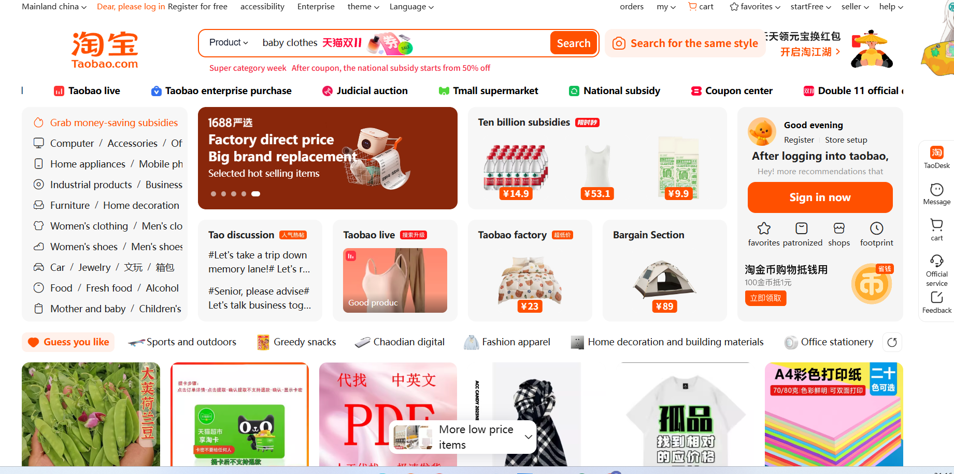
Figure 1 Screenshot of the Taobao homepage.
Source: Taobao. (n.d.). Retrieved November 8, 2025, from https://www.taobao.com/

The traditional manual customer service on Taobao is shown in Figure 2. It mainly consists of two types. The first type is to provide users with professional knowledge guidance through cloud services online, or to solve users' problems directly by making phone calls offline.
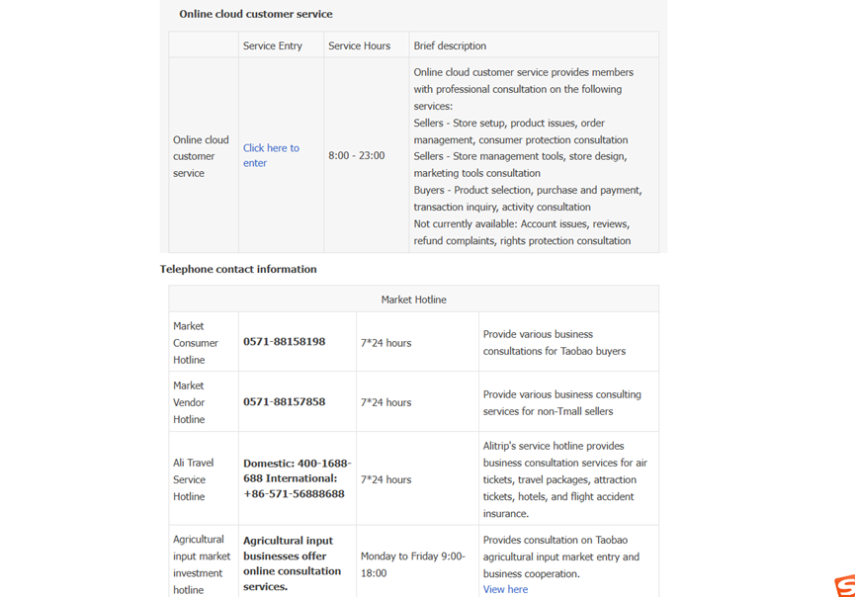
Figure 2 Screenshot of the “Contact Us” page on Taobao’s official website.
Source: Taobao. (2025). https://www.taobao.com/about/contact.php
The traditional customer service system heavily relies on human agents to interpret customer requests, search for relevant information across multiple systems, and apply organizational strategies to formulate responses. Although human agents possess flexibility, contextual judgment, and emotional sensitivity, such service configurations are limited by scalability, queuing delays, and variability in decision consistency (Hao, X., et al., 2025).

In the post-sale environment, service tasks involve the interpretation of information and policies related to specific transactions, and human agents often manually coordinate among heterogeneous information systems. This process introduces cognitive load and decision delays, especially during periods of high service demand. Although a people-oriented service model can provide nuanced judgments in certain circumstances, in the face of many standardized requests, they may struggle to maintain consistent efficiency and accuracy (Hao, X., et al., 2025).

2.7.2 Characteristics of Retrieval-Augmented Generation
In order to verify the research questions of this paper regarding the artificial intelligence customer service information system based on large language models (LLM) and retrieval augmented technology (RAG), the success of that system was evaluated by comparing the differences in user perception of information quality, system quality, service quality and satisfaction with traditional human customer service in complex post-sale scenario interactions. This article will briefly explain what retrieval augmented generation technology is. And it will explain from the process why this technology can promote AI customer service to have different performance in user-perceived service compared to human customer service.
Retrieval-Augmented Generation (RAG) is a system architecture that combines an information retrieval mechanism with a generative language model. As a method for integrating external knowledge sources, improving the accuracy and relevance of generating responses in specific domains, and addressing data sparsity and dynamic knowledge requirements (Lewis et al., 2020), RAG systems do not merely rely on the parameter knowledge embedded in language models but dynamically retrieve relevant information from external knowledge sources and incorporate this information into the response generation. With the emergence of large language models, machines can fully replace human efforts and achieve more effective enterprise-level solutions, simply by continuously fine-tuning and training the models through artificial intelligence technologies such as machine learning, deep learning, and natural language processing. When machines understand human language, they can generate the knowledge required by humans based on context semantics. Enterprises can fully train large models on the market using retrieval-augmented generation technology (Izacard, G., & Grave, E., 2025). As shown in Figure 3, this technology splits the professional knowledge that enterprises want customers to understand (such as PDF files) into small segments, for example, splitting PDFs by page numbers, and then embedding the vectors into an embedding model to reduce AI illusions. Then, the vector model quantifies and stores these vectors in a vector database. User questions and prompts are quantified using the vector model so that the machine can understand. Then, the vector model searches the vector database, just like students searching for answers in an open-book exam, selects the corresponding knowledge fragments relevant to the question to organize the prompts, and returns them to the large model. Finally, the large model returns the results to the customer.

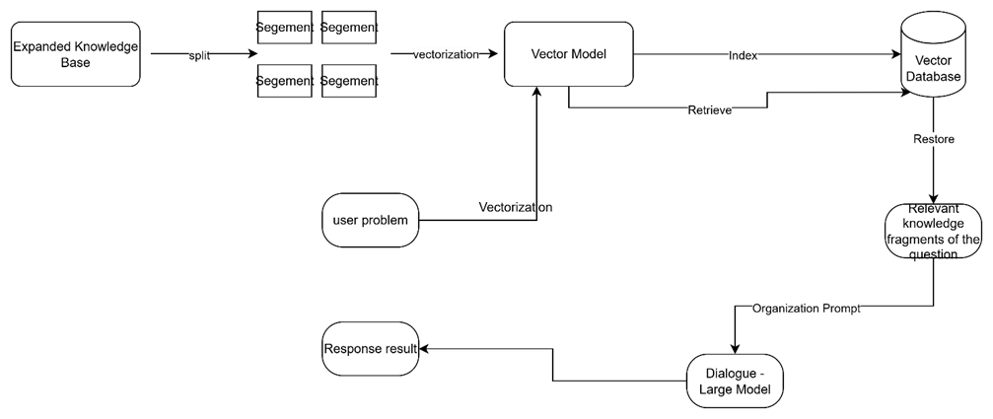
Figure 3 Retrieval-Augmented Generation Principle
Source: Created by the author.

From a process perspective, the value of RAG lies in its ability to reduce information search effort and shorten decision paths within service workflows. In traditional after-sales service processes, agents must manually consult policy documents, transaction records, and knowledge bases before formulating responses. RAG mechanisms automate portions of this retrieval process, potentially reducing conversational loops and minimizing unnecessary interaction rounds. As a result, RAG-enabled systems may influence perceived response efficiency and perceived problem-resolution accuracy by grounding responses in authoritative and up-to-date information sources.

2.7.3 Knowledge Graph (or Structured Knowledge Base)
The knowledge support of intelligent customer service systems usually comes from multiple external knowledge sources, including document-based knowledge bases, structured databases, and knowledge graphs, etc. Enterprises usually model knowledge through ontology, dividing enterprise knowledge into entities, relationships, and attributes. Ontology is usually designed by domain experts or knowledge engineers and is used to standardize the knowledge structure. During the knowledge construction process, large language models can assist in extracting entities and relationships from enterprise documents and perform information extraction based on the established ontology structure. Subsequently, these relationships are stored in the knowledge graph database, thereby forming a structured enterprise knowledge network (Rajabi E, George AN, Kumar K ,2024).
To address the issues of knowledge timeliness and insufficient domain knowledge of large language models, it is usually necessary to introduce external knowledge bases. However, since knowledge bases are typically much larger than the model's context window, it is impossible to directly input the entire knowledge base into the prompt. Therefore, a retrieval mechanism is needed to select the most relevant knowledge fragments from the knowledge base and provide them as context to the enterprise knowledge graph or large language model. This process is usually achieved through technologies such as document parsing, vector embedding models (embedding models), and vector databases.
Therefore, Retrieval-Augmented Generation (RAG) is an artificial intelligence technology framework that combines "information retrieval" and "generative language models". It is an important method to improve the accuracy and knowledge credibility of current large language models (such as GPT, ERNIE Bot, Gemini); The task of RAG is to partition the knowledge base, then vectorize it using a vector model and store it in a vector database, and then query through retrieval (Tekgoz, Erdogan, Uz, and Altinok, 2025). By finding the required documents through RAG, knowledge graph queries can be performed. Knowledge graph queries are usually implemented through graph database query languages (such as Cypher or SPARQL) for retrieving structured relationships between entities. By retrieving the user's problem from the enterprise knowledge graph, it is sent to the large model to generate context and then returned to the user. This can improve the accuracy and effectiveness of automated customer service in answering questions and enhance the perception service quality of the information system, including perception of answer accuracy and perception efficiency.

2.7.4 Large Language Models

What is a large language model?
In order to verify the research questions of this paper regarding the artificial intelligence customer service information system based on large language models (LLM) and retrieval-enhanced technology (RAG), by comparing users' perception of information quality, system quality, service quality, and the differences with traditional human customer service satisfaction in complex post-sale scenario interactions, the success of this system is evaluated. This paper will briefly explain what a large language model is. From a process perspective, it will explain why this technology will change the customer service process and support the differences in service performance perceived by users and human customer service.
Large language models are artificial intelligence models based on machine learning/deep learning, especially the Transformer architecture based on natural language processing technology. They form the basis of modern chatbots like ChatGPT and have completely transformed numerous fundamental fields such as biomedicine (Sohail, S. S., 2024). To enable large language models to acquire such capabilities, they need to undergo pre-training on massive amounts of text data. As a result, they have acquired the ability to understand, generate, translate, reason, and summarize natural language. “LLM" is one of the core concepts in the field of artificial intelligence in recent years. Almost all modern chatbots (such as ChatGPT, Wenxin Yiyan, Claude, Gemini) are based on it. LLMs features are below:
• 1. Natural Language Understanding (NLU): Labels semantics, context, emotion, etc.
• 2. Natural Language Generation (NLG): Write articles, summary, code, etc.
• 3. Multi-round Dialogue & Reasoning: Keep context and reason logically.
• 4. Knowledge Q&A & Retrieval Augmentation (RAG): Produce right answer with external knowledge.
• 5. Multimodal Fusion (Multimodal AI): Accept information with multiple forms, e.g., text, image, voice, video, etc.
In simple terms, large language models (LLMs) are advanced AI models trained on a large amount of text data, enabling natural language understanding and generation (Larson, 2025). In the context of customer service, LLMs support multi-round conversations, context reasoning, and dynamic response generation.
From the perspective of information systems, the relevance of large language models lies not only in their language fluency but also in their ability to support adaptive interaction processes. By maintaining the context of the conversation and interpreting the user's intentions, LLMs can reduce errors and repetitive clarification cycles in the service workflow. However, in high-risk service scenarios, there are still concerns about hallucination risks, context misunderstandings, and the reliability of generated outputs (Zhou, Z., 2025). Therefore, the extent to which the capabilities of LLMs can be transformed into improved service process outcomes remains an unproven issue rather than a purely technical assumption.

2.7.5 Characteristics of AI customer service
In order to verify the research questions of this paper regarding the artificial intelligence customer service information system based on large language models (LLM) and retrieval augmented technology (RAG), the success of that system was evaluated by comparing the differences in user perception of information quality, system quality, service quality and satisfaction with traditional human customer service in complex post-sale scenario interactions. This article will briefly explain what AI customer service is. And from the process perspective, it will explain why this technology can promote the AI customer service of RAG + LLM to have different results in user-perceived service performance compared to human customer service.
As shown in Figure 4 below, this is an example of intelligent customer service. AI-based systems mitigate the latency associated with queueing mechanisms inherent in manual service workflows Firstly, it will analyze the user's question and send it to the vector model. Then, it will search for the most relevant answer from the pre-prepared vector database. If there is no relevant answer and the language model cannot handle these specific questions related to the company, the following situation will occur: the problem cannot be solved. There may also be another situation where the model may hallucinate, that is, the model may give you random answers, resulting in these answers being completely useless. This requires continuous fine-tuning of the model to prevent underfitting and overfitting until the trained model can perfectly answer the user's questions.

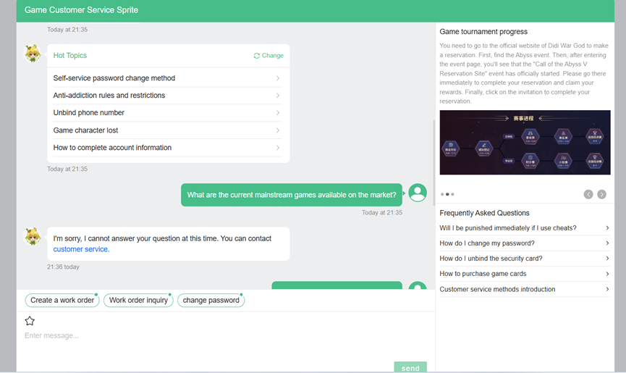
Figure 4 The NetEase Qiyu customer service interface without Retrieval-Augmented Generation.
Source: NetEase Qiyu (n.d.). Customer service system page. Retrieved November 8, 2025, from https://ysxsys.qiyukf.com/client?k=20331fffc98a2355d3be8f1edaaf0820&wp=1&robotShuntSwitch=1&robotId=5305768&shuntId=0&templateId=6630471

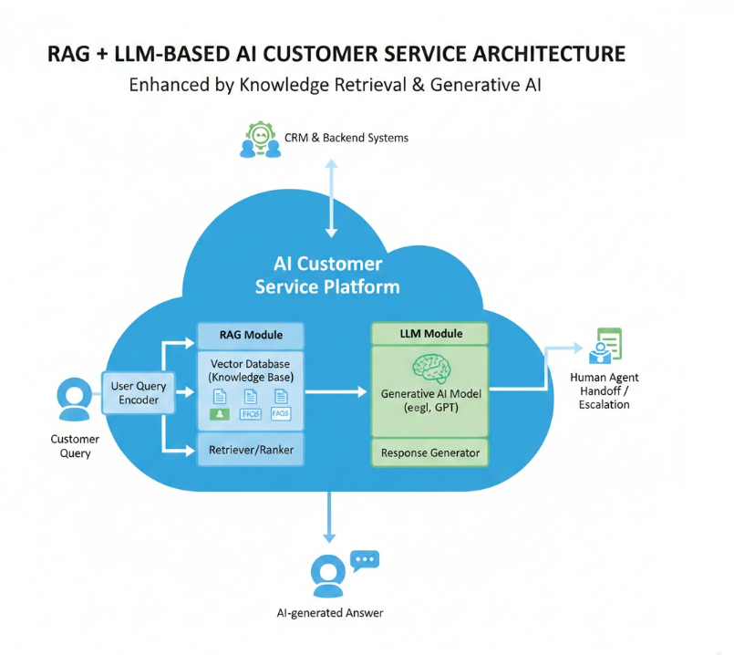
Figure 5 Architecture diagram of artificial intelligence customer service and search enhancement.
Source: Created by the author.
As shown in Figure 5, This is a typical example and architecture diagram of how artificial intelligence answers users' questions. The AI-based customer service system combines the language function with structured knowledge retrieval. In some cases, it integrates at the system level with the CRM backend system and the intelligent retrieval system. Compared with the human-centered service model, the AI system has advantages in scalability, real-time availability, and standardized response generation.
From a process perspective, artificial intelligence systems can reduce queuing delays and response delays by automating routine query processing. However, potential limitations still exist, especially when dealing with ambiguous, emotional, or non-standard service requests (Luo, X., Tong, S., Fang, Z., & Qu, Z., 2019). Moreover, if the artificial intelligence system fails to retrieve accurate information or generate responses suitable for the context, the response time will increase, but users' perception of service efficiency may decline. Therefore, improvements in technological automation do not guarantee an increase in the perception of service effectiveness. However, with the development of RAG technology, enterprises and organizations now have their own knowledge bases that can answer users' complex questions specific to the enterprises. This article will use empirical research to verify the success of this information system.

2.7.6 Mechanism of Tool Invocation via API
In order to verify the research questions of this paper regarding the artificial intelligence customer service information system based on large language models (LLM) and retrieval augmented technology (RAG), the success of that system was evaluated by comparing the differences in user perception of information quality, system quality, service quality and satisfaction with traditional human customer service in complex post-sale scenario interactions. This article will briefly explain what the ability of AI customer service to call external tools means. And it will explain from the process why this technology promotes the RAG + LLM AI customer service to have different results in user-perceived service performance compared to human customer service.
The large model can call external tools through the Function calling function. In a broad sense, function invocation refers to the technical implementation that enables a large model to call external tools: Firstly, a list of available functions and their descriptions is provided to the large model. Then, the model intelligently decides whether to invoke the function during the conversation and automatically generates the parameters required for the invocation. Large language models achieve function invocation by selecting APIs, completing parameters, and generating requests, without the need for fine-tuning, thereby enhancing their ability to effectively utilize external tools through prompts (Zhang et al., 2023). Finally, the function invocation request is returned in a text format in a format consistent with the protocol.
The narrow sense of Function Calling specifically refers to a capability provided by the model provider within the model and at the API level, which was first introduced by OpenAI:
• At the model level: The model provider needs to specially optimize the large model to enable it to correctly select the appropriate function based on the context and generate valid parameters (such as supervised fine-tuning, reinforcement learning).
• At the API level: The model provider needs to additionally open support for Function Calling (for example, the GPT API provides a "functions" parameter).

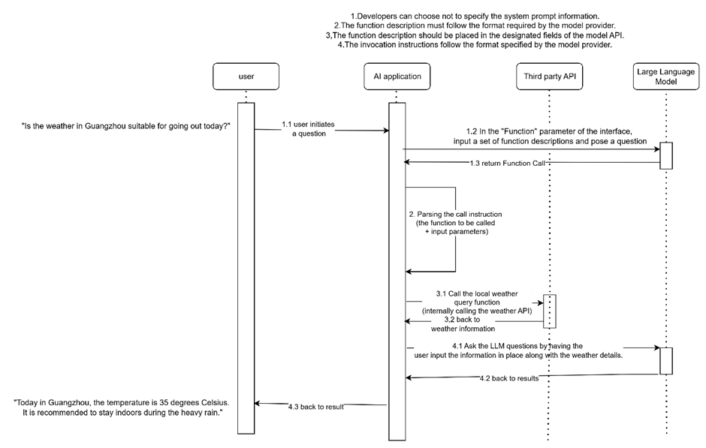
Figure 6 Function calling and MCP protocol based on API for invoking the tool
Source: Created by the author.
As shown in Figure 6, the example of main process is as follows:
1. User asks a question: User feeds the question to the backend in natural language. E.g. What's the weather like in Guangzhou today? It's possible to go outside.
2.Backend sends the first request to the large model API to get the call instruction of invoking above function. The backend sends user's original input, description of function, and other context information to large model API to get the call instructions. Function description includes function name, usage description, parameter type, etc.
3.The model generates the call instruction: The model decides whether to call a function and chooses the right function to call. Then, it automatically generates call instruction (function name + parameters) based on the context and return it.
4.Backend sends the second request to the large model API to get the final response. It passes the results of above calling and other context information to the model to get the final response.
5.The backend sends the function execution result + other context information (including user's original input) to the model. Currently, the model finds that there is enough information to answer the user's question, and there is no need to call a function. So, it directly outputs the result. e.g. The temperature in Guangzhou today is 35 degrees Celsius with heavy rain. It is suggested that you stay indoors.
From the above examples, apart from dialogue interaction, advanced AI-based customer service systems are increasingly integrating with organizational information systems through application programming interfaces (APIs). Through the function call mechanism, large language models can identify user intentions, extract relevant parameters, and trigger backend operations, such as querying the order management system or the refund database.
From the perspective of the information system process, integrating AI systems that support APIs into the customer service workflow represents a significant transformation from traditional human-centered interaction to an automated, action-oriented process. This transformation can improve operational efficiency by reducing process fragmentation and decision delays, ultimately shortening the perceived response time. The ability of AI systems to access authoritative backend data directly contributes to obtaining more accurate problem-solving results, as they can seamlessly coordinate retrieval and task execution (Lewis, P., 2020). This integration transforms the service workflow from purely dialogue-based interaction to an action-oriented sequence. AI systems supporting APIs do not require manual agents to manually retrieve and interpret system information; instead, they can coordinate retrieval and task execution in a unified interaction. This reorganization can reduce process fragmentation and decision delays, thereby affecting the efficiency of perceived response. Moreover, by directly accessing authoritative backend data, the tool call mechanism can improve the accuracy of perceived problem-solving.

2.8 Literature Review Summary
In order to verify the research questions of this paper regarding the artificial intelligence customer service information system based on large language models (LLM) and retrieval augmented technology (RAG), the success of that system was evaluated by comparing the differences in user perception of information quality, system quality, service quality and satisfaction with traditional human customer service in complex post-sale scenario interactions. The key dimensions of perceived service performance measured in this paper include perceived efficiency and perceived problem-solving degree, especially in after-sales environments with high perceived risks. The after-sales service processes such as refunds, returns, and complaint handling require precise interpretation of transaction-specific information and accurate application of organizational policies. Previous research has shown that in complex and high-risk tasks, users tend to prefer human judgment rather than automated systems because of concerns about responsibility, context understanding, and error consequences. Therefore, as perceived risks increase, trust in automated systems decreases, while trust in human decision-assisting tools also increases under similar conditions (Pearson et al., 2016). These findings make human service agents more suitable for handling complex post-sale issues. However, with the rapid development of RAG and LLM artificial intelligence chatbot technologies, it may be necessary to further verify this assumption in enterprises that have enterprise private knowledge graphs. At the same time, research on the trust that humans have in artificial intelligence indicates that users' evaluations of artificial intelligence systems largely depend on whether the system can provide clear explanations. Clear explanations can enhance users' trust because when there is no explanation, users tend to form their own mental models (Regina de Brito Duarte, Filipa Correia, Patrícia Arriaga, & Ana Paiva. 2023). Even if the artificial intelligence system demonstrates comparable or superior technical performance, if users believe that the system lacks understanding or context awareness, they may still be skeptical. Therefore, the perceived accuracy of artificial intelligence services is closely related to trust, transparency, and confidence in the information source of the system.
The latest advancements in large language models and retrieval-enhanced generation have challenged the traditional assumptions about the limitations of AI-based customer service. The retrieval-enhanced generation mechanism generates responses based on authoritative and organization-specific knowledge sources, aiming to reduce illusions and enhance the reliability of information, such as the RAG system, which utilizes external knowledge sources, like Wikipedia, to construct responses based on factual data, thereby reducing illusions and improving accuracy (Lewis et al., 2020). From the perspective of information systems, the potential value of such systems lies in being able to improve information quality and the accuracy of professional information, reducing uncertainty in the service process, especially in high-risk after-sales environments.
Contemporary research increasingly conceptualizes AI systems as supplementary components in hybrid service processes rather than completely replacing human agents. In this configuration, AI systems are responsible for efficient and intensive information tasks, while humans focus on exception handling, judgment-intensive decisions, and emotionally complex interactions (Akata et al., 2020). Therefore, human agents are crucial for handling exceptions and making detailed judgments that AI cannot effectively manage. From this perspective, this paper will explore the differences in user perception between today's advanced RAG+LLM AI customer service systems and human service systems. This study conducts an empirical investigation and will use the latest information system success model by DeLone and McLean to verify the success of the RAG+LLM intelligent customer service information system. The main test will be to compare the response efficiency and problem-solving accuracy of the AI customer service system based on large language models and retrieval-enhanced generation with traditional human customer service, to determine whether it is more successful (DeLone and McLean, 2013).

2.9 Research Gaps
Although research on AI-driven customer service has grown rapidly in recent years, several important gaps remain in the literature.
First, many empirical studies examining chatbot effectiveness focus primarily on early rule-based or retrieval-based dialogue systems. These systems operate using predefined scripts and limited knowledge bases, which significantly restrict their ability to handle complex service interactions (Luo et al., 2019). However, contemporary AI customer service systems increasingly rely on advanced architectures that combine large language models with retrieval-augmented generation and enterprise knowledge bases. These technologies fundamentally change the capabilities of AI agents by enabling dynamic knowledge retrieval and contextual response generation. Despite their growing adoption in industry, empirical evidence evaluating the service performance of these systems remains limited.
Second, existing research on AI service technologies largely focuses on user attitudes such as trust, adoption intention, or perceived risk. While these dimensions provide valuable insights into users’ acceptance of AI systems, they offer limited understanding of how such technologies affect the effectiveness of service processes. In high-risk after-sales environments—such as refund processing or complaint handling—the success of customer service interactions depends heavily on both response efficiency and the accuracy of problem resolution. Consequently, a process-oriented evaluation framework is needed to assess how AI systems influence service outcomes from the user’s perspective.
Third, although the DeLone and McLean Information System Success Model has been widely used to evaluate digital information systems, its application in AI-driven service environments remains relatively limited. Traditional information systems typically support organizational processes by storing or processing information, whereas AI systems actively participate in service interactions by interpreting user requests, retrieving knowledge, and generating responses. As a result, it remains unclear whether the core constructions of the IS success model—particularly system quality and information quality—can effectively explain user satisfaction in AI-mediated service contexts.
Therefore, this study applies the DeLone and McLean Information System Success Model to evaluate the effectiveness of AI-based customer service systems that integrate LLM and RAG technologies. By examining perceived response efficiency, perceived problem-resolution accuracy, and customer satisfaction, this research aims to provide empirical evidence on whether AI-enabled service systems can outperform traditional human customer service in complex aftersales scenarios.

3.Methodology

3.1 Methodology Introduction
This chapter outlines the methodology used to study the differences in the perceived service process performance between an AI-based customer service system and traditional manual customer service in the e-commerce after-sales service scenario. Based on the research objectives and hypotheses, this method aims to empirically compare users' perceptions of response efficiency, problem-solving accuracy, and user satisfaction for the three service types.
Given that this study focuses on users' subjective assessment of the service process rather than purely objective system performance indicators, a quantitative research method was adopted. This study employed a retrospective questionnaire design, requiring participants to evaluate the specific customer service experiences generated from their actual interactions with the AI customer service system or human customer service representatives. This design not only captures the process-level perception based on actual usage experience but also conforms to established information system research practices.
This study adopted a between-group design. Although all participants must have experience with both AI customer service and human customer service, each participant only evaluated one service experience in the questionnaire. This design ensures the independence of the observation results and allows the use of group-level statistical techniques to directly compare the situations of AI services and human services.
Data collection was conducted using structured questionnaires, with multiple Likert scales used in the questionnaire. Perceived response efficiency and perceived problem-solving accuracy, as well as user satisfaction, were operationalized as key dependent variables, reflecting the process-level service performance from an information system perspective. To enhance robustness and validity, relevant control variables and operational checks were included. This chapter elaborates on the research concept, design, development of measurement methods, sampling, data collection procedures, and data analysis methods.

3.2 Research Philosophy and Methodological Approach

3.2.1 Philosophy of Research (Post-Positivism)
This study is based on post-positivist research philosophy, which assumes the existence of a latent reality, but can only be imperfectly understood through empirical observation and measurement. In the field of information systems, this perspective holds that social-technical phenomena such as service process performance are influenced by both technical and human factors and therefore can be evaluated systematically through perception-based measurement methods.
From a metaphysical perspective, this study assumes that the performance of the after-sales service process is a real phenomenon influenced by system design, information quality, and interaction structure. However, this study does not view performance as a directly observable indicator but rather conceptualizes it as an embodiment of users' subjective evaluations, because these evaluations are important indicators of the effectiveness of the process in the service environment.
From a philosophical perspective, knowledge is developed through empirical measurement and statistical analysis. Users' perceptions of response efficiency and problem-solving accuracy are collected through structured survey tools and subjected to quantitative analysis. Although individual perceptions may vary, post-positivism holds that systematic patterns can be identified across different groups, enabling probabilistic explanations and hypothesis testing.

3.2.2 Quantitative research methods (based on recall surveys)
As shown in Figure 3, this article compares the following three aspects and considers them to be mainly within the scope of quantitative analysis. The main aim of this study is to test hypotheses and relationships. Moreover, since the variables and hypotheses in this study are very clear, quantitative research is the most appropriate method. It is different from qualitative research which needs to explore users' feelings and reasons to discover unknown latent variables, and it also does not require overly complex and time-consuming mixed methods. This is the most suitable method for this study.

_{ASPECT} | _{QUALITATIVE} | _{QUANTITATIVE} | _{MIXED METHODS}
_{MAIN PURPOSE} | Explore user feelings and reasons | Test hypotheses and relationships | _{Explore and then test}
_{DATA} | _{Interviews, open questions} | _{Structured questionnaires} | _{Interviews + questionnaires}
_{BEST USED WHEN} | _{Research factors are unclear} | Variables and hypotheses are clear | Both exploration and testing are needed
_{STRENGTHS} | _{Deep understanding of emotions} | Statistical testing, comparison, generalization | Rich explanation with validation
_{WEAKNESSES} | _{No statistical testing} | _{Limited emotional depth} | _{High complexity and time cost}
_{SUITABILITY FOR THIS STUDY} | _{Useful in early exploration} | _{Most suitable for this study} | _{Useful for future research}
Table 3 Compare with Three Method
This study employed a quantitative survey based on recall to explore users' perception of the performance of the e-commerce after-sales service process. Participants recalled and evaluated a complete after-sales service experience, which might involve an artificial intelligence customer service system or a human customer service representative. This method can capture users' subjective evaluations of response efficiency, perceived accuracy and user satisfaction based on real interactions rather than hypothetical scenarios.
Although qualitative methods were considered, they were not ultimately adopted because the main objective of this research was to test hypotheses and conduct a systematic comparison of different service types. In summary, the quantitative method based on recall provided a feasible and methodologically coherent approach to answering the research questions and testing the hypotheses.

3.3 Research Design

3.3.1 Overall Research Design
This study employed a between-subjects comparison design to examine the perceived differences between artificial intelligence-based customer service (LLM + RAG) and human customer service in the after-sales service process. Each participant was required to evaluate one recalled after-sales service experience (either artificial intelligence service or human service). The dependent variables were perceived response efficiency, perceived problem-solving accuracy and use satisfaction, which were conceptualized as results based on perception and reflected how users evaluated the effectiveness of the service process during the interaction.

3.3.2 Analysis unit and research background
- Analysis unit: One service interaction (completed consultation/work process, such as refund, return, complaint handling).
- Background: The e-commerce after-sales service process involves either an AI-based service system (LLM + RAG based on enterprise knowledge resources) or an AI customer service provided by CRM and related infrastructure.

3.4 Conceptual Model and Construct Operationalization

3.4.1 Conceptual Model
This thesis mainly follows the successful model of information systems proposed by DeLone and McLean for research.
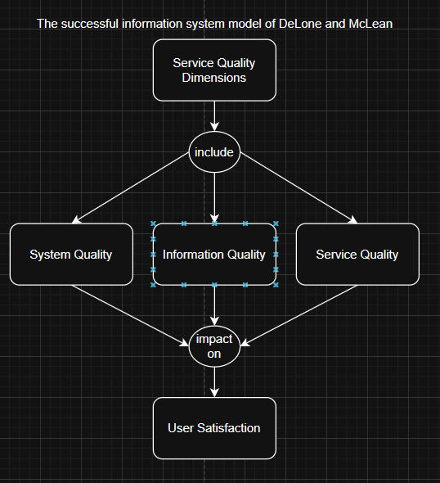

This model is mainly divided into several dimensions, including system quality, information quality, service quality, and user satisfaction, etc. In this paper, system quality is summarized as perceived response efficiency, and information quality is summarized as the accuracy of question answers. These two dimensions together constitute another dimension, namely the overall system service quality. These dimensions collectively form the quality dimension that affects the user satisfaction dimension. Therefore, this study also compared the customer satisfaction dimension to prove which party, human or artificial intelligence customer service information system, is more successful.
As shown in the following figure 7, this figure is the conceptual model of this paper. This conceptual model examines the impact of customer service types (based on artificial intelligence and provided by humans) on the perceived performance of the service process:
Customer service type → Perceived response efficiency (System quality) →Overall Perceived Service Quality
Customer service type → Perception of problem-solving accuracy rate (Information Quality) →Overall Perceived Service Quality
Overall Perceived Service Quality’s gap leads to overall customer satisfaction differences, so this essay will compare the difference satisfaction.
Customer service type →Overall Perceived Service Satisfaction (User Satisfaction)
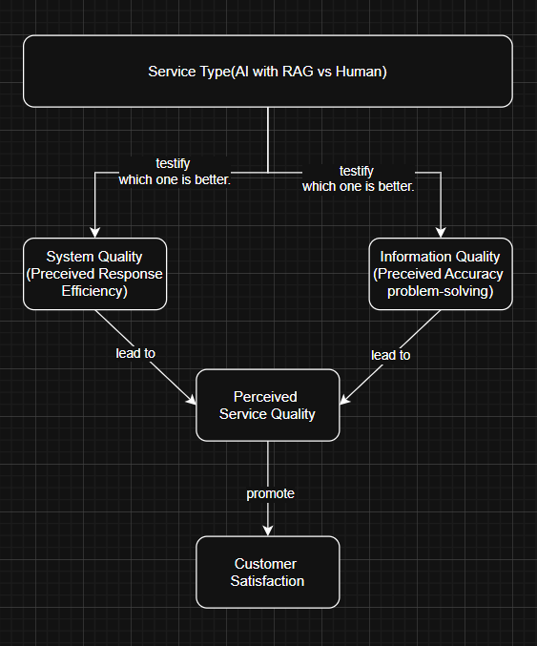
Figure 7 Research AI Customer Service with Retrieve Augmented Generation Information System Modeling

3.4.2 Independent Variable
The type of customer service is a categorical independent variable, consisting of two conditions:
- Customer service based on artificial intelligence (LLM + RAG)
- Human customer service

3.4.3 Dependent Variables
- Perceived Response Efficiency refers to users’ perceptions of the timeliness, smoothness, and effort-saving characteristics of the service interaction.
- Perceived Problem-Resolution Accuracy refers to users’ perceptions of the correctness, reliability, and effectiveness of the service solution provided.
- Perceived user satisfaction refers to the users' perception of whether the information system is successful and meets their needs.

3.4.4 Control Variables
To reduce potential confounding effects, the study controls demographic and experiential variables such as:
- Age
- Prior experience with AI customer service
- Prior experience with human customer service

3.5 Development of measurement methods and design of questionnaires

3.5.1 Scale Development and Response Format
This questionnaire was developed based on the existing literature in the field of information systems and artificial intelligence customer service and was adjusted according to the background of e-commerce after-sales service. To ensure the measurement validity, the constructions used in this study were all adapted from the existing scales in the literature on information systems and service quality. The operational definition of perceived response efficiency is based on previous research on system responsiveness and service efficiency in the digital service environment (Petter, DeLone, and McLean, 2013). Perceived problem-solving accuracy is conceptualized as the degree to which users believe that the service interaction provides a correct and reliable solution to their problems.
Customer satisfaction is measured by adapting the items from the established research on the success of information systems (Bhattacherjee, 2001), which conceptualizes satisfaction as the overall evaluation of the user's system experience. All items are measured using a five-point Likert scale, ranging from 1 (strongly disagree) to 5 (strongly agree). The use of a multi-item structure can improve measurement reliability and allow for statistical testing of the relationships between variables. All perception-based projects are measured using the five-point Likert scale, with the range being:
- 1 = Strongly Disagree
- 2 = Disagree
- 3 = Neutral
- 4 = Agree
- 5 = Strongly Agree
This questionnaire adopts a recall-based structure. Participants are required to recall specific experience of after-sales service (such as refund, return, or complaint handling) and answer all the subsequent questions solely based on that experience.
It is worth noting that the respondents do not need to evaluate the technical back-end systems (such as LLM or RAG). Instead, the AI-based customer service is operated based on the user's interaction experience and their identification of the service type (whether it is AI-based or human service).

3.5.2 Perceived Response Efficiency
To verify the first research question of this study:
RQ1: Compared with traditional human customer service, how does the perceived response efficiency of AI customer service based on LLM and RAG perform in the after-sales consultation process of e-commerce platforms?
Perceived response efficiency refers to the subjective evaluation by participants of the smoothness and efficiency of the after-sales service interaction. This survey questionnaire summarizes the perceived response efficiency in the following three questions:
This study used three items in the questionnaire to measure this construction:
- Compared with other types of customer service, through this service, I feel that the overall time for the customer service to handle the problem is shorter.
- Compared with other forms of customer service, I received the first response from the customer service representative much sooner.
- Throughout the entire after-sales communication process, when waiting for the customer service's reply, I felt that the waiting time was shorter.
These projects reflect the users' opinions on the system's quality and their perception of response efficiency.

3.5.3 Perceived Problem-Resolution Accuracy
To verify Research Question 2:
RQ2: Compared to traditional human customer service, how accurate are the solutions provided by AI customer service based on LLM and RAG in the after-sales service process?
The perception of problem-solving accuracy reflects the participants' assessment of whether the service response was accurate, appropriate, and effectively resolved their issues. This survey questionnaire summarizes the problem-solving accuracy in the following four questions:
This construction is measured by four items:
- Compared with other forms of customer service, I feel that my post-sale issues were understood more accurately by the staff.
- After accurately understanding the problem I encountered, this customer service representative was able to offer a more accurate solution than the other one.
- The solution proposed by this service more accurately captures my personal needs compared to other services.
- Throughout the entire consultation process, the information provided by this service was of higher professionalism and accuracy.
These projects reflect users' perception of the quality of information and the reliability of the solutions.

3.5.4 Overall Service Evaluation
To verify Research Question 3
RQ3: In the after-sales scenario, compared to traditional human agent channels, how do AI chatbots based on LLM and RAG differ in terms of customer satisfaction and perceived service quality?
In addition to the two main structures, the questionnaire also includes five overall assessment items. These items use the same five-point Likert scale to measure customer satisfaction and perceived service quality. This survey questionnaire summarizes customer satisfaction and perceived service quality in the following five questions:
These project evaluations:
- After this after-sales consultation, my problem was effectively and satisfactorily resolved.
- I am satisfied with the entire service experience.
- Throughout the entire consultation process, this service exceeded my expectations.
- This service experience made me feel very pleasant., I am willing to recommend this type of service to others
- Overall, I have a very high evaluation of this service.
These projects provide supplementary insights for a broader assessment of services and behavioral intentions.

3.6.5 Questionnaire Structure
The final questionnaire consists of the following sections:
- Screen the questions to determine whether the participants have used both AI-based customer service and human customer service in the post-sale environment.
- The issue of service type identification requires the participants to indicate whether the recalled experiences involve:

- Customer service based on artificial intelligence
- Human customer service

- Perceptual Response Efficiency Scale (3 items)
- Perception of Problem-solving Accuracy Scale (4 items)
- Overall Service Evaluation Scale (5 items)
- Demographic information, including age and occupation.
- The manipulation test question requires the participants to confirm the type of service they evaluated.

3.5.6 Manipulation Check
A manipulation check item was included to confirm whether participants correctly identified the service provider type associated with the evaluated experience (AI-based customer service vs. human customer service). Responses failing this manipulation check were excluded from subsequent statistical analyses to ensure the validity of group comparisons.

3.6 Sampling and Data Collection

3.6.1 Target Population
The target population of this study consisted of individuals who had prior experience using after-sales services on e-commerce platforms. Specifically, participants were required to engage in after-sales interactions such as refunds, returns, or complaint handling, where they interacted with either AI-based customer service systems or human customer service representatives.
Because the study focuses on process-level service evaluation, only respondents with relevant experiential knowledge were considered suitable for participation.

3.6.2 Sampling Strategy
This study adopted a non-probability sampling approach, combining convenience sampling and purposive sampling techniques.
Convenience sampling was used to recruit participants through online survey distribution channels due to practical constraints related to time and resources in an MSc-level research project. However, to ensure relevance and data validity, purposive screening criteria were applied at the beginning of the questionnaire.
Participants were required to confirm that they had prior experience with both:
- AI-based customer service systems, and
- Human customer service representatives
in e-commerce after-sales contexts.
Respondents who did not meet this requirement were excluded from the study.
Although non-probability sampling limits the generalizability of findings, it is widely used in Information Systems research when the focus is on specific user experiences rather than population-level inference.

3.6.3 Sample Size
The target sample size for this study was approximately 50 valid responses.
This sample size was considered appropriate for an exploratory comparative design at the master’s level, where the objective is to identify preliminary differences between two independent groups rather than to achieve large-scale generalization.
Participants were divided into two independent groups based on the type of service experience evaluated:
- AI-based customer service
- Human customer service
Given the clearly defined constructs and multi-item Likert-scale measurements, this sample size was deemed sufficient to conduct initial statistical comparisons using independent-samples tests.
The implications of the limited sample size for statistical power and generalizability are acknowledged in the limitations section.

3.6.4 Data Collection Procedure
This survey was conducted online.
At the beginning of the questionnaire, it was confirmed that the participants had experienced using both artificial customer service and human customer service in the after-sales scenarios within the past 12 months. The participants were required to recall and select a specific and recent completed after-sales service experience for evaluation. The selected experience could be based on the artificial customer service system provided by the human customer service representative.
Then, the participants were asked to answer all measurement items based solely on the selected experience to ensure consistency in the context.
This recall-based design aims to capture the real user perception of real service interactions, rather than hypothetical scenarios.

3.6.5 Data Quality Control
To enhance the reliability and validity of the data, the following inspection measures are adopted:
- Delete incomplete answers
- Exclude cases where the completion time is too short.
- Perform an inspection on the manipulation of service type identification.
Before conducting the statistical analysis, exclude the responses that do not meet the quality standards.

3.7 Data Analysis Methods

3.7.1 Data Preparation
Check for the presence of missing values, outliers and entry errors in the data. Eliminate cases with a large amount of missing data. Calculate descriptive statistics to summarize the sample and the main variables.

3.7.2 Reliability and Validity Assessment
The internal consistency reliability of a multi-item measurement tool is evaluated using Cronbach’s alpha coefficient. A scale with an alpha coefficient greater than 0.70 is considered acceptable. In appropriate cases, the correlation of the total score of the items will be examined to identify problematic items.
To address the potential common method bias associated with self-reported survey data, we implemented procedural remedial measures (such as anonymity guarantees). Additionally, we conducted statistical diagnostic tests (such as the Harman single-factor test) to examine whether a single factor could account for most of the variance.

3.7.3 Hypothesis Testing Strategy
This study employed an independent samples t-test to examine the group differences in terms of perceived response efficiency, perceived user satisfaction and perceived problem-solving accuracy, as it compared the average values between three independent conditions (based on AI and humans).
Since the current paper contains contradictory expectations (that artificial intelligence is superior to humans vs. that humans are superior to artificial intelligence), these hypotheses are regarded as alternative/competing hypotheses, and statistical tests are used to determine the direction and significance of the observed differences.
The effect size (such as Cohen's d) is reported along with the p-value to reflect its practical significance. Before conducting the t-test, it is necessary to assess assumptions such as normality and homogeneity of variance (for example, Levene test). As shown in Figure 5, this article will conduct independent T-tests separately for the two control groups of artificial intelligence and human customer service to hypothesis testing.

Hypothesis | Method
The differences in perception and response efficiency between artificial intelligence and human services | Independent samples t-test
The differences in the accuracy of problem-solving in perception between artificial intelligence and human services | Independent samples t-test
The differences in overall service satisfaction evaluation between artificial intelligence services and human services | Independent samples t-test
Table 4 Hypothesis and Method

3.8 Mapping with Research Questions and Hypotheses
This method directly addresses the following research questions:
Research Question 1: Test the perceived response efficiency (PRE) through inter-group comparisons
Research Question 2: Test the perceived problem-solving accuracy (PPA) through inter-group comparisons
Research Question 3: The user satisfaction and behavioral outcomes were tested through inter-group comparisons.

3.9 Ethical Considerations
Participation in this study was voluntary. Respondents were informed about the purpose of the study and assured that their responses would remain anonymous and confidential. No personally identifiable information was collected. Data was stored securely and used solely for academic research purposes.

3.10 Chapter Summary
This chapter outlines the methodological framework of the study, including research philosophy, design, measurement development, sampling procedures, and data analysis strategies. The next chapter presents the empirical results derived from statistical analysis.

3.11 Limitations of the Study and Ethical Considerations
This study still has several methodological limitations. Firstly, the research employed non-probability sampling, and the samples were mainly obtained from convenient channels. Therefore, the general applicability and external validity of the research results are somewhat restricted. Secondly, this study adopted a recall-based questionnaire design. Although the deviation was reduced by limiting the time range and providing clear situational prompts, there may still be inaccuracies or selective recall issues in the respondents' memories. Moreover, the sample size of this study is relatively small, which may affect the significance level and statistical power of the statistical tests. Finally, this study used perceptual measurement indicators, which mainly reflect users' subjective experiences rather than based on objective performance data.

4. Data Analysis

4.1 Introduction
This chapter conducts an empirical analysis of the service experience of artificial intelligence customer service and human customer service in the context of e-commerce after-sales service based on questionnaire survey data. The research mainly focuses on three core dimensions: perceived response efficiency, perceived problem-solving accuracy, and customer satisfaction.
This analysis adopts a structured approach. First, it introduces data screening and sample characteristics. Second, it conducts reliability and validity tests to ensure the quality of the measurement scale. Third, it uses descriptive statistics to compare the performance of the two service types. Finally, it conducts an independent samples t-test to determine whether the observed differences are statistically significant and summarizes the results of the hypothesis test.

4.2 Data Screening and Sample Profile

4.2.1 Data cleaning
The original questionnaire revealed that a total of 58 records were collected, but only 56 valid samples were available for analysis. There were no missing values in the main variables of the dataset. Except for the "Informed Consent" column, which was blank, it will not be included in the subsequent analysis. All other questionnaire items were completed in full and met the requirements for subsequent statistical analysis.
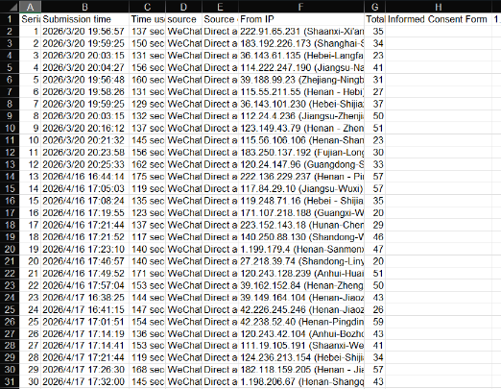

As shown in the figure above, this diagram presents a sample Excel extract of the raw survey data collected for this study. Each row represents an individual respondent, while each column corresponds to a specific survey variable. As the questionnaire collection for this study was mainly conducted on the questionnaire star software platform (like Google Form in China), which lasted for one week, the submission times of the system would vary. Moreover, it was filled out by scanning the QR code on WeChat (like China's WhatsApp) through others, so the public IP addresses of different participants might be different. As for each column, the dataset includes system submitted time, time used for filling, source way to submit, the IP address for submit, total score about their content, and the questionnaire questions content and scores including demographic variables (e.g., age group and career = 2 items), experience-related variables (e.g., prior use of AI and human customer service in advance within recently 12 months, the option objects for this survey =2 items), and key constructs such as perceived response efficiency(3 items), perceived problem-resolution accuracy(4 items), overall satisfaction(5 items) and double-check object variable for this survey(1 item). All perception-based variables were measured using a five-point Likert scale, where 1 indicates “strongly disagree” and 5 indicates “strongly agree”. The raw dataset was subsequently cleaned, coded, and transformed into composite variables for statistical analysis.
This article is mainly based on the users' experiences of using AI customer service and human customer service to conduct the assessment. The sample consists of 56 people, and they are grouped and distributed according to the type of customer service as follows:
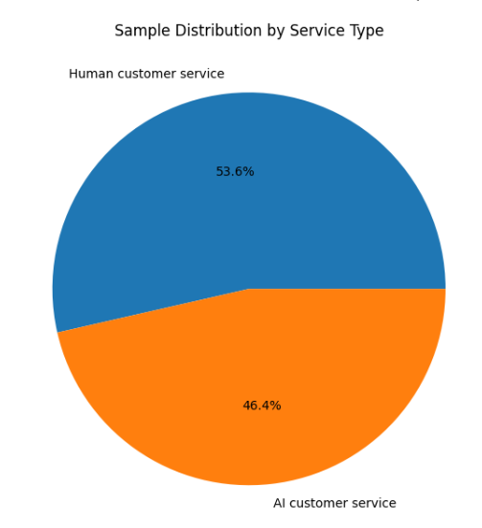
Figure above presents the distribution of respondents based on the type of customer service experience they evaluated.
Among the total 56 samples, 53.6% of participants reported experience with human customer service, while 46.4% evaluated AI-based customer service.
This relatively balanced distribution between the two groups supports the validity of subsequent comparative analysis, particularly the use of independent samples t-tests, as it reduces the risk of group size bias.
The near-equivalent representation of both service types ensures that the comparison of perceived response efficiency, problem-resolution accuracy, and customer satisfaction is methodologically appropriate.

4.3 Variable Construction and Reliability Testing

4.3.1 Variable construction
Based on the research model and questionnaire design, this study divides the service experience into three dimensions:
- Perceived response efficiency:
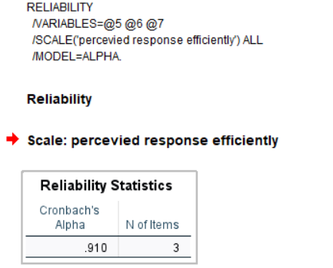
It consists of 3 items, respectively measuring processing time, first response speed and waiting time.

- Perceived problem-resolution accuracy:
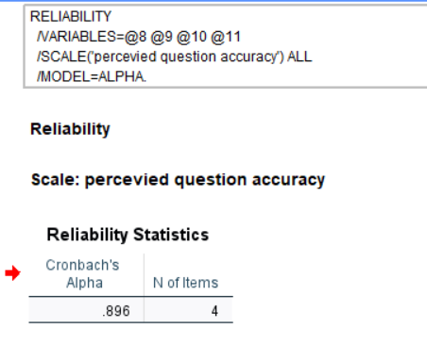
It consists of 4 items, respectively measuring the customer service representative's understanding of the problem, the accuracy of the solution, the degree of alignment with individual needs, as well as professionalism and accuracy.

- Customer satisfaction
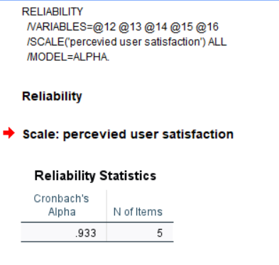
It consists of 5 items, measuring satisfaction with problem-solving, overall satisfaction, whether it exceeded expectations, whether the experience was pleasant, and the overall evaluation.
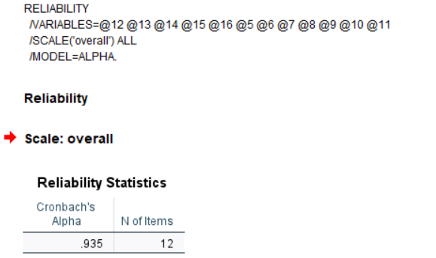
Besides this, there also is reliability analysis about the overall question, it contains all items to improve three dimensions of questionnaire are relative and close.

In this study, the mean score of each item under each dimension was used as the comprehensive score of that dimension, which was employed for subsequent descriptive statistics and independent sample t-tests.

4.3.2 Reliability analysis
To test the internal consistency of the scale, this study calculated Cronbach's alpha coefficients for each of the three dimensions. The results are as follows:
Construct | Number of Items | Cronbach’s Alpha
Perceived response efficiency | 3 | 0.910
Perceived problem-resolution accuracy | 4 | 0.896
Customer satisfaction | 5 | 0.933

Perceived response efficiency: α = 0.910
Perceived problem-resolution accuracy: α = 0.896
Customer satisfaction: α = 0.93
It is generally believed that when Cronbach's alpha is greater than 0.70, the scale has good internal consistency; and when it is greater than 0.80, it indicates a high degree of reliability. Thus, the alpha values of the three dimensions in this study are significantly higher than 0.80, indicating that the scale has high reliability and the items have strong consistency, which can support subsequent statistical analysis.

4.4 Validity Analysis
This study employed exploratory factor analysis (EFA) to assess the construct validity.

4.4.1 KMO and Bartlett Test
As shown in the figure below, this is the KMO and Bartlett test for questions 5 to 16 of the questionnaire.
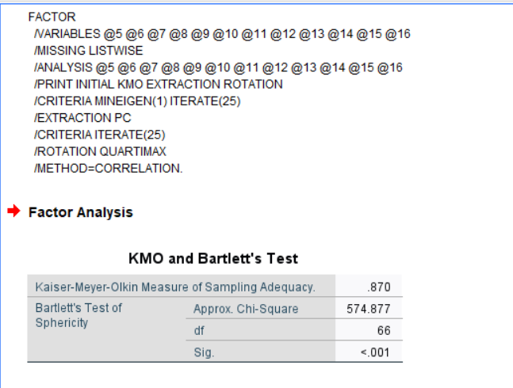

Test | Value
KMO Measure of Sampling Adequacy | 0.870
Bartlett’s Test (Sig.) | 0.000

As table above shown, the KMO value of 0.870 indicates that the sample is adequate for factor analysis. Bartlett’s test is significant (p < 0.001), confirming that the variables are sufficiently correlated.

4.4.2 Factor Extraction
As shown in the figure below, this paper uses the rotation principal component analysis method to extract three factors with eigenvalues greater than 1.
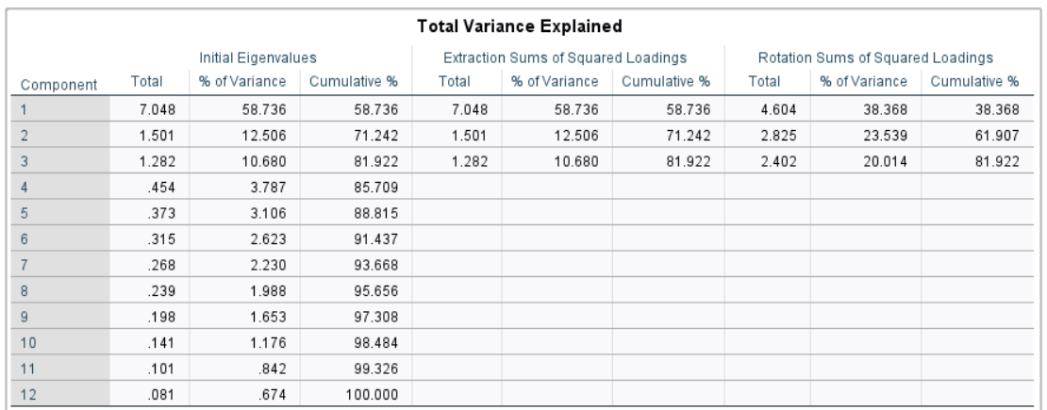
As shown in the chart above, these three factors account for 81.92% of the total variance, indicating that they have a very strong explanatory power.
Component | Eigenvalue | % of Variance | Cumulative %
1 | 7.048 | 58.736 | 58.736
2 | 1.501 | 12.506 | 71.242
3 | 1.282 | 10.680 | 81.922

In the factor extraction stage, principal component analysis was employed, and factors with eigenvalues greater than 1 were retained. The results show that three factors were extracted, with eigenvalues of 7.048, 1.501, and 1.282 respectively, all exceeding the threshold of 1.
Regarding the variance explained, the first factor accounts for 58.736% of the total variance, the second factor explains 12.506%, and the third factor explains 10.680%. Together, the three factors explain 81.922% of the total variance. This indicates that the extracted factors capture most of the information contained in the original 12 measurement items (questions 5 to 16 including RQ1, RQ2, RQ3, all test dimensions) and demonstrate strong explanatory power.
After rotation, the proportions of variance explained by the three factors become more balanced, at 38.368%, 23.539%, and 20.014% respectively, while the cumulative explained variance remains 81.922%. This suggests that the rotation improves the interpretability of the factor structure without changing its overall explanatory capability.
Overall, these results indicate that the questionnaire has a clear and stable three-factor structure, which is consistent with the theoretical design of the study and provides support for good construct validity.

4.4.3 Factor analysis and Its Rotated Component Matrix Interpretation

Rotated Component Matrixª
 | Component
 | 1 | 2 | 3
5. Compared to other types of customer service, I feel that the overall time for customer service to handle issues is shorter through this service. | .403 | .290 | .800
6. Compared to other forms of customer service, I received my first response from customer service much faster. | .331 | .244 | .796
7. Throughout the after-sales communication process, I felt that the waiting time for customer service to reply was shorter. | .276 | .129 | .877
8. Compared to other forms of customer service, I feel my after-sales issues have been understood more accurately. | .521 | .722 | .031
9. After accurately understanding the problem, I was encountering, this customer service representative was able to provide a more accurate solution than another. | .385 | .726 | .342
10. The solutions offered by this service more accurately capture my personal needs compared to other services. | .402 | .775 | .088
11. Throughout the consultation process, the information provided by this service is more professional and accurate. | .227 | .825 | .234
12. After this after-sales consultation, my problem was effectively and satisfactorily resolved. | .852 | .228 | .153
13. I am satisfied with the overall service experience. | .939 | .180 | -.032
14. Throughout the consultation process, the service exceeded my expectations. | .861 | .082 | .229
15. I enjoyed the service experience. | .763 | .487 | .072
16. Overall, I have a very high opinion of this service. | .832 | .082 | .314
Extraction Method: Principal Component Analysis.
Rotation Method: Quartimax with Kaiser Normalization.
a. Rotation converged in 5 iterations.

Table above presents the rotated component matrix obtained from the principal component analysis using Quartimax rotation with Kaiser normalization. The purpose of this analysis was to examine whether the questionnaire items were grouped into distinct underlying constructs consistent with the conceptual design of this study.
The results indicate that the measurement items were broadly clustered into three components, which correspond to the main constructions proposed in this research.
First, Items 5 to 7 loaded most strongly on Component 3, with factor loadings of .800, .796, and .877 respectively. These items all relate to the speed of response, waiting time, and overall efficiency of the interaction process. Therefore, Component 3 can be interpreted as Perceived Response Efficiency.
Second, Items 8 to 11 loaded most strongly on Component 2, with loadings ranging from .722 to .825, except for Item 8, which also showed a moderate cross-loading on Component 1 (.521). These items focus on the accuracy, appropriateness, professionalism, and problem-solving capability of the service provided. Therefore, Component 2 can be interpreted as Perceived Problem-Resolution Accuracy.
Third, Items 12 to 16 loaded primarily on Component 1, with high factor loadings ranging from .763 to .939. These items measure respondents’ overall evaluation of the service experience, including satisfaction, expectation confirmation, enjoyment, and overall impression. Therefore, Component 1 can be interpreted as Overall Service Evaluation / Customer Satisfaction.
Overall, the rotated component matrix provides general support for the construct validity of the measurement scale, as most items loaded strongly on their expected components. This suggests that the questionnaire captured three conceptually meaningful dimensions of service perception in the after-sales context.
However, several items showed moderate cross-loadings, particularly Item 8 and Item 15, indicating that some overlap exists between respondents’ perceptions of service accuracy and overall satisfaction. This is understandable in after-sales service settings, where accurate problem handling may directly influence satisfaction. Nevertheless, the dominant loading remained consistent with the intended structure.

4.5 Independent Samples T-test

4.5.1 Purpose of the test
To further examine whether there are statistically significant differences in the three core dimensions among different types of customer services, this study employed an independent samples t-test to compare the artificial intelligence customer service group with the manual customer service group.
This method is suitable for testing the mean differences between two independent samples and can determine whether the observed average difference is likely caused by sampling errors.

4.5.2 Results of Independent Samples T-test
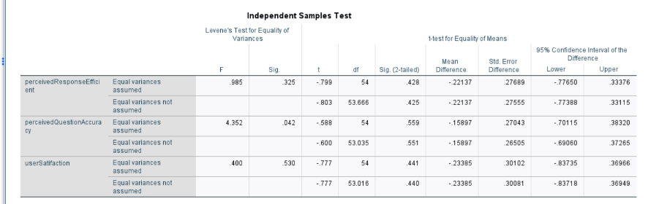
As shown in the figure above, this is the result of the independent T-test obtained using SPSS.
The results of the independent sample t-test are simple conclusions shown in the table below.
Variable | AI Mean | Human Mean | t | p
Response Efficiency | 3.09 | 3.31 | -0.74 | .462
Problem-Resolution Accuracy | 3.18 | 3.34 | -0.21 | .835
Customer Satisfaction | 3.05 | 3.28 | -0.78 | .440

Table above presents the results of the independent samples t-test comparing AI-based customer service and human customer service across three dimensions: response efficiency, problem-resolution accuracy, and customer satisfaction. The results show that no statistically significant differences were found between the two groups in any of the three variables.
For response efficiency, the mean score for AI-based customer service was 3.09, compared with 3.31 for human customer service (t = -0.74, p = .462). Although the human service group reported a slightly higher mean, the difference was not statistically significant.
For problem-resolution accuracy, the AI group reported a mean of 3.18, while the human service group reported a mean of 3.34 (t = -0.21, p = .835). This result indicates that users did not perceive a significant difference between AI-based and human customer service in terms of the accuracy and professionalism of problem handling.
For customer satisfaction, the mean score was 3.05 for AI-based customer service and 3.28 for human customer service (t = -0.78, p = .440). Again, although the human group showed a slightly higher average score, the difference was not statistically significant.
Overall, these findings suggest that AI-based customer service did not significantly outperform human customer service in the after-sales context. Therefore, Hypotheses 1, 2, and 3 were not supported. Rather than indicating superiority of one service type over the other, the results suggest that the two service modes may provide broadly comparable perceived performance in after-sales service interactions.

4.5.3 Effect size interpretation
In addition to statistical significance testing, effect size analysis was conducted to assess the magnitude of differences between AI-based and human customer service. While the independent samples t-test results showed no statistically significant differences, effect size provides further insight into whether any practical differences exist.
As shown below figure shown about effect size analysis by using SPSS:
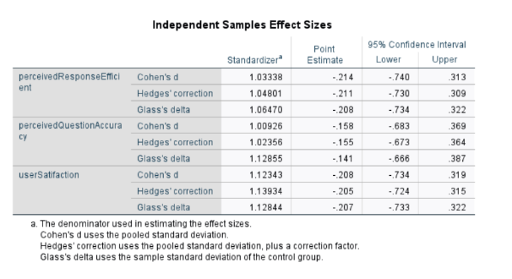
The results of the effect size analysis are simple conclusions shown in the table below.
Dimension | Cohen’s d | Interpretation
Response efficiency | -0.214 | Small effect
Problem-resolution accuracy | -0.158 | Small effect
Customer satisfaction | -0.208 | Small effect

As shown in table and Figure above:
Cohen’s d values for all three variables were small in magnitude. Specifically, response efficiency (d = -0.21), problem-resolution accuracy (d = -0.16), and customer satisfaction (d = -0.21) all fall within the range of small effect sizes based on Cohen’s (1988) guidelines.
These results indicate that the differences between AI-based and human customer service are not only statistically insignificant, but also practically minimal. In other words, even if a larger sample size were used, the observed differences are unlikely to represent meaningful performance gaps between the two service types.
The negative values of Cohen’s d suggest that human customer service had slightly higher mean scores than AI-based customer service across all three variables. However, the magnitude of these differences remains small, reinforcing the conclusion that both service types provide broadly comparable user-perceived performance in after-sales scenarios.

4.6 Descriptive Statistics

4.6.1 Overall Descriptive Statistics
After conducting descriptive statistics on the overall scores of the three core dimensions, it was found that the overall score of the sample was at a moderately high level, indicating that both AI customer service and human customer service received relatively positive but not extremely high evaluations.
After further grouping by customer service type, the average results are shown in the figure below:
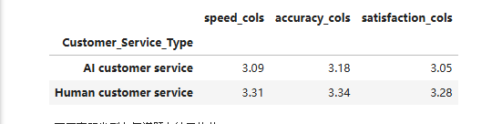

The results of the descriptive statistics are simple conclusions shown in the table below.
Dimension | AI Customer Service (n = 26) | Human Customer Service (n = 30)
Perceived response efficiency | 3.09 | 3.31
Perceived problem-resolution accuracy | 3.18 | 3.34
Customer satisfaction | 3.05 | 3.28

As shown in Table above, on all three dimensions, the average score of human customer service is slightly higher than that of AI customer service. Specifically:
In terms of perceived response efficiency, the average score of human customer service is 3.31, which is higher than the average score of AI customer service (3.09).
In terms of perceived accuracy of problem-solving, the average score of human customer service is 3.34, which is higher than the average score of AI customer service (3.18).
In terms of customer satisfaction, the average score of human customer service is 3.28, which is higher than the average score of AI customer service (3.05).
The results indicate that human customer service is superior in all three aspects.
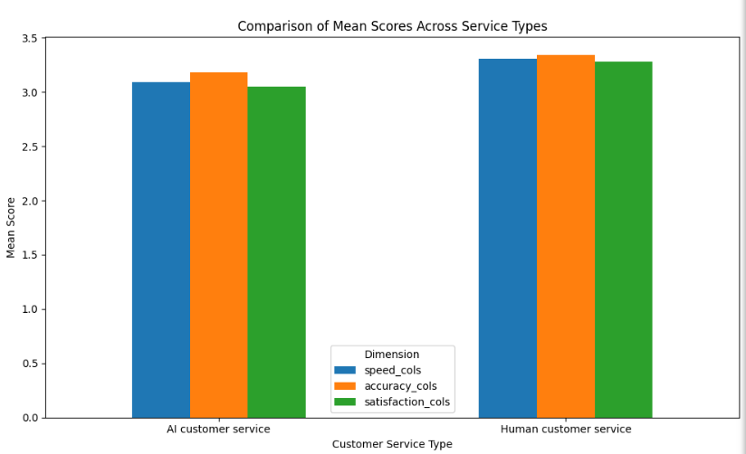
Figure above illustrates the comparison of mean scores between AI-based customer service and human customer service across three dimensions: response efficiency, problem-resolution accuracy, and customer satisfaction.
As shown in the figures, human customer service consistently achieved slightly higher mean scores than AI-based customer service across all three dimensions. Specifically, in terms of response efficiency, human customer service recorded a mean score of approximately 3.31, compared to 3.09 for AI-based service. A similar pattern can be observed for problem-resolution accuracy, where human service scored around 3.34, while AI service scored approximately 3.18. In addition, customer satisfaction was also higher for human service (around 3.28) compared to AI service (approximately 3.05).
Despite these observable differences in mean values, the variations between the two service types are relatively small. This visual pattern is consistent with the results of the independent samples t-test, which indicated that none of these differences are statistically significant (p > .05).
Therefore, while the graph suggests a slight advantage of human customer service in all three dimensions, the differences are not substantial enough to indicate a meaningful performance gap. Overall, both AI-based and human customer service demonstrate comparable levels of perceived performance in after-sales service contexts.

4.6.2 Overall Project-level Comparison
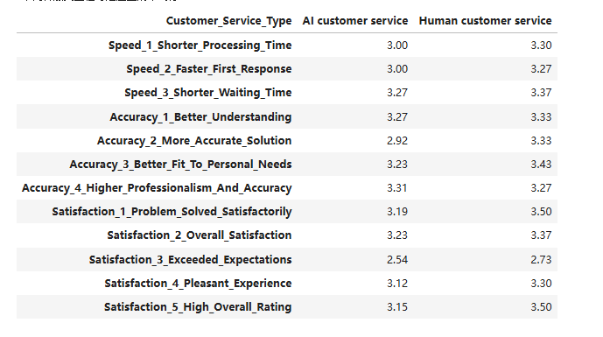
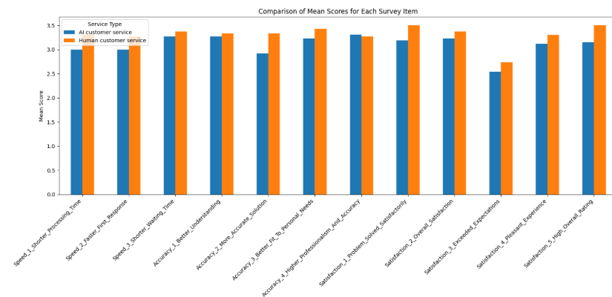
Figures above present the item level mean comparison between AI-based and human customer service across all questionnaire items.
Overall, the results show that human customer service achieved slightly higher mean scores across most items. This pattern is consistent across all three dimensions: response efficiency, problem-resolution accuracy, and customer satisfaction.
In terms of response efficiency, human customer service shows higher scores in all three items, including shorter processing time, faster first response, and shorter waiting time. However, the differences are relatively small, generally within a range of approximately 0.1 to 0.3.
For problem-resolution accuracy, human customer service again demonstrates higher mean scores in most items, particularly in “more accurate solutions” and “better fit to personal needs”, where the differences are more noticeable. However, one exception is observed in “higher professionalism and accuracy”, where AI-based service slightly outperforms human service.
In the customer satisfaction dimension, human customer service consistently scores higher across all items, especially in “problem solved satisfactorily” and “high overall rating”, where the differences are relatively larger compared to other items. Nevertheless, the item “exceeded expectations” shows low scores for both service types, indicating that neither AI nor human service strongly exceeded user expectations in after-sales scenarios.
Despite these observable differences at the item level, the overall variations remain relatively small. This supports the findings from the independent samples t-test, which showed that none of these differences are statistically significant. Therefore, while human customer service appears to have a slight advantage in most aspects, the practical differences between the two service types are limited.

This result indicates that in the e-commerce after-sales service scenario, although artificial intelligence customer service is widely regarded as having the advantage of rapid response, in the sample of this study, this advantage was not clearly reflected in the evaluations of the respondents; instead, artificial customer service still maintained certain advantages in multiple service experience indicators.

4.7 Hypothesis Testing
Based on the research hypotheses proposed in the previous text, the summary of the test results for these hypotheses is as follows:

Hypothesis | Statement | Result
H1 | AI-based customer service is perceived as more efficient than human customer service | Not supported
H2 | AI-based customer service performs better than human customer service in perceived problem-resolution accuracy | Not supported
H3 | AI-based customer service leads to higher customer satisfaction than human customer service | Not supported

From the results, H1, H2 and H3 were not supported.
On the other hand, at the sample mean level, the scores of the human customer service in the three dimensions were slightly higher than those of the AI customer service, but the difference was not significant enough to form a statistically significant conclusion.
If you plan to follow my previous suggestion and change H2/H3 from "There is a significant difference" to "AI is superior", then it can be written as:
H1: Not supported
H2: Not supported
H3: Not supported
If you still hold the directional assumption that "AI is superior to human", then it should be clearly stated as "not supported".

4.8 Chapter Summary
This chapter conducts a systematic analysis of the questionnaire data. Firstly, the data cleaning results show that a total of 56 valid samples were obtained, including 26 from the AI customer service group and 30 from the human customer service group. Secondly, the reliability analysis indicates that the Cronbach’s alpha coefficients of the three core constructs all exceed 0.89, demonstrating high internal consistency of the measurement scales.

Descriptive statistics show that human customer service achieved slightly higher mean scores than AI customer service across all three dimensions: perceived response efficiency, problem-resolution accuracy, and customer satisfaction. However, the independent samples t-test results indicate that these differences did not reach statistical significance (p > .05).

In relation to the research questions, the findings can be summarized as follows:

RQ1: How does AI customer service compare with human customer service in terms of perceived response efficiency?
The results show that although human customer service has a slightly higher mean score, the difference is not statistically significant. Therefore, AI customer service does not significantly outperform human customer service in perceived response efficiency.

RQ2: How does AI customer service compare with human customer service in terms of perceived problem-resolution accuracy?
Similarly, the analysis indicates that there is no statistically significant difference between the two service types. This suggests that AI customer service does not demonstrate a clear advantage over human customer service in problem-solving accuracy.

RQ3: How does AI customer service compare with human customer service in terms of customer satisfaction?
The results again show no statistically significant difference. Although human customer service appears to have slightly higher satisfaction scores, this difference is not substantial.

Overall, this study does not provide empirical evidence to support the assumption that AI customer service significantly outperforms human customer service in e-commerce after-sales scenarios. Instead, the findings suggest that both service types demonstrate broadly comparable levels of perceived performance.

This indicates that, under the current sample and research context, although AI customer service has developed a certain level of service capability, its advantages have not yet translated into a statistically significant lead in user perception. The following chapter will further discuss these findings and explore their possible explanations and theoretical implications.

Appendix: Artificial Intelligence Chatbots ’key Terms’ (Technology Explanation)

This section provides a conceptual overview of the relevant artificial intelligence technologies, aiming to assist readers in understanding the system context rather than focusing on the technical implementation aspects.

What are artificial intelligence chatbots?

Artificial Intelligence chatbots is a computer program using Natural Language Processing (Natural Language Processing, NLP), Machine Learning (Machine Learning, ML), and Deep Learning (Deep Learning) technologies. It can have natural conversations with humans through text or voice to achieve information exchange, task assistance, or emotional communication (Abu Shawar & Atwell, 2007). Mustafa also emphasized that the prominent strong points of chatbots were "fast speed and large number of routine queries", which could significantly decrease enterprise operating costs. However, the fatal defect of chatbots was "lack of empathy and inability to deal with complex context", which could not enhance user experience and even make users dissatisfied (Mustafa, 2024).

Key Terms | Definitions
Artificial Intelligence | Artificial Intelligence is a science and technology that enables computers or machines to simulate human intelligent behavior.
AI Chatbot | AI chatbot is a program based on artificial intelligence that can communicate with people in natural language. Its goal is to simulate human communication methods, making people feel like they are chatting with a "virtual assistant".
Large Language Model | LLM is a type of artificial intelligence model trained on massive text data, belonging to the cutting-edge technology of Natural Language Processing (NLP).
Natural Language Processing | NLP is an important branch of artificial intelligence, aiming to enable computers to understand, process and generate human language.

category of technology | Function declaration
Natural Language Processing (NLP) | Enable robots to understand human language (intention recognition, semantic analysis)
Machine learning / Deep learning | Learn the conversation patterns and knowledge through data.
Large Language Model (LLM) | Generate a natural, smooth, and logically coherent response.
Knowledge Base and Retrieval Technology (RAG) | Obtain accurate answers from external documents
AI chatbot | Users obtain answers through the chatbot.

Machine Learning
Machine learning is the core of modern artificial intelligence, emphasizing the automatic establishment of mathematical models through sample data to achieve prediction or classification tasks. It is the foundation for the realization of "from perception to cognition" in artificial intelligence. Its main forms include supervised learning, unsupervised learning, and reinforcement learning (Bell, 2020).
(1) Supervised Learning ：use manually labeled data to further train your model to do a better job in certain areas.
(2) Reinforcement Learning ：Directly optimize the generative model through human comparison selection （For example: Option A and Option B, which is better）.
(3) Unsupervised Learning ： Unsupervised learning is a type of learning with no manually labeled data. Its goal is to automatically discover these structures, patterns or features from the input data without the help of correct answers or classification labels provided by humans.

Deep Learning
Casas Roma, Lozano Bagén, and Bosch Rué (2020) expounded that deep learning is an important branch of machine learning. Its basic idea is to allow machines to learn automatically from data to draw high-level features and complete intelligent tasks such as perception, understanding and decision-making. While machine learning is still requiring machines to learn by humans to complete tasks, deep learning is allowing machines to "learn by themselves" just like human brain. Its pros are:
1. Automatic Feature Extraction: We don't need to extract features manually. Models learn useful representation of data automatically.
2. Multi-Layer: Multi-layered with neurons (input layer, hidden layer, output layer). Abstract information level by level.
3. End-to-End Learning (End-to-End): From original data to prediction result. We don't need to do anything in the middle manually.
4. Dependence on Big Data and High Computing Power. We need many samples and support for big computing power (GPUs).

Natural Language Processing
Natural language processing is essential for naturalness of intelligent customer service chatbots, only when the system can comprehend and generate users’ natural language. O’Connor and McDermott (1996) studied the basic concepts of NLP. The basic process of NLP is as follows: First, divide input sentences into basic language units and find out part of-speech to give a structure for semantic analysis. For example, the sentence "I love you" is split into I, love, and you, and the part-of-speech is distinguished, such as verb and noun,to facilitate the machine's subsequent understanding. Then, an intent category is needed so that the machine can "understand" what the user wants to do. The intent recognition problem is usually modeled as a text classification problem. Input a segmented text, after feature extraction, output the most likely "category label", that is, to classify a sentence into a certain "category". NLP achieves text classification by the Transform model, which simultaneously examines all the words in the entire sentence and uses the "attention mechanism (Attention)" to determine which words have the strongest relationship, completing text classification. After identifying what the user wants to do, the key entity information in the conversation is extracted, such as time, location, product name, amount, etc. Combined with the context semantic analysis of the user's real needs, understand the real demand of the entire conversation. Representative models include BERT, ERNIE, RoBERTa, GPT, etc. pre-trained language models.

Data Analysis Code
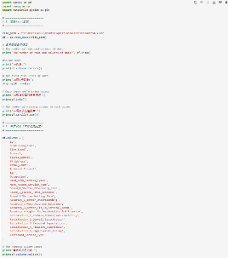
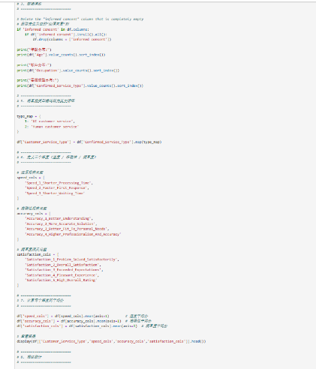
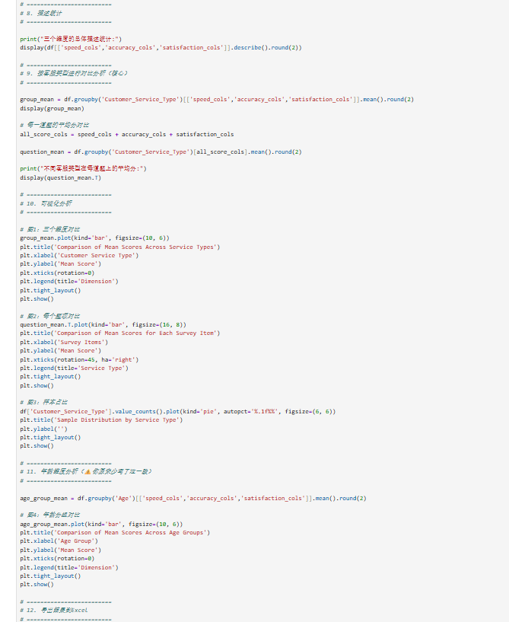
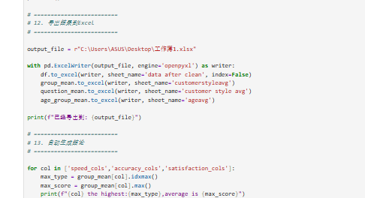

Reference
- Abu Shawar, B. and Atwell, E. (2007) ‘Chatbots: Are they really useful?’, Journal for Language Technology and Computational Linguistics, 22, pp. 29–49.
https://doi.org/10.21248/jlcl.22.2007.88
- Afjal, Gupta, K. K., & Nayak, S. K. (2025). Revolutionizing customer support: Unveiling the potential of voice assistance for seamless service and satisfaction. CRC Press. https://doi.org/10.1201/9781003532521-72
- Akata, Z., Balliet, D., de Rijke, M., Dignum, F., Dignum, V., Eiben, G., Fokkens, A., Grossi, D., Hindriks, K., Hoos, H., Hung, H., Jonker, C., Monz, C., Neerincx, M., Oliehoek, F., Prakken, H., Schlobach, S., van der Gaag, L., van Harmelen, F., … Welling, M. (2020). A Research Agenda for Hybrid Intelligence: Augmenting Human Intellect With Collaborative, Adaptive, Responsible, and Explainable Artificial Intelligence. Computer, 53(8), 18–28. https://doi.org/10.1109/MC.2020.2996587
- Arora, A., Kapale, R., Sharma, P., Nalavade, M., Saifee, M., & Ukey, M. (2024). The Impact of AI-Driven Personalization on Customer Loyalty: A Meta-Analysis of E-commerce Studies. 2024 2nd DMIHER International Conference on Artificial Intelligence in Healthcare, Education and Industry (IDICAIEI), Artificial Intelligence in Healthcare, Education and Industry (IDICAIEI), 2024 2nd DMIHER International Conference On, 1–6. https://doi.org/10.1109/IDICAIEI61867.2024.10842906
- Asif, N. H., Mahmud, M., Rahman, M. W., & Islam, M. B. (2025). The Trust Paradox in AI-Driven Customer Support: A Mixed-Methods Analysis of Human vs. AI Trust. https://doi.org/10.54536/ajdsai.v1i1.4779
- Bell, J. (2020) Machine learning: Hands-on for developers and technical professionals. 2nd edn. Hoboken, NJ: Wiley.
- Bhattacherjee, A. (2001). Understanding Information Systems Continuance: An Expectation-Confirmation Model. MIS Quarterly, 25(3), 351–370. https://doi.org/10.2307/3250921
- C. Ren et al., "Ontological Concept Structure Aware Knowledge Transfer for Inductive Knowledge Graph Embedding," 2021 International Joint Conference on Neural Networks (IJCNN), Shenzhen, China, 2021, pp. 1-8, doi: 10.1109/IJCNN52387.2021.9533852.
- Casas Roma, J., Lozano Bagén, T. and Bosch Rué, A. (2020) Deep learning: Principios y fundamentos. 1st edn. Barcelona: Editorial UOC.
- Cynthia Chizoba Ekechi, Excel G Chukwurah, Lawrence Damilare Oyeniyi, & Chukwuekem David Okeke. (2024). Ai-Infused Chatbots for Customer Support: A Cross-Country Evaluation of User Satisfaction in the Usa and the Uk. International Journal of Management & Entrepreneurship Research; Vol. 6 No. 4 (2024); 1259-1272. https://doi.org/10.51594/ijmer.v6i4.1057
- De Keyser, A., Köcher, S., Alkire, L., Verbeeck, C. and Kandampully, J. (2019) ‘Frontline service technology infusion: Conceptual archetypes and future research directions’, Journal of Service Research, 22(1), pp. 92–106.
https://doi.org/10.1177/1094670518818662
- DeLone, W.H. and McLean, E.R. (1992) ‘Information systems success: The quest for the dependent variable’, Information Systems Research, 3(1), pp. 60–95.
https://doi.org/10.1287/isre.3.1.60
- DeLone, W.H. and McLean, E.R. (2003) ‘The DeLone and McLean model of information systems success: A ten-year update’, Journal of Management Information Systems, 19(4), pp. 9–30.
https://doi.org/10.1080/07421222.2003.11045748
- Ekechi, C. C., Chukwurah, E. G., Oyeniyi, L. D., & Okeke, C. D. (2024). Ai-infused chatbots for customer support: a cross-country evaluation of user satisfaction in the usa and the uk. https://doi.org/10.51594/ijmer.v6i4.1057
- Ferraro, C., Demsar, V., Sands, S., Restrepo, M., & Campbell, C. (2024). The paradoxes of generative AI-enabled customer service: A guide for managers. Business Horizons. https://doi.org/10.1016/j.bushor.2024.04.013
- Fu, S., Yang, F., & Xiao, Y. (2020). AI Inspired Intelligent Resource Management in Future Wireless Network. IEEE Access, 8, 22425–22433. https://doi.org/10.1109/ACCESS.2020.2968554
- Ganesh, R., Kumar, S. and Patel, A., 2024. Enhancing customer service response and efficiency with AI-driven automation. In: Proceedings of the International Conference on Trends in Advanced Computing Systems. Available at: https://doi.org/10.1109/ictacs62700.2024.10840551
- Hao, X., Demir, E. and Eyers, D. (2025) ‘Beyond human-in-the-loop: Sensemaking between artificial intelligence and human intelligence collaboration’, Sustainable Futures, 10, p. 101152. https://doi.org/10.1016/j.sftr.2025.101152.
- Hyungjoon Kim. (2025). Chatbots vs. Human Agents: Emotional Aspects and Trust in Customer Service Interactions. International Journal of Electronic Commerce Studies, 16(3), 1–22. https://doi.org/10.7903/ijecs.2480
- Iqbal, M., Siregar, M. N. H., & Rismayanti, R. (2025). Implementation of Natural Language Processing for Chatbots in Customer Service. 1(1), 18–23. https://doi.org/10.64803/jocsaic.v1i1.4
- Izacard, G., & Grave, E. (2021). Leveraging Passage Retrieval with Large Neural Networks for Open Domain Question Answering.
- Kenner Alexander Rojas Ahumada, Verónica López Zavaleta, & Alberto Carlos Mendoza de los Santos. (2023). El impacto de la Inteligencia Artificial en la mejora de la atención al cliente: Una revisión sistémica. Innovación y Software, 4(2). https://doi.org/10.48168/innosoft.s12.a90
- Larson, A.M. (2025) ‘Large language model (LLM)’, Salem Press Encyclopedia of Science. Available at: https://www.salempress.com (Accessed: 8 November 2025).
- Lasky, J. (2024). Chatbot. Salem Press Encyclopedia of Science.
- Lewis et al. (2020). Retrieval-Augmented Generation for Knowledge-Intensive NLP Tasks, NeurIPS
- Luo, X., Tong, S., Fang, Z., & Qu, Z. (2019). Frontiers: Machines vs. Humans: The Impact of AI Chatbot Disclosure on Customer Purchases.
- Marjanović, U., Mester, G., & Milic Marjanovic, B. (2024). Assessing the Success of Artificial Intelligence Tools: an Evaluation of ChatGPT Using the Information System Success Model. Interdisciplinary Description of Complex Systems, 22(3), 266–275. https://doi.org/10.7906/indecs.22.3.3
- Messner, W. (2005). Customer relationship management technology: A commodity or distinguishing factor? Business Information Review, 22(4), 253–262. https://doi.org/10.1177/0266382105060604
- Mustafa, H. (2024) ‘Exploring the role of AI in customer service communication: A case study on chatbots in delivery apps in the UAE’, Balkan Social Science Review, 24, pp. 445–467.
https://doi.org/10.46763/bssr242424445m
- Nazir, A., & Wang, Z. (2023). A comprehensive survey of ChatGPT: Advancements, applications, prospects, and challenges. Meta-Radiology, 1(2). https://doi.org/10.1016/j.metrad.2023.100022
- NetEase Qiyu (n.d.) Customer service system page. Available at: https://ysxsys.qiyukf.com (Accessed: 8 November 2025).
- Nguyen, T. (2019). Potential effects of chatbot technology on customer support: A case study. https://aaltodoc.aalto.fi:443/handle/123456789/38921
- Nsaif, W. S., Salih, H. M., Saleh, H. H., & Al-nuaim, B. T. (2024). Conversational Agents: An Exploration into Chatbot Evolution, Architecture, and Important Techniques. Volume: 27246-262 ; 2602-3199 ; The Eurasia Proceedings of Science Technology Engineering and Mathematics. https://doi.org/10.55549/epstem.1518795
- O’Connor, J. and McDermott, I. (1996) NLP. London: Thorsons.
- Onohuean, E. (2026). Evaluating the Impact of AI-Powered Chatbots on Customer Service Management and Satisfaction in a Multinational Corporation (Nestlé Nigeria Case Study).
- Pearson, C. J., Welk, A. K., Boettcher, W. A., Mayer, R. C., Streck, S., Simons-Rudolph, J., & Mayhorn, C. B. (2016). Differences in trust between human and automated decision aids. Symposium and Bootcamp on Science of Security, 95–98. https://doi.org/10.1145/2898375.2898385
- Petter, S., DeLone, W., & McLean, E. R. (2013). Information Systems Success: The Quest for the Independent Variables. Journal of Management Information Systems, 29(4), 7–62. https://doi.org/10.2753/MIS0742-1222290401
- Petter, S., DeLone, W.H. and McLean, E.R. (2008) ‘Measuring information systems success: Models, dimensions, measures, and interrelationships’, European Journal of Information Systems, 17(3), pp. 236–263.
https://doi.org/10.1057/ejis.2008.15
- Prasad, K. V. S., Xavier, L. A., Jain, S., Subba, R., Mittal, S., & Anute, N. (2024). AI-Driven Chatbots for E-Commerce Customer Support. 2024 International Conference on Advances in Computing, Communication and Applied Informatics (ACCAI), Advances in Computing, Communication and Applied Informatics (ACCAI), 2024 International Conference On, 1–5. https://doi.org/10.1109/ACCAI61061.2024.10602261
- Rai, A., Constantinides, P. and Sarker, S. (2019) ‘Editor’s comments: Next-generation digital platforms’, MIS Quarterly, 43(1), pp. iii–ix.
https://doi.org/10.25300/MISQ/2019/14376
- Regina de Brito Duarte, Filipa Correia, Patrícia Arriaga, & Ana Paiva. (2023). AI Trust: Can Explainable AI Enhance Warranted Trust? Human Behavior and Emerging Technologies, 2023. https://doi.org/10.1155/2023/4637678
- Resekiani Mas Bakar, Zhafran Fadhil Damara, & Ahmad Yasser Mansyur. (2020). Post-service recovery emotion and customer trust: The role of satisfaction as mediation. Jurnal Manajemen Dan Pemasaran Jasa. https://doi.org/10.25105/jmpj.v13i1.5900
- Sarker, S., Chatterjee, S., Xiao, X. and Elbanna, A. (2021) ‘The sociotechnical axis of cohesion for the IS discipline: Its historical legacy and its continued relevance’, MIS Quarterly, 45(2), pp. 695–720.
https://doi.org/10.25300/MISQ/2021/15865
- Sohail, S. S. (2024). A Promising Start and Not a Panacea: ChatGPT’s Early Impact and Potential in Medical Science and Biomedical Engineering Research. Annals of Biomedical Engineering: The Journal of the Biomedical Engineering Society, 52(5), 1131–1135. https://doi.org/10.1007/s10439-023-03335-6
- Taobao (n.d.) Taobao homepage. Available at: https://www.taobao.com (Accessed: 8 November 2025).
- Taobao (n.d.) Taobao homepage. Available at: https://www.taobao.com (Accessed: 8 November 2025).
- Tekgoz, H., Erdogan, H., Uz, H. and Altinok, H. (2025) ‘Evaluation of vector database and LLM models in retrieval-augmented generation (RAG) systems’, International Journal on Semantic Web and Information Systems, 21(1), pp. 1–18.
https://doi.org/10.4018/IJSWIS.344037
- Unni, M. V., Rudresh, S., Rashmi, B., Renjith Krishnan, K., Kar, R., & Devichandrika, S. (2023). Automation using Artificial Intelligence in Business Landscape. 2023 2nd International Conference on Automation, Computing and Renewable Systems (ICACRS), Automation, Computing and Renewable Systems (ICACRS), 2023 2nd International Conference On, 1519–1523. https://doi.org/10.1109/ICACRS58579.2023.10404252
- Vebrianti, R., Aras, M., Putri, M. S. S., & Swandewi, I. A. (2025). AI Chatbots in E-Commerce: Enhancing Customer Engagement, Satisfaction and Loyalty. PaperAsia, 41(2b), 248–260. https://doi.org/10.59953/paperasia.v41i2b.445
- Yıldırım, Ş., & Samli, R. (2025). A RAG-Based Automotive Sector AI Assistant for Enhanced Information Retrieval. The Eurasia Proceedings of Science, Technology, Engineering & Mathematics, 33, 20–27. https://doi.org/10.55549/epstem.1729714
- Zhang, Y., Cai, H., Chen, Y., Sun, R., & Zheng, J. (2023). Reverse Chain: A Generic-Rule for LLMs to Master Multi-API Planning. arXiv.Org, abs/2310.04474. https://doi.org/10.48550/arxiv.2310.04474
- Zhou, H. (2022). A study of technical support for artificial intelligence systems applied to knowledge management systems. 2022 IEEE 2nd International Conference on Power, Electronics and Computer Applications (ICPECA), Power, Electronics and Computer Applications (ICPECA), 2022 IEEE 2nd International Conference On, 921–924. https://doi.org/10.1109/ICPECA53709.2022.9718930
- Zhou, Z. (2025). Beyond Chat: a Framework for LLMs as Human-Centered Support Systems. https://doi.org/10.5121/csit.2025.151721
- D. Yadav, H. Para, K. Sandhu and P. Selvakumar, "Enhancing Response Generation Systems: Knowledge Graph & Generative AI Synergy for Business Communication and Strategic Decision Making," 2024 International Conference on Electrical, Computer and Energy Technologies (ICECET, Sydney, Australia, 2024, pp. 1-6, doi: 10.1109/ICECET61485.2024.10698632.
- Rajabi E, George AN, Kumar K (2024), "The role of knowledge graphs in chatbots". The Electronic Library, Vol. 42 No. 3 pp. 483–497, doi: https://doi.org/10.1108/EL-03-2023-0066

