Transit Gateway Segmentation through Route Tables Workshop (Handout)

# Overview

Download files needed for this lab here. <https://tiny.amazon.com/hkme9lep/amazawsaworkindehtmlfold99d6>

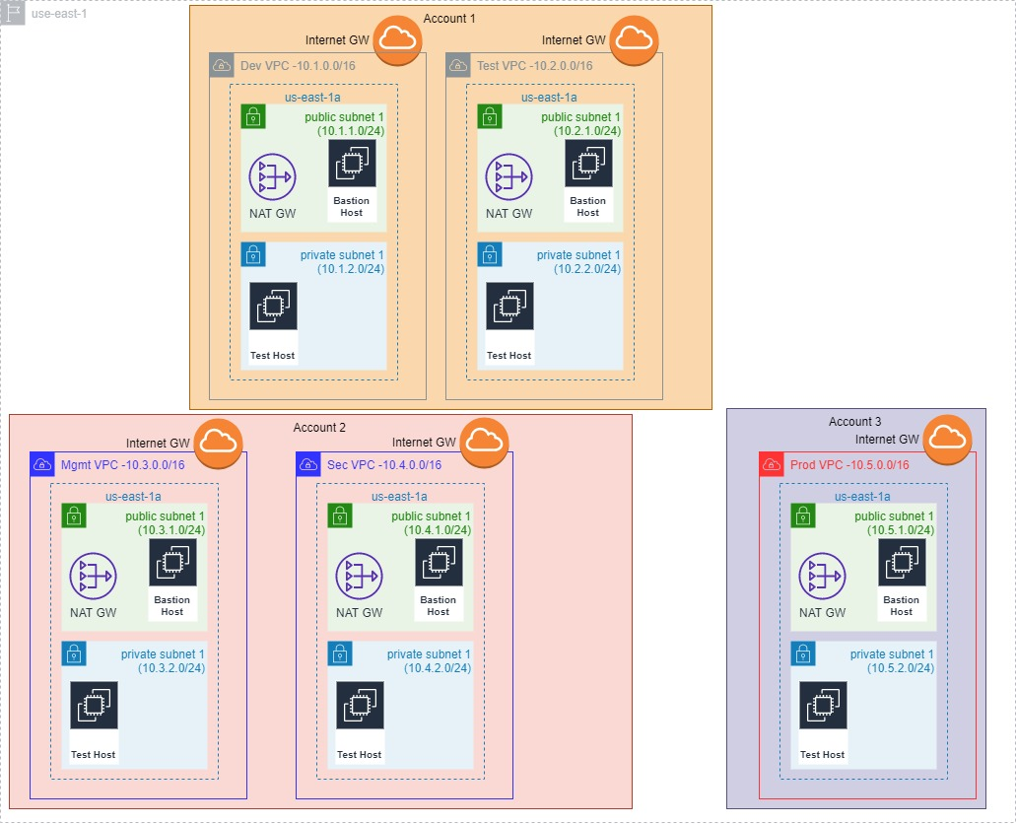

Table : Workshop Prerequisites

|  |  |
| --- | --- |
| **Workshop Prerequisites** | **Value (enter your value)** |
| “Lower” AWS Account Number (for Dev and Test VPC) | 010581050709 |
| “Shared” AWS Account Number (for Management and Security VPC) | 876820548815 |
| “Upper” Account Number (for Production VPC) | 886086245061 |

Table : Environment VPC and Test EC2 Instance IP and Tag Name

|  |  |  |  |
| --- | --- | --- | --- |
| **Stack/Environment** | **VPC CIDR** | **Test EC2 Instance IP** | **Test EC2 Instance Name** |
| Dev-Lab | 10.1.0.0/16 | 10.1.2.11/24 | TestEC2 - Dev-Lab |
| Test-Lab | 10.2.0.0/16 | 10.2.2.11/24 | TestEC2 - Test-Lab |
| Management-Lab | 10.3.0.0/16 | 10.3.2.11/24 | TestEC2 - Management-Lab |
| Security-Lab | 10.4.0.0/16 | 10.4.2.11/24 | TestEC2 - Security-Lab |
| Production-Lab | 10.5.0.0/16 | 10.5.2.11/24 | TestEC2 - Production-Lab |

# Scenario #1

Table : Ping Test #1

|  |  |  |  |  |  |
| --- | --- | --- | --- | --- | --- |
|  | To TestEC2 Dev  10.1.2.11 | To TestEC2 Test  10.2.2.11 | To TestEC2 Management  10.3.2.11 | To TestEC2 Security  10.4.2.11 | To TestEC2 Production  10.5.2.11 |
| From TestEC2 Dev 10.1.2.11 | Same host – skip | No | No | No | No |
| From TestEC2 Test 10.2.2.11 | No | Same host – skip | No | No | No |
| From TestEC2 Management 10.3.2.11 | No | No | Same host – skip | No | No |
| From TestEC2 Security 10.4.2.11 | No | No | No | Same host – skip | No |
| From TestEC2 Production 10.5.2.11 | No | No | No | No | Same host – skip |

# Scenario #2

Table : TGW Attachment Names

|  |  |
| --- | --- |
| **TGW Attachment Name** | **TGW Attachment ID –write your value here** |
| Dev-VPC-Attn | tgw-attach-05ffe03e2b705a9ad |
| Test-VPC-Attn | tgw-attach-053c652cdf972e2ae |
| Production-VPC-Attn | tgw-attach-018b9883075cc6fc8 |
| Management-VPC-Attn | tgw-attach-06e6eead86466aeb3 |
| Security-VPC-Attn | tgw-attach-0f92c1d97b9404845 |

# Scenario #3

Table : Ping Test #2

|  |  |  |  |  |  |
| --- | --- | --- | --- | --- | --- |
|  | To TestEC2 Dev  10.1.2.11 | To TestEC2 Test  10.2.2.11 | To TestEC2 Management  10.3.2.11 | To TestEC2 Security  10.4.2.11 | To TestEC2 Production  10.5.2.11 |
| From TestEC2 Dev 10.1.2.11 | Same host – skip | No | No | No | No |
| From TestEC2 Test 10.2.2.11 | No | Same host – skip | No | No | No |
| From TestEC2 Management 10.3.2.11 | No | NO | Same host – skip | No | No |
| From TestEC2 Security 10.4.2.11 | No | No | No | Same host – skip |  |
| From TestEC2 Production 10.5.2.11 | No | No | No | No | Same host – skip |

Table : Ping Test #3 – after subnet route table change

|  |  |  |  |  |  |
| --- | --- | --- | --- | --- | --- |
|  | To TestEC2 Dev  10.1.2.11 | To TestEC2 Test  10.2.2.11 | To TestEC2 Management  10.3.2.11 | To TestEC2 Security  10.4.2.11 | To TestEC2 Production  10.5.2.11 |
| From TestEC2 Dev 10.1.2.11 | Same host – skip | Yes | No | No | No |
| From TestEC2 Test 10.2.2.11 | Yes | Same host – skip | No | No | No |
| From TestEC2 Management 10.3.2.11 | No | No | Same host – skip | Yes | No |
| From TestEC2 Security 10.4.2.11 | No | No | Yes | Same host – skip | No |
| From TestEC2 Production 10.5.2.11 | No | No | No | No | Same host – skip |

# Scenario #4

Table : Ping Test #4 – After Adding Propagation

|  |  |  |  |  |  |
| --- | --- | --- | --- | --- | --- |
|  | To TestEC2 Dev  10.1.2.11 | To TestEC2 Test  10.2.2.11 | To TestEC2 Management  10.3.2.11 | To TestEC2 Security  10.4.2.11 | To TestEC2 Production  10.5.2.11 |
| From TestEC2 Dev 10.1.2.11 | Same host – skip | Yes | Yes | Yes | No |
| From TestEC2 Test 10.2.2.11 | Yes | Same host – skip | Yes | Yes | No |
| From TestEC2 Management 10.3.2.11 | Yes | Yes | Same host – skip | Yes | Yes |
| From TestEC2 Security 10.4.2.11 | Yes | Yes | Yes | Same host – skip | Yes |
| From TestEC2 Production 10.5.2.11 | No | No | Yes | Yes | Same host – skip |

# Scenario #5

Table : TGW Attachment ID to Remove

|  |  |  |
| --- | --- | --- |
| **TGW Route Tables** | **Remove VPC Attachment to TGW Propagation** | **TGW Attachment ID to Remove** |
| Lower Route Table TGW-Lab | Dev-VPC-Attn | tgw-attach-05ffe03e2b705a9ad |
| Lower Route Table TGW-Lab | Test-VPC-Attn | tgw-attach-053c652cdf972e2ae |

Table : Ping Test #5 – After Removing Propagations

|  |  |  |  |  |  |
| --- | --- | --- | --- | --- | --- |
|  | To TestEC2 Dev  10.1.2.11 | To TestEC2 Test  10.2.2.11 | To TestEC2 Management 10.3.2.11 | To TestEC2 Security 10.4.2.11 | To TestEC2 Production  10.5.2.11 |
| From TestEC2 Dev 10.1.2.11 | Same host – skip | No | Yes | Yes | No |
| From TestEC2 Test 10.2.2.11 | No | Same host – skip | Yes | Yes | No |
| From TestEC2 Management 10.3.2.11 | Yes | Yes | Same host – skip | Yes | Yes |
| From TestEC2 Security 10.4.2.11 | Yes | Yes | Yes | Same host – skip | Yes |
| From TestEC2 Production 10.5.2.11 | No | No | Yes | Yes | Same host – skip |