FORMATIVE ASSIGNMENT
Project Proposal Requirement Analysis
Entrepreneur Empowerment Web Application (EEWA)

- Description of the concept of their Mission;

To empower young entrepreneurs in Africa by providing a centralized digital platform. To empower young entrepreneurs in Africa through the provision of a centralized digital space that integrates mentorship with tracking project opportunities, in addition to linking them with government and non-government opportunities.

Limited mentorship, disjointed resources, and poor institutional links are some of the challenges that many African youth encounter in their entrepreneurial undertakings (World Bank, 2022). The mission helps in the sustainable entrepreneurship growth in Africa, creation of innovation, employment, and economic growth by bridging the gap between education, mentorship, and government / private opportunities.
- Problem statement:

Despite high potential among African youth, student-led ventures often fail due to a lack of mentorship, guidance, and systematic tracking. At ALU, students struggle to connect their projects to relevant programs, funding, and government initiatives.

WHO: ALU students and young African entrepreneurs
WHAT: Lack of mentorship, opportunity linkage, and progress tracking
WHEN: During the project ideation and early-stage implementation
WHERE: Within ALU and the broader African startup ecosystem
WHY: Existing solutions are fragmented; mentorship programs and opportunities are difficult to access

HOW: Through a web-based digital platform providing project documentation, mentor connections, and opportunity updates

Due: 25th January 2026, 23:59 PM

- This is a centralised digital entrepreneurship solution that aims to empower African Student Entrepreneurs. This solution is unique from existing ones because it integrates the following features;

- Mentor and Mentee matching
- Centralized access to government, NGO, and private sector opportunities.
- Alignment with the university institutions, like ALU.
- Structured project tracking

- Software development model

The proposed model is Agile.
An iterative and incremental development model is very relevant to this project because the platform will have to be developed in iterations to allow continuous feedback and improvement from the stakeholders.

The following steps will be applied;
- Gather stakeholder interviews (Mentors, Students)
- Planning the sprints by prioritizing the core features.
- Incrementing the Module development
- Feedback and continuous testing after each sprint.
- Enhancing and iterative deployment of the Software.
By doing all, I will ensure user-centered design, flexibility, and early completion of the core function components.

- The hypothesis of their solution
This centralized platform integrates mentorship, opportunity tracking, and institutional linkage deployment.

This then helps users in the following areas;
- Success of Student’s led projects.
- Funding and growth programs will increase.
- Youth, Mentors, and Institutions Collaboration strengthens.
- Easy to Measure interpreneurial outcomes.

- References

- World Bank. (2022). Fostering entrepreneurship in Africa. World Bank Publications.

The deadline for the submission of the assignment is in the 4th week on 25 January 2026, 23:59 PM.

Software Requirements Specification (SRS) Template

Title: Entrepreneur Empowerment Web Application (EEWA)
Prepared by Frank ISHIMWE
Organization:African Leadership University
Date created:13th January 2026

Table of Contents....................................................................................................................
Revision History.............................................................................................................................
1. Introduction.............................................................................................................................
1.1 Purpose.................................................................................................................................
1.2 Document Conventions..........................................................................................................
1.3 Intended Audience and Reading Suggestions........................................................................
1.4 Product Scope........................................................................................................................
1.5 References.............................................................................................................................
2. Overall Description.................................................................................................................
2.1 Product Perspective................................................................................................................
2.2 Product Functions..................................................................................................................
2.3 User Classes and Characteristics...........................................................................................
2.4 Operating Environment..........................................................................................................
2.5 Design and Implementation Constraints..................................................................................
2.6 User Documentation...............................................................................................................
2.7 Assumptions and Dependencies.............................................................................................
3. External Interface Requirements...........................................................................................
3.1 User Interfaces.......................................................................................................................
3.2 Hardware Interfaces...............................................................................................................
3.3 Software Interfaces.................................................................................................................
3.4 Communications Interfaces.....................................................................................................
4. System Features.......................................................................................................................
4.1 System Feature 1....................................................................................................................
4.2 System Feature 2 (and so on).................................................................................................
5. Other Nonfunctional Requirements......................................................................................
5.1 Performance Requirements.....................................................................................................
5.2 Safety Requirements..............................................................................................................
5.3 Security Requirements............................................................................................................
5.4 Software Quality Attributes....................................................................................................
5.5 Business Rules.......................................................................................................................
6. Appendix................................................................................................................
Appendix A: Glossary...................................................................................................................
Appendix B: Analysis Models......................................................................................................

Revision History
Name | Date | Reason For Changes | Version
Ishimwe Frank | 13th Jan 2026 | It’s an initial draft | 1
Ishimwe FrNK | 14th Jan 2026 | Introduction and description. | 2
Ishimwe Frank | 25th Jan 2026 | Finalization of the document | 3

1. Introduction

1.1 Purpose
This SRS defines both the functional and non-functional requirements for the Entrepreneur Empowerment Web Application (EEWA). The focus on the full software that aims to support student entrepreneurs through tracking their projects, mentorship, and opportunity linkage.

1.2 Document Conventions
- Non-functional requirements are labeled NFR-x
- Functional requirements are labeled FR-x
- Typographic conventions, like bold text as a keyword to highlight
- All the requirements are clearly written in testable language.

1.3 Intended Audience and Reading Suggestions
- Project supervisors: To clearly know what needs to be done and make it easy to evaluate the full completion.
- Software developers: To understand the exact features to complete the project fully.
- Testers and evaluators: To know what exactly to check about the functionalities.
- ALU stakeholders
All readers should start reading from sections 1 and 2 for a clear overview of the SRS, and then proceed to the requirements sections.

1.4 Product Scope
EEWA is a web application that makes it easy for young entrepreneurs to document their projects, connect with mentors, track progress, and get access to verified opportunities. This product supports ALU’s mission of developing ethical and entrepreneurial leaders.

2. Overall Description

2.1 Product Perspective
EEWA is a standalone web application that is designed to integrate with external services such as databases, email, and institutional opportunity portals. It is not a replacement but an enhancement to existing tools.
System context diagram.
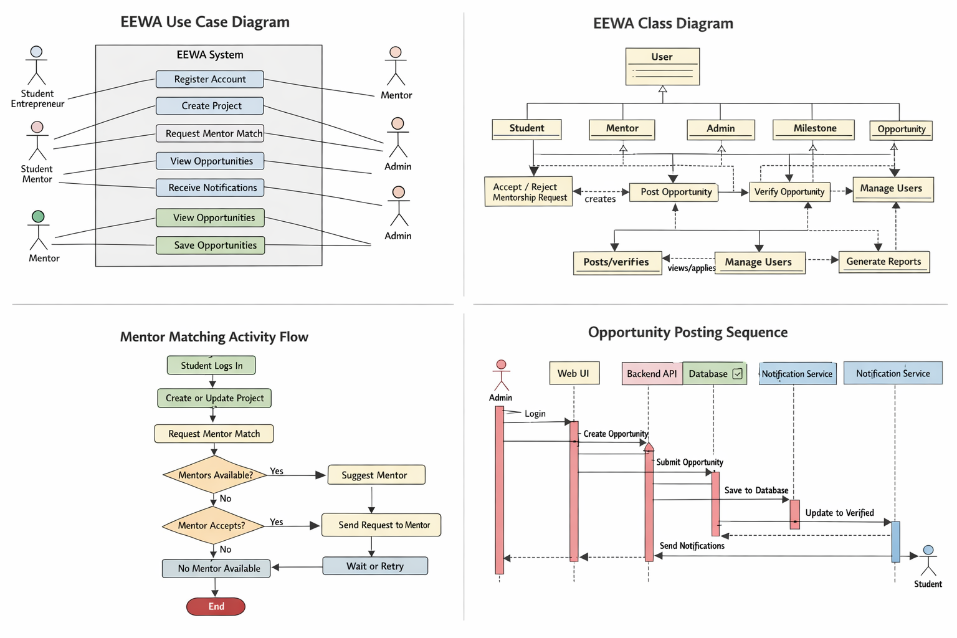

2.2 Product Functions
- User registration and authentication
- Project creation and tracking
- Matching Mentor and Communication.
- Listing opportunity and notifications
- Admin management

2.3 User Classes and Characteristics
- Mentor: Guidance and feedback
- Student Entrepreneurs: Signing in and managing their projects.
- Admin: User and Opportunity Management.

2.4 Operating Environment
- Server-side application
- Web-browser
- Internet-accessing devices like (PC, mobile phone)

2.5 Design and Implementation Constraints
- Web-based architecture
- English language
- Secure authentication required

2.6 User Documentation

- User Manual (PDF Doc): Written means of explaining how the software works
- Demo Video; Visually Explaining how the software works

2.7 Assumptions and Dependencies
- Verified mentors available.
- Internet access for users
- The hosting infrastructure is reliable

3. External Interface Requirements

3.1 User Interfaces
- Web interface responsive

3.2 Hardware Interfaces
- No hardware integration required. Runs on a web browser.

3.3 Software Interfaces
- Email for notification services
- Database system (PostgreSQL): Storing data

3.4 Communications Interfaces
- Encrypted data transmission
- HTTPS protocol: Secure data transfer

4. Requirement Specification

EXAMPLE : (EDIT OUT THIS PART BASED ON YOUR SPECIFIC REQUIREMENTS)

Stakeholder Requirements Specification

Functional Requirements

Req ID | Requirements | Description
FR 1 | User Registration | Allow the users, such as students, mentors, and admins, to create accounts by using email and password
FR 2 | LogIn Secured | Authenticate users and allow access based on roles
FR 3 | Profile management | Allow users to update profiles, such as skills, contact, and bio.
FR 4 | Project creation | Allow the student/entrepreneur to create a project title, sector, goals, and a brief description.
FR 5 | Project Milestone tracking | User Classes and Characteristics Mentor: Guidance and feedback Student Entrepreneurs: Signing in and managing their projects. Admin: User and Opportunity Management.
FR 6 | Matching mentor | User Classes and Characteristics Mentor: Guidance and feedback Student Entrepreneurs: Signing in and managing their projects. Admin: User and Opportunity Management.
FR 7 | Project Management | Create, edit, and Track projects in the software
FR 8 | Listing of opportunities | The system shall notify users about new opportunities and deadlines through email or in-app alerts.
FR 9 | Mentor Communication | The system shall provide a messaging feature for mentor–mentee communication and feedback.
FR 10 | Admin Opportunity Verify | Allow admins to review, reject, approve, and publish opportunities to avoid scams.

5. Other Nonfunctional Requirements

Example of Non-Functional Requirements (EDIT THIS PART)

Requirement Type | Req ID | Description
Security | NFR 1 | Enforcement of role-based access control and encryption of all data transmission using HTTPS.
Performance | NFR 2 | Systems supports 50 users at once without any problem.  Loading core pages like dashboard, opportunities, and projects. Within 3 seconds under normal conditions.
Usability | NFR 3 | The system shall provide a responsive interface that works on mobile and desktop screens.
Reliability | NFR 4 | 99% system uptime per month, excluding maintenance schedules
Maintenability | NFR 5 | Use modular architecture to support easy updates and feature expansion.
Availability | NFR 6 | Provide error handling and user-friendly messages for failing operations.

Guide to Non- Functional Requirements

Performance Requirements
The following performance requirements define how the Entrepreneur Empowerment Web Application (EEWA) must behave under specific circumstances to ensure responsiveness, scalability, and reliability. These are tied to the core functional modules: Project Tracking, Mentorship, Opportunity Management, and Notifications.
- User Authentication and Login Requirement: The system shall authenticate users (students, mentors, admins) within 2 seconds under normal load conditions (up to 100 concurrent users). Rationale: Fast login ensures users can access projects and mentorship support without delay, enhancing engagement. Timing: Response time must not exceed 5 seconds even under peak load (200 concurrent users).
- Project Management (Create/Edit/Update Milestones) Requirement: Project creation or milestone updates shall complete within 3 seconds. Rationale: Quick updates encourage students to maintain real-time tracking of their projects. Timing: Updates should be committed to the database and reflected on the dashboard immediately after submission.
- Mentor Matching Requirement: The system shall provide mentor suggestions based on skills, sector, and availability within 5 seconds. Rationale: Students can receive timely mentor recommendations to prevent delays in project guidance.
- Opportunity Listing and Notifications Requirement: Opportunities shall load within 2 seconds, and push notifications shall be sent to users within 10 seconds of posting a verified opportunity. Rationale: Timely delivery of opportunity alerts is critical to ensure students do not miss application deadlines.
- System Scalability Requirement: The system shall support up to 500 concurrent users with minimal performance degradation (less than 10% increase in average response time). Rationale: The platform may scale to all ALU campuses or other African universities.
- Data Retrieval for Reports Requirement: Administrators and institutional staff shall be able to generate dashboards/reports for up to 1,000 projects and 10,000 milestones within 10 seconds. Rationale: Fast reporting is necessary for monitoring student progress and opportunity effectiveness.
- Reliability and Availability Requirement: Core services (login, project management, mentor matching) must maintain 99% uptime, with less than 1% downtime per month. Rationale: Ensures students and mentors can access the platform whenever required, fostering trust and consistent usage.
Safety Requirements
The EEWA platform must protect users, their data, and the system from harm or misuse. Safety requirements cover data integrity, secure access, and operational reliability.
- Data Protection and Loss Prevention Requirement: All project, mentorship, and opportunity data must be backed up automatically at least once every 24 hours. Rationale: Prevents loss of student or mentor work due to accidental deletion, server failure, or cyberattack. Safeguard: Daily automated backups with versioning; ability for admin to restore any previous version of a project or opportunity.
- Unauthorized Access Requirement: Only authenticated users shall access the platform, and role-based access control (RBAC) must restrict actions based on user type (Student, Mentor, Admin). Rationale: Prevents malicious users or accidental misuse from changing critical data. Safeguard: Enforce strong passwords, two-factor authentication (2FA) for Admins, session timeouts after 15 minutes of inactivity.
- Data Integrity Requirement: All submissions (projects, milestones, mentorship feedback, opportunities) must be validated and stored in a transactional database to prevent corruption. Rationale: Ensures that project progress, mentor feedback, and opportunity details remain accurate and reliable. Safeguard: Database constraints, transactional commits, and input validation on all user forms.
- Malicious Content Prevention Requirement: Users shall not be able to upload scripts, executable files, or malicious content. Rationale: Protects system and user devices from malware, viruses, or XSS attacks. Safeguard: File type filtering, virus scanning, and server-side input sanitization.
- Legal and Regulatory Compliance Requirement: Platform shall comply with data protection and privacy regulations such as GDPR (for international users) and local Rwandan data protection laws. Rationale: Prevents legal liability and ensures user trust. Safeguard: Privacy policy displayed on the platform, explicit user consent for data collection, and encrypted storage of personal data.
- Emergency and System Failure Procedures Requirement: In case of server failure, the platform must continue operating in read-only mode until full recovery. Rationale: Prevents loss of data and allows users to access critical information while the system is restored. Safeguard: Redundant servers, failover strategies, and monitoring alerts to administrators.
- Safety Certifications / Standards EEWA shall follow industry best practices for web security: OWASP Top 10 web security risks mitigation HTTPS encryption with TLS 1.2+ Secure database management practices

Security Requirements
The Entrepreneur Empowerment Web Application (EEWA) shall ensure confidentiality, integrity, and availability (CIA) of all user data while complying with legal regulations on data privacy and cybersecurity.
- User Authentication and Authorization Requirement: All users must have unique accounts and log in with strong credentials (minimum 12-character password with letters, numbers, and symbols). Rationale: Ensures only authorized users can access the platform. Safeguard: Role-based access control (RBAC) ensures each user can perform only actions allowed for their role (Student, Mentor, Admin, Sponsor). Extra: Admins must enable Two-Factor Authentication (2FA).
- Data Encryption Requirement: All sensitive data (passwords, personal info, project content, mentorship feedback) must be encrypted in storage (AES-256) and in transit (HTTPS/TLS 1.2+). Rationale: Protects against unauthorized access, interception, or data breaches.
- Privacy Compliance Requirement: Platform must comply with relevant data protection regulations: GDPR (for EU users or collaborators) Rwandan Data Protection Law (Law No. 058/2021) Rationale: Ensures legal compliance, prevents liability, and builds user trust. Safeguard: Explicit consent for data collection; privacy policy accessible and clear; users can request data deletion.
- Session Management Requirement: User sessions should expire after 15 minutes of inactivity. Rationale: Reduces risk of unauthorized access if a device is left unattended. Safeguard: Automatic logout and session token invalidation.
- Audit and Logging Requirement: The system shall log all critical actions (login, project edits, mentor assignment, opportunity approval) with timestamps and user IDs. Rationale: Ensures accountability and traceability for security incidents. Safeguard: Logs stored securely and accessible only to Admins.
- Access Control and Least Privilege Requirement: Users can only access information and perform actions relevant to their role. Rationale: Prevents accidental or malicious misuse of data.
- Security Certifications / Standards Requirement: The platform must follow industry-standard security practices: OWASP Top 10 mitigation (SQL injection, XSS, CSRF, etc.) ISO/IEC 27001 for information security management HTTPS/TLS encryption for all communications
- Data Retention and Disposal Requirement: Personal and project data must be retained only as long as needed and securely deleted when requested or after retention period expires. Rationale: Reduces exposure to privacy breaches and ensures regulatory compliance.

Software Quality Attributes
The following quality attributes define additional important characteristics of the Entrepreneur Empowerment Web Application (EEWA). These attributes ensure the platform is usable, maintainable, and robust for both users and developers.
- Usability Requirement: The platform shall have an intuitive interface, with 95% of core functions accessible within 3 clicks from the dashboard. Rationale: Maximizes student adoption and reduces training time. Priority: High (ease of use preferred over ease of learning).
- Reliability Requirement: The system shall maintain 99% uptime for all critical modules (login, project management, mentor matching). Rationale: Ensures continuous access for students, mentors, and admins. Measure: Downtime must not exceed 7 hours per year.
- Maintainability Requirement: Developers shall be able to implement updates or fix bugs within 24 hours of detection without affecting other modules. Rationale: Ensures smooth operations and rapid resolution of issues. Safeguard: Modular code structure, clear documentation, and automated testing.
- Portability Requirement: The platform shall be accessible on any modern browser (Chrome, Edge, Firefox, Safari) and responsive on mobile devices. Rationale: Supports students using different devices across Africa.
- Interoperability Requirement: EEWA shall integrate with external services: Email notification service (SMTP/SendGrid) Institutional portals (ALU project databases) Rationale: Allows seamless communication and opportunity updates.
- Robustness Requirement: The system shall handle at least 100 concurrent users per module without crashing or data loss. Rationale: Protects the platform from overload and ensures stable usage.
- Testability Requirement: Every module shall support unit testing and automated functional tests, with at least 80% code coverage. Rationale: Ensures bugs are detected early and quality is measurable.
- Reusability Requirement: Core modules (e.g., login, notifications, mentorship matching) shall be designed as reusable components for future applications or expansion to other universities. Rationale: Reduces development time for future versions or similar platforms.
- Flexibility / Adaptability Requirement: The platform shall allow adding new functional modules (e.g., competitions, funding tracker) without affecting existing core functionality. Rationale: Supports growth and evolving needs of African student entrepreneurs.

Business Rules
The following business rules govern the operations of the Entrepreneur Empowerment Web Application (EEWA) and ensure compliance, consistency, and correct workflow for users:
- Role-Specific Actions
Rule: Each user role has specific permitted actions:
Student: Create, edit, and track projects; request mentorship; view and apply to opportunities Mentor: Accept/decline mentorship requests; provide feedback; view mentee projects
Admin: Manage users, verify opportunities, generate reports, assign mentors
Opportunity Provider: Submit opportunities for verification
Program Coordinator / Institutional Staff: Monitor student progress and recommend mentors or opportunities Enforcement: System must enforce role-based permissions for all actions.
- Mentor Matching Rules
Rule: Mentors can only be assigned to students if their expertise aligns with the student project’s sector and the mentor is verified.
Enforcement: Automated matching algorithm must validate mentor expertise and availability before assignment.
- Opportunity Verification
Rule: No opportunity becomes visible to students until verified by an Admin.
Enforcement: System must block unverified opportunities from appearing in dashboards or notifications.
- Project Ownership
Rule: Projects belong to the student who created them; only the owner can edit project content. Enforcement: Editing access must be restricted via user ID validation in the backend.
- Notifications
Rule: Notifications are sent only to relevant users: Students → updates on their projects, mentor feedback, new opportunities Mentors → updates on assigned mentees
Enforcement: Notification service must filter recipients based on project-mentor relationships and roles.
- Application Eligibility
Rule: Students can only apply for opportunities if they meet eligibility criteria defined by the opportunity provider.
Enforcement: System must validate eligibility fields (program, skills, milestones completed) before allowing application.
- Data Privacy & Access
Rule: Users can only view data that is relevant to their role or relationship with other users. Enforcement: Role-based access control must filter all data queries to enforce privacy.
- System Audit
Rule: All critical actions (project creation, milestone updates, mentorship assignments, opportunity verification) must be logged with timestamp and user ID.
Enforcement: Audit logs must be immutable and accessible only to authorized Admins.
- Session Management
Rule: Sessions expire after 15 minutes of inactivity. Users must log in again to continue actions. Enforcement: Automatic logout and session token invalidation.
- Backup and Recovery
Rule: All project, mentorship, and opportunity data must be backed up daily; recovery procedures must restore lost data within 24 hours.
Enforcement: Automated backup system with versioning and restore procedures.

6. Appendix:

Glossary
- EEWA: Entrepreneur Empowerment Web Application
- ALU: African Leadership University

ANALYSIS MODELS
- Use Diagrams.
- Data flow structure.

REFERENCES
World Bank. (2022). Fostering entrepreneurship. World Bank Publications.

Appendix B;

- Behavioural Diagrams
- USE CASE DIAGRAM
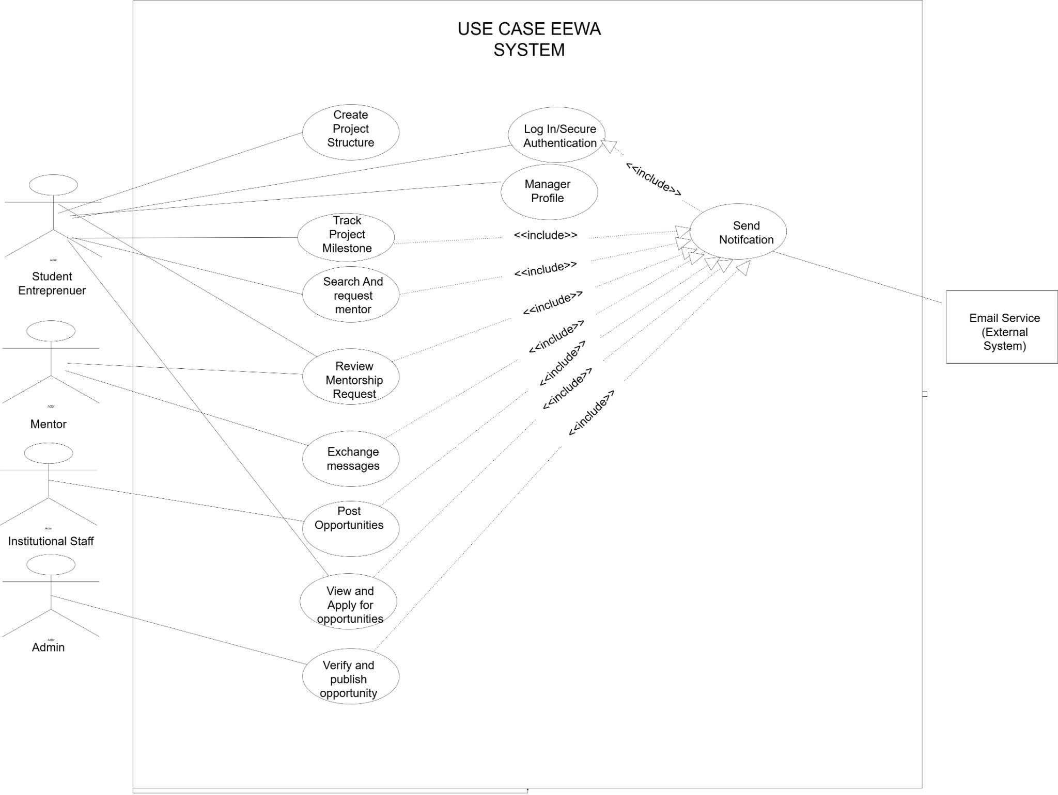
Diagram Description
Such a behavior diagram will determine the functionality of EEWA platform as per the typical UML use case notation. System Boundary is also clear stipulated to give demarcation of internal capability of application and the external Actors who externalise the application. The elements are characterized in a very characteristic way in terms of inclusion relationship. The Role-Based Access Control (RBAC) requirement means that any primary use case (e.g. the one with the name Create Project or Post Opportunity) is based on the arrow of the form of an include to the use case named Secure Login meaning that the process of authentication is one of the required conditions. Moreover, it is possible to associate critical communicative actions (e.g. a student requesting a mentor) with the use case of Send Notification that will cross the system boundary and will interact with the external actor that is the Email Service.

- SEQUENCE BEHAVIAL DIAGRAM
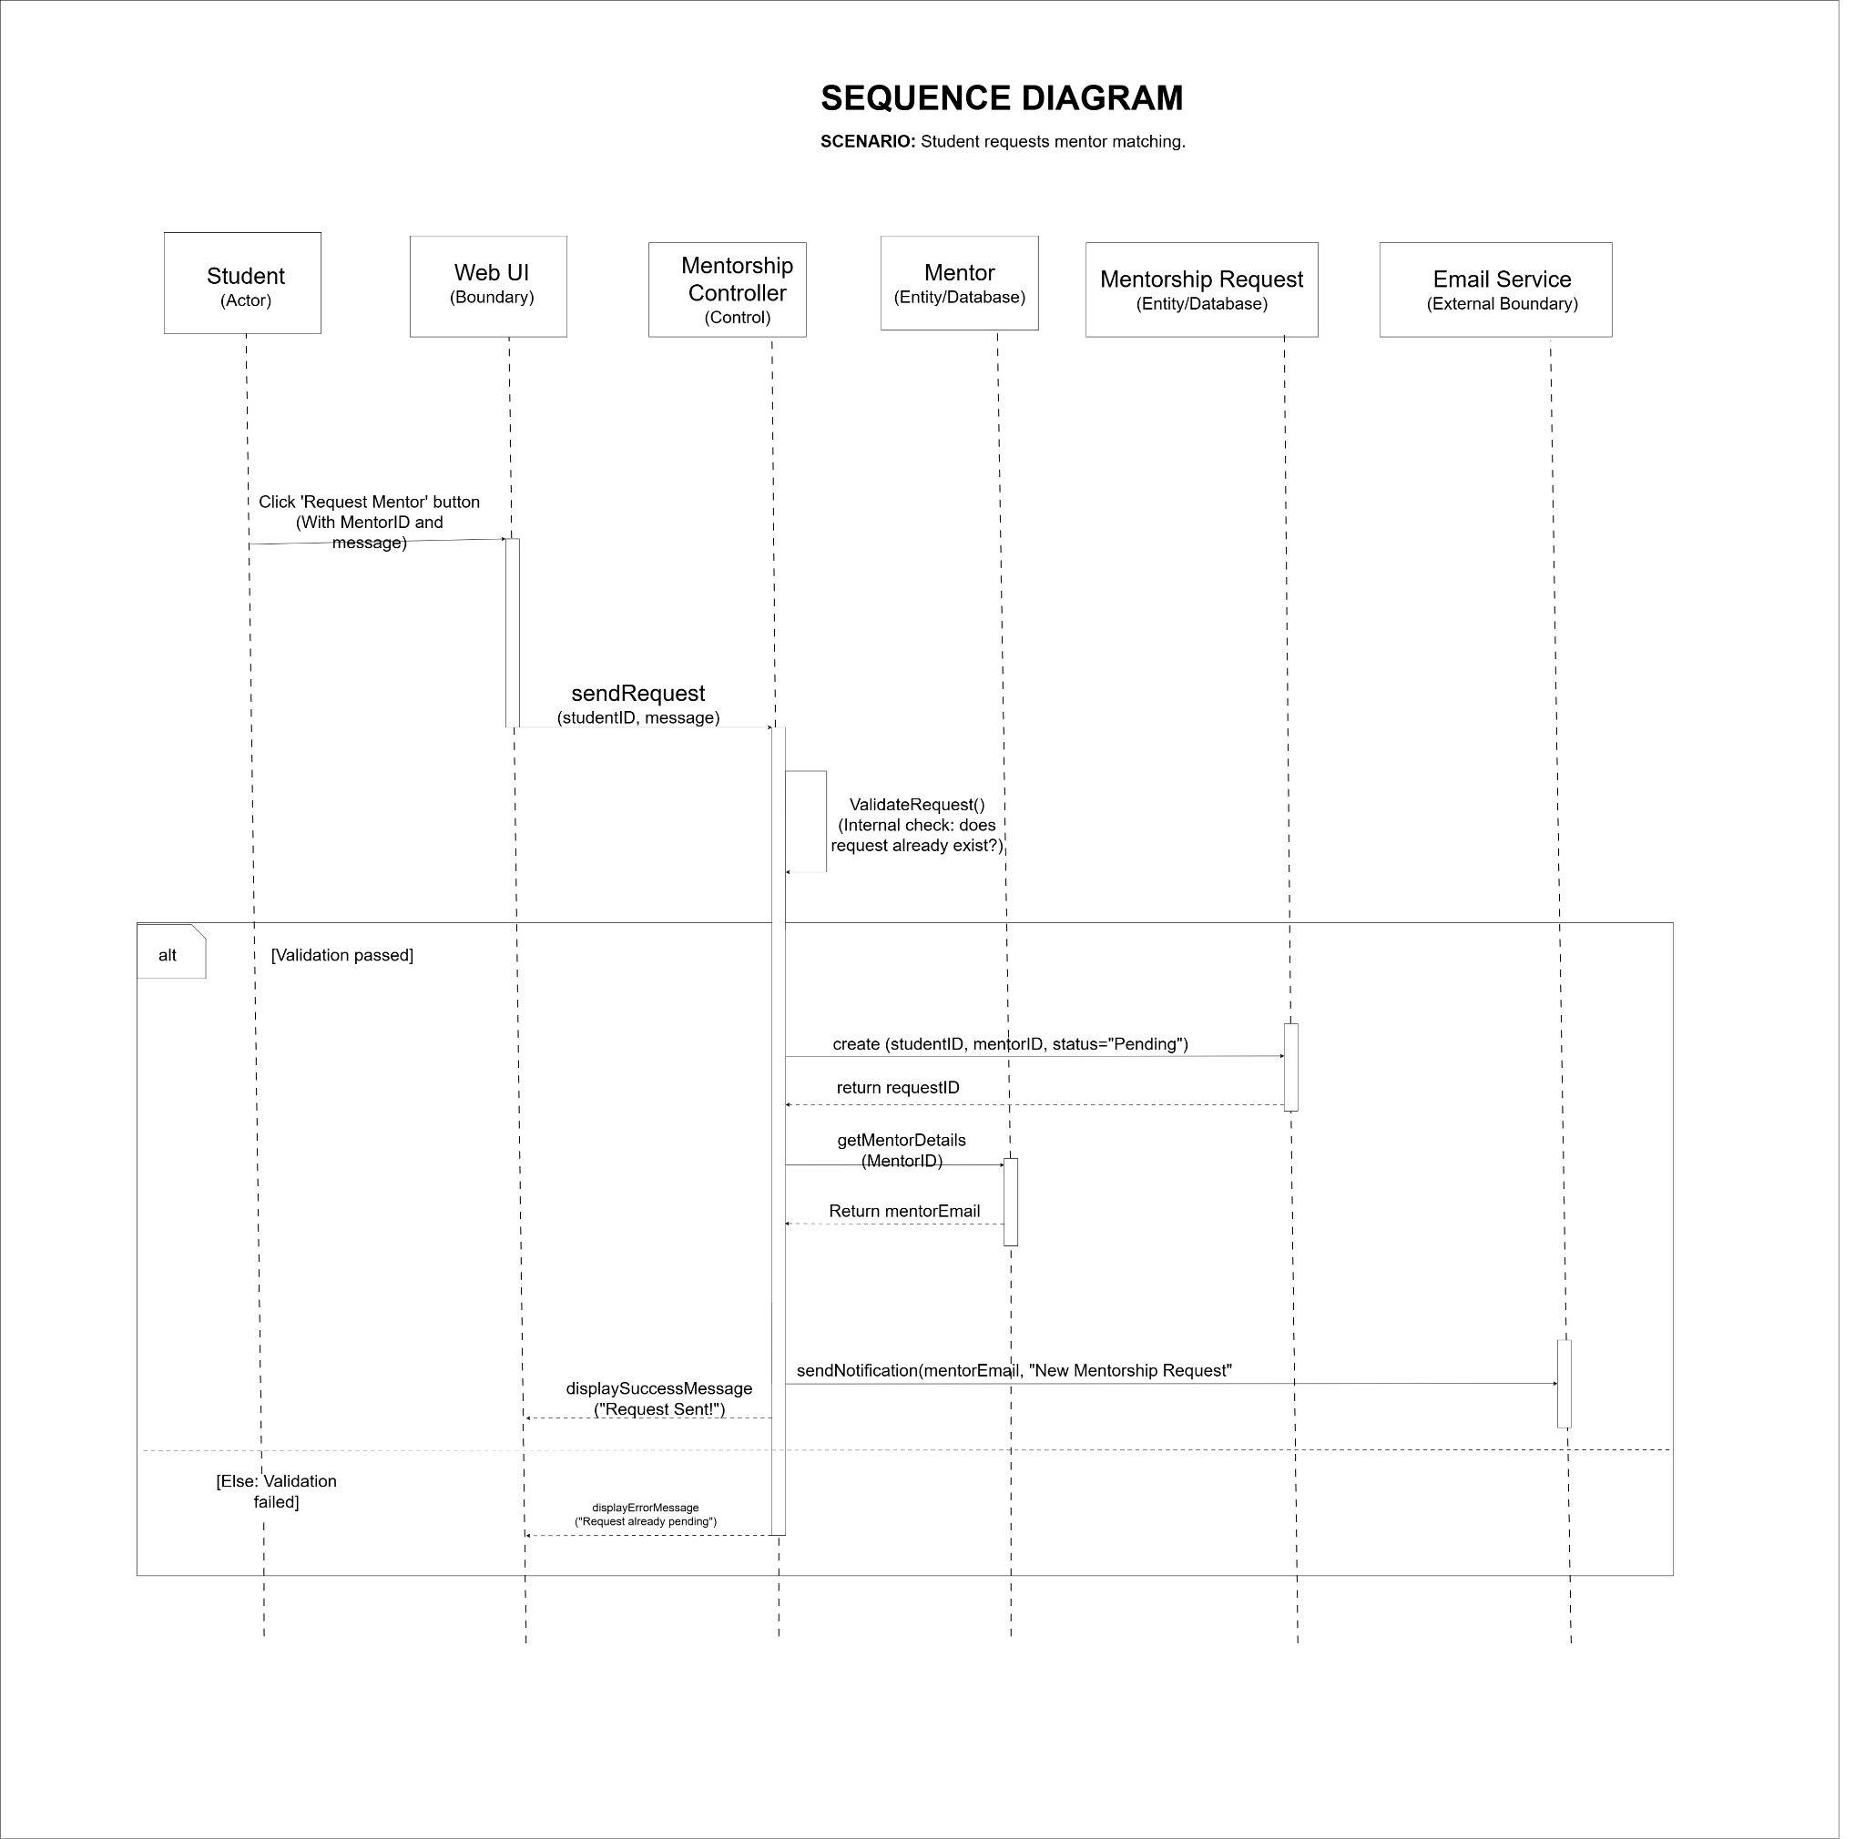
Diagram Description
This is a topology of an architectural design that illustrates both the physical design and logical design of EEWA system. The physical containers (subsystems) represent the deployment boundaries in between the elements. One of the main areas of concern is the use of Provided and Requirement Interfaces. The API Gateway provides an API which is an HTTPS interface as needed by the Web Client. The gateway will then redirect the traffic to the internal modules that have been captured in EEWA Web Application Server. These in-house modular sub-units (Project Tracker and Reporting Engine) are reliant on the PostgreSQL DB through a JDBC/SQL Interface. To be production-ready, the elements of the diagram naturally load the load of the media processing to a Cloud Object Storage node through a REST endpoint and offload communication to the Email Notification Service through an SMTP endpoint.

B. STRUCTURAL DIAGRAMS
- COMPONENT DIAGRAM
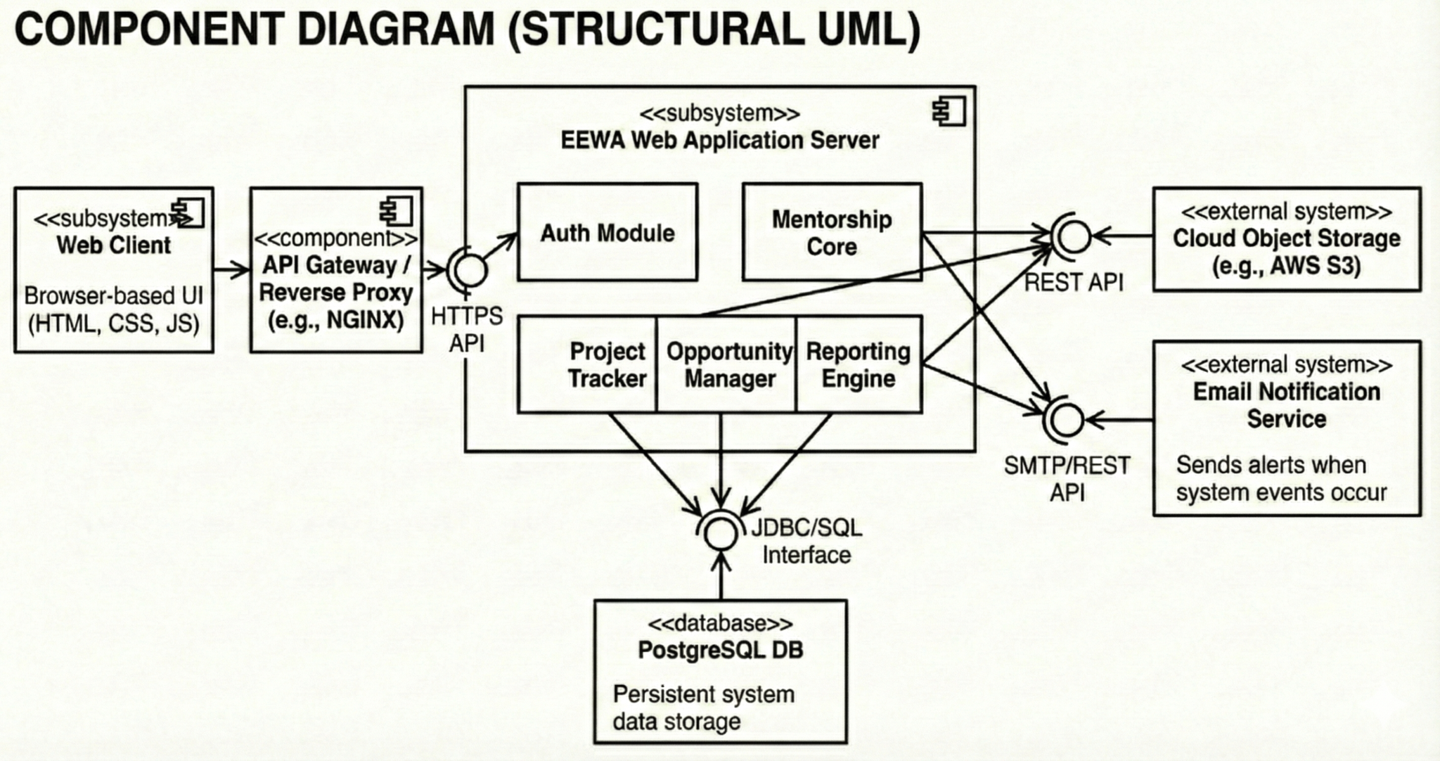
Diagram Description
The behavioral diagram below elaborates the dynamic and time oriented message transmission which shall be necessary to create the mentor matching scenario. The elements are in the Model- View- Controller (MVC) design. Lifelines have a top to bottom flow direction. Boundary element (Web UI) acts as a sender of a message (sendRequest) to Control element (MentorshipController). The other element where there is incredible concentration on this diagram is the alt Combined Fragment which is a critical decision path: the system invokes itself to call requestcheckRequest(). When the controller is successful the data is submitted to the Entity objects (MentorshipRequestDB and MentorDB) so it can create the data and calls asynchronously to the external: EmailService. In the failure of validation, an alt frame is used to specify the immediate error message to the UI which is not in database interactions.

- CLASS DIAGRAM
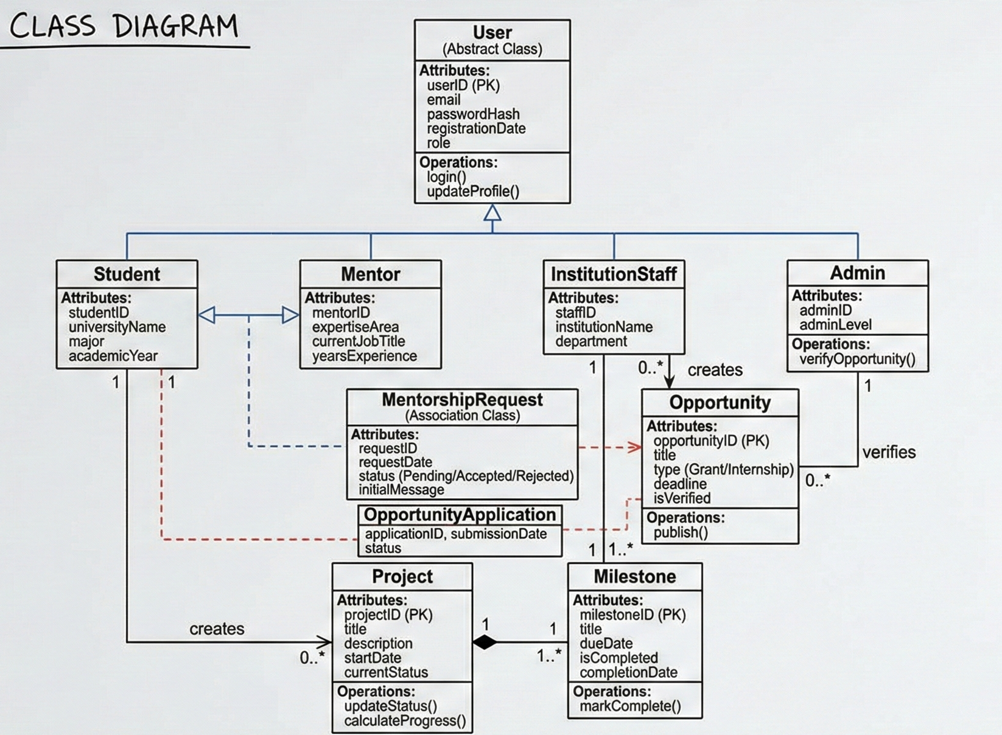
Diagram Description
It is a structural design that comprises of the data schema of the EEWA system (when not in motion) and the immediate basis of the PostgreSQL database design. One of the major centres of focus is the Generalization (Inheritance). To meet RBAC requirement, all the classes, Student, Mentor, Admin and InstitutionStaff are all upwards pointing with hollow arrows and inheritance authentication property of the abstract User class. There is also the strict data integrity management that has been identified in the diagram in the form of Composition: solid diamond within the Project and Milestone (a 1-many relationship where the destruction of a Milestone leads to the destruction of a project). Lastly, many-to-many relationships between the entities (actors and system) are resolved by means of Association Classes (long lines ending up with a class box) e.g. MentorshipRequest in which the specific metadata (date, pending status) of an association between a Student and a Mentor is recorded.

