**Fields Tutorials**

**Exercise 1 :**

1. The following data is needed

Raduis of the moon $3.84*{10}^{8}m$

Mass of the moon $7.35*{10}^{22}kg$

Period of the moon around the earth $2.36*{10}^{6}s$. Calculate

1. The speed of the moon in it’s orbita round the earth
2. The acceleration of the moon
3. The force the earth exerts on the moon
4. The gravitational field strength of the earth on the moon
5. A satellite of mass 600kg is in a circular orbit at height 200km above the earth surface. The raduis of the earth is 6400km and take $g=10N{kg}^{-1}$

**Exercise 2 :**

A small spherical insulator of mass $8.00*{10}^{-2}kg$ and charge $Q_{1}=+0.600μC$ is hung by a thin wore of negligeable mass. A charge of $Q_{2}=-0.9μC$ is held at a distance $d=0.150m$ away from hte sphere and directly to right of it, so the wire makes an angle $θ$ with the vertical as shown below

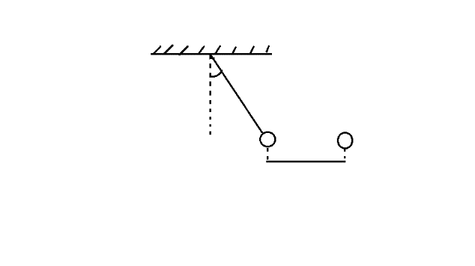

$$Q_{1}$$

$$Q_{2}$$

θ

d

Calculate

1. The angle $θ$
2. The tension in the wire

**Exercise 3 : Cyclotron**

A cyclotron is made of two semi cylidric metalic boxes called « D » separated by a small gap between which a potential difference of $u\left(t\right)$ of frequence $f$ is established. The « D »s are placed in between magnets which creat a uniform magnetic field $\vec{B}$ with field lines perpendicular to the « D »s. We inject the protons (m=1.66 ${10}^{-27}$*kg, q=1.6 ${10}^{-19}$*C) in the direction perpendicular to $\vec{B}$ with a negligeable initial velocity. We give $B=1.5T$

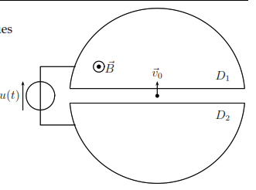

1. Show that in the « D »s, the velocity v of the protons is constant
2. Deduce the raduis R of the trajectory of the proton with velocity $v$ together with the time of passage of the proton in one « D »
3. What must be the frequency $f$ for the proton to be accelerated optimally during each passage through a « D »
4. Let $U_{m}=200KV$ the amplitude of the amplitude $u\left(t\right)$
5. From the kinetic energy, determine the relation between $V_{n}$ and $V_{n+1}$, the velocities during two consecutive semi circles noted n and n+1
6. Deduce in function of n the relation between the radii $R_{n}$ and $R_{n+1}$ of two consecutive semi circles noted n and n+1
7. Caculate the raduis after 1 complete turn(two passages between the « D »s and after 10turns
8. The radius of the last semi circle is $R_{N}=35cm$
9. Determine the kinetic energy of the proton before the collision with a target
10. The number of total turns the proton went through

**Exercise 4 :**