UNIVERSIDAD GERARDO BARRIOS.

Facultad de Ciencia y Tecnología.

Teacher: Gema Montes.

Subject: Technical English Applied to Technology.

Instructions: Each section is 0.28 points to make 1.43 the total of the complete homework.

Complete the next excercises with your own information, and fill the blank with the right answers.

1. Choose the correct words to complete the sentences.

__Is__that Donny yen?

Yes,__it’s

Where ___are you_____ from? ___I’m from _____ Hong Kong.

Is that ___ Restaurant good? Yes it’s

She’s__not___ from Britain. Where’s she__ from?

Where ___is she__ from? _______she is from Vitally.

_______where is Paris? _Is in France.

_____Is___ that the Turkish flag? No, ____isn’t

Spain flag ___is___ red and yellow. Yeah, that’s__ right.

1. Complete the sentences.

I ___am___ from Peru. Where _is___ she from?

He is ____Canada ______. He ____is__ Canadian.

Are _____you_____ Elena?

This __is__ Junko. She ____is from_____ Japan.

You __are___ from Argentina. ______Are you ____ From Chile?

I think ___is______ from India.

1. Complete the chart with the countries and nationalities.

|  |  |
| --- | --- |
| Country | Nationality. |
| France | Frenck |
| Italy | Italian |
| Peru | Peruvian |
| Russia | Russian |
| UK | British |
| Germany | German |
| India | Indian |
| Canada | Canadian |

1. Identify and write the country of the flag.

Romania



Saudi Arabia



Russian

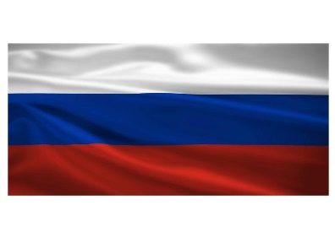

1. Write the meaning of “the stress of a word”.

In English, we do not say each syllable with the same force or strength. In one word, we accentuate ONE syllable. We say one syllable very loudly (big, strong, important) and all the other syllables very quietly.

This happens in ALL words with 2 or more syllables: TEACHer, JaPAN, CHINa, aBOVE, converSAtion, INteresting, imPORtant, deMAND, etCETera, etCETera, etCETera