# Recreated MSSQL Structure

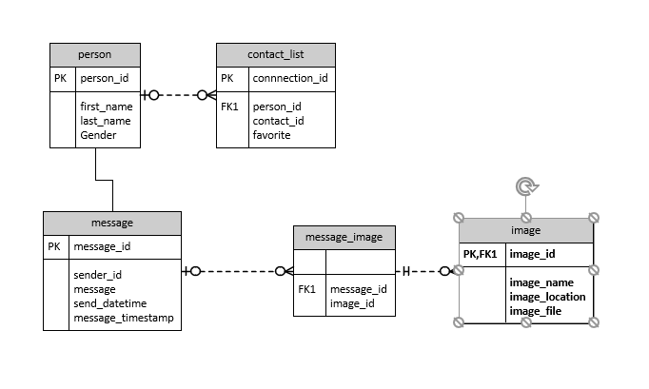

# Table structure

SQL INFORMATION_SCHEMA.COLUMNS

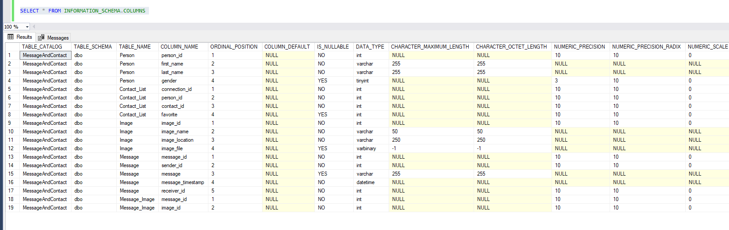

# Testing

## Constraints Contact_List

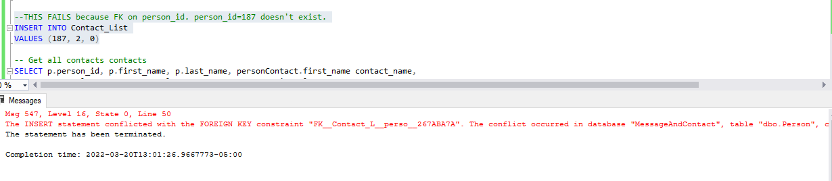

## Constraints Message table

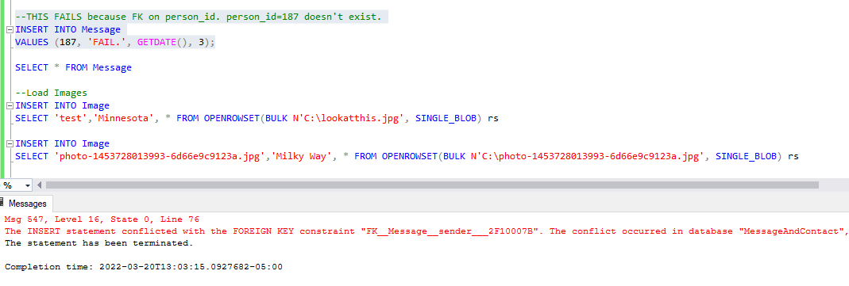  
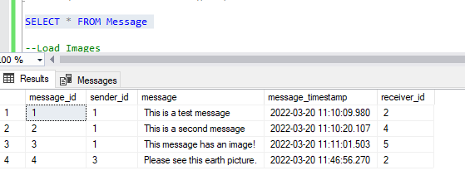

## Constraints Message_Image

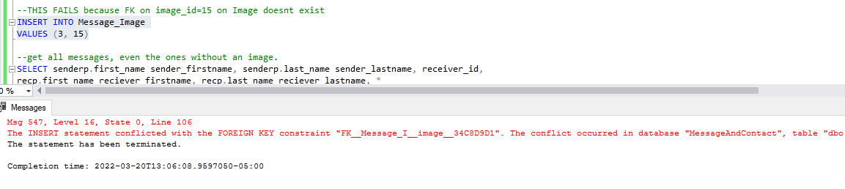  
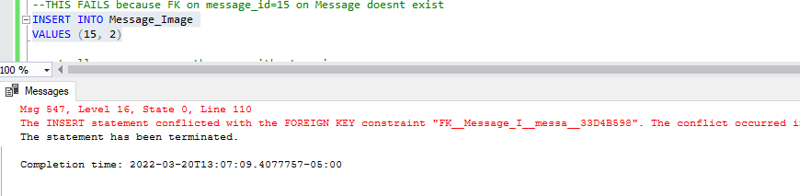

## Messaging tables and images