

Early Rumour Detection in Social Media using Machine Learning

PSG 16 – Dr Zhiwei Lin – BEng Software Engineering

Thomas Franklin B00607399

April 2018

# Abstract

In recent times there has a been a rise in what is deemed as “fake news” when it comes to social media sites such as Twitter. Fake news can be described as the spreading of misinformation to influence the readers thoughts and is becoming a much larger issue in recent times with the rise of social media and particular “influencers”.

As social media tends to be an area where users can express their own belief, large influencers can use it as a playground to misinform their followers and hence start the process of spreading fake news – since content on social media can reach hundreds of thousands of users in minutes, which means current methods of combating fake news is often to slow to stop the spread before it starts, it was time to look in to solutions which can aid in detecting fake news a lot faster and prevent the spread before it is too late.

The aim of this project was to use machine learning to classify all public Tweets from Twitter as a rumour or non-rumour where the results could then be retrieved through a rich internet application for visualisation. From the research conducted there were very few existing projects that have tackled rumour detection in social media, and from the information gathered this will be the first project which uses natural language processing and machine learning for the early detection of a rumour in social media.

The final product produced is a service which continually streams Tweets from Twitter based on keywords, puts them through a processing process which classifies them as either as rumour or non-rumour which is then stored in a SQL database for later retrieval on an interactive web service which will show a breakdown of the results in graphs, charts etc.

In conclusion, the use of natural language processing and machine learning is only the start of tackling fake news, on its own it reduces the amount of results which will still need accessed, as the current methods where individuals who cross-verified results having to go through everything – by reducing the results earlier in the process it can speed up the cross-checking steps that will need to be done.

# Acknowledgements

This project would not have been possible without the support of my mentor Dr. Zhiwei Lin for his guidance and support throughout. Another thanks goes towards the Ulster University teaching staff of whom I had the pleasure to learn from over the last 4 years, and finally I would like to thank those I had the pleasure of working with while on placement – most importantly Aaron Long who was a mentor to me when starting out in placement and with his continued support I have become a better developer.

**Table of Contents**

Abstract 1

Acknowledgements 1

1. Introduction 4

1.1 Problem Elucidation and Statement 4

1.2 Project Aim 4

1.3 Project Objectives 4

1.4 Selected Software Lifecycle Methodology 5

2. Requirement Control Document 5

2.1 Requirements Gathering Methodology 5

2.2 Final Requirements 6

2.3 Requirements Evolution 7

3. System Overview 7

3.1 System Design 8

3.2 Interface Design 9

3.2.1 HCI Considerations 9

3.2.2 Wireframes 10

3.3 Data Support Design 11

3.3.1 Consideration for Security and Data Validation 12

3.3.2 Database Design and Related Artefacts 13

3.4 User Interaction Design 15

3.4.1 Information Flow Diagram 15

3.4.2 Use Case Diagrams 16

3.4.3 Activity Flow Diagram 17

3.5 Other Design Artefacts 18

3.5.1 Classification Process 18

4. System Implementation 20

4.1 Summary and Rationale for tools, languages, databases, APIs and frameworks 20

4.1.1 Tools 20

4.1.2 Languages 21

4.1.3 Database 22

4.1.4 APIs 22

4.1.5 Frameworks and Libraries 23

4.2 Use of Version Control 24

4.3 Summary of Volume of Code Produced 24

4.4 System Walkthrough 25

4.5 Consideration for Security 35

5. System Verification 35

5.1 Verification Strategy 35

5.2 System Verification Results 35

5.3 Other Verification Artefacts 35

5.4 Conclusion of Verification 36

6. System Validation 36

6.1 Validation Strategy 36

6.2 System Validation Results 36

6.3 Other Validation Artefacts 36

6.4 Conclusion of Validation 36

7. Conclusion and Reflection 36

7.1 Critical Appraisal of Project 36

7.2 Reflection of Project Plan 36

7.2.1 Appropriateness of initial time/effort estimation 36

7.2.2 Appropriateness of Software Methodology Used 36

7.3 Conclusion 36

Appendices 38

Appendix A: Final Requirement Formal Format 38

Bibliography: 39

# Introduction

This report will outline the solution developed to tackle the problem identified in the report, along with describing the development process of the proposed solution along with the management and elicitation of the product and user requirements which will be documented in the report, the report will also highlight the design and testing which had been completed to ensure that the project is a success.

## Problem Elucidation and Statement

Fake news[1] is a term which has risen in popularity within the last few years, especially when it comes to social media sites such as Twitter and Facebook (Meyer, R, 2018; Science | AAAS, 2018), although in recent months there has been responses from Facebook on their plans to tackle fake news (The Guardian, 2018; Bloomberg.com, 2018), Twitter on the other hand has been less vocal in their attempts and have only suspended accounts and emailed those who may have been in contact (Ecommerce Week. 2018).

Evidence has come to light in recent months about how the 2016 US Presidential Elections were influenced by what is termed fake news, and how the Russians pioneered and used it to influence the election (Vox, 2018; Conger K, 2018), had there been detection measures in place the spread of the misinformation could have been stopped early enough in order that it had no impact on the results.

Should nothing be done to try and reduce, or completely stop the spread of misinformation then it could continue to sabotage future important events, and as out of the two main social media sites, only Facebook has begun to address the issue it leaves an area open in Twitter to implement a solution to help in the early detection of rumours before they have a chance to spread and sabotage important events.

Should the project be capable of aiding in the early detection of social media the project code should be reusable for different functions that too require assistance in the detection of rumours, which gives it large commercial value as any company could reuse the system with their own filters to find out users opinion on themselves and if users are spreading misinformation about their products which could be brand damaging where they could intervene early and reduce the damage to their brand.

## Project Aim

This project aims to aid in the early detection of Tweets from Twitter early enough, in order for the appropriate action to be taken to prevent the spread of misinformation; often referred to as fake news. With the use of machine learning, this project will continuously stream Tweets from Twitter in real-time using configuration filters for areas of interest, such as Politics, Crisis’, Disasters etc., using the Twitter API which will then classify the individual Tweets as a rumour or non-rumour using the trained classifier where the results will be stored in a database which where an interactive website can get the data required to present the information using various visualisation techniques such as graphs, word clouds, etc.

## Project Objectives

Table Project Objectives Table

|  |  |
| --- | --- |
| Id | Objective |
| 1 | Design and implementation of a system which can continuously process Tweets from Twitter using configurable filters |
| 2 | Implement a classifier capable of assigning a rumour or non-rumour label based on the text from a Tweet |
| 3 | Design and implementation of a website to display the information in meaningful ways using best practices |
| 4 | Design and implementation of a backend service which can retrieve the data |
| 5 | To follow a project plan to ensure completion of the project by the project deadlines |
| 6 | To evaluate different machine learning libraries which can be used for the development of the classifier in objective 2 |
| 7 | To evaluate different frameworks and libraries which can ensure a well-executed system which adheres to appropriate system design considerations |
| 8 | To implement a system which is capable of running independently without much user interaction to adhere to the real-time aspects required of the project aim |
| 9 | The design and implementation of a system which can be reused by others who wish to monitor rumours of a given topic |

## Selected Software Lifecycle Methodology

The lifecycle followed by this project was the Extreme Programming (XP) software development methodology.

# Requirement Control Document

This section will document the methods used by the project owner to gather user/product requirements, along with tables outlining the final set of functional and non-functional requirements which had been identified with the prioritisation value using the prioritisation technique known as Wiegers Relative Weighting, as well as the explanation as to how the requirements evolved during the lifecycle of the project.

## Requirements Gathering Methodology

The initial requirements of the project and for any additional requirements were gathered using the following techniques: peer reviews, scenarios and walk-throughs which were all performed with various members of the stakeholders of the project. The techniques suited the format of the project, as regular meetings were held with the stakeholders in the early stages, and through these meetings the requirements could be identified using the three techniques mentioned above and they were refined using brainstorming techniques to help shape them in to tangible requirements.

## Final Requirements

For the prioritisation of requirements, the project utilised Wiegers Relative Weighting technique (Wiegers K, 1999) which is a technique which uses cost, value and risk to prioritise the requirements. Table 2 shows the final set of functional requirements for the developed system along with their prioritisation value, while in Table 3 it shows the non-functional requirements of the system along with their prioritisation value.

The prioritisation value is calculated using Wiegers Relative Weighting formula as below:

The higher the value the higher the priority, tables 2 and 3 only show the value, they are organised by the Requirement ID rather than the prioritisation value.

Table Final Functional Requirements and Prioritisation Value

|  |  |  |
| --- | --- | --- |
| ID | Description | Prioritisation Value |
| F.01 | System shall continuously process Tweets without user interaction | 0.75 |
| F.02 | Users shall be able to access the website through any browser | 0.7 |
| F.03 | Users shall be able to search for individual hashtags which they are interested in | 0.28 |
| F.04 | System shall display the top hashtags using various visualisation techniques | 0.9 |
| F.05 | System shall display the top users using various visualisation techniques | 0.9 |
| F.06 | Users shall be able to search for individual users which they are interested in | 0.39 |
| F.07 | System shall assign labels to individual Tweets either as a rumour or non-rumour | 0.9 |
| F.08 | System shall store the classification label of each individual Tweet | 0.9 |
| F.09 | System shall store location information of the Tweet | 0.23 |
| F.10 | System shall display service status information | 0.6 |
| F.11 | System shall allow user to search rumours/non-rumours near them | 0.28 |
| F.12 | System shall allow user to report a particular user | 0.23 |
| F.13 | System shall allow user to report a particular hashtag | 0.23 |
| F.14 | System shall provide help through tooltips and a help menu | 0.67 |

Table Final Non-Functional Requirements and Prioritisation Value

|  |  |  |
| --- | --- | --- |
| ID | Description | Prioritisation Value |
| NF.01 | System shall not store data any longer than required | 0.67 |
| NF.02 | System shall be developed using open source frameworks and libraries to reduce risk | 0.55 |
| NF.03 | System shall be tested using appropriate testing strategies | 0.67 |
| NF.04 | System should be robust enough to restart on failure | 0.31 |
| NF.05 | The system shall be protected from SQL injection attacks | 0.45 |
| NF.06 | Systems interface shall be pleasing to the eye | 0.61 |
| NF.07 | System shall log appropriate metrics for future enhancements | 0.25 |
| NF.08 | System shall give user a response within 5 seconds of navigating to a page | 0.5 |
| NF.09 | System shall be developed using best practices | 0.67 |

## Requirements Evolution

From the initial report there have been a few additional requirements which evolved from the regular meetings with the stakeholders using the techniques identified in section 2.1. Notably requirement F.04,05 were added as they matched the capability of the system in its early prototypes, while the functional requirements relating to search (F.03,06,11) were added as they were future enhancement considerations.

As the project followed an agile lifecycle methodology there were plenty of opportunity to revisit the requirements, and add to them if required; as each iteration of the system went through various stages, one of which was release planning/sprint planning where user stories were prioritised, and as part of planning a user story the requirements had to be taken in to account as to what is being addressed – during these stages, requirements had been amended, removed or split to be less ambiguous.

# System Overview

This section will outline the system design, which includes the architecture of the system. The system was designed with performance in mind as it has to continuously stream and process Tweets in real-time while not hindering the user performance which is why the system was split in to multiple micro-services, which meant that each service only had one responsibility which allows for easy scalability of the service if required, and as the services are loosely coupled[2] they can be maintained easier.

Along with the system design, the section will also cover the User Interface design, which will include the wireframes which were designed, and the considerations made for design best practices such as HCI[3]. As the system uses a SQL database for the storage and retrieval of classified Tweets, section 3.3 will show the design of the database, displayed using ER diagrams. Section 3.4 provides information on the system through the uses of use case diagrams and activity flow diagrams and aims to provide detail on how users will interact with the system.

## System Design

The system was designed with micro-services in mind, to ensure that the system can easily be scaled if required and also to ensure that the system can deal with the real-time aspects of the service. With all this in mind, the system was split in to two parts, one which dealt the with processing, and then one which dealt with the user interaction – this allows the system to be more robust in the fact that users interactions will not slow down/affect the processing of data, while the processing of data will not negatively impact the user. Figure 1 shows the architecture of the system where it highlights the high-level components of the system.

Figure High-level System Architecture Diagram

From figure 1 each of the core components are listed, beginning with the one labelled *Twitter* is the Twitter API, and the *Stream* calls the API using Twitter4J[4] which opens up a filtered stream[5], the filter is a list of words which will be streamed in to the service, and is one of the ways in which the system can be reused as different companies can apply their own filters for topics which are relevant to them.

The *Stream* service is the control over the system, and has an endpoint exposed to start and stop the stream when required, when the stream is started it will continuously stream Tweets as per the product requirements identified in section 2.2.

From the stream, each individual streamed Tweet will be loaded on to a message queue in order to keep up with the volume of Tweets coming through the service, the service labelled *Queue Reader*, reads from the same message queue and dispatches it to the *Pre-process* service – where some pre-processing is done on the Tweet, such as lowercasing, removal of certain symbols, etc. in preparation for the classification process, using an endpoint exposed on the service labelled *Classifier* the pre-processor posts the processed Tweet item to it, this is where the Tweet body gets assigned a label as either a rumour or non-rumour based on the classification process outlined in section 3.5.1 – after the classification process, the *Classifier* saves the item to the *Database*, of which the design is outlined in section 3.3.

This is the end of what is referred to as the offline side of the service, which continuously processes in the background without user interaction, moving on to the service labelled *API* is where the user interacts with the service and is referred to as the online part of the service, and it will have various endpoints to retrieve different bits of data in a RESTful[6] way. The service labelled *Frontend* works closely with the *API* as the *Frontend* makes use of the APIs endpoints to retrieve the required data from the *Database* to display to the user on the *Frontend*.

All the services identified in Figure 1 are all ran within their own Docker containers, as a container is a lightweight, standalone package which have all the required tools to run the service (Docker, 2018), i.e. the *Frontend* service will have Tomcat[7] running which will expose the ports in order to connect to the web service, while *Classifier* will have Weka[8] and Mallet[9] running in order to perform the classification of the Tweets.

## Interface Design

The system will provide the required evidence to show that the interface design was done with best practices in mind by following the core principles of HCI and how these considerations will help to improve the usability and accessibility of the final product. Along with the evidence of following the best practices, it will also provide the wireframes that were produced as a guideline for the finalised pages of the website.

### HCI Considerations

When it comes to HCI, there are two key practices which typically come up, the 10 Usability Heuristics for User Interface Design (Jakob Nielsen, 1995) and the 8 Golden Rules of Interface Design (Ben Shneiderman's, 1986). The 10 Usability Heuristics iterate over the ‘golden rules’ (UX Courses, 2018) and as such the project has used these heuristics when considering the design of the interfaces in the project, table 4 shows the 10 heuristics with an explanation.

These 10 heuristics set the guidelines which have been followed when considering the interface of the project, and as such they aim to enhance the usability and accessibility of the service. Interface design should not end at the website, as the project relies heavily on the backend API, the interface of the API needs to be considered, which is why HCI has to be applied through the project to ensure that all aspects applies the principles set out by Jakob Nielsens 10 Usability Heuristics for User Interface Design.

Table 10 Usability Heuristics for Interface Design and a brief explanation

|  |  |  |
| --- | --- | --- |
| ID | Heuristic | Explanation |
| 1 | Visibility of system status | Keep users informed of system progress, i.e. use of progress bars, etc. |
| 2 | Match between system and real-world | Use language familiar to the user, i.e. use icons that represent real-world things |
| 3 | User control and freedom | Allow a “quick escape”, i.e. if user finds they’ve went too far, allow them to go back easily |
| 4 | Consistency and standards | Follow conventions and don’t use multiple words/icons to mean the same thing, i.e. use words consistently |
| 5 | Error prevention | Avoiding situations which could cause an error is better than descriptive errors, i.e. having a fault free system |
| 6 | Recognition rather than recall | Minimising users’ memory load, i.e. the user shouldn’t have to recall something from a previous page if the information is used elsewhere |
| 7 | Flexibility and efficiency of use | Allow users’ control over the system to meet their needs |
| 8 | Aesthetic and minimalist design | Only present users with information that is relevant, do not overburden them with too much |
| 9 | Help users recognise, diagnose, and recover from errors | If an error occurs, use common terminology and do not hide behind error codes |
| 10 | Help and documentation | Although it is best to develop a system which requires minimal support, if there is documentation required ensure it is easy to navigate and gives concrete steps |

### Wireframes

Wireframes are used early in a project to establish basic page structures before any visual design or content is added (Experience UX, 2018). As a wireframe is only an early visual to provide an indication of where core page content and functionality should be positioned – not all structural elements will be shown in them, and as such they are only guidelines for the final design.

Figure Wireframe of the Dashboard - the "homepage" of the website

Figure 2 is a wireframe of the dashboard of the service, which gives an overview of the data which is stored and gives the user a quick glance indication of the system status, such as which services are running – which relates back to heuristic 1 from table 4, about the guideline for providing users with information on the systems current status.

In Figure 3 it illustrates what key information could be provided when the user goes to the “hashtags” section of the service, and as such will allow the user to select different hashtags based on their rank and retrieve information specific to that hashtag – using the term “hashtag” corresponds with heuristic 4 from table 4, as the term “hashtag” is what users’ of the service will be familiar with.

Figure Top Hashtags Wireframe

As the service groups the rumours and non-rumours between users and hashtags, the wireframe in figure 3 also covers the “users” classification page where it too will show the top users rank and allow the user to see various visualisation techniques for the user data. As the classification is done on an individual Tweet, the users/hashtags are just how the data is grouped, and as such the pages for “users” and “hashtags” should be visually similar in order to adhere to heuristic 4 and 6 from table 4.

## Data Support Design

This section will aim to cover the consideration of data validation and security measures for the data of the project, along with the database design artefacts, such as the ER Diagram. As this project is very focused on the accuracy of information and the speed in which it is retrieved, getting the design of the database right is important, as a poorly design database will negatively impact the performance of a system which relies on data (Database Trends and Applications, 2018; SearchDataManagement, 2018).

### Consideration for Security and Data Validation

The most common attacks on a database fall in to the following categories; SQL Injection, Buffer Overflow vulnerabilities, Denial of Service, Privilege Escalation and Weak Authentication (Checkmarx, 2018) all of which can be avoided with good database design and few basic steps to avoid such attacks. First of all, to combat privilege escalation, creating a user and revoking all access is performed, and then only granting the required privileges to the database and tables;

REVOKE ALL PRIVILEGES ON * FROM 'twitter'@'%';

(Revoking all privileges for everything for user ‘twitter’)

GRANT SELECT, UPDATE, DELETE, INSERT ON twitter_classification.* TO 'twitter';

(Only granting SELECT, UPDATE, DELETE and INSERT access to twitter_classification database for user ‘twitter’)

By removing privileges to all other databases, the user ‘twitter’ will not be able to escalate their privileges to get more access than they are allowed. Secondly for weak authentication, using passwords of suitable length and complexity will be applied, and ensuring that the ‘root’ user has a complex password set.

As Denial of Services (DoS) attacks on a database are often cause by Buffer Overflows (Checkmarx, 2018) and are designed to halt the database, by putting rate limits on the ‘twitter’ user will help to prevent a DoS attack and buffer overflows;

ALTER USER 'twitter'@'%' WITH MAX_QUERIES_PER_HOUR 5000;

(Setting the maximum queries per hour for user ‘twitter’)

Finally, for SQL Injection, this will be addressed from the API level, where no data will directly be inserted to the database as all communication with the database will be executed as a Prepared Statement.

Addressing the validity of data should be performed at all levels to ensure a smooth user experience, i.e. a user should not have to wait till they submit something to find out that there is an issue with what they entered. Although in terms of database design, data validation can be done by using a few simple techniques (Validation | Databases | ICT, 2018);

1. Type – using appropriate field types, i.e. for fields which will only contain numbers, use a numeric type, integer, big integer etc.
2. Presence – for compulsory fields, ensure that the database design acknowledges that they cannot be null or empty
3. Uniqueness – any data which should only occur once should be made as a unique field, or a combination of fields should be unique
4. Range – limit the amount of data which it can hold, i.e. if you know the text will be a maximum of 300 characters, then only allow it to store that amount
5. Format – particular inputs might need to be in a certain format

The list above is some of the techniques which can be applied in database design to ensure that data is validated correctly and in the appropriate format, which is expected by the application.

### Database Design and Related Artefacts

The project went with a SQL database as the data has strong relations between a Tweet and a Classification value which then had relationships between individual users of Twitter and could have numerous hashtags that were in the original Tweet.

Figure ER Diagram of Twitter_Classification Database

From figure 4 which illustrates the ER diagram of the database, the relations are indicated by the blue lines, i.e. table *users_tweet_classifications* will have a foreign key constraint on the table *users* through *users.id* to *users_tweet_classifications.user_id*. With the ER Diagram in figure 4 it highlights how the database could be queried to get the Tweets and classification values for a particular hashtag or user of Twitter; which is important as this is the type of information which will be needed to present to the users of the service.

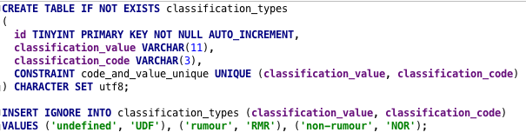

CODE Create Table Statement for classification_types

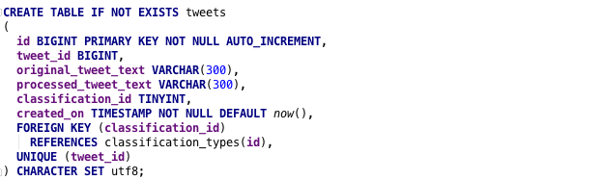

CODE Create Table Statement for tweets

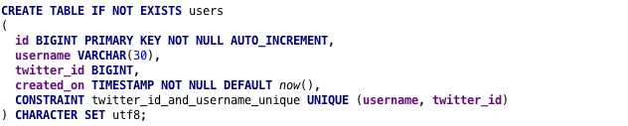

CODE Create Table Statement for users

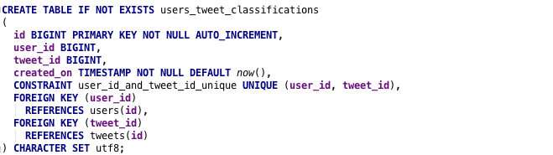

CODE Create Table Statement for users_tweet_classifications

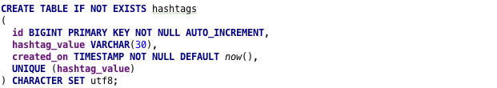

CODE Create Table Statement for hashtags

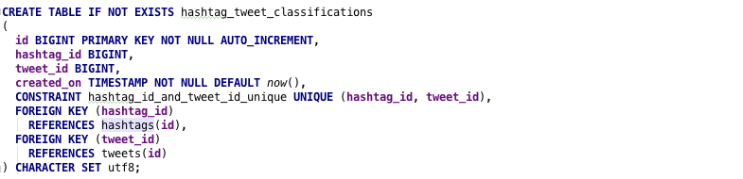

CODE Create Table Statement for hashtag_tweet_classifications

The code entries 1 through to 6 illustrates how the tables have been constructed along with the types of data each field accepts and the constraints which have been applied, code 1 is the statement which had been executed to create the *classification_types* table which stores the two types of classification values which the system deals with; rumours and non-rumours, hence why it is created and then the *INSERT* statement is used to insert values for *undefined, rumour, and non-rumour –* undefined is a precautionary measure for instances which may have thrown an error during classification.

For the fields used, for *classification_code* it is a field with a range of 3 characters as this is all the is required, *classification_value* on the other hand has a range of 11 characters, which is one more than the largest character size of *non-rumour* and a constraint has been placed for the uniqueness of *classification_code and classification_value*, in order to ensure that there is only one entry for each classification type.

Code 2 illustrates the code executed to create the *tweets* table, which is where individual Tweets will be inserted, *original_tweet_text* is the original content of the Tweet without any processing done, and the *processed_tweet_text* is the text which went through the classification process and had processing applied, both of which have a field type of VARCHAR(300) which means they can only store 300 characters, and as the maximum size of a Tweet is 240 characters, this is enough space for them to be stored. From the code it indicates that there is a foreign key for *classification_id* to *classification_types.id* which also iterates what is indicated in the ER diagram on figure 4. As each *tweet* only gets assigned one classification the *tweet_id* is unique in order to ensure that the same Tweet does not get processed more than once which is part of the data validation that is performed at the database level.

For the table *users* the creation is illustrated in code 3, and will store the *username* which is the screenname that the User of Twitter is known as, with a character limit of 30 set, while the combination of *twitter_id* and *username* requires uniqueness to ensure that a particular users Tweets can be traced, as two users could have the same screen name, but two users will not have the same *twitter_id and username*.

The *users* table is related to an individual Tweet through the *users_tweet_classifications* table represented in code 4 which has foreign keys to link the *user_id­* to the *users.id* field and the *tweet_id* to the *tweets.id* while the constraint is set to ensure that *user_id* and *tweet_id* is only stored once.

Code 5 is the code representing the creation of the *hashtags* table, which has a particular *hashtag_value* which needs to be unique, as a hashtag on Twitter is a unique identifier it works well, similarly to *users* it has a field range of 30 characters, and again similarly it has a table *hashtag_tweet_classifications provided in code 6* to relate a particular *hashtag* to a particular *tweet* where the combination of *hashtag­_id and tweet_id* requires uniqueness with foreign keys to relate the *hashtag* to a *tweet* through *hashtags.id to hashtag_tweet_classifications.hashtag_id* and then to relate to individual tweets through the *hashtag_tweet_classifications.tweet_id* to the *tweets.id* relation.

## User Interaction Design

This section will provide the information about how users will interact with the system through the use of an Information Flow Diagram, which shows the exchange of information between system components (Fakhroutdinov K, 2018) which gives an indication of how the system will pass information from one entity to another at a high level, another method used to show the user interaction which is included in this section is the use of Use Case Diagrams, which provide an overview of the requirements of a system (UML 2 Use Case Diagrams: An Agile Introduction, 2018).

### Information Flow Diagram

Figure High-level Information Flow Diagram

Illustrated in figure 5 is the high-level information flow diagram for the project, where it shows the flow of data from the external service *Twitter* right down to the *Database –* and how the information is retrieved through data requests from the user. Starting at *Twitter*, the *Stream* retrieves an individual *Tweet* object which is then transferred on to the *Message Queue* – a *Message Reader* fetches the *Tweet* from this queue and dispatches the object to a *Processor* which transforms the original *Tweet* object in to a *Process Tweet* object which is then dispatched over to the *Classifier* which performs the classification task and creates a *Classified Tweet* object which is then stored in the *Database*. As referred to previously, this is the offline part which continuously works through incoming Tweets from Twitter, while on the left, the *User* makes requests to the website by navigating/searching sections which then makes a request call to the *API* which handles the request and fetches the data from the *Database*.

### Use Case Diagrams

Figure Use Case Diagram of the Offline Processing Part

A use case diagram is a visualisation of the set of actions which a system can perform in connection with users of the system (UML 2 Use Case Diagrams: An Agile Introduction. 2018) – users of the system are not necessarily end-users and can represent different entities in the system, such as the use case diagram provided in figure 6 where the users are different services of the project and it shows the relationships with different use cases (the actions).

With the use case diagram illustrated in figure 6, it shows the relationship between the entities in the offline part of the project, such as how the *Stream* relates to use case 8, receiving a Tweet from Twitter which is extended by the use case 7 – which stores it as a message to be stored in the *Queue*. As it represents the entities of the system with particular actions, it is a helpful way to cross check requirements and to ensure completeness and the numbers relate to events/use cases which allow for traceability between requirements and use cases, as demonstrated in Appendix A where the final set of requirements is provided using Volere templates and additional use case diagrams are provided.

### Activity Flow Diagram

An activity diagram is a flowchart to represent the flow from one activity to another activity, and usually described as an operation of the system (tutorialspoint.com, 2018), to visualise how a new Tweet will be processed on the system, figure 7 shows the activity diagram of a new Tweet entering the *Stream* services, and the flow of it through the system till it reaches the *Database*.

Figure Activity Diagram of a 'New Tweet' entering the service

As illustrated in figure 7, a new Tweet will enter at the *Stream* which uses a Listener class to respond to new Tweets from the stream, from here it will check to see if the message is a Retweet, if it is – it’ll discard it as a Retweet would mean processing a Tweet which has already been done, if it is not a Retweet then the message can be added to the queue, which is done through publishing it, the queue will handle the storage of the Tweet.

The *Queue Reader* runs independently and has a consumer which handles new messages from the *Queue*, the *Queue Reader* will ensure the format of the message is correct and then it posts it to the *Pre-Processor* if the format is correct, otherwise it discards it and removes it from the *Queue*. Once the *Pre-Processor* receives a POST request, it will check to see if *Pre-processing* is required, which is enabled by a configuration variable, if it is, then it will perform the pre-processing steps outlined in section 4 and then it will POST the processed Tweet for classification, if the pre-processing variable is not set then it will POST the Tweet without any processing done.

The *Classifier* receives the POST request and performs the classification using the two trained classifiers, and then does a check to see if the result is the same, if it is it can write the results to the *Database*, if the results differ then it will go based on a *tolerance weight* set up as a configuration variable, if the weight of the main classification is below the tolerance level, then it will use the verification classification result, otherwise if the weight is above the tolerance then it will use the main classification value. Using an activity diagram to visualise the flow of events helped in the development of the project as it helped to ensure tasks were being executed when expected.

## Other Design Artefacts

This section will outline the classification process which has been selected for the project, as the classification of a Tweet is the most important process a few considerations had to be made early to ensure that the project is as accurate as it can be.

### Classification Process

As the project will analyse Tweets and classify them as either a rumour, or non-rumour this process is known as a binary classification, which is the process of classifying given document on the basis of a predefined class (Srivastava S and Kumari R, 2017). In order to classify a new document, in this case a Tweet as a rumour or non-rumour there are a few preliminary steps, first of all a dataset is required which can be used for training a classification model.

The project went with a dataset which contained a collection of Twitter rumours and non-rumours posted during 5 breaking news events (PHEME, 2018); which provided a dataset containing ~3800 non-rumours and ~2000 rumours, although swayed more towards non-rumours it was the most ideal for what was required as the dataset was a collection of Tweets, and the new documents would also be Tweets.

Some steps had to be performed on the dataset to allow it to be used with the classification models, as the original structure of the data was a folder per event, and within each of the five folders were a rumours and non-rumours folder which contained the Tweets as a JSON object[10], in order to use these Tweets, they had to be split in to a CSV format as follows; *label, text* where the *label* will either be rumour or non-rumour and the text will be the Tweet text of the Tweet object, code listing 7 shows the code which created the CSV file;

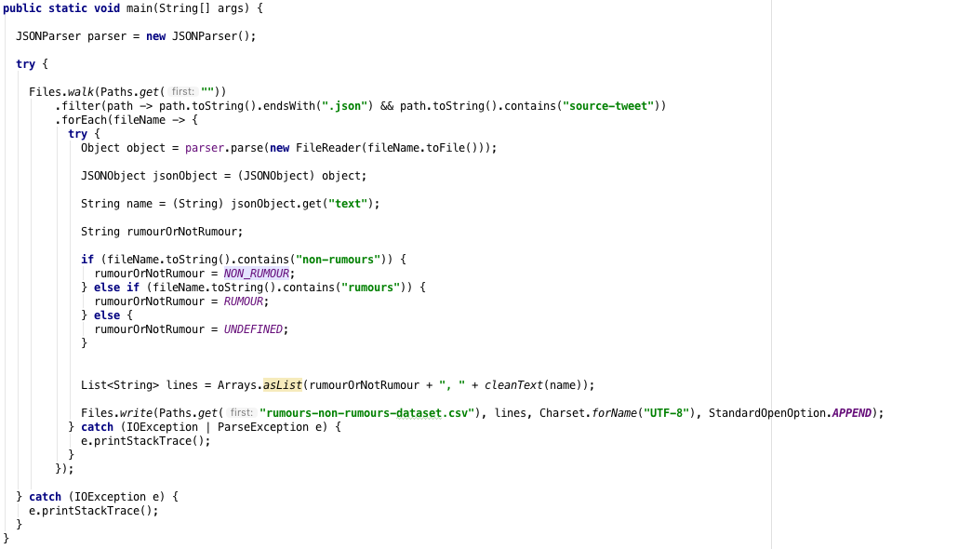

CODE Java Code to convert the PHEME dataset in to a CSV file

In code 7, it filters the files from (PHEME, 2018) dataset which end in ‘.json’ and they are within a ‘source-tweet’ folder, the contents of which are then parsed as a JSON object, in order for the ‘text’ of the Tweet to be retrieved, as the JSON object contains other information, such as ‘userId’ etc. then based on if the file is in the rumour or non-rumour folder the label will be assigned, then this information is appended to a CSV file which is then used as the dataset to train the classification model.

As the classification will be done on natural language, a classification model had to be selected, and in the field of natural language classification there is often three classification models which get considered; Naïve Bayes, Maximum Entropy, and Support Vector Machines (Go et al., 2009; Lee et al., 2011; Pang et al., 2002; Medlock B, 2008), early in the project plan it was swayed towards the use of Naïve Bayes as it was found to be drastically more efficient in terms of training time and individual classification time.

Naïve Bayes is a classification model based on Bayes Theorem and it assumes that the presences of a particular feature is unrelated to the presence of another feature – hence the term naïve (Analytics Vidhya, 2018). As a result, it can calculate the class through what is known in Bayes’ Theorem as the posterior probability, illustrated in figure 8.

Figure Bayes' Theorem Posterior Probability equation (Analytics Vidhya, 2018)

Which can be summarised as follows; given a set of attributes (*X*) the probability of the class (*c*) – *P(c|X)* where *X* is a set of attributes, in the case of natural language processing it would be text split in to a feature list, and *c* would be the class/label which is being evaluated is equal to the probability of x1…n belonging to class *c* multiplied by the class prior probability (*P(c)*) which is the maximum likelihood of something belonging to that class a rough example is as follows;

The same equation would be done for ‘non-rumour’ and the class the highest posterior probability value would be selected as the appropriate label for the text.

# System Implementation

This section will outline the implementation of the project and how it was achieved, discussing the rationale for the tools, languages and other aspects which have been selected as well as providing evidence on the amount of work produced and the use of version control.

## Summary and Rationale for tools, languages, databases, APIs and frameworks

The project aimed to utilise the best tools, languages, and frameworks available at the time of starting the project, and the decisions were made to reflect the knowledge and ability of the developer; some of the tools selected was to ease the development and speed up the progress.

### Tools

The tools selected for the project were mainly for the management side of things and making sure the project was kept on track, and tools which were selected to aid with development, one of the core tools which was vital for the delivery of the project was *Trello[11].*

Figure Trello board for Project

Figure 9 illustrates the *Trello* board which was used to keep track of which stories[12] were currently in progress and what still needed done; a good visualisation tool to record progress and as it is online it means it can be accessed from anywhere, rather than using a physical board.

For the development side of things, as a student the developer had access to all the Jetbrains[13] tools which could aid with the development, for the project the use of *IntelliJ Ultimate* was used, as it is an IDE to be used with the Java Programming Language and something which the developer is familiar in using, another Jetbrains tool which had been selected is *Datagrip* which is an IDE designed for managing databases and writing SQL which is important as the project will utilise the use of a SQL Database.

For maintaining and deploying of the project, the use of *Docker* was selected, as it is described as an open platform for developers and sysadmins to build, ship, and run distributed applications, whether on laptops, data centre VMs, or the cloud (Docker, 2018) – with *Docker* the project could be built with the confidence knowing that it could run anywhere.

For building the project and managing the dependencies the use of *Gradle* was used, which is build tool to help build, automate and deliver better software (Gradle, 2018). *Gradle* meant that the developer did not have to worry about dependencies, and the version of packages which were needed, as *Gradle* does this for you. As seen in section 4.1.2, one of the core development languages is *Java* and with *Java* if dependencies are not managed correctly then it can lead to errors at runtime etc. which is why the use of a build tool is recommended, and *Gradle* has been selected as the developer is familiar with it.

Part of the system as witnessed in figure 1 required the use of a *Queue*, the use of *RabbitMQ* was selected as it is lightweight and easy to deploy and manage (RabbitMQ, 2018) and as it has support for *Java* through its API it was ideal as it fitted in nicely to the rest of the system architecture.

### Languages

The project made use of languages which the developer was most confident in using, as the project was primarily a collection of web applications, the use of *Java EE* was utilised as it allows for the development of scalable web applications (Java EE, 2018), all the code was built using the build tool discussed in section 4.1.1 as runnable *WAR* files[14] which were deployed on *Tomcat* servlets which are running within *Docker* containers as discussed in section 3.1.

*Java EE* is built on top of the *Java SE* (Differences between Java EE and Java SE, 2018) describe how *Java SE* provides the core functionality of the Java programming language, such as the basic types, objects and classes that allow for the creation of a Java application, while *Java EE* extends on this by providing an API for developing and running networked applications.

For the development of the frontend, HTML, CSS and some JavaScript have been selected, as these are core languages to be used in frontend development, the Java web application will pass the required variables and data to the HTML pages using a templating engine which parses the data and renders it correctly, a template engine allows pre-built HTML pages that allows for the information to be plug in at rendering time; the use of Handlebars[15] was selected as the templating engine as it is suited for Java and based on the popular Mustache[16] templating engine, meaning it is well documented.

### Database

As discussed in section 3.3.2 the project went with a SQL database design, when it comes to databases which support SQL there are various types, *PostgreSQL, Oracle SQL, SQL Server, SQLite* amongst others, and choosing one usually comes down to preference although it is good to consider the flexibility, performance and scalability (Lifewire, 2018) if the database is going be running server side, which the project will utilise.

The project went with *MySQL* as its database choice, as it is considered one of the most popular open-source databases which offers high-performance and scalability (MySQL, 2018) and it a database technology which the developer is most use too meaning it was the most suited out the possibilities that were available.

### APIs

An Application Programming Interface (API), is described as a software intermediary that allows two applications to talk to each other (MuleSoft, 2018) and specifies how software components should interact by providing the building blocks, and the developer needs to put them together (Webopedia, 2018).

In terms of this project it required the use of an external API which is the *Twitter Filter Real-time Tweets* *API* (POST statuses/filter — Twitter Developers, 2018) and it was compulsory for retrieving a life feed of Tweets in to the service. In order to communicate with this API the use of a library known as *Twitter4J* was used which as mentioned in section 3.1 is known as the unofficial Java Library for the Twitter API (Twitter4j, 2018) and provides a collection of methods for interacting with the Twitter API which sped up implementation time as it contained all the required classes for retrieving live Tweets.

The project itself made use of internal APIs for communication between its services, such as the *Processing* service could communicate to the *Classifier* service through an API which was developed, this relied on the use of *Jersey* which is a Java framework for creating RESTful services which allow communication through various resource types (Jersey, 2018), with the use of this framework it meant that each of the services could communicate to each other by passing JSON objects, which would then be handled by the appropriate service, this helped to decouple the code, and meant that if one service needed to change, it could be done without affecting the other service, providing the *Interface[17]* is kept the same.

### Frameworks and Libraries

The project made use of Bootstrap framework/library, as it is designed to make the development of a website faster and easier by providing high quality JavaScript and CSS to build a more responsive site (Bootstrap, 2018), and as it is considered to be easy to use and provides responsive features (Bootstrap Get Started, 20180) it was an ideal choice for the developer, as they had little experience in this area.

As briefly mentioned in section 4.1.4, the *Jersey* framework was used in order to help with the development of the project as it extends on the *Java JAX-RS[18]* implementation to aid in the development of a *RestFUL* service (Jersey, 2018), and had been selected as it is considered lightweight and worked nicely with the rest of the system architecture.

As most of the project dealt with exchanging data through JSON, a Java Library for easy parsing of JSON objects in to Java objects and vice-versa was required, which is why the use of Jackson JSON[19] was selected as it allows for efficient serialisation of a Java object in to a JSON object and vice-versa (tutorialspoint.com, 2018) and works nicely with Jersey as it is built with *JAX-RS* in-mind.

For the frontend, JQuery is also in use as it is a nice library which speeds up interacting with the website easier as it allows a clean API for Document Object Model (DOM) manipulation, animation and AJAX (Asynchronous JavaScript and XML) (JQuery Foundation, 2018), the use of JQuery allows for the interactivity of the website, and only displays content which is required allowing for smoother performance, another frontend framework/library which had been selected was Chart.JS[20], as it is a simple JavaScript framework for creating interactive charts, and supports a range of chart types.

For performing the classification there are lots of libraries available, there were two main ones which had been considered as they are popular classification libraries for Java, and as Java was the language of choice, both had to be considered as they are equally popular, and as previously mentioned in section 3.1, both Weka and Mallet were evaluated and provided similar results, and neither one was “better” than the other.

It was determined to do a two-stage classification process, where the use of Mallet was used to perform a classification and get a label and weight value, then the same instance went through classification with the Weka library, and then the labels were compared – if they are equivalent then this was the label that will get assigned, otherwise the weight from Mallet will be evaluated and if it is below a configurable value then it will go with the classification label from Weka – although both libraries used the same classification algorithm, as both were Naïve Bayes classifiers, the features from each library differ and there will be variation between results, which is why the choice of using both was made.

## Use of Version Control

Version control is a system that records changes to a file or set of files over time so that you can recall specific versions later (Git – About Version Control, 2018) and is a way to keep track of particular versions or see changes of a file, and is particularly useful in software as it means multiple people can work on the same file and conflicts can be controlled easier – but most importantly if a mistake is made the changes can be easily reverted, rather than having to manually make all the changes.

Git was the version control of choice for the project, as the developer has prior experience in using it, and it offers command line integration along with a GUI version to easily manage and maintain the versioning of the project.

Although a particular branching strategy is best used when working with version control if there are multiple developers, such as the common *Git flow[21]* branching strategy, as the project consisted of one developer no particular strategy was used other than applying a rule that only “complete” commits were allowed to be committed, i.e. if a commit contained code which didn’t run then it was not allowed to be committed to the master branch – although it could still be stashed or stored in a separate branch.

Figure Git log output for 'master' branch

Illustrated in figure 10 is the commits which have been made to the master branch, all of which are bits of work which if checked out would provide an indication of the progress and allow a working product at that particular time.

## Summary of Volume of Code Produced

The project was split in to 6 services, along with a common package of classes/methods which was used in more than one service, table 5 provides the volume of code produced in each package, referred to as ‘service name’.

Table Volume of Code produced per service

|  |  |  |  |  |  |  |
| --- | --- | --- | --- | --- | --- | --- |
| Service Name | Classes | Methods | SQL Queries | HTML Pages | JavaScript | CSS |
| API | 21 | 30 | 15 | 0 | 0 | 0 |
| Classifier | 30 | 47 | 5 | 0 | 0 | 0 |
| Common | 34 | 60 | 0 | 0 | 0 | 0 |
| Frontend | 11 | 20 | 0 | 6 | 5 | 3 |
| Pre-processor | 4 | 6 | 0 | 0 | 0 | 0 |
| Queue Reader | 5 | 7 | 0 | 0 | 0 | 0 |
| Stream | 6 | 15 | 0 | 0 | 0 | 0 |
| Total | 111 | 185 | 20 | 6 | 5 | 3 |

## System Walkthrough

The system walkthrough is simulated on the development system where the localhost is mapped to exposed ports running in the Docker containers, to help with the walkthrough it is assumed that the Stream has not been initiated. Beginning with the *Stream, it* is initiated by issuing a GET request to <https://localhost:9001/stream/start> which is mapped to port 8080 on the Docker container running the *Stream* which contains a WAR file which contains the classes required to run, and the WEB-INF/web.xml file points the entry to the twitter.classification.stream.application.WebApplication class which extends a Jersey server configuration, and it binds the required classes that will be needed.

As Jersey is being used, it handles the GET request by finding the /stream/start path which is annotated in the StreamTweetsResource() as seen in code listing 8 where any requests to /stream will come to this class and any request to /start will go to the method *startStream()*.

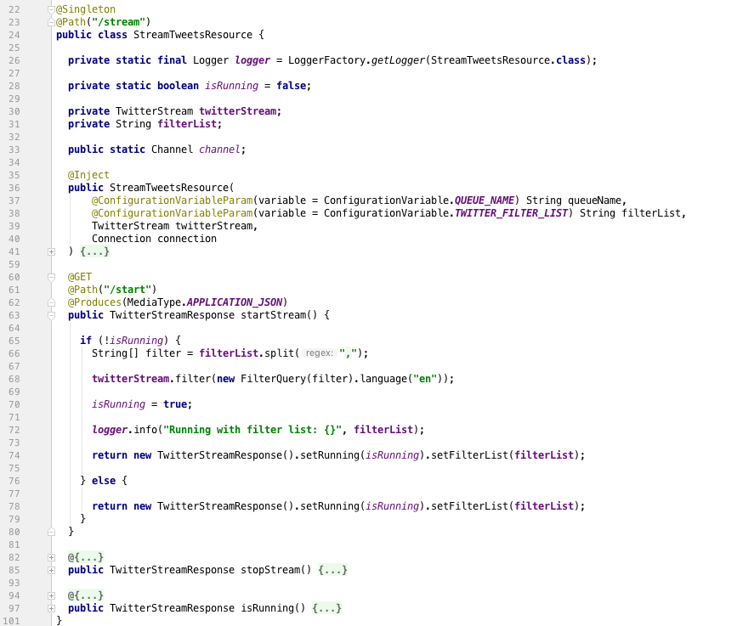

CODE StreamTweetResource /stream/start

In code 8 on like 68, *twitterStream.filter(…)* is where the Twitter API Real-time filter stream is initialised, the *twitterStream* is a class from Twitter4J library which had been built and injected in to the class and a listener is attached to it, which has an *onStatus* method which is invoked when a new Tweet is streamed through the API, the code of which can be seen in code listing 9.

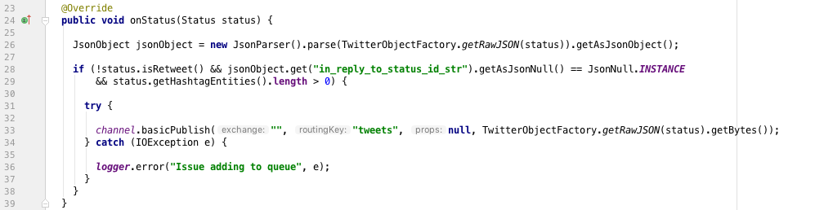

CODE onStatus method which is invoked when a New Tweet is streamed in to the service

Once the new Tweets follow the condition that it is not a Retweet, and it contains some hashtags, then they get loaded on to a queue as seen on line 33 in code listing 9. Once the Tweets, which are converted to messages are on the *Queue* they are free to be consumed by the *Queue Reader*. The *Queue Reader* is a packaged JAR file that has a *main* method which is illustrated in code listing 10;

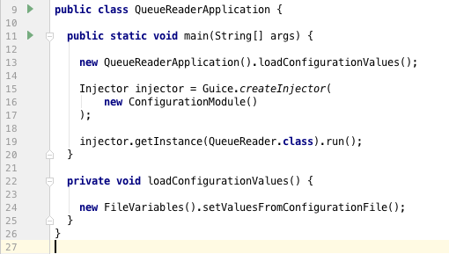

CODE QueueReader Application main method which initialises the reading from queue

The *Queue Reader* makes use of the Google Guice library for dependency injection, as it makes it easier to inject services in to your code and makes the code easier to manage (GitHub – google/guice, 2018), on line 16 in code listing 10, the ‘*new Configuration Module()*’ can be seen in code listing 11;

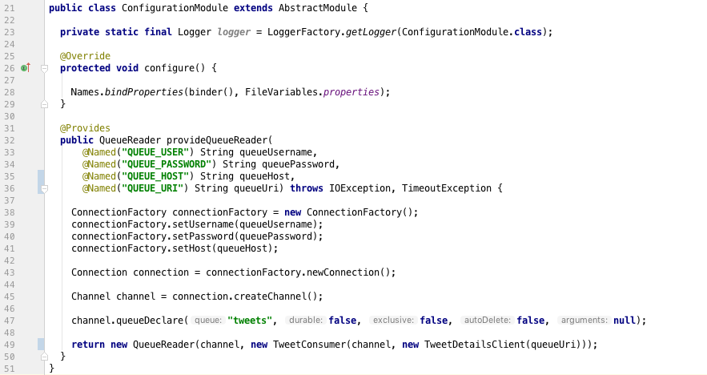

CODE new ConfigurationModule code highlighing the power of Guice

The *QueueReader* provided on line 25 is how Guice allows an easy facility to inject services, rather than having to create objects within the class, they can be separated out, making it easier to unit test at the testing stages. On line 49 from code listing 11 there is reference to a ‘new TweetConsumer’, this consumer is what handles the delivery from the *Queue* to the *Queue Reader* through the use of a overridden method in the *TweetConsumer* class which makes use of the *RabbitMQ* API which was mentioned in section 4.1.1, the consumer reads in the message from the *Queue* and then posts it for processing after doing a few checks, such as to make sure the Tweet doesn’t contain any hashtags that are in the ignore list as witnessed in code listing 12;

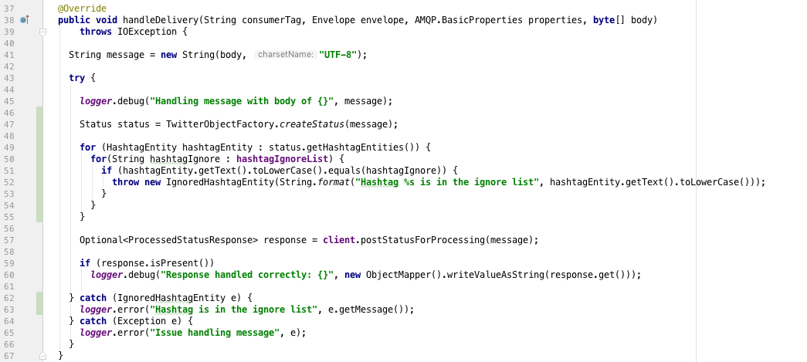

CODE Queue Reader handle delivery of message from the Queue

Once the *Queue Reader* has handled the Tweet it posts the message to the *Pre-processor*, as illustrated on line 57 in code listing 12, the *client.postStatusForProcessing* makes use of the *JAX-RS* functionality in *Java* to post the message to a specified URI, the code is provided in code listing 13;

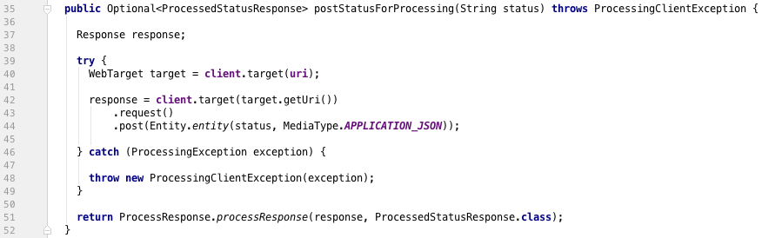

CODE Example of using JAX-RS client to post from one service to another

The *Pre-processor*, similar to other services makes use of *Jersey* which has a @POST path set as /process for the class *ReceiveTweetStatusResource*, once the *Queue Reader* executes the code in listing 13, the *Pre-processor* receives the Tweet message and can proceed with the processing, the *Pre-processing* has one method which receives the POST message from the *Queue Reader* as provided in code listing 14;

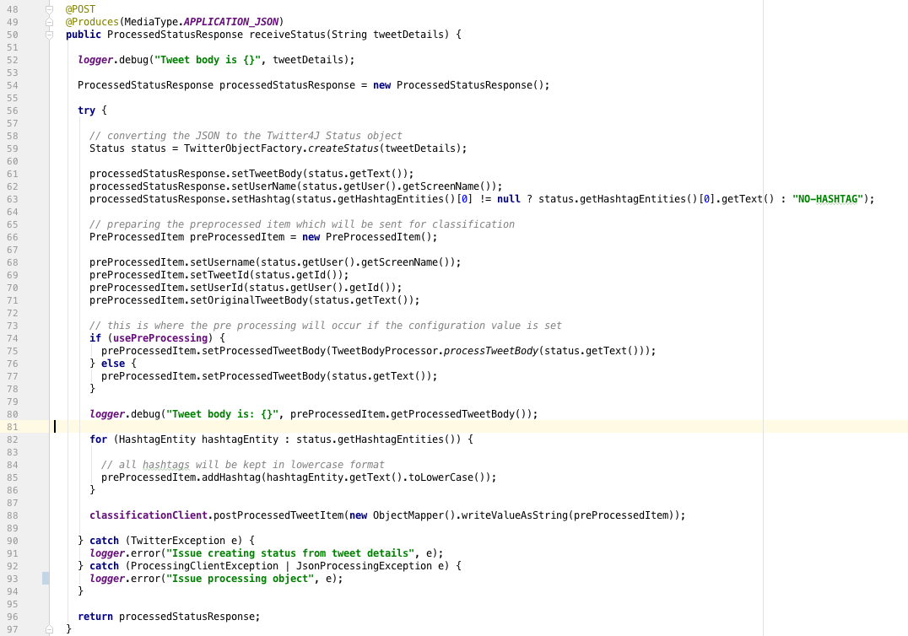

CODE Pre-processor POST method to receive messages from the Queue Reader

On line 74 in code listing 14, there is a check to see if *usePreProcessing* is true, this is to adhere to the requirements set for the project where it should be configurable to swap between the use of with or without processing, if the use of processing is set to true, which is provided as a configuration variable, it goes through the *processTweetBody* method on line 75 from code listing 14, which applies the following rules:

* Lower case the Tweet body, line 7 code listing 15
* Replace the # at the start of a hashtag, e.g. #doctor becomes doctor, line 10 code listing 15
* Replace the @ at the start of a user, e.g. @john_smith becomes john_smith, line 13 code listing 15
* Remove any URL, line 16 code listing 15
* To remove any double or more spaces, line 19 code listing 15
* To remove any new lines/character returns, line 22 code listing 15
* And, to remove any trailing whitespaces, line 25 code listing 15

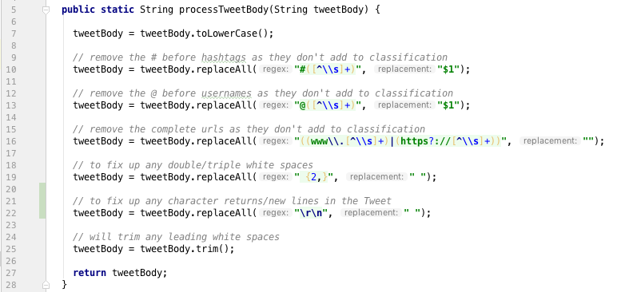

CODE The processing rules which are applied when pre-processing is enabled

Once the Tweet has went through the processing steps, it gets posted to the *Classifier*, which is the last stage before storing to the *Database* as illustrated in figure 7 previously. Similarly, to the other services, the *Classifier* also is running with *Jersey* filters and has an annotated @POST method at the /classify path which the *Pre-processor* posts the processed message too, illustrated on line 88 in figure 14.

The *Classifier* has a trained *Naïve Bayes* classification model using the Weka and Mallet libraries as a two-stage classification process was used as described previously in section 4.1.5, which follows the basic rules of;

* If the classification value match, then return that value
* If the classification values do not match, then check the Mallets class weight, if it is lower than the allowed limit return the Weka classification value
* If the classification weight is above the limit, then return Mallets class value

The code can be witnessed in the *consolidateClassificationWithVerification* method outlined in code listing 16;

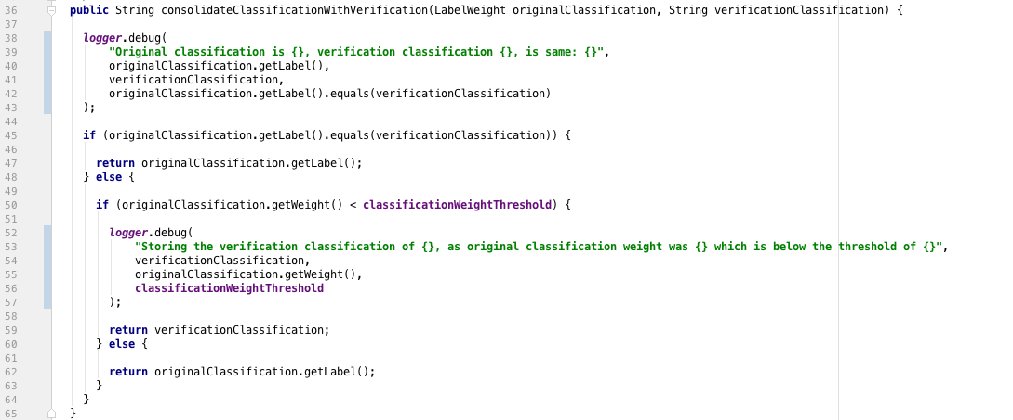

CODE Consolidation between the original classification value with the verification classification value

Once a classification label has been assigned, the results can be stored to the *Database*, a *HandleProcessedTweetService* class achieves this through the series of inserts for the necessary tables, which is illustrates in code listing 17.

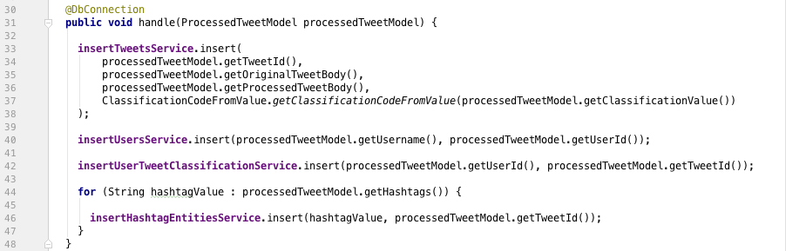

CODE HandleProcessTweetSerive handle method to insert the processed Tweet in to Database

The service needs to insert in to the Tweets table, line 33 of code listing 17 once this is done it can then insert the Twitter user information and the hashtag information. Once the information is stored in the *Database* it ends the “offline” part of the system walkthrough.

For the “online” part of the service, figures 11, 12 and 13 show the various pages of the service which were modelled around the wireframes from section 3.2.2. Figure 11 illustrates the homepage/dashboard that is displayed when the user navigates to the home page route on the frontend service, while figure 12 shows the “top users” page which is reachable by the route /users on the frontend and finally figure 13 illustrates the “top hashtags” page which is reachable by the route /hashtags.

The frontend, similarly to the others and as described in section 4.1.4 the use of *Jersey* allows for annotated classes to match route resources that the user accesses through requests, while the frontend Java service communicates with API, which hides the requests from the user on the frontend, and they only receive and see the data which is required.

Figure Dashboard/Homepage webpage showing the various stats and status of the service

Figure /users page illustrating the use of bar charts to visualise the rumours/non-rumours

Figure /hashtags page illustrating the use of pie charts to provide details on rumours/non-rumours

The walk through outlined in this section, illustrates how a new Tweet from Twitter can make its way through the service in order to reach the audience on the frontend. The use of filters and ignore lists allows for control of the service to ensure only appropriate Tweets come through the service, as Twitter is a public service, there is a lot of advertisements etc. that are in large volumes as they make use of popular keywords/hashtags in order to reach a larger audience, by adding these known users/hashtags to ignore lists can prevent them from being shown in the frontend.

## Consideration for Security

The project did not require any form of user login, which meant that authentication or authorisation was not a huge concern, as the project presents public data in an interactive way it would have been counter intuitive to hide it behind a login; however the most common attacks are designed to steal information, introduce vulnerabilities, and even cause damage to the behaviour of the software (Techopedia.com, 2018) and often come in the form of buffer/stack overflow, command injection and SQL Injections.

As discussed in section 3.3.1, the security against SQL Injection will be tackled with the use of prepared statements, as this is often the first form of defence against an SQL Injection attack, as it ensures that the attacker is not able to change the intent of the query (SQL Injection Prevention Cheat Sheet – OWASP, 2018).

The prevention of buffer/stack overflow attacks come down to the system design, as measures have been put in place so that rate limits have been set on user requests etc. in order to ensure that someone does not try and take down the service in the form of a denial of service attack, and by separating out the services, it means that if one service is targeted, then it can be isolated and prevent the spread to other services within the project.

To ensure the security of the service, monitoring will be in place and additional techniques can be implemented if deemed necessary, such as the use of honey pots, which is described as a computer system that is set up to act as a decoy to lure cyber attackers, and to detect, deflect or study attempts to gain unauthorized access to information systems (SearchSecurity, 2018).

# System Verification

This section will provide the details and evidence of the testing of the project through using various testing strategies that are used within industry, as well as providing the results and the conclusion as to if the project meets the product requirements.

## Verification Strategy

This Paragraph

## System Verification Results

This Paragraph

## Other Verification Artefacts

This Paragraph

## Conclusion of Verification

This Paragraph

# System Validation

This Paragraph

## Validation Strategy

This Paragraph

## System Validation Results

This Paragraph

## Other Validation Artefacts

This Paragraph

## Conclusion of Validation

This Paragraph

# Conclusion and Reflection

This Paragraph

## Critical Appraisal of Project

This Paragraph

## Reflection of Project Plan

This Paragraph

### 7.2.1 Appropriateness of initial time/effort estimation

This Paragraph

### 7.2.2 Appropriateness of Software Methodology Used

This Paragraph

## Conclusion

This Paragraph

# Appendices

## Appendix A: Final Requirement Formal Format

# Bibliography:

A

About | What is Trello?. 2018. About | What is Trello?. [ONLINE] Available at: https://trello.com/about. [Accessed 11 April 2018].

Analytics Vidhya. 2018. 6 Easy Steps to Learn Naive Bayes Algorithm (with code in Python) . [ONLINE] Available at: https://www.analyticsvidhya.com/blog/2017/09/naive-bayes-explained/. [Accessed 10 April 2018].

Apache Tomcat Project. 2018. Apache Tomcat® - Welcome!. [ONLINE] Available at: http://tomcat.apache.org/. [Accessed 07 April 2018].

B

Ben Shneiderman. 1997. Designing the User Interface: Strategies for Effective Human-Computer Interaction (3rd ed.). Addison-Wesley Longman Publishing Co., Inc., Boston, MA, USA.

Ben W. Medlock, Investigating classification for natural language processing tasks, Tech. Report UCAM-CL-TR-721, University of Cambridge, Computer Laboratory, June 2008.

Bloomberg.com. 2018. Fake News, Trump and the Pressure on Facebook: QuickTake Q&A - Bloomberg. [ONLINE] Available at: https://www.bloomberg.com/news/articles/2016-11-25/fake-news-trump-and-the-pressure-on-facebook-quicktake-q-a. [Accessed 07 April 2018].

Bo Pang, Lillian Lee, and Shivakumar Vaithyanathan. 2002. Thumbs up? sentiment classification using machine learning techniques. In Proceedings of the ACL-02 conference on Empirical methods in natural language processing - Volume 10 (EMNLP '02), Vol. 10. Association for Computational Linguistics, 79-86 [ONLINE] Available at: http://delivery.acm.org/10.1145/1120000/1118704/p79- pang.pdf [Accessed 11 October 2017].

Bootstrap 4 Get Started. 2018. Bootstrap 4 Get Started. [ONLINE] Available at: https://www.w3schools.com/bootstrap4/bootstrap_get_started.asp. [Accessed 11 April 2018].

Building RESTful Web Services with JAX-RS - The Java EE 6 Tutorial. 2018. Building RESTful Web Services with JAX-RS - The Java EE 6 Tutorial. [ONLINE] Available at: https://docs.oracle.com/javaee/6/tutorial/doc/giepu.html. [Accessed 11 April 2018].

C

Checkmarx. 2018. The Importance of Database Security and Integrity. [ONLINE] Available at: https://www.checkmarx.com/2016/06/24/20160624the-importance-of-database-security-and-integrity/. [Accessed 09 April 2018].

Creately Blog. 2018. Use Case Diagram Relationships Explained with Examples - Creately Blog. [ONLINE] Available at: https://creately.com/blog/diagrams/use-case-diagram-relationships/. [Accessed 10 April 2018].

D

Database Trends and Applications. 2018. Bad Database Standards Can Cause Performance Problems - Database Trends and Applications . [ONLINE] Available at: http://www.dbta.com/Columns/DBA-Corner/Bad-Database-Standards-Can-Cause-Performance-Problems-91192.aspx. [Accessed 09 April 2018].

DigitalOcean. 2018. How To Create a New User and Grant Permissions in MySQL | DigitalOcean. [ONLINE] Available at: https://www.digitalocean.com/community/tutorials/how-to-create-a-new-user-and-grant-permissions-in-mysql. [Accessed 09 April 2018].

Differences between Java EE and Java SE - Your First Cup: An Introduction to the Java EE Platform. 2018. Differences between Java EE and Java SE - Your First Cup: An Introduction to the Java EE Platform. [ONLINE] Available at: https://docs.oracle.com/javaee/6/firstcup/doc/gkhoy.html. [Accessed 11 April 2018].

Docker. 2018. Docker - Build, Ship, and Run Any App, Anywhere. [ONLINE] Available at: https://www.docker.com/. [Accessed 11 April 2018].

Docker. 2018. What is a Container | Docker. [ONLINE] Available at: https://www.docker.com/what-container. [Accessed 07 April 2018].

E

Experience UX. 2018. What is wireframing | Experience UX. [ONLINE] Available at: https://www.experienceux.co.uk/faqs/what-is-wireframing/. [Accessed 09 April 2018].

Extreme Programming: A Gentle Introduction.. 2018. Extreme Programming: A Gentle Introduction.. [ONLINE] Available at: http://www.extremeprogramming.org/. [Accessed 09 April 2018].

F

Facebook and Twitter unveil plans to tackle fake news | News | Ecommerce Week. 2018. Facebook and Twitter unveil plans to tackle fake news | News | Ecommerce Week. [ONLINE] Available at: http://www.ecommerceweek.co.uk/news/683/facebook-and-twitter-unveil-plans-to-tackle-fake-news/. [Accessed 07 April 2018].

Fake news definition and meaning | Collins English Dictionary. 2018. Fake news definition and meaning | Collins English Dictionary. [ONLINE] Available at: https://www.collinsdictionary.com/dictionary/english/fake-news. [Accessed 07 April 2018].

G

Git. 2018. Git. [ONLINE] Available at: https://git-scm.com/. [Accessed 11 April 2018].

Git - About Version Control. 2018. Git - About Version Control. [ONLINE] Available at: https://git-scm.com/book/en/v2/Getting-Started-About-Version-Control. [Accessed 11 April 2018].

GitHub. 2018. GitHub - google/guice: Guice (pronounced 'juice') is a lightweight dependency injection framework for Java 6 and above, brought to you by Google.. [ONLINE] Available at: https://github.com/google/guice. [Accessed 14 April 2018].

GitHub. 2018. GitHub - jknack/handlebars.java: Logic-less and semantic Mustache templates with Java. [ONLINE] Available at: https://github.com/jknack/handlebars.java. [Accessed 14 April 2018].

Go, Bhayani, Huang, 2009. Twitter Sentiment Classification using Distant Supervision. Final. Computer Science: Stanford University.

Gradle Build Tool. 2018. Gradle Build Tool. [ONLINE] Available at: https://gradle.org/. [Accessed 11 April 2018].

H

I

J

Java EE - Java Platform, Enterprise Edition | Oracle United Kingdom. 2018. Java EE - Java Platform, Enterprise Edition | Oracle United Kingdom. [ONLINE] Available at: https://www.oracle.com/uk/java/technologies/java-ee.html. [Accessed 11 April 2018].

Jersey. 2018. Jersey. [ONLINE] Available at: https://jersey.github.io/. [Accessed 11 April 2018].

JSON. 2018. JSON. [ONLINE] Available at: https://www.json.org/. [Accessed 11 April 2018].

jQuery Foundation - jquery.org. 2018. jQuery. [ONLINE] Available at: https://jquery.com/. [Accessed 14 April 2018].

K

Karl Wiegers. 1999. First things first. Softw. Dev. 7, 9 (September 1999), 48-53.

Kate Conger. 2018. Here Are 14 Russian Ads That Ran on Facebook During The 2016 Election. [ONLINE] Available at: https://gizmodo.com/here-are-14-russian-ads-that-ran-on-facebook-during-the-1820052443. [Accessed 07 April 2018].

Kirill Fakhroutdinov. 2018. UML Information Flow Diagrams - Overview of Graphical Notation. [ONLINE] Available at: https://www.uml-diagrams.org/information-flow-diagrams.html. [Accessed 09 April 2018].

Kirill Fakhroutdinov. 2018. Use case diagrams are UML diagrams describing units of useful functionality (use cases) performed by a system in collaboration with external users (actors).. [ONLINE] Available at: https://www.uml-diagrams.org/use-case-diagrams.html. [Accessed 09 April 2018].

L

Lee K, Palsetia D, Narayanan R, Patwary M, Agrawal A, and Choudhary A, 2011. Twitter Trending Topic Classification. Final. Department of Electrical Engineering and Computer Science: Northwestern University.

Lifewire. 2018. Choosing a Database for Your Organization. [ONLINE] Available at: https://www.lifewire.com/choosing-a-database-for-your-organization-1019601. [Accessed 11 April 2018].

M

MALLET homepage. 2018. MALLET homepage. [ONLINE] Available at: http://mallet.cs.umass.edu/. [Accessed 10 April 2018].

Mark Otto, Jacob Thornton, and Bootstrap contributors. 2018. Bootstrap · The most popular HTML, CSS, and JS library in the world.. [ONLINE] Available at: https://getbootstrap.com/. [Accessed 11 April 2018].

Meyer, Robinson. 2018. Huge MIT Study of ‘Fake News’: Falsehoods Win on Twitter - The Atlantic. [ONLINE] Available at: https://www.theatlantic.com/technology/archive/2018/03/largest-study-ever-fake-news-mit-twitter/555104/. [Accessed 07 April 2018].

MuleSoft. 2018. What is an API? (Application Programming Interface) | MuleSoft. [ONLINE] Available at: https://www.mulesoft.com/resources/api/what-is-an-api. [Accessed 11 April 2018].

MySQL. 2018. MySQL. [ONLINE] Available at: http://www.oracle.com/technetwork/database/mysql/index.html. [Accessed 11 April 2018].

MySQL :: MySQL 5.7 Reference Manual :: 6.3.5 Setting Account Resource Limits. 2018. MySQL :: MySQL 5.7 Reference Manual :: 6.3.5 Setting Account Resource Limits. [ONLINE] Available at: https://dev.mysql.com/doc/refman/5.7/en/user-resources.html. [Accessed 09 April 2018].

MySQL :: MySQL 5.7 Reference Manual :: 13.7.1.4 GRANT Syntax. 2018. MySQL :: MySQL 5.7 Reference Manual :: 13.7.1.4 GRANT Syntax. [ONLINE] Available at: https://dev.mysql.com/doc/refman/5.7/en/grant.html. [Accessed 09 April 2018].

MySQL :: MySQL 5.7 Reference Manual :: 13.5 Prepared SQL Statement Syntax. 2018. MySQL :: MySQL 5.7 Reference Manual :: 13.5 Prepared SQL Statement Syntax. [ONLINE] Available at: https://dev.mysql.com/doc/refman/5.7/en/sql-syntax-prepared-statements.html. [Accessed 09 April 2018].

N

Nick Babich. 2018. Golden Rules of User Interface Design. [ONLINE] Available at: http://babich.biz/golden-rules-of-user-interface-design/. [Accessed 09 April 2018].

Nielsen Norman Group. 2018. 10 Heuristics for User Interface Design: Article by Jakob Nielsen. [ONLINE] Available at: https://www.nngroup.com/articles/ten-usability-heuristics/. [Accessed 09 April 2018].

NGINX. 2018. Microservices at Netflix: Lessons for Architectural Design. [ONLINE] Available at: https://www.nginx.com/blog/microservices-at-netflix-architectural-best-practices/. [Accessed 07 April 2018].

O

Oxford Dictionaries | English. 2018. interface | Definition of interface in English by Oxford Dictionaries. [ONLINE] Available at: https://en.oxforddictionaries.com/definition/interface. [Accessed 11 April 2018].

P

PHEME. 2018. PHEME dataset of rumours and non-rumours. [ONLINE] Available at: https://figshare.com/articles/PHEME_dataset_of_rumours_and_non-rumours/4010619. [Accessed 10 April 2018].

POST statuses/filter — Twitter Developers. 2018. POST statuses/filter — Twitter Developers. [ONLINE] Available at: https://developer.twitter.com/en/docs/tweets/filter-realtime/api-reference/post-statuses-filter.html. [Accessed 07 April 2018].

Q

R

RabbitMQ - Messaging that just works. 2018. RabbitMQ - Messaging that just works. [ONLINE] Available at: https://www.rabbitmq.com/. [Accessed 11 April 2018].

S

Science | AAAS. 2018. Fake news spreads faster than true news on Twitter—thanks to people, not bots | Science | AAAS. [ONLINE] Available at: http://www.sciencemag.org/news/2018/03/fake-news-spreads-faster-true-news-twitter-thanks-people-not-bots. [Accessed 07 April 2018].

SearchDataManagement. 2018. Three indicators that could signal database performance issues. [ONLINE] Available at: https://searchdatamanagement.techtarget.com/feature/Three-indicators-that-could-signal-database-performance-issues. [Accessed 09 April 2018].

SearchMicroservices. 2018. What is RESTful API? - Definition from WhatIs.com. [ONLINE] Available at: https://searchmicroservices.techtarget.com/definition/RESTful-API. [Accessed 07 April 2018].

SearchSecurity. 2018. What is honeypot (honey pot)? - Definition from WhatIs.com. [ONLINE] Available at: https://searchsecurity.techtarget.com/definition/honey-pot. [Accessed 15 April 2018].

SearchSoftwareQuality. 2018. What is user story? - Definition from WhatIs.com. [ONLINE] Available at: https://searchsoftwarequality.techtarget.com/definition/user-story. [Accessed 11 April 2018].

Shneiderman's "Eight Golden Rules of Interface Design" | Design Principles FTW. 2018. Shneiderman's "Eight Golden Rules of Interface Design" | Design Principles FTW. [ONLINE] Available at: https://www.designprinciplesftw.com/collections/shneidermans-eight-golden-rules-of-interface-design. [Accessed 09 April 2018].

Srivastava S, Kumari R, 2017. Machine Learning: A Review on Binary Classification. Internation Journal of Computer Applications, [Online]. Vol. 160, No. 7, 11-15. Available at: https://pdfs.semanticscholar.org/55b0/b0478fad2cd6c70d851e2be594a2788910ff.pdf [Accessed 10 April 2018].

SQL Injection Prevention Cheat Sheet - OWASP. 2018. SQL Injection Prevention Cheat Sheet - OWASP. [ONLINE] Available at: https://www.owasp.org/index.php/SQL_Injection_Prevention_Cheat_Sheet. [Accessed 15 April 2018].

T

Techopedia.com. 2018. What is Software Security? - Definition from Techopedia. [ONLINE] Available at: https://www.techopedia.com/definition/24866/software-security. [Accessed 15 April 2018].

The Guardian. 2018. New Facebook controls aim to regulate political ads and fight fake news | Technology | The Guardian. [ONLINE] Available at: https://www.theguardian.com/technology/2018/apr/06/facebook-launches-controls-regulate-ads-publishers. [Accessed 07 April 2018].

tutorialspoint.com. 2018. UML - Activity Diagrams. [ONLINE] Available at: https://www.tutorialspoint.com/uml/uml_activity_diagram.htm. [Accessed 10 April 2018].

tutorialspoint.com. 2018. Jackson Tutorial. [ONLINE] Available at: https://www.tutorialspoint.com/jackson/index.htm. [Accessed 11 April 2018].

Twitter4J - A Java library for the Twitter API. 2018. Twitter4J - A Java library for the Twitter API. [ONLINE] Available at: http://twitter4j.org/en/index.html. [Accessed 07 April 2018].

U

UML 2 Use Case Diagrams: An Agile Introduction. 2018. UML 2 Use Case Diagrams: An Agile Introduction. [ONLINE] Available at: http://www.agilemodeling.com/artifacts/useCaseDiagram.htm. [Accessed 09 April 2018].

Understanding WAR. 2018. Understanding WAR. [ONLINE] Available at: https://spring.io/understanding/WAR. [Accessed 11 April 2018].

UX courses. 2018. What is Human-Computer Interaction (HCI)? | Interaction Design Foundation. [ONLINE] Available at: https://www.interaction-design.org/literature/topics/human-computer-interaction. [Accessed 09 April 2018].

UX courses. 2018. User Interface Design Guidelines: 10 Rules of Thumb | Interaction Design Foundation. [ONLINE] Available at: https://www.interaction-design.org/literature/article/user-interface-design-guidelines-10-rules-of-thumb. [Accessed 09 April 2018].

UX courses. 2018. Shneiderman’s Eight Golden Rules Will Help You Design Better Interfaces | Interaction Design Foundation. [ONLINE] Available at: https://www.interaction-design.org/literature/article/shneiderman-s-eight-golden-rules-will-help-you-design-better-interfaces. [Accessed 09 April 2018].

V

Validation | Databases | ICT. 2018. Validation | Databases | ICT. [ONLINE] Available at: http://www.advanced-ict.info/databases/validation.html. [Accessed 09 April 2018].

Vox. 2018. Russia, Donald Trump, and “fake news”: How Russia pioneered the art of fake news - Vox. [ONLINE] Available at: https://www.vox.com/world/2018/4/5/17172754/russia-fake-news-trump-america-timothy-snyder. [Accessed 07 April 2018].

W

Weka 3 - Data Mining with Open Source Machine Learning Software in Java . 2018. Weka 3 - Data Mining with Open Source Machine Learning Software in Java . [ONLINE] Available at: https://www.cs.waikato.ac.nz/ml/weka/. [Accessed 07 April 2018].

What is API - Application Program Interface? Webopedia. 2018. What is API - Application Program Interface? Webopedia. [ONLINE] Available at: https://www.webopedia.com/TERM/A/API.html. [Accessed 11 April 2018].

What are HTML Web Templates? | HTML Design Website Templates. 2018. What are HTML Web Templates? | HTML Design Website Templates. [ONLINE] Available at: https://allwebcodesign.com/html-templates.htm. [Accessed 14 April 2018].

X

Y

Z

1. false, often sensational, information disseminated under the guise of news reporting (Fake news definition and meaning | Collins English Dictionary, 2018)
2. Loosely coupled means that you can update the services independently; updating one service doesn’t require changing any other services. (NGINX, 2018)
3. Human Computer Interaction - a field of study focusing on the design of computer technology and, in particular, the interaction between humans (the users) and computers (UX Courses, 2018)
4. <http://twitter4j.org/en/index.html> – Twitter4J is an unofficial Java library for the Twitter API. (Twitter4J, 2018)
5. <https://developer.twitter.com/en/docs/tweets/filter-realtime/api-reference/post-statuses-filter.html> - Returns public statuses that match one or more filter predicates. (POST statuses/filter — Twitter Developers. 2018)
6. A RESTful API is an application program interface (API) that uses HTTP requests to GET, PUT, POST and DELETE data. (SearchMicroservices, 2018)
7. The Apache Tomcat® software is an open source implementation of the Java Servlet, JavaServer Pages, Java Expression Language and Java WebSocket technologies. (Apache Tomcat Project, 2018)
8. Weka is a collection of machine learning algorithms for data mining tasks. The algorithms can either be applied directly to a dataset or called from your own Java code. (Weka 3 - Data Mining with Open Source Machine Learning Software in Java, 2018)
9. MALLET is a Java-based package for statistical natural language processing, document classification, clustering, topic modeling, information extraction, and other machine learning applications to text. (MALLET, 2018)
10. JavaScript Object Notation – a lightweight data-interchange format, which is easy for humans to understand and for machines to parse and generate (JSON, 2018)
11. Trello is the easy, free, flexible, and visual way to manage your projects and organize anything, trusted by millions of people from all over the world. (About | What is Trello?, 2018)
12. A user story is a tool used in Agile software development to capture a description of a software feature from an end-user perspective. (SearchSoftwareQuality, 2018)
13. https://www.jetbrains.com/
14. WAR files are used to combine JSPs, servlets, Java class files, XML files, javascript libraries, JAR libraries, static web pages, and any other resources needed to run the application. (Understanding WAR, 2018)
15. <https://github.com/jknack/handlebars.java>
16. <http://mustache.github.io/mustache.5.html>
17. A device or program for connecting two items of hardware or software so that they can be operated jointly or communicate with each other. (Oxford Dictionaries, 2018)
18. Java API for RESTful Web Services
19. <https://github.com/FasterXML/jackson-docs>
20. <https://www.chartjs.org/>
21. <http://nvie.com/posts/a-successful-git-branching-model/>