**I Setting up the project**

1. Install nod js and NPM

<https://nodejs.org/en/download/>

1. Install angular 5 from command line

npm install angular-cli -g

1. Link to demo project

<https://github.com/FranklinParker/NodeAngular>

1. After downloading project from the nodeserver directory run npm install

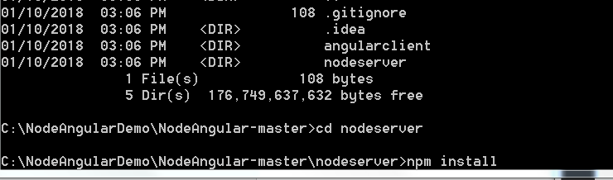

1. From command line above run npm start:

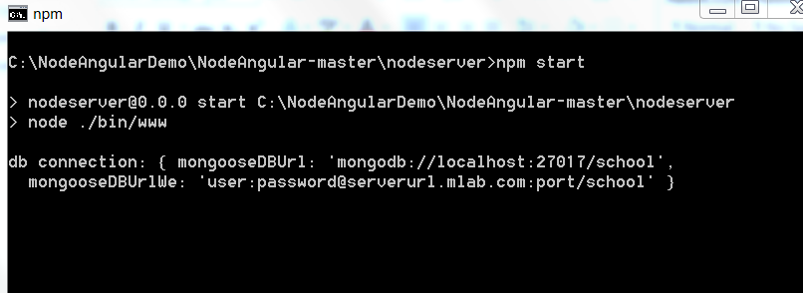

1. Go to a browser and enter localhost:3000

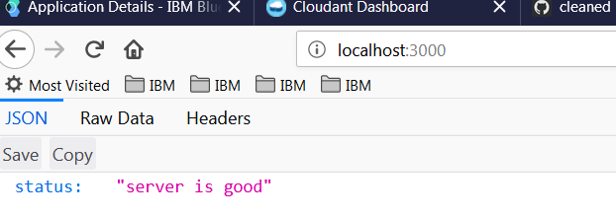

1. From go to angularclient and run npm install

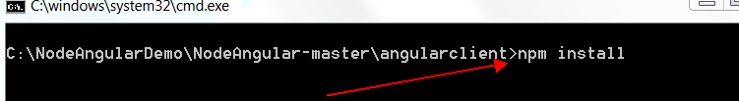

1. Run ng serve and open browser localhost:4200

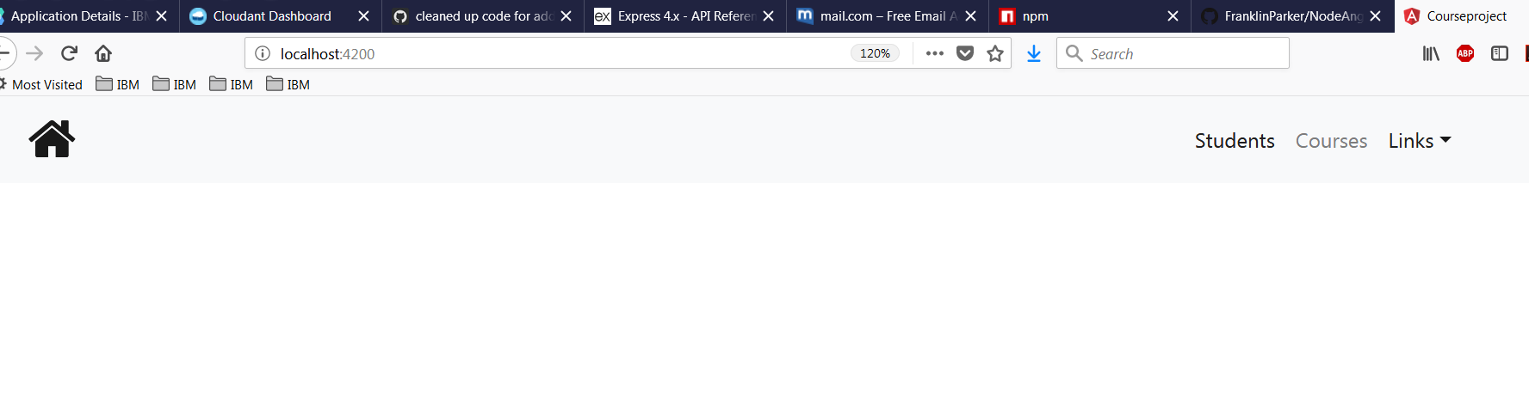

1. Click Students (data is pulled from node server):

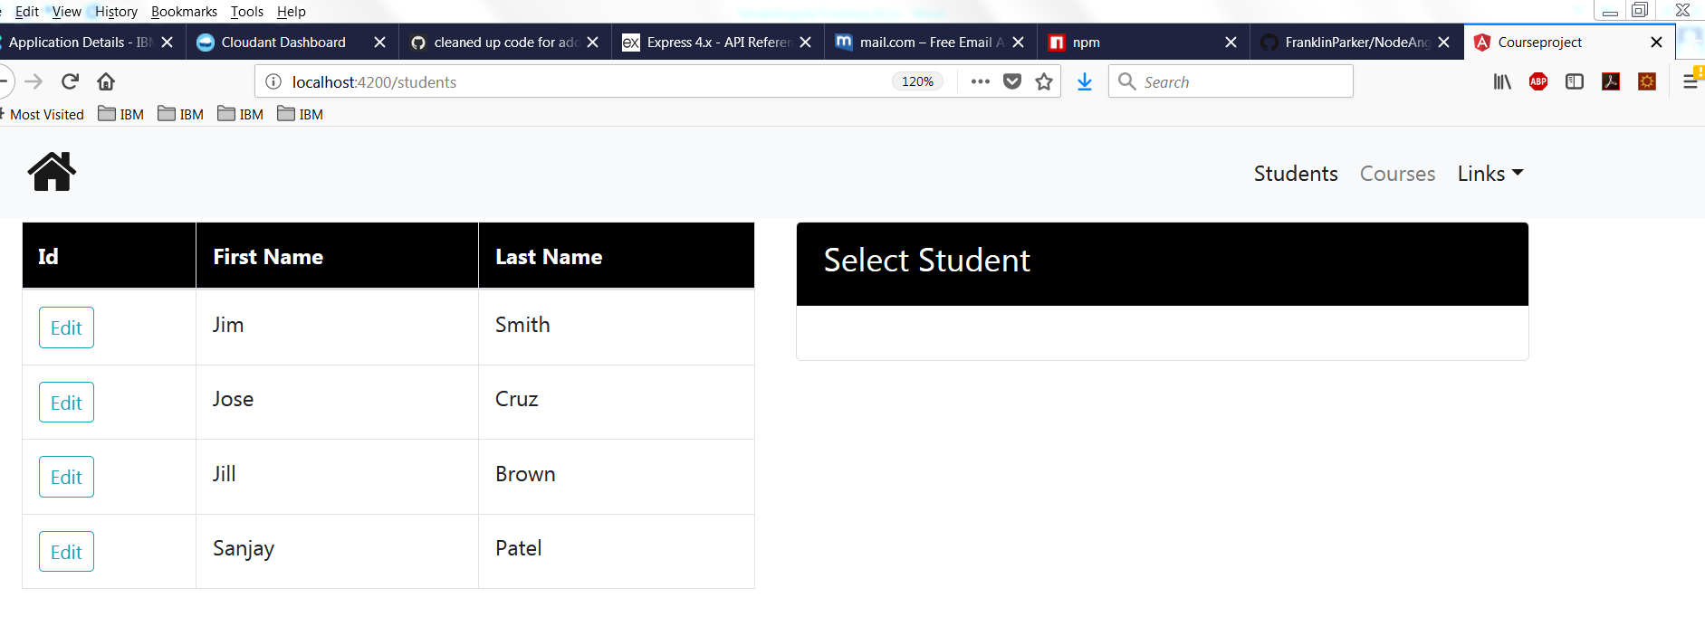

**II Creating an Angular prod build and deploying to Node server**

1. **From command line in angularclient directory run >npm run build:**

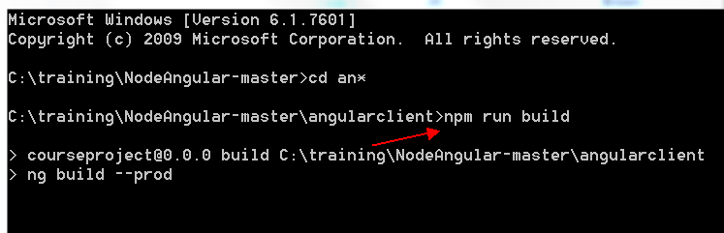

1. **This creates a directory angularclient/dist with the below files:**

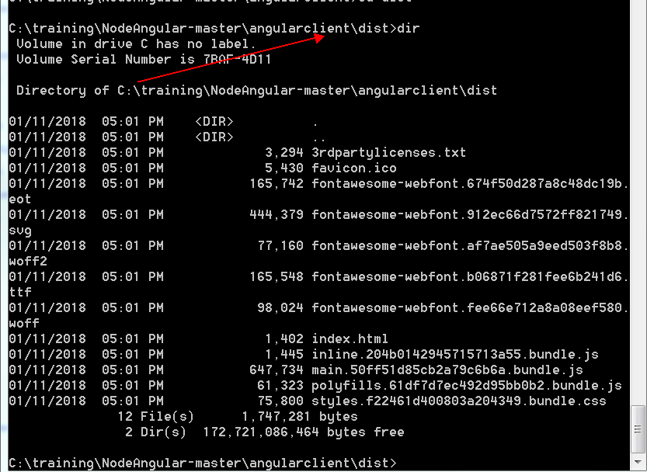

1. **Copy all those files to the nodeserver/public dir:**

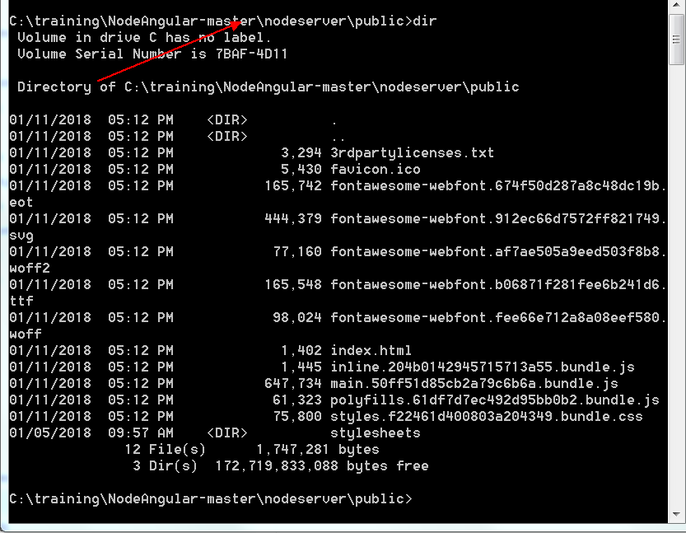

1. **From nodeserver dir run npm start:**

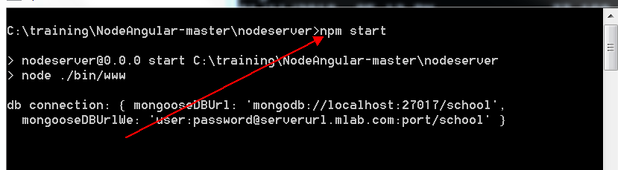

1. **Go to the browser** [**http://localhost:3000/students**](http://localhost:3000/students)

