Project 2 Write Up
Demo:
My code simulates a battle between a hero and 3 different monsters. The user is first prompted to select which character they would like to play as given the options elf, wizard, and barbarian. Each character has a different special ability, different stats, and different weapons to choose from. The user then is prompted to choose which weapon they would like to use given they character they selected. For example, a wizard has the option between potions and a wand as their weapon. After the selection prosses the first battle begins. Each round of battle is simulated and printed out for the user to read where each character gets one attack. The user presses enter to move on to the next rounds until finally either the hero or the monster is out of health. After the first battle if the user won, they move on to the upgrade section in which they can upgrade one of their stats. After upgrading they move on to level 2 and finally level 3 where their characters stats get maxed out. If the user beats level 3 a “congratulations, you won” message pops up on screen, otherwise if they lose any of the rounds a “game over” message pops up and the user is prompted to choose to play again or not. 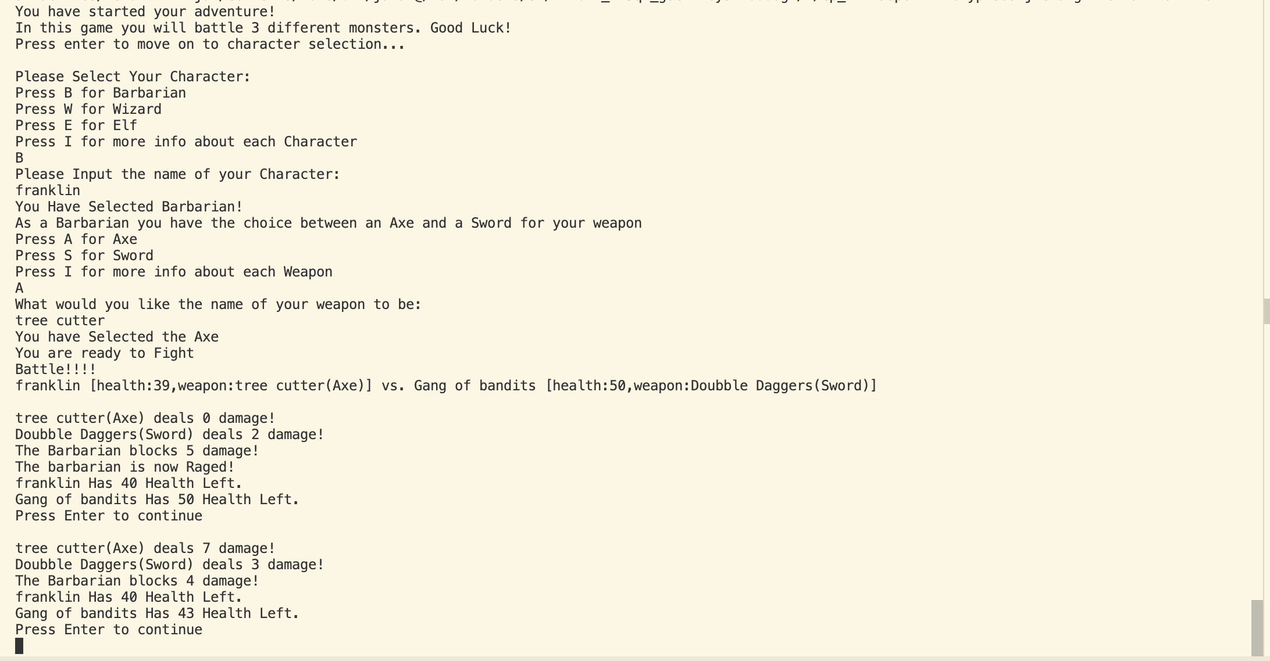
Figure 1. Example of start of game
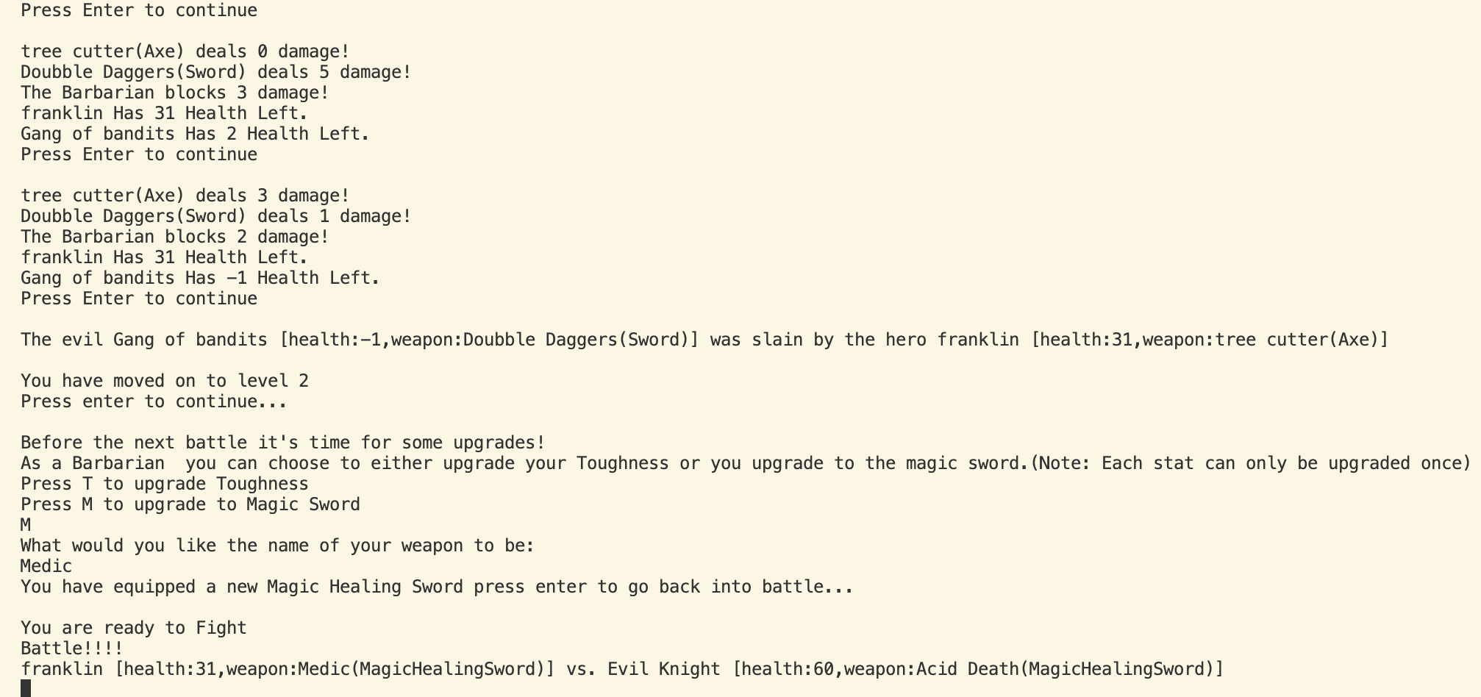
Figure 2. Example of upgrades post battle
Self-Evaluation:
I believe that I earned full points on the size potion of the coding section. Even though some parts of my code may not have been the most effect, the overall size of the code that I added was much more then 500 lines. I also added 7 new files, so I am over the threshold of the 5 required files. All my code runs well and doesn’t crash or throw errors regardless of user input. My code is well commented throughout, every method has Javadoc comments on it. I have Junit tests to make sure key features of my code are working, such as making sure monsters don’t stay poisoned too long, or a character doesn’t keep their special ability for too long. There are also Junit tests to ensure that characters are taking damage correctly and are not healing from negative damage. There are try-catch blocks around every instance of user input to ensure that the code never crashes regardless of what is input. I am yet to come across a way to make my code crash. I implemented 2 interfaces in my code. I added these to the code at the end even though they could have been much more useful if I would have added them earlier. If I was to add on to my code, they could become more useful, as I may want to add more characters with special abilities. My code was built around inheritance, and I added more inheritance with my new classes, so I think I met that requirement. Overall, I think that I deserve full points on the coding section as I met each requirement, and they are all functioning as intended.
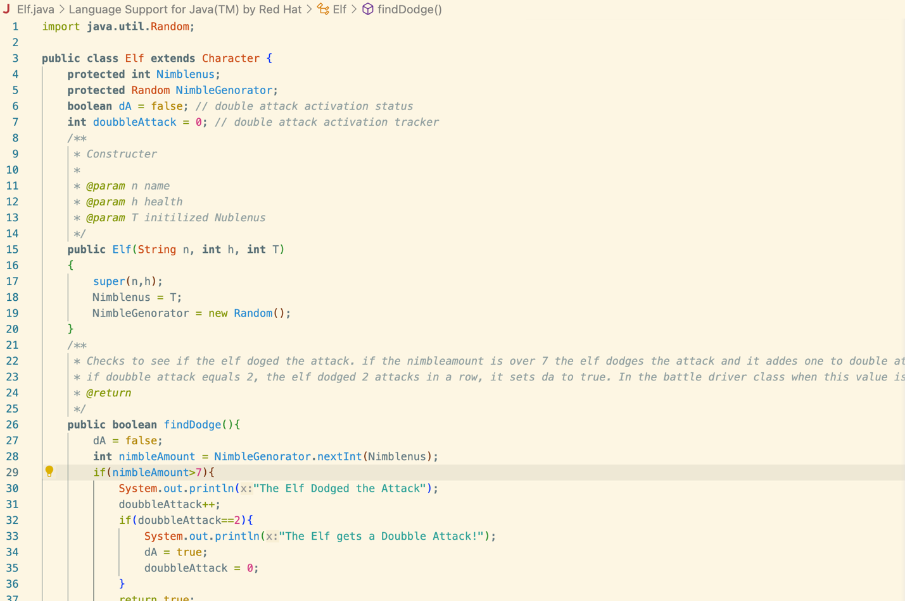
Figure 3. Example of JavaDoc comments
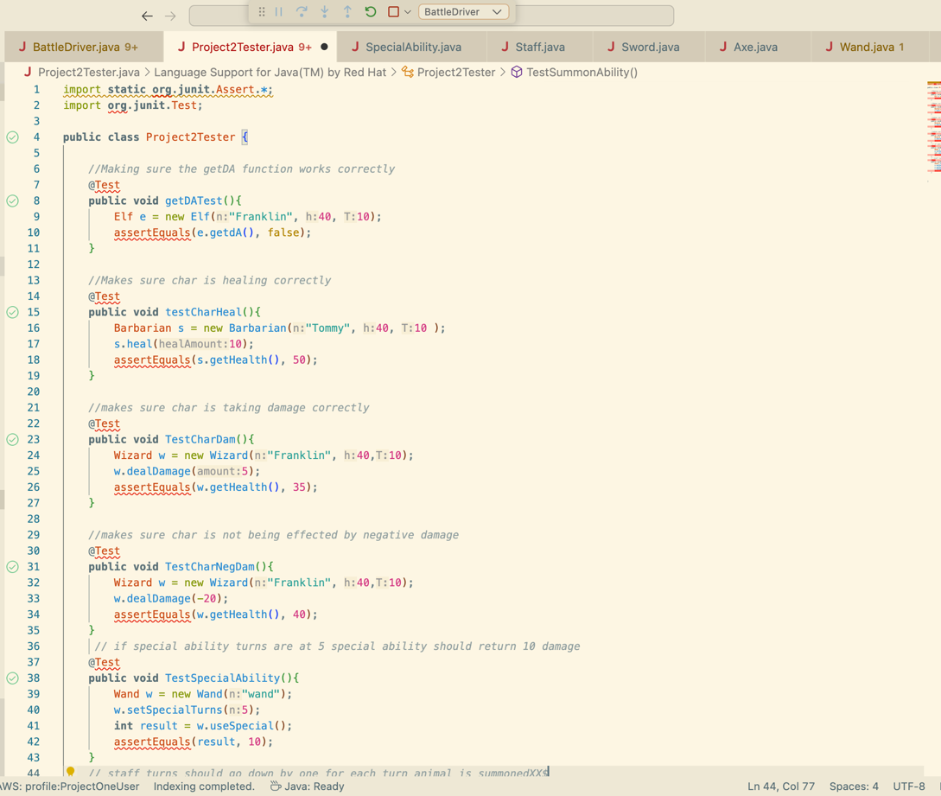
Figure 4. Example of JUnit testing
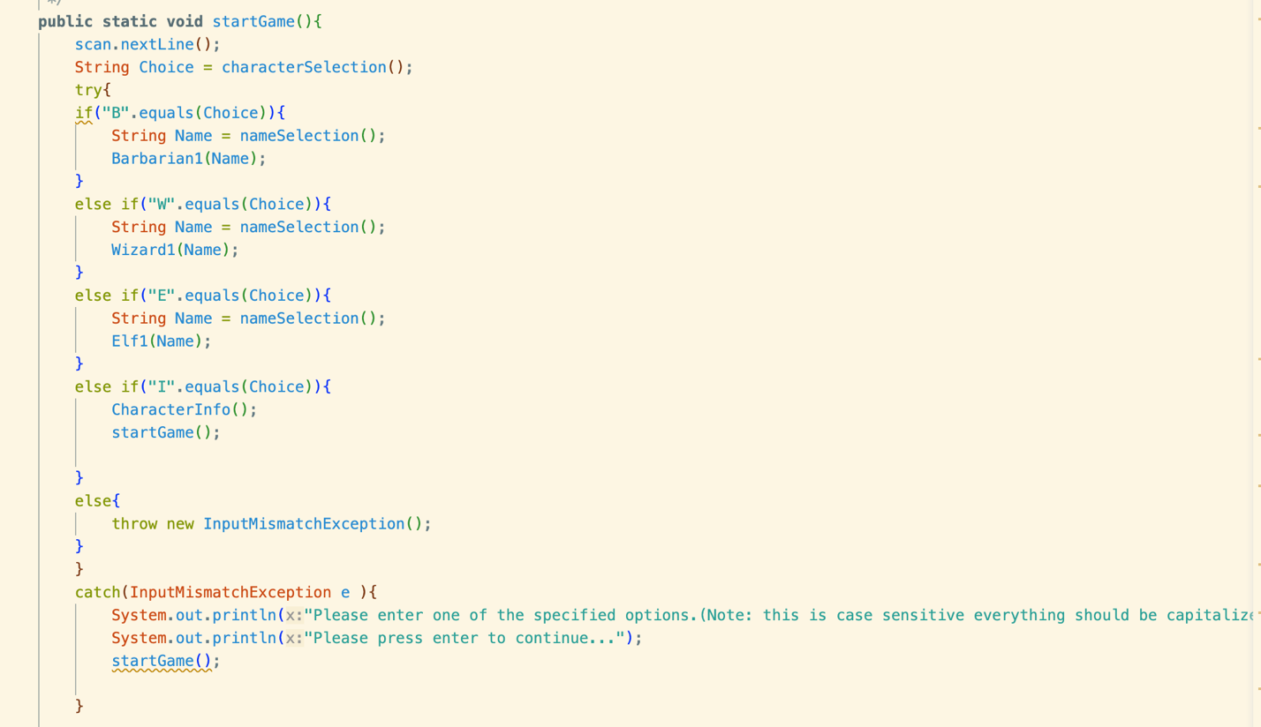
Figure 5. Example of Try Catch blocks
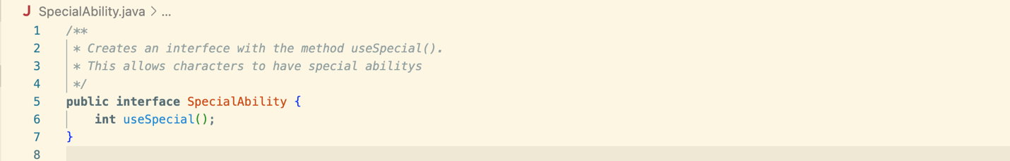
Figure 6. Example of Implemented Interface
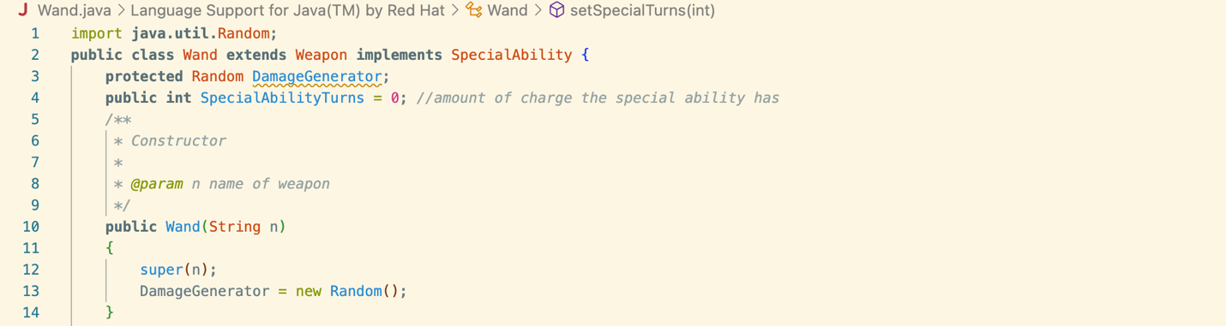Figure 7. Example of Inheritance

Reflection:
A lot of different things go into object-oriented programing. Encapsulation is used to tie different methods and fields that relate to each other into one class. Encapsulation is important to keep code organized and make it easy to add onto. In my project I used encapsulation when creating each of my different character and weapon classes. I could have maybe Improved on the encapsulation aspect of my project by splitting the battle driver up a little more, for example having a separate class for character upgrades, or a separate battle driver class.
Messaging is an important part of object-oriented programing because it is what allows objects to communicate with each other. These objects communicate with each other though calling different methods. My code demonstrated this quite a bit in the battle simulation, dealing damage to characters based on the output from another character. I could have improved on messaging in the upgrades section of my code. I decided to create a whole new object after the user decided to upgrade a certain stat, when instead I could have just created a method like setHealth and called that, setting the new health to the upgraded version.
Another part of object-oriented programing is data hiding. This involves the use of access modifiers that restrict or allow access to certain fields of an object. I demonstrated data hiding by using private, public and protected access modifiers for the most part correctly.
Inherence was something I feel my project did a great job of demonstrating. Inheritance is when a class inherits fields from another class but also can create its own new ones. The new class also inherits all the methods from the original class and can add more. All the new characters and weapons I created inherited from the character and weapon class because they all had the same base parameters, like a name and health. This made my code work better because I didn’t have to repeat all these methods, and it made it so that all my character objects were related.
Polymorphism is what allows a single interface in java to be used for multiple different objects. A common example of this is overriding. Overriding allows for a new method to be ran in a subclass of an object. My code didn’t do a great job of using polymorphism, however with my inheritance I was able to use overriding for my dealDamage methods. This allowed my new characters take damage and attack in different ways.
Overall, I think that my project did a good job of demonstrating object-oriented programing though some improvements could be made. With more time some parts of the code could be made more efficient by splitting them up into different classes, using more polymorphism to get rid of some of the if statements, or using more messaging to overcome some logically confusing parts of my code. My code in some way or another demonstrated all the important aspects of object-oriented programing.

