Project 2 – Technical Report

## Case Study: Credit Card Approval Predictions

## Data of Submission: Monday 19th of December 2022

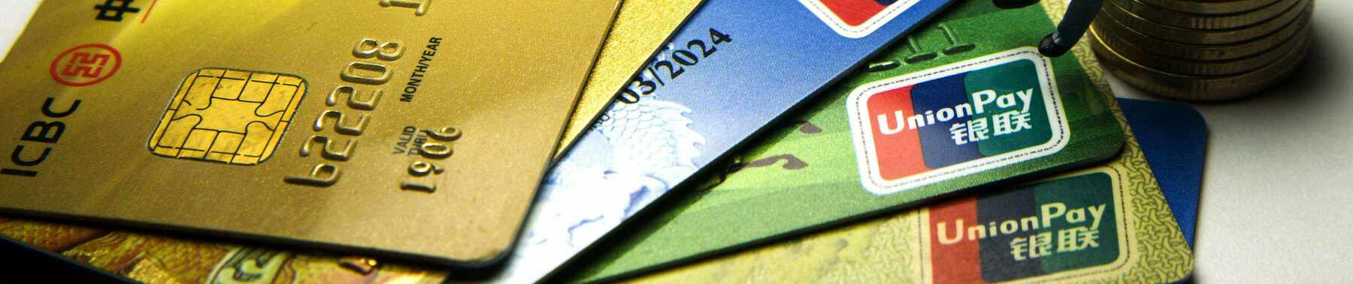

**Robert Franklin, Sandra Reyes, Zalak Shan**

Contents

Case Study: Credit Card Approval Predictions 1

Data of Submission: Monday 19th of December 2022 1

Executive Summary 2

1. Extract 2

2. Transform 2

3. Load 2

# Executive Summary

## Introduction

The research question for this project was to determine the likelihood of credit card approval by analysing client application data.

The dataset consists of 2 csv files. application_record.csv constains information about applicants including income, children, house ownership etc. credit_record.csv constains credit information about a group of clients. It is not clear exactly how these two files are related. I can guess a few possibilities:

## Extract

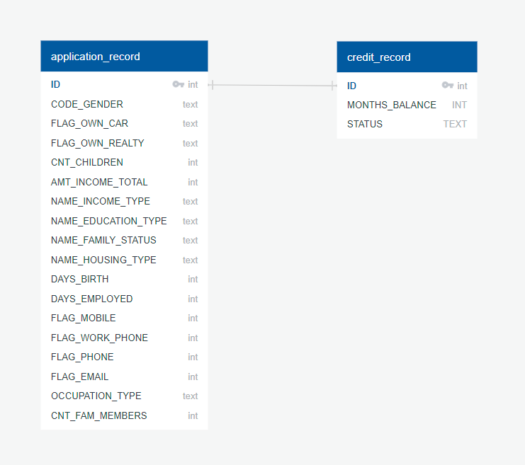

Figure - Entity Relationship Diagram (ERD)

## Transform

## Load

## Conclusion

## References