|  |
| --- |
| BankAccount |
| -balance : double |
| +BankAccount()  +BankAccount(obj : BankAccount)  +BankAccount(startBalance : double)  +BankAccount(str : String)  +deposit(amount : double) : void  +deposit (str : String) : void  +withdraw(amount : double) : void  +withdraw(str : String) : void  +getBalance() : double |

**MAIN CLASS:**

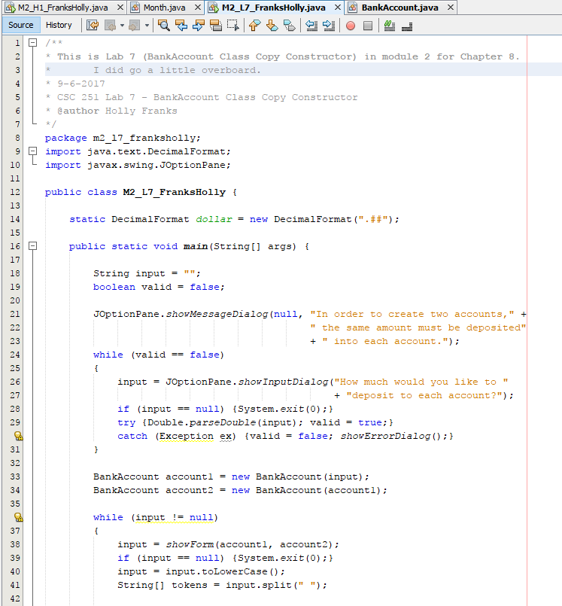

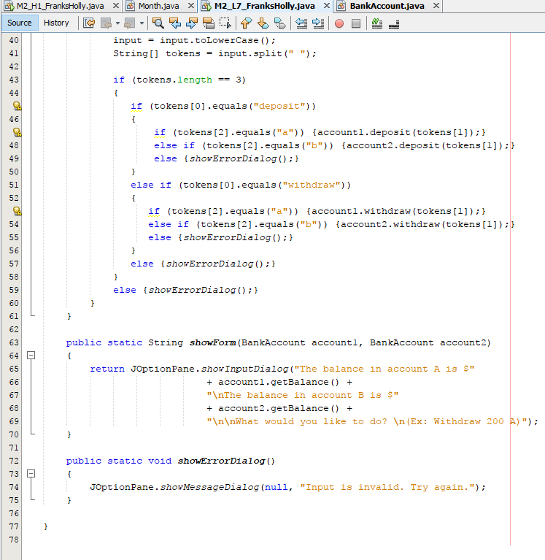

**BANKACCOUNT CLASS:**

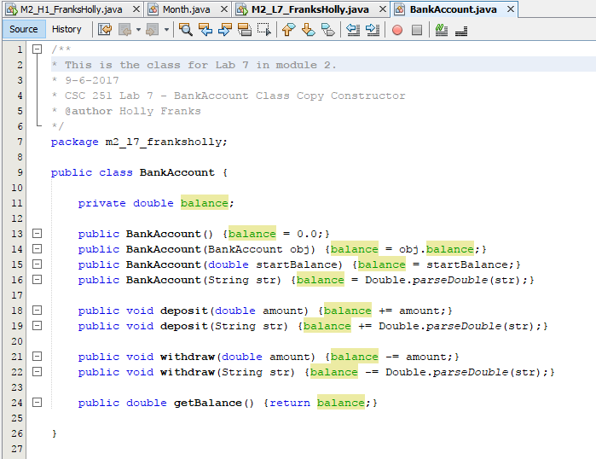

**OUTPUT:**

