|  |
| --- |
| PasswordVerification |
| -password : String |
| +PasswordVerification(String input)  +VerifyPassword() : boolean |

**MAIN CODE:**

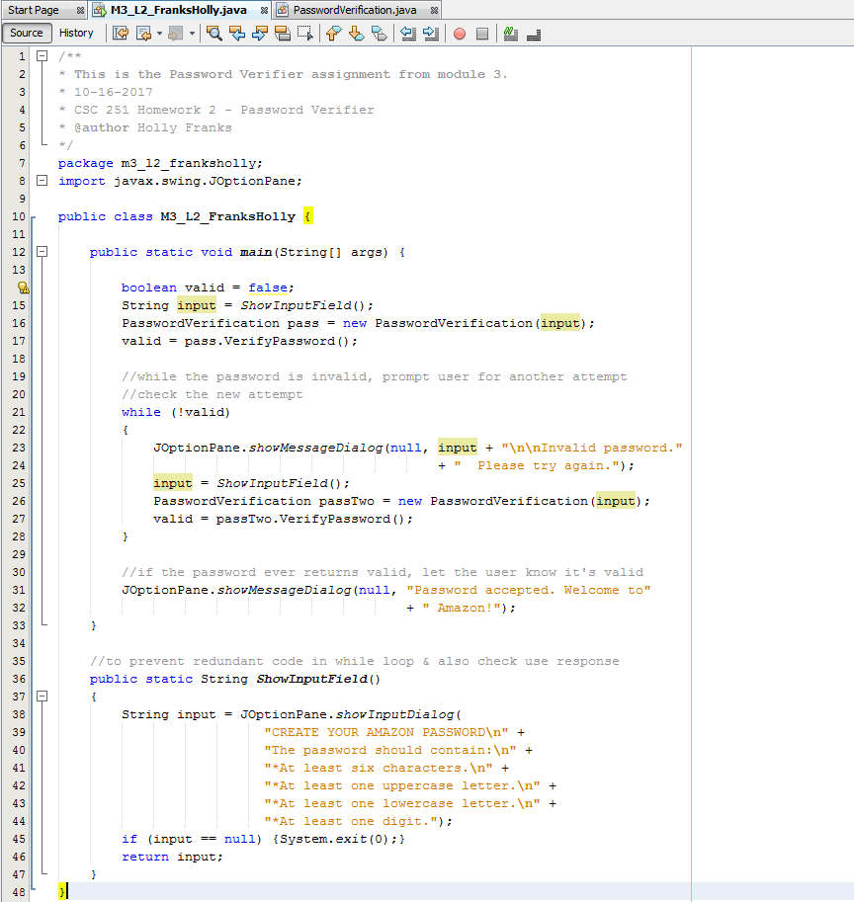

**PASSWORDVERIFICATION CLASS:**

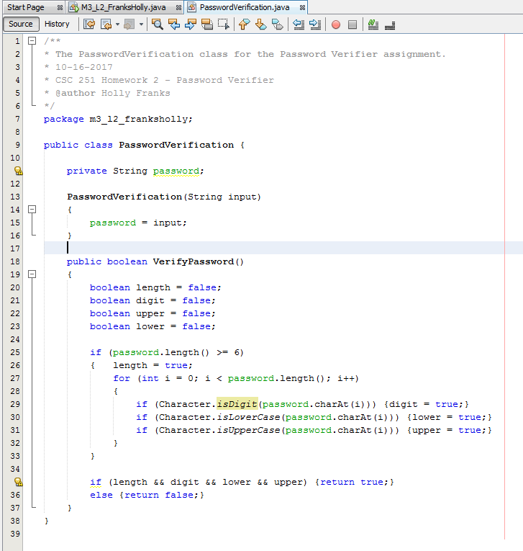

**OUTPUT (NO ERRORS):**

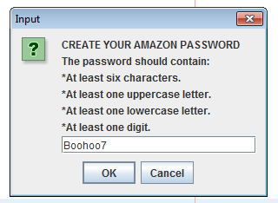

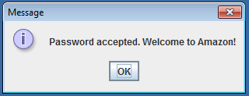

**OUTPUT (ERRORS):**

**(where the input is shown in the error message)**

