|  |
| --- |
| Employee |
| -employeeName : String  -employeeNumber : String  -hireDate : String |
| +Employee()  +Employee(name : String, num : String, date : String)  +setEmployeeName(String name) : void  +setEmployeeNumber(String num) : void  +setHireDate(String date) : void  +getEmployeeName() : String  +getEmployeeNumber() : String  +getHireDate() : String  +toString() : String |

|  |
| --- |
| ProductionWorker |
| -shift : int  -hourlyRate : double |
| +ProductionWorker()  +ProductionWorker(n : String, num : String, date : String, sh : int, r : double)  +setShift(int sh) : void  +setHourlyRate(double rate) : void  +getShift() : int  +getHourlyRate() : double  +toString() : String |

**MAIN CODE:**

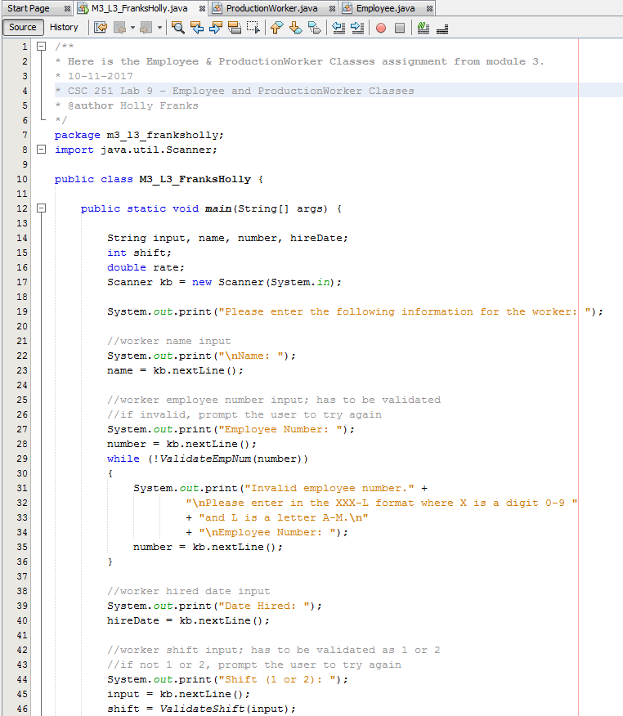

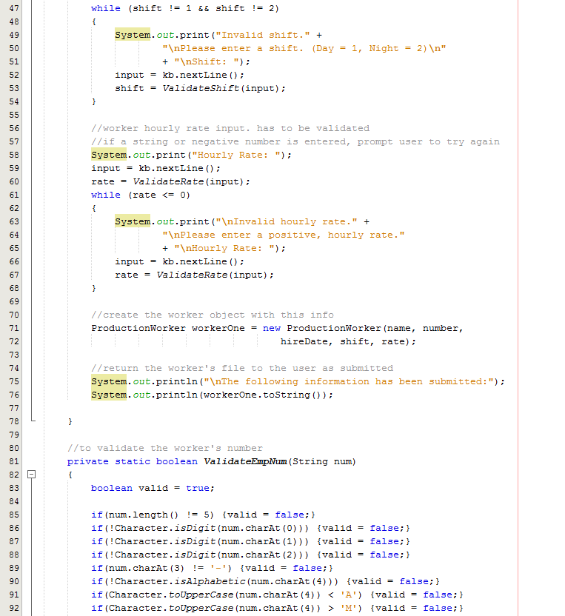

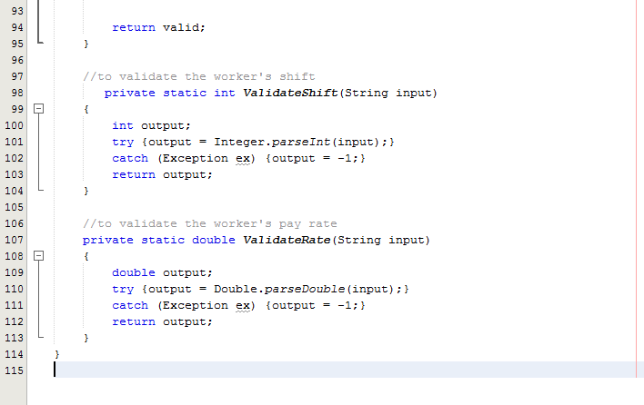

**EMPLOYEE CLASS:**

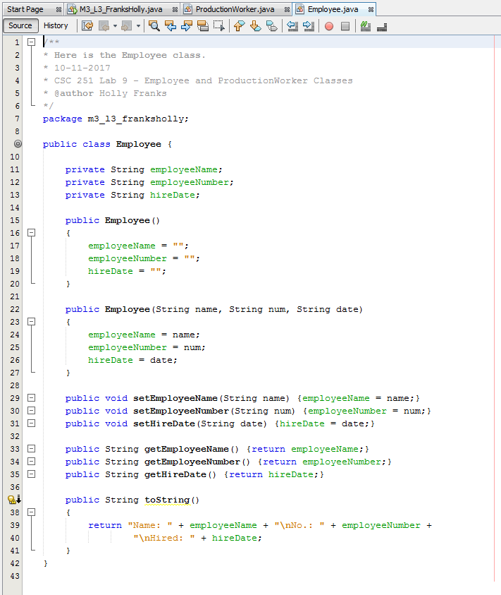

**PRODUCTIONWORKER CLASS:**

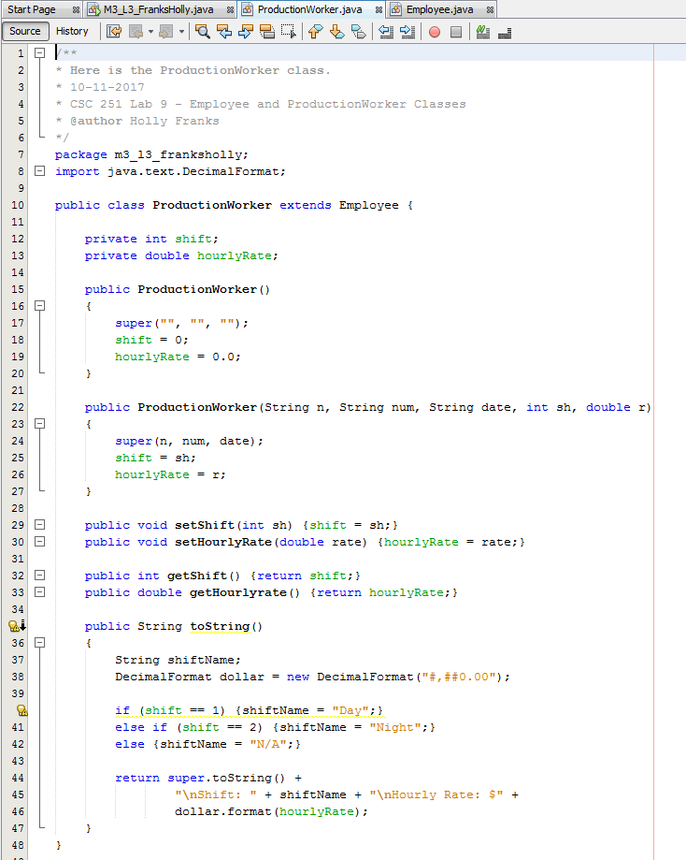

**OUTPUT (NO ERRORS):**

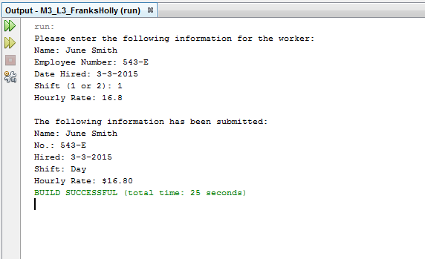

**OUTPUT (ERRORS):**

