|  |
| --- |
| GradedActivity |
| -score : double |
| +setScore(double s) : void  +getScore(): double  +getGrade(): char |

|  |  |  |
| --- | --- | --- |
| Essay | FinalExam | PassFailExam |
| -grammar: double  -spelling: double  -length: double  -content: double | -NUMQUESTIONS: final int  -pointsEach: double  -numMissed: double | -NUMQUESTIONS: final int  -pointsEach: double  -numMissed: double |
| +Essay(double[] scores)  +getGrammar(): double  +getSpelling(): double  +getLength(): double  +getContent(): double | +FinalExam(double missed)  +getPointsEach(): double  +getNumMissed(): double | +FinalExam(double missed)  +getPointsEach(): double  +getNumMissed(): double |

|  |
| --- |
| CourseGrades |
| -grades[] : GradedActivity[4] array |
| +CourseGrades(GradedActivity lab, GradedActivity exam, GradedActivity essay, GradedActivity fexam)  +setLab(GradedActivity lab): void  +setPassFailExam(GradedActivity exam): void  +setEssay(GradedActivity essay): void  +setFinalExam(GradedActivity exam): void  +toString(): String |

**MAIN CODE:**

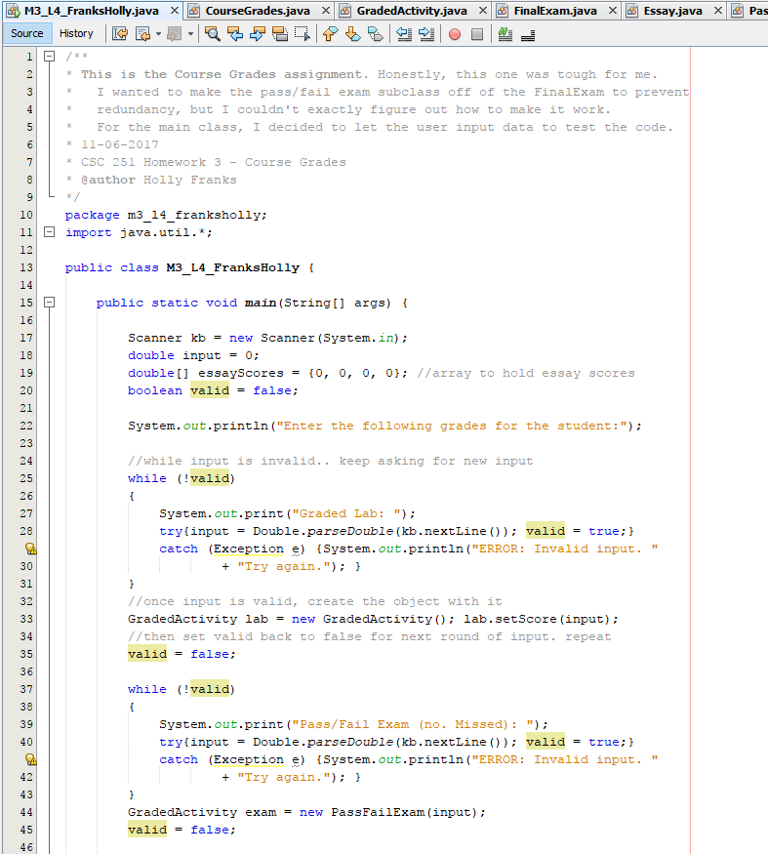

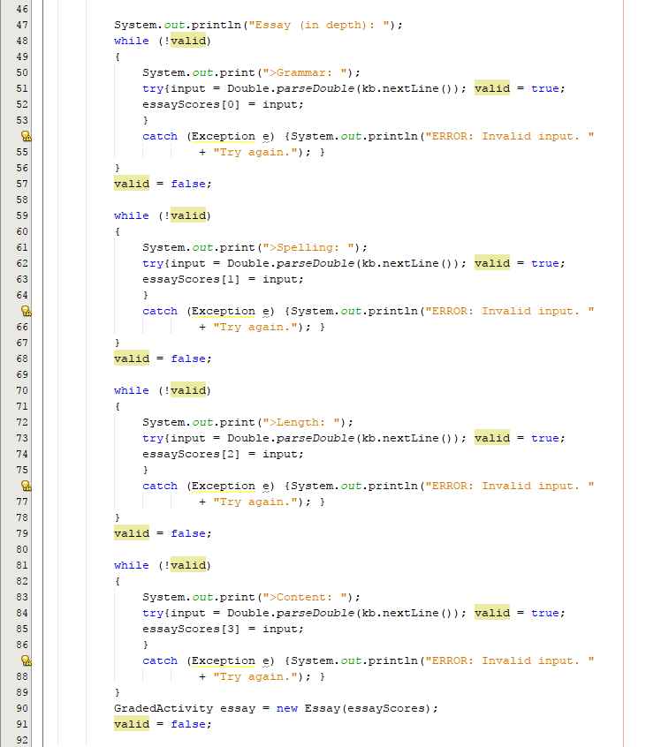

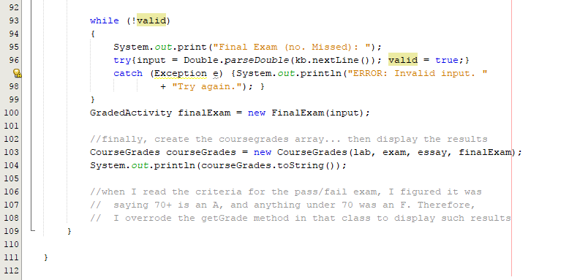

**COURSEGRADES CLASS:**

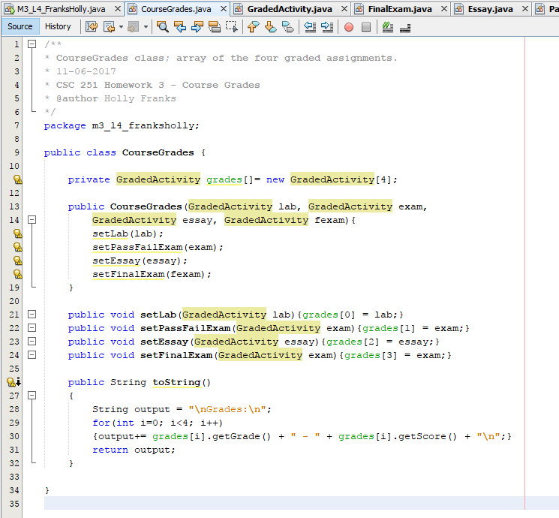

**GRADEDACTIVITY CLASS:**

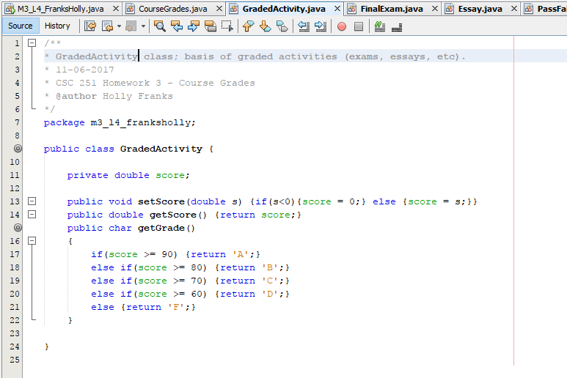

**ESSAY CLASS:**

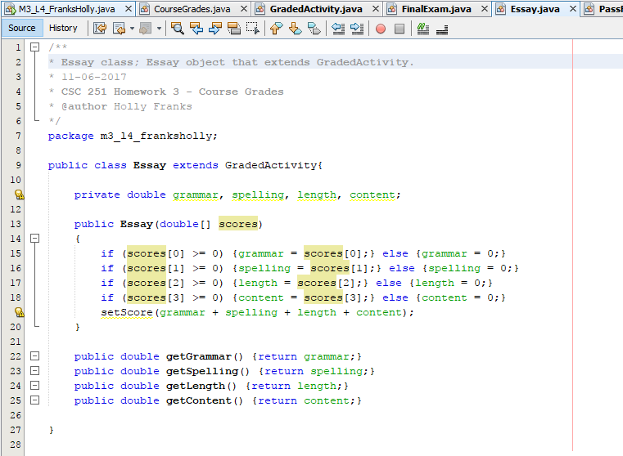

**FINALEXAM CLASS:**

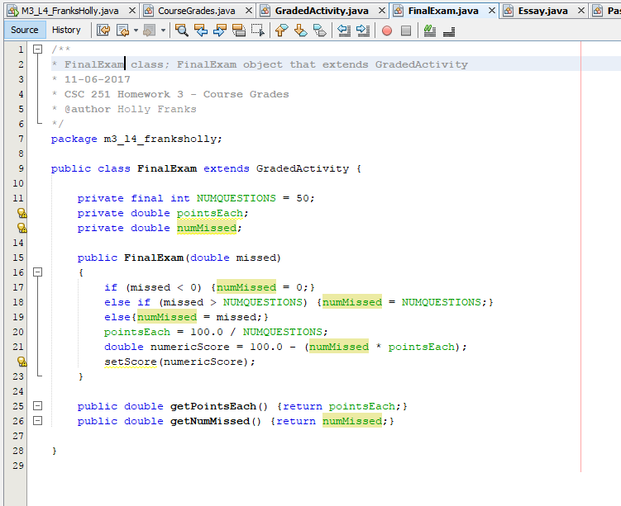

**PASSFAILEXAM CLASS:**

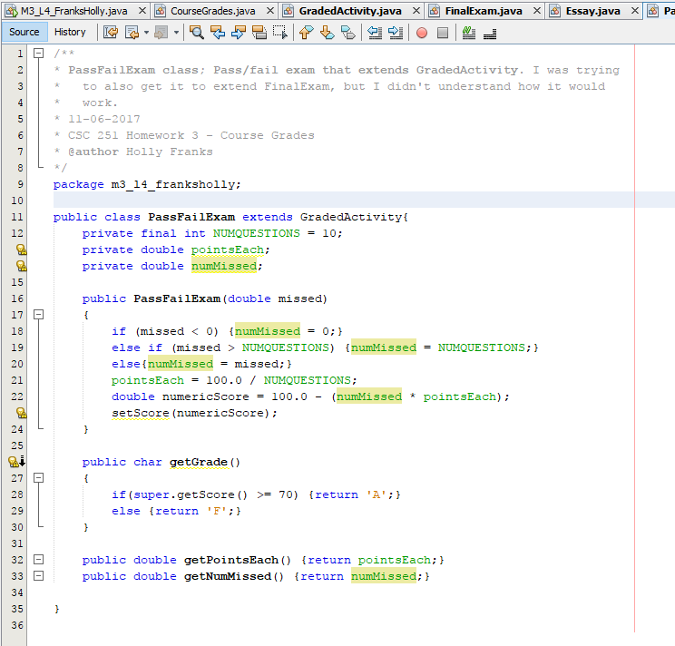

**OUTPUT (NO ERRORS):**

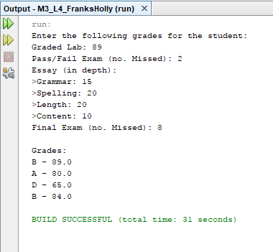

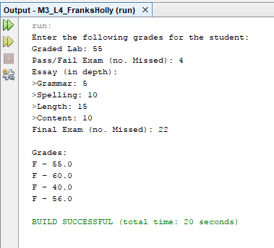

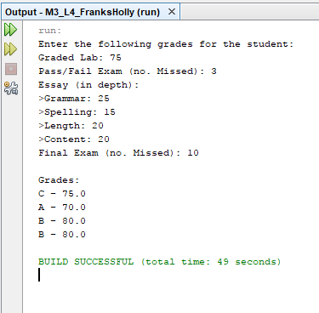

**OUTPUT (ERRORS):**

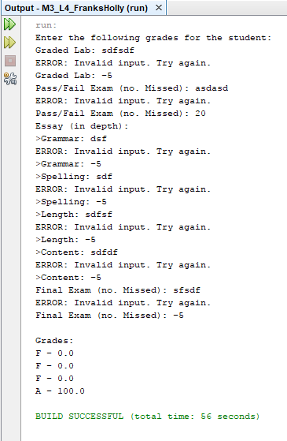

**(Negative input turns into 0! Additionally, input for missed that’s higher than the total questions turns into the total questions)**