|  |
| --- |
| Month |
| - monthNumber : int  - monthName : String[] |
| + Month()  + Month(num : int)  + Month(month : String)  + setMonthNumber(int num) : void  + getMonthNumber() : int  + getMonthName() : String  + toString() : String  + equals(month : Month) : boolean  +greaterThan(month : Month) : boolean  +lessThan(month : Month) : boolean |

|  |
| --- |
| **InvalidMonthName (extends Exception)** |
| **InvalidMonthName()** |

|  |
| --- |
| **InvalidMonthNumber (extends Exception)** |
| **InvalidMonthNumber()** |

**MAIN CLASS:**

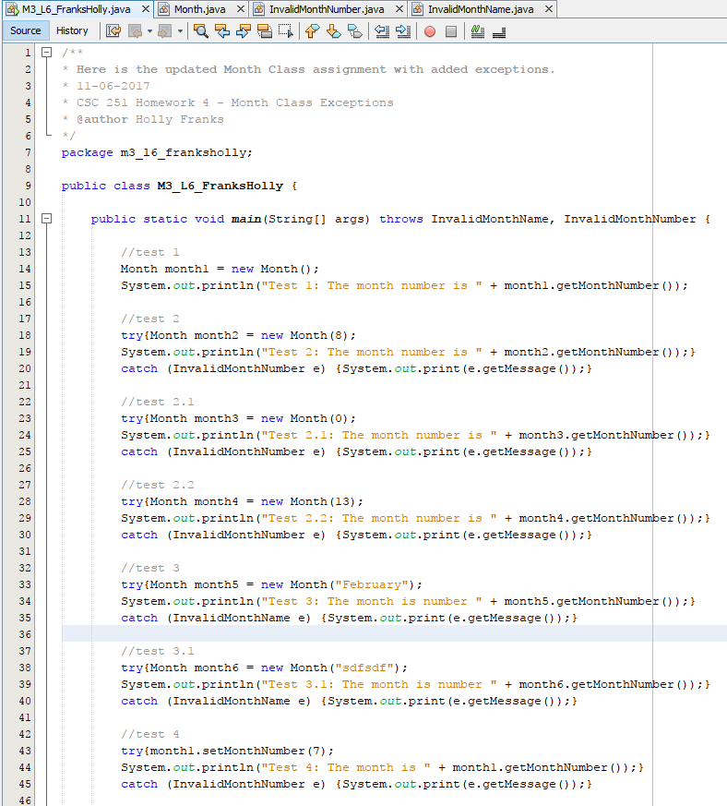

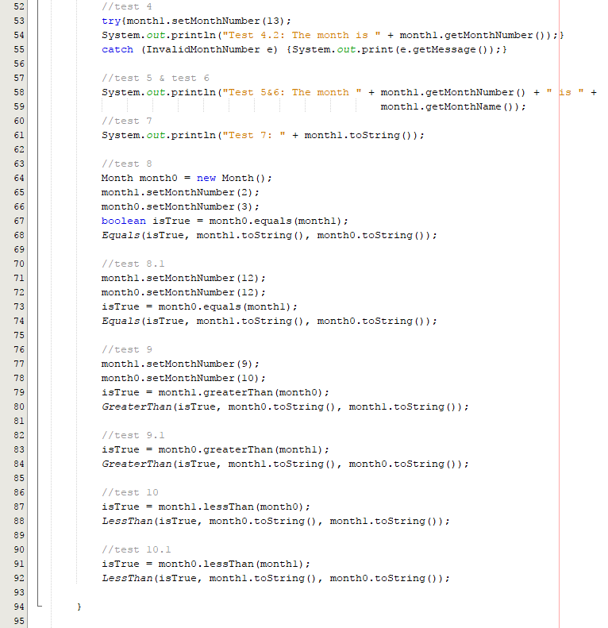

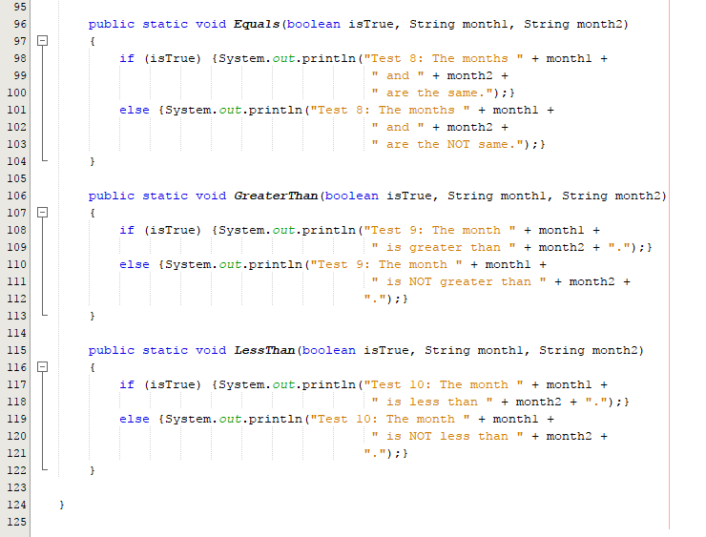

**MONTH CLASS:**

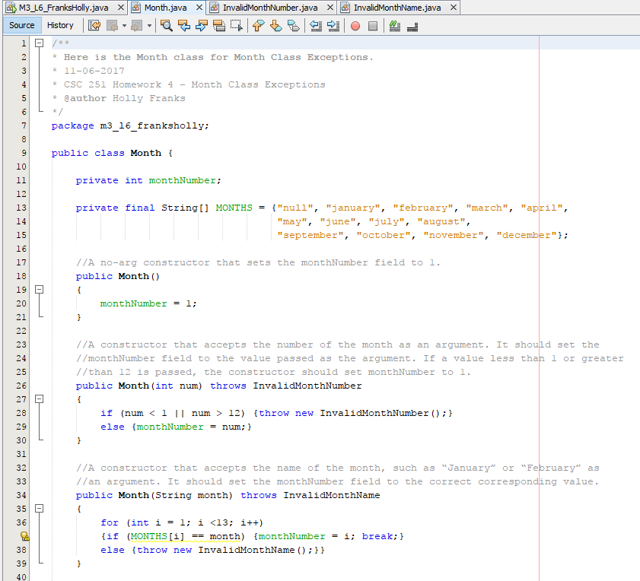

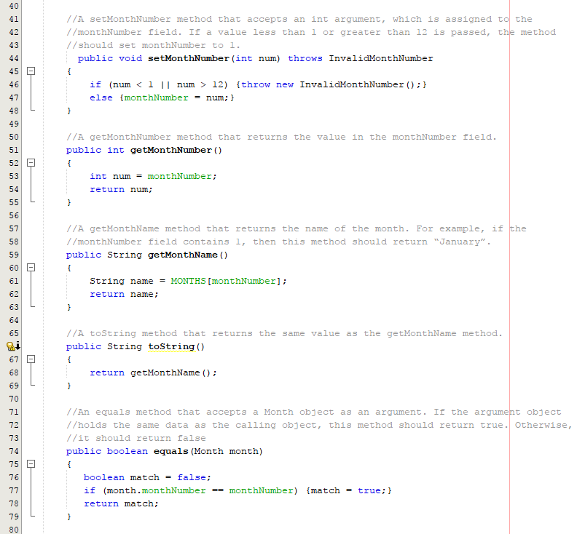

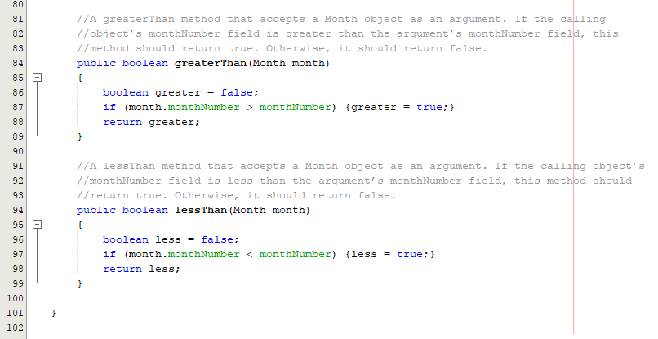

**INVALIDMONTHNAME CLASS:**

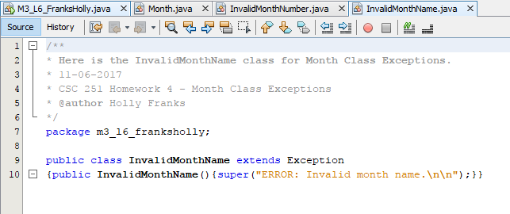

**INVALIDMONTHNUMBER CLASS:**

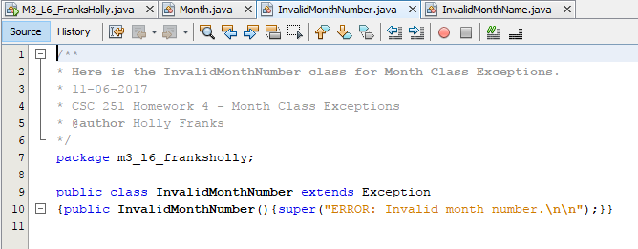

**OUTPUT:**

