PIZZERIA PROJECT APP // HOLLY FRANKS

In order for the program to work, a database must be created in the services tab of Netbeans named “PizzeriaDB”.

It may also be required to comment out the drop statement in the PizzeriaTable for the first run. DB programming is new to me and I wasn’t able to find much help that I could make sense of. Despite this, I was able to create tables and rows and fetch data using SQL statements.

Additionally, the app is not completely error proof. I ran out of time to weed out errors (such as being able to submit empty options).

I guess if a customer just wants to order olives in a cup… They can for $0.50. Unfortunately a few of the Cici’s Pizzas I’ve been to made you pay for a cup of shredded cheese to put on salad rather than put it out on the buffet… Savage.

MAIN CODE:

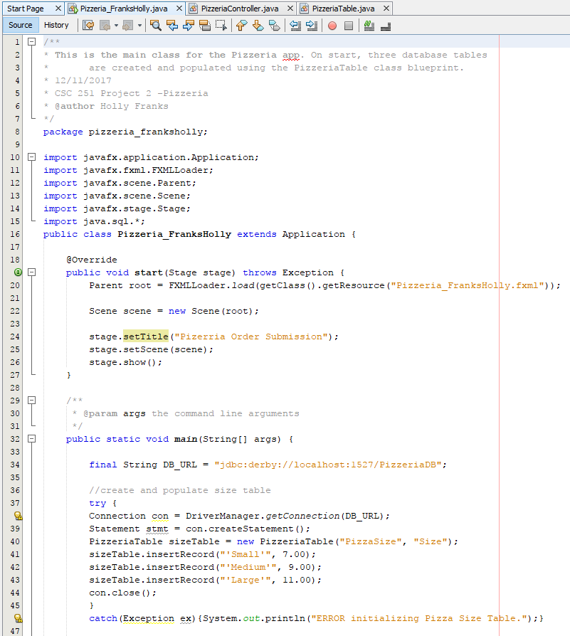

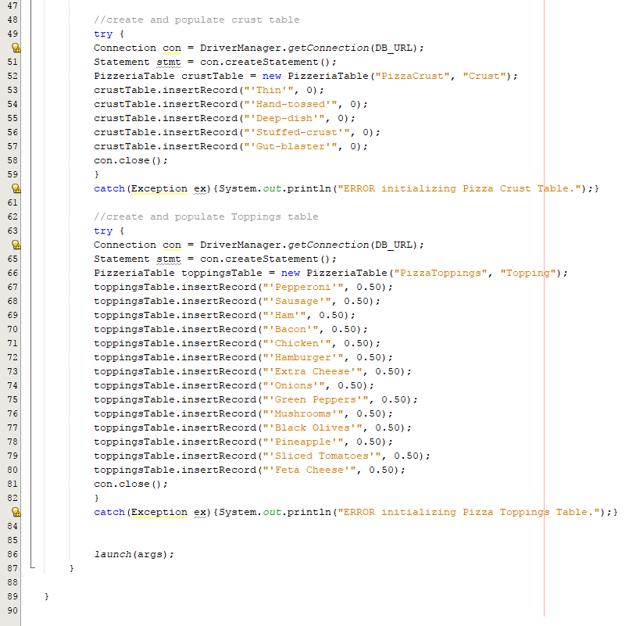

PIZZERIA TABLE:

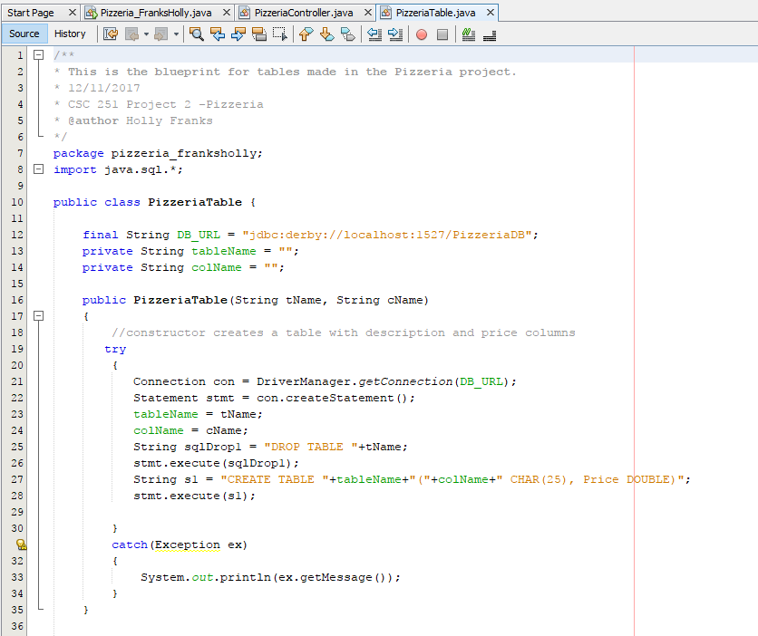

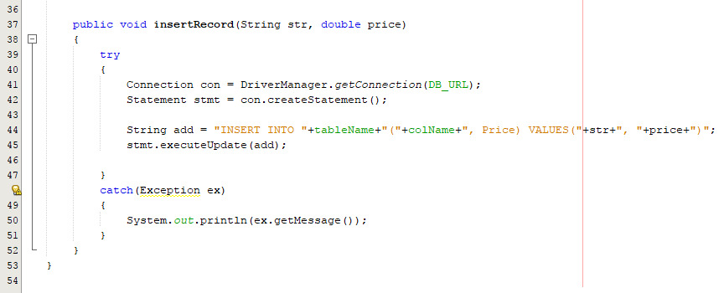

PIZZERIA CONTROLLER: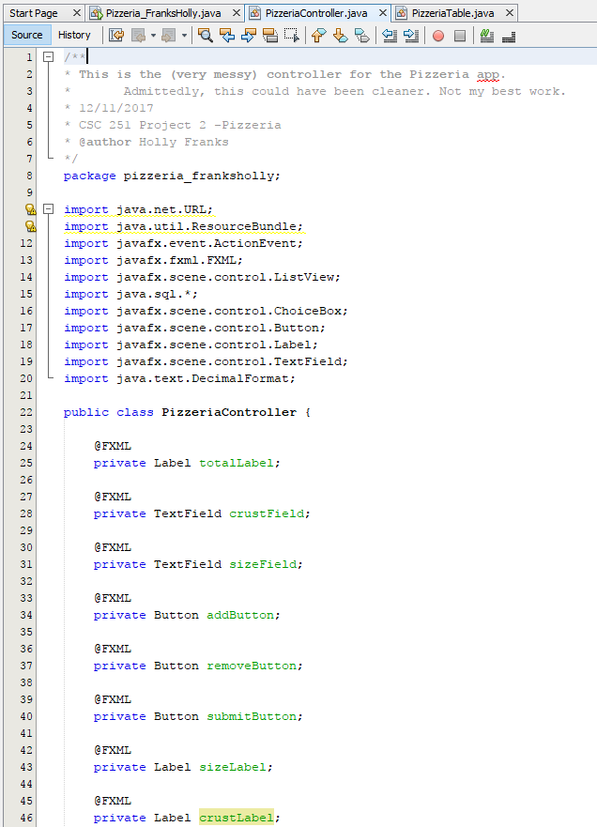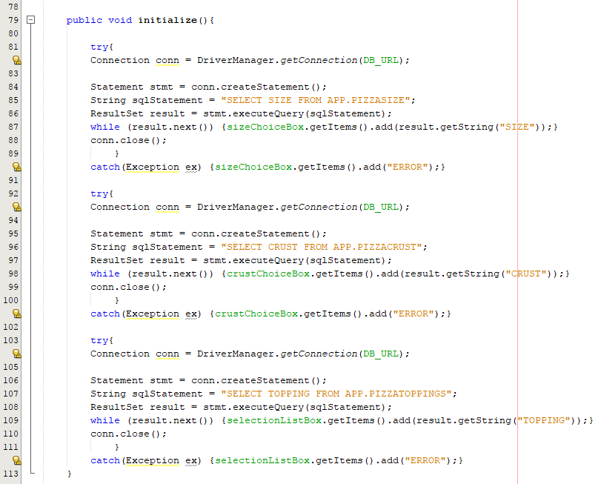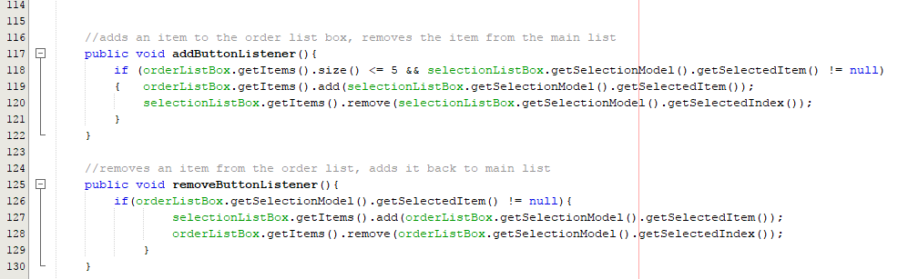

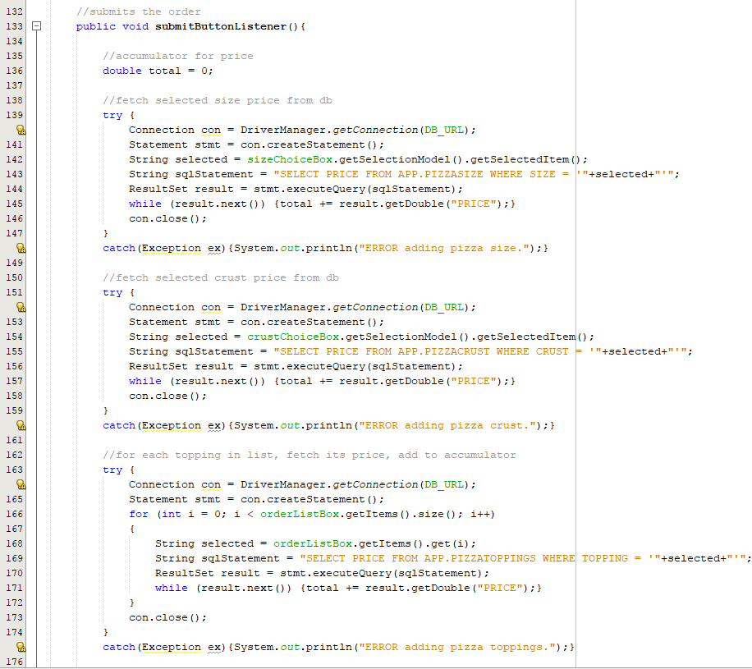

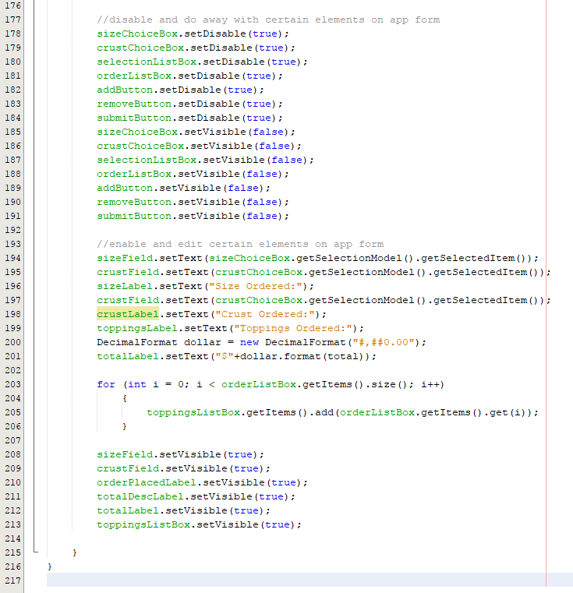

OUTPUT:

